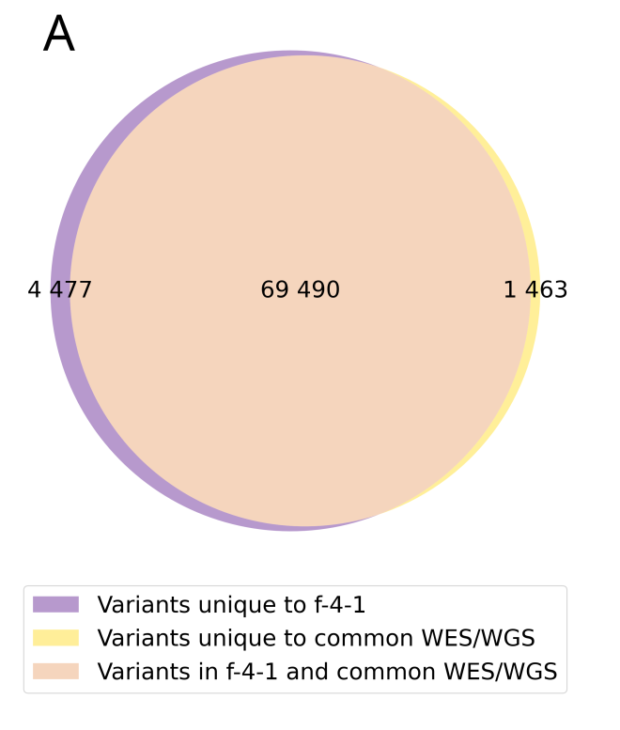
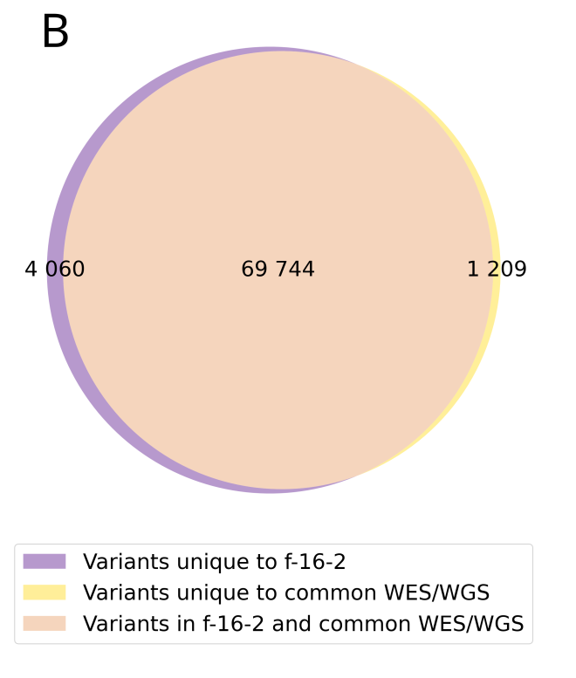
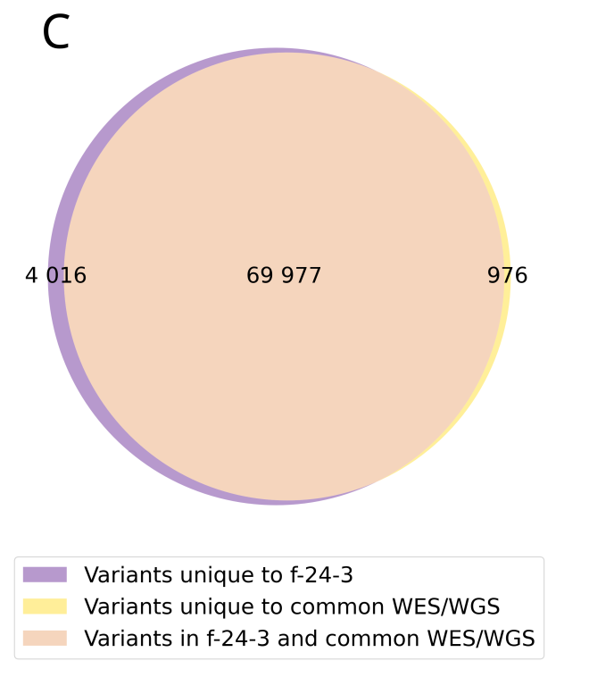

Figure S1. Venn diagram showing the intersection of PTA-WES
and common WES/WGS variants for sample including A) 4 cells, B) 16 cells, C) 24 cells

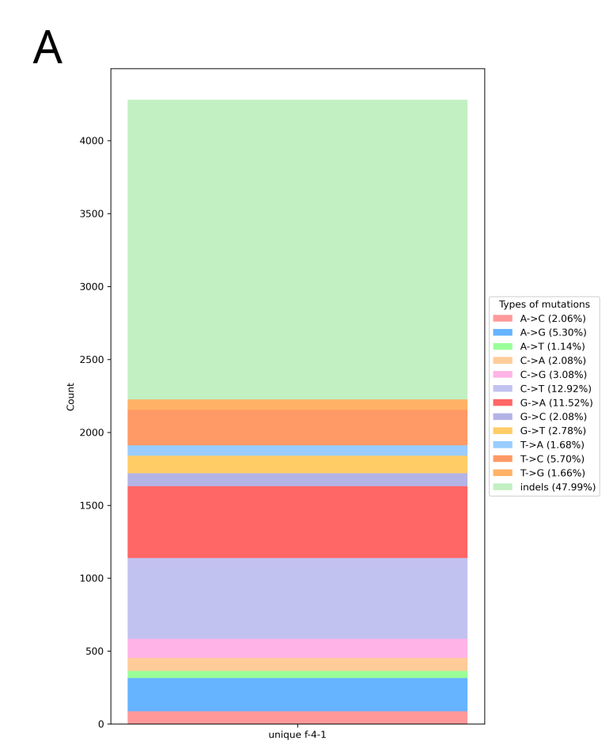
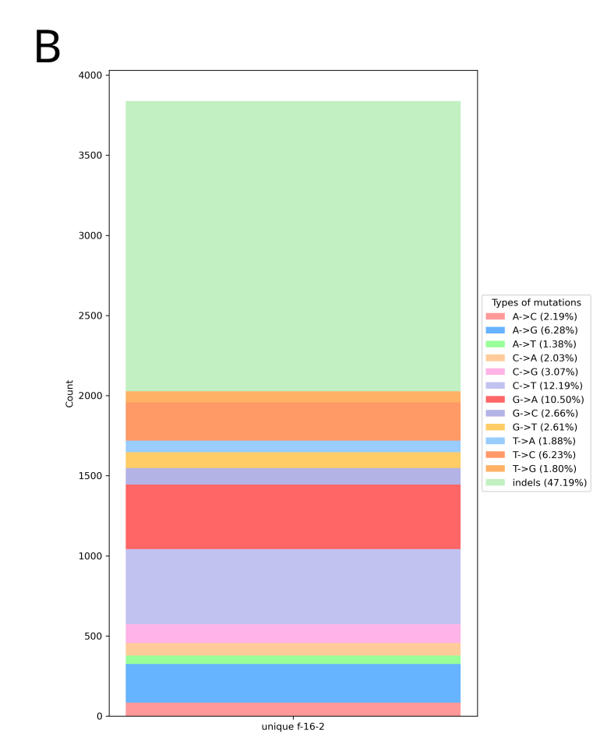
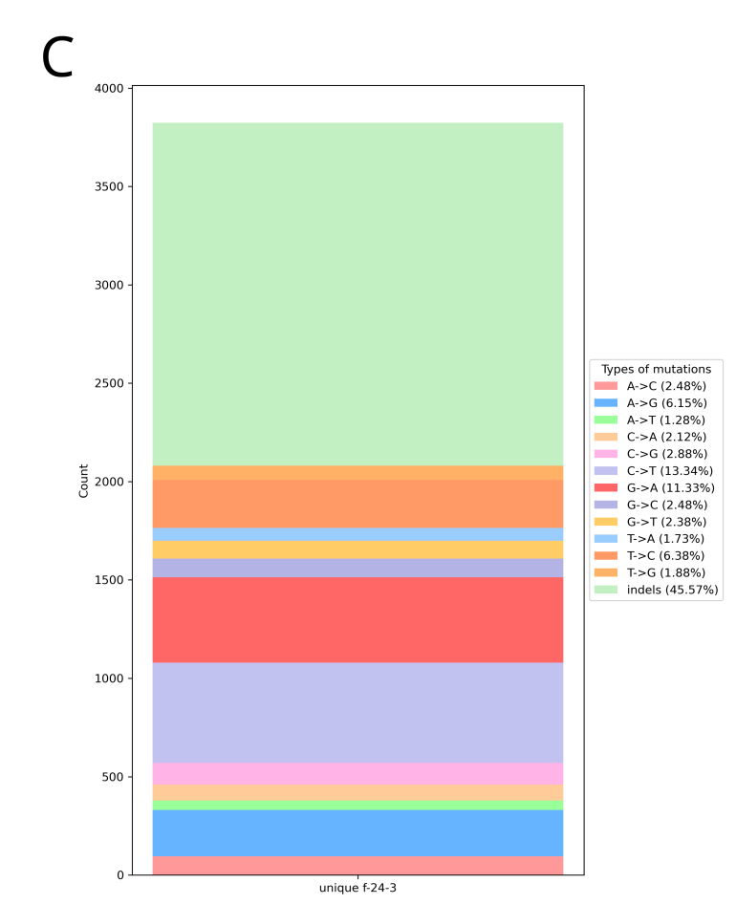

Figure S2. Distribution of variant types among unique PTA-WES variants for sample including A) 4 cells, B) 16 cells, C) 24 cells
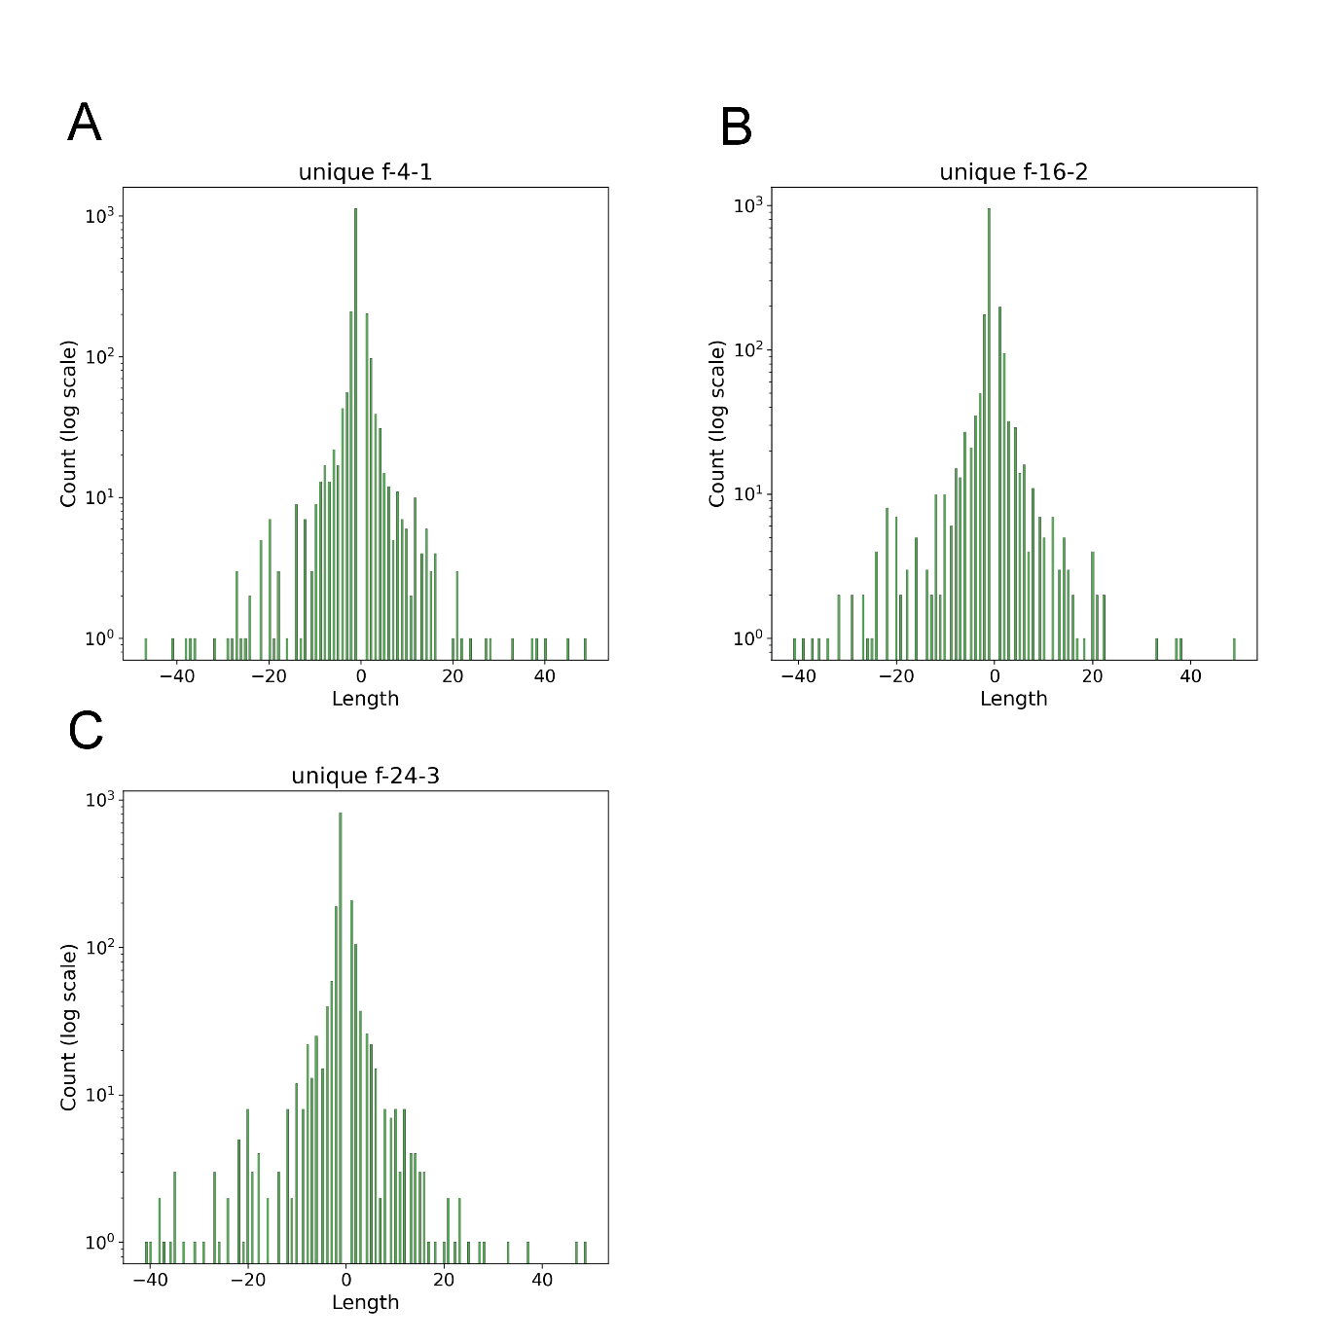

Figure S3. Indel length distributions among unique PTA-WES variants for sample including A) 4 cells, B) 16 cells, C) 24 cells. Indels with a length more than 50 were excluded

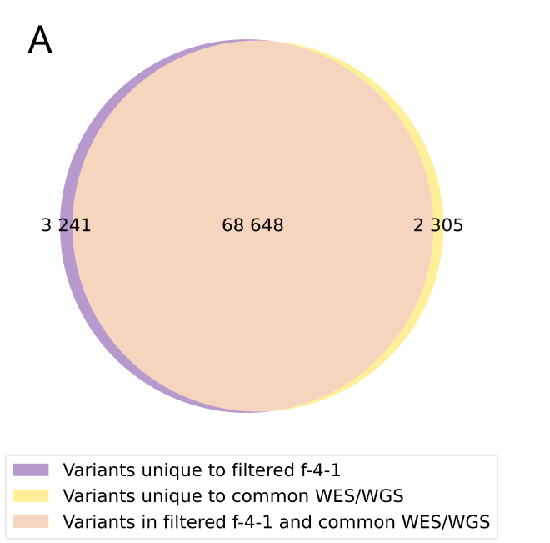
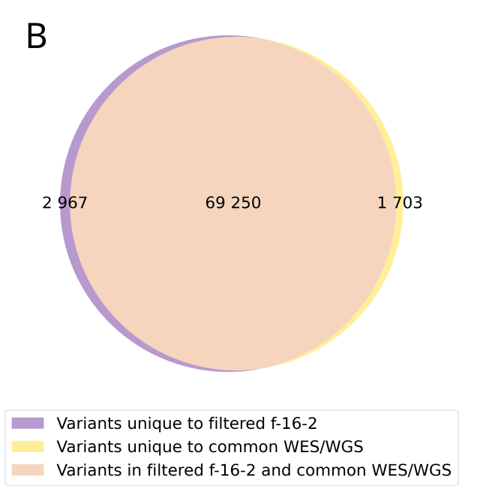
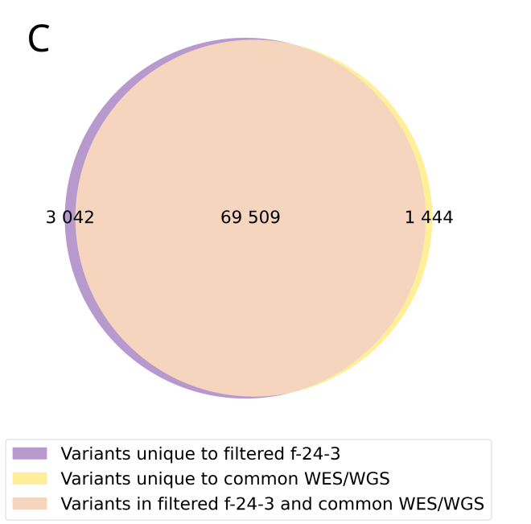

Figure S4. Venn diagram showing the intersection of filtered PTA-WES
and common WES/WGS variants for sample including A) 4 cells, B) 16 cells, C) 24 cells

