Supplementary materials

Figures

Figure S1. Mitochondrial genome map of P. g. guttatus GXG3635. Genes encoded by the light or heavy strand are indicated inside or outside, respectively, showing the direction of transcription. The transport RNA (tRNA) is denoted by the purple color and labeled according to the three-letter amino acid code. The ribosomal RNA (rRNA) and protein coding genes (PCG) are indicated by red and yellow colors respectively. The control region or displacement loop (D-loop) is given in green color. The picture of the P. g. guttatus was taken by D. Ualiyeva.

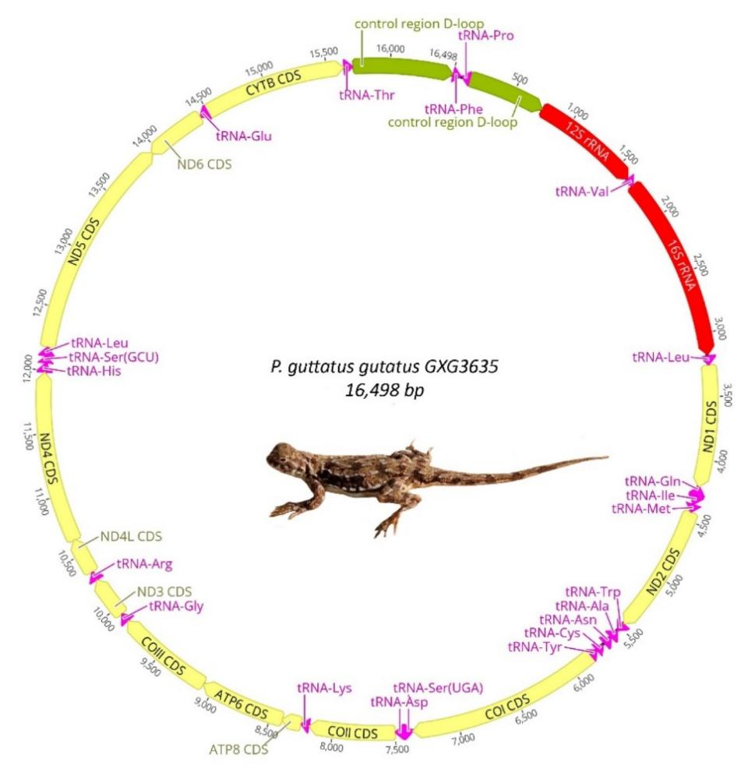

Figure S2. Mitochondrial genome map of P. moltschanovi GXG3641. The picture of the P. moltschanovi was taken by D. Ualiyeva.
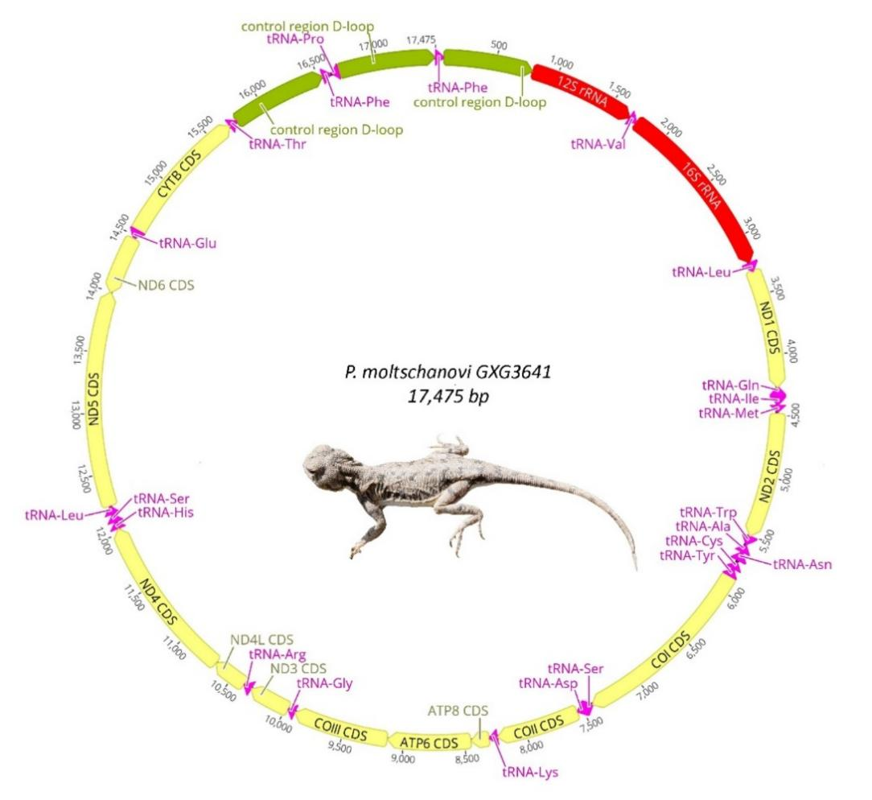

Figure S3. Mitochondrial genome map of P. alpherakii GUO2270. The picture of the P. akpherakii was taken by X. Guo.

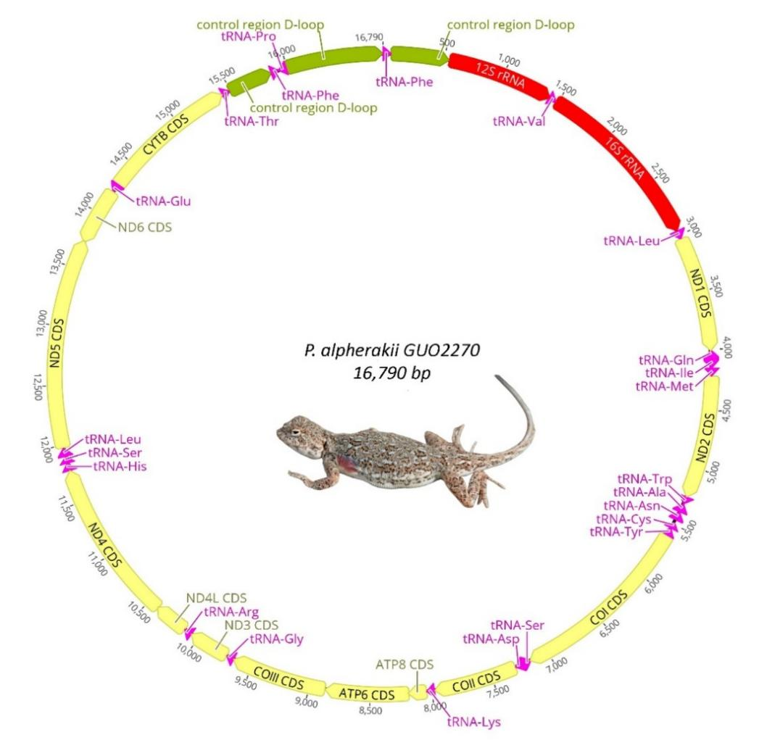

Figure S4. Mitochondrial genome map of P. incertus KZ73. The picture of the P. incertus was taken by O. Belyalov.

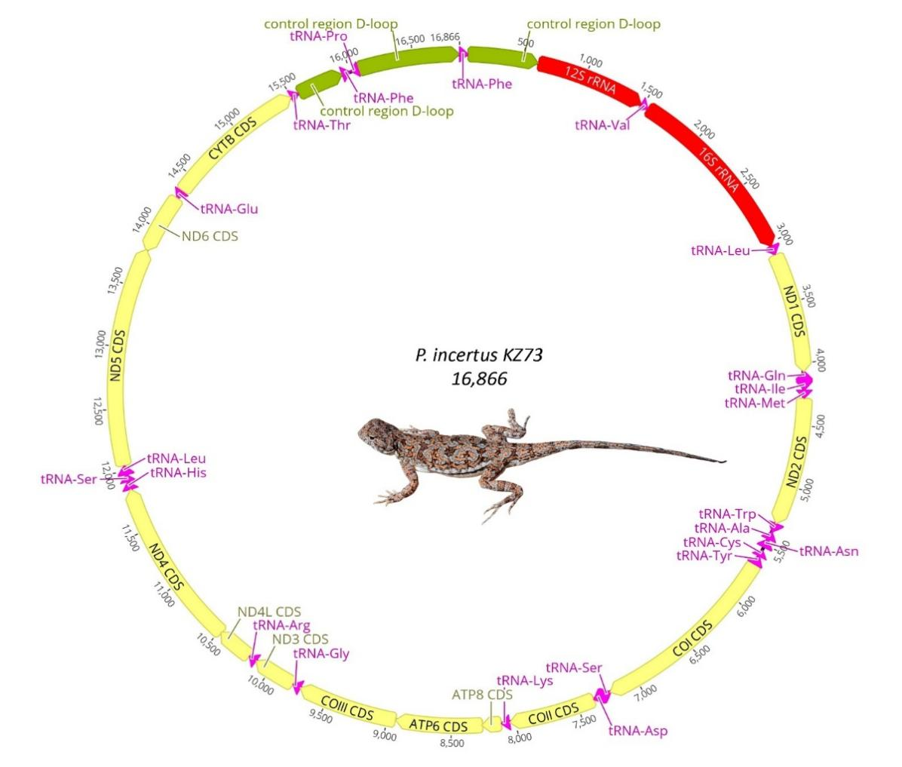

Figure S5. Mitochondrial genome map of P. kuschakewitschii KZL22. The picture of the P. kuschakewitschii was taken by O. Belyalov.

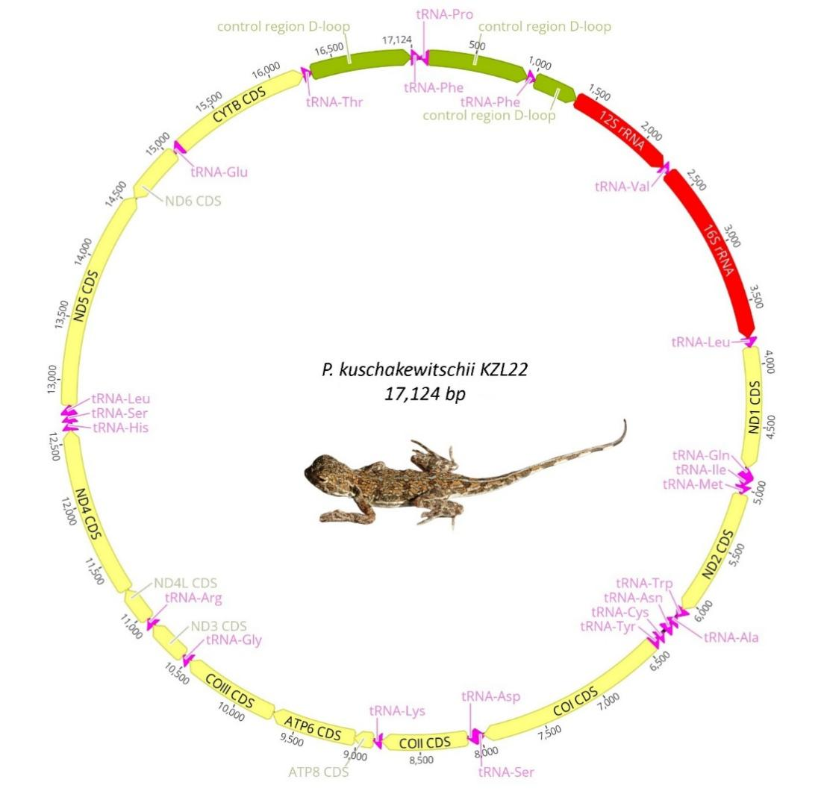

Figure S6. Mitochondrial genome map of P. melanurus 1 KZ202. The picture of the P. melanurus 1 was taken by J. Liu.

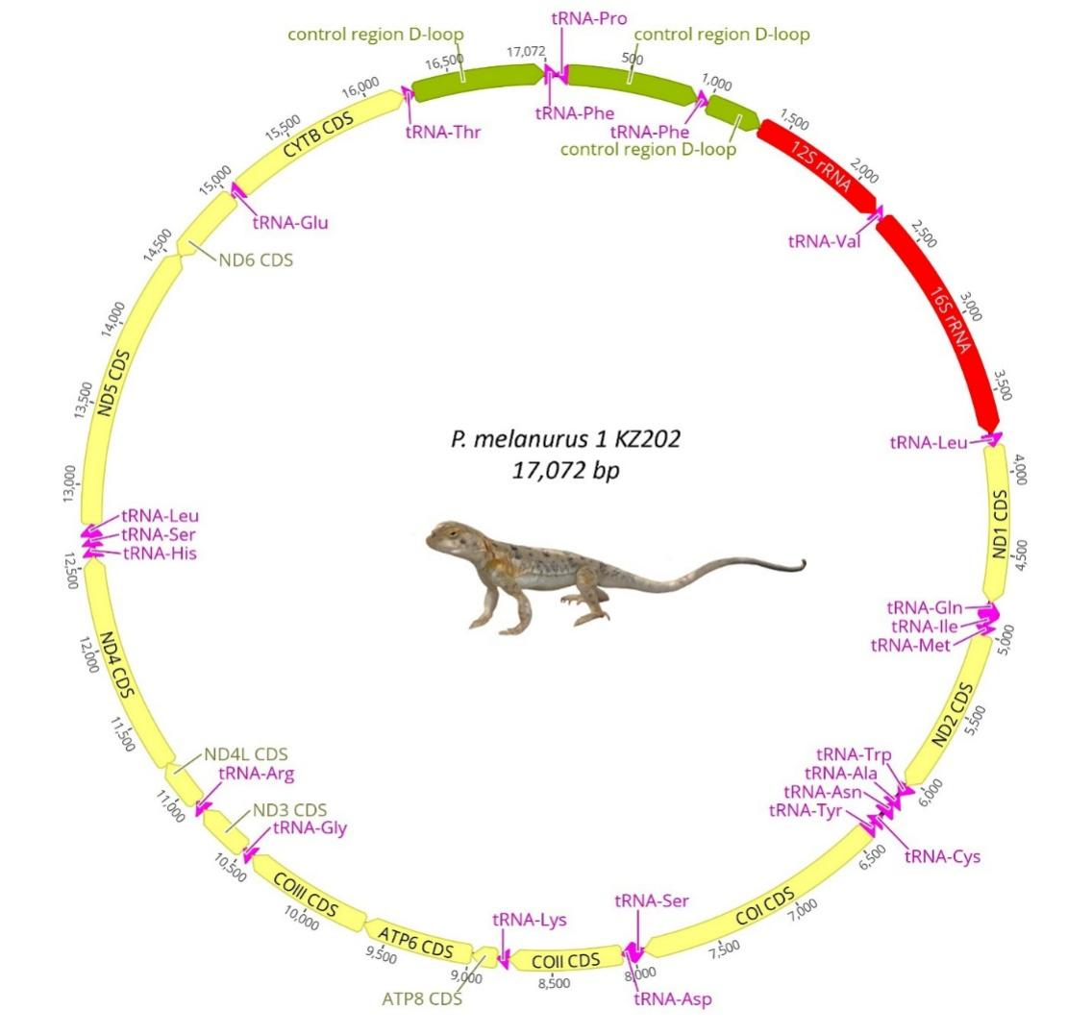

Figure S7. Mitochondrial genome map of P. melanurus 2 GUO541. The picture of the P. melanurus 2 was taken by X. Guo.

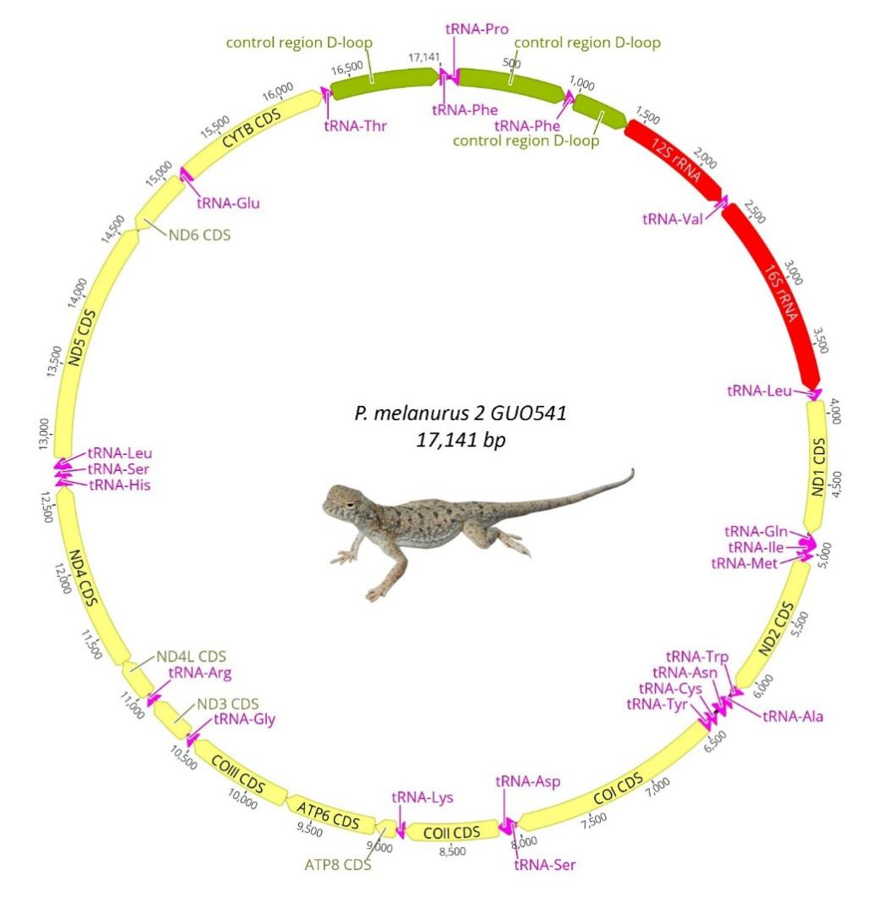

Figure S8 a, b, c. The relative synonymous codon usage (RSCU) in the mitogenomes of Aral-Caspian Basin`s toad-headed agamas: P. g. kalmykus, P. g. guttatus, and P. moltschanovi. The abscissa represents the type of amino acid translated by the codon, and the ordinate represents the codon bias score calculated for the amino acid. The higher the score, the higher the codon bias score. High, the more types of codons, the more dynamic the evolutionary variation of the genes in the genome. Stop codons are not shown.

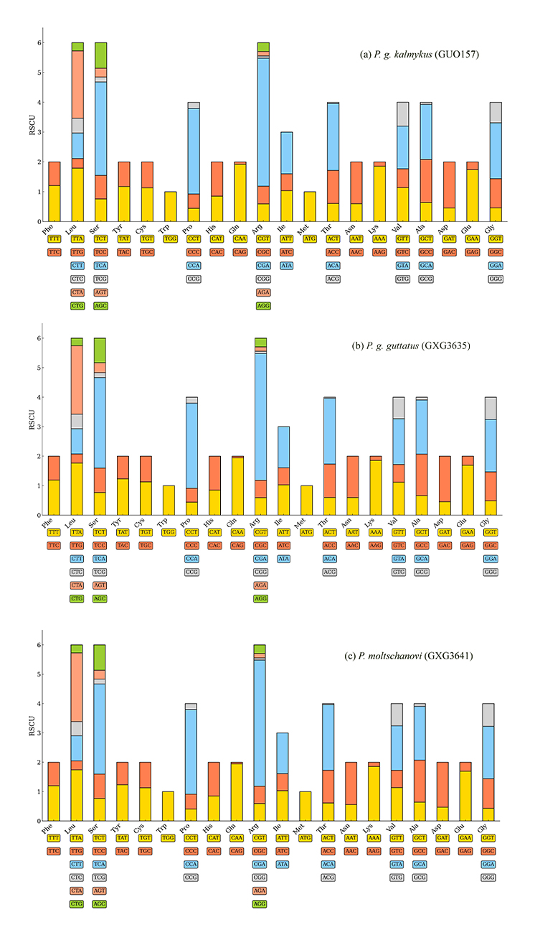
Figure S8 d, e, f. The relative synonymous codon usage (RSCU) in the mitogenomes of Ily River Valley and Balkhash-Alakol Basin`s toad-headed agamas: (a) P. alpherakii, P. incertus, and P. kuschakewitschii.
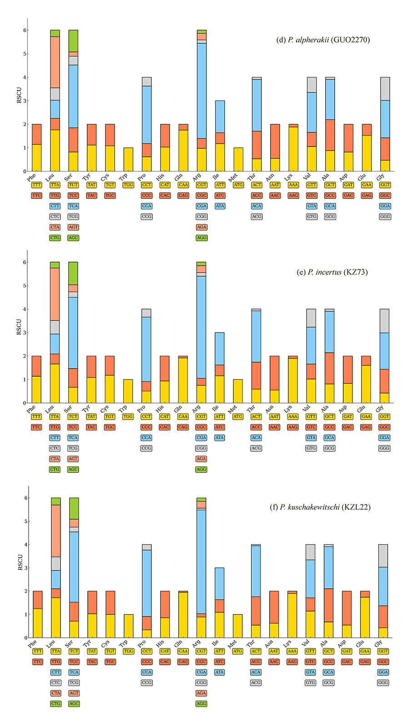
Figure S8 g, h. The relative synonymous codon usage (RSCU) in the mitogenomes of Dzungar and Zaisan Basins` toad-headed agamas: P. melanurus 2, and P. melanurus 1 respectively.

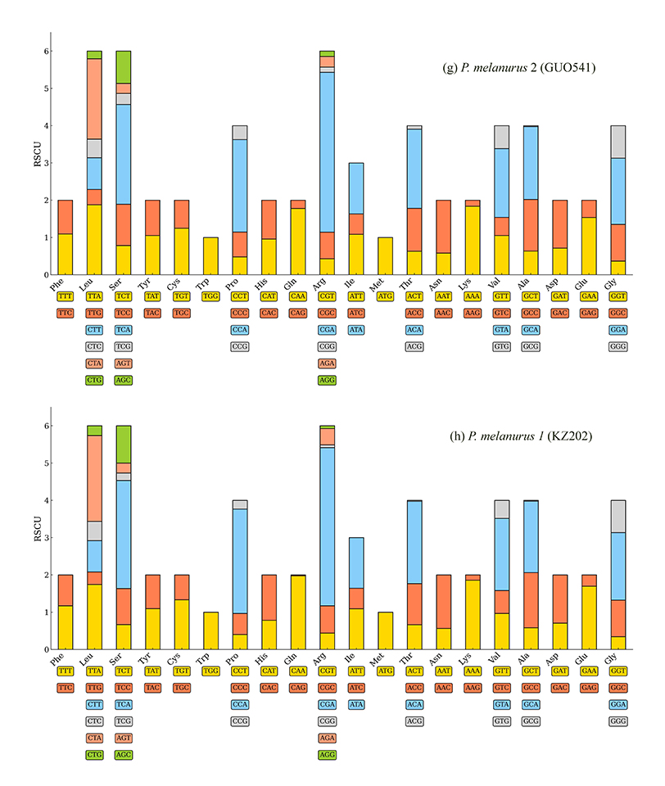

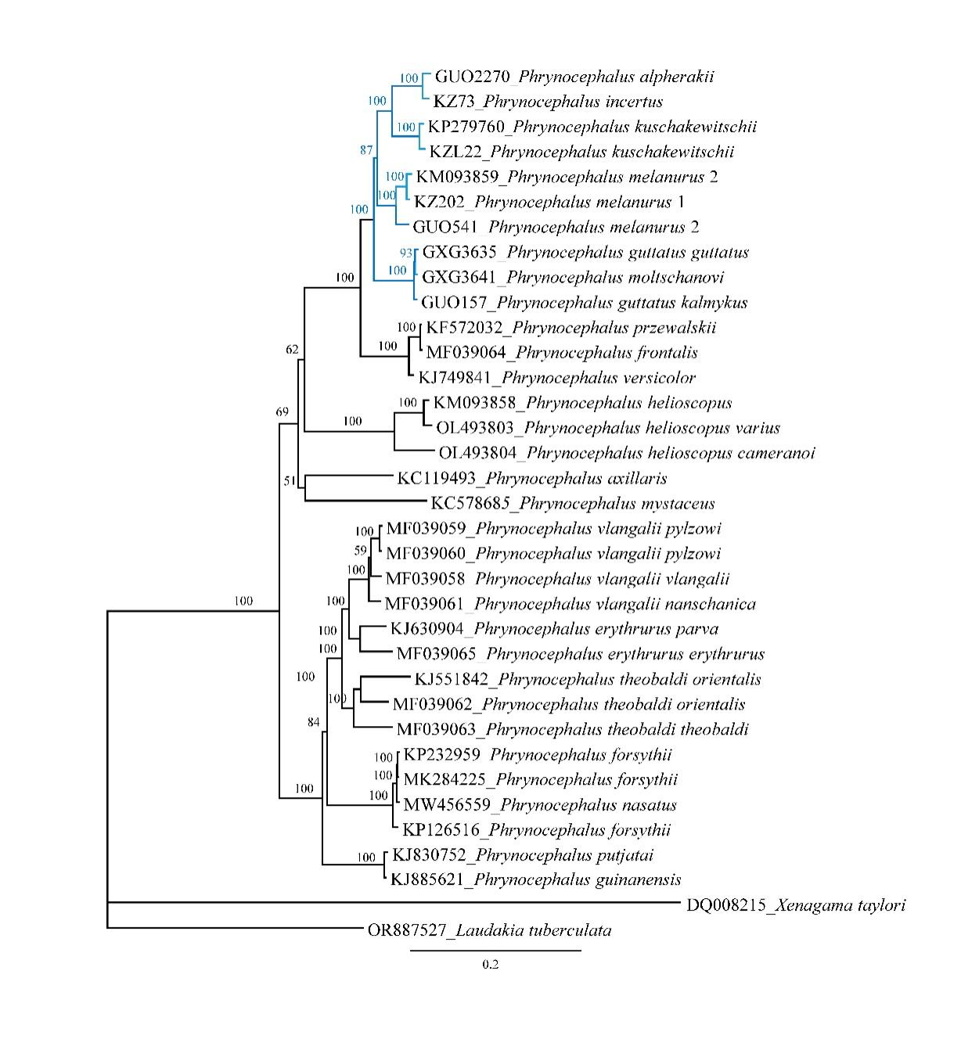
Figure S9. ML-tree based on 13 PCG of the studied sequences of Phrynocephalus guttatus species-group.

Tables

Table S1. Sampling information used for the phylogenetic analyses.
Taxon | Family | GenBank Acc. No. | Size (bp) | Reference
- g. kalmykus (GUO157) | Agamidae | PX111099 | 16472 | This study
P. g. guttatus (GXG3635) | Agamidae | PX111100 | 16498 | This study
- moltschanovi (GXG3641) | Agamidae | PX111101 | 17475 | This study
- alpherakii (GUO2270) | Agamidae | PX111102 | 16790 | This study
- incertus (KZ73) | Agamidae | PX111103 | 16790 | This study
- kuschakewitschii (KZL22) | Agamidae | PX111104 | 17124 | This study
- melanurus 1 (KZ202) | Agamidae | PX111105 | 17072 | This study
- melanurus 2 (GUO541) | Agamidae | PX111106 | 17141 | This study
- grumgrzhimailoi | Agamidae | KM093859 | 16301 | [S1]
- albolineatus | Agamidae | KP279760 | 16808 | [S2]
P. versicolor | Agamidae | KJ749841 | 16429 | [S3]
P. przewalskii | Agamidae | KF572032 | 16892 | [S4]
P. frontalis | Agamidae | MF039064 | 17041 | [S5]
P. axillaris | Agamidae | KC119493 | 17937 | [S6]
P. h. cameranoi | Agamidae | OL493804 | 17102 | [S7]
P. h. varius | Agamidae | OL493803 | 17253 | [S7]
P. helioscopus | Agamidae | KM093858 | 16249 | [S8]
P. mystaceus | Agamidae | KC578685 | 16660 | [S9]
P. putjatai | Agamidae | KJ830752 | 16283 | [S10]
P. guinanensis | Agamidae | KJ885621 | 16279 | [S11]
P. e. parva | Agamidae | KJ630904 | 16379 | [S12]
P. e. erythrurus | Agamidae | MF039065 | 16456 | [S5]
P. vlangalii nanschanica | Agamidae | MF039061 | 16251 | [S5]
P. vlangalii pylzowi | Agamidae | MF039060 | 16725 | [S5]
P. vlangalii pylzowi | Agamidae | MF039059 | 16442 | [S5]
P. vlangalii vlangalii | Agamidae | MF039058 | 16319 | [S5]
P. forsythii | Agamidae | KP126516 | 17542 | [S13]
P. forsythii | Agamidae | MK284225 | 16060 | [S14]
P. forsythii | Agamidae | KP232959 | 16143 | [S15]
P. nasatus | Agamidae | MW456559 | 16852 | Guo et al., 2021 (unpubl.)
P. theobaldi orientalis | Agamidae | KJ551842 | 16608 | [S16]
P. theobaldi orientalis | Agamidae | MF039062 | 17129 | [S5]
P. theobaldi theobaldi | Agamidae | MF039063 | 16365 | [S5]
Laudakia tuberculata | Agamidae | OR887527 | 17015 | Peng and Weng, 2024 (unpubl.)
Xenagama taylori | Agamidae | DQ008215 | 16220 | [S17]

References to the Table S1.

S1. Shuang L, Liu LJ, Song S. The complete mitochondrial genome of Grumgzimailo’s toad-headed agama, Phrynocephalus grumgrizimailoi (Reptilia, Squamata, Agamidae). Mitochondrial DNA A DNA Mapp Seq Anal. 2016;27:1581–2.

S2. Shao M, Ma L, Zhang G, Wang Z. The complete mitochondrial genome of the toad-headed lizard, Phrynocephalus albolineatus (Reptilia, Squamata, Agamidae). Mitochondrial DNA A DNA Mapp Seq Anal. 2015;28:137–8.

S3. Song S, Li D, Zhang C, et al. The complete mitochondrial genome of the color changeable toad-headed agama, Phrynocephalus versicolor (Reptilia, Squamata, Agamidae). Mitochondrial DNA A DNA Mapp Seq Anal. 2014;27:1121–2.

S4. Li D, Song S, Chen T, et al. Complete mitochondrial genome of the desert toad-headed agama, Phrynocephalus przewalskii (Reptilia, Squamata, Agamidae), a novel gene organization in vertebrate mtDNA. Mitochondrial DNA A DNA Mapp Seq Anal. 2013;26:696–7.

S5. Jin Y, Brown R. Partition number, rate priors and unreliable divergence times in Bayesian phylogenetic dating. Cladistics. 2017;34:568–73.

S6. Li J, Guo X, Chen D, et al. The complete mitochondrial genome of the Yarkand toad-headed agama, Phrynocephalus axillaris (Reptilia, Squamata, Agamidae). Mitochondrial DNA A DNA Mapp Seq Anal. 2013;24:234–6.

S7. Wu N, Liu J, Wang S, et al. Comparative analysis of mitochondrial genomes in two subspecies of the sunwatcher toad-headed agama (Phrynocephalus helioscopus): prevalent intraspecific gene rearrangements in Phrynocephalus. Genes (Basel). 2022;13:203. doi:10.3390/genes13020203

S8. Li D, Guo J, Zhou X, et al. The complete mitochondrial genome of Phrynocephalus helioscopus (Reptilia, Squamata, Agamidae). Mitochondrial DNA A DNA Mapp Seq Anal. 2014;27:1846–7.

S9. Chen D, Guo X, Li J. The complete mitochondrial genome of secret toad-headed agama, Phrynocephalus mystaceus (Reptilia, Squamata, Agamidae). Mitochondrial DNA A DNA Mapp Seq Anal. 2014;25:19–20.

S10. Tong H, Jin Y. The complete mitochondrial genome of an agama, Phrynocephalus putjatia (Reptilia, Squamata, Agamidae). Mitochondrial DNA A DNA Mapp Seq Anal. 2014;27:1028–9.

S11. Fu C, Chen W, Jin Y. The complete mitochondrial genome of Phrynocephalus guinanensis (Reptilia, Squamata, Agamidae). Mitochondrial DNA A DNA Mapp Seq Anal. 2014;27:1103–4.

S12. Zhu L, Liao P, Tong H, et al. The complete mitochondrial genome of the subspecies Phrynocephalus erythrurus parva (Reptilia, Squamata, Agamidae), a toad-headed lizard dwelling at the highest elevations of any reptile in the world. Mitochondrial DNA A DNA Mapp Seq Anal. 2014;27:703–4.

S13. Chen D, Zhou T, Guo X. The complete mitochondrial genome of Phrynocephalus forsythii (Reptilia, Squamata, Agamidae), a toad-headed agama endemic to the Taklamakan Desert. Mitochondrial DNA A DNA Mapp Seq Anal. 2015;27:4046–8.

S14. Chen D, Li J, Guo X. Next-generation sequencing yields a nearly complete mitochondrial genome of the Forsyth’s toad-headed agama, Phrynocephalus forsythii (Reptilia, Squamata, Agamidae). Mitochondrial DNA B Resour. 2019;4:817–9.

S15. Shao M, Ma L, Wang Z. The complete mitochondrial genome of the toad-headed lizard, Phrynocephalus forsythii (Reptilia, Squamata, Agamidae). Mitochondrial DNA A DNA Mapp Seq Anal. 2016;27:3147–8.

S16. Liao P, Jin Y. The complete mitochondrial genome of the toad-headed lizard subspecies, Phrynocephalus theobaldi orientalis (Reptilia, Squamata, Agamidae). Mitochondrial DNA A DNA Mapp Seq Anal. 2014;27:559–60.

S17. Macey JR, Schulte JA II, Fong JJ, et al. The complete mitochondrial genome of an agamid lizard from the Afro-Asian subfamily Agaminae and the phylogenetic position of Bufoniceps and Xenagama. Mol Phylogenet Evol. 2006;39:881–6. doi:10.1016/j.ympev.2005.08.020

Table S2. Mitochondrial genomes composition of eight representatives of P. guttatus species-group.
(a) P. g. kalmykus (GXG157)
Gene/Element | From | To | Anticodon | Length | Codon |  | Spacer | Strand
 |  |  |  | (bp) | Start | Stop | (+)/Overlap (-)
tRNA-Phe | 1 | 65 | GAA | 65 |  |  |  | H
CRII | 66 | 729 |  | 664 |  |  |  | H
12S rRNA | 730 | 1604 |  | 875 |  |  |  | H
tRNA-Val | 1602 | 1668 | TAC | 67 |  |  | -3 | H
16S rRNA | 1669 | 3148 |  | 1480 |  |  |  | H
tRNA-Leu (UAA) | 3152 | 3225 | TAA | 74 |  |  | +3 | H
ND1 | 3223 | 4191 |  | 969 | ATA | TAG | -3 | H
tRNA-Gln | 4188 | 4260 | TTG | 72 |  |  | -4 | L
tRNA-Ile | 4269 | 4336 | GAT | 68 |  |  | +8 | H
tRNA-Met | 4337 | 4400 | CAT | 64 |  |  |  | H
ND2 | 4402 | 5436 |  | 1035 | ATT | AGG | +1 | H
tRNA-Trp | 5437 | 5506 | TCA | 70 |  |  |  | H
tRNA-Ala | 5507 | 5575 | TGC | 69 |  |  |  | L
tRNA-Asn | 5576 | 5647 | GTT | 72 |  |  |  | L
tRNA-Cys | 5667 | 5726 | GCA | 60 |  |  | +19 | L
tRNA-Tyr | 5727 | 5793 | GTA | 67 |  |  |  | L
COX1 | 5794 | 7341 |  | 1548 | ATG | AGA |  | H
tRNA-Ser (UGA) | 7333 | 7402 | TGA | 70 |  |  | -9 | L
tRNA-Asp | 7406 | 7475 | GTC | 70 |  |  | +3 | H
COX2 | 7476 | 8160 |  | 685 | ATG | T |  | H
tRNA-Lys | 8161 | 8223 | TTT | 63 |  |  |  | H
ATP8 | 8224 | 8382 |  | 159 | GTG | TAA |  | H
ATP6 | 8376 | 9057 |  | 682 | ATG | T | -7 | H
COX3 | 9058 | 9841 |  | 784 | ATG | T |  | H
tRNA-Gly | 9842 | 9906 |  | 65 |  |  |  | H
ND3 | 9907 | 10246 |  | 340 | ATT | T |  | H
tRNA-Arg | 10247 | 10314 | TCG | 68 |  |  |  | H
ND4L | 10315 | 10605 |  | 291 | GTG | A |  | H
ND4 | 10599 | 11963 |  | 1365 | ATG | TAA | -7 | H
tRNA-His | 11965 | 12028 | GTG | 64 |  |  | +1 | H
tRNA-Ser (GCU) | 12029 | 12088 | GCT | 60 |  |  |  | H
tRNA-Leu (UAG) | 12089 | 12159 | TAG | 71 |  |  |  | H
ND5 | 12161 | 13930 |  | 1770 | ATG | TAA | +1 | H
ND6 | 13918 | 14400 |  | 483 | ATG | AGG | -13 | L
tRNA-Glu | 14401 | 14470 | TTC | 70 |  |  |  | L
Cytb | 14463 | 15612 |  | 1150 | ATA | T | +8 | H
tRNA-Thr | 15613 | 15678 | TGT | 66 |  |  |  | H
CRI | 15679 | 16472 |  | 794

(b) P. g. guttatus (GXG3635)
Gene/Element | From | To | Anticodon | Length | Codon |  | Spacer | Strand
 |  |  |  | (bp) | Start | Stop | (+)/Overlap (-)
tRNA-Phe | 1 | 66 | GAA | 66 |  |  | +3 | H
tRNA-Pro | 70 | 132 |  | 63
CRII | 133 | 754 |  | 622 |  |  |  | H
12S rRNA | 755 | 1629 |  | 875 |  |  |  | H
tRNA-Val | 1627 | 1692 | TAC | 66 |  |  | -3 | H
16S rRNA | 1693 | 3174 |  | 1482 |  |  |  | H
tRNA-Leu (UAA) | 3178 | 3251 | TAA | 74 |  |  | +3 | H
ND1 | 3249 | 4217 |  | 969 | ATA | TAG | -1 | H
tRNA-Gln | 4214 | 4286 | TTG | 73 |  |  | -4 | L
tRNA-Ile | 4295 | 4362 | GAT | 68 |  |  | +8 | H
tRNA-Met | 4363 | 4426 | CAT | 64 |  |  |  | H
ND2 | 4428 | 5462 |  | 1035 | ATT | AGG | +1 | H
tRNA-Trp | 5463 | 5532 | TCA | 70 |  |  |  | H
tRNA-Ala | 5533 | 5601 | TGC | 69 |  |  |  | L
tRNA-Asn | 5602 | 5673 | GTT | 72 |  |  |  | L
tRNA-Cys | 5693 | 5752 | GCA | 60 |  |  | +19 | L
tRNA-Tyr | 5753 | 5819 | GTA | 67 |  |  |  | L
COX1 | 5820 | 7367 |  | 1548 | ATG | AGA |  | H
tRNA-Ser (UGA) | 7359 | 7428 | TGA | 70 |  |  | -9 | L
tRNA-Asp | 7432 | 7501 | GTC | 70 |  |  | +3 | H
COX2 | 7502 | 8186 |  | 685 | ATG | T |  | H
tRNA-Lys | 8187 | 8249 | TTT | 63 |  |  |  | H
ATP8 | 8250 | 8408 |  | 159 | GTG | TAA |  | H
ATP6 | 8402 | 9083 |  | 682 | ATG | T | -7 | H
COX3 | 9084 | 9867 |  | 784 | ATG | T |  | H
tRNA-Gly | 9868 | 9932 | TCC | 65 |  |  |  | H
ND3 | 9933 | 10272 |  | 340 | ATT | T |  | H
tRNA-Arg | 10273 | 10340 | TCG | 68 |  |  |  | H
ND4L | 10341 | 10631 |  | 291 | GTG | A |  | H
ND4 | 10625 | 11989 |  | 1365 | ATG | TAA | -7 | H
tRNA-His | 11991 | 12054 | GTG | 64 |  |  | +1 | H
tRNA-Ser (GCU) | 12055 | 12114 | GCT | 60 |  |  |  | H
tRNA-Leu (UAG) | 12115 | 12185 | TAG | 71 |  |  |  | H
ND5 | 12187 | 13956 |  | 1770 | ATG | TAA | +1 | H
ND6 | 13944 | 14426 |  | 483 | ATG | AGG | -13 | L
tRNA-Glu | 14427 | 14496 | TTC | 70 |  |  |  | L
Cytb | 14489 | 15638 |  | 1150 | ATA | T | +8 | H
tRNA-Thr | 15639 | 15704 | TGT | 66 |  |  |  | H
CRI | 15705 | 16498 |  | 794 |  |  |  | H

(c) P. moltschanovi (GXG3641)
Gene/Element | From | To | Anticodon | Length | Codon |  | Spacer | Strand
 |  |  |  | (bp) | Start | Stop | (+)/Overlap (-)
tRNA-Phe | 1 | 66 | GAA | 66 |  |  |  | H
CRII | 67 | 802 |  | 736 |  |  |  | H
12S rRNA | 803 | 1677 |  | 875 |  |  |  | H
tRNA-Val | 1675 | 1740 | TAC | 66 |  |  | -3 | H
16S rRNA | 1741 | 3222 |  | 1482 |  |  |  | H
tRNA-Leu (UAA) | 3226 | 3299 | TAA | 74 |  |  | +3 | H
ND1 | 3297 | 4265 |  | 969 | ATA | TAG | -3 | H
tRNA-Gln | 4262 | 4334 | TTG | 73 |  |  | -4 | L
tRNA-Ile | 4343 | 4410 | GAT | 68 |  |  | +8 | H
tRNA-Met | 4411 | 4474 | CAT | 64 |  |  |  | H
ND2 | 4476 | 5510 |  | 1035 | ATT | AGG | +1 | H
tRNA-Trp | 5511 | 5580 | TCA | 70 |  |  |  | H
tRNA-Ala | 5581 | 5649 | TGC | 69 |  |  |  | L
tRNA-Asn | 5650 | 5721 | GTT | 72 |  |  |  | L
tRNA-Cys | 5741 | 5800 | GCA | 60 |  |  | +19 | L
tRNA-Tyr | 5801 | 5867 | GTA | 67 |  |  |  | L
COX1 | 5868 | 7415 |  | 1548 | ATG | AGA |  | H
tRNA-Ser (UGA) | 7407 | 7476 | TGA | 70 |  |  | -9 | L
tRNA-Asp | 7480 | 7549 | GTC | 70 |  |  | +3 | H
COX2 | 7550 | 8234 |  | 685 | ATG | T |  | H
tRNA-Lys | 8235 | 8297 | TTT | 63 |  |  |  | H
ATP8 | 8298 | 8456 |  | 159 | GTG | TAA |  | H
ATP6 | 8450 | 9131 |  | 682 | ATG | T | -7 | H
COX3 | 9132 | 9915 |  | 784 | ATG | T |  | H
tRNA-Gly | 9916 | 9980 | TCC | 65 |  |  |  | H
ND3 | 9981 | 10320 |  | 340 | ATT | T |  | H
tRNA-Arg | 10321 | 10388 | TCG | 68 |  |  |  | H
ND4L | 10389 | 10679 |  | 291 | GTG | A |  | H
ND4 | 10673 | 12037 |  | 1365 | ATG | TAA | -7 | H
tRNA-His | 12039 | 12102 | GTG | 64 |  |  | +1 | H
tRNA-Ser (GCU) | 12103 | 12162 | GCT | 60 |  |  |  | H
tRNA-Leu (UAG) | 12163 | 12233 | TAG | 71 |  |  |  | H
ND5 | 12235 | 14004 |  | 1770 | ATG | TAA | +1 | H
ND6 | 13992 | 14474 |  | 483 | ATG | AGG | -13 | L
tRNA-Glu | 14475 | 14544 | TTC | 70 |  |  |  | L
Cytb | 14537 | 15686 |  | 1150 | ATA | T | +8 | H
tRNA-Thr | 15687 | 15752 | TGT | 66 |  |  |  | H
CRIII | 15753 | 16546 |  | 794 |  |  |  | H
tRNA-Phe | 16547 | 16614 | GAA | 68 |  |  |  | H
tRNA-Pro | 16616 | 16678 | TGG | 63 |  |  | +1 | L
CRI | 16679 | 17475 |  | 797 |  |  |  | H

(d) P. alpherakii (GUO2270)
Gene/Element | From | To | Anticodon | Length | Codon |  | Spacer | Strand
 |  |  |  | (bp) | Start | Stop | (+)/Overlap (-)
tRNA-Phe | 1 | 66 | GAA | 66 |  |  |  | H
CRII | 67 | 546 |  | 480 |  |  |  | H
12S rRNA | 547 | 1420 |  | 874 |  |  |  | H
tRNA-Val | 1418 | 1482 | TAC | 65 |  |  | -3 | H
16S rRNA | 1483 | 2960 |  | 1478 |  |  |  | H
tRNA-Leu (UAA) | 2964 | 3037 | TAA | 74 |  |  | +3 | H
ND1 | 3035 | 4003 |  | 969 | ATA | TAG | -3 | H
tRNA-Gln | 4000 | 4072 | TTG | 73 |  |  | -4 | L
tRNA-Ile | 4081 | 4148 | GAT | 68 |  |  | +8 | H
tRNA-Met | 4149 | 4213 | CAT | 65 |  |  |  | H
ND2 | 4214 | 5248 |  | 1035 | ATT | AGA |  | H
tRNA-Trp | 5248 | 5317 | TCA | 69 |  |  |  | H
tRNA-Ala | 5318 | 5386 | TGC | 69 |  |  |  | L
tRNA-Asn | 5387 | 5458 | GTT | 72 |  |  |  | L
tRNA-Cys | 5482 | 5541 | GCA | 60 |  |  | +23 | L
tRNA-Tyr | 5542 | 5608 | GTA | 67 |  |  |  | L
COX1 | 5609 | 7156 |  | 1548 | ATG | AGA |  | H
tRNA-Ser (UGA) | 7148 | 7217 | TGA | 70 |  |  | -9 | L
tRNA-Asp | 7221 | 7290 | GTC | 70 |  |  | +3 | H
COX2 | 7291 | 7975 |  | 685 | ATG | T |  | H
tRNA-Lys | 7976 | 8038 | TTT | 63 |  |  |  | H
ATP8 | 8039 | 8197 |  | 141 | GTG | TAA |  | H
ATP6 | 8191 | 8872 |  | 682 | ATG | T | -7 | H
COX3 | 8873 | 9656 |  | 784 | ATG | T |  | H
tRNA-Gly | 9657 | 9721 | TCC | 65 |  |  |  | H
ND3 | 9722 | 10061 |  | 340 | ATT | T |  | H
tRNA-Arg | 10062 | 10129 | TCG | 68 |  |  |  | H
ND4L | 10130 | 10420 |  | 291 | GTG | TAA |  | H
ND4 | 10414 | 11778 |  | 1365 | ATG | TAA | -7 | H
tRNA-His | 11780 | 11843 | GTG | 64 |  |  | +1 | H
tRNA-Ser (GCU) | 11844 | 11901 | GCT | 58 |  |  |  | H
tRNA-Leu (UAG) | 11902 | 11972 | TAG | 71 |  |  |  | H
ND5 | 11974 | 13743 |  | 1770 | ATG | TAA | +1 | H
ND6 | 13731 | 14213 |  | 483 | ATG | AGG | -13 | L
tRNA-Glu | 14214 | 14283 | TTC | 70 |  |  |  | L
Cytb | 14290 | 15427 |  | 1138 | ATG | T | +6 | H
tRNA-Thr | 15428 | 15493 | TGT | 66 |  |  |  | H
CRIII | 15494 | 15862 |  | 369 |  |  |  | H
tRNA-Phe | 15863 | 15930 | GAA | 68 |  |  |  | H
tRNA-Pro | 15932 | 15993 | TGG | 62 |  |  | +1 | L
CRI | 15994 | 16790 |  | 797 |  |  |  | H

(e) P. incertus (KZ73)
Gene/Element | From | To | Anticodon | Length | Codon |  | Spacer | Strand
 |  |  |  | (bp) | Start | Stop | (+)/Overlap (-)
tRNA-Phe | 1 | 66 | GAA | 66 |  |  |  | H
CRII | 67 | 614 |  | 548 |  |  |  | H
12S rRNA | 615 | 1487 |  | 873 |  |  |  | H
tRNA-Val | 1485 | 1549 | TAC | 65 |  |  | -3 | H
16S rRNA | 1550 | 3027 |  | 1478 |  |  |  | H
tRNA-Leu (UAA) | 3031 | 3104 | TAA | 74 |  |  | +3 | H
ND1 | 3102 | 4070 |  | 969 | ATA | TAG | -3 | H
tRNA-Gln | 4067 | 4139 | TTG | 73 |  |  | -4 | L
tRNA-Ile | 4148 | 4215 | GAT | 68 |  |  | +8 | H
tRNA-Met | 4216 | 4280 | CAT | 65 |  |  |  | H
ND2 | 4281 | 5315 |  | 1035 | ATT | AGA |  | H
tRNA-Trp | 5315 | 5384 | TCA | 70 |  |  | -1 | H
tRNA-Ala | 5385 | 5453 | TGC | 69 |  |  |  | L
tRNA-Asn | 5454 | 5525 | GTT | 72 |  |  |  | L
tRNA-Cys | 5549 | 5609 | GCA | 61 |  |  | +23 | L
tRNA-Tyr | 5610 | 5676 | GTA | 67 |  |  |  | L
COX1 | 5677 | 7224 |  | 1548 | ATG | AGA |  | H
tRNA-Ser (UGA) | 7216 | 7285 | TGA | 70 |  |  | -9 | L
tRNA-Asp | 7289 | 7358 | GTC | 70 |  |  | +3 | H
COX2 | 7359 | 8043 |  | 685 | ATG | T |  | H
tRNA-Lys | 8044 | 8106 | TTT | 63 |  |  |  | H
ATP8 | 8107 | 8265 |  | 159 | GTG | TAA |  | H
ATP6 | 8259 | 8940 |  | 682 | ATG | T | -7 | H
COX3 | 8941 | 9724 |  | 784 | ATG | T |  | H
tRNA-Gly | 9725 | 9789 | TCC | 65 |  |  |  | H
ND3 | 9790 | 10129 |  | 340 | ATT | T |  | H
tRNA-Arg | 10130 | 10197 | TCG | 68 |  |  |  | H
ND4L | 10198 | 10488 |  | 291 | GTG | TAA |  | H
ND4 | 10482 | 11846 |  | 1365 | ATG | TAA | -7 | H
tRNA-His | 11848 | 11911 | GTG | 64 |  |  | +1 | H
tRNA-Ser (GCU) | 11912 | 11970 | GCT | 59 |  |  |  | H
tRNA-Leu (UAG) | 11971 | 12041 | TAG | 71 |  |  |  | H
ND5 | 12043 | 13812 |  | 1770 | ATG | TAA | +1 | H
ND6 | 13800 | 14282 |  | 483 | ATG | AGG | -13 | L
tRNA-Glu | 14283 | 14352 | TTC | 70 |  |  |  | L
Cytb | 14359 | 15496 |  | 1138 | ATG | T | +6 | H
tRNA-Thr | 15497 | 15562 | TGT | 66 |  |  |  | H
CRIII | 15563 | 15935 |  | 373 |  |  |  | H
tRNA-Phe | 15936 | 16001 | GAA | 66 |  |  |  | H
tRNA-Pro | 16005 | 16066 | TGG | 62 |  |  | +3 | L
CRI | 16067 | 16866 |  | 800 |  |  |  | H

(f) P. kuschakewitschii (KZL22)
Gene/Element | From | To | Anticodon | Length | Codon |  | Spacer | Strand
 |  |  |  | (bp) | Start | Stop | (+)/Overlap (-)
tRNA-Phe | 1 | 66 | GAA | 66 |  |  |  | H
tRNA-Pro | 70 | 131 | TGG | 62 |  |  | +3 | L
CRII | 132 | 938 |  | 807 |  |  |  | H
tRNA-Phe | 939 | 1004 |  | 66 |  |  |  | H
CRIII | 1005 | 1373 |  | 369 |  |  |  | H
12S rRNA | 1374 | 2245 |  | 872 |  |  |  | H
tRNA-Val | 2243 | 2307 | TAC | 65 |  |  | -3 | H
16S rRNA | 2308 | 3786 |  | 1479 |  |  |  | H
tRNA-Leu (UAA) | 3790 | 3863 | TAA | 74 |  |  | +3 | H
ND1 | 3861 | 4829 |  | 969 | ATA | TAG | -3 | H
tRNA-Gln | 4826 | 4898 | TTG | 73 |  |  | -4 | L
tRNA-Ile | 4907 | 4974 | GAT | 68 |  |  | +8 | H
tRNA-Met | 4975 | 5038 | CAT | 64 |  |  |  | H
ND2 | 5040 | 6074 |  | 1035 | ATT | AGG | +1 | H
tRNA-Trp | 6074 | 6143 | TCA | 70 |  |  |  | H
tRNA-Ala | 6144 | 6212 | TGC | 69 |  |  |  | L
tRNA-Asn | 6213 | 6284 | GTT | 72 |  |  |  | L
tRNA-Cys | 6310 | 6369 | GCA | 60 |  |  | +25 | L
tRNA-Tyr | 6370 | 6436 | GTA | 67 |  |  |  | L
COX1 | 6437 | 7984 |  | 1548 | ATG | AGA |  | H
tRNA-Ser (UGA) | 7976 | 8045 | TGA | 70 |  |  | -9 | L
tRNA-Asp | 8049 | 8118 | GTC | 70 |  |  | +3 | H
COX2 | 8119 | 8803 |  | 685 | ATG | T |  | H
tRNA-Lys | 8804 | 8866 | TTT | 63 |  |  |  | H
ATP8 | 8867 | 9025 |  | 159 | GTG | TAA |  | H
ATP6 | 9019 | 9700 |  | 682 | ATG | T | -7 | H
COX3 | 9701 | 10484 |  | 784 | ATG | T |  | H
tRNA-Gly | 10485 | 10549 | TCC | 65 |  |  |  | H
ND3 | 10550 | 10889 |  | 340 | ATT | T |  | H
tRNA-Arg | 10890 | 10957 | TCG | 68 |  |  |  | H
ND4L | 10958 | 11248 |  | 291 | GTG | A |  | H
ND4 | 11242 | 12606 |  | 1365 | ATG | TAA | -7 | H
tRNA-His | 12608 | 12671 | GTG | 64 |  |  | +1 | H
tRNA-Ser (GCU) | 12672 | 12730 | GCT | 59 |  |  |  | H
tRNA-Leu (UAG) | 12731 | 12801 | TAG | 71 |  |  |  | H
ND5 | 12803 | 14572 |  | 1770 | ATG | TAA | +1 | H
ND6 | 14560 | 15042 |  | 483 | ATG | AGG | -13 | L
tRNA-Glu | 15043 | 15112 | TTC | 70 |  |  |  | L
Cytb | 15113 | 16256 |  | 1144 | ATA | T |  | H
tRNA-Thr | 16257 | 16320 | TGT | 64 |  |  |  | H
CRI | 16321 | 17124 |  | 804 |  |  |  | H

(g) P. melanurus 1 (Zaisan lineage) (KZ202)
Gene/Element | From | To | Anticodon | Length | Codon |  | Spacer | Strand
 |  |  |  | (bp) | Start | Stop | (+)/Overlap (-)
tRNA-Phe | 1 | 66 | GAA | 66 |  |  |  | H
tRNA-Pro | 70 | 131 | TGG | 62 |  |  | +3 | L
CRII | 132 | 926 |  | 795 |  |  |  | H
tRNA-Phe | 927 | 992 |  | 66 |  |  |  | H
CRIII | 993 | 1339 |  | 347 |  |  |  | H
12S rRNA | 1340 | 2211 |  | 872 |  |  |  | H
tRNA-Val | 2209 | 2274 | TAC | 66 |  |  | -3 | H
16S rRNA | 2275 | 3752 |  | 1478 |  |  |  | H
tRNA-Leu (UAA) | 3756 | 3829 | TAA | 74 |  |  | +3 | H
ND1 | 3827 | 4795 |  | 969 | ATA | TAG | -3 | H
tRNA-Gln | 4792 | 4864 | TTG | 73 |  |  | -4 | L
tRNA-Ile | 4873 | 4940 | GAT | 68 |  |  | +8 | H
tRNA-Met | 4941 | 5003 | CAT | 63 |  |  |  | H
ND2 | 5005 | 6039 |  | 1035 | ATT | AGA | +1 | H
tRNA-Trp | 6039 | 6108 | TCA | 70 |  |  | -1 | H
tRNA-Ala | 6109 | 6177 | TGC | 69 |  |  |  | L
tRNA-Asn | 6178 | 6249 | GTT | 72 |  |  |  | L
tRNA-Cys | 6272 | 6331 | GCA | 60 |  |  | +22 | L
tRNA-Tyr | 6332 | 6398 | GTA | 67 |  |  |  | L
COX1 | 6399 | 7946 |  | 1548 | ATG | AGA |  | H
tRNA-Ser (UGA) | 7938 | 8007 | TGA | 70 |  |  | -9 | L
tRNA-Asp | 8011 | 8078 | GTC | 68 |  |  | +3 | H
COX2 | 8079 | 8763 |  | 685 | ATG | T |  | H
tRNA-Lys | 8764 | 8826 | TTT | 63 |  |  |  | H
ATP8 | 8827 | 8985 |  | 159 | GTG | TAA |  | H
ATP6 | 8979 | 9660 |  | 682 | ATG | T | -7 | H
COX3 | 9661 | 10444 |  | 784 | ATG | T |  | H
tRNA-Gly | 10445 | 10509 | TCC | 65 |  |  |  | H
ND3 | 10510 | 10849 |  | 340 | ATT | T |  | H
tRNA-Arg | 10850 | 10917 | TCG | 68 |  |  |  | H
ND4L | 10918 | 11208 |  | 291 | GTG | TAA |  | H
ND4 | 11202 | 12566 |  | 1365 | ATG | TAA | -7 | H
tRNA-His | 12568 | 12631 | GTG | 64 |  |  | +1 | H
tRNA-Ser (GCU) | 12632 | 12690 | GCT | 59 |  |  |  | H
tRNA-Leu (UAG) | 12691 | 12761 | TAG | 71 |  |  |  | H
ND5 | 12763 | 14532 |  | 1770 | ATG | TAA | +1 | H
ND6 | 14520 | 15002 |  | 483 | ATG | AGA | -13 | L
tRNA-Glu | 15003 | 15072 | TTC | 70 |  |  |  | L
Cytb | 15079 | 16216 |  | 1138 | ATG | T | +6 | H
tRNA-Thr | 16217 | 16280 | TGT | 64 |  |  |  | H
CRI | 16281 | 17072 |  | 792 |  |  |  | H

(h) P. melanurus 2 (Dzungar lineage) (GUO541)
Gene/Element | From | To | Anticodon | Length | Codon |  | Spacer | Strand
 |  |  |  | (bp) | Start | Stop | (+)/Overlap (-)
tRNA-Phe | 1 | 66 | GAA | 66 |  |  |  | H
tRNA-Pro | 70 | 131 | TGG | 62 |  |  | +3 | L
CRII | 132 | 926 |  | 795 |  |  |  | H
tRNA-Phe | 927 | 992 | GAA | 66 |  |  |  | H
CRIII | 993 | 1409 |  | 417 |  |  |  | H
12S rRNA | 1410 | 2281 |  | 872 |  |  |  | H
tRNA-Val | 2279 | 2344 | TAC | 66 |  |  | -3 | H
16S rRNA | 2345 | 3822 |  | 1478 |  |  |  | H
tRNA-Leu (UAA) | 3826 | 3899 | TAA | 74 |  |  | +3 | H
ND1 | 3897 | 4865 |  | 969 | ATA | TAG | -1 | H
tRNA-Gln | 4862 | 4934 | TTG | 73 |  |  | -4 | L
tRNA-Ile | 4943 | 5010 | GAT | 68 |  |  | +8 | H
tRNA-Met | 5011 | 5073 | CAT | 63 |  |  |  | H
ND2 | 5075 | 6109 |  | 1035 | ATT | AGA | +1 | H
tRNA-Trp | 6109 | 6178 | TCA | 70 |  |  |  | H
tRNA-Ala | 6179 | 6247 | TGC | 69 |  |  |  | L
tRNA-Asn | 6248 | 6319 | GTT | 72 |  |  |  | L
tRNA-Cys | 6342 | 6401 | GCA | 60 |  |  | +22 | L
tRNA-Tyr | 6402 | 6468 | GTA | 67 |  |  |  | L
COX1 | 6469 | 8016 |  | 1548 | ATG | AGA |  | H
tRNA-Ser (UGA) | 8008 | 8077 | TGA | 70 |  |  | -9 | L
tRNA-Asp | 8081 | 8148 | GTC | 68 |  |  | +3 | H
COX2 | 8149 | 8833 |  | 685 | ATG | T |  | H
tRNA-Lys | 8834 | 8896 | TTT | 63 |  |  |  | H
ATP8 | 8897 | 9055 |  | 159 | GTG | TAA |  | H
ATP6 | 9049 | 9730 |  | 682 | GTG | T | -7 | H
COX3 | 9731 | 10514 |  | 784 | ATG | T |  | H
tRNA-Gly | 10515 | 10579 | TCC | 65 |  |  |  | H
ND3 | 10580 | 10919 |  | 340 | ATT | T |  | H
tRNA-Arg | 10920 | 10987 | TCG | 68 |  |  |  | H
ND4L | 10988 | 11278 |  | 291 | GTG | TAA |  | H
ND4 | 11272 | 12636 |  | 1365 | ATG | TAA | -7 | H
tRNA-His | 12638 | 12701 | GTG | 64 |  |  | +1 | H
tRNA-Ser (GCU) | 12702 | 12760 | GCT | 59 |  |  |  | H
tRNA-Leu (UAG) | 12761 | 12831 | TAG | 71 |  |  |  | H
ND5 | 12833 | 14602 |  | 1770 | ATG | TAA | +1 | H
ND6 | 14590 | 15072 |  | 483 | ATG | AGG | -13 | L
tRNA-Glu | 15073 | 15142 | TTC | 70 |  |  |  | L
Cytb | 15135 | 16284 |  | 1150 | ATA | T | +8 | H
tRNA-Thr | 16285 | 16349 | TGT | 65 |  |  |  | H
CRI | 16350 | 17141 |  | 792 |  |  |  | H

Table S3. Comparison of the composition and skew values of eight mitogenomes for P. guttatus
species-group.

Element | 1 | 2 | 3 | 4 | 5 | 6 | 7 | 8
Mitogenomes
T | 26.4 | 26.4 | 26.6 | 26.4 | 26.5 | 26.5 | 26.6 | 26.6
C | 25 | 25 | 24.9 | 25 | 25 | 25.1 | 25 | 25.1
A | 36.3 | 36.2 | 36.2 | 36.1 | 36 | 35.9 | 36.2 | 36.1
G | 12.2 | 12.3 | 12.3 | 12.4 | 12.5 | 12.5 | 12.2 | 12.2
Length (bp) | 16472 | 16498 | 17475 | 16790 | 16866 | 17124 | 17072 | 17141
A+T | 62.6 | 62.8 | 62.5 | 62.5 | 62.4 | 62.8 | 62.7 | 62.6
G+C | 37.2 | 37.3 | 37.2 | 37.4 | 37.5 | 37.6 | 37.2 | 37.3
AT-skew | 0.157 | 0.156 | 0.152 | 0.155 | 0.152 | 0.150 | 0.152 | 0.151
GC-skew | -0.344 | -0.340 | -0.338 | -0.336 | -0.333 | -0.335 | -0.344 | -0.345
13 PCG
T | 26.7 | 26.7 | 26.7 | 26.9 | 26.9 | 26.7 | 27 | 26.9
C | 25.9 | 25.9 | 25.9 | 25.8 | 25.8 | 26 | 25.7 | 25.8
A | 36.4 | 36.2 | 36.3 | 36.1 | 36 | 36.1 | 36.2 | 36.3
G | 11 | 11.1 | 11.1 | 11.2 | 11.3 | 11.3 | 11.1 | 11
Length (bp) | 11261 | 11261 | 11261 | 11249 | 11249 | 11255 | 11249 | 11261
A+T | 63.1 | 62.9 | 63 | 66 | 62.9 | 62.8 | 63.2 | 63.2
G+C | 36.9 | 37 | 37 | 37 | 37.1 | 37.3 | 36.8 | 36.8
AT-skew | 0.153 | 0.151 | 0.152 | 0.146 | 0.144 | 0.149 | 0.145 | 0.148
GC-skew | -0.403 | -0.4 | -0.4 | -0.394 | -0.390 | -0.394 | -0.396 | -0.402
tRNAs
T | 25.8 | 25.9 | 25.5 | 26.7 | 26.6 | 26.1 | 25.9 | 26
C | 23.2 | 23.1 | 23.3 | 22.3 | 22.4 | 23 | 22.9 | 22.8
A | 35.3 | 35.4 | 35.6 | 35.5 | 35.4 | 35.5 | 36.1 | 36.1
G | 15.7 | 15.6 | 15.6 | 15.6 | 15.5 | 15.5 | 15.1 | 15.1
Length (bp) | 1416 | 1479 | 1547 | 1542 | 1544 | 1540 | 1538 | 1539
A+T | 61.1 | 61.3 | 61.1 | 62.2 | 62 | 61.6 | 62 | 62.1
G+C | 38.9 | 38.7 | 38.9 | 37.9 | 37.9 | 38.5 | 38 | 37.9
AT-skew | 0.155 | 0.154 | 0.165 | 0.141 | 0.141 | 0.152 | 0.164 | 0.162
GC-skew | -0.192 | -0.193 | -0.197 | -0.176 | -0.182 | -0.194 | -0.205 | -0.203
rRNAs
T | 20.8 | 20.8 | 20.9 | 20.7 | 20.7 | 20.8 | 20.8 | 20.9
C | 24.2 | 24.1 | 24.1 | 24.1 | 24 | 24.1 | 24.2 | 24.1
A | 38 | 38 | 37.8 | 37.8 | 37.9 | 37.4 | 37.9 | 37.6
G | 17 | 17.1 | 17.2 | 17.5 | 17.4 | 17.7 | 17.1 | 17.4
Length (bp) | 2355 | 2357 | 2357 | 2352 | 2351 | 2351 | 2350 | 2350
A+T | 58.8 | 58.8 | 58.7 | 58.5 | 58.6 | 58.2 | 58.7 | 58.5
G+C | 41.2 | 41.2 | 41.3 | 41.6 | 41.4 | 41.8 | 41.3 | 41.5
AT-skew | 0.292 | 0.292 | 0.287 | 0.292 | 0.293 | 0.285 | 0.291 | 0.285
GC-skew | -0.174 | -0.169 | -0.167 | -0.158 | -0.159 | -0.153 | -0.171 | -0.161
CRI
T | 31.7 | 31.5 | 31.4 | 31.4 | 30.9 | 31.8 | 31.8 | 31.8
C | 23.9 | 23.9 | 24.1 | 24.6 | 25 | 23.9 | 23.9 | 24
A | 33 | 32.9 | 32.9 | 32.1 | 32.5 | 32.5 | 32.6 | 32.2
G | 11.3 | 11.7 | 11.7 | 11.9 | 11.6 | 11.8 | 11.7 | 12
Length (bp) | 794 | 794 | 797 | 797 | 800 | 804 | 792 | 792
A+T | 64.7 | 64.4 | 64.3 | 63.5 | 63.4 | 64.3 | 64.4 | 64
G+C | 35.2 | 35.6 | 35.8 | 36.5 | 36.6 | 35.7 | 35.6 | 36
AT-skew | 0.02 | 0.021 | 0.023 | 0.011 | 0.025 | 0.01 | 0.012 | 0.006
GC-skew | -0.357 | -0.342 | -0.346 | -0.347 | -0.366 | -0.338 | -0.342 | -0.333
CRII
T | 36.6 | 37 | 35.2 | 33.1 | 35 | 31.7 | 31.7 | 31.7
C | 17.2 | 18 | 17.1 | 20.2 | 18.6 | 24 | 24 | 24.2
A | 37.5 | 37.1 | 38.5 | 39.2 | 37.2 | 32.5 | 32.6 | 32.2
G | 8.7 | 7.9 | 9.2 | 7.5 | 9.1 | 11.8 | 11.7 | 11.9
Length (bp) | 664 | 622 | 736 | 480 | 548 | 807 | 795 | 795
A+T | 74.1 | 74.1 | 73.7 | 72.3 | 72.2 | 64.2 | 64.3 | 63.9
G+C | 25.9 | 25.9 | 26.3 | 27.7 | 27.7 | 35.8 | 35.7 | 36.1
AT-skew | 0.012 | 0.001 | 0.044 | 0.084 | 0.03 | 0.012 | 0.013 | 0.007
GC-skew | -0.328 | -0.389 | -0.300 | -0.458 | -0.342 | -0.340 | -0.344 | -0.340
CRIII
T | - | - | 31.4 | 29.5 | 29.2 | 35 | 32.9 | 32.6
C | - | - | 23.9 | 24.7 | 24.9 | 15.7 | 19.9 | 20.1
A | - | - | 33 | 35 | 35.1 | 40.7 | 41.2 | 39.6
G | - | - | 11.7 | 10.8 | 10.7 | 8.7 | 6.1 | 7.7
Length (bp) | - | - | 794 | 369 | 373 | 369 | 347 | 417
A+T | - | - | 64.4 | 64.5 | 64.3 | 75.7 | 74.1 | 72.2
G+C | - | - | 35.6 | 35.5 | 35.6 | 24.4 | 26 | 27.8
AT-skew | - | - | 0.024 | 0.085 | 0.091 | 0.075 | 0.112 | 0.096
GC-skew | - | - | -0.342 | -0.391 | -0.398 | -0.286 | -0.530 | -0.446
T - thymine; C - cytosine; A - adenine; G - guanine; bp - base pairs; PCG - protein-coding genes, tRNAs - transfer ribonucleic acid; rRNAs - ribosomal ribonucleic acids; CR - control region.

Table S4. Comparison of the codon usage in mitochondrial protein-coding genes for P. guttatus species-group representatives from this study. 1 - P. g. kalmykus; 2 - P. g. guttatus; 3 - P. moltschanovi; 4 - P. alpherakii; 5 - P. incertus; 6 - P. kuschakewitschii; 7 - P. melanurus 1; 8 - P. melanurus 2.
Codon | 1 |  | 2 |  | 3 |  | 4 |  | 5 |  | 6 |  | 7 |  | 8
Codon | Count | RSCU | Count | RSCU | Count | RSCU | Count | RSCU | Count | RSCU | Count | RSCU | Count | RSCU | Count | RSCU
UUU(F) | 124 | 1.17 | 123 | 1.15 | 124 | 1.16 | 123 | 1.15 | 130 | 1.18 | 134 | 1.24 | 126 | 1.17 | 125 | 1.16
UUC(F) | 88 | 0.83 | 90 | 0.85 | 90 | 0.84 | 90 | 0.85 | 91 | 0.82 | 83 | 0.76 | 89 | 0.83 | 90 | 0.84
UUA(L) | 152 | 1.64 | 150 | 1.62 | 147 | 1.59 | 150 | 1.62 | 144 | 1.55 | 150 | 1.62 | 154 | 1.67 | 157 | 1.7
UUG(L) | 22 | 0.24 | 21 | 0.23 | 22 | 0.24 | 21 | 0.23 | 29 | 0.31 | 26 | 0.28 | 24 | 0.26 | 24 | 0.26
CUU(L) | 87 | 0.94 | 88 | 0.95 | 88 | 0.95 | 88 | 0.95 | 85 | 0.92 | 84 | 0.9 | 89 | 0.96 | 95 | 1.03
CUC(L) | 49 | 0.53 | 47 | 0.51 | 46 | 0.5 | 47 | 0.51 | 55 | 0.59 | 54 | 0.58 | 49 | 0.53 | 46 | 0.5
CUA(L) | 217 | 2.34 | 220 | 2.37 | 221 | 2.39 | 220 | 2.37 | 217 | 2.34 | 210 | 2.26 | 214 | 2.32 | 216 | 2.34
CUG(L) | 30 | 0.32 | 30 | 0.32 | 31 | 0.34 | 30 | 0.32 | 26 | 0.28 | 33 | 0.36 | 24 | 0.26 | 17 | 0.18
AUU(I) | 191 | 1.22 | 191 | 1.21 | 193 | 1.22 | 191 | 1.21 | 209 | 1.37 | 202 | 1.29 | 211 | 1.31 | 207 | 1.29
AUC(I) | 122 | 0.78 | 126 | 0.79 | 123 | 0.78 | 126 | 0.79 | 97 | 0.63 | 112 | 0.71 | 112 | 0.69 | 115 | 0.71
AUA(M) | 252 | 1.77 | 252 | 1.75 | 252 | 1.76 | 252 | 1.75 | 245 | 1.7 | 242 | 1.7 | 243 | 1.71 | 247 | 1.73
AUG(M) | 33 | 0.23 | 36 | 0.25 | 35 | 0.24 | 36 | 0.25 | 44 | 0.3 | 42 | 0.3 | 42 | 0.29 | 38 | 0.27
GUU(V) | 35 | 1.04 | 34 | 1.02 | 35 | 1.03 | 34 | 1.02 | 32 | 0.9 | 36 | 1.05 | 30 | 0.92 | 30 | 0.92
GUC(V) | 21 | 0.62 | 20 | 0.6 | 21 | 0.62 | 20 | 0.6 | 29 | 0.82 | 23 | 0.67 | 21 | 0.64 | 19 | 0.58
GUA(V) | 58 | 1.72 | 59 | 1.77 | 60 | 1.76 | 59 | 1.77 | 60 | 1.69 | 62 | 1.81 | 66 | 2.02 | 63 | 1.92
GUG(V) | 21 | 0.62 | 20 | 0.6 | 20 | 0.59 | 20 | 0.6 | 21 | 0.59 | 16 | 0.47 | 14 | 0.43 | 19 | 0.58
UCU(S) | 33 | 0.76 | 32 | 0.74 | 34 | 0.79 | 32 | 0.74 | 28 | 0.65 | 30 | 0.7 | 27 | 0.62 | 32 | 0.73
UCC(S) | 38 | 0.87 | 40 | 0.93 | 38 | 0.88 | 40 | 0.93 | 39 | 0.89 | 38 | 0.89 | 47 | 1.08 | 44 | 1
UCA(S) | 137 | 3.15 | 133 | 3.08 | 134 | 3.1 | 133 | 3.08 | 132 | 3.08 | 130 | 3.04 | 127 | 2.92 | 128 | 2.91
UCG(S) | 5 | 0.11 | 6 | 0.14 | 5 | 0.12 | 6 | 0.14 | 8 | 0.19 | 8 | 0.19 | 7 | 0.16 | 6 | 0.14
CCU(P) | 18 | 0.39 | 18 | 0.39 | 17 | 0.36 | 18 | 0.39 | 20 | 0.43 | 18 | 0.39 | 17 | 0.36 | 19 | 0.41
CCC(P) | 29 | 0.62 | 29 | 0.62 | 29 | 0.62 | 29 | 0.62 | 28 | 0.6 | 30 | 0.64 | 30 | 0.63 | 29 | 0.62
CCA(P) | 131 | 2.82 | 132 | 2.82 | 132 | 2.82 | 132 | 2.82 | 129 | 2.47 | 129 | 2.76 | 131 | 2.77 | 125 | 2.69
CCG(P) | 8 | 0.17 | 8 | 0.17 | 9 | 0.19 | 8 | 0.17 | 11 | 0.23 | 10 | 0.21 | 11 | 0.23 | 13 | 0.28
ACU(T) | 63 | 0.58 | 62 | 0.58 | 62 | 0.58 | 62 | 0.58 | 62 | 0.58 | 56 | 0.52 | 68 | 0.64 | 62 | 0.58
ACC(T) | 124 | 1.15 | 123 | 1.15 | 122 | 1.14 | 123 | 1.15 | 127 | 1.18 | 128 | 1.19 | 114 | 1.07 | 123 | 1.15
ACA(T) | 240 | 2.22 | 236 | 2.21 | 238 | 2.23 | 236 | 2.21 | 233 | 2.16 | 237 | 2.21 | 239 | 2.25 | 238 | 2.23
ACG(T) | 5 | 0.05 | 6 | 0.06 | 5 | 0.05 | 6 | 0.06 | 9 | 0.08 | 8 | 0.07 | 4 | 0.04 | 3 | 0.03
GCU(A) | 38 | 0.63 | 39 | 0.64 | 39 | 0.65 | 39 | 0.64 | 44 | 0.76 | 38 | 0.63 | 36 | 0.61 | 35 | 0.59
GCC(A) | 88 | 1.46 | 87 | 1.44 | 87 | 1.44 | 87 | 1.44 | 83 | 1.43 | 91 | 1.51 | 89 | 1.5 | 87 | 1.46
GCA(A) | 108 | 1.79 | 110 | 1.82 | 107 | 1.78 | 110 | 1.82 | 97 | 1.67 | 107 | 1.78 | 111 | 1.87 | 114 | 1.91
GCG(A) | 7 | 0.12 | 6 | 0.1 | 8 | 0.13 | 6 | 0.1 | 8 | 0.14 | 5 | 0.08 | 2 | 0.03 | 3 | 0.05
UAU(Y) | 55 | 1.03 | 57 | 1.07 | 58 | 1.08 | 57 | 1.07 | 46 | 0.89 | 46 | 0.88 | 53 | 0.99 | 55 | 1.03
UAC(Y) | 52 | 0.97 | 50 | 0.93 | 49 | 0.92 | 50 | 0.93 | 57 | 1.11 | 58 | 1.12 | 54 | 1.01 | 52 | 0.97
UAA(*) | 0 | 0 | 0 | 0 | 0 | 0 | 0 | 0 | 0 | 0 | 0 | 0 | 0 | 0 | 0 | 0
UAG(*) | 0 | 0 | 0 | 0 | 0 | 0 | 0 | 0 | 0 | 0 | 0 | 0 | 0 | 0 | 0 | 0
CAU(H) | 34 | 0.82 | 35 | 0.84 | 33 | 0.8 | 35 | 0.84 | 40 | 0.93 | 38 | 0.89 | 34 | 0.83 | 33 | 0.8
CAC(H) | 49 | 1.18 | 48 | 1.16 | 50 | 1.2 | 48 | 1.16 | 46 | 1.07 | 47 | 1.11 | 48 | 1.17 | 50 | 1.2
CAA(Q) | 106 | 1.93 | 107 | 1.95 | 107 | 1.95 | 107 | 1.95 | 103 | 1.91 | 106 | 1.91 | 109 | 1.96 | 107 | 1.95
CAG(Q) | 4 | 0.07 | 3 | 0.05 | 3 | 0.05 | 3 | 0.05 | 5 | 0.09 | 5 | 0.09 | 2 | 0.04 | 3 | 0.05
AAU(N) | 47 | 0.61 | 46 | 0.6 | 44 | 0.57 | 46 | 0.6 | 46 | 0.62 | 48 | 0.62 | 47 | 0.62 | 42 | 0.56
AAC(N) | 106 | 1.39 | 107 | 1.4 | 110 | 1.43 | 107 | 1.4 | 103 | 1.38 | 106 | 1.38 | 104 | 1.38 | 109 | 1.44
AAA(K) | 125 | 1.89 | 123 | 1.88 | 123 | 1.88 | 123 | 1.88 | 125 | 1.89 | 122 | 1.86 | 122 | 1.85 | 122 | 1.86
AAG(K) | 7 | 0.11 | 8 | 0.12 | 8 | 0.12 | 8 | 0.12 | 7 | 0.11 | 9 | 0.14 | 10 | 0.15 | 9 | 0.14
GAU(D) | 14 | 0.51 | 16 | 0.57 | 16 | 0.58 | 16 | 0.57 | 23 | 0.79 | 13 | 0.48 | 20 | 0.7 | 20 | 0.7
GAC(D) | 41 | 1.49 | 40 | 1.43 | 39 | 1.42 | 40 | 1.43 | 35 | 1.21 | 41 | 1.52 | 37 | 1.3 | 37 | 1.3
GAA(E) | 74 | 1.78 | 72 | 1.73 | 73 | 1.76 | 72 | 1.73 | 74 | 1.78 | 76 | 1.83 | 73 | 1.76 | 72 | 1.73
GAG(E) | 9 | 0.22 | 11 | 0.27 | 10 | 0.24 | 11 | 0.27 | 9 | 0.22 | 7 | 0.17 | 10 | 0.24 | 11 | 0.27
UGU(C) | 15 | 1 | 15 | 1 | 15 | 1 | 15 | 1 | 16 | 1.1 | 13 | 0.9 | 15 | 1.07 | 15 | 1.03
UGC(C) | 15 | 1 | 15 | 1 | 15 | 1 | 15 | 1 | 13 | 0.9 | 16 | 1.1 | 13 | 0.93 | 14 | 0.97
UGA(W) | 87 | 1.85 | 84 | 1.79 | 86 | 1.83 | 84 | 1.79 | 86 | 1.83 | 83 | 1.77 | 84 | 1.75 | 86 | 1.81
UGG(W) | 7 | 0.15 | 10 | 0.21 | 8 | 0.17 | 10 | 0.21 | 8 | 0.17 | 11 | 0.23 | 12 | 0.25 | 9 | 0.19
CGU(R) | 6 | 0.39 | 6 | 0.39 | 6 | 0.39 | 6 | 0.39 | 8 | 0.52 | 8 | 0.52 | 7 | 0.46 | 7 | 0.46
CGC(R) | 6 | 0.39 | 6 | 0.39 | 6 | 0.39 | 6 | 0.39 | 3 | 0.19 | 3 | 0.2 | 6 | 0.39 | 6 | 0.39
CGA(R) | 47 | 3.08 | 46 | 3.02 | 46 | 3.02 | 46 | 3.02 | 49 | 3.16 | 47 | 3.08 | 48 | 3.15 | 47 | 3.08
CGG(R) | 2 | 0.13 | 3 | 0.2 | 3 | 0.2 | 3 | 0.2 | 2 | 0.13 | 3 | 0.2 | 0 | 0 | 1 | 0.07
AGU(S) | 12 | 0.28 | 13 | 0.3 | 12 | 0.28 | 13 | 0.3 | 12 | 0.28 | 14 | 0.33 | 13 | 0.3 | 12 | 0.27
AGC(S) | 36 | 0.83 | 35 | 0.81 | 36 | 0.83 | 35 | 0.81 | 39 | 0.91 | 37 | 0.86 | 40 | 0.92 | 42 | 0.95
AGA(*) | 0 | 0 | 0 | 0 | 0 | 0 | 0 | 0 | 0 | 0 | 0 | 0 | 0 | 0 | 0 | 0
AGG(*) | 0 | 0 | 0 | 0 | 0 | 0 | 0 | 0 | 0 | 0 | 0 | 0 | 0 | 0 | 0 | 0
GGU(G) | 22 | 0.44 | 23 | 0.46 | 21 | 0.42 | 23 | 0.46 | 21 | 0.42 | 18 | 0.36 | 18 | 0.36 | 21 | 0.42
GGC(G) | 47 | 0.95 | 47 | 0.95 | 48 | 0.97 | 47 | 0.95 | 53 | 1.05 | 52 | 1.05 | 49 | 0.99 | 50 | 1.01
GGA(G) | 93 | 1.88 | 89 | 1.8 | 93 | 1.88 | 89 | 1.8 | 83 | 1.65 | 87 | 1.75 | 93 | 1.88 | 91 | 1.84
GGG(G) | 36 | 0.73 | 39 | 0.79 | 36 | 0.73 | 39 | 0.79 | 44 | 0.86 | 42 | 0.84 | 38 | 0.77 | 36 | 0.73

Table S5. TAS and CSB motifs found across eight mitogenomes of P. guttatus species-group representatives. By asterisk “*” demonstrated that the nucleotide composition and order is identical to standard motifs given in the section 3.4 of the Results part. By red color given nucleotides which are different from canonical order. Species order from 1 to 8 representing: 1 - P. g. kalmykus, 2 - P. g. guttatus, 3 - P. moltschanovi, 4 - P. alpherakii, 5 - P. incertus, 6 - P. kuschakewitschii, 7 - P. melanurus 1, 8 - P. melanurus 2 respectively. “/” - incomplete motif. Type of control regions (V-1, V-11) are according to Tian et al., (2022).

Species |  | TAS1 | TAS2 | CSB1 | CSB2 | CSB3 | Type
1 | CRI | - | - | CTTTCATGCTCATAAGACATA | * | * | V-11
1 | CRII | CCCTCAAAAGAGGAA | * | - | - | - | V-1
2 | CRI | - | - | CTTTTCATGCTCGTAAGACATA | * | - | V-12
2 | CRII | - | - | - | AAACATCAAACAAAT | - | V-13
3 | CRI | - | - | CTTTCATGCTCATAAGACATA | * | * | V-11
3 | CRII | * | * | - | - | - | V-1
3 | CRIII | - | - | CTTTCATGCTCATAAGACATA | * | * | V-11
4 | CRI | - | - | CTTTTCATGCTCGTAAAACGCTA | * | * | V-11
4 | CRII | * | TCAAACATCATATC/ | - | - | - | V-1
4 | CRIII | - | - | CTTTTCATGCTCGTAAACTTTCA | * | * | V-11
5 | CRI | - | - | CTTTTCATGCTCATAAAACTAA | * | * | V-11
5 | CRII | * | TCAAACATCATATC/ | - | - | - | V-1
5 | CRIII | - | - | CTTTTCATGCTCATAAAACTAA | * | * | V-11
6 | CRI | - | - | CTTTTCATGCTCGTAAGACATA | * | * | V-11
6 | CRII | - | - | CTTTTCATGCTCGTAAGACATA | * | * | V-11
6 | CRIII | CCCTCAAAAGAGGGT | AATCAAACATACCTA | - | - | - | V-1
7 | CRI | - | - | CTTTCCATGCTCGTAAGACATA | * | * | V-11
7 | CRII | - | - | CTTTCCATGCTCGTAAGACATA | * | * | V-11
7 | CRIII | CCCTCAAAAAGGGAA | AAACATGCCAC/ | - | - | - | V-1
8 | CRI | - | - | CTTTCCATGCTCGTAAGACATA | * | * | V-11
8 | CRII | - | - | CTTTCCATGCTCGTAAGACATA | * | * | V-11
8 | CRIII | CCCTCAAAAAGGGAA | AAACATACCTC/ | - | - | - | V-1

Table S6. Best partitioning scheme and model for the data set of 13 PCG of the examined P. guttatus species-group.
PCG | Site | Model
ATP8, ATP6, ND2, ND5 | 3621 | TIM+I+G
COI, COIII | 2328 | GTR+I+G
ND4L, COII, ND4, ND3, ND1, Cytb | 4767 | K81UF+I+G
ND6 | 468 | HKY+G

Table S7. Ancestral area reconstruction for P. guttatus species-group obtained with BBM and S-DIVA. Arrow, caret and bar symbols indicating the following information: “→” indicate lineage transition or area continuity, “^” area duplication (shared among descendants), and “│” descendant lineages in the tree respectively. DIS - dispersal, VIC - vicariance, and EX - extinction events. Node numbers refer to Fig. 7.
Node | BBM
Node | Ancestral Area | Events | Routes | Probability
1 | A - 37.49%, E - 24.52%, F - 21.36% | DIS - 1, VIC - 1, EX - 0 | A→EA→E│A | 0.1512
2 | A - 83.06%, C - 7.79%, E - 1.75% | DIS - 1, VIC - 1, EX - 0 | A→AC→A│C | 0.4107
3 | C - 50.25%, A - 37.72%, AC - 6.54% | DIS - 0, VIC - 0, EX - 0 | C→C^C→C│C | 0.2014
4 | A - 98.41%, AB - 0.55%, B - 0.36% | DIS - 0, VIC - 0, EX - 0 | A→A^A→A│A | 0.9477
5 | C - 82.60%, D - 8.24%, CD - 3.49% | DIS -1, VIC -1, EX - 0 | C→CD→C│D | 0.8260
6 | C - 48.53%, A - 42.65%, AC - 6.68% | DIS -1, VIC - 1, EX - 0 | C→AC→A│C | 0.4853
7 | E - 48.57%, F - 41.35%, EF - 4.59% | DIS - 1, VIC - 1, EX - 0 | E→FE→F│E | 0.4825
8 | A - 96.30%, AB - 2.05%, B - 1.24% | DIS - 1, VIC - 1, EX - 0 | A→BA→B│A | 0.9630
9 | E - 99.35%, EF - 0.31%, F - 0.10% | DIS - 0, VIC - 0, EX - 0 | E→E^E→E│E | 0.9935
 | S-DIVA
1 | CF 25%; CE 25%; AE 25%; AF 25% | DIS - 2, VIC - 1, EX - 0 | CF→EFAC→EF│AC | 0.1250
2 | AC 50%; A 50% | DIS - 1, VIC - 0, EX - 0 | AC→AC^A→A│AC | 0.1667
3 | AC 33.33%; AD 33.33%; C 33.33% | DIS - 2, VIC - 0, EX - 0 | AC→ AC^C→ CDA^C→ CD│AC | 0.3333
4 | A 100% | DIS - 1, VIC - 0, EX - 0 | A→A^A→AB^A→ A│AB | 1.0000
5 | CD 100% | DIS - 0, VIC - 1, EX - 0 | CD→C│D | 1.0000
6 | AC 100% | DIS - 0, VIC - 1, EX - 0 | AC→A│C | 1.0000
7 | EF 100% | DIS - 0, VIC - 1, EX - 0 | EF→F│E | 1.0000
8 | AB 100% | DIS - 0, VIC - 1, EX - 0 | AB→B│A | 1.0000
9 | E 100% | DIS - 0, VIC - 0, EX - 0 | E→E^E→E│E | 1.0000

