Integrated analysis of DNA methylome and transcriptome of the backfat and longissimus dorsi muscle of Chinese-European hybrid pigs

Supplementary Figures and Legends

Fig. S1 RNA-seq quality control and difference analysis between tissues. A Visualization of the sequencing depth of RNA-seq for all samples. From left to right: the number of total reads, the number of unique mapped reads, and the unique mapping rate. B The overall expression box plot for all samples. C The heatmap indicates the expression levels of differentially expressed genes in each sample. D The tracks plot shows the expression levels of the MSTN in each sample from BF and LD. E The tracks plot shows the expression levels of the PLIN1 in each sample from BF and LD. F The tracks plot shows the expression levels of the PRKAR2B in each sample from BF and LD.

Fig. S2 GM-seq quality control and difference analysis between tissues. A Visualization of the sequencing depth of GM-seq for all samples. From left to right: the number of total reads, the number of unique mapped reads. B From left to right are the DNA methylation level, negative conversion rate, and positive conversion rate of each sample. C Distribution of methylation levels of mCpG sites in BF and LD. D The distribution of the number of mCpGs contained in the identified DMRs. E The heatmap shows the methylation level of differentially methylated genes in the promoter for each sample. F GO pathway enrichment analysis of DMGs in the promoter.

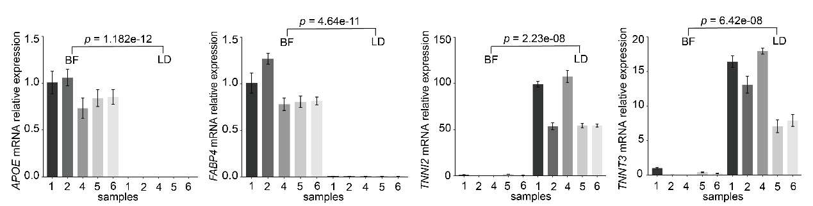
Fig. S3 QPCR validation experiments of specific genes. From left to right, the relative expression levels of APOE, FABP4, TNNI2, and TNNT3 are shown in BF and LD.

Fig. S4 Integration analysis of DEGs and DMGs in the genebody. A The overlapping of DEGs and DMGs in the genebody. B Correlation analysis of gene expression levels and DNA methylation levels in the genebody. Green represents genes with a non-classical negative correlation. Orange indicates classical positively correlated genes. C The heatmap shows the expression level and DNA methylation level in the genebody of overlapping genes in each sample. From left to right: DNA methylation level; direction of differential methylation; gene expression level. D GO pathway enrichment analysis of the overlapping genes.

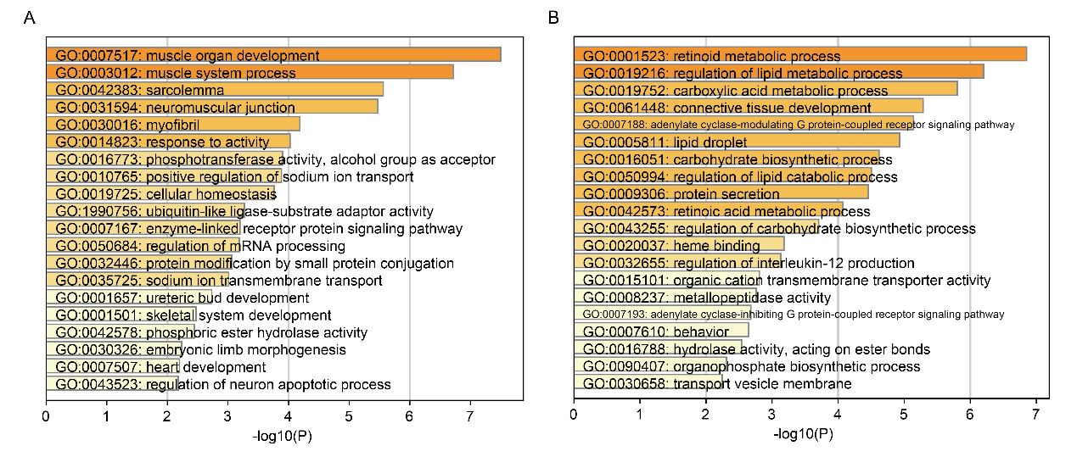
Fig. S5 The GO functional enrichment analysis of genes exclusively expressed in one tissue. A and B respectively show the functional enrichment of genes expressed only in muscle and adipose tissues.

