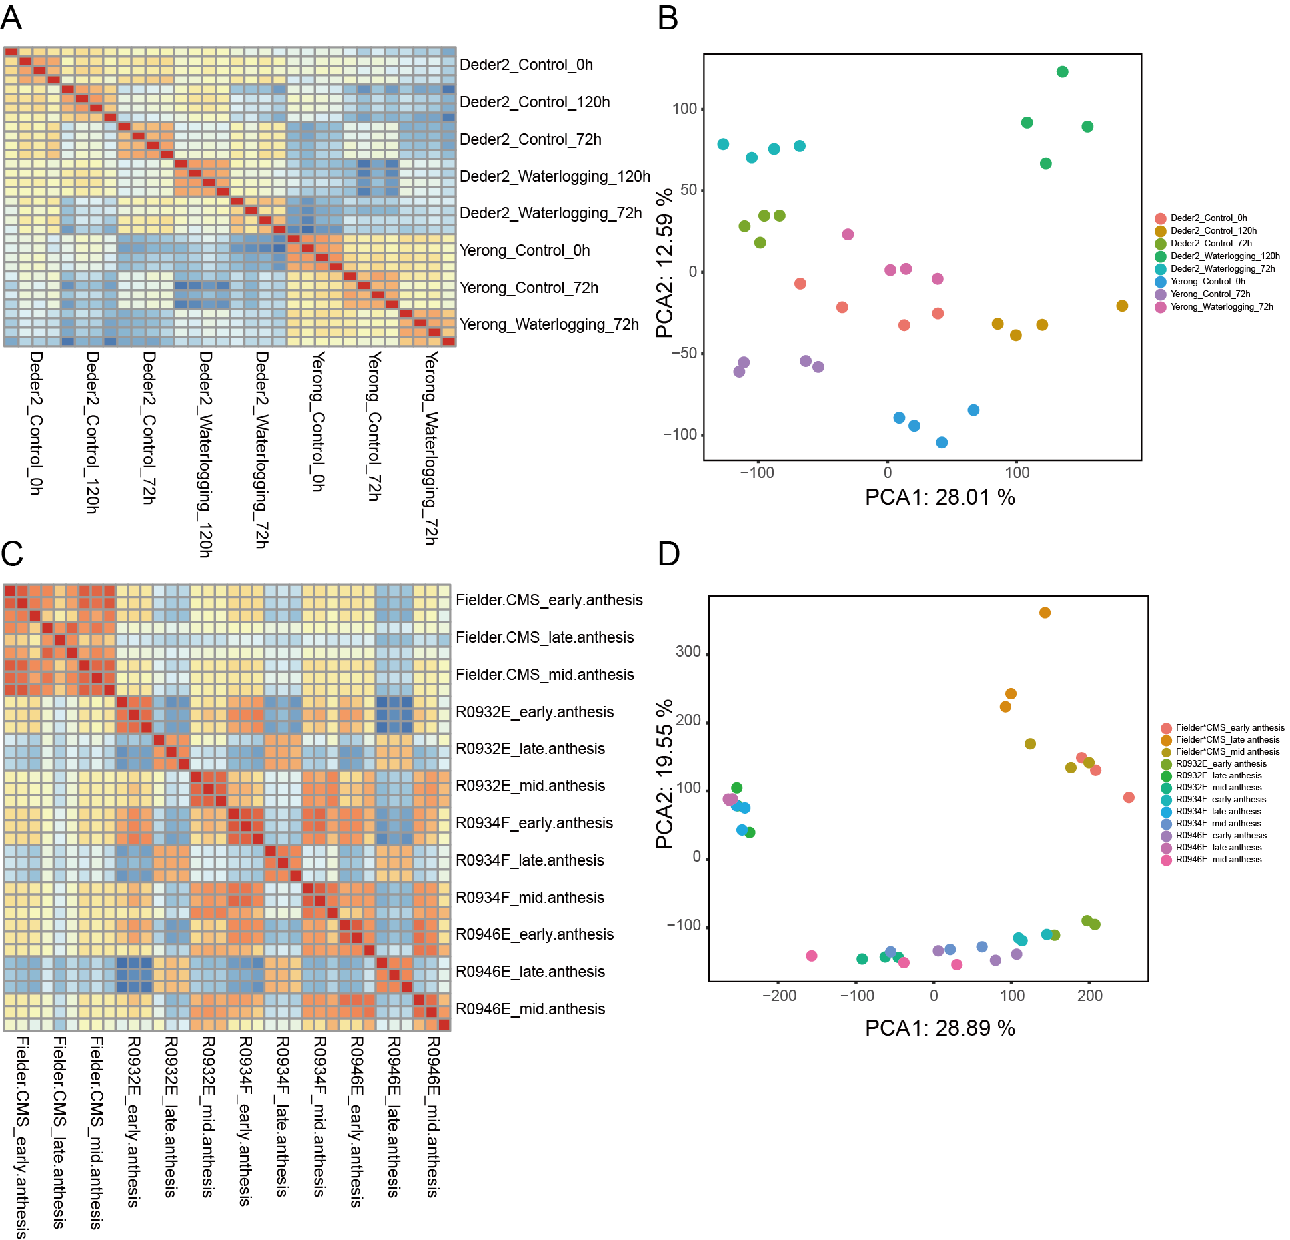
Figure S1. Sample reproducibility assessment. (A) Hierarchical clustering based on pairwise Pearson coefficients (Hordeum vulgare samples from BioProject PRJNA602700). (B) PCA plot of global gene expression patterns (Hordeum vulgare samples from BioProject PRJNA602700). (C) Hierarchical clustering of pairwise Pearson coefficients (Triticum aestivum samples from BioProject PRJNA675907). (D) PCA plot of global gene expression patterns (Triticum aestivum samples from BioProject PRJNA675907).

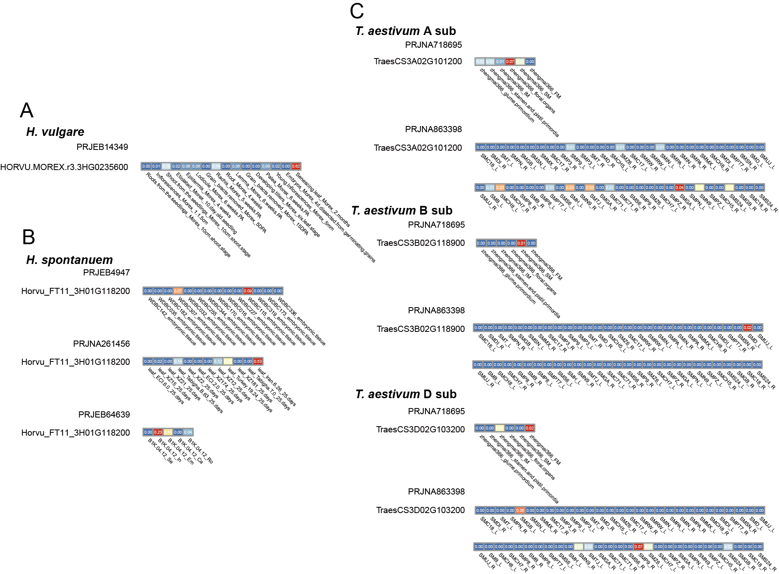
Figure S2. Expression profiles of Btr1 genes. (A) Expression pattern of Btr1 in Hordeum vulgare (PRJEB14349). (B) Expression pattern of Btr1 in Hordeum spontaneum (PRJEB4947, PRJNA261456, and PRJEB64639). (C) Expression pattern of Btr1 in Triticum aestivum (PRJNA718695 and PRJNA863398).

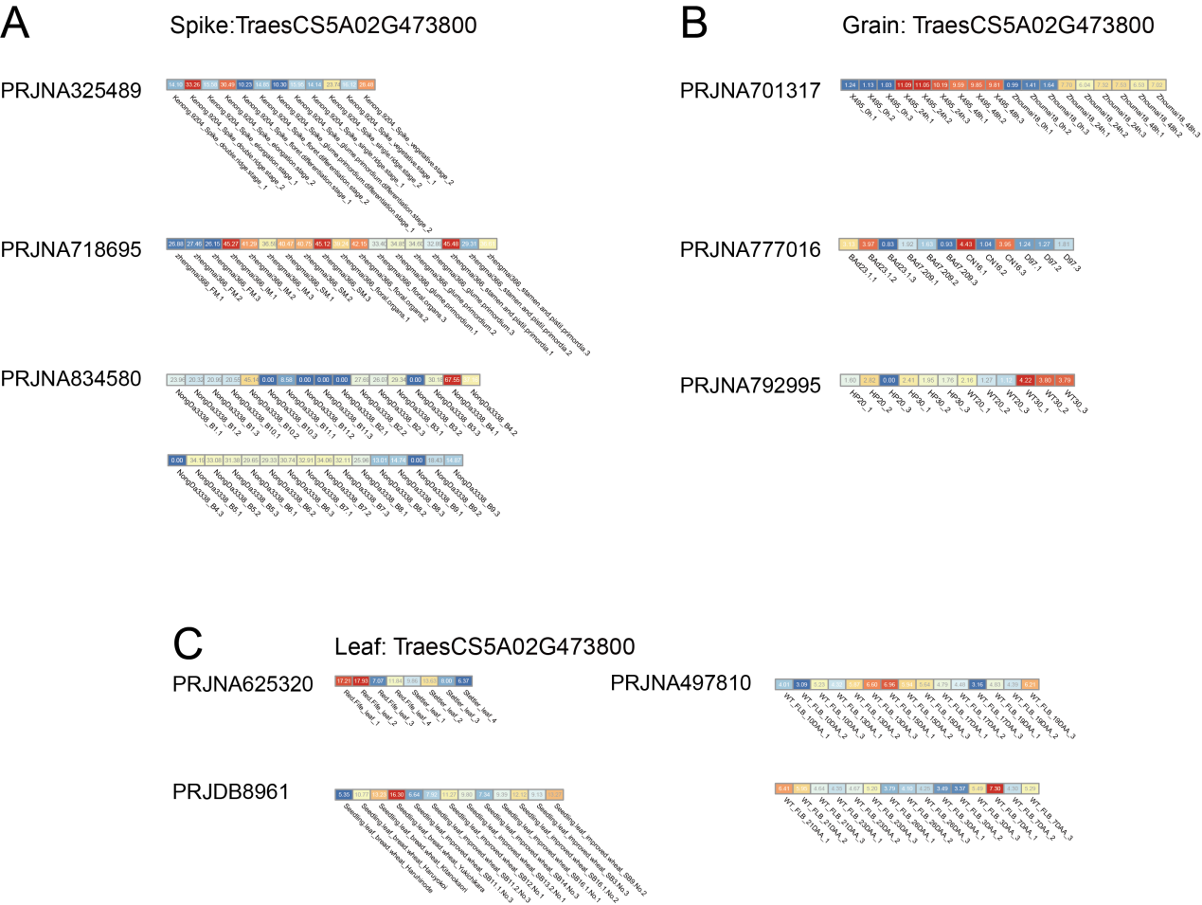
Figure S3. Widespread expression pattern concerning the key wheat domestication gene Q. (A) Q gene expression in spikes, analyzed using PRJNA325489, PRJNA718695, and PRJNA834580. (B) Q gene expression in grains, analyzed using PRJNA701317, PRJNA777016 and PRJNA792995. (C) Q gene expression in leaves, analyzed using PRJNA625320, PRJNA497810 and PRJDB8961.

