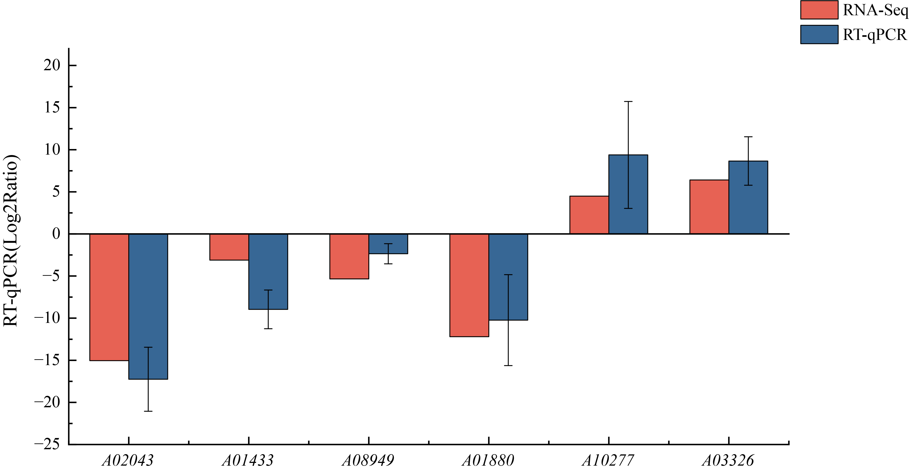
Additional Fig S2.png Title of data: Validation of the RNA-Seq of 6 selected DEGs in the A. cornea transcriptome by RT-qPCR. Description of data: The blue column represents the results by RT-qPCR, and the red column represents the results by RNA-Seq. The error bars represented the standard deviation of three biological replicates and three replicates of RT-qPCR runs.

