Text

DMC composition
The same nine DMCs with public nanopore sequencing data available from an earlier study were used ¹, with minor modifications and the addition of one DMC. Specifically, two DMCs with ONT R9 chemistry were replaced by ONT R10 chemistry and one DMC with R10 chemistry was added. The samples included a mix of: solely bacteria; bacteria with fungi; bacteria with archaea; or all three groups together. Their complexity ranged from simple with only 10 different species to very complex with over 60 species. Species were distributed in three ways: even (all species equally abundant), staggered (different abundances without a constant factor, although equal abundances occurred) or logarithmic (different abundances with each species one-tenth as abundant as the previous one). Hence, the DMCs provide a broad representation of possible metagenomic samples, excluding viruses.

PDMC composition
The products were purchased either online or from local stores and sequenced in-house. According to their labels, the products contained between one and fourteen species (Supplementary Table S8). The labeled species composition was used as the reference truth.

DMCs and database taxonomic consistency
To ensure taxonomic consistency between the DMCs and the employed reference database, all species names were updated with TaxonKit 0.18.0 ² to reflect the taxonomy as of February 2023, when the reference database was created. For nearly all organisms in the DMCs, genome assemblies were available on NCBI, where an automatic taxonomy check based on the average nucleotide ID is performed ³. In some cases, the submitted name of the assembly did not match the taxonomy of NCBI’s check. In such cases, species names in our datasets were corrected to match the taxonomy of NCBI’s check. A full overview of updated species names can be found in Supplementary Table S2, with further detail in the Supplementary Text.

PDMCs and database taxonomic consistency
Species names were harmonized according to the NCBI taxonomy (as of February 2023; see Section 1.3). Updated species names are provided in Supplementary Table S8. As no genome assemblies were available for these strains, potential taxonomic misannotations could not be corrected through NCBI’s taxonomy check, though some names were manually updated (see Supplementary Text).

Abundance conversion
The abundance of the three strain madness datasets was in the original study described as taxonomic abundance (see Table S2). To convert this to sequence abundance, the taxonomic abundance of each genome was multiplied with its genome length. The relative sequence abundance was then calculated by dividing each sequence abundance by the total sequence abundance. The abundance of sample HM 276D was expressed in rRNA operon counts; 1,000,000 copies per genome. The rRNA operon abundance was first converted to taxonomic abundance by dividing each species’ original abundance by its corresponding average RNA operon copy number, gathered from the rrnDB ⁴. Afterwards, the sequence abundance of each genome was calculated by multiplying the taxonomic abundance with its genome length. The relative sequence abundance was then calculated by dividing each sequence abundance by the total sequence abundance. Sample HM 277D contained 10,000 to 10,000,000 copies per organism. However, because the specific copy numbers per species were not disclosed, this sample was excluded from the LOD analysis. Other samples were originally expressed in sequence abundance, so no conversion was necessary.

Update ground truth
Due to the changing nature of nomenclature, previously assigned names may no longer be accurate. Since the database was built at a different time than the ground truth labels were defined, taxonomic updates can lead to inaccurate or misleading assignments. These updates generally fall into two types.
The first, and simplest, is a straightforward name change, which can be resolved by updating the ground truth label. For example, the ground truth of Zymo D6300 states Lactobacillus fermentum, but was changed to Limosilactobacillus fermentum in 2020. As such, the labels of each DMC and probiotic-derived mock community were updated to reflect the taxonomy as of February 2023.
The second is more complex and involves the splitting of an existing species into two or more distinct species. For example, Bacillus spizizenii is a fairly recent species from 2020, which used to be named Bacillus subtilis. In such cases, the associated genomes must be re-evaluated to determine whether they belong to the original species or should be reassigned to the newly defined one. For re-evaluation, the automatic taxonomy check of NCBI was used ³. Both types of updates are denoted in separate columns of Table S3. An exception was the Pseudomonas fluorescens genome (GCA_000009225, full name Pseudomonas [fluorescens] SBW25) in the strain madness datasets. A BLAST search revealed an almost identical match to a Pseudomonas marginalis genome (GCF_034424355, full name Pseudomonas marginalis SBW25). This P. marginalis passed NCBI’s taxonomy check. As a result, P. fluorescens was updated to P. marginalis.
For the probiotic-derived mock communities, re-evaluation of the species was more difficult as species in the probiotic-derived mock communities are often proprietary and their genomes are not readily available. Although an automated check through NCBI’s taxonomy check was therefore not possible, a few species names were still manually updated. The strain Lactobacillus casei PXN® 37™ from sample PROBIOTIC 8 is not listed on NCBI. However, a literature search indicates that this strain is also known as Lactobacillus casei NCIMB 30185 ^{5,6}, which updated to the taxonomy of February 2023 should be Lacticaseibacillus casei NCIMB 30185. Given that another study proposed reclassifying it as Lacticaseibacillus paracasei ⁷ and our results strongly support this classification, the name was updated accordingly to Lacticaseibacillus paracasei. The sample PROBIOTIC 10 contained Lacticaseibacillus casei R0215. Although the strain is not described in literature, other probiotic products describe the strain as Lacticaseibacillus paracasei R0215, even other probiotic products from same brand as PROBIOTIC 10. Additionally, a BLAST search of the sample to both species shows the majority of the reads mapping to L. paracasei (results not shown). Based on this information, along with our own classification results, Lacticaseibacillus casei in PROBIOTIC 10 was reclassified as Lacticaseibacillus paracasei.

Validation of the standard versus the novel approach using PDMCs
Figure S3 compares the standard and novel approaches by showing the median precision, recall, and F1 scores across ten PDMCs under three selection strategies (no thresholds applied, maximum F1 score, and FDR5) and five sample yields. Without any filtering applied, precision declined as yield increased, with values of 83.77% and 55.77% for the novel approach, and 45% and 22.5% for the standard approach, at 200M and 2000M, respectively. The median precision of the standard approach was substantially lower than that of the novel approach, largely due to the detection of many plasmids, which, unlike chromosomal DNA, are typically not species-specific. In contrast, for both approaches, the recall of all PDMCs was 100% across all yields, indicating that all species present in the ground truth were detected. Consequently, the median F1 scores decreased as yields increased, with lower scores for the standard compared to the novel approach, with values of 61.90% and 91.15% at 200M, and 36.67% and 71.43% at 2000M, respectively.
Using a maximum F1 score selection strategy, the median precision increased for both approaches. Both approaches achieved perfect median precision, recall, and consequently also F1 scores, of 100% across all yields. However, when not considering solely median values, one sample (PROBIOTIC8) did not reach this perfect score of 100% recall when using the standard approach, which was not the case for the novel approach.
Lastly, using FDR5 as selection strategy, the observed performance was similarly higher for the PDMCs compared to the DMCs. The standard and novel approaches reached a median precision of 96.15% and 100% across all yields, respectively, although two samples displayed notably lower precision values. For both approaches, a median recall of 100% across all yields was reached. This resulted in corresponding median F1 scores of 98% for the standard approach and 100% for the novel approach across all yields.
In conclusion, as with the DMCs, the novel approach performed better for all three selection strategies compared to the standard approach.

Tables

Table S1
Table S1: Sources and information on the ten DMC. The first, second, and third columns respectively present the DMC name, the company or authors responsible for producing the DMC, and its catalog number (if applicable). The fourth, fifth, and seventh columns indicate the Nanopore instrument used, the pore chemistry version (along with the kit used, if available), and the software used for basecalling, respectively. The eighth and ninth columns present the source of the DMCs and their corresponding ENA accession numbers, respectively.
Name | Source | Catalog | Instrument | Chemistry version | Basecaller version | Composition | Link | Run accession
Zymo D6300 | Zymo Research | D6300 | GridION | R9 | Guppy v2.2.2 | 8 bacteria;  2 fungi | https://doi.org/10.1093/gigascience/giz043 | ERR2906227
Zymo D6310 | Zymo Research | D6310 | GridION | R9 | Guppy v2.2.2 | 8 bacteria;  2 fungi | https://doi.org/10.1093/gigascience/giz043 | ERR2906229
Zymo D6322 | Zymo Research | D6322 | PromethION | R10.4.1  LSK114 | Dorado 0.7.3 | 7 bacteria  1 fungus | https://github.com/Kirk3gaard/MicroBench | ERR14251398
Zymo D6331 | Zymo Research | D6331 | PromethION | R10.4.1  SQK-NBD114.24 | Dorado 0.8.2 | 1 archaea;  14 bacteria;  2 fungi | https://doi.org/10.1186/s40168-022-01415-8 | SRR17913200
Zymo D6332 | Zymo Research | D6332 | PromethION | R10.4.1  SQK-NBD114.24 | Dorado 0.8.2 | 12 bacteria | https://github.com/Kirk3gaard/MicroBench | ERR14789832
Bei Resources HM-276D | Bei Resources | HM-276D | GridION | R9.4  SQK-LSK109 | NA | 20 bacteria | https://doi.org/10.1016/j.isci.2020.101223 | SRR11700265
Bei Resources HM-277D | Bei Resources | HM-277D | GridION | R9.4  SQK-LSK109 | NA | 20 bacteria | https://doi.org/10.1016/j.isci.2020.101223 | SRR11700264
Strain madness 1 | Meslier, V., Quinquis, B., Da Silva, K. et al. | / | NA | R9  SQK-LSK109 | Guppy 2.3.1 | 22 archaea;  45 bacteria | https://doi.org/10.1038/s41597-022-01762-z | ERR9765780
Strain madness 2 |  |  |  |  |  | 22 archaea;  61 bacteria | https://doi.org/10.1038/s41597-022-01762-z | ERR9765781
Strain madness 3 |  |  |  |  |  | 14 archaea;  46 bacteria | https://doi.org/10.1038/s41597-022-01762-z | ERR9765782

Table S2
Table S2: Species information of the ten DMCs. The first column denotes the DMC name. The second column shows the NCBI’s assembly accession of the species in the DMCs. The third column represents the original species name, while the fourth and fifth columns represent the updated species name as explained under 1.6 Update ground truth (NA means the species name was not updated). The last column shows the relative abundance (%) of the present species in the DMC(s).
 | NCBI Reference Genome Accession No. | Original species name | Species name on 02/2023 | Changed species name | Genomic DNA (%)
Zymo D6300 | GCF_028743795 | Bacillus subtilis | NA | Bacillus spizizenii | 12
Zymo D6300 | GCA_028975465 | Cryptococcus neoformans | NA | NA | 2
Zymo D6300 | GCF_028743535 | Enterococcus faecalis | NA | NA | 12
Zymo D6300 | GCF_028743555 | Escherichia coli | NA | NA | 12
Zymo D6300 | GCF_030770375 | Lactobacillus fermentum | Limosilactobacillus fermentum | NA | 12
Zymo D6300 | GCF_028743575 | Listeria monocytogenes | NA | NA | 12
Zymo D6300 | GCF_028743595 | Pseudomonas aeruginosa | NA | NA | 12
Zymo D6300 | GCA_028975445 | Saccharomyces cerevisiae | NA | NA | 2
Zymo D6300 | GCF_028743635 | Salmonella enterica | NA | NA | 12
Zymo D6300 | GCF_028743615 | Staphylococcus aureus | NA | NA | 12
Zymo D6310 | GCF_028743795 | Bacillus subtilis | NA | Bacillus spizizenii | 0.89
Zymo D6310 | GCA_028975465 | Cryptococcus neoformans | NA | NA | 0.00089
Zymo D6310 | GCF_028743535 | Enterococcus faecalis | NA | NA | 0.00089
Zymo D6310 | GCF_028743555 | Escherichia coli | NA | NA | 0.089
Zymo D6310 | GCF_030770375 | Lactobacillus fermentum | Limosilactobacillus fermentum | NA | 0.0089
Zymo D6310 | GCF_028743575 | Listeria monocytogenes | NA | NA | 89.1
Zymo D6310 | GCF_028743595 | Pseudomonas aeruginosa | NA | NA | 8.9
Zymo D6310 | GCA_028975445 | Saccharomyces cerevisiae | NA | NA | 0.89
Zymo D6310 | GCF_028743635 | Salmonella enterica | NA | NA | 0.089
Zymo D6310 | GCF_028743615 | Staphylococcus aureus | NA | NA | 0.000089
Zymo D6322 | GCF_028743795 | Bacillus subtilis | NA | Bacillus spizizenii | 14
Zymo D6322 | GCF_028743535 | Enterococcus faecalis | NA | NA | 14
Zymo D6322 | GCF_028743555 | Escherichia coli | NA | NA | 14
Zymo D6322 | GCF_028743575 | Listeria monocytogenes | NA | NA | 14
Zymo D6322 | GCF_028743595 | Pseudomonas aeruginosa | NA | NA | 14
Zymo D6322 | GCA_028975445 | Saccharomyces cerevisiae | NA | NA | 2
Zymo D6322 | GCF_028743635 | Salmonella enterica | NA | NA | 14
Zymo D6322 | GCF_028743615 | Staphylococcus aureus | NA | NA | 14
Zymo D6331 | GCF_028743255 | Akkermansia muciniphila | NA | NA | 1.5
Zymo D6331 | GCF_028743275 | Bacteroides fragilis | NA | NA | 14
Zymo D6331 | GCF_028743295 | Bifidobacterium adolescentis | NA | NA | 6
Zymo D6331 | NA | Candida albicans | NA | NA | 1.5
Zymo D6331 | GCF_028743315 | Clostridioides difficile | NA | NA | 1.5
Zymo D6331 | GCF_028743735 | Clostridium perfringens | NA | NA | 0.0001
Zymo D6331 | NA | Enterococcus faecalis | NA | NA | 0.001
Zymo D6331 | GCF_028743355  GCF_028743335  GCF_028743755  GCF_028743555  GCF_028743375 | Escherichia coli | NA | NA | 14
Zymo D6331 | GCF_028743395 | Faecalibacterium prausnitzii | NA | NA | 14
Zymo D6331 | GCF_028743415 | Fusobacterium nucleatum | NA | NA | 6
Zymo D6331 | GCF_028743095 | Lactobacillus fermentum | Limosilactobacillus fermentum | NA | 6
Zymo D6331 | GCF_028743435 | Methanobrevibacter smithii | NA | NA | 0.1
Zymo D6331 | GCF_028743775 | Prevotella corporis | NA | NA | 6
Zymo D6331 | GCF_028743455 | Roseburia hominis | NA | NA | 14
Zymo D6331 | GCA_030867715 | Saccharomyces cerevisiae | NA | NA | 1.4
Zymo D6331 | GCF_028743635 | Salmonella enterica | NA | NA | 0.01
Zymo D6331 | GCF_028743475 | Veillonella rogosae | NA | NA | 14
Zymo D6332 | GCF_031191795 | Fusobacterium nucleatum | NA | NA | 1
Zymo D6332 | GCF_031191205 | Haemophilus parainfluenzae | NA | NA | 8
Zymo D6332 | GCF_031190635 | Neisseria subflava | NA | NA | 16
Zymo D6332 | GCF_031323855 | Porphyromonas gingivalis | NA | NA | 1
Zymo D6332 | GCF_031191185 | Prevotella nigrescens | NA | NA | 16
Zymo D6332 | GCF_031191775 | Rothia dentocariosa | NA | NA | 8
Zymo D6332 | GCF_031191545 | Schaalia odontolytica | NA | NA | 8
Zymo D6332 | GCF_031191225 | Streptococcus mitis | NA | NA | 8
Zymo D6332 | GCF_044360185 | Streptococcus mutans | NA | NA | 1
Zymo D6332 | GCF_031582885 | Streptococcus parasanguinis | NA | NA | 16
Zymo D6332 | GCF_031192325 | Streptococcus salivarius | NA | NA | 1 |  | NA
Zymo D6332 | GCF_031190775 | Veillonella parvula | NA | NA | 16 |  | NA
HM 276D  HM 277D | GCF_000015425 | Acinetobacter baumannii | NA | NA | 4.86 |  | NA
HM 276D  HM 277D | GCF_000154225 | Actinomyces odontolyticus | Schaalia odontolytica | Schaalia dentiphila | 5.78 |  | NA
HM 276D  HM 277D | GCF_000008005 | Bacillus cereus | NA | Bacillus pacificus | 2.87 |  | NA
HM 276D  HM 277D | GCF_000012825 | Bacteroides vulgatus | Phocaeicola vulgatus | NA | 5.34 |  | NA
HM 276D  HM 277D | GCF_000016965 | Clostridium beijerinckii | NA | NA | 2.86 |  | NA
HM 276D  HM 277D | GCF_000008565 | Deinococcus radiodurans | NA | NA | 7.93 |  | NA
HM 276D  HM 277D | GCF_000172575 | Enterococcus faecalis | NA | NA | 4.99 |  | NA
HM 276D  HM 277D | GCF_000005845 | Escherichia coli | NA | NA | 4.82 |  | NA
HM 276D  HM 277D | GCF_000008525 | Helicobacter pylori | NA | NA | 6.14 |  | NA
HM 276D  HM 277D | GCF_000014425 | Lactobacillus gasseri | NA | NA | 2.7 |  | NA
HM 276D  HM 277D | GCF_000196035 | Listeria monocytogenes | NA | NA | 3.77 |  | NA
HM 276D  HM 277D | GCF_000008805 | Neisseria meningitidis | NA | NA | 4.1 |  | NA
HM 276D  HM 277D | GCF_000008345 | Propionibacterium acnes | Cutibacterium acnes | NA | 6.08 |  | NA
HM 276D  HM 277D | GCF_000006765 | Pseudomonas aeruginosa | NA | NA | 11.36 |  | NA
HM 276D  HM 277D | GCF_000012905 | Rhodobacter sphaeroides | Cereibacter sphaeroides | NA | 10.26 |  | NA
HM 276D  HM 277D | GCF_000017085 | Staphylococcus aureus | NA | NA | 3.66 |  | NA
HM 276D  HM 277D | GCF_000007645 | Staphylococcus epidermidis | NA | NA | 3.3 |  | NA
HM 276D  HM 277D | GCF_000007265 | Streptococcus agalactiae | NA | NA | 2.25 |  | NA
HM 276D  HM 277D | GCF_000007465 | Streptococcus mutans | NA | NA | 2.94 |  | NA
HM 276D  HM 277D | GCF_000006885 | Streptococcus pneumoniae | NA | NA | 4.0 |  | NA
Strain Madness 1  Strain Madness 2  Strain Madness 3 | GCA_000144915 | Acidilobus saccharovorans | NA | NA | 0.0183 | 0.018 |  | 0.0182
Strain Madness 1  Strain Madness 2  Strain Madness 3 | GCA_000022565 | Acidobacterium capsulatum | NA | NA | 0.2967 | 0.2924 |  | 0.1825
Strain Madness 1  Strain Madness 2  Strain Madness 3 | GCA_000025665 | Aciduliprofundum boonei | Candidatus Aciduliprofundum boonei | NA | 0.0183 | 0.018 |  | 0.0
Strain Madness 1  Strain Madness 2  Strain Madness 3 | GCA_000015425 | Acinetobacter baumannii | NA | NA | 0.0 | 0.0722 |  | 0.0
Strain Madness 1  Strain Madness 2  Strain Madness 3 | GCA_000020225 | Akkermansia muciniphila | NA | NA | 0.8699 | 0.8573 |  | 1.2136
Strain Madness 1  Strain Madness 2  Strain Madness 3 | GCA_000008665 | Archaeoglobus fulgidus | NA | NA | 0.9157 | 0.9025 |  | 0.73
Strain Madness 1  Strain Madness 2  Strain Madness 3 | GCA_000008005 | Bacillus cereus | NA | NA | 0.0 | 0.0722 |  | 0.0
Strain Madness 1  Strain Madness 2  Strain Madness 3 | GCA_000011065 | Bacteroides thetaiotaomicron | NA | NA | 0.7325 | 0.722 |  | 0.4562
Strain Madness 1  Strain Madness 2  Strain Madness 3 | GCA_000010425 | Bifidobacterium adolescentis | NA | NA | 0.0 | 0.0722 |  | 0.0
Strain Madness 1  Strain Madness 2  Strain Madness 3 | GCA_000195675 | Bordetella pertussis | Bordetella bronchiseptica | NA | 0.9157 | 0.9025 |  | 0.9125
Strain Madness 1  Strain Madness 2  Strain Madness 3 | GCA_000022325 | Caldicellulosiruptor bescii | NA | NA | 0.2253 | 0.222 |  | 0.2245
Strain Madness 1  Strain Madness 2  Strain Madness 3 | GCA_000016545 | Caldicellulosiruptor saccharolyticus | NA | NA | 0.9523 | 0.9386 |  | 1.4235
Strain Madness 1  Strain Madness 2  Strain Madness 3 | GCA_000015985 | Cereibacter A | Cereibacter sphaeroides | NA | 0.0 | 0.0722 |  | 0.0
Strain Madness 1  Strain Madness 2  Strain Madness 3 | GCA_000006985 | Chlorobaculum tepidum | NA | NA | 0.1886 | 0.1859 |  | 0.4708
Strain Madness 1  Strain Madness 2  Strain Madness 3 | GCA_000020465 | Chlorobium limicola | NA | NA | 2.3075 | 2.2742 |  | 1.3797
Strain Madness 1  Strain Madness 2  Strain Madness 3 | GCA_000015125 | Chlorobium phaeobacteroides | NA | NA | 0.7783 | 0.7671 |  | 0.7756
Strain Madness 1  Strain Madness 2  Strain Madness 3 | GCA_000016085 | Chlorobium phaeovibrioides | NA | NA | 0.9157 | 0.9025 |  | 1.3687
Strain Madness 1  Strain Madness 2  Strain Madness 3 | GCA_000018865 | Chloroflexus aurantiacus | NA | NA | 0.3846 | 0.379 |  | 0.1916
Strain Madness 1  Strain Madness 2  Strain Madness 3 | GCA_000767745 | Clostridium beijerinckii | NA | NA | 0.0 | 0.0722 |  | 0.0
Strain Madness 1  Strain Madness 2  Strain Madness 3 | GCA_000231215 | Cutibacterium acnes | NA | NA | 0.0 | 0.0722 |  | 0.0
Strain Madness 1  Strain Madness 2  Strain Madness 3 | GCA_000008565 | Deinococcus radiodurans | NA | NA | 0.7325 | 0.7931 |  | 0.5475
Strain Madness 1  Strain Madness 2  Strain Madness 3 | GCA_000243155 | Desulfitobacterium dehalogenans | NA | NA | 0.0055 | 0.0054 |  | 0.0
Strain Madness 1  Strain Madness 2  Strain Madness 3 | GCA_002952055 | Desulfobulbus oralis | NA | NA | 7.3253 | 7.2196 |  | 3.65
Strain Madness 1  Strain Madness 2  Strain Madness 3 | GCA_000023225 | Desulfomicrobium baculatum | NA | NA | 0.0 | 0.0 |  | 0.0547
Strain Madness 1  Strain Madness 2  Strain Madness 3 | GCA_000189295 | Desulfovibrio mercurii | NA | NA | 0.0733 | 0.0722 |  | 0.0456
Strain Madness 1  Strain Madness 2  Strain Madness 3 | GCA_000156375 | Desulfovibrio piger | NA | NA | 4.5783 | 4.5123 |  | 6.8437
Strain Madness 1  Strain Madness 2  Strain Madness 3 | GCA_000021645 | Dictyoglomus turgidum | NA | NA | 0.4578 | 0.4512 |  | 0.365
Strain Madness 1  Strain Madness 2  Strain Madness 3 | GCA_000172575 | Enterococcus faecalis | NA | NA | 0.1831 | 0.2516 |  | 0.365
Strain Madness 1  Strain Madness 2  Strain Madness 3 | GCA_000005845 | Escherichia coli | NA | NA | 0.0 | 0.0722 |  | 0.0
Strain Madness 1  Strain Madness 2  Strain Madness 3 | GCA_003019295 | Fusobacterium nucleatum | NA | NA | 2.1976 | 2.1659 |  | 1.095
Strain Madness 1  Strain Madness 2  Strain Madness 3 | GCA_000010305 | Gemmatimonas aurantiaca | NA | NA | 4.0289 | 3.9708 |  | 4.015
Strain Madness 1  Strain Madness 2  Strain Madness 3 | GCA_000020725 | Geobacter bemidjiensis | NA | NA | 0.0055 | 0.0054 |  | 0.0
Strain Madness 1  Strain Madness 2  Strain Madness 3 | GCA_000007985 | Geobacter sulfurreducens | NA | NA | 0.8058 | 0.7942 |  | 0.1405
Strain Madness 1  Strain Madness 2  Strain Madness 3 | GCA_000006805 | Halobacterium salinarum | NA | NA | 1.8313 | 1.8049 |  | 1.825
Strain Madness 1  Strain Madness 2  Strain Madness 3 | GCA_000025685 | Haloferax volcanii | NA | NA | 0.0494 | 0.0487 |  | 0.0493
Strain Madness 1  Strain Madness 2  Strain Madness 3 | GCA_000008525 | Helicobacter pylori | NA | NA | 0.0 | 0.0722 |  | 0.0
Strain Madness 1  Strain Madness 2  Strain Madness 3 | GCA_000018565 | Herpetosiphon aurantiacus | NA | NA | 4.0289 | 3.9708 |  | 6.4239
Strain Madness 1  Strain Madness 2  Strain Madness 3 | GCA_000020785 | Hydrogenobaculum sp. | Hydrogenobaculum sp. Y04AAS1 | NA | 0.9157 | 0.9025 |  | 0.73
Strain Madness 1  Strain Madness 2  Strain Madness 3 | GCA_000017945 | Ignicoccus hospitalis | NA | NA | 1.3277 | 1.3086 |  | 1.9838
Strain Madness 1  Strain Madness 2  Strain Madness 3 | GCA_001481685 | Ignicoccus islandicus | NA | NA | 0.5494 | 0.5415 |  | 1.3687
Strain Madness 1  Strain Madness 2  Strain Madness 3 | GCA_000014425 | Lactobacillus gasseri | NA | NA | 0.0 | 0.0722 |  | 0.0
Strain Madness 1  Strain Madness 2  Strain Madness 3 | GCA_000019785 | Leptothrix cholodnii | NA | NA | 0.0879 | 0.0866 |  | 0.0
Strain Madness 1  Strain Madness 2  Strain Madness 3 | GCA_001639275 | Methanobrevibacter oralis | NA | NA | 0.586 | 0.5776 |  | 0.0
Strain Madness 1  Strain Madness 2  Strain Madness 3 | GCA_000091665 | Methanocaldococcus jannaschii | NA | NA | 3.5345 | 3.4835 |  | 7.0444
Strain Madness 1  Strain Madness 2  Strain Madness 3 | GCA_000016125 | Methanococcus maripaludis | NA | NA | 0.7508 | 0.74 |  | 0.7482
Strain Madness 1  Strain Madness 2  Strain Madness 3 | GCA_000011585 | Methanococcus maripaludis | NA | NA | 0.2747 | 0.2707 |  | 0.1825
Strain Madness 1  Strain Madness 2  Strain Madness 3 | GCA_000308215 | Methanomassiliicoccus luminyensis | NA | NA | 0.0549 | 0.0541 |  | 0.0
Strain Madness 1  Strain Madness 2  Strain Madness 3 | GCA_000328665 | Methanomethylovorans hollandica | NA | NA | 0.0458 | 0.0451 |  | 0.0
Strain Madness 1  Strain Madness 2  Strain Madness 3 | GCA_000007185 | Methanopyrus kandleri | NA | NA | 0.1282 | 0.1263 |  | 0.1606
Strain Madness 1  Strain Madness 2  Strain Madness 3 | GCA_000007345 | Methanosarcina acetivorans | NA | NA | 0.3663 | 0.361 |  | 0.365
Strain Madness 1  Strain Madness 2  Strain Madness 3 | GCA_000166095 | Methanothermus fervidus | NA | NA | 3.2048 | 3.1586 |  | 2.555
Strain Madness 1  Strain Madness 2  Strain Madness 3 | GCA_000018265 | Micromonospora arenicola | Salinispora arenicola | NA | 0.8131 | 0.8014 |  | 0.657
Strain Madness 1  Strain Madness 2  Strain Madness 3 | GCA_000016425 | Micromonospora tropica | Salinispora tropica | NA | 0.9157 | 0.9025 |  | 0.73
Strain Madness 1  Strain Madness 2  Strain Madness 3 | GCA_000008085 | Nanoarchaeum equitans | NA | NA | 0.1685 | 0.1661 |  | 0.1113
Strain Madness 1  Strain Madness 2  Strain Madness 3 | GCA_000008805 | Neisseria meningitidis | NA | NA | 0.0 | 0.0722 |  | 0.0
Strain Madness 1  Strain Madness 2  Strain Madness 3 | GCA_000195755 | Nitratidesulfovibrio vulgaris | NA | NA | 0.0366 | 0.0361 |  | 0.073
Strain Madness 1  Strain Madness 2  Strain Madness 3 | GCA_000009145 | Nitrosomonas europaea | NA | NA | 5.7504 | 5.6674 |  | 2.8652
Strain Madness 1  Strain Madness 2  Strain Madness 3 | GCA_000013645 | Paraburkholderia xenovorans | NA | NA | 2.0145 | 1.9854 |  | 1.0037
Strain Madness 1  Strain Madness 2  Strain Madness 3 | GCA_000154225 | Pauljensenia odontolyticus | Schaalia dentiphila | NA | 0.0 | 0.0722 |  | 0.0
Strain Madness 1  Strain Madness 2  Strain Madness 3 | GCA_000020645 | Pelodictyon phaeoclathratiforme | NA | NA | 0.0 | 0.0 |  | 0.1131
Strain Madness 1  Strain Madness 2  Strain Madness 3 | GCA_000021565 | Persephonella marina | NA | NA | 2.0035 | 1.9746 |  | 1.095
Strain Madness 1  Strain Madness 2  Strain Madness 3 | GCA_000012825 | Phocaeicola vulgatus | NA | NA | 0.8717 | 0.9298 |  | 2.6061
Strain Madness 1  Strain Madness 2  Strain Madness 3 | GCA_000010505 | Porphyromonas gingivalis | NA | NA | 1.8387 | 1.887 |  | 3.6646
Strain Madness 1  Strain Madness 2  Strain Madness 3 | GCA_002563335 | Pseudomonas aeruginosa | NA | NA | 0.0 | 0.0722 |  | 0.0
Strain Madness 1  Strain Madness 2  Strain Madness 3 | GCA_931907645 | Pseudomonas fluorescens | NA | Pseudomonas marginalis | 2.747 | 2.7074 |  | 0.9125
Strain Madness 1  Strain Madness 2  Strain Madness 3 | GCA_000007565 | Pseudomonas putida | NA | NA | 3.2964 | 3.2488 |  | 2.6645
Strain Madness 1  Strain Madness 2  Strain Madness 3 | GCA_000007225 | Pyrobaculum aerophilum | NA | NA | 0.1831 | 0.1805 |  | 0.0912
Strain Madness 1  Strain Madness 2  Strain Madness 3 | GCA_000016385 | Pyrobaculum arsenaticum | NA | NA | 0.0366 | 0.0361 |  | 0.0
Strain Madness 1  Strain Madness 2  Strain Madness 3 | GCA_000015805 | Pyrobaculum calidifontis | NA | NA | 1.8313 | 1.8049 |  | 0.365
Strain Madness 1  Strain Madness 2  Strain Madness 3 | GCA_000007305 | Pyrococcus furiosus | NA | NA | 0.2747 | 0.2707 |  | 0.0
Strain Madness 1  Strain Madness 2  Strain Madness 3 | GCA_000011105 | Pyrococcus horikoshii | NA | NA | 3.6627 | 3.6098 |  | 4.5625
Strain Madness 1  Strain Madness 2  Strain Madness 3 | GCA_000196115 | Rhodopirellula baltica | NA | NA | 3.388 | 3.3391 |  | 2.0257
Strain Madness 1  Strain Madness 2  Strain Madness 3 | GCA_000011965 | Ruegeria pomeroyi | NA | NA | 0.1099 | 0.1083 |  | 0.0
Strain Madness 1  Strain Madness 2  Strain Madness 3 | GCA_000015865 | Ruminiclostridium thermocellum | Acetivibrio thermocellus | NA | 0.3718 | 0.3664 |  | 0.2226
Strain Madness 1  Strain Madness 2  Strain Madness 3 | GCA_000017325 | Shewanella baltica | NA | NA | 2.5932 | 2.5558 |  | 3.4456
Strain Madness 1  Strain Madness 2  Strain Madness 3 | GCA_000021665 | Shewanella baltica | NA | NA | 4.8897 | 4.8191 |  | 5.8472
Strain Madness 1  Strain Madness 2  Strain Madness 3 | GCA_000016065 | Shewanella loihica | NA | NA | 0.9157 | 0.9025 |  | 1.2775
Strain Madness 1  Strain Madness 2  Strain Madness 3 | GCA_000013465 | Staphylococcus aureus | NA | NA | 0.0 | 0.0722 |  | 0.0
Strain Madness 1  Strain Madness 2  Strain Madness 3 | GCA_000007645 | Staphylococcus epidermidis | NA | NA | 0.0 | 0.0722 |  | 0.0
Strain Madness 1  Strain Madness 2  Strain Madness 3 | GCA_000007265 | Streptococcus agalactiae | NA | NA | 0.0 | 0.0722 |  | 0.0
Strain Madness 1  Strain Madness 2  Strain Madness 3 | GCA_000817065 | Streptococcus mutans | NA | NA | 0.0 | 0.0722 |  | 0.0
Strain Madness 1  Strain Madness 2  Strain Madness 3 | GCA_000020325 | Sulfurihydrogenibium sp. | Sulfurihydrogenibium sp. YO3AOP1 | NA | 0.4578 | 0.4512 |  | 0.365
Strain Madness 1  Strain Madness 2  Strain Madness 3 | GCA_000011205 | Sulfurisphaera tokodaii | NA | NA | 0.0733 | 0.0722 |  | 0.073
Strain Madness 1  Strain Madness 2  Strain Madness 3 | GCA_000019085 | Thermoanaerobacter pseudethanolicus | NA | Thermoanaerobacter brockii | 2.1097 | 2.0793 |  | 1.5768
Strain Madness 1  Strain Madness 2  Strain Madness 3 | GCA_000019625 | Thermotoga maritima | Thermotoga sp. RQ2 | NA | 0.0 | 0.0 |  | 4.1975
Strain Madness 1  Strain Madness 2  Strain Madness 3 | GCA_000018945 | Thermotoga neapolitana | NA | NA | 1.0896 | 1.0739 |  | 2.1717
Strain Madness 1  Strain Madness 2  Strain Madness 3 | GCA_000016785 | Thermotoga petrophila | NA | NA | 4.56 | 4.4942 |  | 0.0
Strain Madness 1  Strain Madness 2  Strain Madness 3 | GCA_000008185 | Treponema denticola | NA | NA | 1.2966 | 1.2779 |  | 1.6151
Strain Madness 1  Strain Madness 2  Strain Madness 3 | GCA_000009705 | Trichormus sp. | Nostoc sp. PCC 7120 = FACHB-418 | NA | 3.5528 | 3.5015 |  | 5.3107
Strain Madness 1  Strain Madness 2  Strain Madness 3 | GCA_000196135 | Wolinella succinogenes | NA | NA | 0.4981 | 0.4909 |  | 0.4143
Strain Madness 1  Strain Madness 2  Strain Madness 3 | GCA_000007105 | Zymomonas mobilis | NA | NA | 0.0 | 0.0 |  | 0.0365

Table S3
Table S3: Sequence statistics of the DMCs before and after filtering. The first column denotes before (raw) and after (filtered) filtering. The second column shows the DMC name. The third, the fourth, the fifth, the sixth and seventh columns denote the number of sequences, the number of bases, their average Phred score, average length and N50, respectively.
 | DMC | #Sequences | Yield | AvgQual | AvgLen | N50
Raw | Zymo D6300 | 3,491,078 | 14,007,156,825 | 8.33 | 4,012.3 | 5,213
Raw | Zymo D6310 | 3,667,007 | 16,032,264,247 | 7.96 | 4,372 | 5,290
Raw | Zymo D6322 | 8,851,918 | 31,995,546,765 | 13.56 | 3,614.5 | 13,837
Raw | Zymo D6331 | 5,757,345 | 28,443,158,238 | 13.65 | 4,940.3 | 5,913
Raw | Zymo D6332 | 1,140,052 | 7,530,532,667 | 20.57 | 6,605.4 | 8,598
Raw | Bei Resources HM-276D | 11,610,183 | 35,578,375,166 | 8.68 | 3,064.4 | 6,828
Raw | Bei Resources HM-277D | 18,254,839 | 72,312,638,112 | 10.06 | 3,961.3 | 7,857
Raw | Strain madness 1 | 696,944 | 3,125,920,499 | 10.62 | 4,485.2 | 6,086
Raw | Strain madness 2 | 831,802 | 3,690,876,744 | 10.63 | 4,437.2 | 6,057
Raw | Strain madness 3 | 791,715 | 3,412,736,796 | 10.6 | 4,310.6 | 5,788
Filtered | Zymo D6300 | 688,666 | 3,184,351,336 | 10.38 | 4,623.9 | 5,397
Filtered | Zymo D6310 | 407,843 | 1,934,530,540 | 10.31 | 4,743.3 | 5,442
Filtered | Zymo D6322 | 4,401,162 | 28,272,769,892 | 13.95 | 6,423.9 | 15,966
Filtered | Zymo D6331 | 5,757,345 | 28,443,158,238 | 13.65 | 4,940.3 | 5,913
Filtered | Zymo D6332 | 1,076,408 | 7,468,390,687 | 20.84 | 6,938.3 | 8,627
Filtered | Bei Resources HM-276D | 2,163,256 | 11,018,419,575 | 10.52 | 5,093.4 | 8,572
Filtered | Bei Resources HM-277D | 7,002,956 | 37,506,985,368 | 11.71 | 5,355.9 | 8,560
Filtered | Strain madness 1 | 485,802 | 2,428,082,669 | 11.2 | 4,998.1 | 6,182
Filtered | Strain madness 2 | 579,446 | 2,875,480,429 | 11.2 | 4,962.5 | 6,157
Filtered | Strain madness 3 | 553,288 | 2,647,336,371 | 11.17 | 4,784.7 | 5,882

Table S4
Table S4: Sequence statistics of the probiotic-derived mock communities before and after filtering. The first column denotes before (raw) and after (filtered) filtering. The second column shows the probiotic-derived mock community name. The third, the fourth, the fifth, the sixth and seventh columns denote the number of sequences, the number of bases, their average Phred score, average length and N50, respectively.
 | Probiotic | #Sequences | Yield | AvgQual | AvgLen | N50
Raw | PROBIOTIC1 | 3,541,293 | 19,215,502,743 | 11.72 | 5,426.1 | 12,928
Raw | PROBIOTIC2 | 5,814,033 | 12,001,290,346 | 12.28 | 2,064.2 | 3,454
Raw | PROBIOTIC3 | 1,375,061 | 2,356,782,880 | 12.97 | 1,713.9 | 2,463
Raw | PROBIOTIC4 | 4,527,675 | 16,019,595,242 | 12.9 | 3,538.2 | 4,519
Raw | PROBIOTIC5 | 751,547 | 2,490,777,975 | 12.71 | 3,314.2 | 4,423
Raw | PROBIOTIC6 | 1,089,396 | 4,019,809,690 | 13.7 | 3,689.9 | 6,423
Raw | PROBIOTIC7 | 1,063,709 | 2,628,339,571 | 12.04 | 2,470.9 | 3,982
Raw | PROBIOTIC8 | 4,002,421 | 11,231,916,704 | 14.1 | 2,806.3 | 3,743
Raw | PROBIOTIC9 | 4,150,274 | 9,860,786,912 | 13.47 | 2,375.9 | 3,331
Raw | PROBIOTIC10 | 5,676,447 | 7,758,362,901 | 12.95 | 1,366.8 | 2,373
Filtered | PROBIOTIC1 | 2,074,105 | 14,347,056,176 | 16.17 | 6,917.2 | 13,060
Filtered | PROBIOTIC2 | 2,718,591 | 8,847,033,162 | 16.05 | 3,254.3 | 3,872
Filtered | PROBIOTIC3 | 745,755 | 1,780,800,204 | 17.84 | 2,387.9 | 2,646
Filtered | PROBIOTIC4 | 3,275,806 | 13,054,825,270 | 17.41 | 3,985.2 | 4,560
Filtered | PROBIOTIC5 | 540,226 | 2,091,326,685 | 17.27 | 3,871.2 | 4,444
Filtered | PROBIOTIC6 | 742,646 | 3,496,515,149 | 17.56 | 4,708.2 | 6,540
Filtered | PROBIOTIC7 | 581,947 | 1,970,407,791 | 16.69 | 3,385.9 | 4,246
Filtered | PROBIOTIC8 | 2,852,193 | 9,608,104,802 | 18.14 | 3,368.7 | 3,834
Filtered | PROBIOTIC9 | 2,610,428 | 8,020,864,325 | 17.6 | 3,072.6 | 3,474
Filtered | PROBIOTIC10 | 1,961,931 | 5,215,493,143 | 17.15 | 2,658.3 | 3,119

Table S5
Table S5: Template ID values and its corresponding template coverage and similarity for our optimized pipeline. The first and second column shows the sample yield and filter setting. The third, fourth and fifth column show the corresponding template ID, along with its template coverage and similarity.
Sample Yield | Filter setting | Template ID (%) | Template Coverage (%) | Similarity (%)
200M | Maximum F1 | 6.60 | 7.11 | 95.84
200M | FDR 15% | 0.00 | 0.00 | 0.00
200M | FDR 10% | 0.10 | 0.16 | 95.13
200M | FDR 5% | 1.72 | 1.85 | 94.78
200M | FDR 1% | 8.11 | 8.65 | 94.71
500M | Maximum F1 | 2.67 | 2.84 | 94.81
500M | FDR 15% | 0.07 | 0.12 | 81.95
500M | FDR 10% | 0.15 | 0.60 | 93.60
500M | FDR 5% | 1.97 | 2.13 | 93.32
500M | FDR 1% | 10.88 | 13.44 | 93.46
1000M | Maximum F1 | 3.14 | 3.39 | 93.18
1000M | FDR 15% | 1.06 | 1.15 | 95.50
1000M | FDR 10% | 1.46 | 1.56 | 94.20
1000M | FDR 5% | 2.39 | 2.90 | 84.48
1000M | FDR 1% | 12.78 | 15.21 | 88.06
1500M | Maximum F1 | 11.16 | 12.99 | 95.66
1500M | FDR 15% | 1.18 | 1.27 | 94.14
1500M | FDR 10% | 2.05 | 2.27 | 95.48
1500M | FDR 5% | 2.59 | 2.81 | 94.10
1500M | FDR 1% | 13.71 | 14.96 | 93.39
2000M | Maximum F1 | 12.25 | 13.14 | 93.50
2000M | FDR 15% | 1.26 | 1.47 | 87.46
2000M | FDR 10% | 2.25 | 2.69 | 93.91
2000M | FDR 5% | 2.75 | 3.35 | 86.00
2000M | FDR 1% | 18.13 | 22.23 | 94.36

Table S6
Table S6: DMC filtering threshold used for Figure 2, Figure 4 and Figure S1. The first column shows the filter approach. The second, third column and fourth lists the selection strategy, the sample yield and the used filter threshold, respectively. For the standard approach, the filter threshold is based on the relative abundance, while to the novel approach, the threshold is based on the Template ID.
Approach | Selection strategy | Sample yield | Threshold (%)
Standard | No threshold | 200M | NA
Standard | No threshold | 500M | NA
Standard | No threshold | 1000M | NA
Standard | No threshold | 1500M | NA
Standard | No threshold | 2000M | NA
Standard | Maximum F1 | 200M | 0.017
Standard | Maximum F1 | 500M | 0.009
Standard | Maximum F1 | 1000M | 0.016
Standard | Maximum F1 | 1500M | 0.015
Standard | Maximum F1 | 2000M | 0.016
Standard | FDR 5% | 200M | 0.305
Standard | FDR 5% | 500M | 0.387
Standard | FDR 5% | 1000M | 0.386
Standard | FDR 5% | 1500M | 0.384
Standard | FDR 5% | 2000M | 0.387
Novel | No threshold | 200M | NA
Novel | No threshold | 500M | NA
Novel | No threshold | 1000M | NA
Novel | No threshold | 1500M | NA
Novel | No threshold | 2000M | NA
Novel | Maximum F1 | 200M | 6.595
Novel | Maximum F1 | 500M | 2.674
Novel | Maximum F1 | 1000M | 3.135
Novel | Maximum F1 | 1500M | 11.163
Novel | Maximum F1 | 2000M | 12.252
Novel | FDR 5% | 200M | 1.716
Novel | FDR 5% | 500M | 1.968
Novel | FDR 5% | 1000M | 2.390
Novel | FDR 5% | 1500M | 2.592
Novel | FDR 5% | 2000M | 2.745

Table S7
Table S 7: PDMC filtering threshold used for Figure S7B. The first and second column shows the sample yield and filter setting. The third column shows the corresponding template ID.
Sample Yield | Filter setting | Template ID (%)
200M | Maximum F1 | 7.359
200M | FDR 15% | 0.003
200M | FDR 10% | 0.003
200M | FDR 5% | 1.023
200M | FDR 1% | 1.023
500M | Maximum F1 | 12.442
500M | FDR 15% | 0.019
500M | FDR 10% | 1.324
500M | FDR 5% | 1.383
500M | FDR 1% | 1.383
1000M | Maximum F1 | 17.258
1000M | FDR 15% | 1.405
1000M | FDR 10% | 1.57
1000M | FDR 5% | 1.60
1000M | FDR 1% | 1.60
1500M | Maximum F1 | 23.28
1500M | FDR 15% | 1.50
1500M | FDR 10% | 1.82
1500M | FDR 5% | 2.44
1500M | FDR 1% | 2.44
2000M | Maximum F1 | 26.02
2000M | FDR 15% | 1.50
2000M | FDR 10% | 1.88
2000M | FDR 5% | 3.59
2000M | FDR 1% | 3.59

Table S8
Table S8: Species information of the ten probiotic-derived mock communities. The first column denotes the probiotic name The second column represents the original species name based on the product label, while the fourth column represents the updated species name as explained under 1.2 Update ground truth (NA means the species name was not updated).
Sample name | Species name | Species name on 02/2023 | Changed species name
PROBIOTIC1 | Lactobacillus gasseri | NA | NA
PROBIOTIC1 | Bifidobacterium bifidum | NA | NA
PROBIOTIC1 | Bifidobacterium longum | NA | NA
PROBIOTIC2 | Lactobacillus rhamnosus | Lacticaseibacillus rhamnosus | NA
PROBIOTIC2 | Lactobacillus acidophilus | NA | NA
PROBIOTIC2 | Lactobacillus paracasei | Lacticaseibacillus paracasei | NA
PROBIOTIC2 | Lactobacillus plantarum | Lactiplantibacillus plantarum | NA
PROBIOTIC2 | Bifidobacterium longum | NA | NA
PROBIOTIC2 | Bifidobacterium breve | NA | NA
PROBIOTIC3 | Lactobacillus crispatus | NA | NA
PROBIOTIC3 | Lactobacillus acidophilus | NA | NA
PROBIOTIC3 | Lactobacillus brevis | Levilactobacillus brevis | NA
PROBIOTIC4 | Lactobacillus reuteri | Limosilactobacillus reuteri | NA
PROBIOTIC4 | Lactobacillus rhamnosus | Lacticaseibacillus rhamnosus | NA
PROBIOTIC5 | Akkermansia muciniphila | NA | NA
PROBIOTIC6 | Lactiplantibacillus pentosus | NA | NA
PROBIOTIC6 | Lactiplantibacillus plantarum | NA | NA
PROBIOTIC7 | Streptococcus salivarius | NA | NA
PROBIOTIC8 | Bacillus subtilis | NA | NA
PROBIOTIC8 | Bifidobacterium bifidum | NA | NA
PROBIOTIC8 | Bifidobacterium breve | NA | NA
PROBIOTIC8 | Bifidobacterium infantis | Bifidobacterium longum | NA
PROBIOTIC8 | Bifidobacterium longum | NA | NA
PROBIOTIC8 | Lactobacillus helveticus | NA | NA
PROBIOTIC8 | Lactobacillus delbrueckii | NA | NA
PROBIOTIC8 | Lactobacillus casei | Lacticaseibacillus casei | Lacticaseibacillus paracasei
PROBIOTIC8 | Lactobacillus plantarum | Lactiplantibacillus plantarum | NA
PROBIOTIC8 | Lactobacillus rhamnosus | Lacticaseibacillus rhamnosus | NA
PROBIOTIC8 | Lactobacillus salivarius | Ligilactobacillus salivarius | NA
PROBIOTIC8 | Lactococcus lactis | NA | NA
PROBIOTIC8 | Streptococcus thermophilus | NA | NA
PROBIOTIC9 | Bifidobacterium breve | NA | NA
PROBIOTIC9 | Bifidobacterium longum | NA | NA
PROBIOTIC9 | Bifidobacterium infantis | Bifidobacterium longum | NA
PROBIOTIC9 | Streptococcus thermophilus | NA | NA
PROBIOTIC9 | Lactobacillus acidophilus | NA | NA
PROBIOTIC9 | Lactobacillus rhamnosus | Lacticaseibacillus rhamnosus | NA
PROBIOTIC9 | Lactobacillus plantarum | Lactiplantibacillus plantarum | NA
PROBIOTIC9 | Lactobacillus paracasei | Lacticaseibacillus paracasei | NA
PROBIOTIC9 | Lactobacillus gasseri | NA | NA
PROBIOTIC9 | Lactobacillus bulgaricus | Lactobacillus delbrueckii | NA
PROBIOTIC10 | Lacticaseibacillus rhamnosus | NA | NA
PROBIOTIC10 | Lactobacillus helveticus | NA | NA
PROBIOTIC10 | Pediococcus acidilactici | NA | NA
PROBIOTIC10 | Lacticaseibacillus casei | NA | Lacticaseibacillus paracasei
PROBIOTIC10 | Bifidobacterium longum | NA | NA
PROBIOTIC10 | Lactiplantibacillus plantarum | NA | NA
PROBIOTIC10 | Bifidobacterium breve | NA | NA
PROBIOTIC10 | Lactococcus lactis subsp. lactis | Lactococcus lactis | NA

Table S9
Table S9: PDMC filtering threshold used for Figure S3. The first column shows the filter approach. The second, third column and fourth lists the selection strategy, the sample yield and the used filter threshold, respectively. For the standard approach, the filter threshold is based on the relative abundance, while to the novel approach, the threshold is based on the Template ID.
Approach | Selection strategy | Sample yield | Threshold (%)
Standard | No threshold | 200M | NA
Standard | No threshold | 500M | NA
Standard | No threshold | 1000M | NA
Standard | No threshold | 1500M | NA
Standard | No threshold | 2000M | NA
Standard | Maximum F1 | 200M | 2.10
Standard | Maximum F1 | 500M | 2.10
Standard | Maximum F1 | 1000M | 2.04
Standard | Maximum F1 | 1500M | 2.05
Standard | Maximum F1 | 2000M | 2.03
Standard | FDR 5% | 200M | 0.03
Standard | FDR 5% | 500M | 0.03
Standard | FDR 5% | 1000M | 0.04
Standard | FDR 5% | 1500M | 0.04
Standard | FDR 5% | 2000M | 0.04
Novel | No threshold | 200M | NA
Novel | No threshold | 500M | NA
Novel | No threshold | 1000M | NA
Novel | No threshold | 1500M | NA
Novel | No threshold | 2000M | NA
Novel | Maximum F1 | 200M | 7.36
Novel | Maximum F1 | 500M | 12.44
Novel | Maximum F1 | 1000M | 17.26
Novel | Maximum F1 | 1500M | 23.29
Novel | Maximum F1 | 2000M | 26.02
Novel | FDR 5% | 200M | 1.02
Novel | FDR 5% | 500M | 1.38
Novel | FDR 5% | 1000M | 1.60
Novel | FDR 5% | 1500M | 2.44
Novel | FDR 5% | 2000M | 3.59

Figures

Figure S1
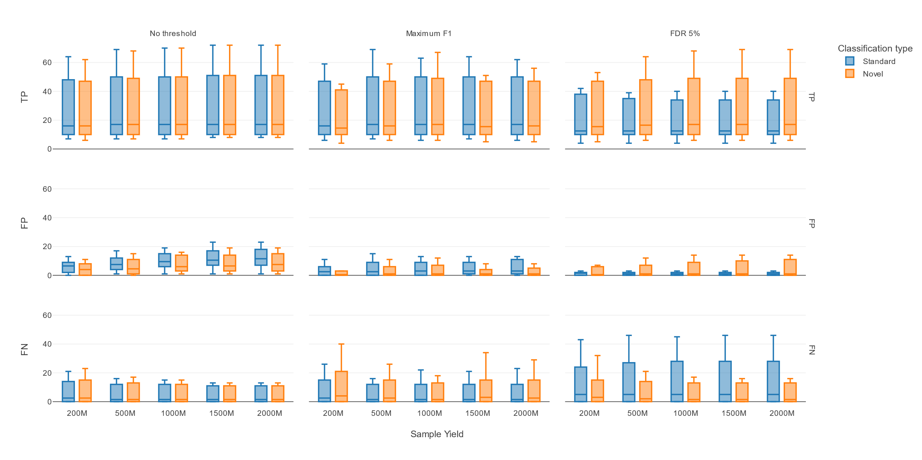
Figure S1: Number of TPs, FPs and FNs of the standard and novel approaches applied to the DMCs. Rows show the number of TPs, FPs, and FNs, while columns represent the three selection strategies: no thresholds applied, maximum F1 score, and FDR5. The x-axis shows the five sample yields, whereas the y-axis shows the respective metric values expressed as boxplots. Blue and orange boxplots indicate the performance for the standard and novel approaches, respectively, with solid and dotted lines indicating the median and mean of each boxplot. The used filter thresholds are shown in Table S6.

Figure S2
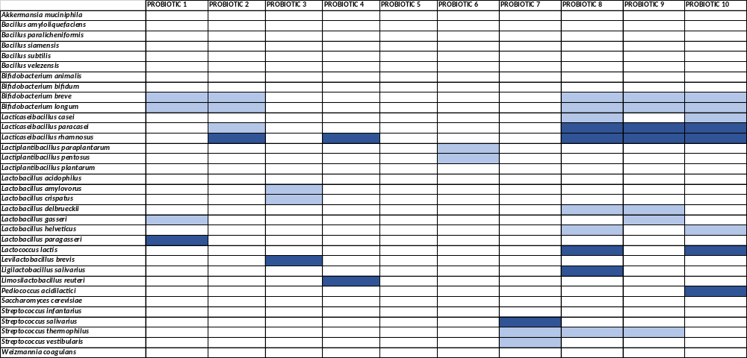
Figure S2: MetaCARP analysis of the ten probiotic-derived mock communities. Rows show the species names and columns show the probiotic-derived mock community names. A cell filled with dark blue means a high confidence detection with MetaCARP while a light blue means a low confidence detection. Hatched cells are expected species based on the product label (i.e., species in the ground truth).

Figure S3
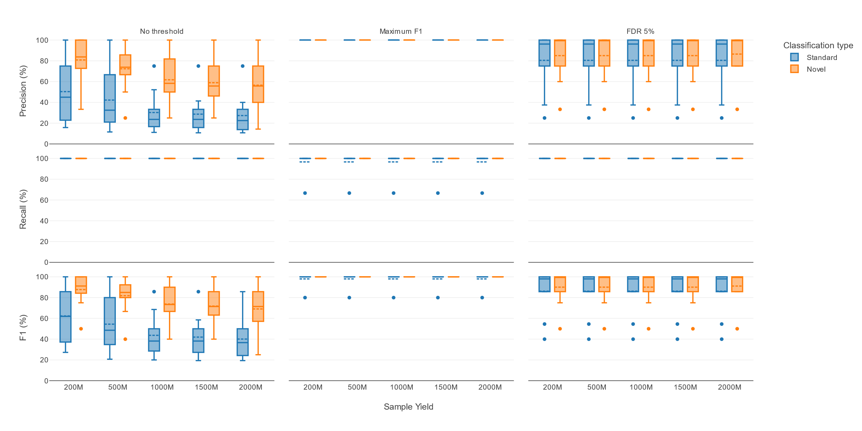
Figure S3: Precision, recall, and F1 scores of the standard and novel approaches applied to the PDMCs. Rows show precision, recall, and F1 scores, while columns represent the three selection strategies: no thresholds applied, maximum F1 score, and FDR5. The x-axis shows the five sample yields, whereas the y-axis shows the respective metric values of the ten probiotic samples expressed as boxplots. Blue and orange boxplots indicate the performance for the standard and novel approaches, respectively, with solid and dotted lines indicating the median and mean of each boxplot. Note that the used thresholds were based on the PDMCs and not the ones from the DMCs. The used filter thresholds are shown in Table S9.

Figure S4
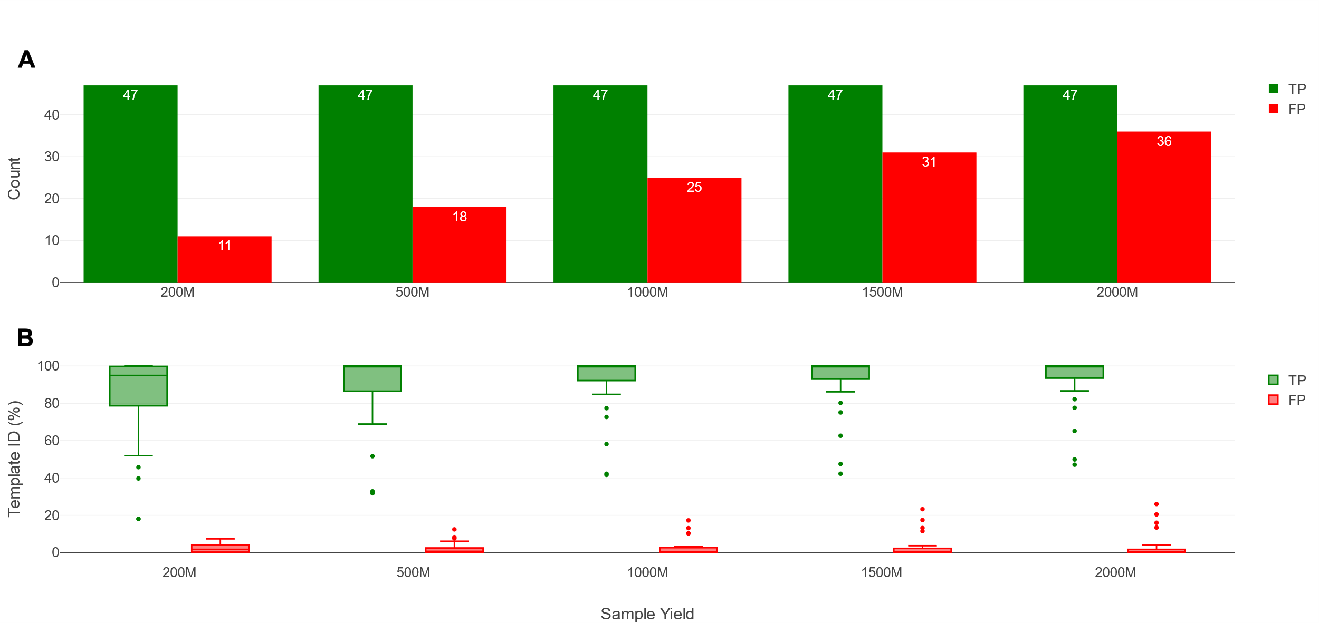
Figure S4: Effects of sequencing yield on TPs, FPs and FNs for the novel approach applied to the probiotic-derived mock communities. (A) Number of TPs, FPs and FNs for all ten probiotic-derived mock communities using the novel approach without filtering. The x-axis shows the five different yields, while the y-axis shows the counts of TPs (green bars), FPs (red bars), and FNs (blue bars). (B) Template IDs of TPs and FPs for all ten probiotic-derived mock communities using the novel approach without filtering. The x-axis shows the five different yields, while the y-axis shows the template ID. Green and red boxplots indicate TPs and FPs, respectively, with a solid line indicating the median. FNs are not shown as they all have a template ID of 0%.

Figure S5
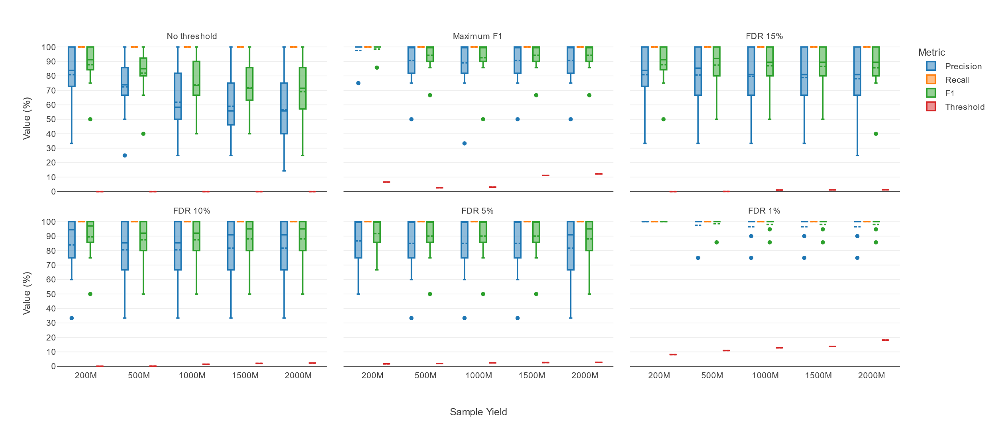
Figure S5: Effects of DMC-derived template ID filtering for different selection strategies across different sequencing yields applied to the probiotic-derived mock communities. Each subplot represents the six different selection strategies. The x-axis represents the different sequencing yields, while the y-axis shows the value (%) of the performance metrics and associated DMC-derived template ID thresholds (see also Figure 4). Blue, orange, green and red boxplots indicate the precision, recall, F1 and template ID threshold of all ten probiotic-derived mock communities.

Figure S6
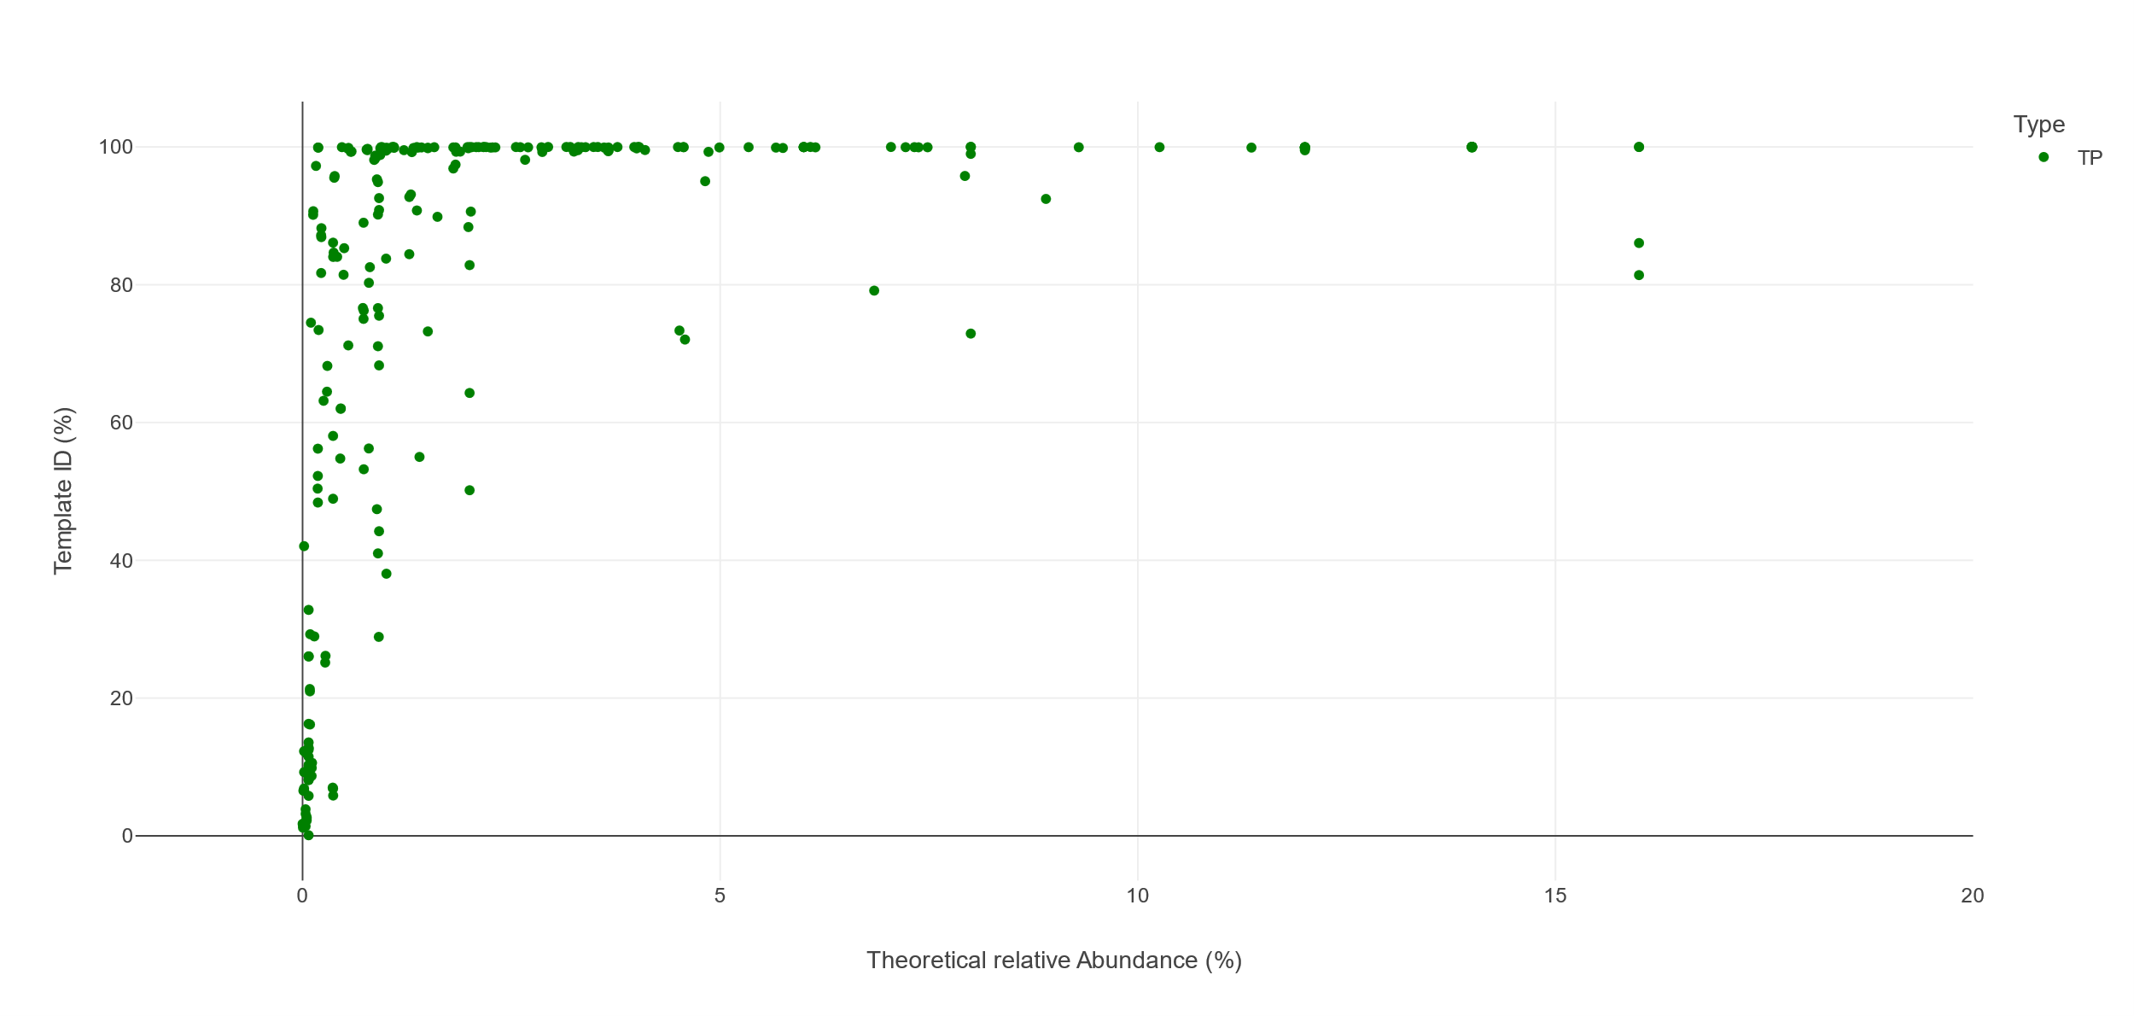
Figure S6: Template ID and theoretical relative abundance of all TPs in the ten DMCs at yield 2000M. The x-axis shows the theoretical relative abundance (%), while the y-axis shows the template ID (%). Green markers represent the TPs.

References
1. Van Uffelen, A. et al. Benchmarking bacterial taxonomic classification using nanopore metagenomics data of several mock communities. Sci. Data 11, (2024).
2. Shen, W. & Ren, H. TaxonKit: A practical and efficient NCBI taxonomy toolkit. J. Genet. Genomics 48, 844–850 (2021).
3. Ciufo, S. et al. Using average nucleotide identity to improve taxonomic assignments in prokaryotic genomes at the NCBI. Int. J. Syst. Evol. Microbiol. 68, 2386–2392 (2018).
4. Stoddard, S. F., Smith, B. J., Hein, R., Roller, B. R. K. & Schmidt, T. M. rrnDB: improved tools for interpreting rRNA gene abundance in bacteria and archaea and a new foundation for future development. Nucleic Acids Res. 43, D593–D598 (2014).
5. Bepeyeva, A. et al. Encapsulation of Lactobacillus casei into Calcium Pectinate‐Chitosan Beads for Enteric Delivery. J. Food Sci. 82, 2954–2959 (2017).
6. Tejero-Sariñena, S., Barlow, J., Costabile, A., Gibson, G. R. & Rowland, I. Antipathogenic activity of probiotics against Salmonella Typhimurium and Clostridium difficile in anaerobic batch culture systems: Is it due to synergies in probiotic mixtures or the specificity of single strains? Anaerobe 24, 60–65 (2013).
7. Rodenes, A. et al. Reclassification of Probiotic Lactobacillus Acidophilus NCIMB 30184 as Lactobacillus Helveticus and Lactobacillus Casei NCIMB 30185 as Lacticaseibacillus Paracasei. http://biorxiv.org/lookup/doi/10.1101/2022.10.17.512536 (2022) doi:10.1101/2022.10.17.512536.

