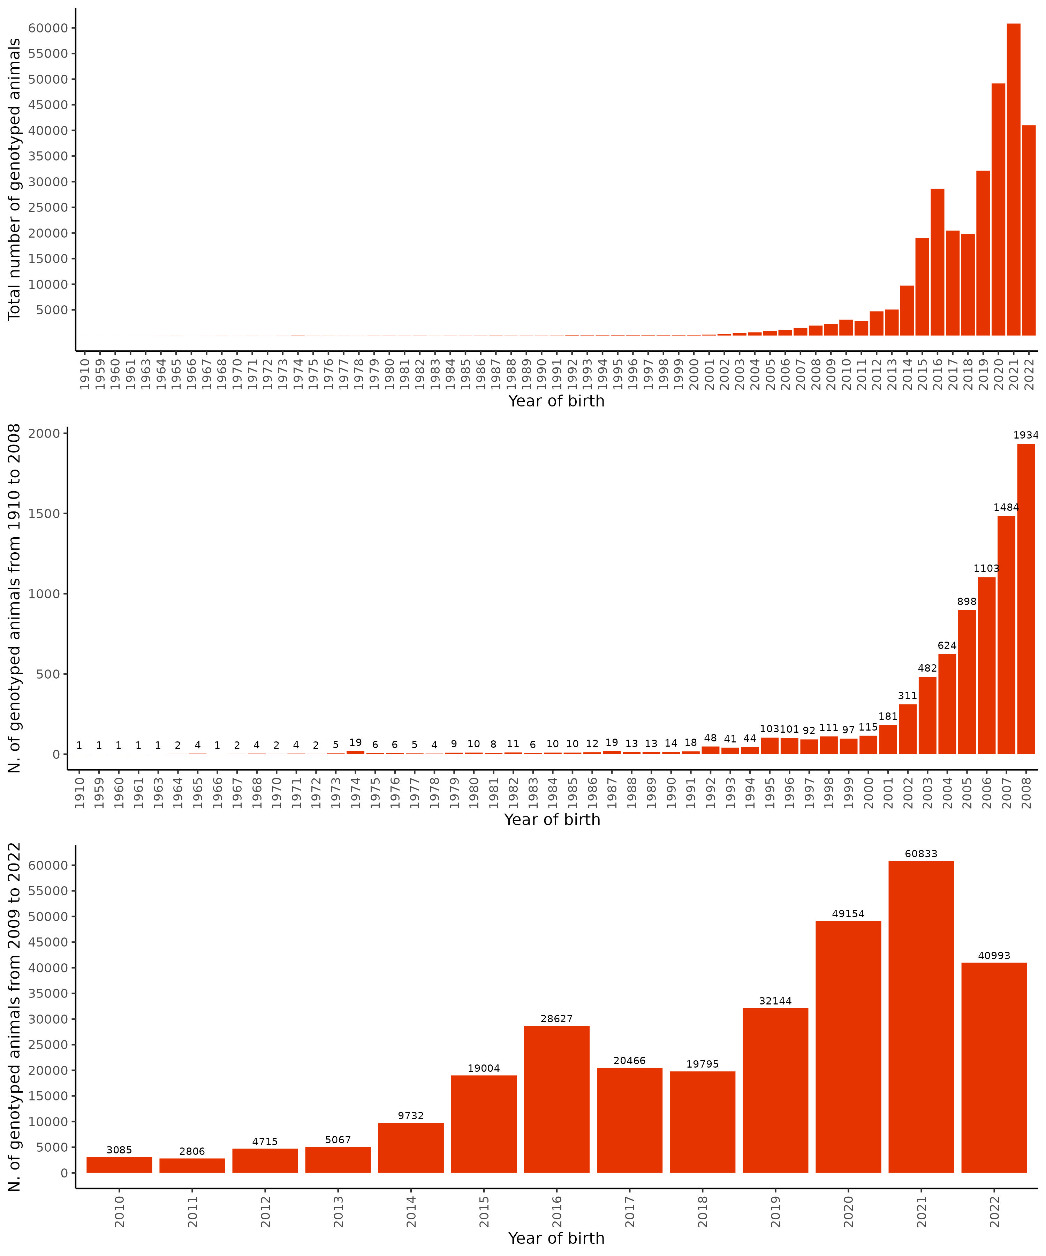
Supplementary 2 Figure S1. Distribution of genotyped animals from the Nellore population according to year of birth. The top panel shows the total number of genotyped animals per birth year across the entire period (1910–2022). The middle panel provides a detailed view of early years (1910–2008), highlighting the gradual increase in genotyping before large-scale adoption of genomic technologies. The bottom panel summarizes the most recent period (2009–2022), illustrating the rapid expansion of genotyping efforts in recent years. Numbers above the bars indicate the exact count of genotyped animals for each year.

