Supplementary Figure

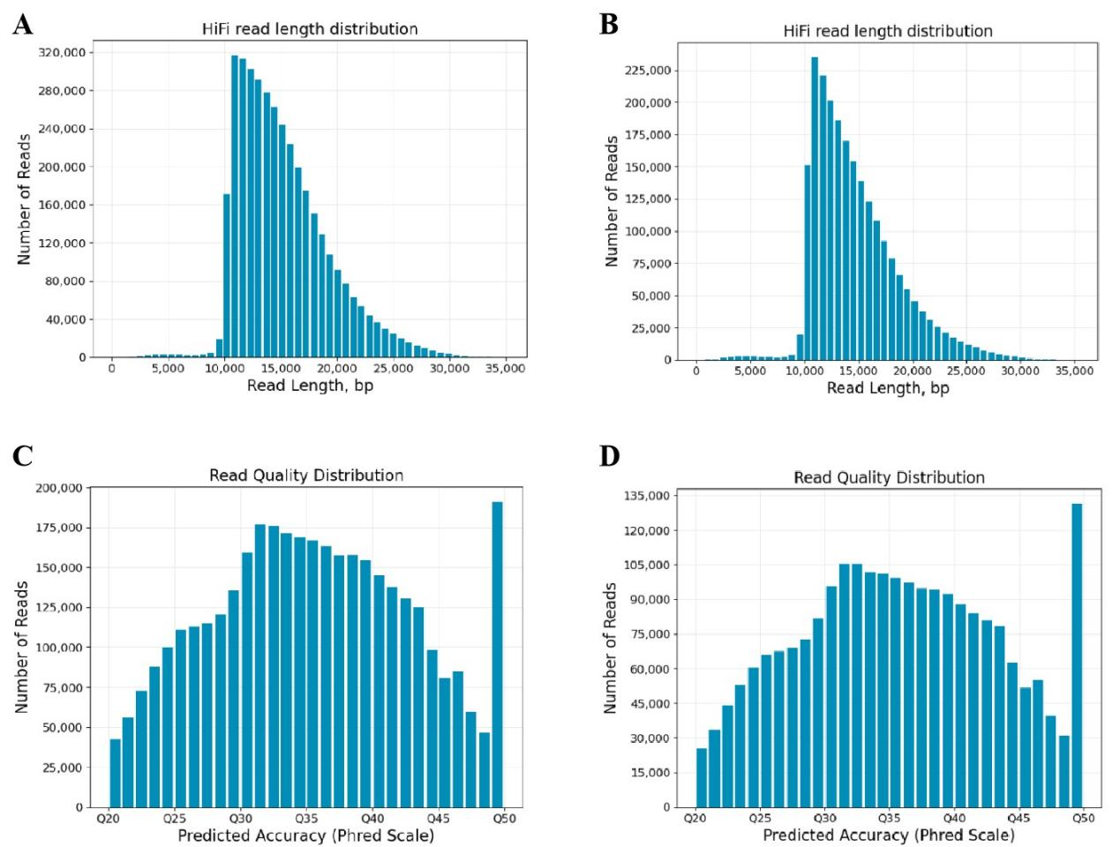

Figure S1. HiFi read length and quality distributions from whole-genome sequencing. (A, B) Read length distributions for samples I-13 and II-22, respectively. The majority of reads exceeded 10 kb. (C, D) Read quality score (Q-score) distributions for samples I-13 and II-22, respectively. Median Q-scores were Q35 for both samples.

