Supplemental figures

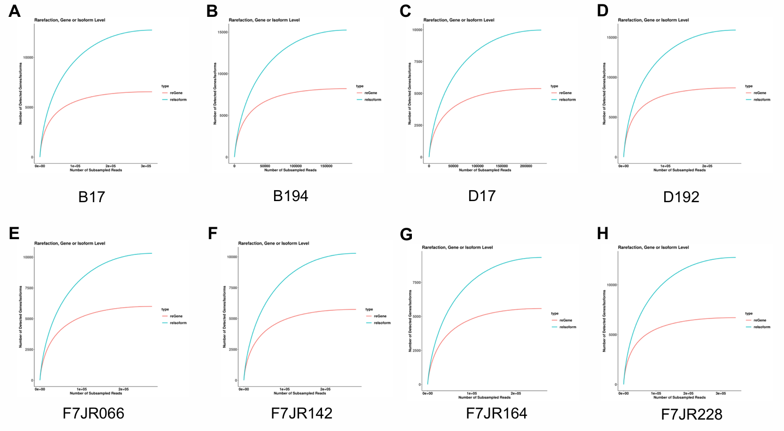
Fig. S1 Saturation curves of 8 TGS data
A-H) The saturation curve of each individual's iso-seq data after clustering. B17, B194: BamaXiang; D17, D192: Duroc; F7: Seventh generation of hybrid pig.

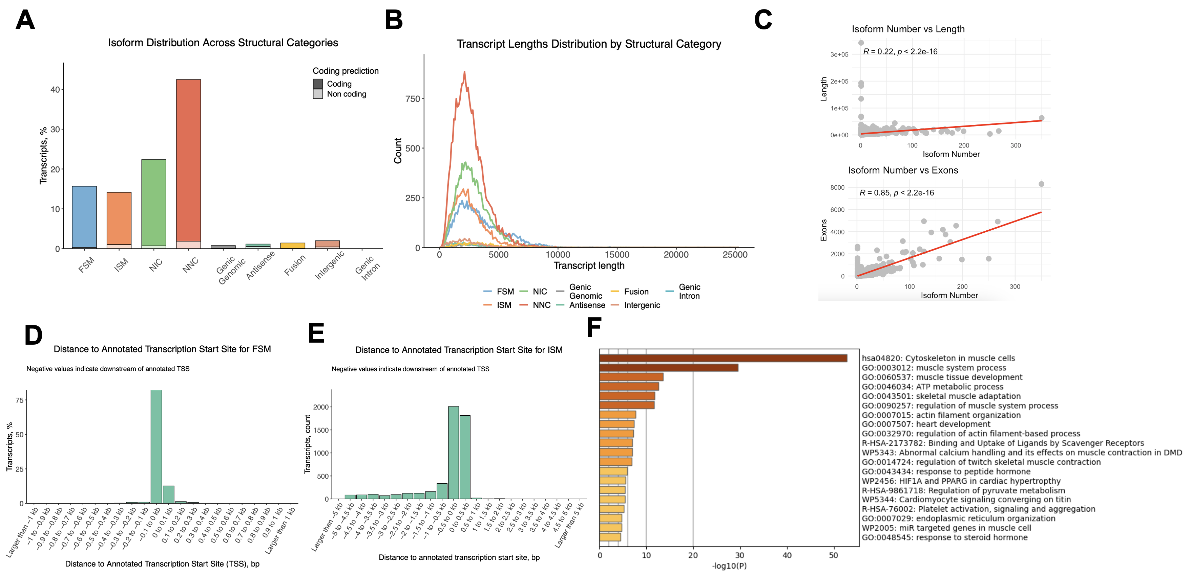

Fig. S2 Transcriptome annotation status and overview
A) Isoform distribution across structural categories.
B) Isoform lengths distribution across structural categories.
C) The correlation between transcript length and exon number with transcript number.
D) Distance between FSM type isoform and TSS.
E) Distance between ISM type isoform and TSS.
F) The pathway enrichment analysis of gene function shows that the top 100 most isoformic genes.

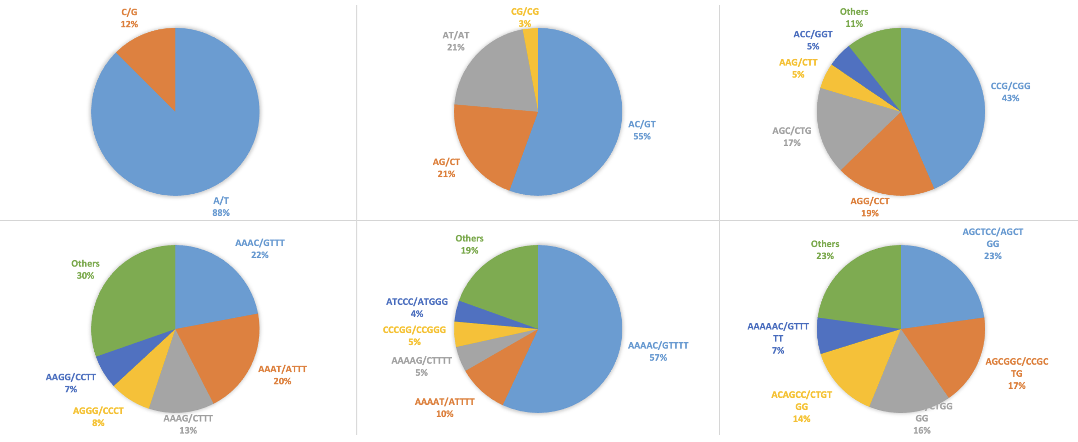
Fig. S3 SSR types and proportions of different motifs
A-F) The distribution represents the proportion of different types in SSRs with motifs ranging from 1 to 6 bases.

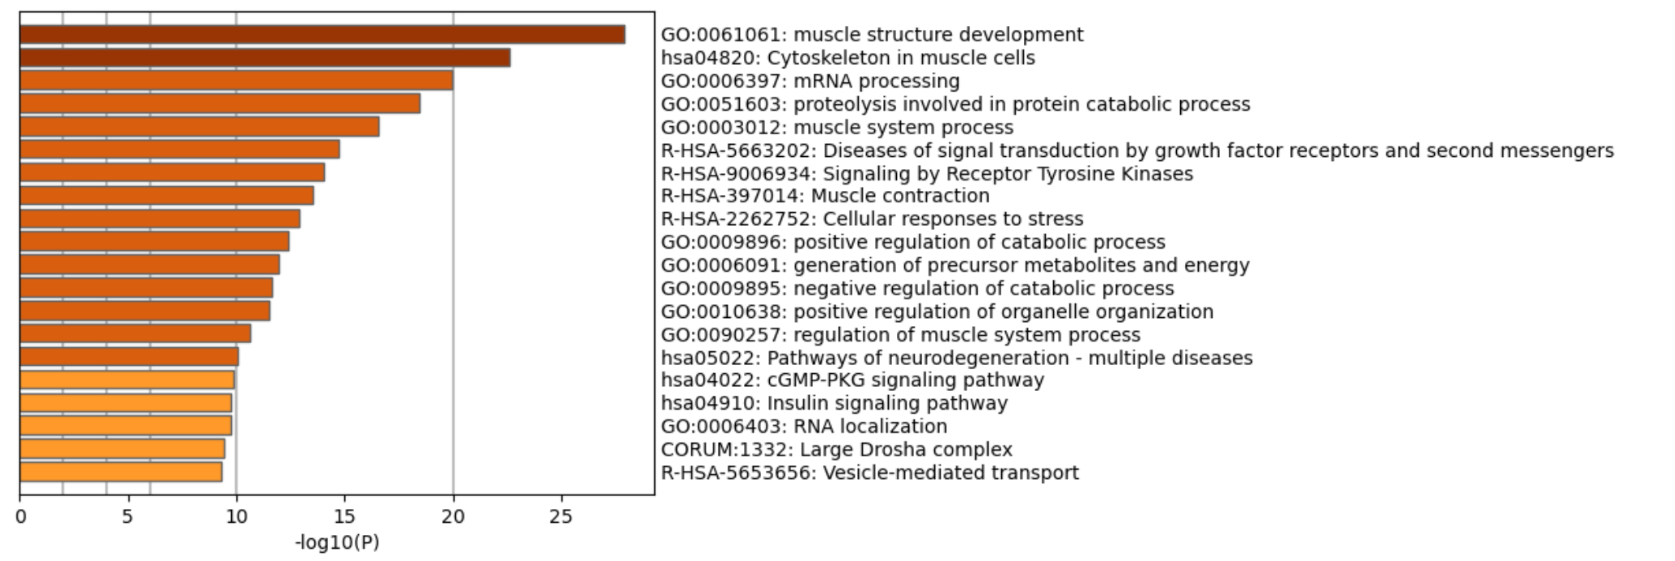
Fig. S4 Functional enrichment shared by AS gene and APA gene
The pathway enrichment analysis of 785 genes shared by AS gene and APA gene.

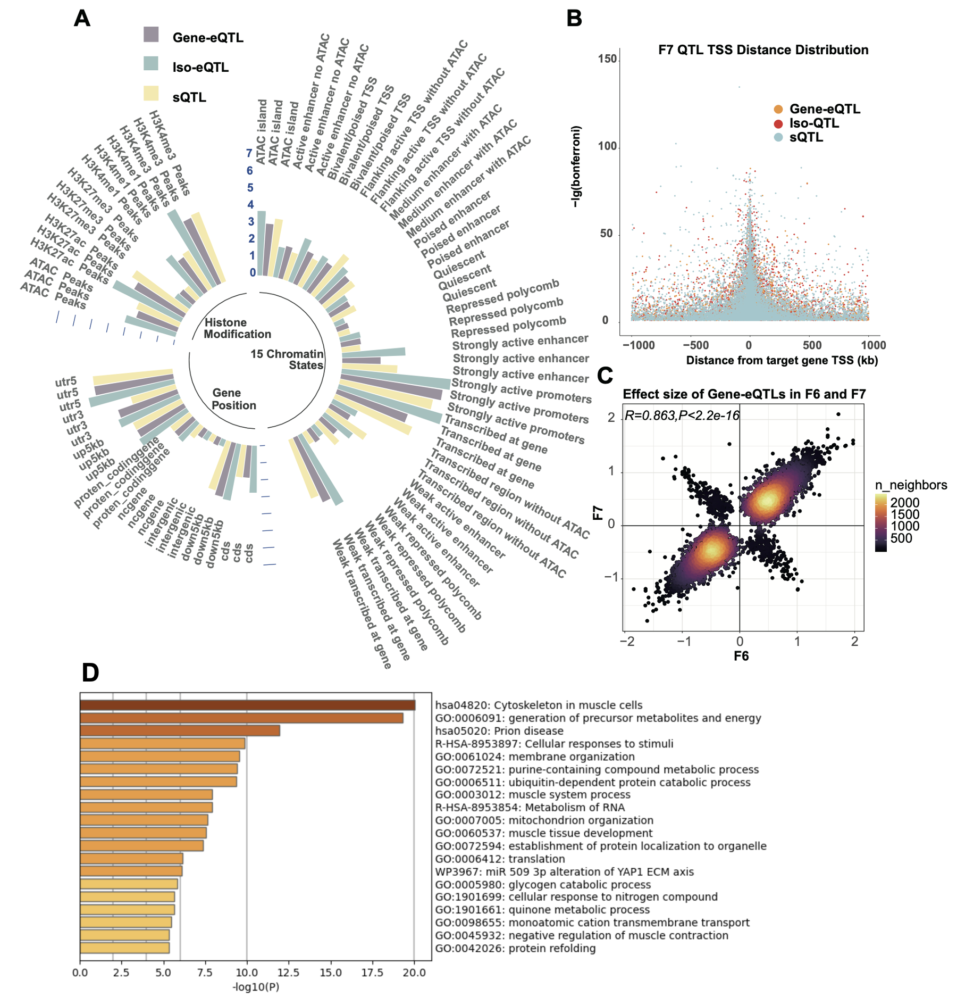
Fig. S5 Location analysis of xQTLs in F7 population
A) Fold changes in gene position, histone modification, and chromatin states distribution of xQTLs in F7 population.
B) Distance distribution of xQTL and TSS in F7 population.
C) The correlation between the magnitude and direction of effect values of iso-eQTL in F6 and F7 populations.
D) The pathway enrichment analysis of specific iso-eQTLs correspond to 321 genes.
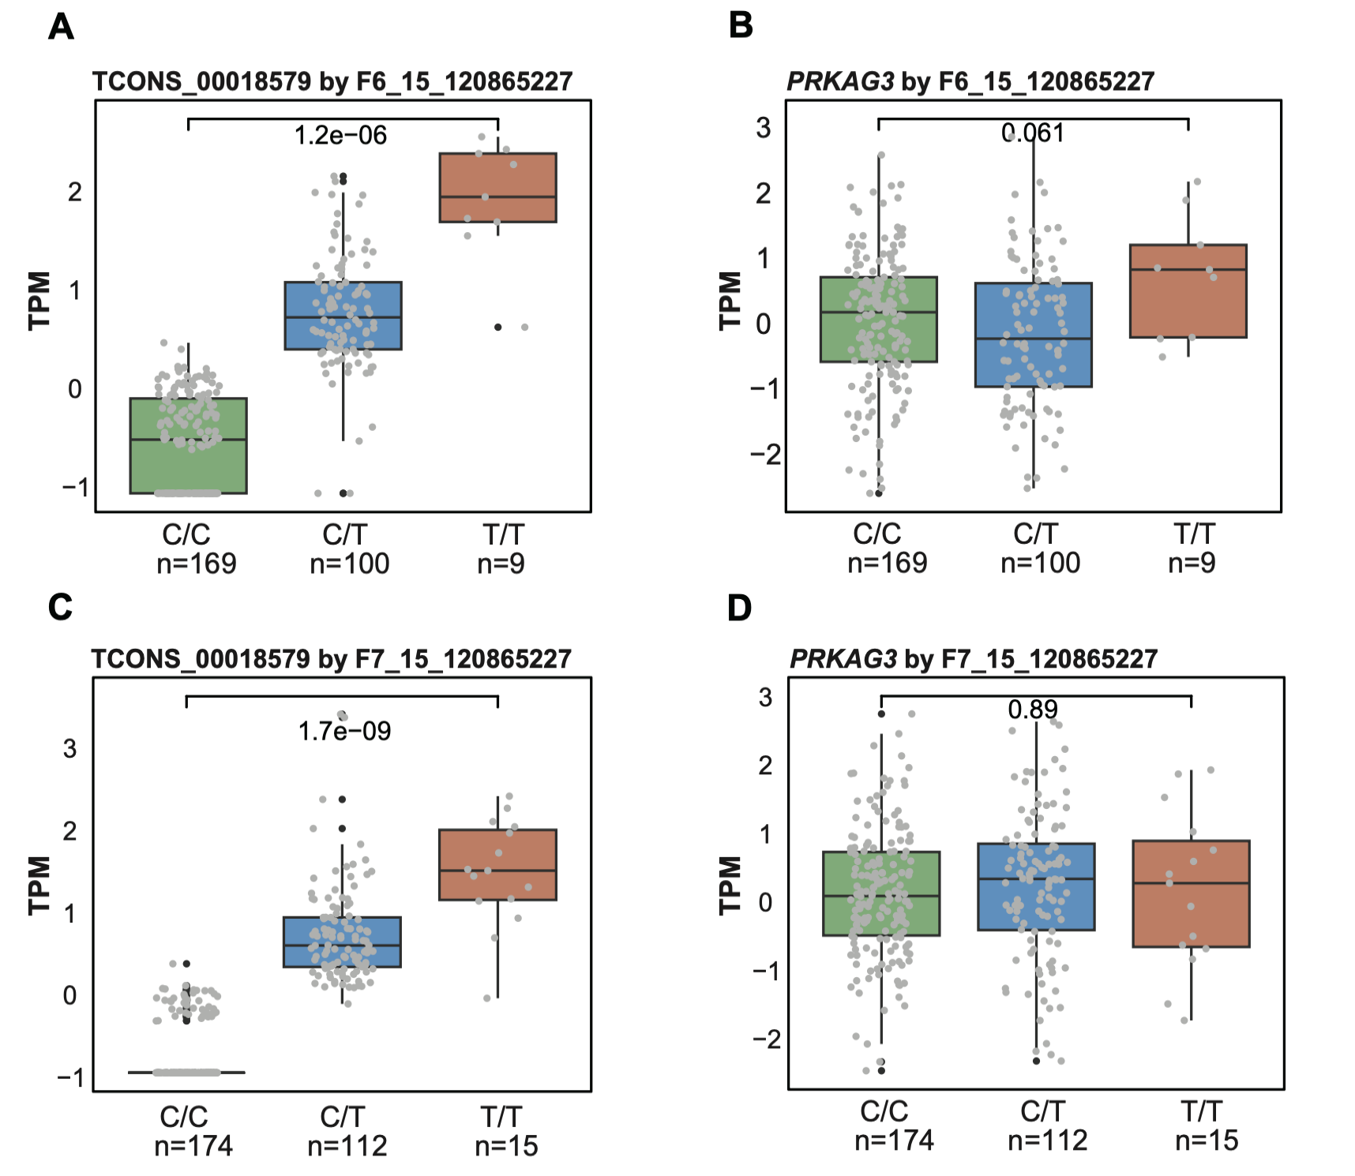 Fig. S6 Example of iso-eQTL for meat quality traits
A) The effect of different genotypes of SNP 15_120865227 in F6 on the expression level of the isoform (TCONS_00018579) of PRKAG3.
B) The effect of different genotypes of SNP 15_120865227 in F6 on the expression level of PRKAG3.
C) The effect of different genotypes of SNP 15_120865227 in F7 on the expression level of the isoform (TCONS_00018579) of PRKAG3.
D) The effect of different genotypes of SNP 15_120865227 in F7 on the expression level of PRKAG3.
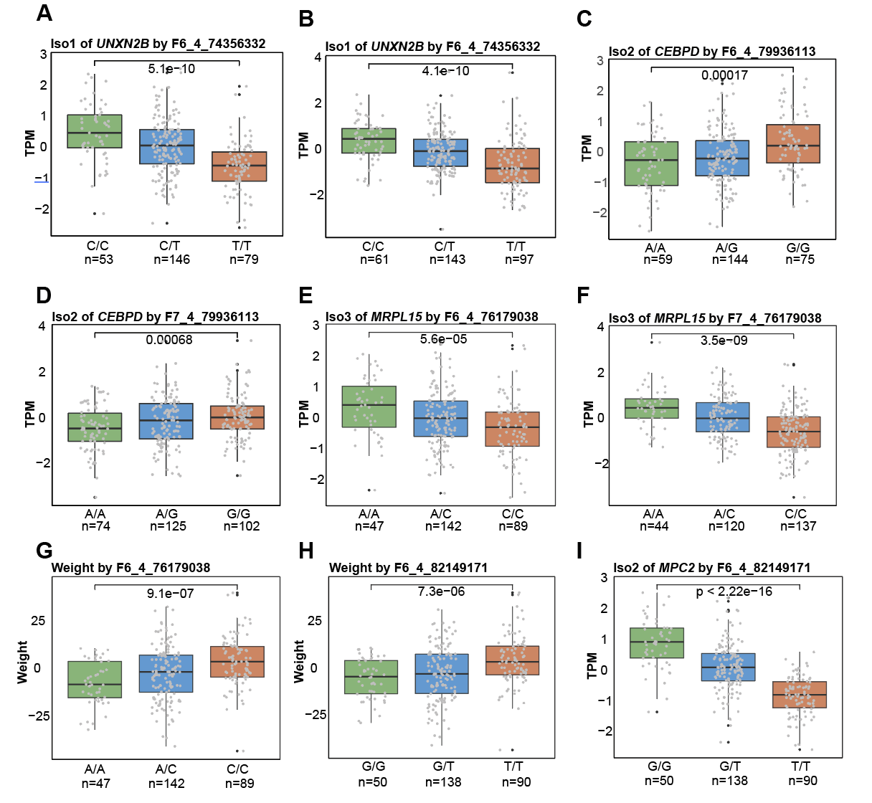
Fig. S7 Example of GWAS-iso-eQTL joint analysis
A-B) The effect of different genotypes of SNP 4_74356332 in F6 and F7 on the Iso-1 (TCONS_00034377) expression level of gene UBXN2B.
C-D) The effect of different genotypes of SNP 4_79936113 in F6 and F7 on the Iso-2 (TCONS_00033567) expression level of gene CEBPD.
E-F) The effect of different genotypes of SNP 4_76179038 in F6 and F7 on the Iso-3 (TCONS_00035820) expression level of gene MRPL15.
G) Weight changes at different genotypes of SNP 4_76179038 in F6.
H) Weight changes at different genotypes of SNP 4_82149171 in F6.
I) The effect of different genotypes of SNP 4_82149171 in F6 population on the Iso-2 (TCONS_00035213) expression level of gene MPC2.

