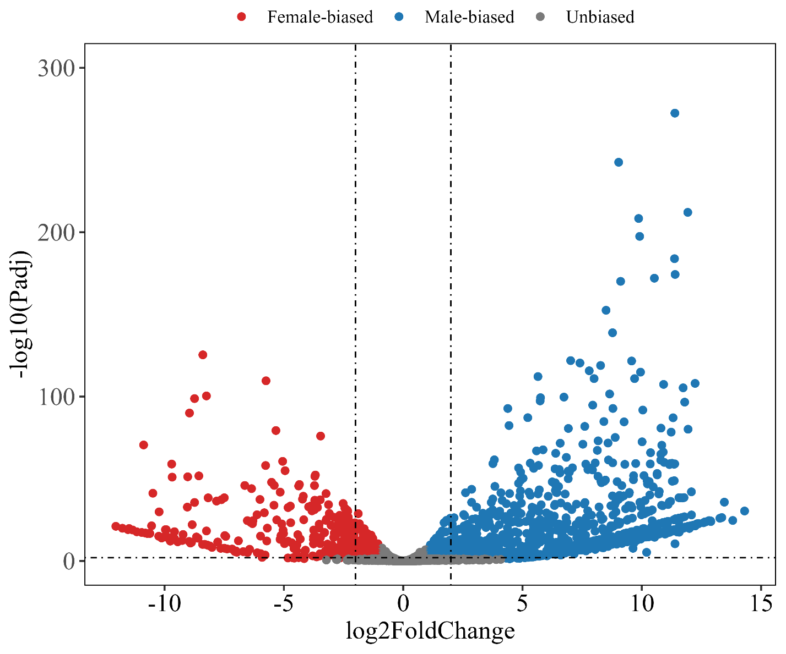
Fig. S1 Volcano plots of sex-biased genes.

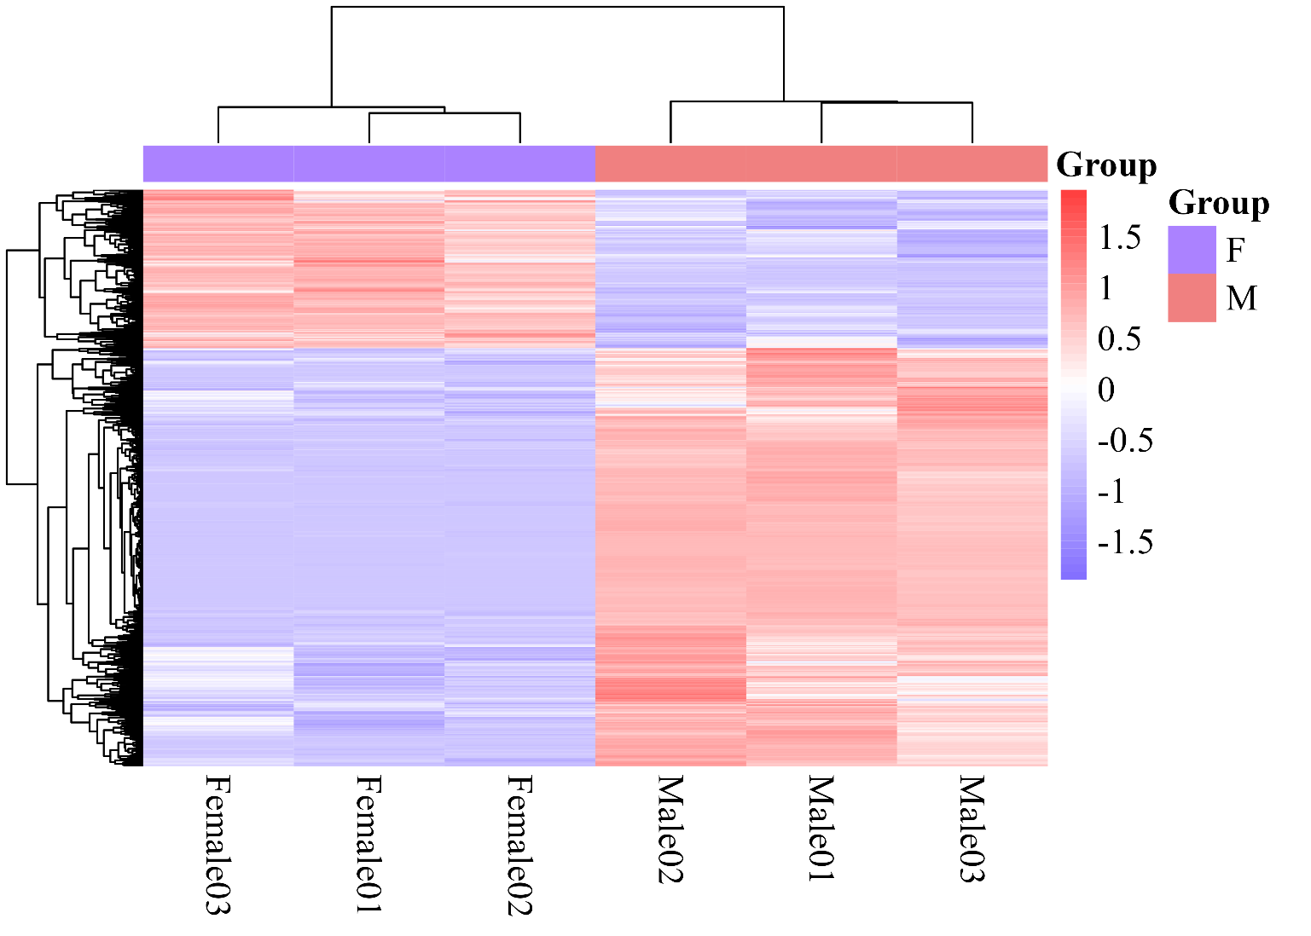
Fig. S2 Heatmap of sex-biased genes.

