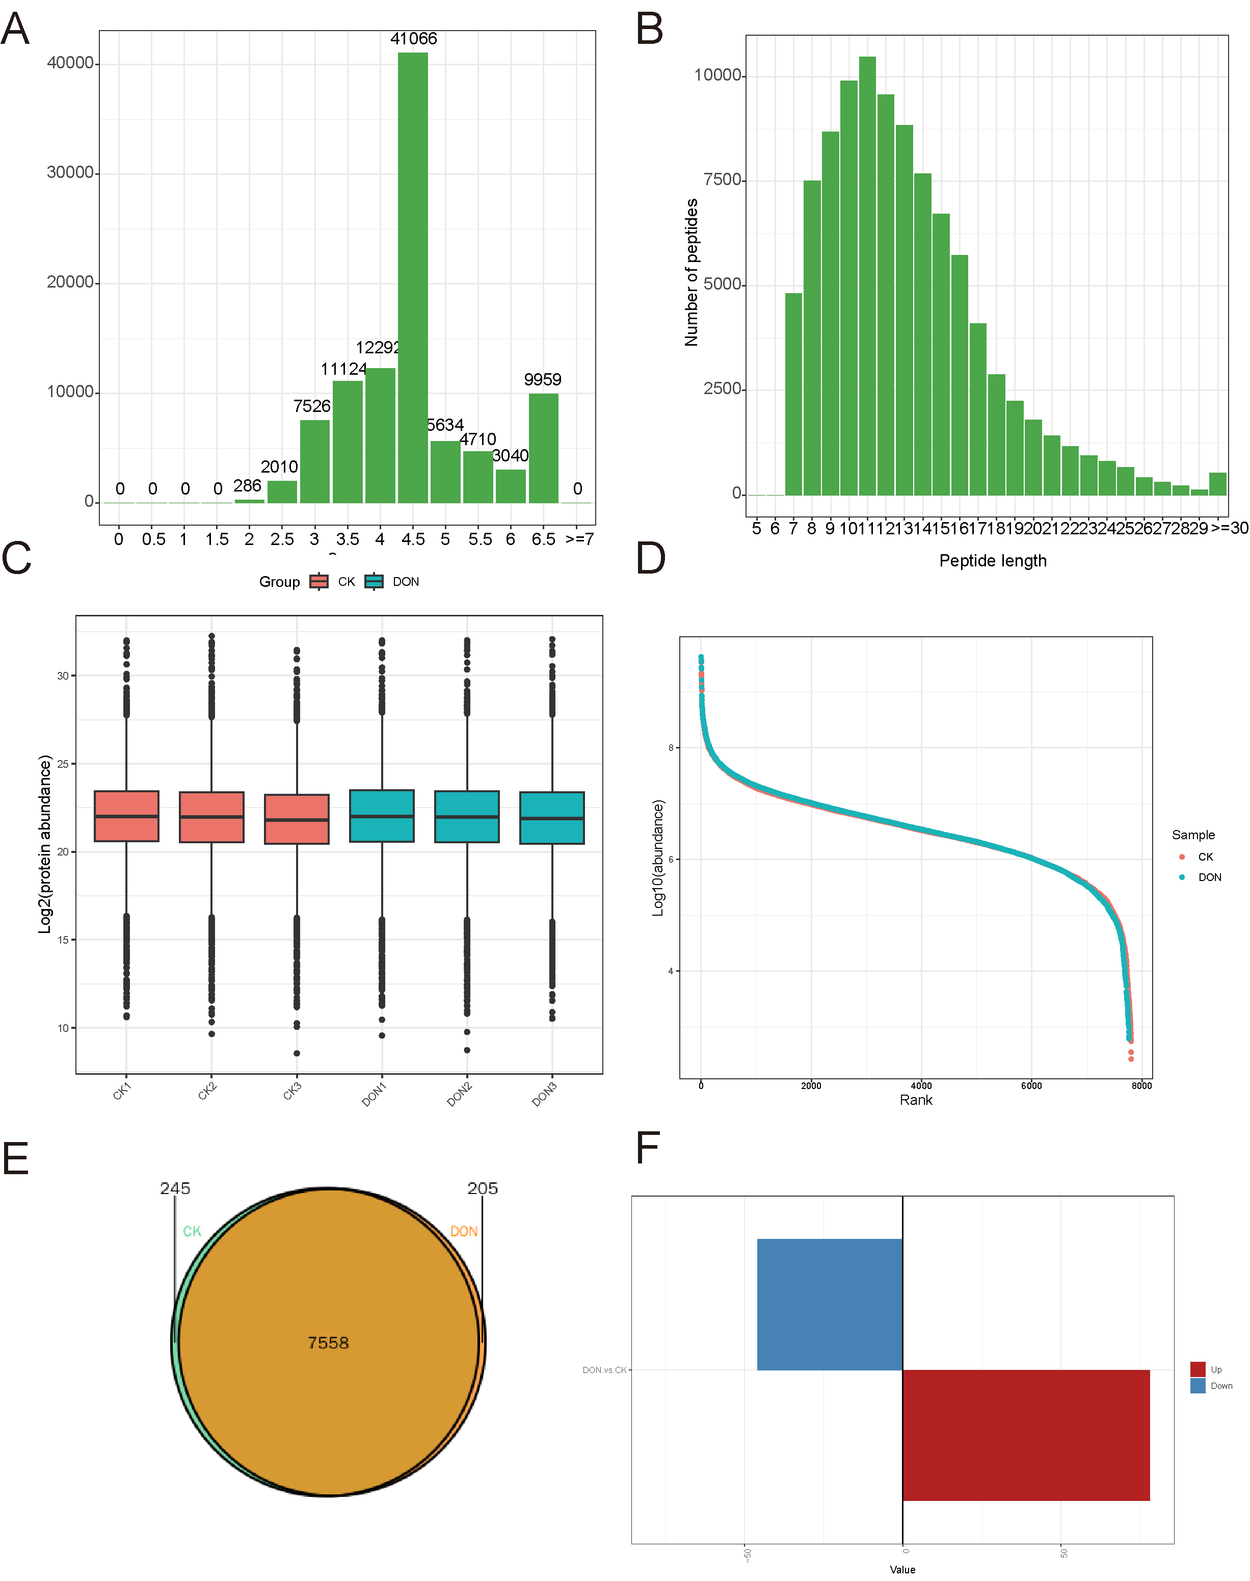
Supplementary Figure 1. Protein identified with proteomics and DEPs analysis. A. The peptide length profile shows the distribution of all identified peptide lengths. The abscissa represents the peptide length, and the ordinate represents the number of peptides detected. B. The bar chart of peptide scores represents the distribution of peptides with different scores. The abscissa represents the score of peptides, and the ordinate represents the number of peptides detected. C. The box plot represents the normalized protein quantification values. The vertical axis indicates the protein quantification values after Log2 transformation. D. Scatter plots of quantitative values distribution for each group of data. The X-axis represents proteins sorted by quantitative values, and the Y-axis represents the quantitative values after taking the Log10. E. Numbers of proteins in each group. F. Number of upregulated and downregulated differentially expressed proteins. Red represents upregulated proteins, and blue represents downregulated proteins.

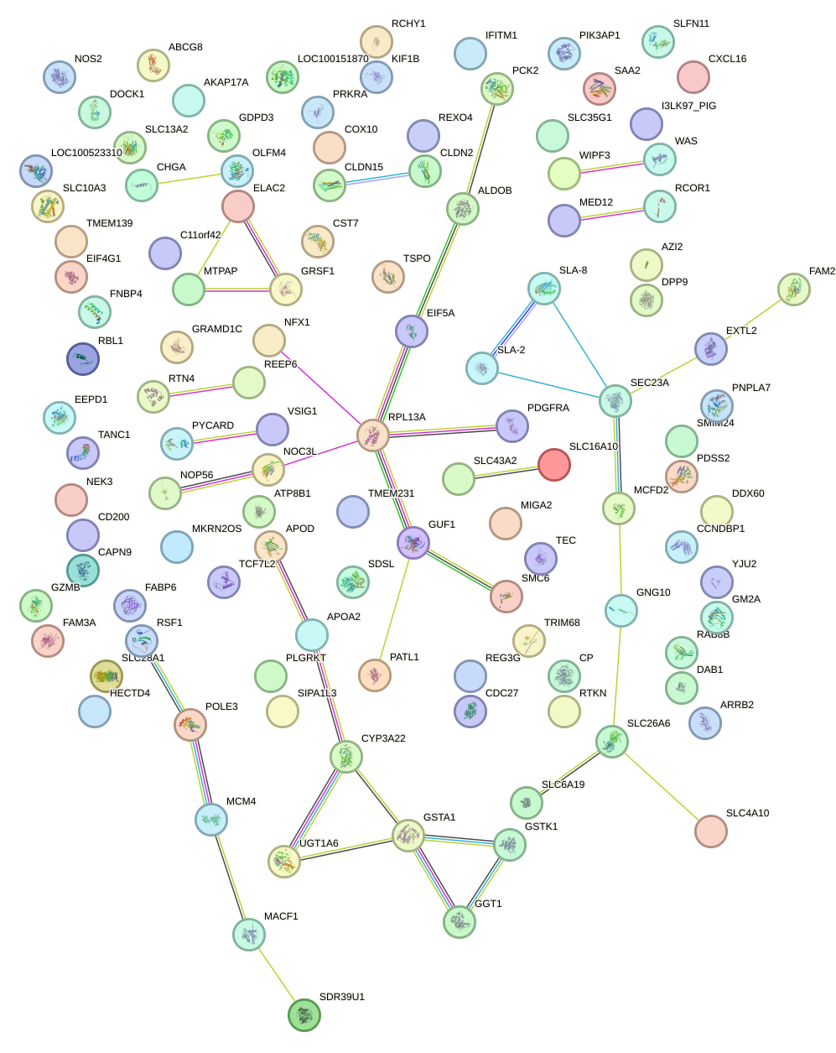
Supplementary Figure 2. PPI analysis for all DEPs.

Supplementary Table 1. Details of Antibodies. List of detail information for each antibody.
Proteins | Antibodies | Supplier | Art.No. | Application
ZO-1 | Anti-ZO-1 antibody | Abcam | ab307799 | WB
Claudin-1 | Anti-Claudin 1 antibody | Abcam | ab211737 | WB
SLC16A10 | Anti-MCT 10 antibody | Abcam | ab121519 | WB
EIF5A | Anti-eIF5A antibody | Abcam | ab32443 | WB
Tubulin | Anti-alpha tubulin Rabbit | PTM BIO | PTM-5442 | WB

Supplementary Table 2. Differential expressed proteins in proteomics. All DEPs were listed in this table.
Gene Name | sign | Pvalue | FDR | Log₂FC
SLC16A10 | Up | 0.00018032 | 0.06803123 | 16.5058936
PATL1 | Up | 6.8416E-06 | 0.01885787 | 15.72896194
SLC28A1 | Up | 0.00078159 | 0.13478128 | 15.08746442
WIPF3 | Up | 3.6133E-06 | 0.01885787 | 14.85155833
SDR39U1 | Up | 0.00536031 | 0.44114361 | 14.11071593
CHGA | Up | 4.8366E-05 | 0.04049872 | 13.78593778
CAPN9 | Up | 0.00024373 | 0.08223227 | 13.49352837
MKRN2OS | Up | 0.00053835 | 0.11559811 | 13.39515726
RBL1 | Up | 0.00436964 | 0.38594893 | 13.24422601
GUF1 | Up | 0.00034692 | 0.09322232 | 13.16694271
CXCL16 | Up | 0.0020961 | 0.22909496 | 12.94562526
SAA2 | Up | 0.0001044 | 0.05063266 | 12.77892496
ELAC2 | Up | 6.2627E-05 | 0.04049872 | 12.67135835
NEK3 | Up | 0.00019268 | 0.06803123 | 12.65441742
SMC6 | Up | 0.00039528 | 0.09894636 | 12.59545649
FAM3A | Up | 5.4729E-05 | 0.04049872 | 12.50087439
SLC4A10 | Up | 0.00011286 | 0.0515153 | 12.31774165
EIF4G1 | Up | 0.00217619 | 0.23454512 | 12.24660315
GNG11 | Up | 2.4519E-05 | 0.03805282 | 12.21067448
POLE3 | Up | 7.2904E-06 | 0.01885787 | 12.14165965
LOC100526118 | Up | 0.0007006 | 0.13260141 | 12.0207591
PDSS2 | Up | 0.00077895 | 0.13478128 | 11.84220007
MIGA2 | Up | 0.00029899 | 0.08923816 | 11.76486134
COX10 | Up | 0.00174551 | 0.20216685 | 11.68225099
RPL13A | Up | 0.00924324 | 0.54677848 | 11.66277004
TSPO | Up | 1.2982E-05 | 0.02518458 | 11.65169218
TMEM139 | Up | 0.00038843 | 0.09894636 | 11.59130125
APOD | Up | 0.00054802 | 0.11559811 | 11.5057753
CST7 | Up | 0.00011981 | 0.05165137 | 11.47391411
RCHY1 | Up | 0.00161296 | 0.19256312 | 10.74898964
VCF1 | Up | 0.00029459 | 0.08923816 | 10.32852816
NFX1 | Up | 0.00065477 | 0.1302826 | 10.08866968
GRAMD1C | Up | 0.00059347 | 0.12119299 | 9.885705275
NOC3L | Up | 3.8587E-05 | 0.04049872 | 9.548725882
TRIM68 | Up | 7.1643E-05 | 0.04276532 | 7.750128033
UBL4A | Up | 0.00016147 | 0.06594978 | 4.451410724
GRSF1 | Up | 0.01597719 | 0.68122514 | 2.893688546
SIPA1L3 | Up | 0.01922562 | 0.69501337 | 2.767721297
UGT1A6 | Up | 0.00019287 | 0.06803123 | 2.766972443
ABCG8 | Up | 0.02280982 | 0.71115501 | 2.451057789
DDX60 | Up | 0.02399163 | 0.7244164 | 2.341138871
RTKN | Up | 0.04076056 | 0.83130283 | 2.316173543
AZI2 | Up | 0.04170973 | 0.83130283 | 2.095590621
GST | Up | 0.03092141 | 0.78075746 | 1.967861353
RTN4 | Up | 0.00266949 | 0.26902953 | 1.880751004
FAM20B | Up | 0.01361284 | 0.65612219 | 1.767082064
MCFD2 | Up | 0.01792775 | 0.68812664 | 1.758373314
REEP6 | Up | 0.04540976 | 0.83130283 | 1.747206697
DPP9 | Up | 0.02902617 | 0.77670035 | 1.719635708
NOP56 | Up | 0.01825571 | 0.68812664 | 1.674849085
PCK2 | Up | 0.00156832 | 0.1914577 | 1.59718479
LOC100516628 | Up | 0.00737403 | 0.50639343 | 1.578636789
CYP3A22 | Up | 0.01732971 | 0.68812664 | 1.564838355
SLC43A2 | Up | 0.04803141 | 0.83130283 | 1.517379392
SLC13A2 | Up | 0.00423229 | 0.38427727 | 1.505545394
ATP8B1 | Up | 0.03131523 | 0.78105254 | 1.499707316
ALDOB | Up | 0.01585987 | 0.68122514 | 1.44140775
CYP2J33 | Up | 0.02776983 | 0.75710202 | 1.402408442
CLDN15 | Up | 0.00157903 | 0.1914577 | 1.323298486
PLGRKT | Up | 0.01637678 | 0.686663 | 1.323273238
GDPD3 | Up | 0.00085245 | 0.13781267 | 1.314346805
GZMB | Up | 0.01001953 | 0.57170251 | 1.293335184
GGT1 | Up | 0.03702829 | 0.82097019 | 1.266049366
LOC100151870 | Up | 0.04751844 | 0.83130283 | 1.253843225
MTPAP | Up | 0.02923506 | 0.77919034 | 1.192761038
CLDN2 | Up | 0.01763835 | 0.68812664 | 1.17734414
SLC6A19 | Up | 0.00420094 | 0.38427727 | 1.1721131
DAB1 | Up | 0.01794751 | 0.68812664 | 1.139961136
SLC26A6 | Up | 0.00735794 | 0.50639343 | 1.138218055
SMIM24 | Up | 0.00442648 | 0.38594893 | 1.135577778
GSTK1 | Up | 0.00797506 | 0.51572048 | 1.133204691
SLC35G1 | Up | 0.01474897 | 0.66157224 | 1.124017092
CP | Up | 0.02458593 | 0.72850146 | 1.121537324
RAB8B | Up | 0.00090848 | 0.1436374 | 1.100973152
DOCK1 | Up | 0.04718633 | 0.83130283 | 1.087719589
SDSL | Up | 0.01986072 | 0.69501337 | 1.086729983
MACF1 | Up | 0.02565453 | 0.74841789 | 1.065139389
SEC23A | Up | 0.03500798 | 0.80035521 | 1.034415848
FNBP4 | Down | 0.02261887 | 0.71115501 | -1.007328737
SLFN11 | Down | 0.04511696 | 0.83130283 | -1.028482903
RCOR1 | Down | 0.03078041 | 0.78075746 | -1.040632058
GM2A | Down | 0.01246405 | 0.62000677 | -1.046918842
WAS | Down | 0.00957369 | 0.55858495 | -1.049247395
AKAP17A | Down | 0.04269512 | 0.83130283 | -1.073342261
SLA-8 | Down | 0.01852217 | 0.68812664 | -1.078309275
GNG10 | Down | 0.01448905 | 0.66157224 | -1.101528189
A0A8W4FKJ9 | Down | 0.00442376 | 0.38594893 | -1.197499843
APOA2 | Down | 0.0269569 | 0.75710202 | -1.208054094
EEPD1 | Down | 0.03320578 | 0.78707588 | -1.212613439
SLA-2 | Down | 0.00554781 | 0.44382495 | -1.23883759
PYCARD | Down | 0.03845708 | 0.82822003 | -1.260658884
OLFM4 | Down | 0.04227507 | 0.83130283 | -1.275847416
CCNDBP1 | Down | 0.03583663 | 0.80373476 | -1.296041699
MCM4 | Down | 0.0299977 | 0.77953267 | -1.483525766
PIK3AP1 | Down | 0.0268886 | 0.75710202 | -1.538080881
IFITM1 | Down | 0.03045326 | 0.78075746 | -1.647360782
A0A8W4FMI6 | Down | 0.02430096 | 0.72529024 | -1.736981055
PRKRA | Down | 0.03546222 | 0.80373476 | -1.794936782
A0A8W4FJA1 | Down | 0.00026383 | 0.08530504 | -2.142648321
HECTD4 | Down | 0.01852549 | 0.68812664 | -2.188888458
PNPLA7 | Down | 0.00425874 | 0.38427727 | -2.423222866
NOS2 | Down | 0.00116343 | 0.15356871 | -2.644342574
KIF1B | Down | 0.00113864 | 0.15356871 | -3.031126812
ARRB2 | Down | 0.02170938 | 0.70929144 | -3.397700437
RSF1 | Down | 0.03054837 | 0.78075746 | -3.420543512
PTP | Down | 0.00099289 | 0.1436374 | -4.546051244
LOC102161784 | Down | 0.04828126 | 0.83130283 | -6.167333792
A0A286ZNH4 | Down | 0.00082031 | 0.13781267 | -6.79724815
FABP6 | Down | 0.00792848 | 0.51572048 | -7.288119135
TMEM231 | Down | 4.4453E-05 | 0.04049872 | -10.24169493
EXTL2 | Down | 0.00101805 | 0.1436374 | -10.27576688
REXO4 | Down | 0.01092836 | 0.59303539 | -10.42012103
YJU2 | Down | 0.03741188 | 0.82488525 | -10.46875068
TCF7L2 | Down | 0.00055118 | 0.11559811 | -10.69304045
PDGFRA | Down | 0.00073276 | 0.13478128 | -11.27450298
MED12 | Down | 9.6532E-05 | 0.04993926 | -11.77969984
CD200 | Down | 0.00095809 | 0.1436374 | -11.96885376
TEC | Down | 0.00054614 | 0.11559811 | -12.04257275
C9H11orf42 | Down | 0.00144786 | 0.18356728 | -12.12843416
CDC27 | Down | 0.00034838 | 0.09322232 | -12.65281191
EIF5A | Down | 0.00499 | 0.42089593 | -13.11816415
TANC1 | Down | 0.00031354 | 0.09011434 | -14.34995331
NLRP12L | Down | 8.6623E-05 | 0.04801395 | -14.90137925
A0A287BLF6 | Down | 0.00684914 | 0.49212363 | -15.25124491

