Supplementary files 1

Transcriptomic signatures of high-intensity pyrethroid resistance in Anopheles gambiae from a Cameroonian agricultural hotspot

Arnaud Tepa ^{1,2,}*, Mersimine Kouamo¹, Jonas A. Kengne-Ouafo¹, Magellan Tchouakui ¹, Constant A. Pieme ² and Charles S. Wondji ^{1,3,4}*

Figure S1.1. Mapping statistic for all RNA-seq samples.
This figure summarizes the sequencing and alignment quality metrics obtained for all samples included in the study. For each sample, the total number of raw reads (black circles) is shown on the left y-axis (read count), while the proportion of reads successfully mapped to the reference genome (green squares) and the percentage of properly paired reads (pink triangles) are shown on the right y-axis (frequency, %). Samples include the Kisumu susceptible strain (Kisumu 1–4), three permethrin-resistant populations corresponding to mosquitoes surviving 1×, 5×, and 10× the diagnostic dose of permethrin (Permethrin1× 1–4, Permethrin5× 1–4, and Permethrin10× 1–4 respectively), and unexposed controls (Unexposed 1–4). Across all samples, total read counts ranged from approximately 4.5 × 10⁷ to 8.5 × 10⁷ reads, with mapping rates consistently between 75–82% and properly paired reads between 65–75%.

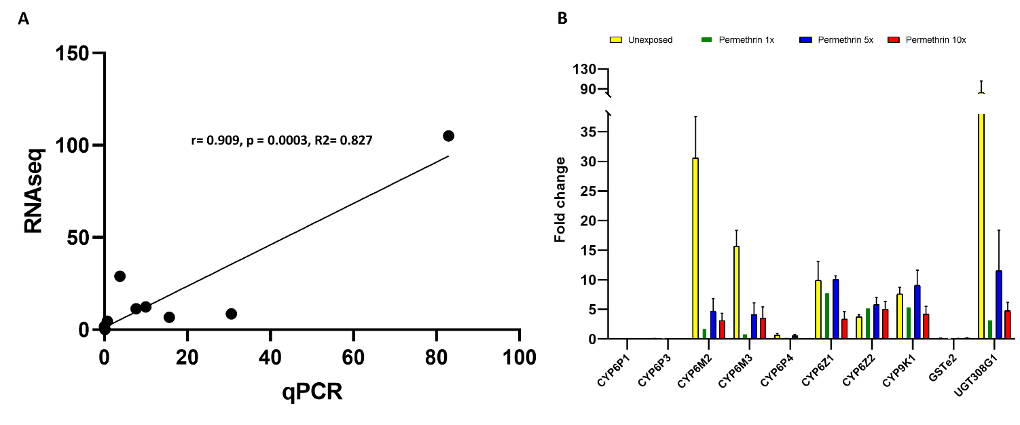
Figure S1.2. Correlation of RNA-seq and qRT-PCR data and expression profiles of detoxification genes linked to permethrin resistance in An. gambiae. A. Correlation curve between RNA-seq data and qRT-PCR: The dots represent fold changes in control versus susceptible groups, respectively, in RNA-seq and qRT-PCR. B. Expression profiles of key detoxification genes associated with permethrin resistance in An. gambiae mosquitoes from mangoum, compared to the sensitive Kisumu strain. The data are presented as fold changes relative to the kisumu population, with four different conditions: Unexposed (yellow), Permethrin 1x (green), Permethrin 5x (blue), and Permethrin 10x (red).

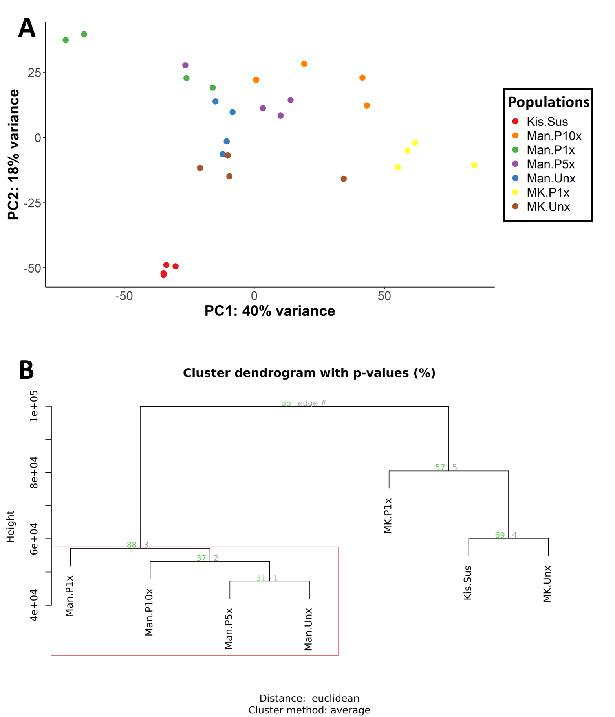
Figure S1.3. Exploratory clustering of samples. (A) Principal Component Analysis (PCA) of normalized gene expression data from Mangoum F1 progeny (Man.Unx, Man.P1x, Man.P5x and Man.Unx), Mangoum X Kisumu F4 progeny (MK.Unx and MK.P1x) and Susceptible strain (Kis.Sus). (B) Hierarchical clustering of samples based on genome-wide SNP distribution, showing genetic relationships among resistant field populations, hybrids, and susceptible strains. Bootstrap support values (BP) indicate the robustness of cluster groupings.

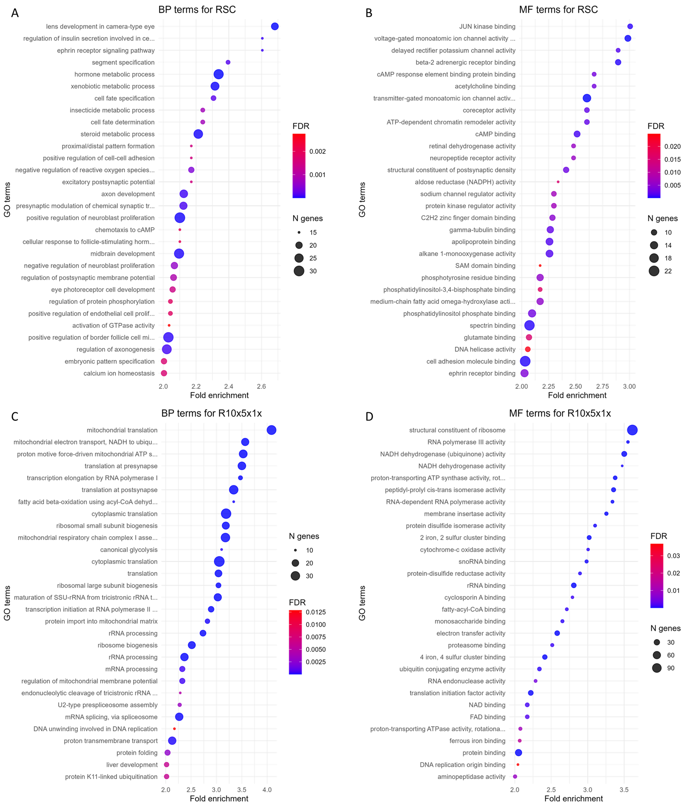
Figure S1.4. GO enrichment analysis of overexpressed genes across experimental contrasts
This figure presents Gene Ontology (GO) enrichment analysis for biological processes (BP) and molecular functions (MF) associated with two gene sets. RSC: genes overexpressed in at least one of the contrasts R–S, R–C, or C–S (A and B). R10x5x1x: genes overexpressed in at least one of the contrasts 10x–1x, 5x–1x, or 10x–5x (C and D). Bubble plots display the top enriched GO terms ranked by fold enrichment. Bubble size indicates the number of genes annotated to each term, and color represents the false discovery rate (FDR), with darker shades corresponding to higher significance.

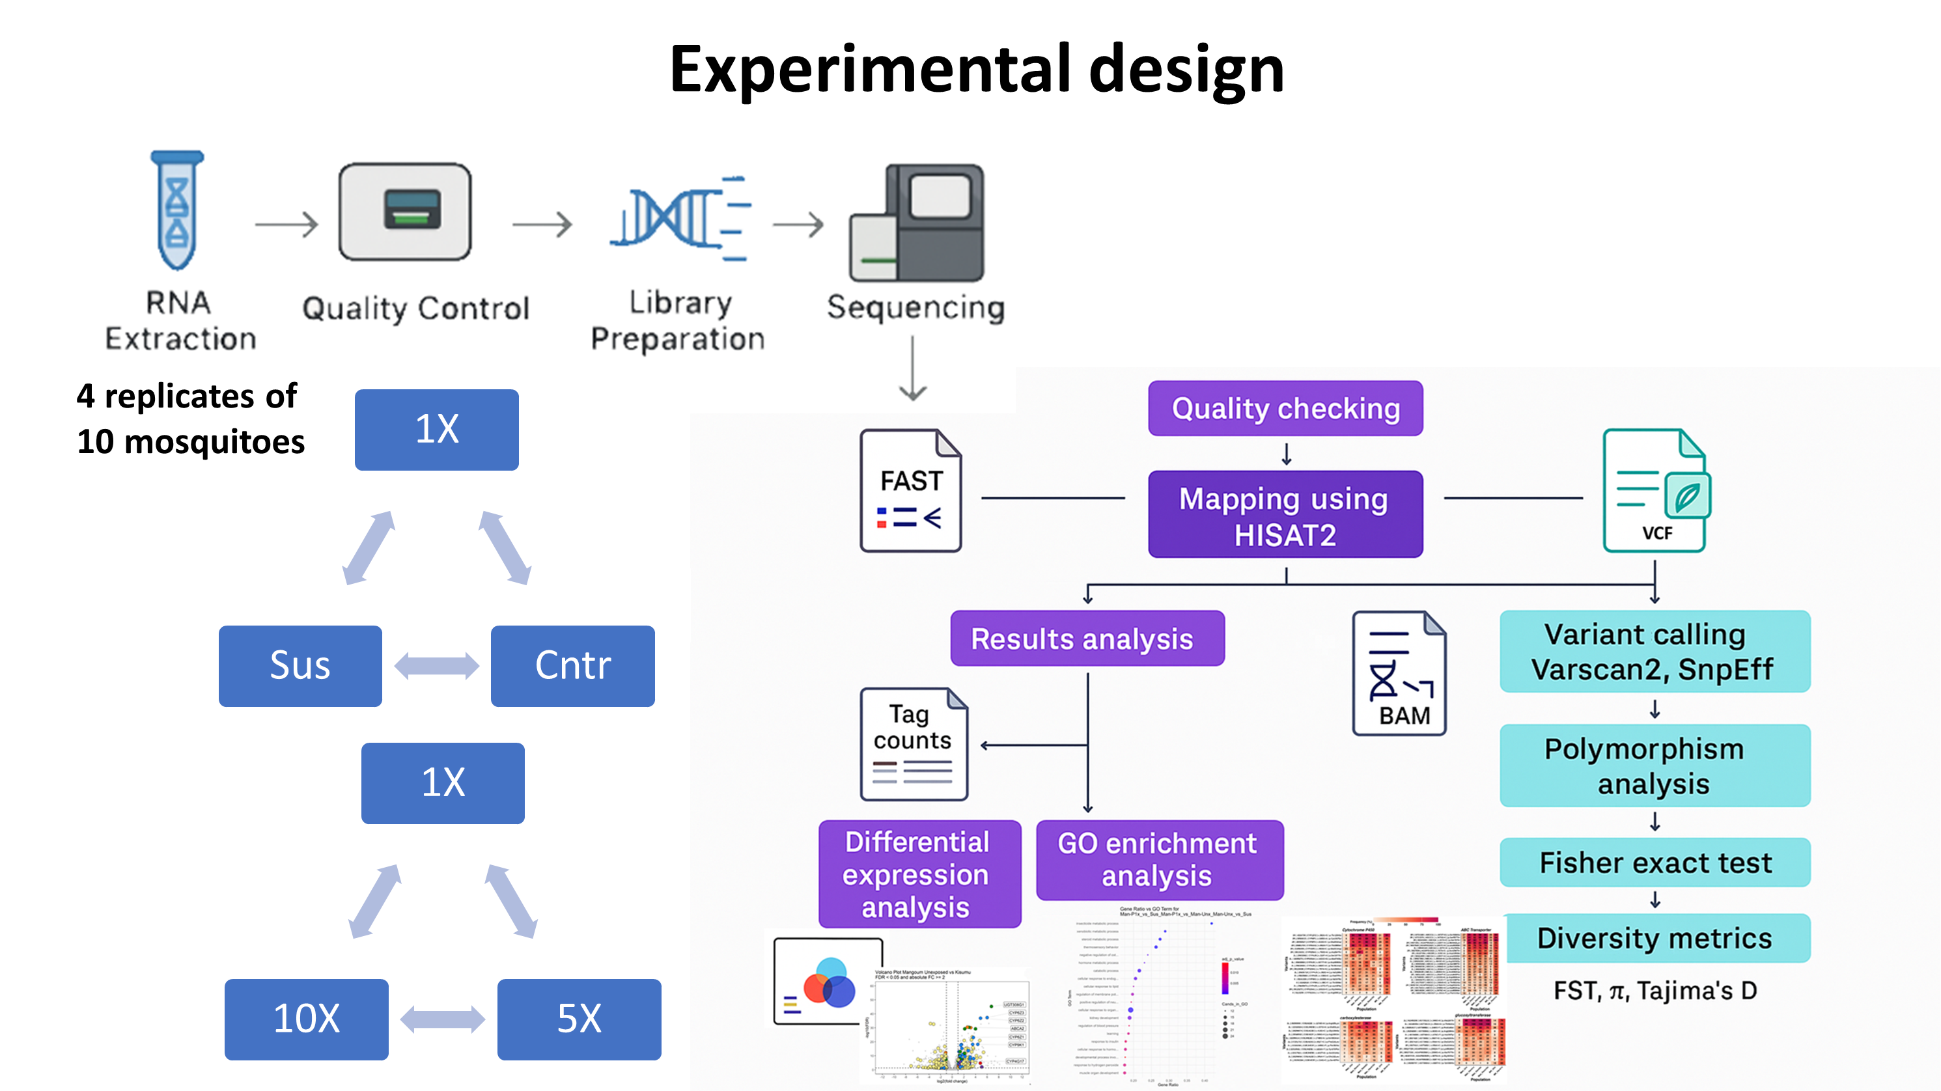
Figure S1.5. Workflow of mosquito sampling, RNA-seq processing, and downstream analyses. Mosquitoes from field, hybrid, and susceptible lines were exposed to graded permethrin doses or kept as controls and processed in 4 biological replicates of 10 individuals. The figure summarizes RNA extraction, quality control, library preparation, sequencing, mapping, differential-expression analysis, GO enrichment, SNP identification, and selection-signature analyses.

