Supplementary Figures & Tables
Table S1: GenBank reference of the different Psychromonadaceae genomes included in Figure 4.
Strain | GenBank reference
Agarivorans aestuarii KCTC 32543^{T} | GCA_019670125.1
Agarivorans albus JCM 21469^{T} | GCA_019670105.1
Agarivorans gilvus CGMCC 1.10131^{T} | GCA_014636215.1
Agarivorans litoreus NBRC 110444^{T} | GCA_019649015.1
Aliagarivorans marinus DSM 23064^{T} | GCA_000429485.1
Aliagarivorans taiwanensis DSM 22990^{T} | GCA_000429505.1
Psychromonas antarctica DSM 10704^{T} | GCA_022267535.1
Psychromonas aquimarina ATCC BAA-1526^{T} | GCA_000428725.1
Psychromonas arctica DSM 14288^{T} | GCA_000482725.1
Psychromonas hadalis ATCC BAA-638^{T} | GCA_000420245.1
Psychromonas ingrahamii 37^{T} | GCA_000015285.1
Psychromonas marina NBRC 103166^{T} | GCA_030161115.1
Psychromonas ossibalaenae ATCC BAA-1528^{T} | GCA_000381745.1

Table S2: Comparison between the identified genomic characteristics and the observed phenotype of the Motilimonas strains. Phenotypic information was retrieved from [1-3] and [5]. / = not tested , GlcNAc = N-acetyl-glucosamine, GalNAc = N-acetylgalactosamine

 | Strain | Motilimonas sp. Spo1_1 | Motilimonas sp. E26 | Motilimonas sp. 1_MG-2023 G1M02 | Motilimonas  cestriensis MKS20^{T} | Motilimonas  eburnea YH6^{T} | Motilimonas  sp.KMU-193 | Motilimonas  pumila  PLHSC7-2^{T}
Salt resistance strategy | Genomic traits | Proline & glycine betaine transport (proU), proline biosynthesis (proA,B,C) and ectoine biosynthesis (ectB & ectC).  Potassium transport (trkH) | Proline & glycine betaine transport (proU) and ectoine biosynthesis (ectB & ectC).  Potassium transport (trkH) | Proline & glycine betaine transport (proU), proline biosynthesis (proA,B,C) and ectoine biosynthesis (ectB & ectC).  Potassium transport (trkH) | Proline & glycine betaine transport (proU), proline biosynthesis (proA,B,C) and ectoine biosynthesis (ectB & ectC).  Potassium transport (trkH) | Proline & glycine betaine transport (proU), proline biosynthesis (proA,B,C) and ectoine biosynthesis (ectB & ectC).  Potassium transport (trkH) | Proline biosynthesis (proA,B,C) and ectoine biosynthesis (ectB & ectC).  Potassium transport (trkH) | Proline biosynthesis (proA,B,C)  Potassium transport (trkH)
Salt resistance strategy | Phenotype | / | / | / | NaCl optimal growth : 1-3% (w/v) | NaCl optimal growth : 2-4% (w/v) | NaCl optimal growth : 1% (w/v) | NaCl optimal growth : 2-3% (w/v)
Sugar metabolism | Genomic traits | Complete gene set for transport of:  maltose/ maltodextrine, glucose/mannose,  ribose, GlcNAc, fructose | Complete gene set for transport of:  maltose/ maltodextrine, glucose/mannose,  ribose, GlcNAc, fructose | Complete gene set for transport of: maltose/ maltodextrine, glucose/mannose,  ribose, GlcNAc, fructose, GalNAc | Complete gene set for transport of:  maltose/ maltodextrine, glucose/mannose, ribose, GlcNAc, trehalose, fructose, Mannitol, GalNAc | Complete gene set for transport of:  maltose/ maltodextrine, glucose, GlcNAc | Complete gene set for transport of:  maltose/ maltodextrine, glucose/mannose, GlcNAc, fructose | Complete gene set for transport of: maltose/ maltodextrine, glucose, GlcNAc, mannitol
Sugar metabolism | Phenotype | / | / | / | Oxidation of :  maltose, mannitol, GalNAc, glucose, mannose, GlcNAc | Oxidation of :  fructose, GalNAc, glucose, mannose, GlcNAc | Oxidation of :  fructose, glucose, mannose, GlcNAc | Oxidation of :  maltose, GalNAc, glucose, mannose, GlcNAc
Sugar polymer degradation | Genomic traits | No genes for pectin or agar degradation  Genes for chitin degradation | No genes for pectin or agar degradation  Genes for chitin degradation | No genes for pectin or agar degradation  Genes for chitin degradation | No genes for pectin or agar degradation  Genes for chitin degradation | No genes for pectin or agar degradation  Genes for chitin degradation | No genes for pectin or agar degradation  Genes for chitin degradation | No genes for pectin or agar degradation  Genes for chitin degradation
Sugar polymer degradation | Phenotype | Chitin (+) | / | / | Pectin (-) | Pectin (-) | Pectin (-)  Agar (-) | Pectin (-)
Motility | Genomics traits | Complete set of genes for motility | Complete set of genes for motility | Complete set of genes for motility | Complete set of genes for motility | Complete set of genes for motility | Complete set of genes for motility | Complete set of genes for motility
Motility | Phenotype | / | / | / | Motile | Motile | Motile | Motile
Oxygen requirement | Genomic traits | High-affinity oxidases  ROS detoxification | High-affinity oxidases  ROS detoxification | High-affinity oxidases  ROS detoxification | High-affinity oxidases  ROS detoxification | High-affinity oxidases  ROS detoxification | High-affinity oxidases  ROS detoxification | High-affinity oxidases  ROS detoxification
Oxygen requirement | Phenotype | / | / | / | Facultatively anaerobic | Facultatively anaerobic | Obligately aerobic | Facultatively anaerobic
Nitrate reduction | Genomic traits | napA, napB, nirB, nirD (genes for nitrate reduction) | napA, napB, nirB, nirD (genes for nitrate reduction) | napA, napB, nirB, nirD (genes for nitrate reduction) | No gene | napA, napB, nirB, nirD (genes for nitrate reduction) | napA, napB, nirB, nirD (genes for nitrate reduction) | napA, napB, nirB, nirD (genes for nitrate reduction)
Nitrate reduction | Phenotype | / | / | / | Nitrate reduction (-) | Nitrate reduction (+) | Nitrate reduction (+) | Nitrate reduction (+)

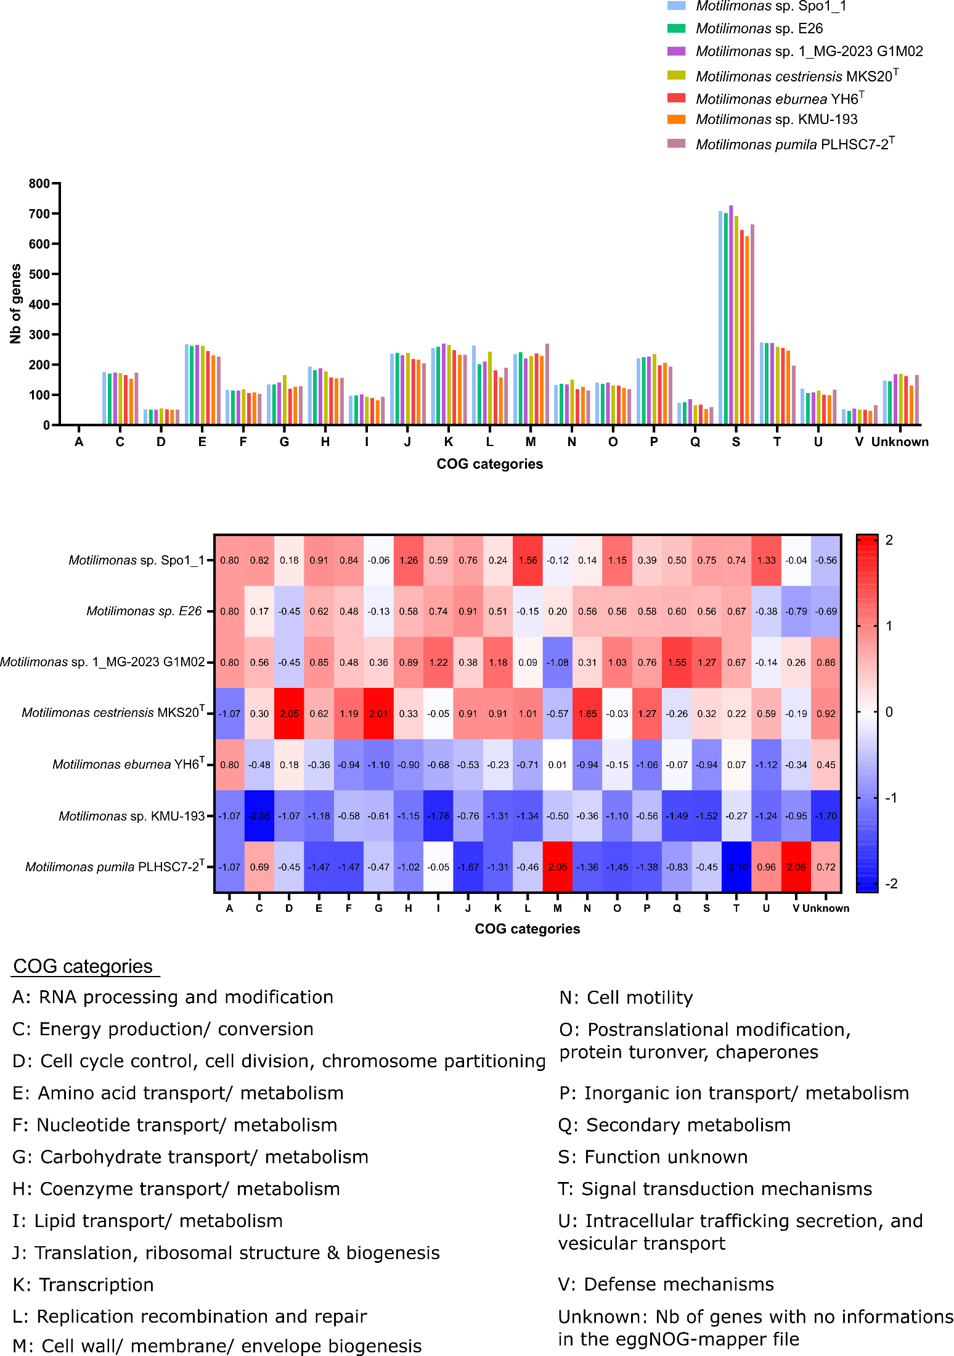
Figure S1: a) Functional classification of the different Motilimonas genomes based on COG assignments. b) Enrichment heatmap of COG categories in the Motilimonas genomes.

