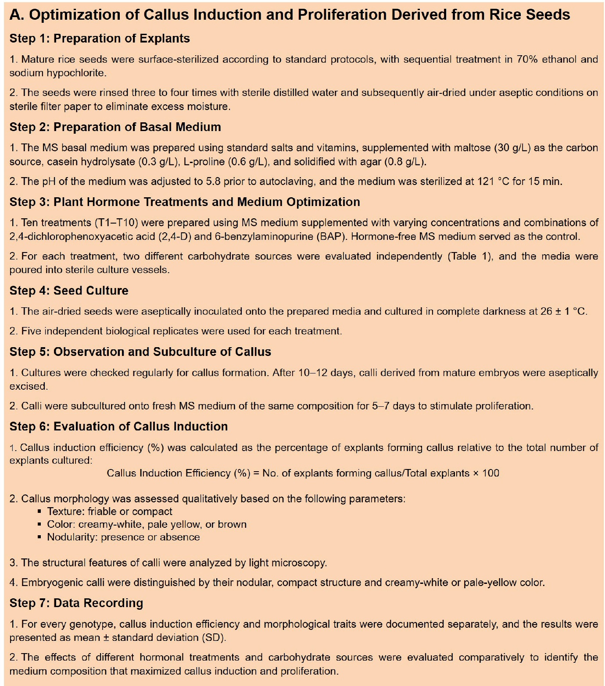

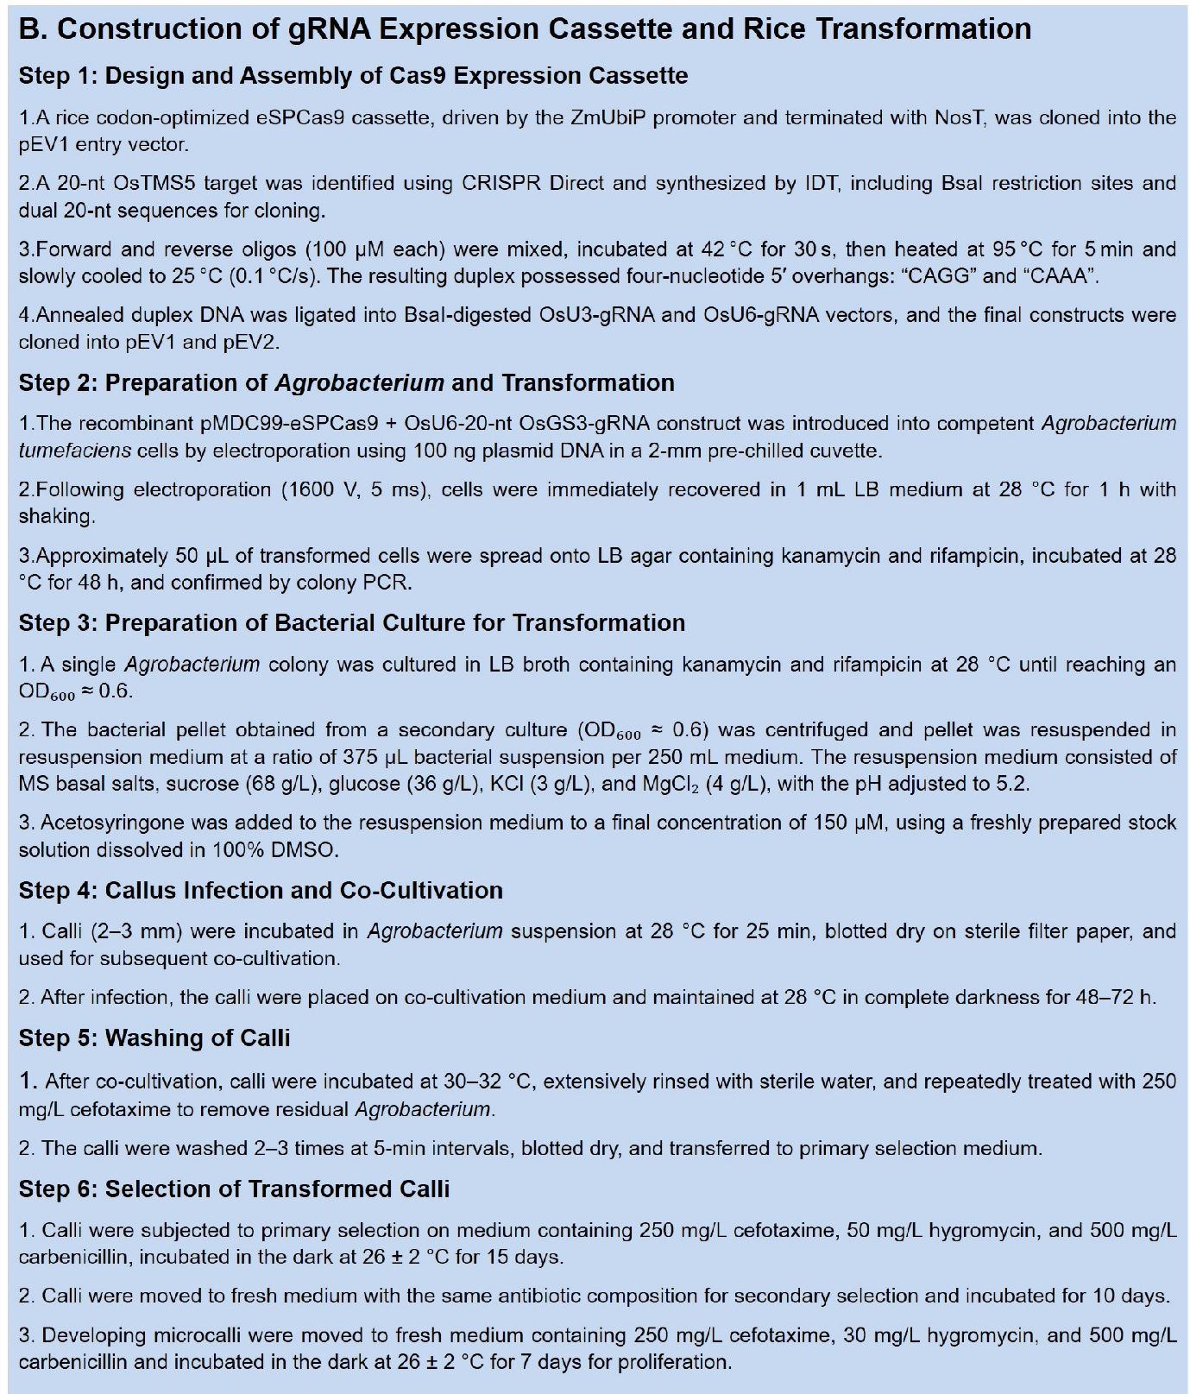

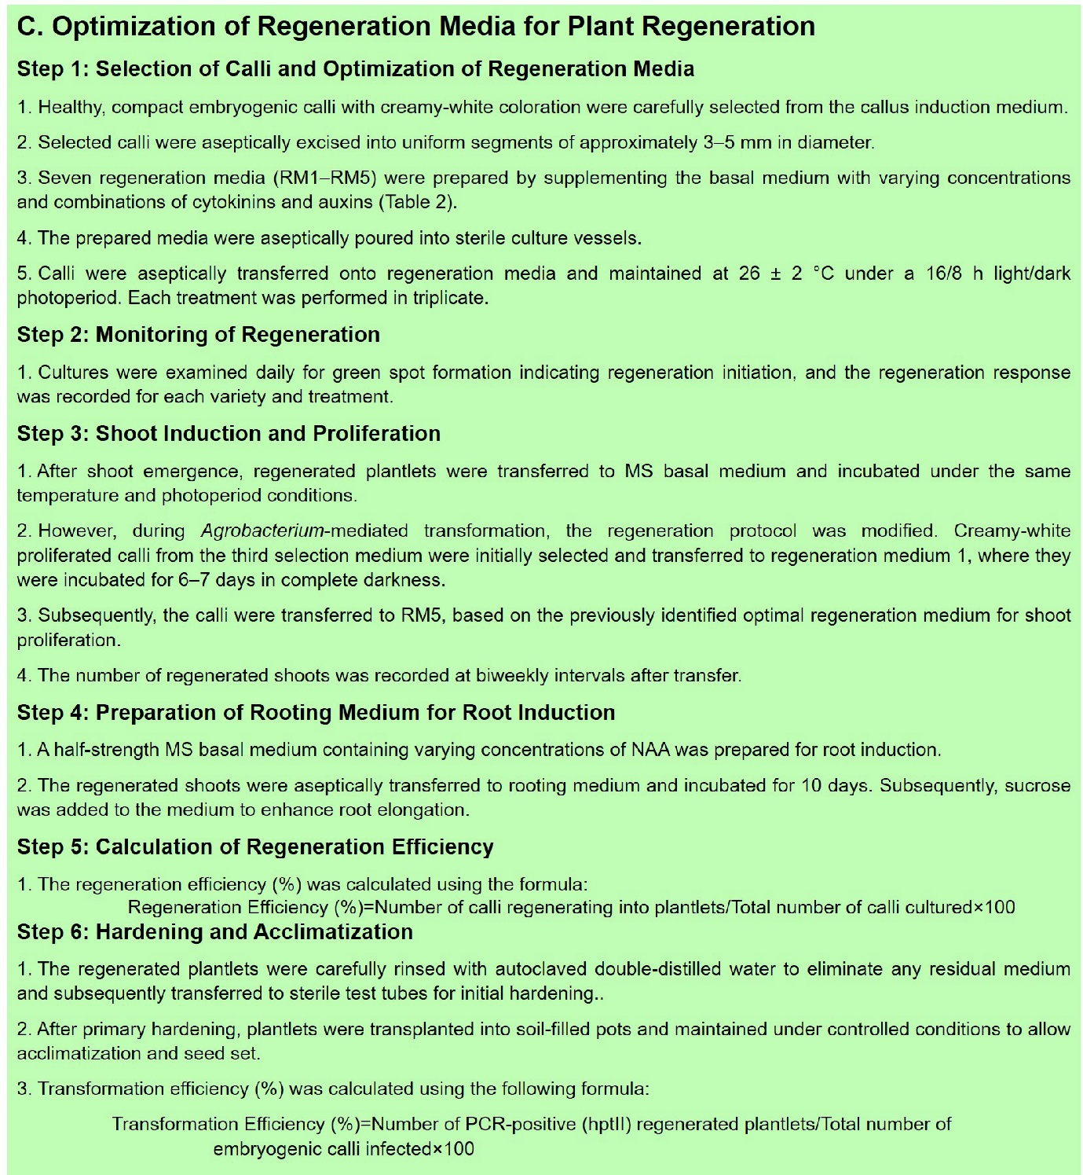
Fig. S1. Agrobacterium-mediated transformation of OsTMS5 in rice. (A) Optimization of callus induction and proliferation from mature rice seeds. (B) Construction of the gRNA expression cassette and rice transformation. (C) Optimization of regeneration media for efficient plant regeneration.

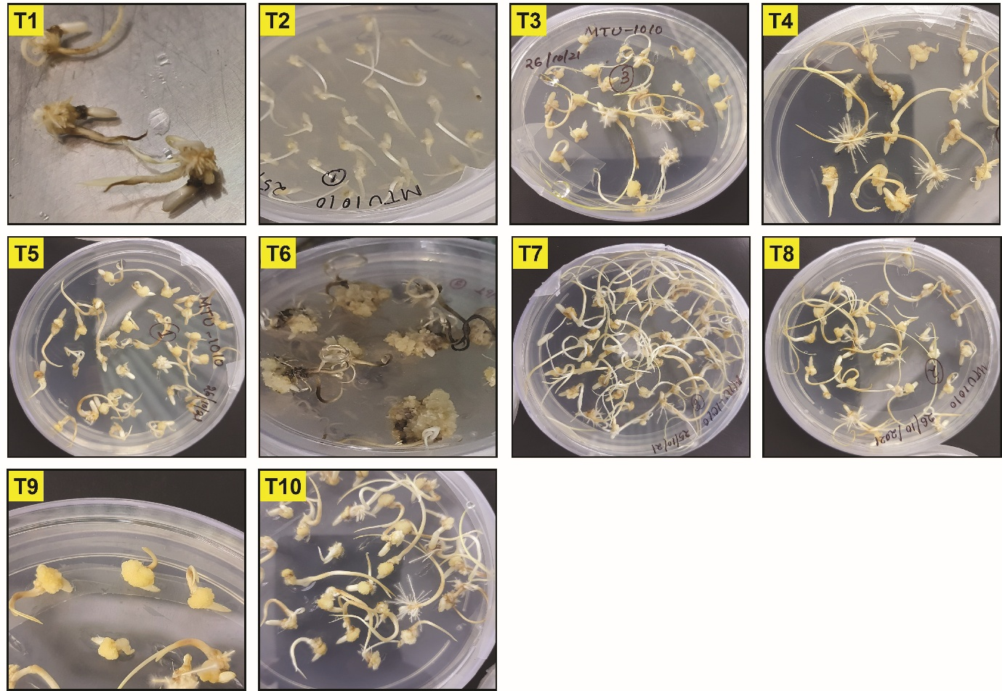
Fig. S2. The callus induction rates were evaluated in two indica rice varieties, MTU-1010. After 12 days of culturing under various treatments (T1 to T10), the effects of different concentrations of 2,4-D and BAP incorporated into MS media were assessed, as detailed in Table 1.
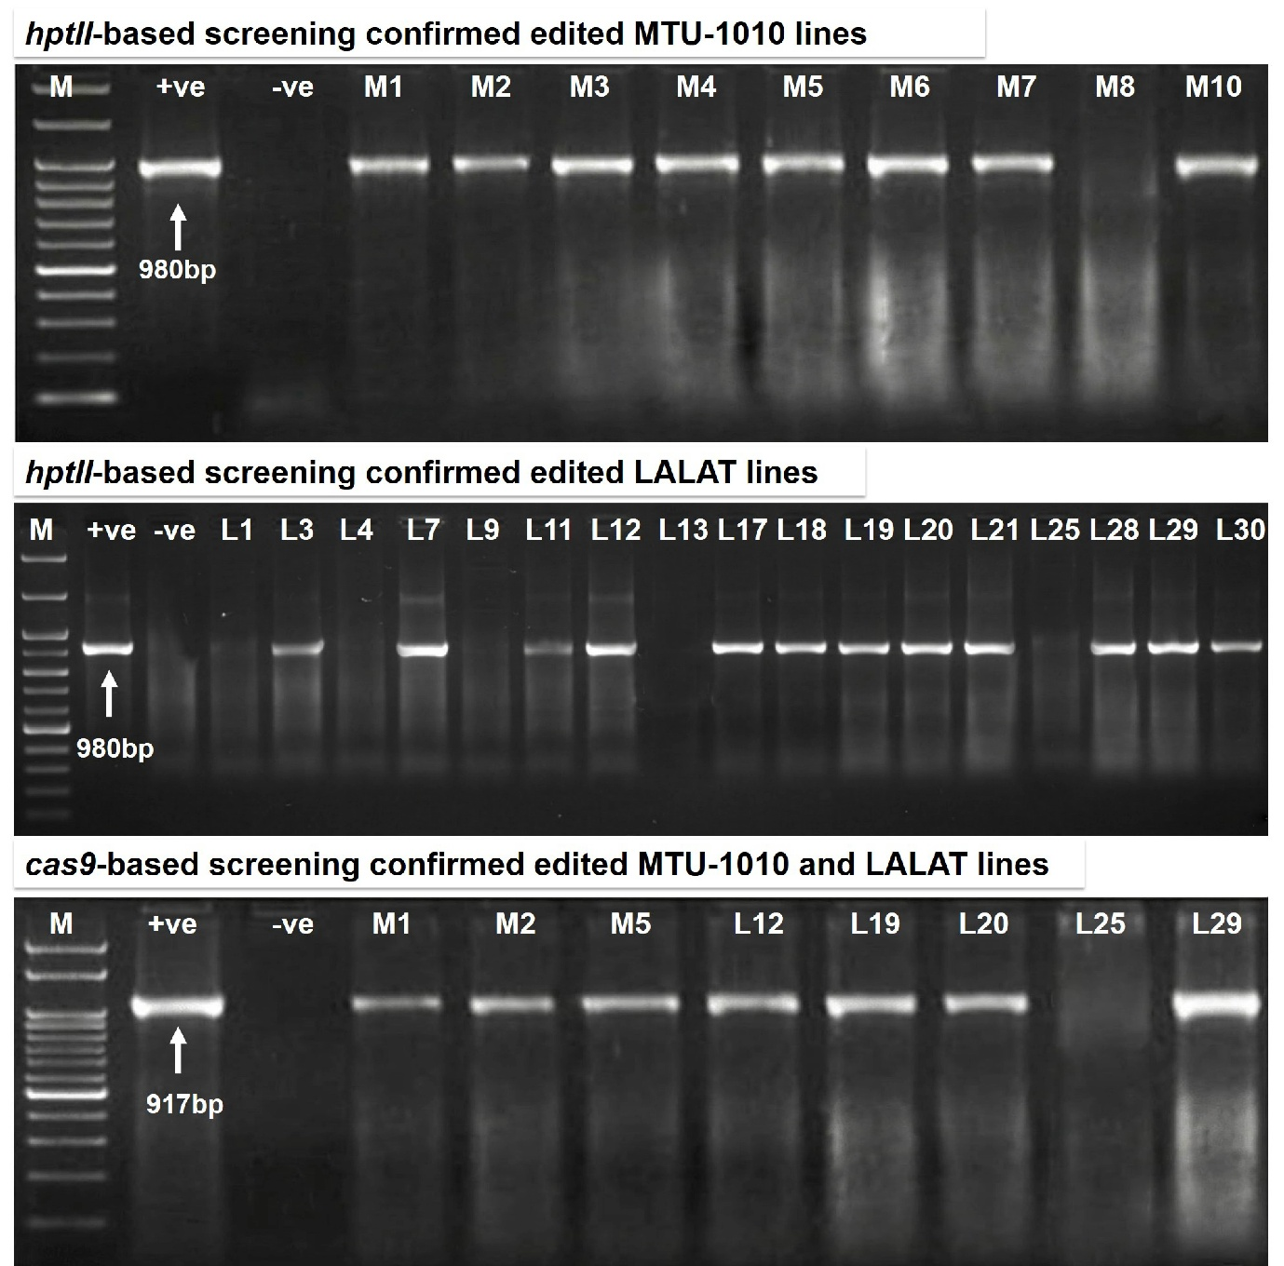
Fig. S3. The successful integration of the hptII and cas9 gene into the plant genome is confirmed by PCR analysis. Screening for positive transformation events involves amplifying the hptII and cas9 gene from the genomic DNA of genome edited lines of MTU-1010 and Lalat. Agarose gel electrophoresis is used to assess the PCR results, with positive controls containing plasmid DNA (+ve), and markers (M) to indicate size standards. Edited lines are designated as M1, M2, M3, M4, M5, M6, M7, M8 and M10 for MTU-1010 lines, and L1, L3, L4, L7, L9, L11, L12, L13, L17, L18, L19, L20, L21, L25, L28, L29, and L30 for Lalat lines.
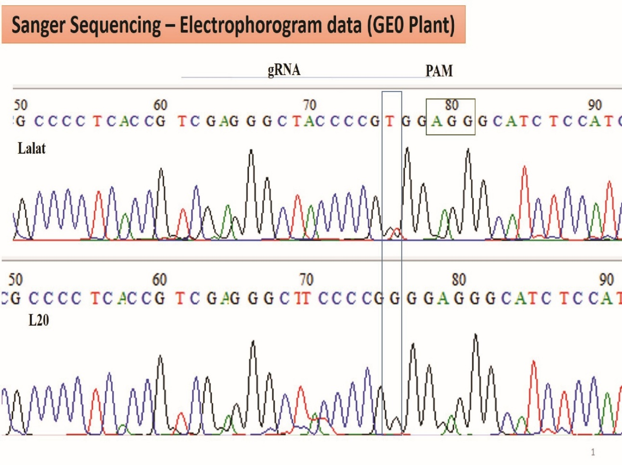
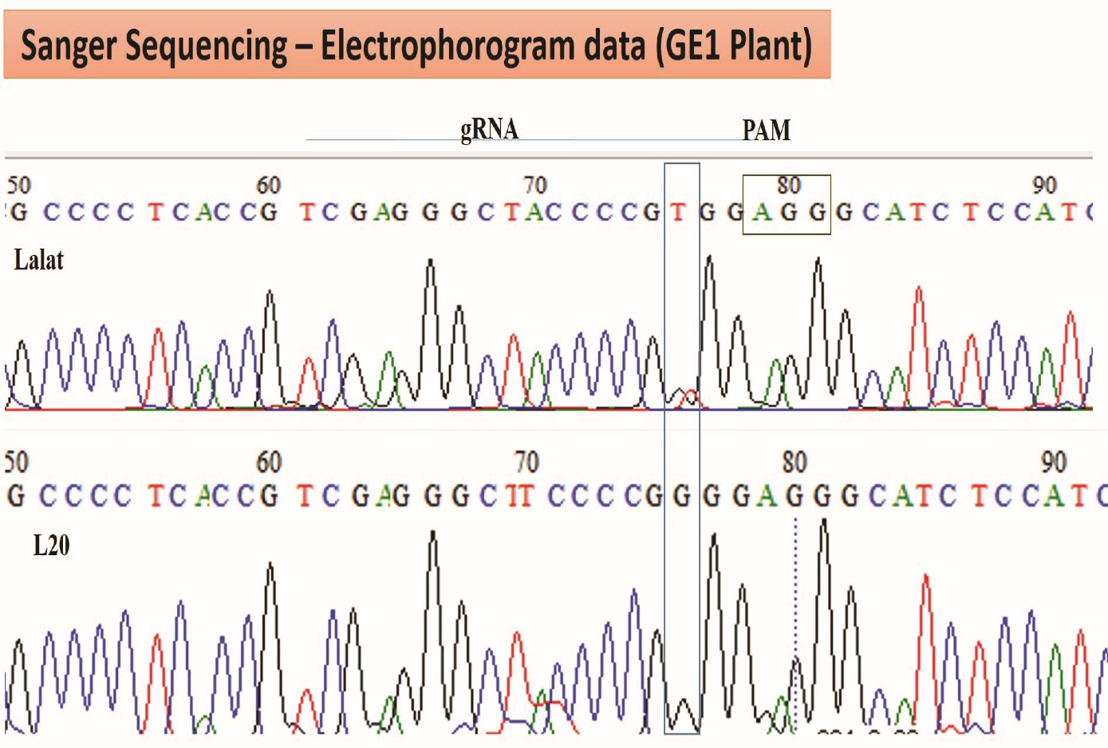
Fig. S4. DNA sequencing of the GE0 and GE1 lines was performed and subsequently confirmed by Sanger sequencing to validate the CRISPR/Cas9-mediated edits. The detected mutations included a point mutation (single nucleotide change), which is highlighted in a light blue box.

