Supplementary Information
Whole-genome characterization and analysis of Pantoea agglomerans R6

Methods
Swarming motility assay
Mueller–Hinton agar plates (0.5% agar) were prepared and allowed to dry at room temperature prior to inoculation. A single colony of P. agglomerans R6 from a 24 h nutrient-agar culture was spot-inoculated at the centre of each plate. Plates were photographed at time 0 and incubated at 25 °C for 48 h. Colony expansion was recorded at 24 h intervals, and swarming diameters were measured using ImageJ software [1]. Experiments were performed in three biological replicates, and plates inoculated with heat treated P. agglomerans R6 served as negative controls. Swarming was quantified by measuring colony surface area (arbitrary units) from digital images using ImageJ; identical regions of interest were applied to all plates. Growth patterns before and after incubation were compared to determine swarming capacity.

Structural Visualization via Scanning Electron Microscopy (SEM)
Overnight cultures of P. agglomerans R6 were centrifuged at 6000 ×g for 5 min and the supernatant was discarded. Pellets were fixed in 2.5% (v/v) glutaraldehyde in phosphate buffer (pH 7.2) for 8 h at 4 °C following the protocol of Tian, Hu [2] with minor modifications. Samples were rinsed with buffer and post-fixed in 1% (w/v) osmium tetroxide for 1 h, followed by rinsing with buffer and ultrapure water. Dehydration was performed through a graded ethanol series (30%, 50%, 70%, 90%, 95%, and 100% v/v) for 10 min each.
Dehydrated pellets were transferred to filter paper, mounted on aluminium stubs using conductive carbon adhesive, and treated with hexamethyldisilazane (HMDS) for approximately 45 min to complete drying. Samples were sputter-coated with a gold–palladium alloy and examined using a scanning electron microscope at 5–10 kV. Scale bars were added to all micrographs.

Results
S1 – Swarming analysis of P. agglomerans R6

Table S1: Quantification of swarming motility of Pantoea agglomerans R6 expressed as colony surface area. Swarming expansion was measured from digital images using identical regions of interest in ImageJ. Pseudomonas aeruginosa was included as a positive swarming control, while P. agglomerans R6 subjected to 121 °C for 15 min served as a heat-inactivated negative control. Values represent mean area (AU – arbitrary units) from three biological replicates
Strain / control | Time (h) | Area (AU)
P. agglomerans R6 (Heat treated - Negative control) | 48 | 0.20
P. agglomerans R6 | 48 | 5.92
Pseudomonas aeruginosa (Positive control) | 48 | 6.34

Figure S1: Comparative swarming motility of Pantoea agglomerans R6 and Pseudomonas aeruginosa.
Swarming behaviour on Mueller–Hinton agar was monitored over 48 h. Panels represent: A: heat-inactivated P. agglomerans R6 (negative control), B: viable P. agglomerans R6, and C: Pseudomonas aeruginosa (positive control). Time points are indicated as 1 = 0 h, 2 = 24 h, and 3 = 48 h. Plates were incubated at 25 °C. Surface area was quantified using ImageJ (AU) and presented in S1 Table 1.

S2 - Comprehensive characterization of Pantoea agglomerans R6
Table S2: Comparative biochemical characterization of P. agglomerans R6. The ‘+’ and ‘-’ symbols indicate the presence or absence of a particular characteristic respectively.
Characterization |  | R6
Enzyme Activity | Amylase | +
 | Catalase | +
 | Cellulase | -
 | Chitinase | -
 | Lipase | +
 | Oxidase | +
 | Protease | -
 | Urease | -
Metabolism | Glucose | +
 | Lactose | +
 | Starch | -
 | Sucrose | +
Compound production | Hydrogen sulphide | +
 | Indole-3-acetic acid | 24.921
 | Siderophore activity | +
Antibiotic Resistance | Ampicillin | -
Nutrient Utilization | Phosphate | +
 | Zinc | +
Morphology | Gram stain | -
 | Motility | +

S3 – Utilization of API 20E for biochemical profiling of bacteria
Table S3: Metabolic activity of P. agglomerans R6. The table presents the results of various metabolic activities tested using an API-20E characterization strip. The ‘+’ and ‘-’ symbols indicate the presence or absence of a particular metabolic activity respectively. The metabolic activities tested include enzyme activities, nutrient utilization, and antibiotic resistance.
Metabolic Activities | P. agglomerans R6
ϐ-galactosidase (ONPG) | +
Arginine dihydrolase (ADH) | -
Lysine decarboxylase (LDC) | -
Ornithine decarboxylase (ODC) | -
Citrate utilization (CIT) | -
Hydrogen Sulphide (H2S) | -
Urease (URE) | -
Tryptophane deaminase (TDA) | -
Indole production (IND) | -
Voges-Proskauer (VP) | +
Gelatinase (GEL) | -
Glucose (GLU) | +
Mannitol (MAN) | +
Inositol (INO) | -
Sorbitol (SOR) | -
Rhamnose (RHA) | +
Saccharose (SAC) | +
Melibiose (MEL) | -
Amygdalin (AMY) | +
Arabinose (ARA) | +
Cytochrome oxidase (OX) | +

S4 – Quantitative Crystal violet biofilm assay
Table S4: Biofilm quantification for P. agglomerans R6. Biofilm concentrations were determined using a glucose calibration curve and expressed as µg glucose equivalents mL⁻¹. Data represent mean ± SD from three independent experiments.
Bacterium | Biofilm (µg/mL)
P. agglomerans R6 | 0.84 ± 0.07 a
Microbacterium sp. (+ ve control) | 1.02 ± 0.09 a
Luria broth (- ve control) | 0.11 ± 0.02 b

These results confirm that strain R6 produces substantial biofilm biomass significantly above background and comparable to the positive control.

S5 – Additional SEM analysis
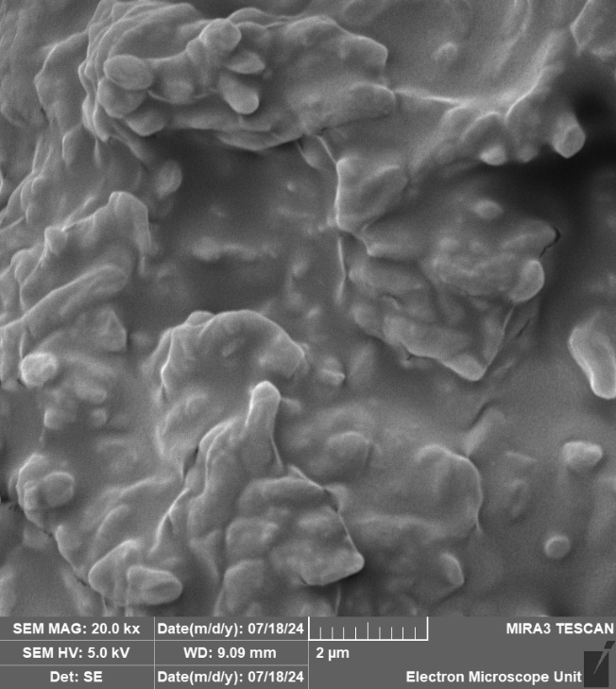
Figure 2: Scanning electron micrograph (2 µm scale indicated at the bottom of the image), observed with a SEM MAG of 20.0 kx and SEM HV of 5.0 kV.

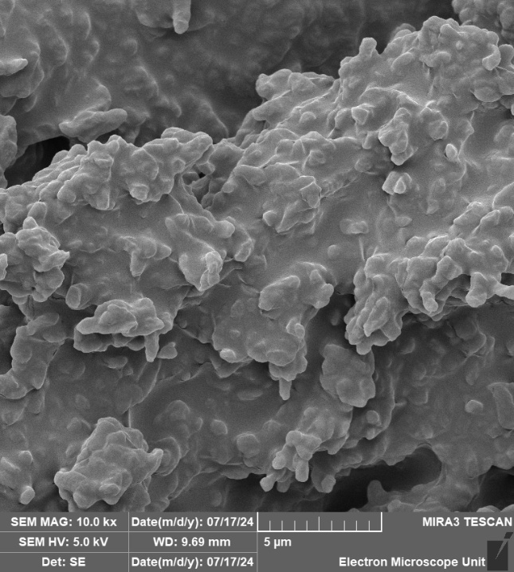
Figure 3: Scanning electron micrograph (5 µm scale indicated at the bottom of the image), observed with a SEM MAG of 10.0 kx and SEM HV of 5.0 kV.

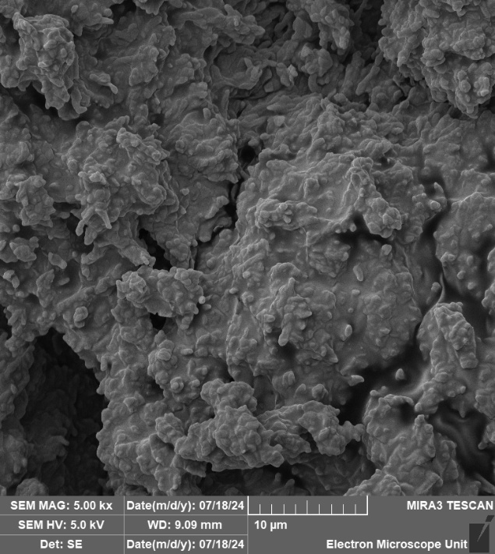
Figure 4: Scanning electron micrograph (10 µm scale indicated at the bottom of the image), observed with a SEM MAG of 5.00 kx and SEM HV of 5.0 kV.

End of supplementary information

References
1. Abràmoff, M.D., P.J. Magalhães, and S.J. Ram, Image processing with ImageJ. Biophotonics international, 2004. 11(7): p. 36-42.
2. Tian, L., et al., Antagonism of rhizosphere Streptomyces yangpuensis CM253 against the pathogenic fungi causing corm rot in saffron (Crocus sativus L.). Pathogens, 2022. 11(10): p. 1195.

