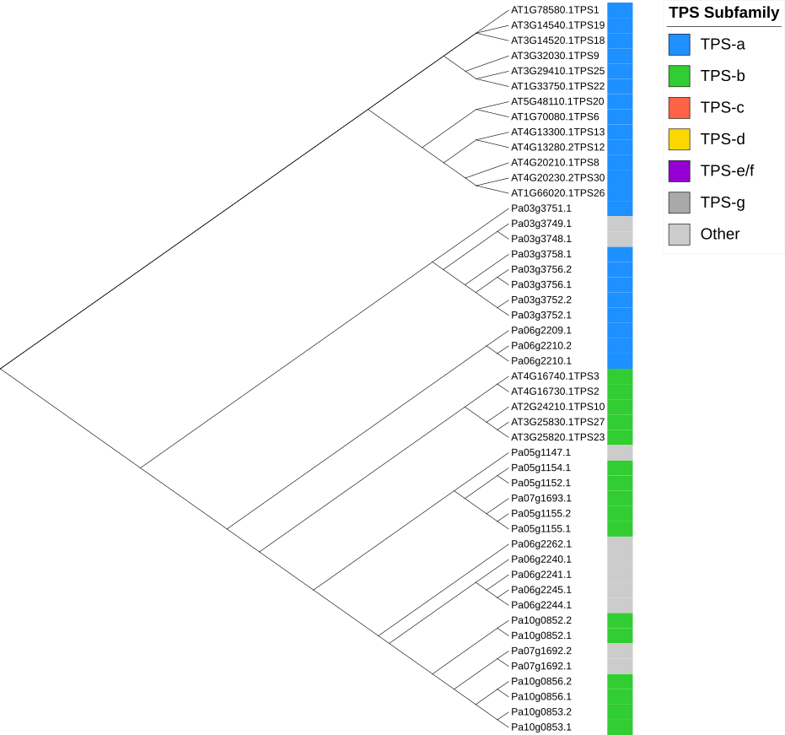
Figure S1. The situation of the subfamilies of the TPS gene family: TPS-a is labeled in blue, and TPS-b is labeled in green.

