The original images of gels in manuscript
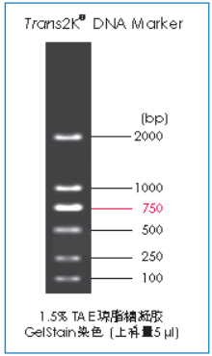
Figure 7B: The DNA Marker was shown on the left and the gel was shown on the right. (M: DNA Marker, 1: Liver, 2: Spleen, 3: Lung, 4: Kidney, 5: Stomach, 6: Muscle, 7: Cell)

Figure 7C: The DNA Maker was shown on the left and the gel was shown on the right. (M: DNA Marker, 1: Liver, 2: Spleen, 3: Lung, 4: Kidney, 5: Stomach, 6: Muscle, 7: Cell)

