Stable nutritional endosymbiosis across cryptic diversity of a leafhopper species complex

Anna Michalik^{1*}, Emilia Majewska², Veronika Andriienko^{1,3}, Karol H. Nowak^{2,3}, Adam Stroiński⁴, Piotr Łukasik²

^{1.} Department of Developmental Biology and Invertebrate Morphology, Institute of Zoology and Biomedical Research, Faculty of Biology, Jagiellonian University, Kraków, Poland
^{2.} Institute of Environmental Sciences, Faculty of Biology, Jagiellonian University, Kraków, Poland
^{3.} Doctoral School of Exact and Natural Sciences, Jagiellonian University, Kraków, Poland
^{4.} Museum and Institute of Zoology, Polish Academy of Sciences, Warsaw, Poland
* Correspondence: a.michalik@uj.edu.pl

Supplementary Figures

Figure S1. Heatmap showing the distribution of the most abundant bacterial zOTUs in Verdanus populations

Figure S2. The relative abundance of dominant ITS1 zOTUs across individual leafhoppers from across 15 populations.

Figure S3. The relative abundance of dominant ITS2 zOTUs across individual leafhoppers from across 17 populations.

Figure S4. The relative abundance of dominant 18S rDNA zOTUs across individual leafhoppers from across 17 populations.

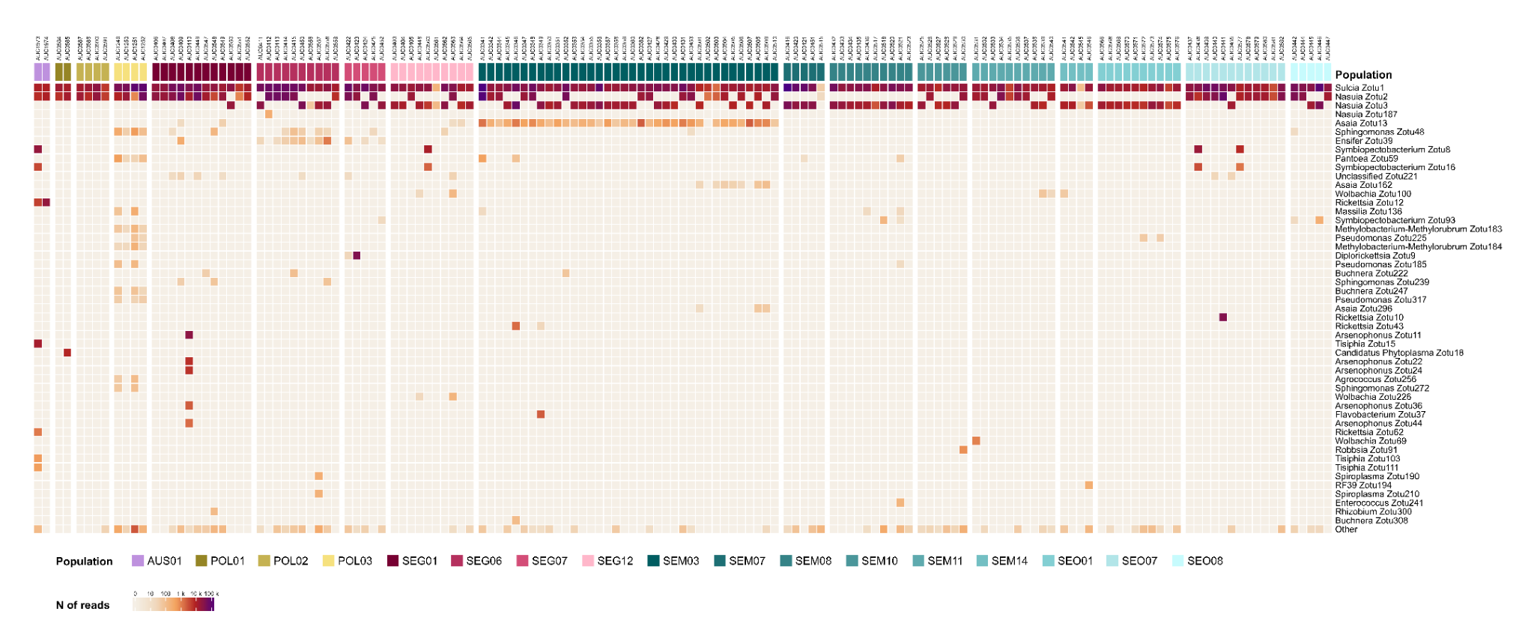
Figure S1. Heatmap showing the distribution of the most abundant bacterial zOTUs in the Verdanus populations.

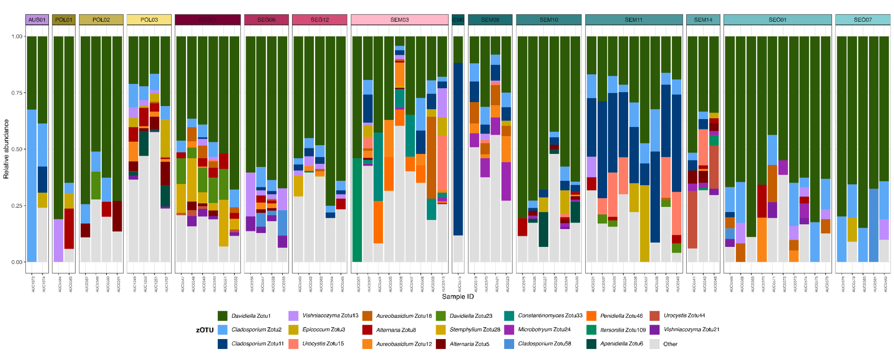
Figure S2. The relative abundance of dominant ITS1 zOTUs across individual leafhoppers from across 15 populations.
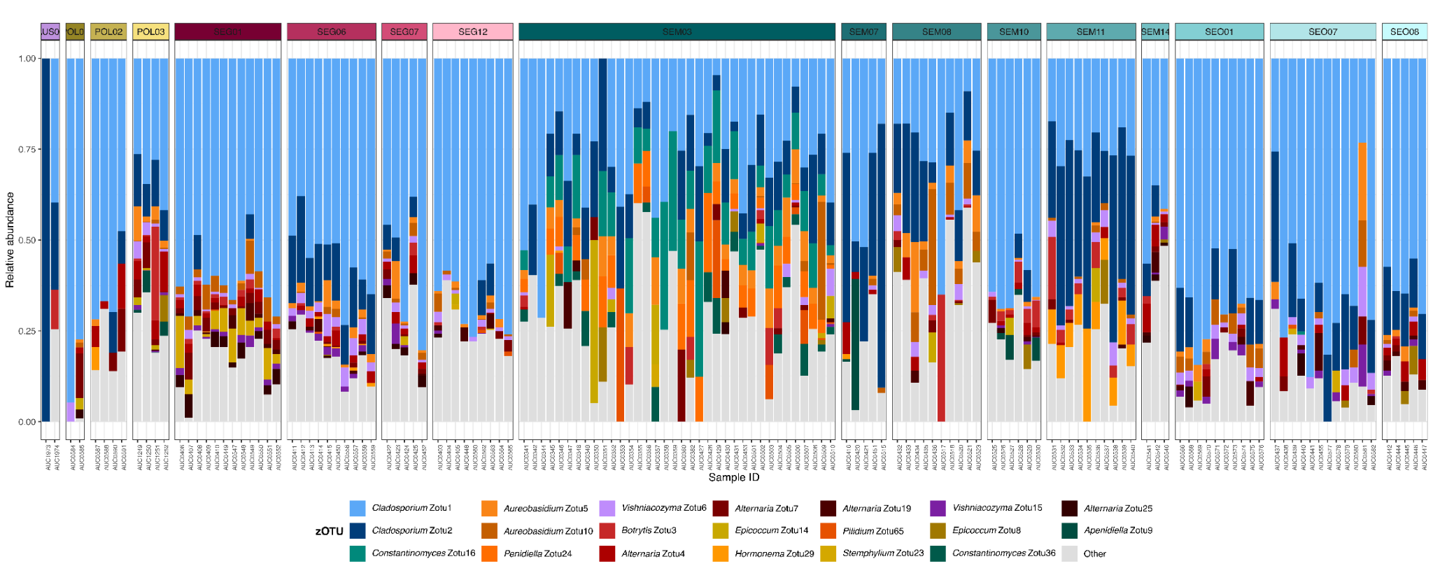
Figure S3. The relative abundance of dominant ITS2 zOTUs across individual leafhoppers from across 17 populations.

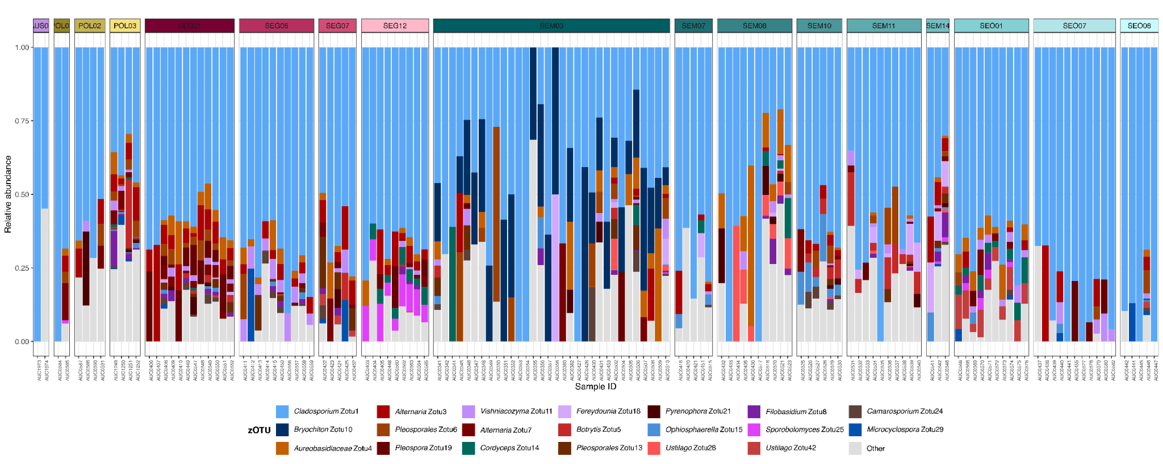
Figure S4. The relative abundance of dominant 18S rDNA zOTUs across individual leafhoppers from across 17 populations.

