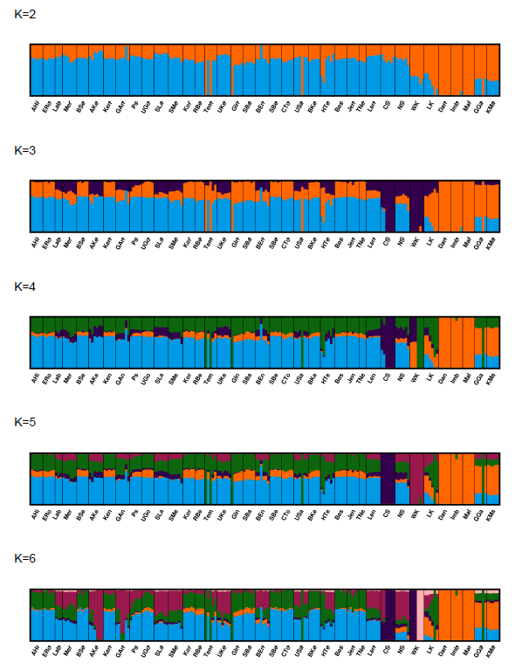
Supplementary Information
Peninsular Malaysia
Borneo
Sumatra
(A)

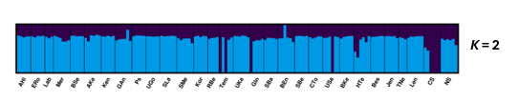
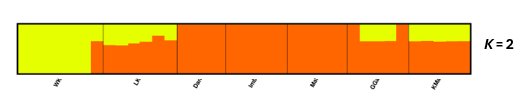
Western group (Cluster A)
Eastern group (Cluster B)
(B)

Supplementary Fig. S1 Genetic structure of Rubroshorea leprosula based on the pruned neutral SNP dataset. (A) Global ADMIXTURE analysis at the optimal K = 2, identifying two primary lineages. (B) Nested ADMIXTURE analysis within each primary lineage. The Western lineage (K = 2) differentiates the Sumatra population from Peninsular Malaysia, while the Eastern lineage (K = 2) reveals internal sub-structuring and heterogeneity within Borneo.

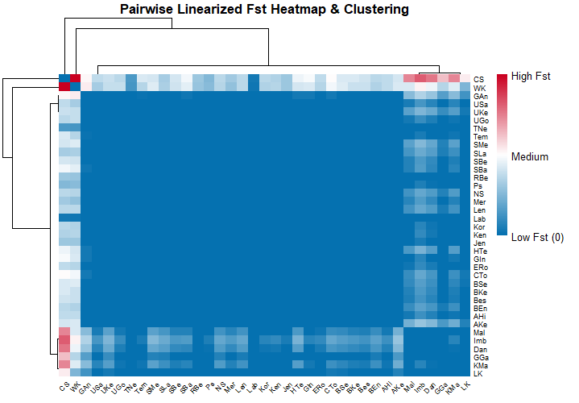

Supplementary Fig. S2 Heatmap of pairwise F_{ST} estimates among 37 populations of R. leprosula. Colour intensity represents the degree of genetic differentiation, with values ranging from 0.000 (blue) to 0.075 (red). The dendrogram (top and left) illustrates hierarchical clustering based on genetic similarity.

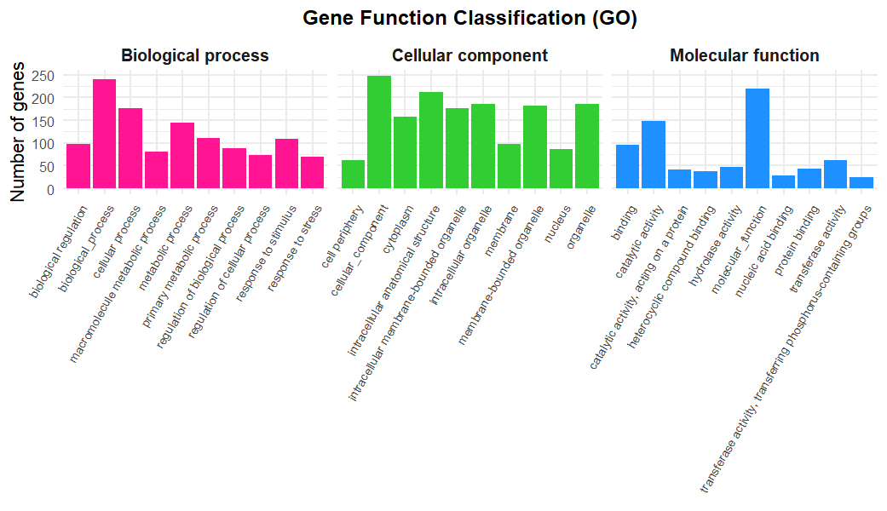
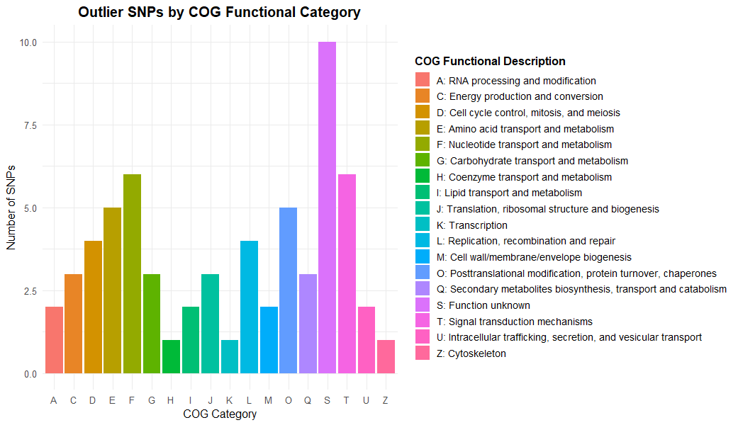
(A)
(B)

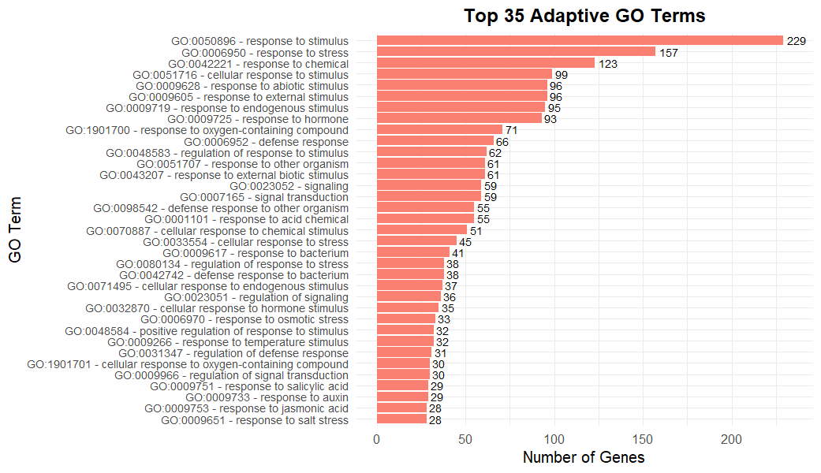
(D)
(C)
Top 35 adaptation-related GO terms
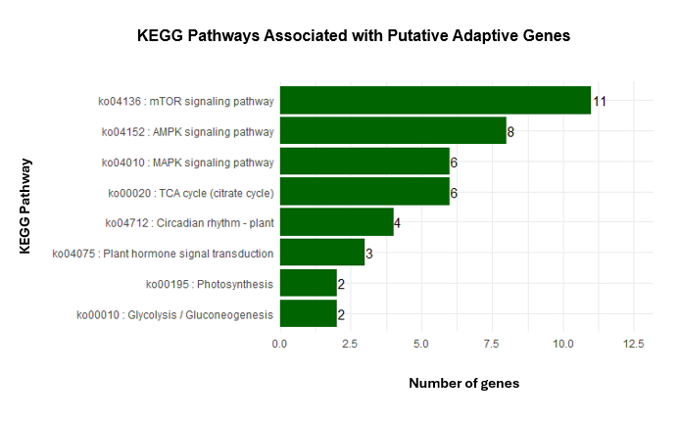

Supplementary Fig. S3 Functional classification and enrichment of genes associated with pairwise F_{ST}-based outlier SNPs between Cluster A and Cluster B of Rubroshorea leprosula. (A) Distribution of outlier SNPs across Clusters of Orthologous Groups (COG) functional categories. (B) Gene Ontology (GO) classification of candidate genes under Biological Process, Cellular Component and Molecular Function categories. (C) Top 35 significantly enriched GO terms related to putative adaptive functions. D) KEGG pathways associated with putative adaptive genes, highlighting major stress response and regulatory pathways.

Supplementary Table S1 Climatic variables for the 37 sampled populations of Rubroshorea leprosula, including mean maximum temperature of the warmest month (BIO5, °C), mean minimum temperature of the coldest month (BIO6, °C), annual precipitation (BIO13, mm), precipitation of the driest month (BIO14, mm) and elevation (m)
Population | BIO5 | BIO6 | BIO13 | BIO14 | Elevation
AHi | 31.648 | 22.174 | 231 | 119 | 26
ERo | 30.486 | 21.497 | 487 | 134 | 203
Lab | 30.107 | 21.111 | 300 | 125 | 274
Mer | 31.482 | 22.425 | 555 | 153 | 28
BSe | 31.521 | 22.019 | 211 | 95 | 82
AKe | 31.858 | 22.206 | 222 | 88 | 32
Ken | 31.388 | 21.302 | 264 | 105 | 206
GAn | 30.575 | 20.828 | 247 | 107 | 329
Ps | 31.734 | 21.868 | 254 | 104 | 121
UGo | 30.895 | 20.892 | 316 | 139 | 257
SLa | 31.266 | 21.268 | 290 | 123 | 209
SMe | 31.683 | 22.201 | 247 | 87 | 26
Kor | 28.704 | 18.210 | 384 | 138 | 695
RBe | 30.929 | 21.075 | 313 | 73 | 316
Tem | 27.981 | 17.442 | 362 | 102 | 867
UKe | 30.196 | 20.086 | 379 | 170 | 382
GIn | 31.721 | 21.477 | 397 | 97 | 247
SBa | 31.681 | 21.065 | 273 | 40 | 227
BEn | 31.820 | 21.372 | 361 | 71 | 197
SBe | 31.070 | 20.613 | 310 | 95 | 248
CTo | 32.113 | 21.878 | 646 | 89 | 81
USa | 31.059 | 21.095 | 597 | 101 | 219
BKe | 31.432 | 21.638 | 674 | 119 | 94
HTe | 30.734 | 20.883 | 672 | 143 | 218
Bes | 31.978 | 22.461 | 669 | 151 | 32
Jen | 31.606 | 21.476 | 291 | 122 | 83
TNe | 30.895 | 20.994 | 275 | 96 | 161
Len | 29.208 | 19.100 | 307 | 125 | 536
CS | 29.981 | 21.373 | 287 | 110 | 215
NS | 21.324 | 10.039 | 271 | 101 | 2043
WK | 27.861 | 18.114 | 405 | 212 | 841
LK | 32.281 | 22.134 | 321 | 114 | 77
Dan | 29.788 | 21.241 | 232 | 145 | 300
Imb | 30.032 | 21.495 | 241 | 169 | 254
Mal | 29.164 | 20.591 | 259 | 155 | 442
GGa | 31.351 | 22.265 | 696 | 143 | 98
KMa | 31.612 | 22.328 | 762 | 178 | 54

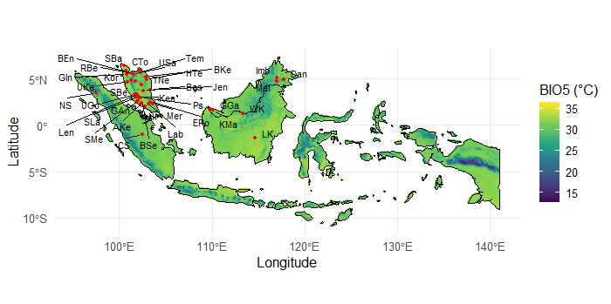
(A)
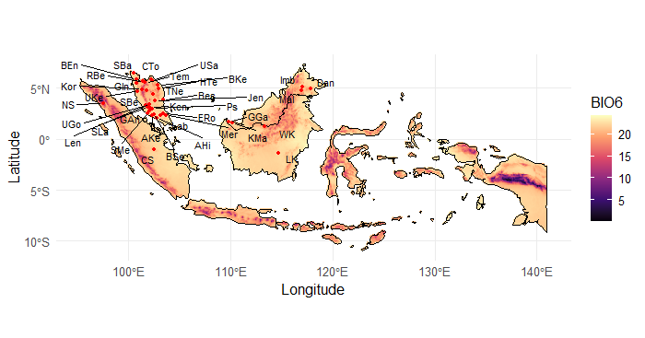
(B)
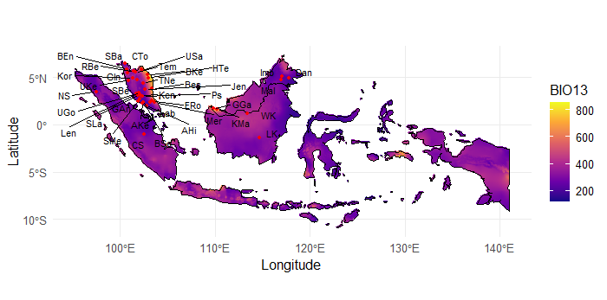
(C)
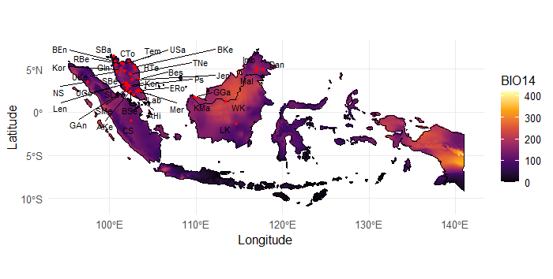
(D)
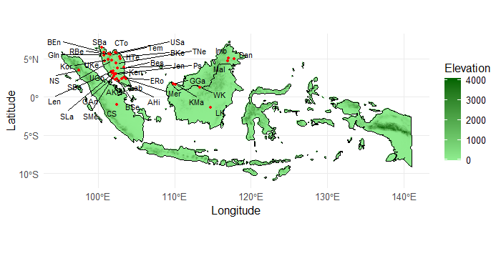
(E)
Supplementary Fig. S4 Spatial distribution of environmental variables across the 37 sampled populations of Rubroshorea leprosula, showing variation in (A) mean maximum temperature of the warmest month (BIO5, °C), (B) mean minimum temperature of the coldest month (BIO6, °C), (C) annual precipitation (BIO13; mm), (D) precipitation of the driest month (BIO14, mm) and (E) elevation

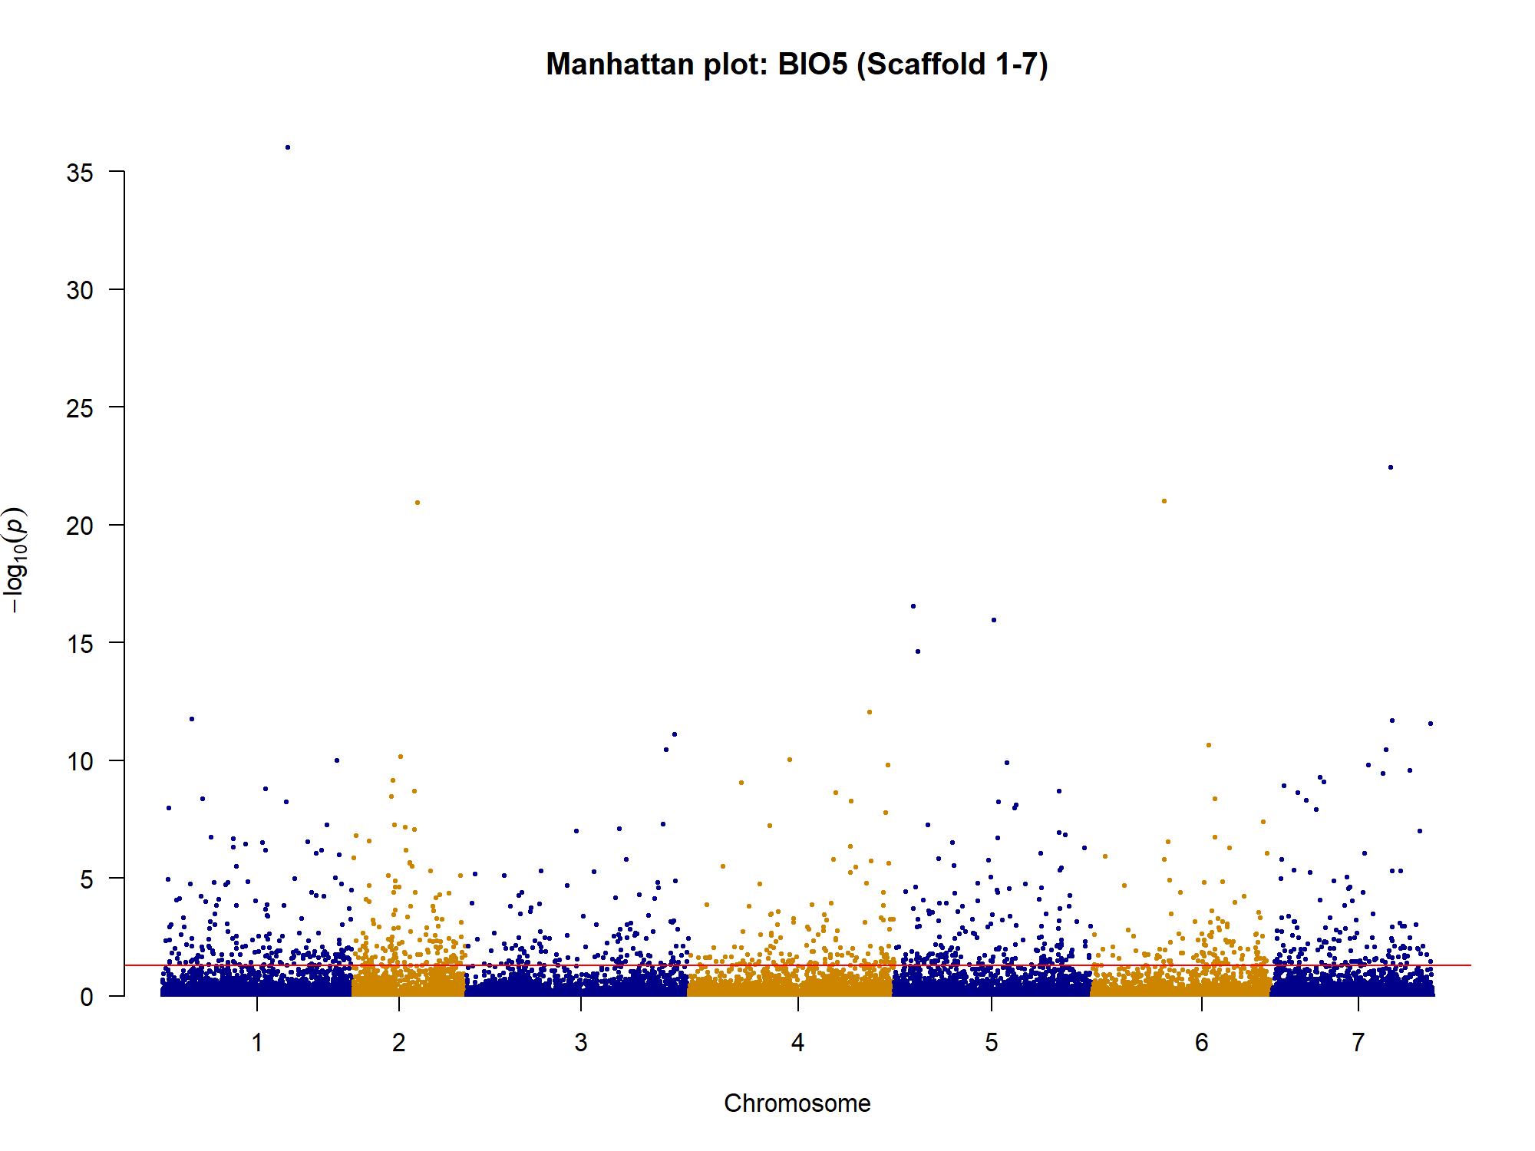
(A)
Scaffold
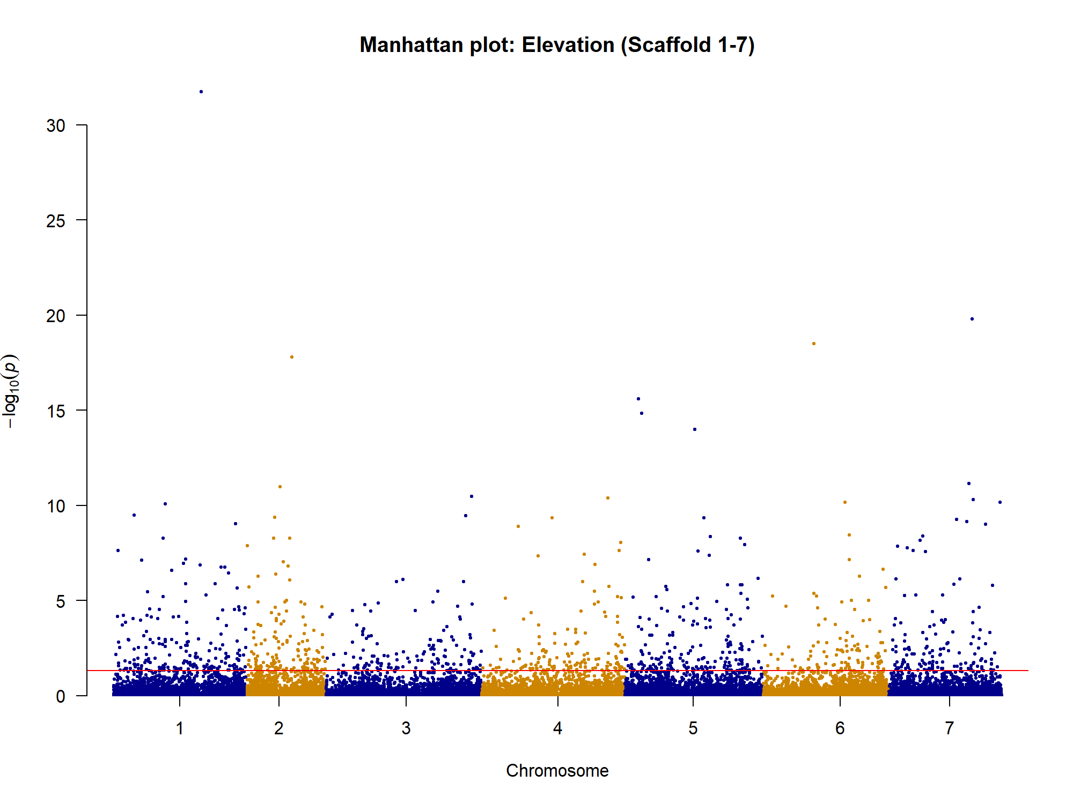
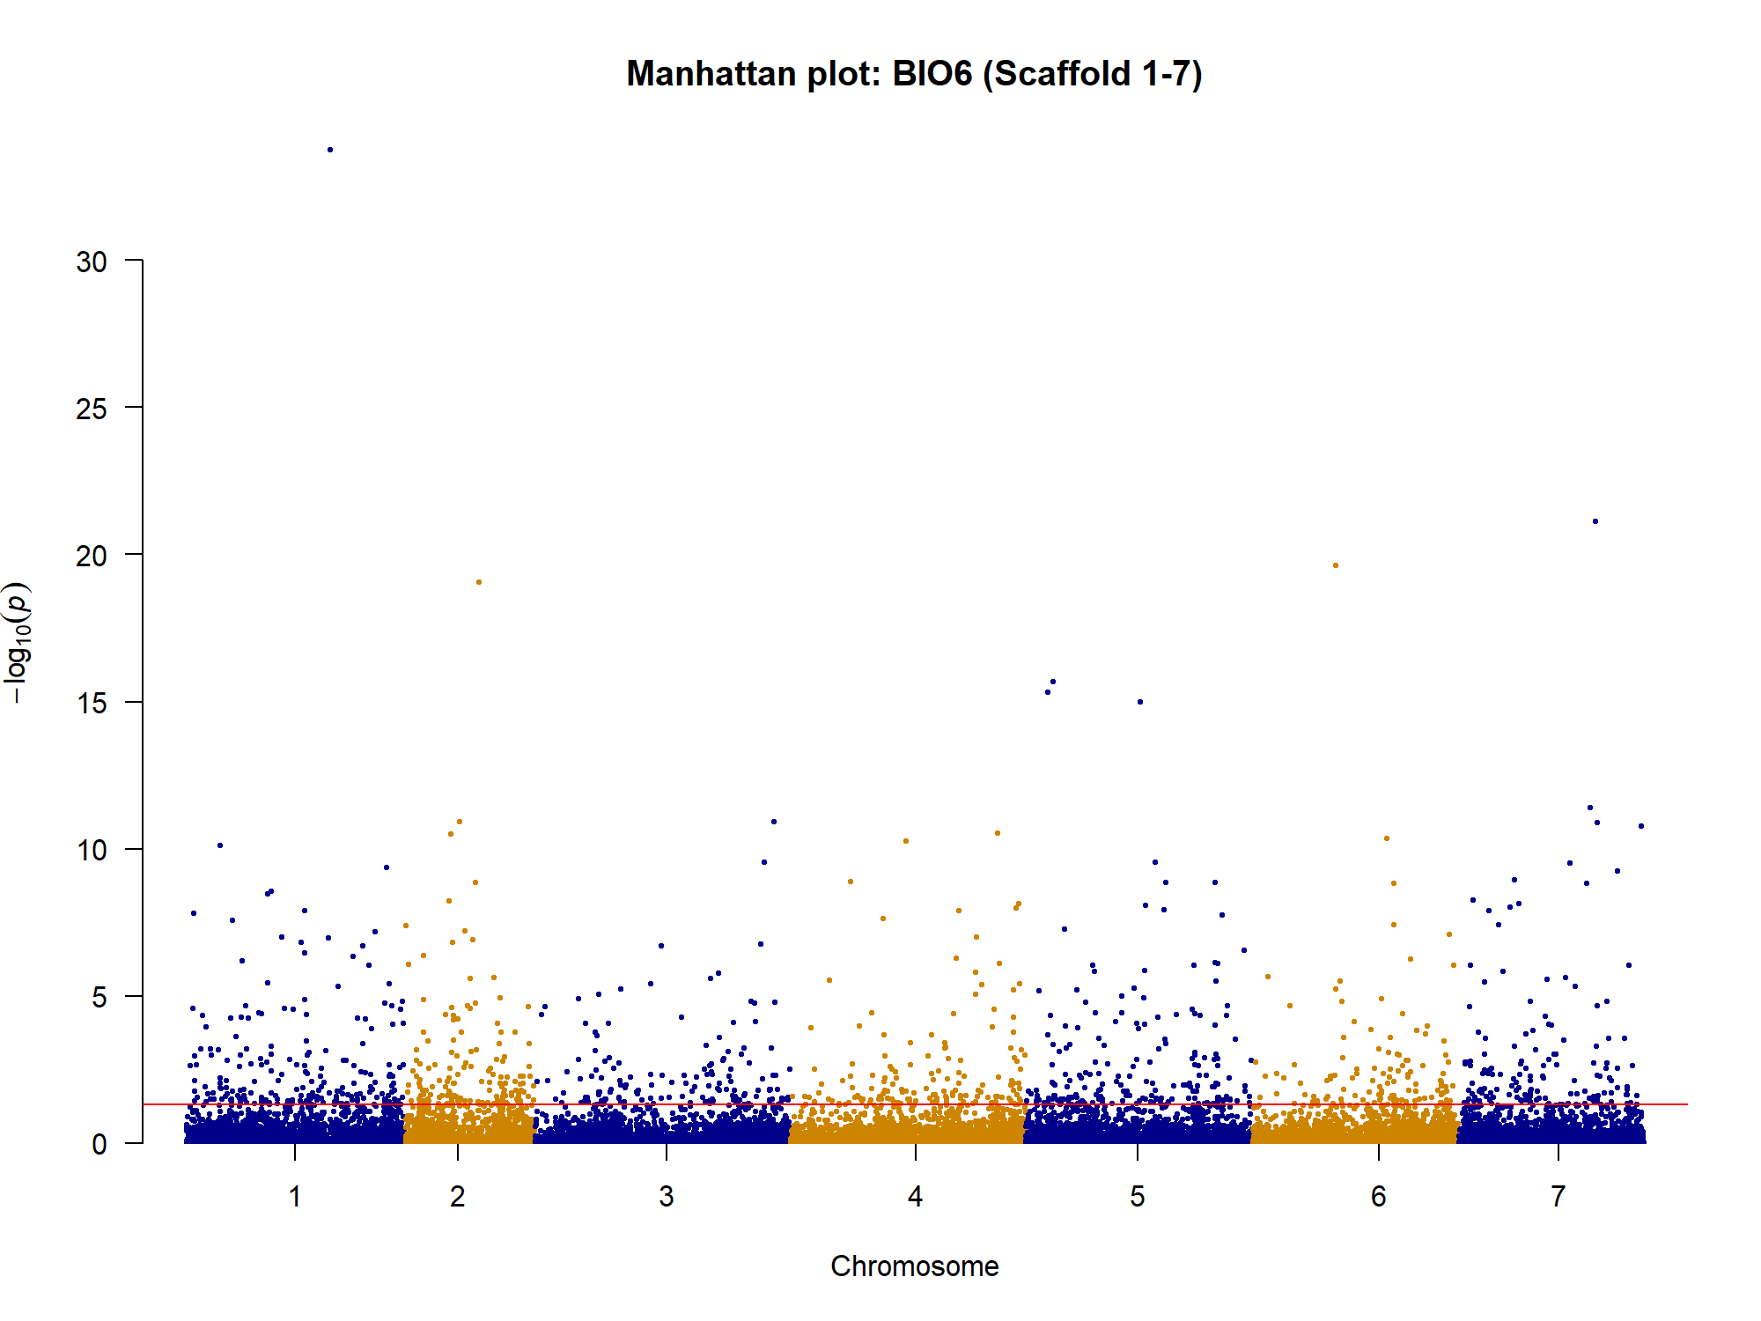
Scaffold
(B)
Scaffold
(C)
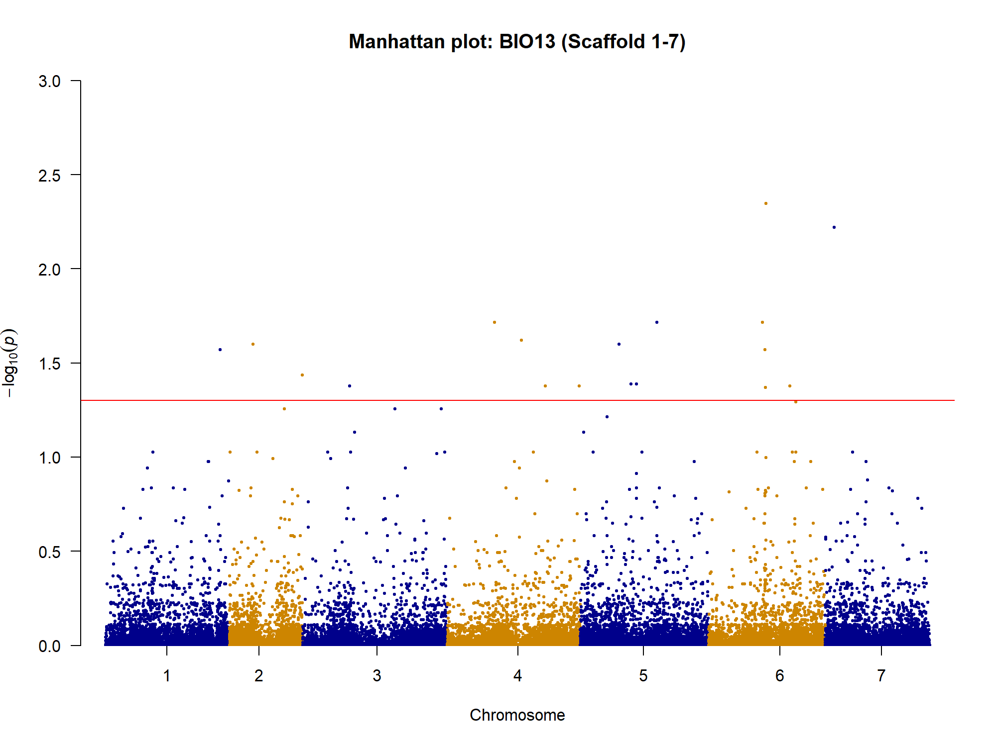
(D)
Scaffold
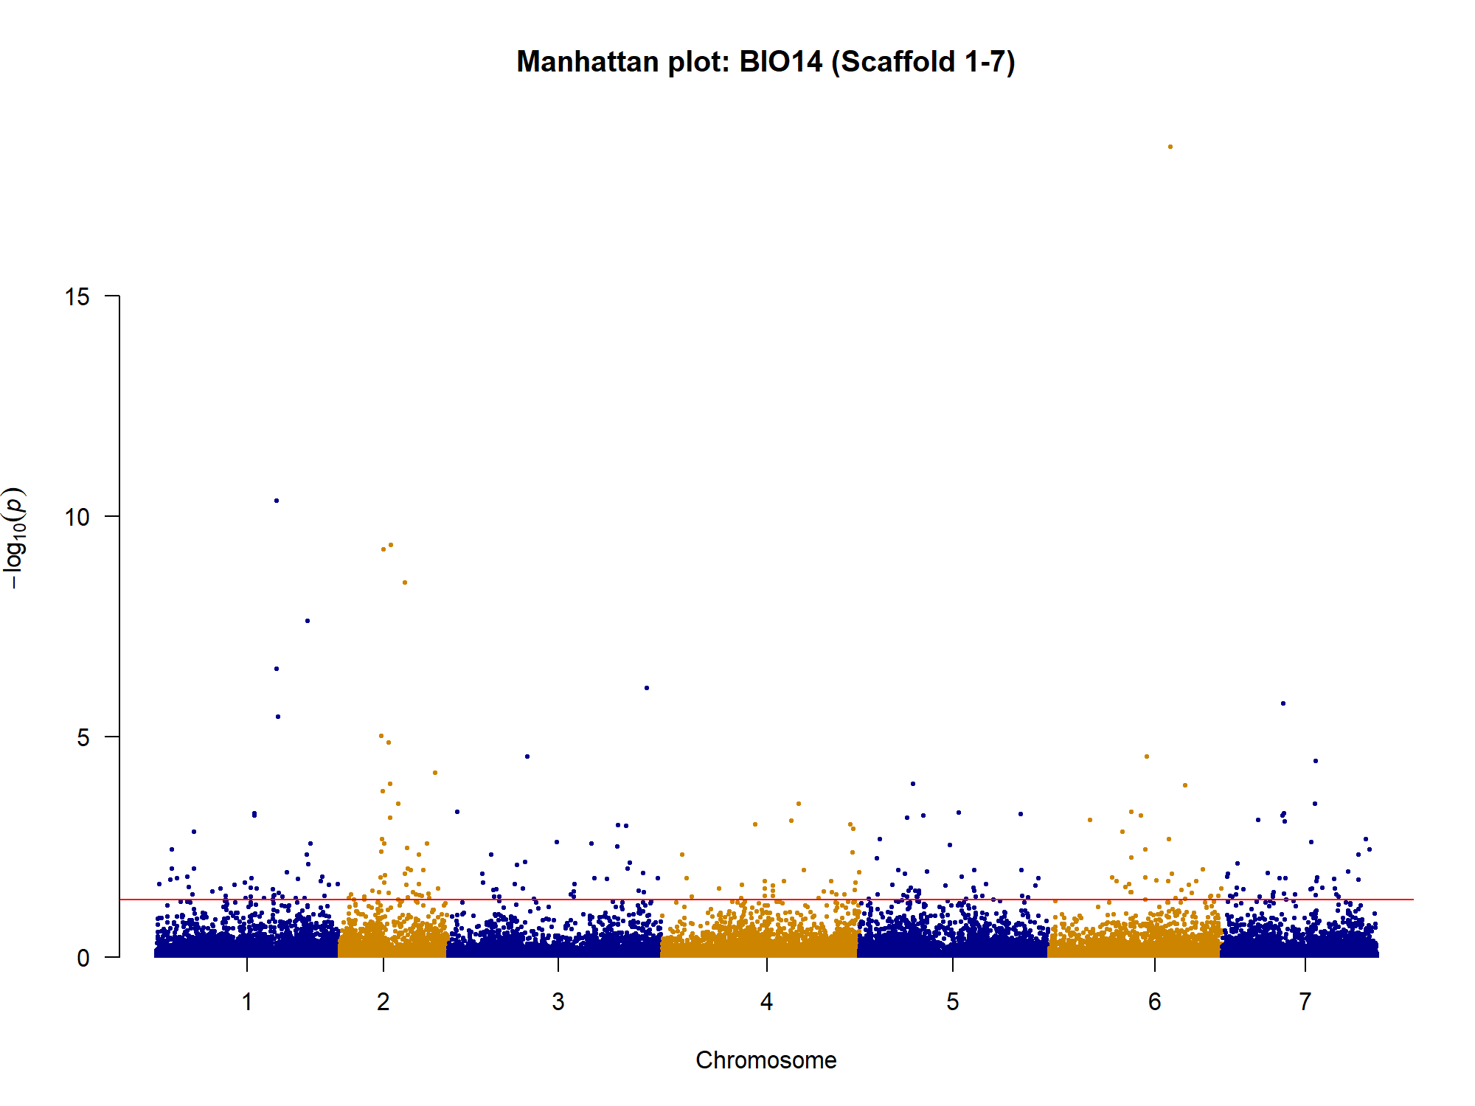
(E)
Scaffold

Supplementary Fig. S5 Manhattan plots showing genome-wide SNP associations with environmental variables in Rubroshorea leprosula: (A) Maximum temperature of warmest month (BIO5), (B) Minimum temperature of coldest month (BIO6), (C) Elevation, (D) Annual precipitation (BIO13) and (D) Precipitation of driest month (BIO14). The red horizontal line indicates the Benjamini-Hochberg significance threshold (adjusted p < 0.05). SNPs exceeding this threshold are considered significantly associated with the corresponding environmental variable.

