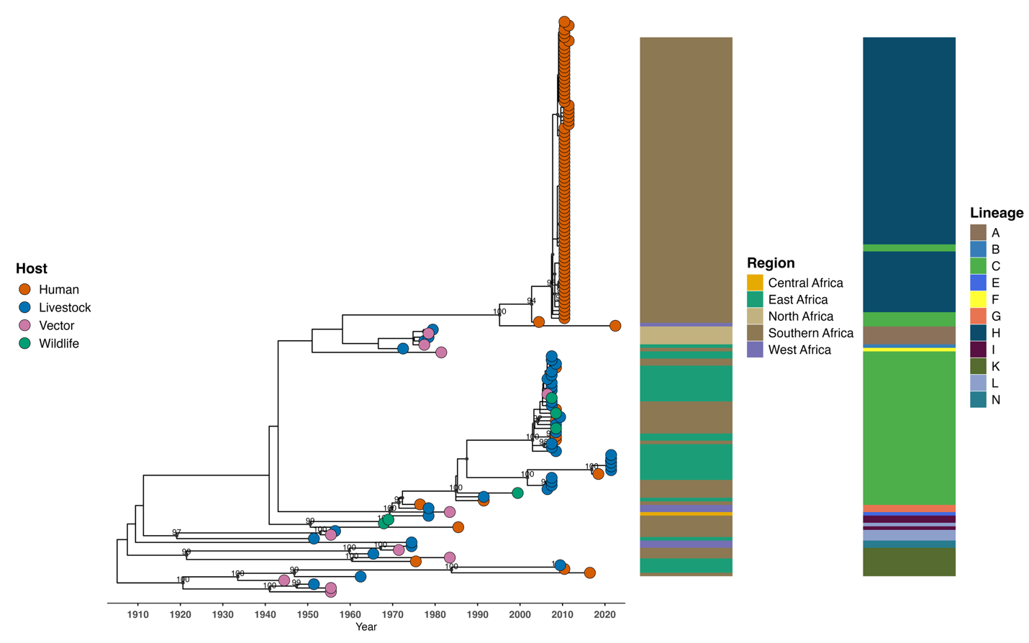
Figure S2: Phylogenetic structure of the RVFV L segment by host and geographic region. The tips are colored by host category (Human, Livestock, Wildlife and Vector). The heatmaps show the geographic regions (North Africa: Egypt, East: Uganda, Kenya, Madagascar, Southern Africa: South Africa, Namibia, Zimbabwe, Central Africa: Central African Republic, Angola and West Africa: Mauritania, Senegal, Burkina Faso, Guinea). Bootstrap values are shown on major nodes to indicate statistical support (≥70%).

