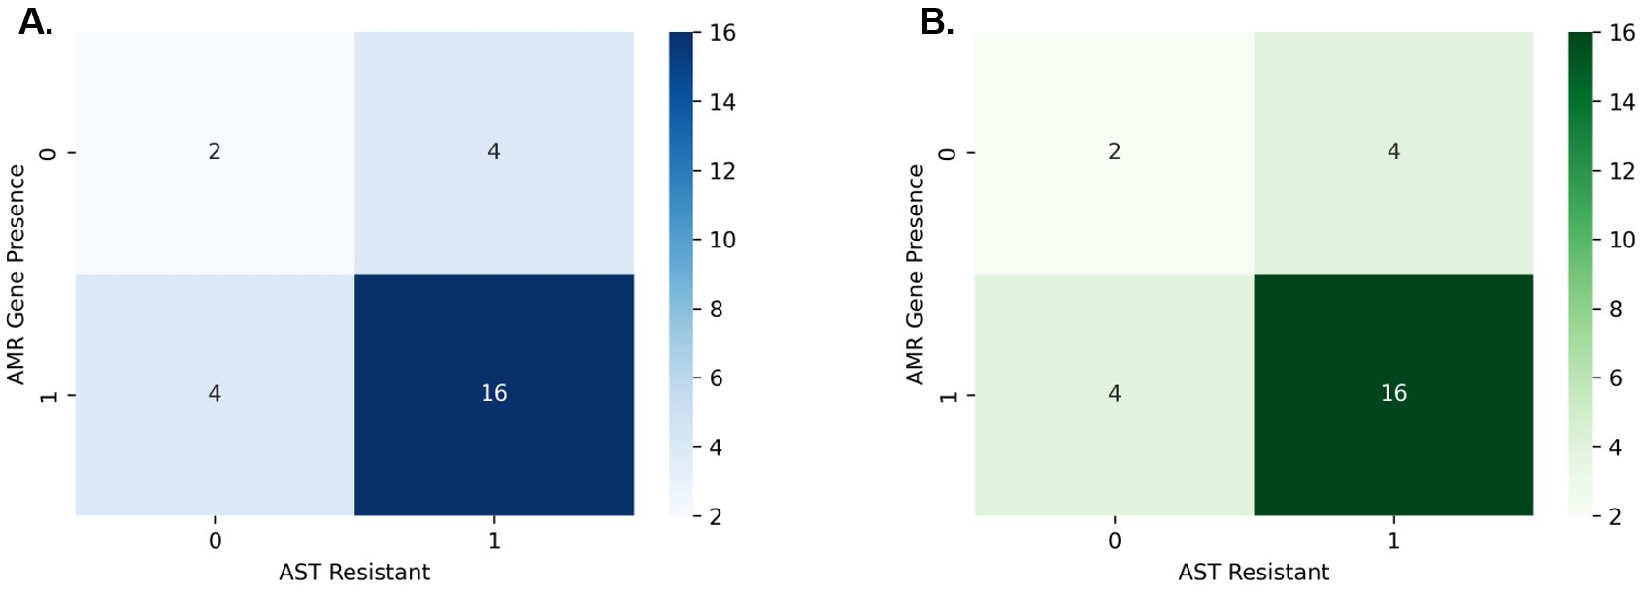

Supplementary Figure S1. Heatmap of AMR–AST concordance. A total of 26 bacterial genomes were analysed using either (A) locally installed computational workflows or (B) web-based tools. “0” indicates susceptibility and “1” indicates resistance for both phenotypic antimicrobial susceptibility testing (AST) and in silico AMR gene detection. The numbers shown in each cell represent the number of genomes in each category, and the colour intensity reflects the genome counts.

