Supplementary Appendix

Korean Soybean Nested Association Mapping (K-SoyNAM) Population: Genetic Linkage Map, Genetic Mapping, and Genotype Imputation

Ji-Min Kim¹, Jung-Kyung Moon², Soo-Kwon Park², Man-Soo Choi², Bo-Keun Ha³, Sungwoo Lee⁴, Kyung Do Kim⁵, Soon-Chun Jeong⁶, Ju Seok Lee⁶, Sungtaeg Kang^{1*}

Supplementary Appendix A: Genetic map information of NAM01~NAM24 RIL population
Supplementary Appendix B: Collinearity of genetic (cM) and physical position (Mbp) of the SNP integrated into the genetic map on chromosome 1~20 from 24 family of the K-SoyNAM population.
Supplementary Appendix C: Comparison between composite genetic linkage map and genetic linkage map from single RIL population
Supplementary Appendix A.1. Genetic map information of NAM01 (Daepung × Bangsa) RIL population
Chromosome | Length (cM) | No. of  total SNPs | No. of polymorphic SNPs | No. of  SNPs after binning | No. of mapped SNPs | Average distance  between SNPs (cM)
1 | 77.65 | 8379 | 1359 | 367 | 323 | 0.240
2 | 156.22 | 9514 | 1879 | 385 | 271 | 0.576
3 | 69.51 | 7673 | 841 | 109 | 100 | 0.695
4 | 120.65 | 8399 | 1497 | 318 | 290 | 0.416
5 | 114.97 | 7577 | 1130 | 323 | 293 | 0.392
6 | 102.68 | 9392 | 1681 | 447 | 416 | 0.247
7 | 135.08 | 8126 | 665 | 123 | 115 | 1.175
8 | 144.36 | 10475 | 1299 | 310 | 291 | 0.496
9 | 99.75 | 8621 | 1510 | 390 | 353 | 0.283
10 | 125.48 | 8820 | 1496 | 306 | 252 | 0.498
11 | 121.36 | 7481 | 740 | 160 | 138 | 0.879
12 | 81.35 | 7222 | 1147 | 325 | 293 | 0.278
13 | 113.68 | 10338 | 1488 | 460 | 436 | 0.261
14 | 116.02 | 7195 | 771 | 88 | 85 | 1.365
15 | 133.54 | 9423 | 1388 | 168 | 154 | 0.867
16 | 22.29 | 6980 | 483 | 241 | 163 | 0.137
16 | 5 | 6980 | 483 | 241 | 65 | 0.077
17 | 122.51 | 8347 | 884 | 182 | 172 | 0.712
18 | 73.23 | 9103 | 2277 | 819 | 757 | 0.097
19 | 134.31 | 8166 | 940 | 177 | 157 | 0.855
20 | 99.26 | 7797 | 735 | 189 | 175 | 0.567
Average | 103.28 | 8,451.4 | 1,210.5 | 294.35 | 252.3 | 0.409
Total | 2,168.9 | 169,028 | 24,210 | 5,887 | 5,299

Supplementary Appendix A.2. Genetic map information of NAM02 (Daepung × Pungwon) RIL population
Chromosome | Length (cM) | No. of  total SNPs | No. of polymorphic SNPs | No. of  SNPs after binning | No. of mapped SNPs | Average distance  between SNPs (cM)
1 | 96.38 | 8379 | 994 | 315 | 294 | 0.328
2 | 123.76 | 9514 | 1764 | 554 | 434 | 0.285
3 | 94.06 | 7673 | 807 | 335 | 317 | 0.297
4 | 119.37 | 8399 | 1624 | 559 | 515 | 0.232
5 | 98.65 | 7577 | 1395 | 599 | 550 | 0.179
6 | 122.99 | 9392 | 1626 | 647 | 573 | 0.215
7 | 105.3 | 8126 | 1561 | 614 | 611 | 0.172
8 | 139.97 | 10475 | 1067 | 439 | 401 | 0.349
9 | 111.84 | 8621 | 1671 | 660 | 549 | 0.204
10 | 120.96 | 8820 | 1181 | 484 | 453 | 0.267
11 | 112.2 | 7481 | 527 | 223 | 177 | 0.634
12 | 64.77 | 7222 | 832 | 411 | 395 | 0.164
13 | 115.15 | 10338 | 1458 | 432 | 421 | 0.274
14 | 89.91 | 7195 | 987 | 305 | 231 | 0.389
15 | 99.35 | 9423 | 1240 | 389 | 368 | 0.270
16 | 91.18 | 6980 | 1529 | 511 | 435 | 0.210
17 | 112.22 | 8347 | 851 | 368 | 336 | 0.334
18 | 94.52 | 9103 | 2303 | 820 | 782 | 0.121
19 | 101.25 | 8166 | 1421 | 435 | 395 | 0.256
20 | 81.43 | 7797 | 983 | 430 | 411 | 0.198
Average | 104.76 | 8,451.4 | 1,291.05 | 476.5 | 432.4 | 0.242
Total | 2,095.26 | 169,028 | 25,821 | 9,530 | 8,648
Supplementary Appendix A.3. Genetic map information of NAM03 (Daepung × Hannam) RIL population
Chromosome | Length (cM) | No. of  total SNPs | No. of polymorphic SNPs | No. of  SNPs after binning | No. of mapped SNPs | Average distance  between SNPs (cM)
1 | 105.92 | 8379 | 1212 | 594 | 562 | 0.188
2 | 147.27 | 9514 | 1826 | 603 | 550 | 0.268
3 | 101.4 | 7673 | 1156 | 527 | 512 | 0.198
4 | 148.32 | 8399 | 1364 | 543 | 501 | 0.296
5 | 96.33 | 7577 | 1256 | 600 | 586 | 0.164
6 | 111.46 | 9392 | 2152 | 942 | 902 | 0.124
7 | 128.31 | 8126 | 988 | 533 | 486 | 0.264
8 | 136.64 | 10475 | 1344 | 658 | 606 | 0.225
9 | 105.56 | 8621 | 1906 | 775 | 720 | 0.147
10 | 115.52 | 8820 | 1635 | 576 | 498 | 0.232
11 | 118.6 | 7481 | 970 | 452 | 378 | 0.314
12 | 48.46 | 7222 | 613 | 362 | 286 | 0.169
13 | 145.44 | 10338 | 849 | 425 | 390 | 0.373
14 | 108.59 | 7195 | 981 | 479 | 454 | 0.239
15 | 107.88 | 9423 | 1455 | 578 | 559 | 0.193
16 | 90.74 | 6980 | 774 | 377 | 369 | 0.246
17 | 103.49 | 8347 | 1300 | 552 | 511 | 0.203
18 | 103.51 | 9103 | 2052 | 747 | 676 | 0.153
19 | 112.58 | 8166 | 1222 | 496 | 419 | 0.269
20 | 110.06 | 7797 | 1044 | 551 | 526 | 0.209
Average | 112.30 | 8,451.4 | 1,304.95 | 568.5 | 524.55 | 0.214
Total | 2,246.08 | 169,028 | 26,099 | 11,370 | 10,491
Supplementary Appendix A.4. Genetic map information of NAM04 (Daepung × Somyeong) RIL population
Chromosome | Length (cM) | No. of  total SNPs | No. of polymorphic SNPs | No. of  SNPs after binning | No. of mapped SNPs | Average distance  between SNPs (cM)
1 | 91.85 | 8379 | 1181 | 388 | 369 | 0.249
2 | 120.37 | 9514 | 2003 | 618 | 570 | 0.211
3 | 46.78 | 7673 | 646 | 261 | 203 | 0.230
4 | 121.32 | 8399 | 791 | 323 | 302 | 0.402
5 | 103.4 | 7577 | 1278 | 476 | 450 | 0.230
6 | 119.95 | 9392 | 1552 | 643 | 610 | 0.197
7 | 51.73 | 8126 | 1474 | 636 | 357 | 0.145
7 | 25.33 | 8126 | 1474 | 636 | 244 | 0.104
8 | 142.75 | 10475 | 1715 | 771 | 703 | 0.203
9 | 111.72 | 8621 | 1480 | 603 | 544 | 0.205
10 | 91.82 | 8820 | 1271 | 576 | 556 | 0.165
11 | 104.18 | 7481 | 533 | 238 | 148 | 0.704
12 | 111.11 | 7222 | 1344 | 544 | 519 | 0.214
13 | 117.85 | 10338 | 1612 | 561 | 539 | 0.219
14 | 90.1 | 7195 | 1125 | 394 | 337 | 0.267
15 | 117.27 | 9423 | 1395 | 546 | 475 | 0.247
16 | 44.91 | 6980 | 1211 | 352 | 166 | 0.271
16 | 8.53 | 6980 | 1211 | 352 | 125 | 0.068
17 | 126.42 | 8347 | 1119 | 408 | 372 | 0.340
18 | 63.11 | 9103 | 2022 | 778 | 707 | 0.089
19 | 100.05 | 8166 | 1750 | 672 | 625 | 0.160
20 | 87.58 | 7797 | 987 | 434 | 408 | 0.215
Average | 90.82 | 8,451.4 | 1,324.45 | 511.1 | 424.05 | 0.214
Total | 1,998.13 | 169,028 | 26,489 | 10,222 | 9,329
Supplementary Appendix A.5. Genetic map information of NAM05 (Daepung × Galchae) RIL population
Chromosome | Length (cM) | No. of  total SNPs | No. of polymorphic SNPs | No. of  SNPs after binning | No. of mapped SNPs | Average distance  between SNPs (cM)
1 | 145.3 | 8379 | 892 | 422 | 325 | 0.447
2 | 189.97 | 9514 | 2168 | 1132 | 719 | 0.264
3 | 120.64 | 7673 | 1282 | 645 | 421 | 0.287
4 | 161.74 | 8399 | 1487 | 676 | 343 | 0.472
5 | 129.59 | 7577 | 1429 | 807 | 486 | 0.267
6 | 169.11 | 9392 | 2059 | 988 | 514 | 0.329
7 | 140.13 | 8126 | 930 | 484 | 305 | 0.459
8 | 179.39 | 10475 | 1473 | 799 | 530 | 0.338
9 | 152.97 | 8621 | 1951 | 1063 | 604 | 0.253
10 | 179.62 | 8820 | 1373 | 613 | 347 | 0.518
11 | 161.2 | 7481 | 955 | 600 | 353 | 0.457
12 | 103.26 | 7222 | 949 | 418 | 324 | 0.319
13 | 183.71 | 10338 | 1732 | 930 | 532 | 0.345
14 | 122.28 | 7195 | 1698 | 861 | 535 | 0.229
15 | 130.09 | 9423 | 1507 | 705 | 346 | 0.376
16 | 120.04 | 6980 | 878 | 591 | 290 | 0.414
17 | 148.86 | 8347 | 1240 | 708 | 409 | 0.364
18 | 139.26 | 9103 | 2407 | 1412 | 754 | 0.185
19 | 153.39 | 8166 | 1425 | 782 | 525 | 0.292
20 | 127.26 | 7797 | 921 | 570 | 332 | 0.383
Average | 147.89 | 8,451.4 | 1,437.8 | 760.3 | 449.7 | 0.329
Total | 2,957.81 | 169,028 | 28,756 | 15,206 | 8,994
Supplementary Appendix A.6. Genetic map information of NAM06 (Daepung × Soho) RIL population
Chromosome | Length (cM) | No. of  total SNPs | No. of polymorphic SNPs | No. of  SNPs after binning | No. of mapped SNPs | Average distance  between SNPs (cM)
1 | 73.43 | 8379 | 1358 | 627 | 517 | 0.142
2 | 153.14 | 9514 | 1873 | 953 | 656 | 0.233
3 | 105.14 | 7673 | 845 | 438 | 367 | 0.286
4 | 117.1 | 8399 | 1499 | 738 | 607 | 0.193
5 | 107.07 | 7577 | 1131 | 515 | 439 | 0.244
6 | 115.61 | 9392 | 1687 | 845 | 755 | 0.153
7 | 129.27 | 8126 | 663 | 310 | 283 | 0.457
8 | 86.53 | 10475 | 1305 | 627 | 550 | 0.157
9 | 97.69 | 8621 | 1517 | 804 | 673 | 0.145
10 | 123.55 | 8820 | 1498 | 719 | 551 | 0.224
11 | 108.84 | 7481 | 742 | 426 | 301 | 0.362
12 | 90.43 | 7222 | 1150 | 680 | 596 | 0.152
13 | 130.19 | 10338 | 1482 | 636 | 628 | 0.207
14 | 50.84 | 7195 | 774 | 379 | 194 | 0.262
15 | 95.99 | 9423 | 1396 | 635 | 427 | 0.225
16 | 54.78 | 6980 | 483 | 253 | 153 | 0.358
16 | 8.59 | 6980 | 483 | 253 | 85 | 0.101
17 | 107.72 | 8347 | 889 | 468 | 440 | 0.245
18 | 100.15 | 9103 | 2284 | 1181 | 819 | 0.122
19 | 87.11 | 8166 | 932 | 540 | 418 | 0.208
20 | 131.5 | 7797 | 735 | 432 | 404 | 0.325
Average | 98.79 | 8,451.4 | 1,212.15 | 610.3 | 469.67 | 0.210
Total | 2074.67 | 169,028 | 24,243 | 12,206 | 9,863
Supplementary Appendix A.7. Genetic map information of NAM07 (Daepung × Shinhwa) RIL population
Chromosome | Length (cM) | No. of  total SNPs | No. of polymorphic SNPs | No. of  SNPs after binning | No. of mapped SNPs | Average distance  between SNPs (cM)
1 | 89.29 | 8379 | 1228 | 444 | 349 | 0.256
2 | 129.6 | 9514 | 1777 | 659 | 458 | 0.283
3 | 89.95 | 7673 | 1007 | 561 | 492 | 0.183
4 | 118.1 | 8399 | 1190 | 510 | 387 | 0.305
5 | 97.86 | 7577 | 1220 | 537 | 467 | 0.210
6 | 143.08 | 9392 | 1465 | 672 | 492 | 0.291
7 | 36.48 | 8126 | 437 | 206 | 115 | 0.317
7 | 26.88 | 8126 | 437 | 206 | 27 | 0.996
8 | 152.28 | 10475 | 1051 | 437 | 343 | 0.444
9 | 85.26 | 8621 | 2014 | 945 | 597 | 0.143
10 | 126.04 | 8820 | 884 | 417 | 381 | 0.331
11 | 105.13 | 7481 | 562 | 288 | 199 | 0.528
12 | 98.51 | 7222 | 1103 | 485 | 424 | 0.232
13 | 112.85 | 10338 | 1161 | 527 | 400 | 0.282
14 | 86.69 | 7195 | 1050 | 366 | 296 | 0.293
15 | 85.94 | 9423 | 909 | 406 | 339 | 0.254
16 | 35.43 | 6980 | 534 | 231 | 124 | 0.286
16 | 8.32 | 6980 | 534 | 231 | 75 | 0.111
17 | 116.88 | 8347 | 1122 | 482 | 460 | 0.254
18 | 85.74 | 9103 | 2347 | 966 | 747 | 0.115
19 | 122.89 | 8166 | 1069 | 404 | 293 | 0.419
20 | 93.3 | 7797 | 1122 | 503 | 455 | 0.205
Average | 93.02 | 8,451.4 | 1,162.6 | 502.3 | 360 | 0.258
Total | 2,046.5 | 169,028 | 23,252 | 10,046 | 7,920
Supplementary Appendix A.8. Genetic map information of NAM08 (Daepung × Pureun) RIL population
Chromosome | Length (cM) | No. of  total SNPs | No. of polymorphic SNPs | No. of  SNPs after binning | No. of mapped SNPs | Average distance  between SNPs (cM)
1 | 53.17 | 8379 | 971 | 325 | 235 | 0.226
2 | 103.69 | 9514 | 1605 | 562 | 418 | 0.248
3 | 105.94 | 7673 | 1051 | 432 | 386 | 0.274
4 | 114.21 | 8399 | 1453 | 506 | 433 | 0.264
5 | 45.37 | 7577 | 812 | 306 | 217 | 0.209
5 | 2.57 | 7577 | 812 | 306 | 37 | 0.069
6 | 51.95 | 9392 | 693 | 287 | 177 | 0.294
6 | 3.56 | 9392 | 693 | 287 | 79 | 0.045
7 | 105.23 | 8126 | 757 | 254 | 250 | 0.421
8 | 102.19 | 10475 | 937 | 352 | 328 | 0.312
9 | 88.88 | 8621 | 2207 | 757 | 634 | 0.140
10 | 89.04 | 8820 | 1300 | 421 | 353 | 0.252
11 | 134.48 | 7481 | 542 | 225 | 179 | 0.751
12 | 72.68 | 7222 | 1274 | 498 | 479 | 0.152
13 | 98.87 | 10338 | 551 | 219 | 193 | 0.512
14 | 97.77 | 7195 | 750 | 276 | 220 | 0.444
15 | 57.54 | 9423 | 986 | 403 | 359 | 0.160
16 | 92.52 | 6980 | 618 | 220 | 203 | 0.456
17 | 88.72 | 8347 | 1487 | 510 | 462 | 0.192
18 | 96.36 | 9103 | 2062 | 637 | 525 | 0.184
19 | 83.19 | 8166 | 1530 | 533 | 435 | 0.191
20 | 102.52 | 7797 | 980 | 387 | 353 | 0.290
Average | 81.38 | 8,451.4 | 1,128.3 | 405.5 | 316.14 | 0.257
Total | 1,790.45 | 169,028 | 22,566 | 8,110 | 6,955
Supplementary Appendix A.9. Genetic map information of NAM09 (Daepung × Taekwang) RIL population
Chromosome | Length (cM) | No. of  total SNPs | No. of polymorphic SNPs | No. of  SNPs after binning | No. of mapped SNPs | Average distance  between SNPs (cM)
1 | 85.68 | 8379 | 1444 | 815 | 729 | 0.118
2 | 75.38 | 9514 | 971 | 711 | 571 | 0.132
3 | 59.5 | 7673 | 1043 | 668 | 577 | 0.103
4 | 119.96 | 8399 | 640 | 434 | 378 | 0.317
5 | 83.67 | 7577 | 1297 | 698 | 583 | 0.144
6 | 113.51 | 9392 | 1604 | 1045 | 907 | 0.125
7 | 109.81 | 8126 | 769 | 553 | 451 | 0.243
8 | 137.6 | 10475 | 1257 | 840 | 704 | 0.195
9 | 69.66 | 8621 | 1438 | 775 | 594 | 0.117
10 | 33.25 | 8820 | 811 | 507 | 165 | 0.202
10 | 60.96 | 8820 | 811 | 507 | 219 | 0.278
11 | 16.15 | 7481 | 274 | 162 | 135 | 0.120
12 | 84.46 | 7222 | 1056 | 664 | 607 | 0.139
13 | 109.35 | 10338 | 1110 | 734 | 644 | 0.170
14 | 56.61 | 7195 | 545 | 382 | 271 | 0.209
14 | 6.13 | 7195 | 545 | 382 | 81 | 0.076
15 | 80.04 | 9423 | 1353 | 827 | 515 | 0.155
16 | 75.97 | 6980 | 1192 | 712 | 602 | 0.126
17 | 28.08 | 8347 | 498 | 337 | 153 | 0.184
17 | 36.05 | 8347 | 498 | 337 | 109 | 0.331
18 | 69.73 | 9103 | 2008 | 1219 | 976 | 0.071
19 | 83.87 | 8166 | 1477 | 924 | 862 | 0.097
20 | 56.43 | 7797 | 476 | 267 | 265 | 0.213
Average | 71.82 | 8,451.4 | 1,063.15 | 663.7 | 482.52 | 0.149
Total | 1651.85 | 169,028 | 21,263 | 13,274 | 11,098
Supplementary Appendix A.10. Genetic map information of NAM10 (Daepung × Uram) RIL population
Chromosome | Length (cM) | No. of  total SNPs | No. of polymorphic SNPs | No. of  SNPs after binning | No. of mapped SNPs | Average distance  between SNPs (cM)
1 | 62.67 | 8379 | 963 | 311 | 248 | 0.253
2 | 147.5 | 9514 | 1649 | 832 | 704 | 0.210
3 | 111.35 | 7673 | 720 | 365 | 316 | 0.352
4 | 119.06 | 8399 | 1128 | 420 | 342 | 0.348
5 | 100.55 | 7577 | 928 | 358 | 309 | 0.325
6 | 110.85 | 9392 | 1281 | 545 | 515 | 0.215
7 | 105.49 | 8126 | 871 | 458 | 348 | 0.303
8 | 36.46 | 10475 | 650 | 280 | 96 | 0.380
8 | 17.55 | 10475 | 650 | 280 | 94 | 0.187
8 | 4.13 | 10475 | 650 | 280 | 63 | 0.066
9 | 145.38 | 8621 | 2046 | 858 | 667 | 0.218
10 | 133.34 | 8820 | 1211 | 493 | 440 | 0.303
11 | 127.13 | 7481 | 931 | 372 | 287 | 0.443
12 | 91.42 | 7222 | 1059 | 483 | 375 | 0.244
13 | 111.73 | 10338 | 901 | 404 | 358 | 0.312
14 | 108.43 | 7195 | 639 | 384 | 376 | 0.288
15 | 2.26 | 9423 | 352 | 101 | 19 | 0.119
15 | 22.37 | 9423 | 352 | 101 | 47 | 0.476
15 | 11.22 | 9423 | 352 | 101 | 15 | 0.748
16 | 99.18 | 6980 | 764 | 411 | 374 | 0.265
17 | 92.11 | 8347 | 631 | 299 | 219 | 0.421
18 | 131.19 | 9103 | 2020 | 867 | 646 | 0.203
19 | 21.04 | 8166 | 1540 | 639 | 277 | 0.076
19 | 51.11 | 8166 | 1540 | 639 | 269 | 0.190
20 | 120.6 | 7797 | 901 | 445 | 372 | 0.324
Average | 83.36 | 8,451.4 | 1,059.25 | 466.25 | 311.04 | 0.268
Total | 2084.12 | 169,028 | 21,185 | 9,325 | 7,776
Supplementary Appendix A.11. Genetic map information of NAM11 (Daepung × Danbaek) RIL population
Chromosome | Length (cM) | No. of  total SNPs | No. of polymorphic SNPs | No. of  SNPs after binning | No. of mapped SNPs | Average distance  between SNPs (cM)
1 | 68.72 | 8379 | 1171 | 364 | 331 | 0.208
2 | 87.83 | 9514 | 1907 | 421 | 394 | 0.223
3 | 55.86 | 7673 | 810 | 225 | 205 | 0.272
4 | 71.54 | 8399 | 759 | 247 | 224 | 0.319
5 | 40.1 | 7577 | 1264 | 378 | 350 | 0.115
6 | 81.11 | 9392 | 1539 | 455 | 428 | 0.190
7 | 69.71 | 8126 | 657 | 146 | 134 | 0.520
8 | 43.67 | 10475 | 749 | 139 | 119 | 0.367
9 | 68.46 | 8621 | 1394 | 397 | 345 | 0.198
10 | 86.26 | 8820 | 1360 | 222 | 218 | 0.396
11 | 94.64 | 7481 | 731 | 266 | 226 | 0.419
12 | 47.55 | 7222 | 1041 | 379 | 357 | 0.133
13 | 74.02 | 10338 | 1812 | 612 | 588 | 0.126
14 | 61.1 | 7195 | 972 | 339 | 330 | 0.185
15 | 76.32 | 9423 | 1665 | 404 | 378 | 0.202
16 | 53.32 | 6980 | 919 | 148 | 119 | 0.448
17 | 80.95 | 8347 | 1355 | 388 | 380 | 0.213
18 | 72.26 | 9103 | 2093 | 671 | 637 | 0.113
19 | 58.49 | 8166 | 620 | 250 | 239 | 0.245
20 | 68.3 | 7797 | 1486 | 252 | 242 | 0.282
Average | 68.01 | 8,451.4 | 1,215.2 | 335.15 | 312.2 | 0.218
Total | 1,360.21 | 169,028 | 24,304 | 6,703 | 6,244
Supplementary Appendix A.12. Genetic map information of NAM12 (Daepung × PI96983) RIL population
Chromosome | Length (cM) | No. of  total SNPs | No. of polymorphic SNPs | No. of  SNPs after binning | No. of mapped SNPs | Average distance  between SNPs (cM)
1 | 102.85 | 8379 | 900 | 380 | 369 | 0.279
2 | 144.97 | 9514 | 1894 | 456 | 391 | 0.371
3 | 102.29 | 7673 | 1419 | 437 | 410 | 0.249
4 | 119.34 | 8399 | 1374 | 398 | 365 | 0.327
5 | 123.48 | 7577 | 1226 | 421 | 406 | 0.304
6 | 135.43 | 9392 | 1686 | 534 | 497 | 0.272
7 | 124.27 | 8126 | 1133 | 433 | 416 | 0.299
8 | 112.32 | 10475 | 1335 | 435 | 376 | 0.299
9 | 110.78 | 8621 | 1866 | 604 | 598 | 0.185
10 | 137.61 | 8820 | 1514 | 579 | 536 | 0.257
11 | 133.87 | 7481 | 802 | 257 | 215 | 0.623
12 | 93.71 | 7222 | 1343 | 412 | 399 | 0.235
13 | 119.57 | 10338 | 1223 | 439 | 325 | 0.368
14 | 101.74 | 7195 | 1333 | 468 | 464 | 0.219
15 | 102.77 | 9423 | 1572 | 355 | 315 | 0.326
16 | 102.64 | 6980 | 1383 | 435 | 413 | 0.249
17 | 118.9 | 8347 | 1124 | 375 | 362 | 0.328
18 | 100.57 | 9103 | 2082 | 675 | 624 | 0.161
19 | 119.75 | 8166 | 1521 | 539 | 514 | 0.233
20 | 106.75 | 7797 | 959 | 342 | 337 | 0.317
Average | 115.68 | 8,451.4 | 1,384.45 | 448.7 | 416.6 | 0.278
Total | 2,313.61 | 169,028 | 27,689 | 8,974 | 8,332
Supplementary Appendix A.13. Genetic map information of NAM13 (Daepung × Haman) RIL population
Chromosome | Length (cM) | No. of  total SNPs | No. of polymorphic SNPs | No. of  SNPs after binning | No. of mapped SNPs | Average distance  between SNPs (cM)
1 | 87.26 | 8379 | 881 | 265 | 260 | 0.336
2 | 136.73 | 9514 | 2003 | 482 | 434 | 0.315
3 | 110.98 | 7673 | 1316 | 323 | 316 | 0.351
4 | 99.67 | 8399 | 1550 | 212 | 197 | 0.506
5 | 115.26 | 7577 | 1380 | 281 | 232 | 0.497
6 | 130.5 | 9392 | 1908 | 385 | 367 | 0.356
7 | 89.23 | 8126 | 1007 | 137 | 121 | 0.737
8 | 112.76 | 10475 | 1162 | 184 | 181 | 0.623
9 | 110.18 | 8621 | 1884 | 349 | 324 | 0.340
10 | 121.14 | 8820 | 1624 | 240 | 224 | 0.541
11 | 117.14 | 7481 | 1051 | 202 | 158 | 0.741
12 | 102.26 | 7222 | 1438 | 415 | 380 | 0.269
13 | 111.01 | 10338 | 1578 | 281 | 274 | 0.405
14 | 126.9 | 7195 | 944 | 56 | 55 | 2.307
15 | 96.55 | 9423 | 1452 | 275 | 232 | 0.416
16 | 42.65 | 6980 | 1388 | 279 | 215 | 0.198
17 | 48.82 | 8347 | 1011 | 142 | 58 | 0.842
17 | 47.71 | 8347 | 1011 | 142 | 82 | 0.582
18 | 70 | 9103 | 2045 | 586 | 522 | 0.134
19 | 109.72 | 8166 | 1269 | 219 | 208 | 0.528
20 | 105.59 | 7797 | 1032 | 237 | 213 | 0.496
Average | 99.62 | 8,451.4 | 1,396.15 | 277.5 | 240.62 | 0.414
Total | 2,092.06 | 169,028 | 27,923 | 5,550 | 5,053
Supplementary Appendix A.14. Genetic map information of NAM14 (Daepung × Williams 82) RIL population
Chromosome | Length (cM) | No. of  total SNPs | No. of polymorphic SNPs | No. of  SNPs after binning | No. of mapped SNPs | Average distance  between SNPs (cM)
1 | 10.46 | 8379 | 870 | 238 | 56 | 0.187
1 | 5.12 | 8379 | 870 | 238 | 129 | 0.040
1 | 3.17 | 8379 | 870 | 238 | 40 | 0.079
2 | 30.87 | 9514 | 1616 | 556 | 259 | 0.119
2 | 61.59 | 9514 | 1616 | 556 | 283 | 0.218
3 | 123.1 | 7673 | 757 | 380 | 341 | 0.361
4 | 116.59 | 8399 | 1470 | 402 | 382 | 0.305
5 | 26.93 | 7577 | 858 | 246 | 194 | 0.139
6 | 56.75 | 9392 | 421 | 168 | 123 | 0.461
6 | 2.61 | 9392 | 421 | 168 | 24 | 0.109
7 | 14.27 | 8126 | 763 | 220 | 52 | 0.274
7 | 47.39 | 8126 | 763 | 220 | 164 | 0.289
8 | 35.83 | 10475 | 151 | 123 | 57 | 0.629
9 | 102.32 | 8621 | 2246 | 669 | 605 | 0.169
10 | 54.79 | 8820 | 889 | 285 | 257 | 0.213
11 | 111.14 | 7481 | 570 | 243 | 217 | 0.512
12 | 86.64 | 7222 | 990 | 239 | 228 | 0.380
13 | 120 | 10338 | 1123 | 515 | 503 | 0.239
14 | 13.67 | 7195 | 575 | 215 | 134 | 0.102
14 | 51.39 | 7195 | 575 | 215 | 72 | 0.714
15 | 62.56 | 9423 | 1732 | 520 | 387 | 0.162
16 | 91.31 | 6980 | 699 | 300 | 276 | 0.331
17 | 104.52 | 8347 | 640 | 267 | 242 | 0.432
18 | 97.6 | 9103 | 2084 | 777 | 711 | 0.137
19 | 20.77 | 8166 | 1418 | 392 | 185 | 0.112
19 | 55.81 | 8166 | 1418 | 392 | 163 | 0.342
20 | 99.34 | 7797 | 739 | 275 | 195 | 0.509
Average | 59.50 | 8,451.4 | 1,030.55 | 351.5 | 232.56 | 0.256
Total | 1,606.54 | 169,028 | 20,611 | 7,030 | 6,279
Supplementary Appendix A.15. Genetic map information of NAM15 (Daepung × Saedanbaek) RIL population
Chromosome | Length (cM) | No. of  total SNPs | No. of polymorphic SNPs | No. of  SNPs after binning | No. of mapped SNPs | Average distance  between SNPs (cM)
1 | 68.02 | 8379 | 1513 | 174 | 170 | 0.400
2 | 70.76 | 9514 | 1338 | 253 | 226 | 0.313
3 | 74.19 | 7673 | 1170 | 265 | 252 | 0.294
4 | 56.68 | 8399 | 1360 | 216 | 203 | 0.279
5 | 59.78 | 7577 | 1352 | 243 | 221 | 0.270
6 | 70.22 | 9392 | 1612 | 259 | 237 | 0.296
7 | 54.99 | 8126 | 1112 | 215 | 208 | 0.264
8 | 78.34 | 10475 | 1372 | 272 | 234 | 0.335
9 | 46.51 | 8621 | 1177 | 196 | 160 | 0.291
10 | 55.11 | 8820 | 1488 | 284 | 252 | 0.219
11 | 70.87 | 7481 | 579 | 107 | 93 | 0.762
12 | 42.93 | 7222 | 1025 | 74 | 72 | 0.596
13 | 63.78 | 10338 | 1695 | 319 | 306 | 0.208
14 | 60.36 | 7195 | 1104 | 208 | 198 | 0.305
15 | 60.43 | 9423 | 1947 | 362 | 319 | 0.189
16 | 53.81 | 6980 | 1313 | 235 | 221 | 0.243
17 | 70.93 | 8347 | 717 | 168 | 164 | 0.433
18 | 75.82 | 9103 | 2172 | 143 | 141 | 0.538
19 | 62.91 | 8166 | 1548 | 253 | 175 | 0.359
20 | 56.21 | 7797 | 1098 | 218 | 204 | 0.276
Average | 62.63 | 8,451.4 | 1,334.6 | 223.2 | 202.8 | 0.309
Total | 1,252.65 | 169,028 | 26,692 | 4,464 | 4,056
Table A.16. Genetic map information of NAM16 (Daepung × Daewon) RIL population
Chromosome | Length (cM) | No. of  total SNPs | No. of polymorphic SNPs | No. of  SNPs after binning | No. of mapped SNPs | Average distance  between SNPs (cM)
1 | 120.23 | 8379 | 1290 | 263 | 246 | 0.489
2 | 79.36 | 9514 | 748 | 182 | 161 | 0.493
3 | 99.01 | 7673 | 1121 | 226 | 222 | 0.446
4 | 97.26 | 8399 | 1504 | 219 | 193 | 0.504
5 | 104.61 | 7577 | 1349 | 313 | 301 | 0.348
6 | 132.49 | 9392 | 1580 | 338 | 313 | 0.423
7 | 109.74 | 8126 | 1400 | 312 | 308 | 0.356
8 | 142.62 | 10475 | 1341 | 314 | 308 | 0.463
9 | 92.8 | 8621 | 1812 | 347 | 326 | 0.285
10 | 110.42 | 8820 | 1347 | 217 | 186 | 0.594
11 | 106.21 | 7481 | 940 | 194 | 157 | 0.676
12 | 91.38 | 7222 | 1005 | 204 | 199 | 0.459
13 | 136.4 | 10338 | 1503 | 298 | 281 | 0.485
14 | 91.35 | 7195 | 1147 | 302 | 296 | 0.309
15 | 117.91 | 9423 | 1634 | 312 | 297 | 0.397
16 | 123.76 | 6980 | 1731 | 232 | 231 | 0.536
17 | 116.11 | 8347 | 785 | 233 | 220 | 0.528
18 | 78.36 | 9103 | 1857 | 297 | 292 | 0.268
19 | 114.38 | 8166 | 1608 | 325 | 298 | 0.384
20 | 104.56 | 7797 | 686 | 228 | 209 | 0.500
Average | 108.45 | 8,451.4 | 1,319.4 | 267.8 | 252.2 | 0.430
Total | 2,168.96 | 169,028 | 26,388 | 5,356 | 5,044
Supplementary Appendix A.17. Genetic map information of NAM17 (Daepung × Hwangkeum) RIL population
Chromosome | Length (cM) | No. of  total SNPs | No. of polymorphic SNPs | No. of  SNPs after binning | No. of mapped SNPs | Average distance  between SNPs (cM)
1 | 99.58 | 8379 | 1381 | 351 | 344 | 0.289
2 | 62.88 | 9514 | 722 | 228 | 217 | 0.290
3 | 104.16 | 7673 | 1329 | 330 | 327 | 0.319
4 | 98.07 | 8399 | 1290 | 238 | 192 | 0.511
5 | 102.19 | 7577 | 1467 | 379 | 366 | 0.279
6 | 127.51 | 9392 | 1735 | 485 | 454 | 0.281
7 | 104.34 | 8126 | 1259 | 315 | 271 | 0.385
8 | 140.52 | 10475 | 1387 | 349 | 306 | 0.459
9 | 104.42 | 8621 | 1953 | 411 | 349 | 0.299
10 | 82.47 | 8820 | 1265 | 227 | 188 | 0.439
11 | 120.86 | 7481 | 855 | 234 | 214 | 0.565
12 | 90.82 | 7222 | 1049 | 258 | 243 | 0.374
13 | 141.17 | 10338 | 1267 | 312 | 274 | 0.515
14 | 91.89 | 7195 | 807 | 214 | 182 | 0.505
15 | 111.89 | 9423 | 1622 | 313 | 294 | 0.381
16 | 85.59 | 6980 | 1682 | 263 | 243 | 0.352
17 | 156.06 | 8347 | 666 | 163 | 151 | 1.034
18 | 116.01 | 9103 | 2041 | 553 | 517 | 0.224
19 | 123.97 | 8166 | 1181 | 277 | 264 | 0.470
20 | 116.39 | 7797 | 674 | 253 | 227 | 0.513
Average | 109.04 | 8,451.4 | 1,281.6 | 307.65 | 281.15 | 0.388
Total | 2,180.79 | 169,028 | 25,632 | 6,153 | 5,623
Supplementary Appendix A.18. Genetic map information of NAM18 (Daepung × Cheongja) RIL population
Chromosome | Length (cM) | No. of  total SNPs | No. of polymorphic SNPs | No. of  SNPs after binning | No. of mapped SNPs | Average distance  between SNPs (cM)
1 | 91.32 | 8379 | 1345 | 314 | 308 | 0.296
2 | 118.3 | 9514 | 1203 | 232 | 205 | 0.577
3 | 123.42 | 7673 | 1428 | 371 | 368 | 0.335
4 | 91.56 | 8399 | 1438 | 288 | 261 | 0.351
5 | 118.06 | 7577 | 1380 | 419 | 386 | 0.306
6 | 149.99 | 9392 | 1797 | 517 | 459 | 0.327
7 | 114.99 | 8126 | 1058 | 269 | 265 | 0.434
8 | 150.88 | 10475 | 1580 | 301 | 283 | 0.533
9 | 107.89 | 8621 | 1923 | 459 | 429 | 0.251
10 | 111.82 | 8820 | 1603 | 230 | 210 | 0.532
11 | 108.19 | 7481 | 926 | 206 | 173 | 0.625
12 | 82.91 | 7222 | 1283 | 363 | 353 | 0.235
13 | 112.24 | 10338 | 1754 | 274 | 254 | 0.442
14 | 89.46 | 7195 | 910 | 268 | 263 | 0.340
15 | 100.67 | 9423 | 1469 | 350 | 293 | 0.344
16 | 83.89 | 6980 | 1272 | 394 | 369 | 0.227
17 | 128.08 | 8347 | 831 | 118 | 103 | 1.243
18 | 102.36 | 9103 | 2207 | 445 | 428 | 0.239
19 | 85.52 | 8166 | 1334 | 288 | 243 | 0.352
20 | 101.06 | 7797 | 966 | 265 | 259 | 0.390
Average | 108.63 | 8,451.4 | 1,385.35 | 318.55 | 295.6 | 0.367
Total | 2,172.61 | 169,028 | 27,707 | 6,371 | 5,912
Supplementary Appendix A.19. Genetic map information of NAM19 (Daepung × Cheongja3) RIL population
Chromosome | Length (cM) | No. of  total SNPs | No. of polymorphic SNPs | No. of  SNPs after binning | No. of mapped SNPs | Average distance  between SNPs (cM)
1 | 106.76 | 8379 | 1322 | 277 | 237 | 0.450
2 | 125.5 | 9514 | 1782 | 426 | 391 | 0.321
3 | 107.51 | 7673 | 1300 | 351 | 317 | 0.339
4 | 91.8 | 8399 | 1173 | 275 | 257 | 0.357
5 | 104.1 | 7577 | 1399 | 384 | 368 | 0.283
6 | 149.15 | 9392 | 1822 | 513 | 457 | 0.326
7 | 114.95 | 8126 | 1019 | 305 | 266 | 0.432
8 | 156.65 | 10475 | 1492 | 401 | 387 | 0.405
9 | 114.9 | 8621 | 2064 | 444 | 408 | 0.282
10 | 116.2 | 8820 | 1405 | 378 | 349 | 0.333
11 | 121.32 | 7481 | 973 | 276 | 219 | 0.554
12 | 79.89 | 7222 | 1296 | 372 | 370 | 0.216
13 | 146.39 | 10338 | 1649 | 433 | 370 | 0.396
14 | 91.83 | 7195 | 1041 | 360 | 299 | 0.307
15 | 102.56 | 9423 | 1838 | 507 | 459 | 0.223
16 | 100.69 | 6980 | 1593 | 376 | 280 | 0.360
17 | 120.06 | 8347 | 383 | 141 | 123 | 0.976
18 | 101.81 | 9103 | 2204 | 477 | 412 | 0.247
19 | 80.86 | 8166 | 1408 | 424 | 378 | 0.214
20 | 99.08 | 7797 | 916 | 207 | 184 | 0.538
Average | 111.60 | 8,451.4 | 1,403.95 | 366.35 | 326.55 | 0.342
Total | 2,232.01 | 169,028 | 28,079 | 7,327 | 6,531
Supplementary Appendix A.20. Genetic map information of NAM20 (Daepung × Sochung2) RIL population
Chromosome | Length (cM) | No. of  total SNPs | No. of polymorphic SNPs | No. of  SNPs after binning | No. of mapped SNPs | Average distance  between SNPs (cM)
1 | 110.32 | 8379 | 1814 | 590 | 524 | 0.211
2 | 138.35 | 9514 | 1412 | 265 | 263 | 0.526
3 | 107.51 | 7673 | 1371 | 304 | 300 | 0.358
4 | 139.28 | 8399 | 1532 | 344 | 316 | 0.441
5 | 107.62 | 7577 | 639 | 168 | 156 | 0.690
6 | 133.65 | 9392 | 2000 | 569 | 517 | 0.259
7 | 116.84 | 8126 | 1622 | 323 | 313 | 0.373
8 | 136.13 | 10475 | 2414 | 542 | 530 | 0.257
9 | 123.31 | 8621 | 1166 | 335 | 301 | 0.410
10 | 118.41 | 8820 | 1171 | 317 | 302 | 0.392
11 | 137.88 | 7481 | 1205 | 323 | 278 | 0.496
12 | 59.78 | 7222 | 733 | 146 | 124 | 0.482
13 | 136.42 | 10338 | 2225 | 573 | 547 | 0.249
14 | 96.29 | 7195 | 1011 | 327 | 321 | 0.300
15 | 123.3 | 9423 | 1986 | 486 | 449 | 0.275
16 | 92.81 | 6980 | 1615 | 328 | 316 | 0.294
17 | 132.21 | 8347 | 1786 | 396 | 385 | 0.343
18 | 108.45 | 9103 | 1055 | 307 | 296 | 0.366
19 | 100.67 | 8166 | 1351 | 374 | 365 | 0.276
20 | 108.14 | 7797 | 1645 | 424 | 409 | 0.264
Average | 116.37 | 8,451.4 | 1,487.65 | 372.05 | 350.6 | 0.332
Total | 2,327.37 | 169,028 | 29,753 | 7,441 | 7,012
Supplementary Appendix A.21. Genetic map information of NAM21 (Daepung × Ilpumgeomjeong) RIL population
Chromosome | Length (cM) | No. of  total SNPs | No. of polymorphic SNPs | No. of  SNPs after binning | No. of mapped SNPs | Average distance  between SNPs (cM)
1 | 106.26 | 8379 | 1467 | 465 | 444 | 0.239
2 | 138.97 | 9514 | 1937 | 356 | 207 | 0.671
3 | 96.44 | 7673 | 1192 | 435 | 407 | 0.237
4 | 113.21 | 8399 | 1525 | 500 | 436 | 0.260
5 | 47.66 | 7577 | 1211 | 345 | 321 | 0.148
6 | 156.03 | 9392 | 1736 | 573 | 542 | 0.288
7 | 127.83 | 8126 | 1031 | 392 | 349 | 0.366
8 | 158.11 | 10475 | 1503 | 661 | 603 | 0.262
9 | 106.35 | 8621 | 1824 | 682 | 571 | 0.186
10 | 125.37 | 8820 | 1097 | 322 | 311 | 0.403
11 | 125.19 | 7481 | 1016 | 464 | 401 | 0.312
12 | 92.21 | 7222 | 1414 | 357 | 318 | 0.290
13 | 153.51 | 10338 | 1504 | 569 | 483 | 0.318
14 | 120.65 | 7195 | 1268 | 378 | 359 | 0.336
15 | 106.73 | 9423 | 1896 | 441 | 274 | 0.390
16 | 89.53 | 6980 | 966 | 486 | 314 | 0.285
17 | 118.36 | 8347 | 1086 | 397 | 368 | 0.322
18 | 120.45 | 9103 | 1939 | 460 | 362 | 0.333
19 | 103.28 | 8166 | 1511 | 476 | 361 | 0.286
20 | 82.03 | 7797 | 579 | 211 | 188 | 0.436
Average | 114.41 | 8,451.4 | 1,385.1 | 448.5 | 380.95 | 0.300
Total | 2,288.17 | 169,028 | 27,702 | 8,970 | 7,619
Supplementary Appendix A.22. Genetic map information of NAM23 (Daepung × Josaengseori) RIL population
Chromosome | Length (cM) | No. of  total SNPs | No. of polymorphic SNPs | No. of  SNPs after binning | No. of mapped SNPs | Average distance  between SNPs (cM)
1 | 106.94 | 8379 | 1260 | 407 | 330 | 0.324
2 | 134.16 | 9514 | 1809 | 455 | 321 | 0.418
3 | 93.48 | 7673 | 1283 | 285 | 216 | 0.433
4 | 110.11 | 8399 | 1439 | 431 | 289 | 0.381
5 | 95.64 | 7577 | 1270 | 433 | 345 | 0.277
6 | 95.8 | 9392 | 1769 | 705 | 549 | 0.174
7 | 127.32 | 8126 | 981 | 345 | 226 | 0.563
8 | 140.81 | 10475 | 1420 | 490 | 403 | 0.349
9 | 88.22 | 8621 | 1958 | 660 | 456 | 0.193
10 | 132.76 | 8820 | 1612 | 494 | 366 | 0.363
11 | 150.53 | 7481 | 1047 | 385 | 280 | 0.538
12 | 93.34 | 7222 | 1339 | 456 | 316 | 0.295
13 | 162.99 | 10338 | 1652 | 454 | 332 | 0.491
14 | 89.78 | 7195 | 1223 | 385 | 299 | 0.300
15 | 102.79 | 9423 | 1698 | 549 | 463 | 0.222
16 | 62.43 | 6980 | 1622 | 549 | 316 | 0.198
17 | 123.28 | 8347 | 1082 | 359 | 282 | 0.437
18 | 123.19 | 9103 | 2012 | 614 | 488 | 0.252
19 | 142.22 | 8166 | 1423 | 354 | 278 | 0.512
20 | 110.51 | 7797 | 976 | 397 | 367 | 0.301
Average | 114.32 | 8,451.4 | 1,443.75 | 460.35 | 346.1 | 0.330
Total | 2,286.3 | 169,028 | 28,875 | 9,207 | 6,922
Supplementary Appendix A.23. Genetic map information of NAM24 (Daepung × Yonpoong) RIL population
Chromosome | Length (cM) | No. of  total SNPs | No. of polymorphic SNPs | No. of  SNPs after binning | No. of mapped SNPs | Average distance  between SNPs (cM)
1 | 105.21 | 8379 | 1342 | 659 | 634 | 0.166
2 | 121.43 | 9514 | 1787 | 894 | 731 | 0.166
3 | 95.26 | 7673 | 1196 | 661 | 633 | 0.150
4 | 113.44 | 8399 | 966 | 623 | 423 | 0.268
5 | 83.92 | 7577 | 960 | 629 | 504 | 0.167
5 | 3.75 | 7577 | 960 | 629 | 64 | 0.059
6 | 139.66 | 9392 | 1401 | 855 | 691 | 0.202
7 | 104.15 | 8126 | 1030 | 584 | 529 | 0.197
8 | 131.55 | 10475 | 1011 | 521 | 496 | 0.265
9 | 85.97 | 8621 | 1861 | 1111 | 988 | 0.087
10 | 106.48 | 8820 | 1430 | 661 | 606 | 0.176
11 | 103.55 | 7481 | 988 | 554 | 501 | 0.207
12 | 83.43 | 7222 | 1070 | 651 | 603 | 0.138
13 | 112.72 | 10338 | 884 | 571 | 506 | 0.223
14 | 78.57 | 7195 | 1007 | 543 | 444 | 0.177
15 | 101.87 | 9423 | 1826 | 807 | 646 | 0.158
16 | 72.93 | 6980 | 511 | 330 | 225 | 0.324
17 | 95.67 | 8347 | 1141 | 604 | 553 | 0.173
18 | 89.05 | 9103 | 2006 | 1083 | 760 | 0.117
19 | 89.38 | 8166 | 1436 | 780 | 725 | 0.123
20 | 102.53 | 7797 | 972 | 598 | 475 | 0.216
Average | 96.22 | 8,451.4 | 1,241.25 | 685.95 | 558.90 | 0.172
Total | 2,020.52 | 169,028 | 24,825 | 13,719 | 11,737
Supplementary Appendix A.24. Genetic map information of NAM25 (Daepung × 1000Al) RIL population
Chromosome | Length (cM) | No. of  total SNPs | No. of polymorphic SNPs | No. of  SNPs after binning | No. of mapped SNPs | Average distance  between SNPs (cM)
1 | 107.55 | 8379 | 811 | 186 | 177 | 0.608
2 | 52.68 | 9514 | 1612 | 260 | 115 | 0.458
2 | 55.23 | 9514 | 1612 | 260 | 136 | 0.406
3 | 102.89 | 7673 | 1062 | 299 | 291 | 0.354
4 | 98.99 | 8399 | 1314 | 250 | 243 | 0.407
5 | 107.47 | 7577 | 1026 | 205 | 196 | 0.548
6 | 104.14 | 9392 | 1507 | 262 | 237 | 0.439
7 | 7.48 | 8126 | 28 | 18 | 17 | 0.440
8 | 139.99 | 10475 | 1242 | 243 | 234 | 0.598
9 | 120.33 | 8621 | 2019 | 372 | 354 | 0.340
10 | 92.34 | 8820 | 1176 | 215 | 205 | 0.450
11 | 124 | 7481 | 836 | 174 | 147 | 0.844
12 | 53.51 | 7222 | 950 | 157 | 115 | 0.465
13 | 2.64 | 10338 | 821 | 134 | 19 | 0.139
13 | 6.78 | 10338 | 821 | 134 | 16 | 0.424
13 | 51.21 | 10338 | 821 | 134 | 93 | 0.551
14 | 73.24 | 7195 | 1367 | 297 | 272 | 0.269
15 | 71.63 | 9423 | 937 | 240 | 231 | 0.310
16 | 93.12 | 6980 | 993 | 177 | 172 | 0.541
17 | 113.11 | 8347 | 944 | 251 | 235 | 0.481
18 | 102.55 | 9103 | 2390 | 505 | 492 | 0.208
19 | 18.84 | 8166 | 85 | 22 | 20 | 0.942
20 | 112.49 | 7797 | 878 | 242 | 236 | 0.477
Average | 78.79 | 8,451.4 | 1,099.9 | 225.45 | 184.91 | 0.426
Total | 1,812.21 | 169,028 | 21,998 | 4,509 | 4,253
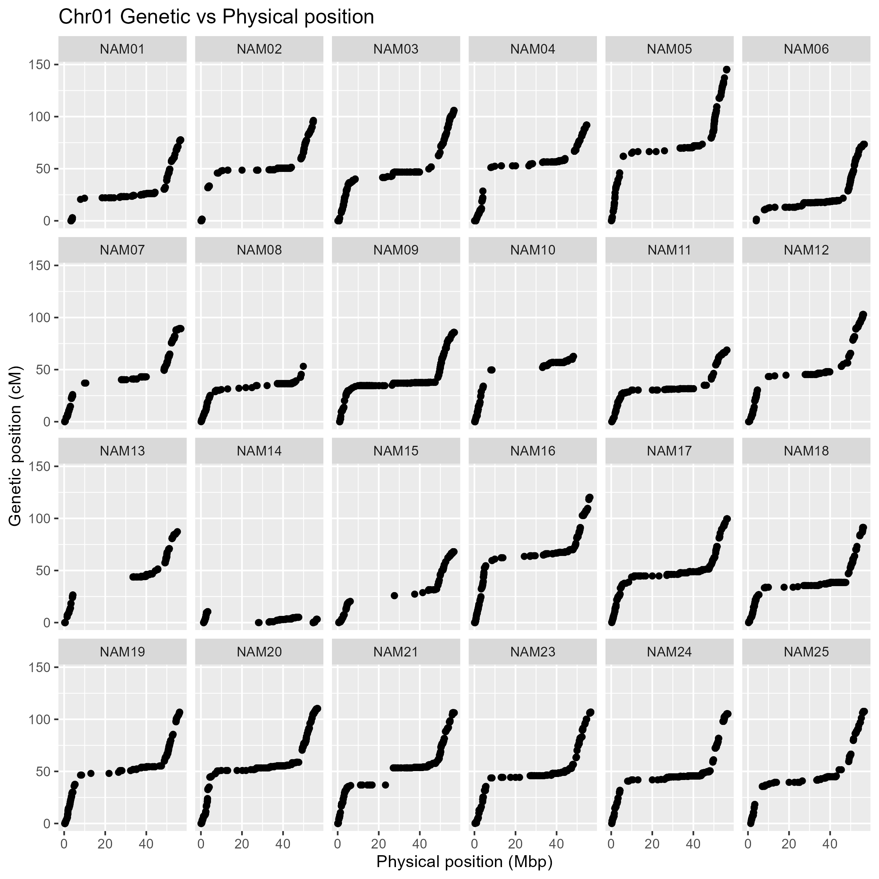
Supplementary Appendix B.1. Collinearity of genetic (cM) and physical position (Mbp) of the SNP integrated into the genetic map on chromosome 1 from 24 family of the K-SoyNAM population. The y-axis and x-axis indicate the genetic and physical positions based on the reference soybean genome, respectively (Glyma.Wm82.a2.v1).
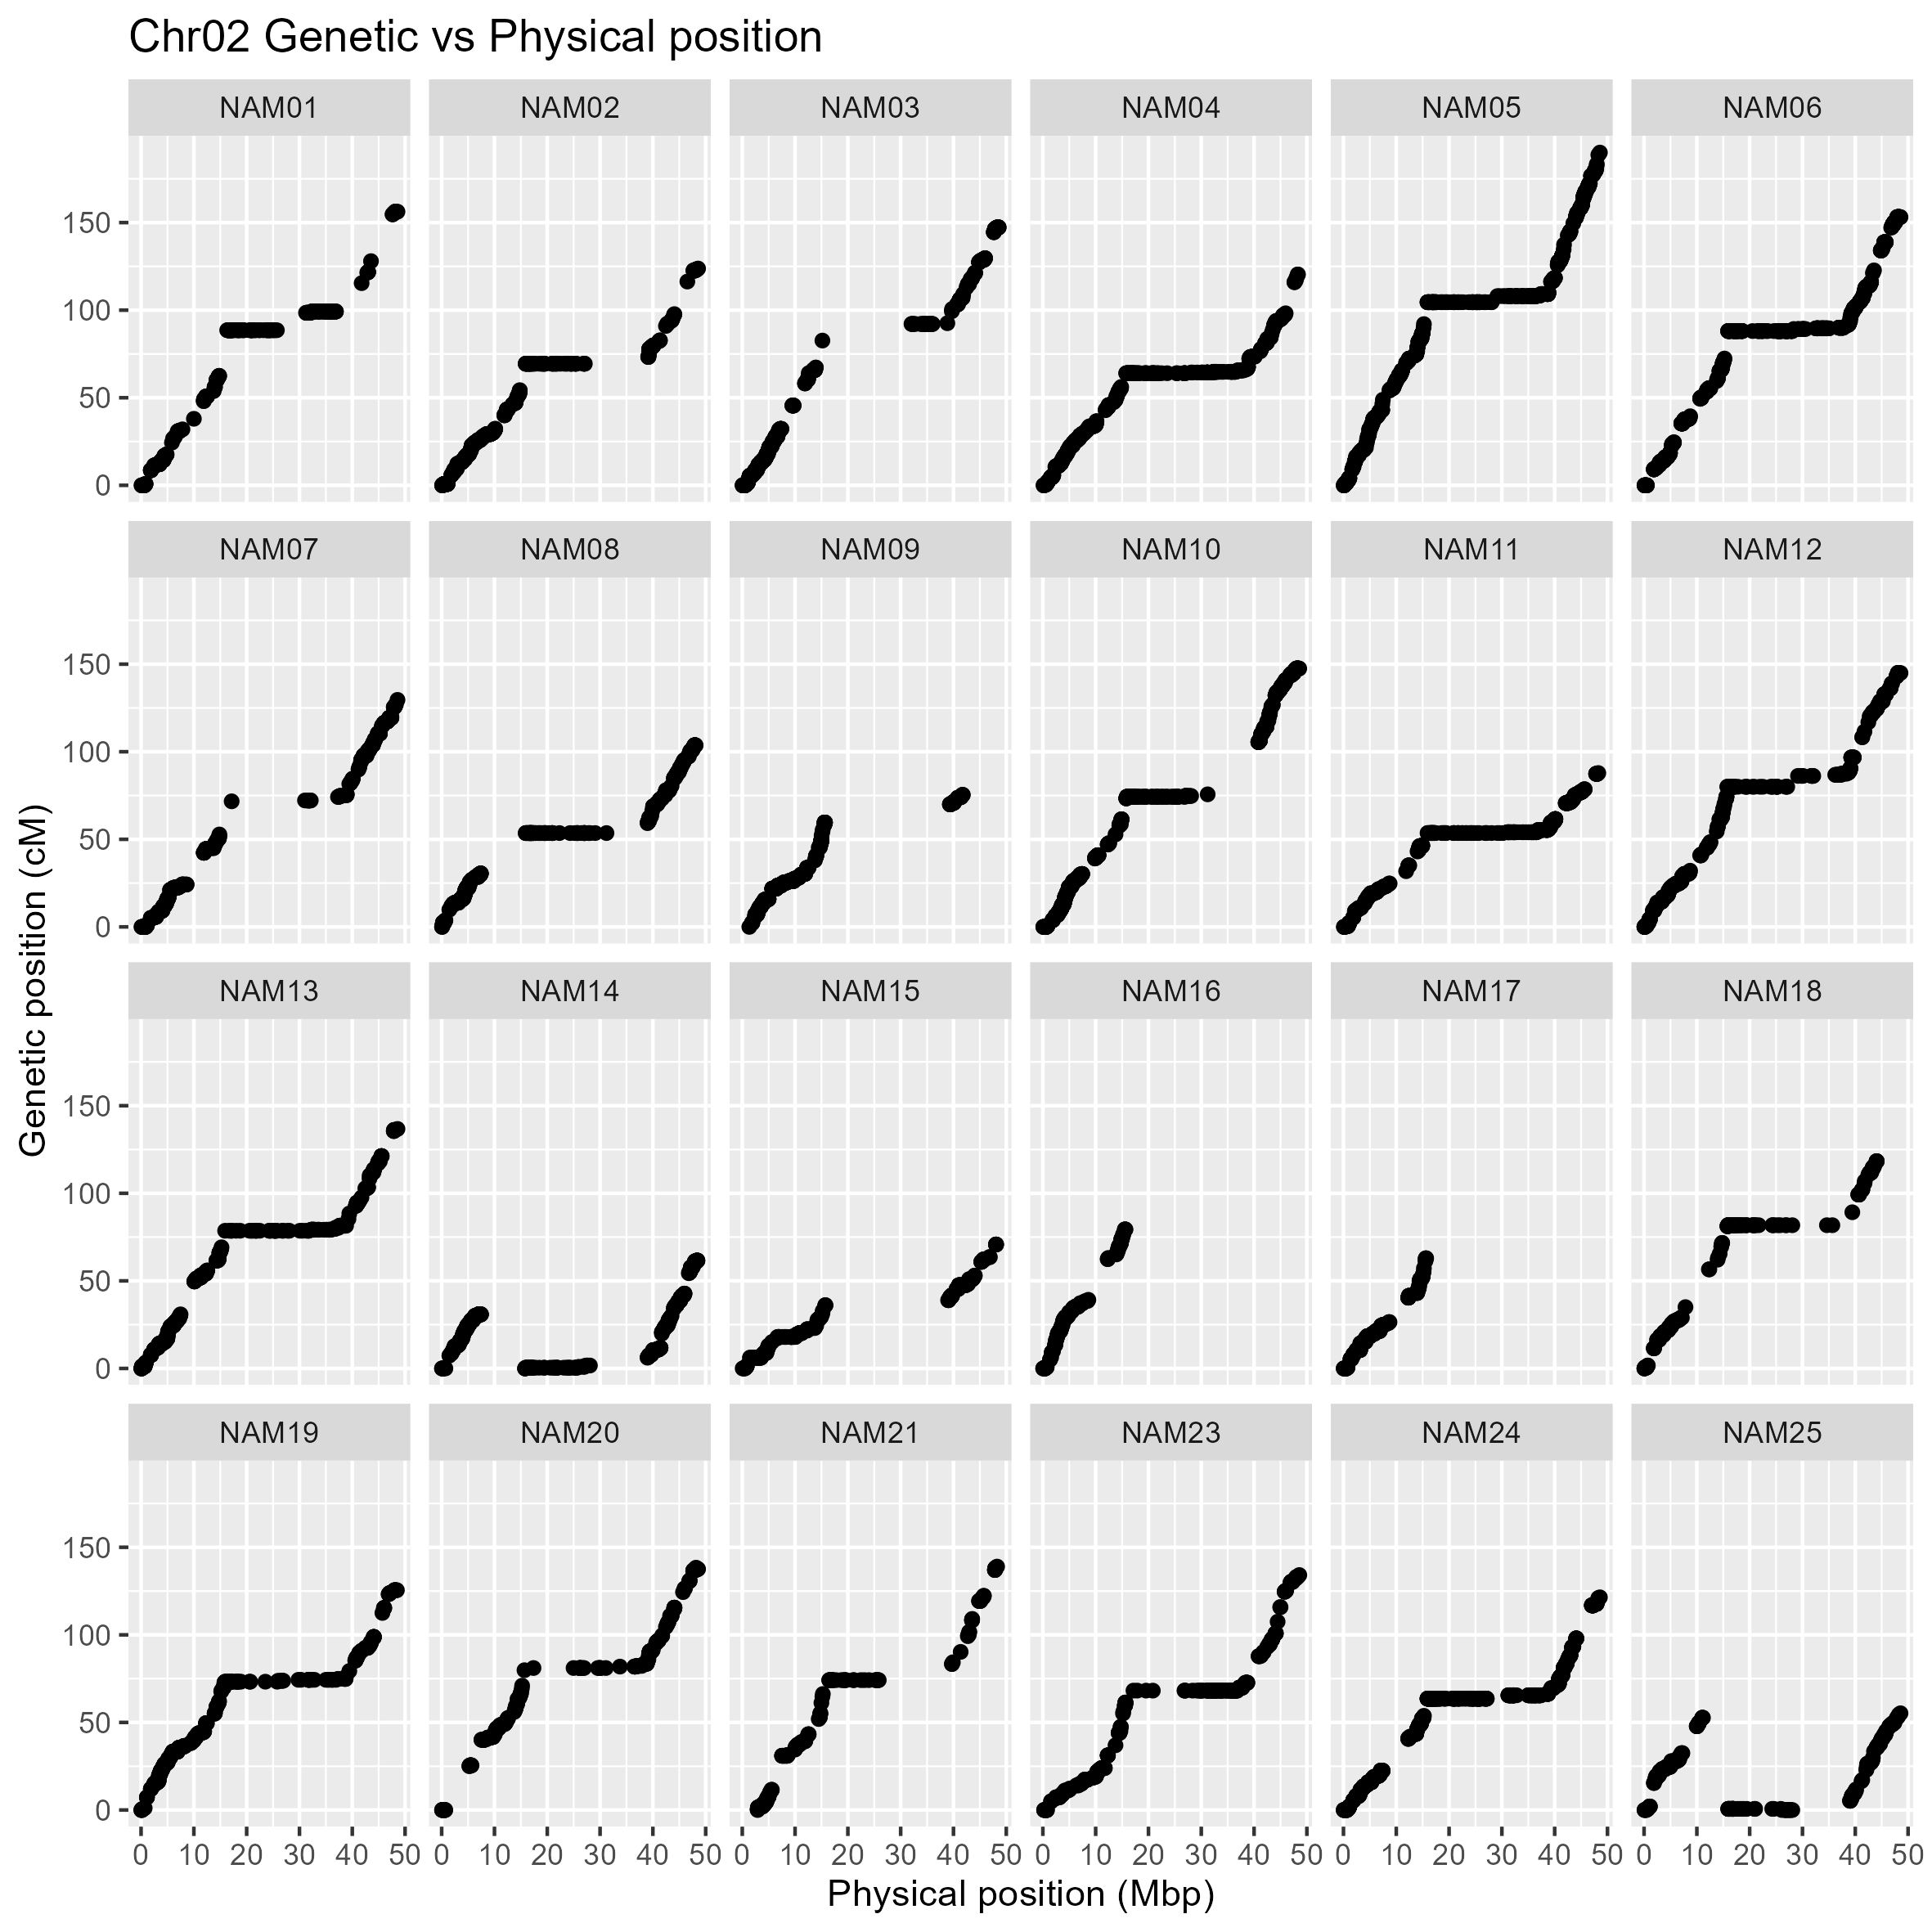
Supplementary Appendix B.2. Collinearity of genetic (cM) and physical position (Mbp) of the SNP integrated into the genetic map on chromosome 2 from 24 family of the K-SoyNAM population. The y-axis and x-axis indicate the genetic and physical positions based on the reference soybean genome, respectively (Glyma.Wm82.a2.v1).
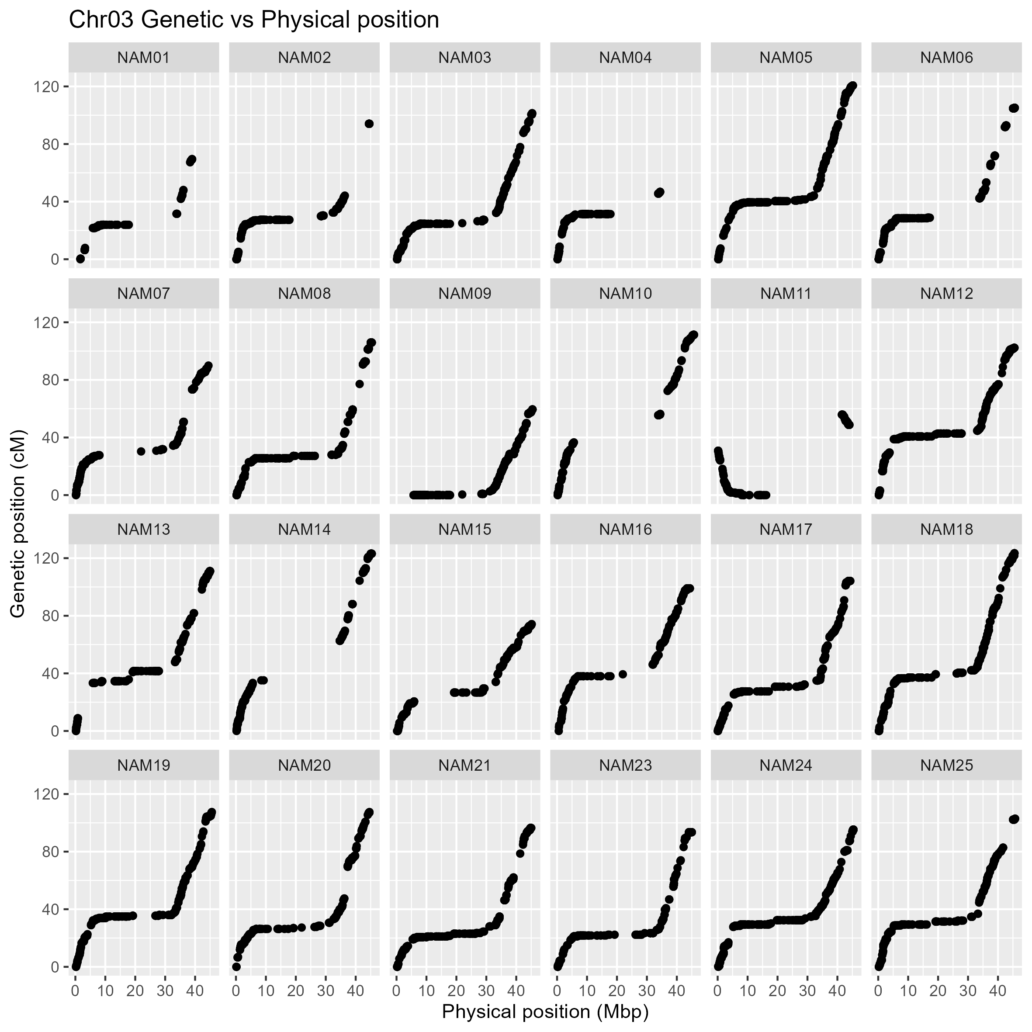
Supplementary Appendix B.3. Collinearity of genetic (cM) and physical position (Mbp) of the SNP integrated into the genetic map on chromosome 3 from 24 family of the K-SoyNAM population. The y-axis and x-axis indicate the genetic and physical positions based on the reference soybean genome, respectively (Glyma.Wm82.a2.v1).
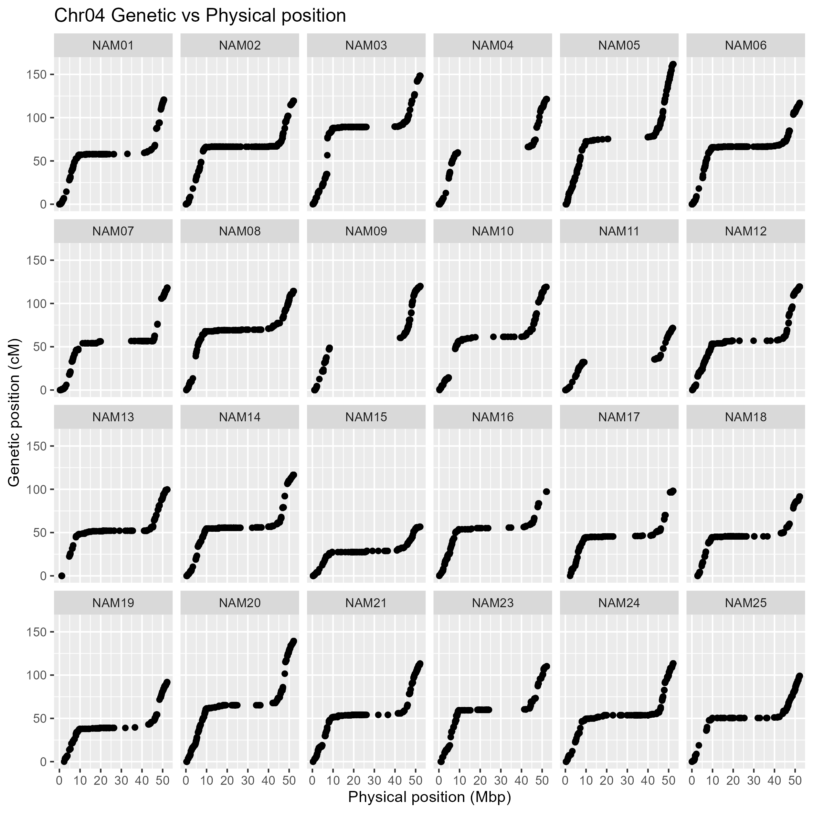
Supplementary Appendix B.4. Collinearity of genetic (cM) and physical position (Mbp) of the SNP integrated into the genetic map on chromosome 4 from 24 family of the K-SoyNAM population. The y-axis and x-axis indicate the genetic and physical positions based on the reference soybean genome, respectively (Glyma.Wm82.a2.v1).
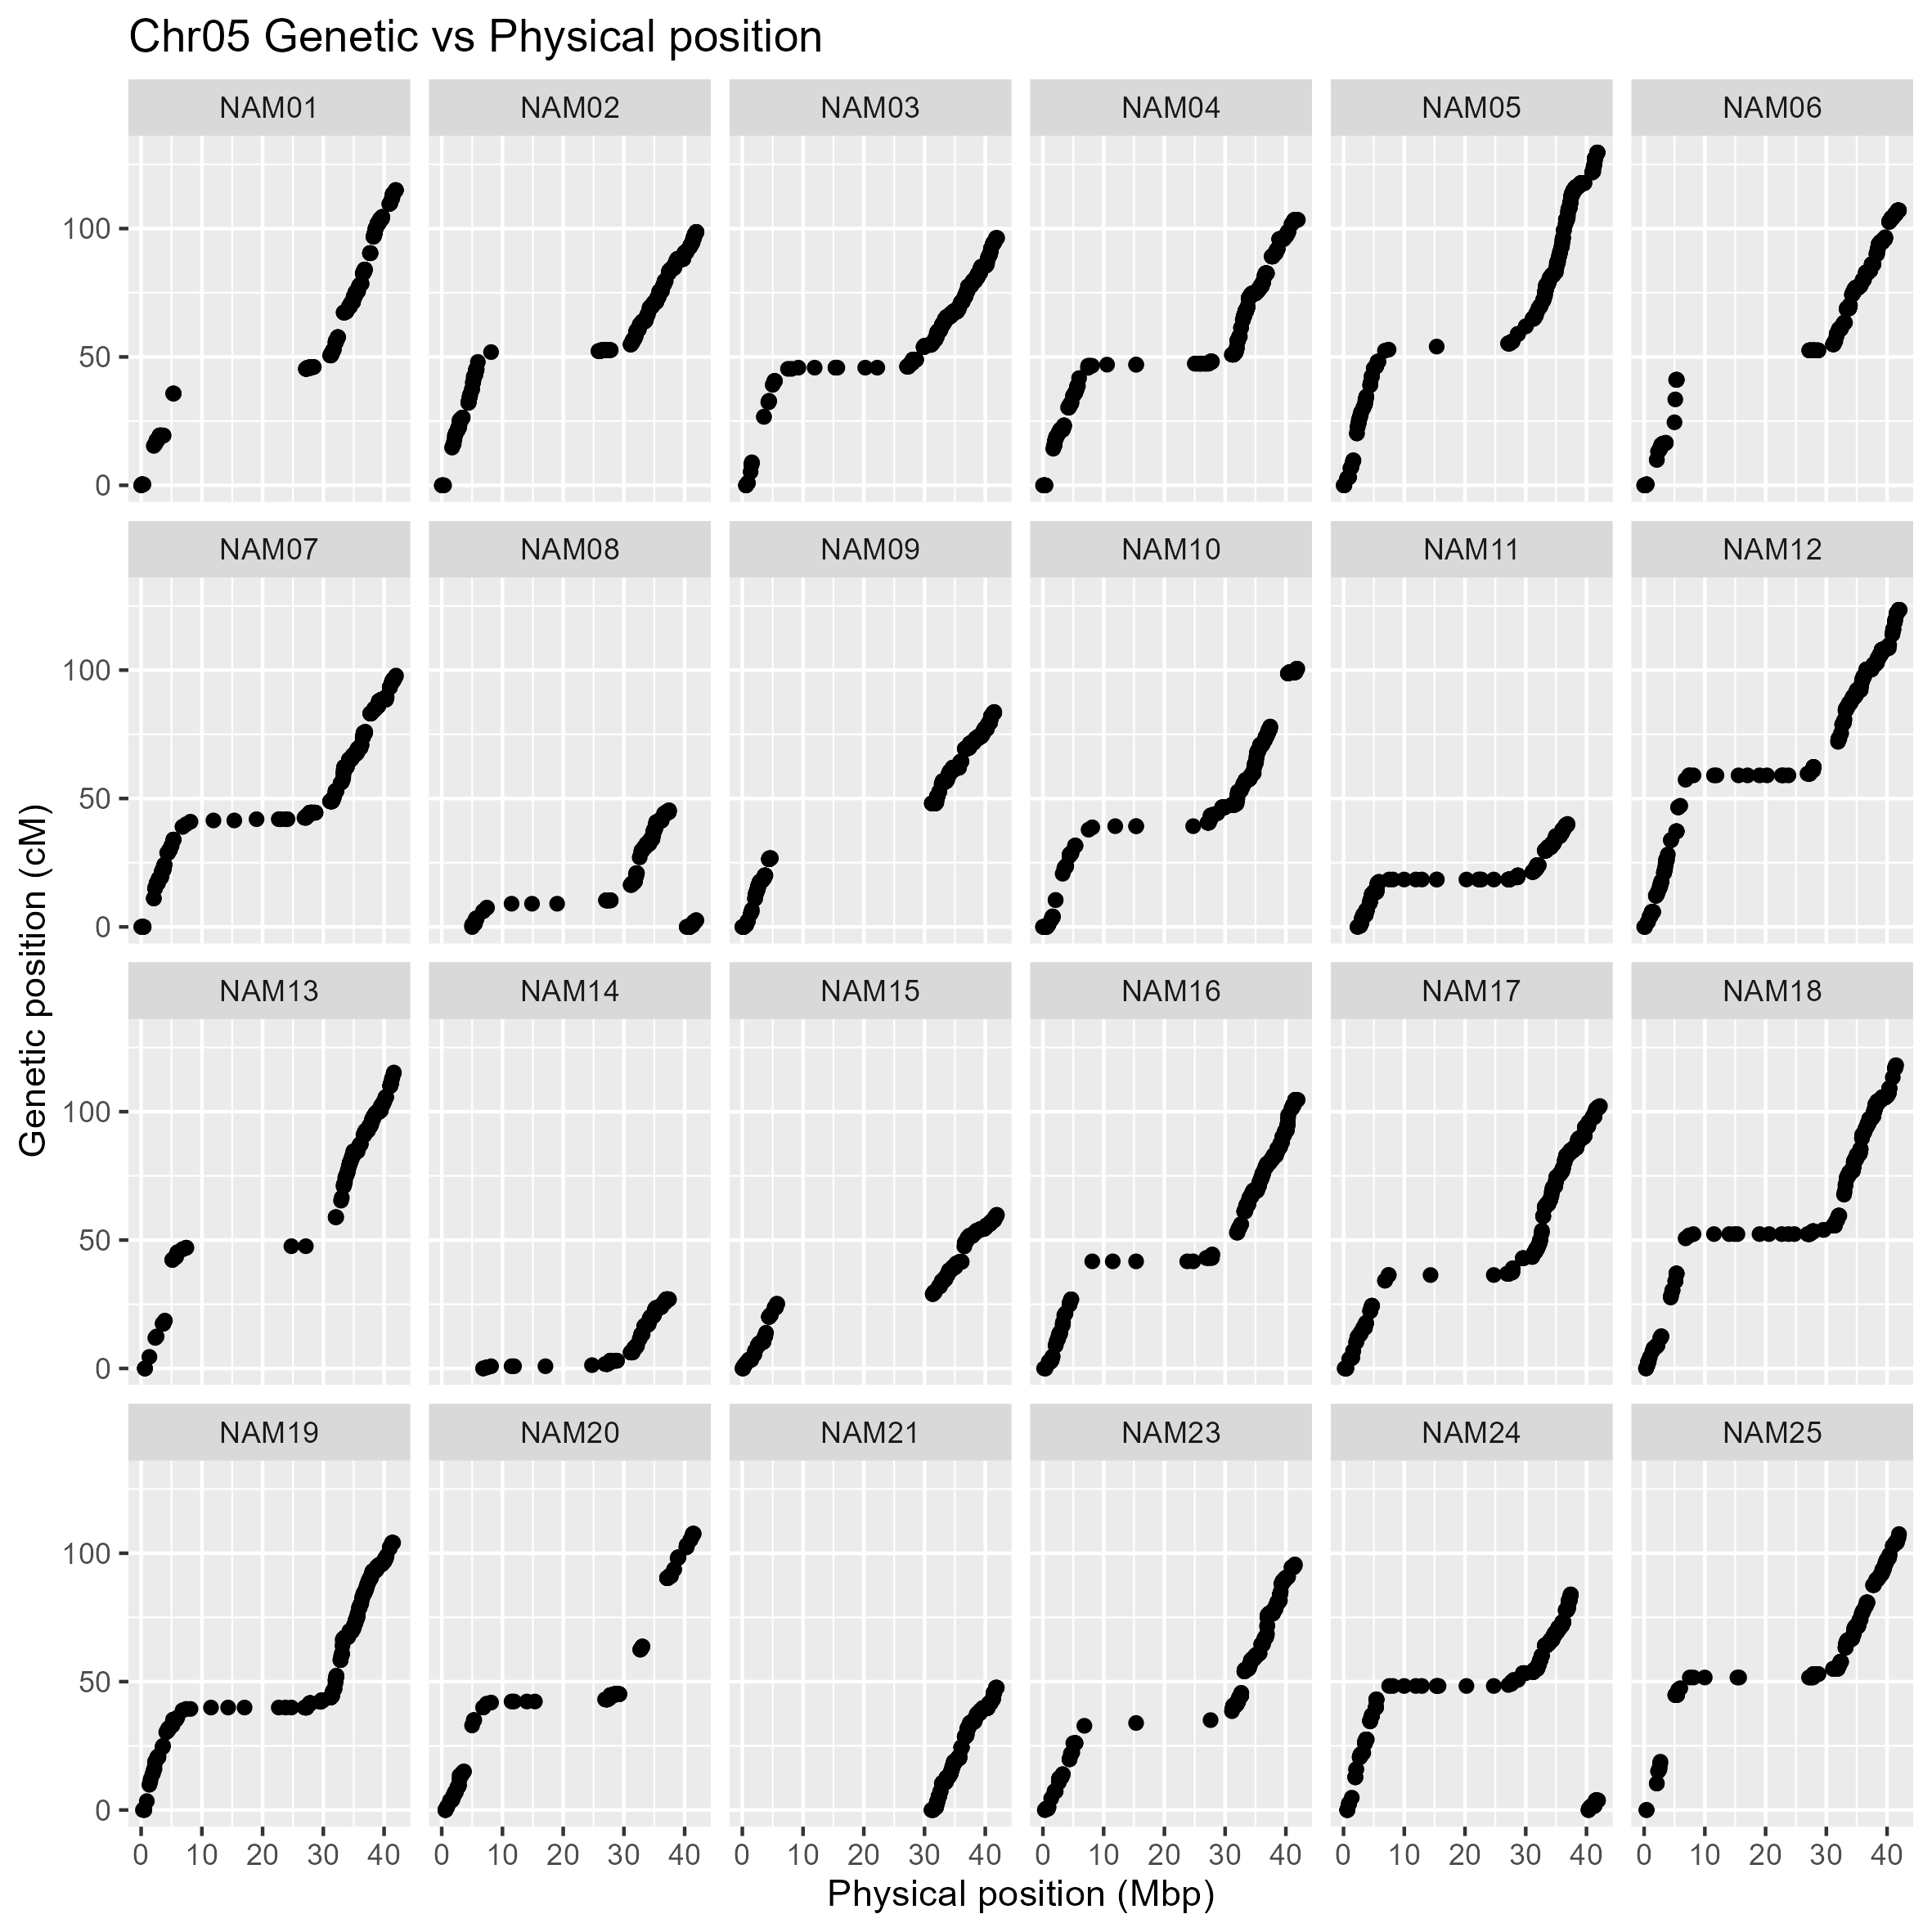
Supplementary Appendix B.5. Collinearity of genetic (cM) and physical position (Mbp) of the SNP integrated into the genetic map on chromosome 5 from 24 family of the K-SoyNAM population. The y-axis and x-axis indicate the genetic and physical positions based on the reference soybean genome, respectively (Glyma.Wm82.a2.v1).
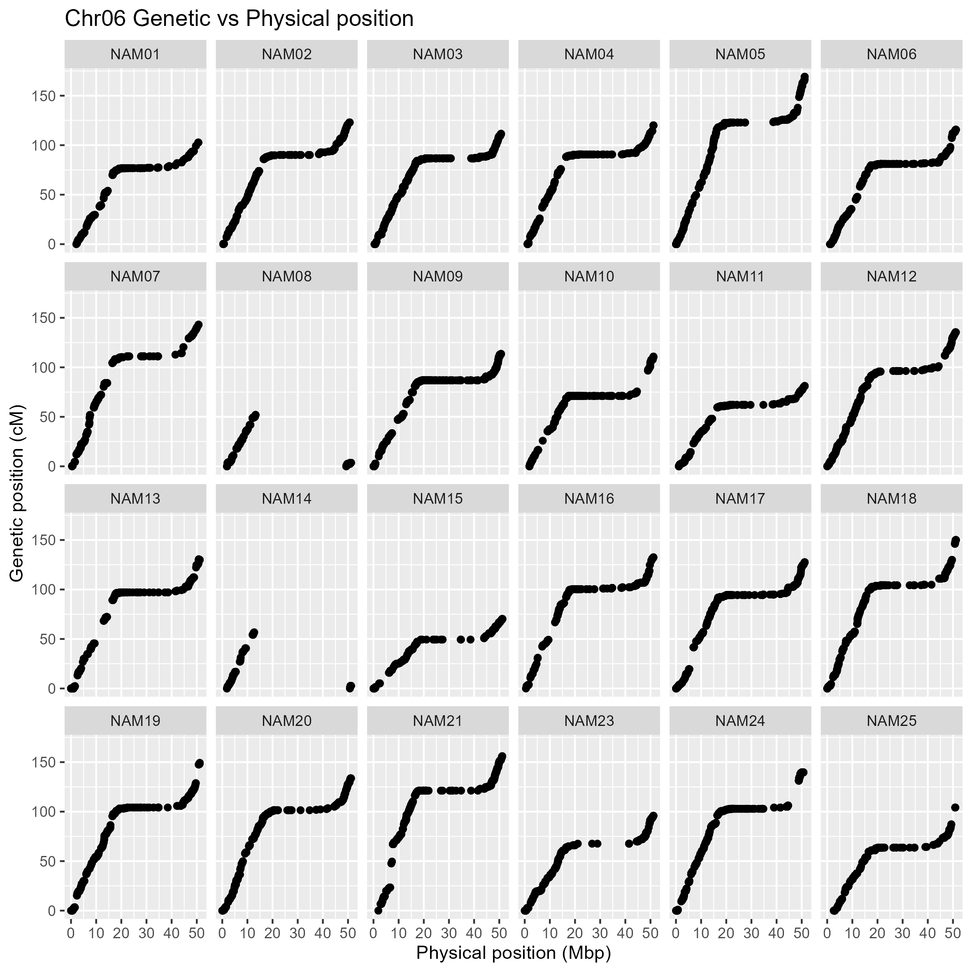
Supplementary Appendix B.6. Collinearity of genetic (cM) and physical position (Mbp) of the SNP integrated into the genetic map on chromosome 6 from 24 family of the K-SoyNAM population. The y-axis and x-axis indicate the genetic and physical positions based on the reference soybean genome, respectively (Glyma.Wm82.a2.v1).
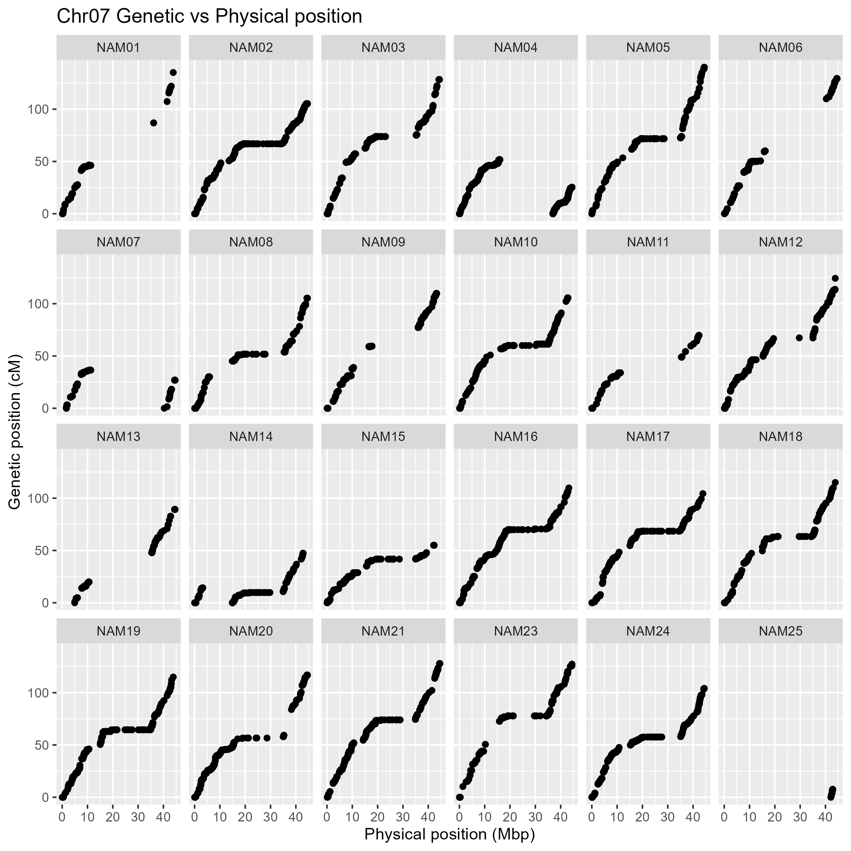
Supplementary Appendix B.7. Collinearity of genetic (cM) and physical position (Mbp) of the SNP integrated into the genetic map on chromosome 7 from 24 family of the K-SoyNAM population. The y-axis and x-axis indicate the genetic and physical positions based on the reference soybean genome, respectively (Glyma.Wm82.a2.v1).
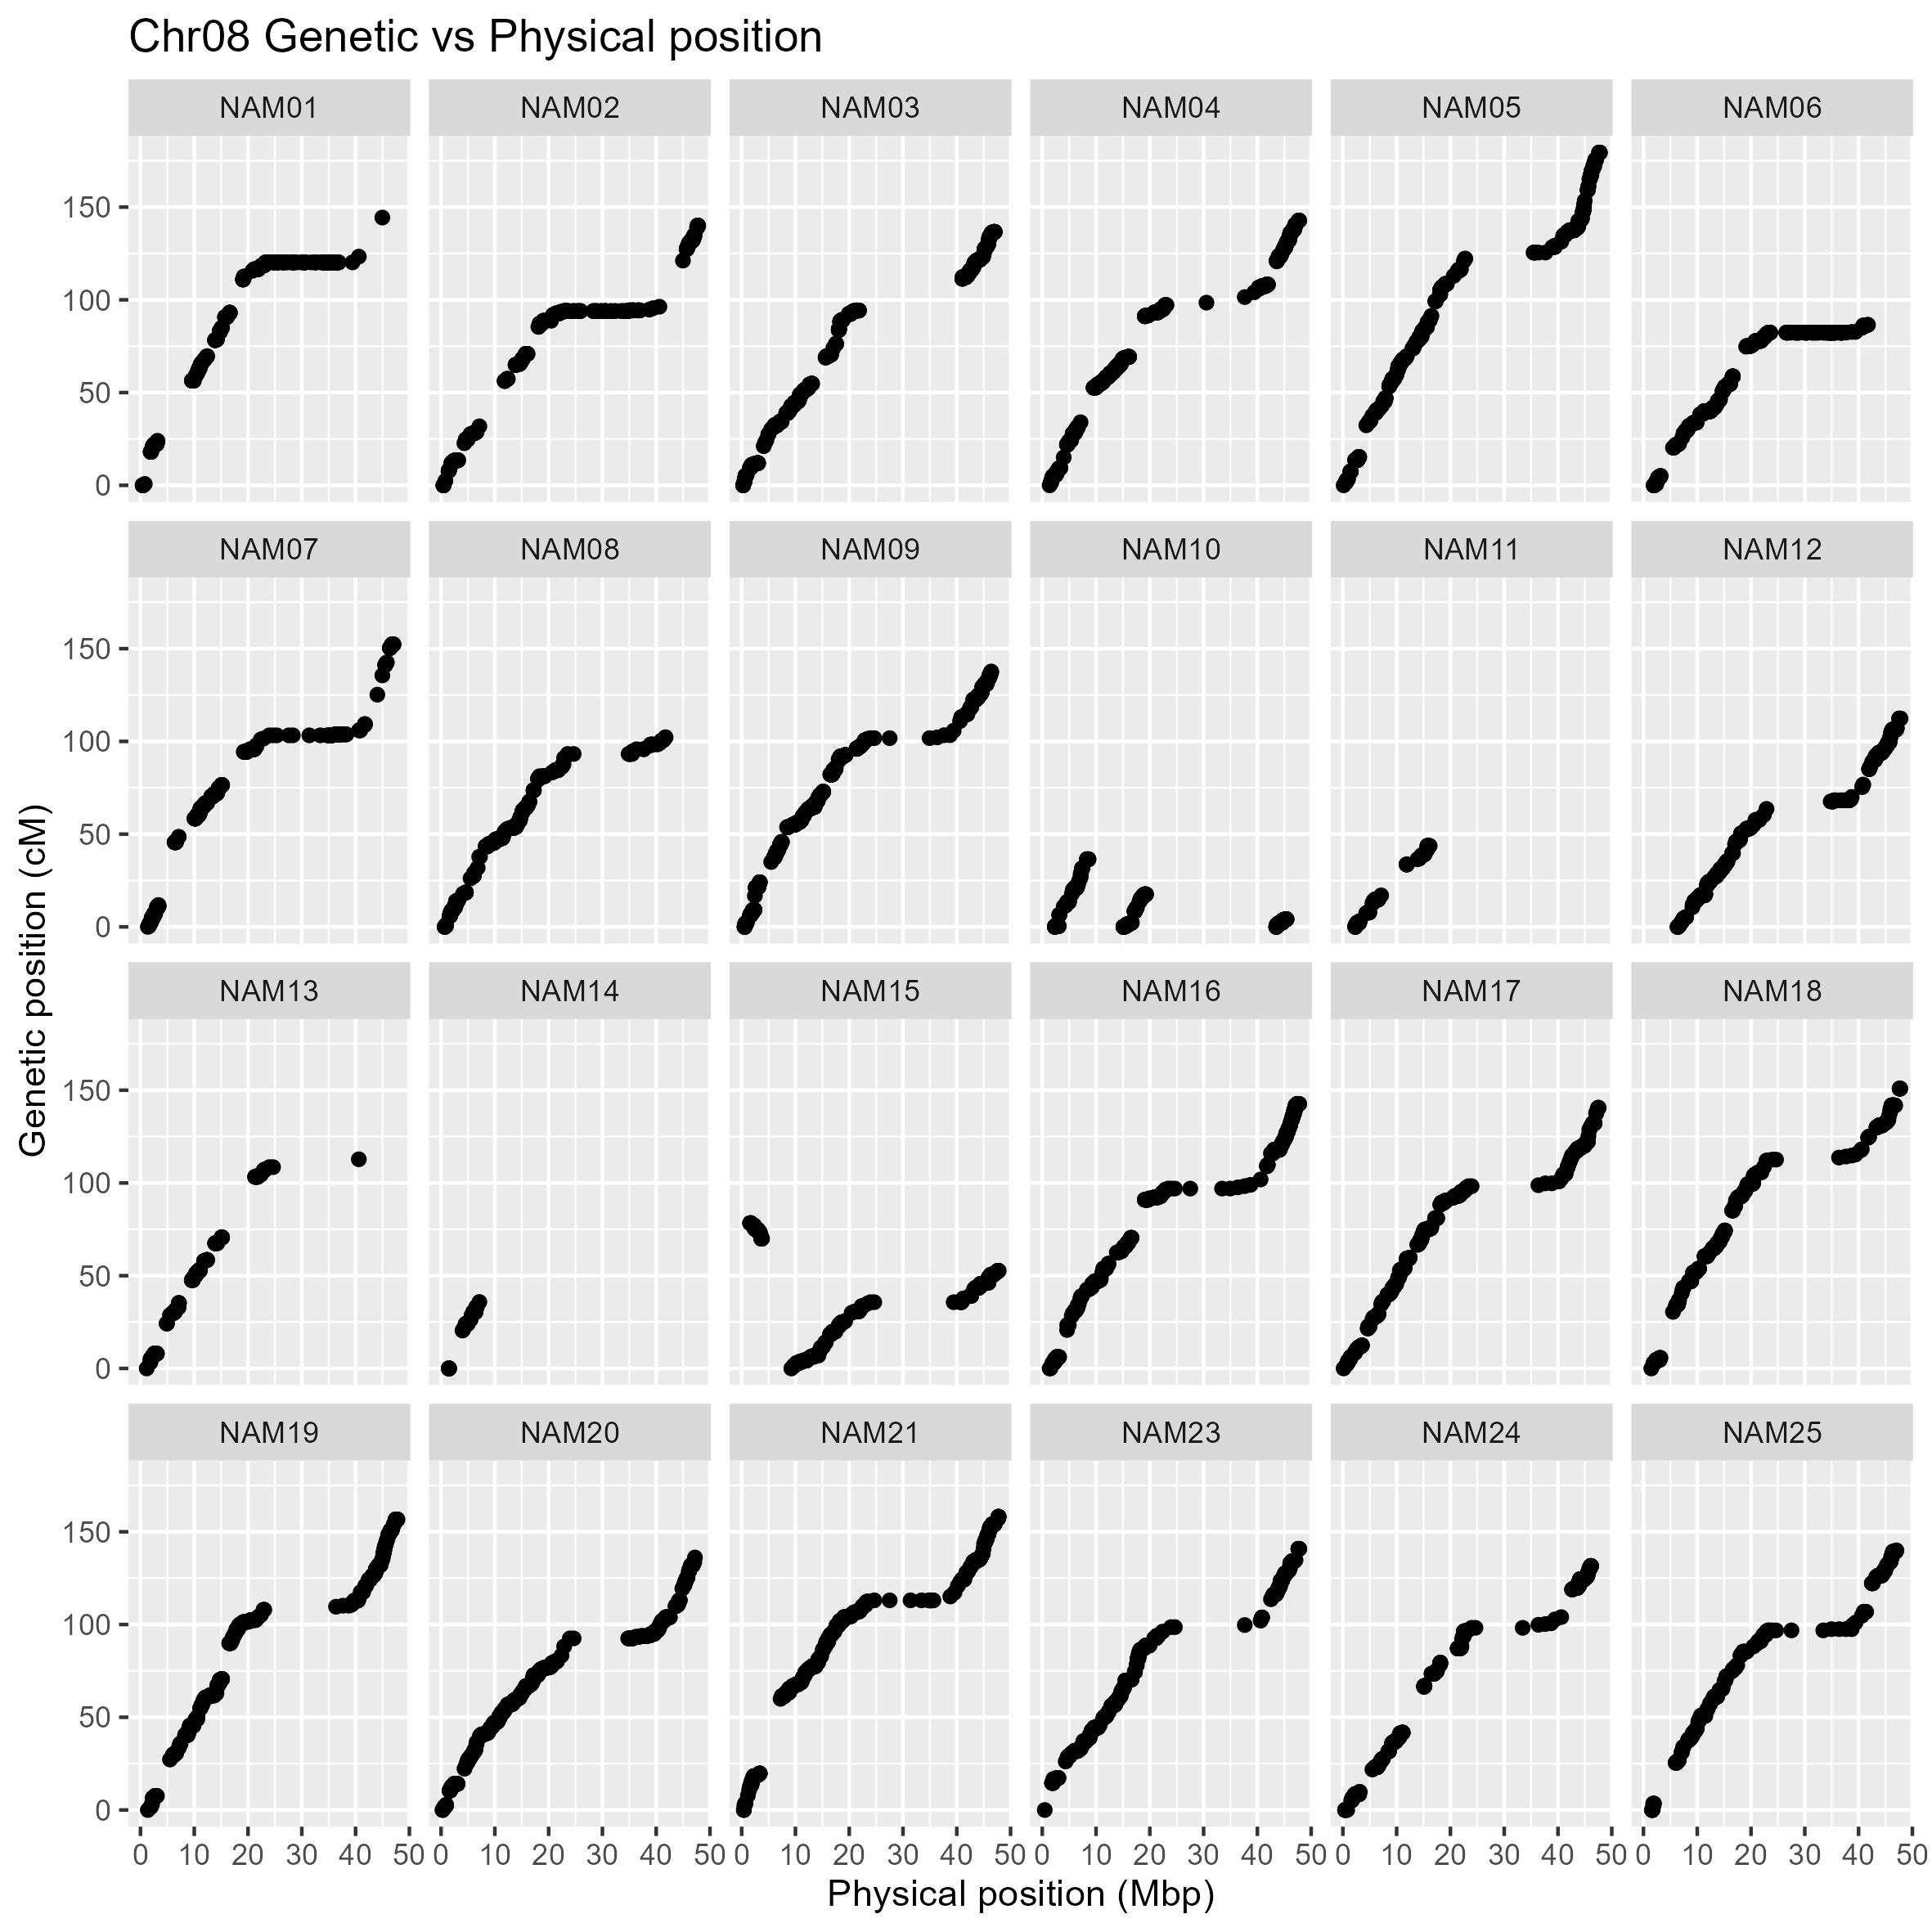
Supplementary Appendix B.8. Collinearity of genetic (cM) and physical position (Mbp) of the SNP integrated into the genetic map on chromosome 8 from 24 family of the K-SoyNAM population. The y-axis and x-axis indicate the genetic and physical positions based on the reference soybean genome, respectively (Glyma.Wm82.a2.v1).
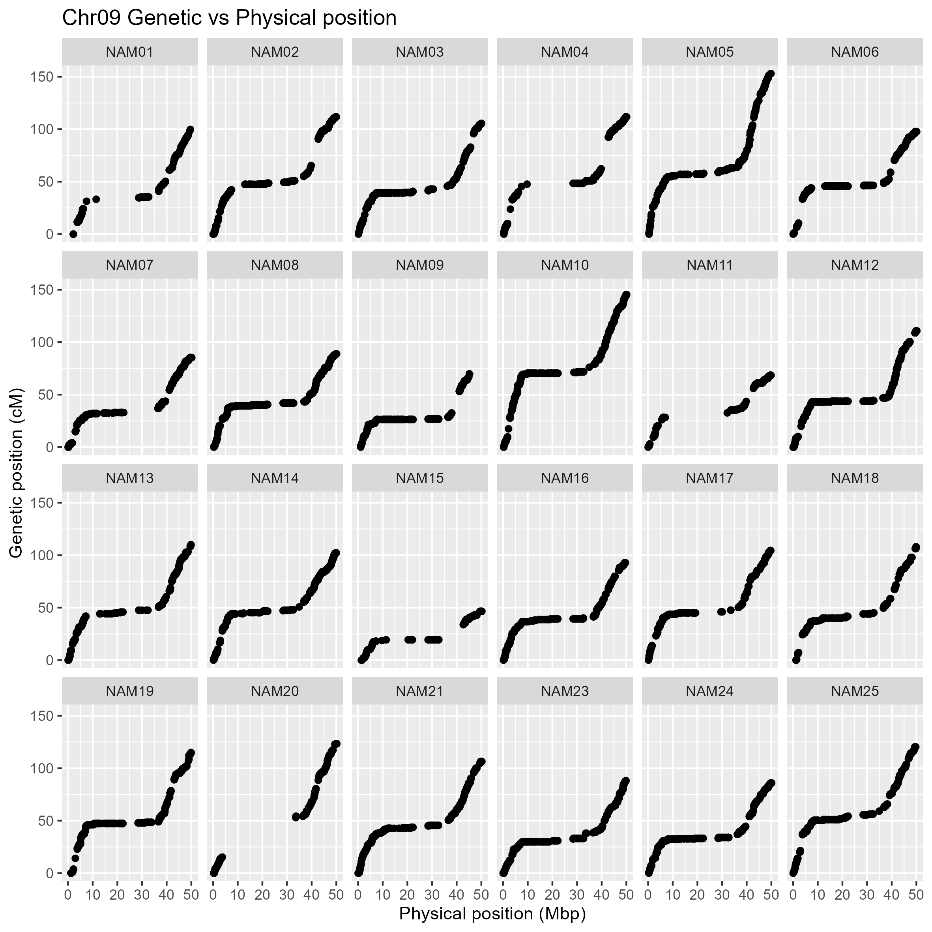Supplementary Appendix B.9. Collinearity of genetic (cM) and physical position (Mbp) of the SNP integrated into the genetic map on chromosome 9 from 24 family of the K-SoyNAM population. The y-axis and x-axis indicate the genetic and physical positions based on the reference soybean genome, respectively (Glyma.Wm82.a2.v1).
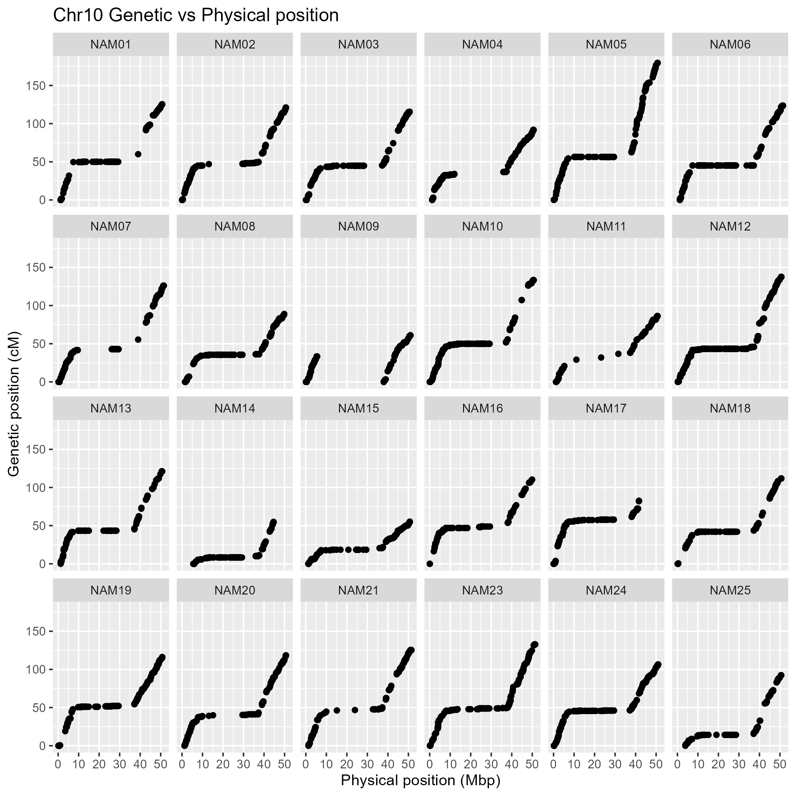
Supplementary Appendix B.10. Collinearity of genetic (cM) and physical position (Mbp) of the SNP integrated into the genetic map on chromosome 10 from 24 family of the K-SoyNAM population. The y-axis and x-axis indicate the genetic and physical positions based on the reference soybean genome, respectively (Glyma.Wm82.a2.v1).
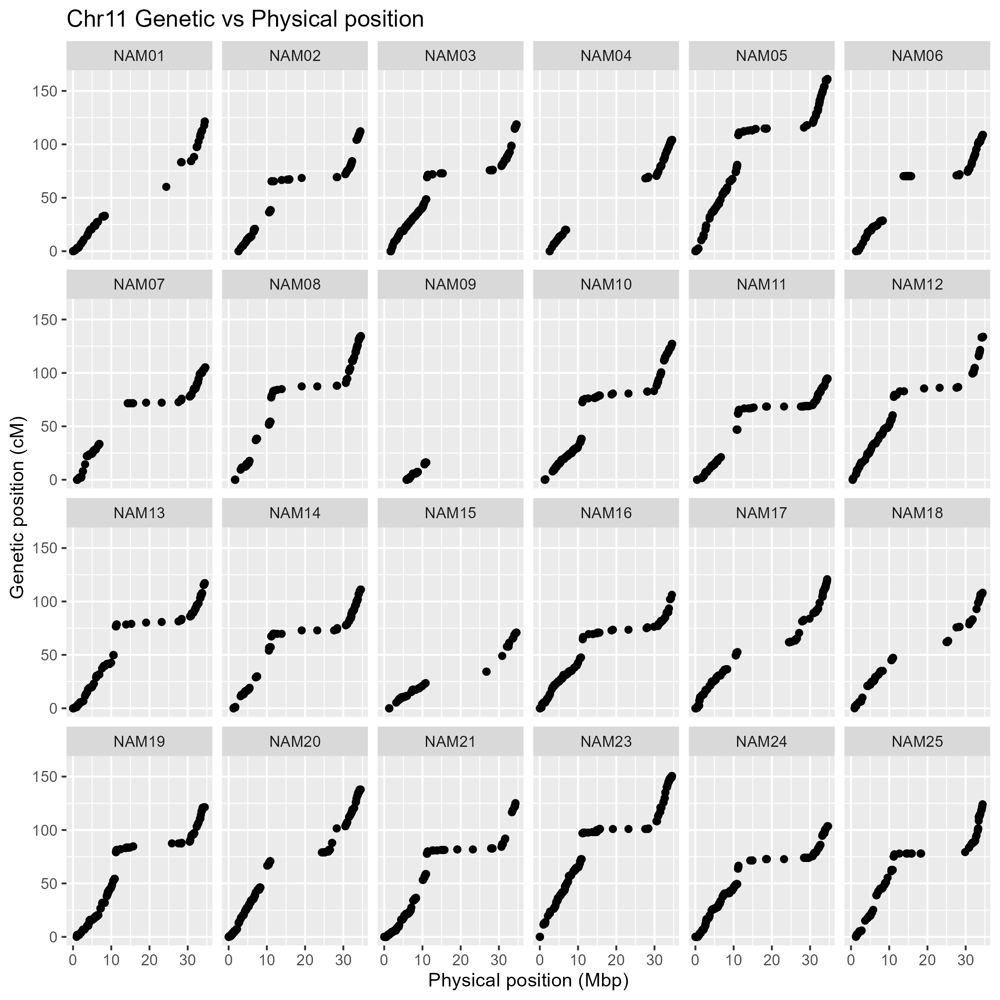
Supplementary Appendix B.11. Collinearity of genetic (cM) and physical position (Mbp) of the SNP integrated into the genetic map on chromosome 11 from 24 family of the K-SoyNAM population. The y-axis and x-axis indicate the genetic and physical positions based on the reference soybean genome, respectively (Glyma.Wm82.a2.v1).
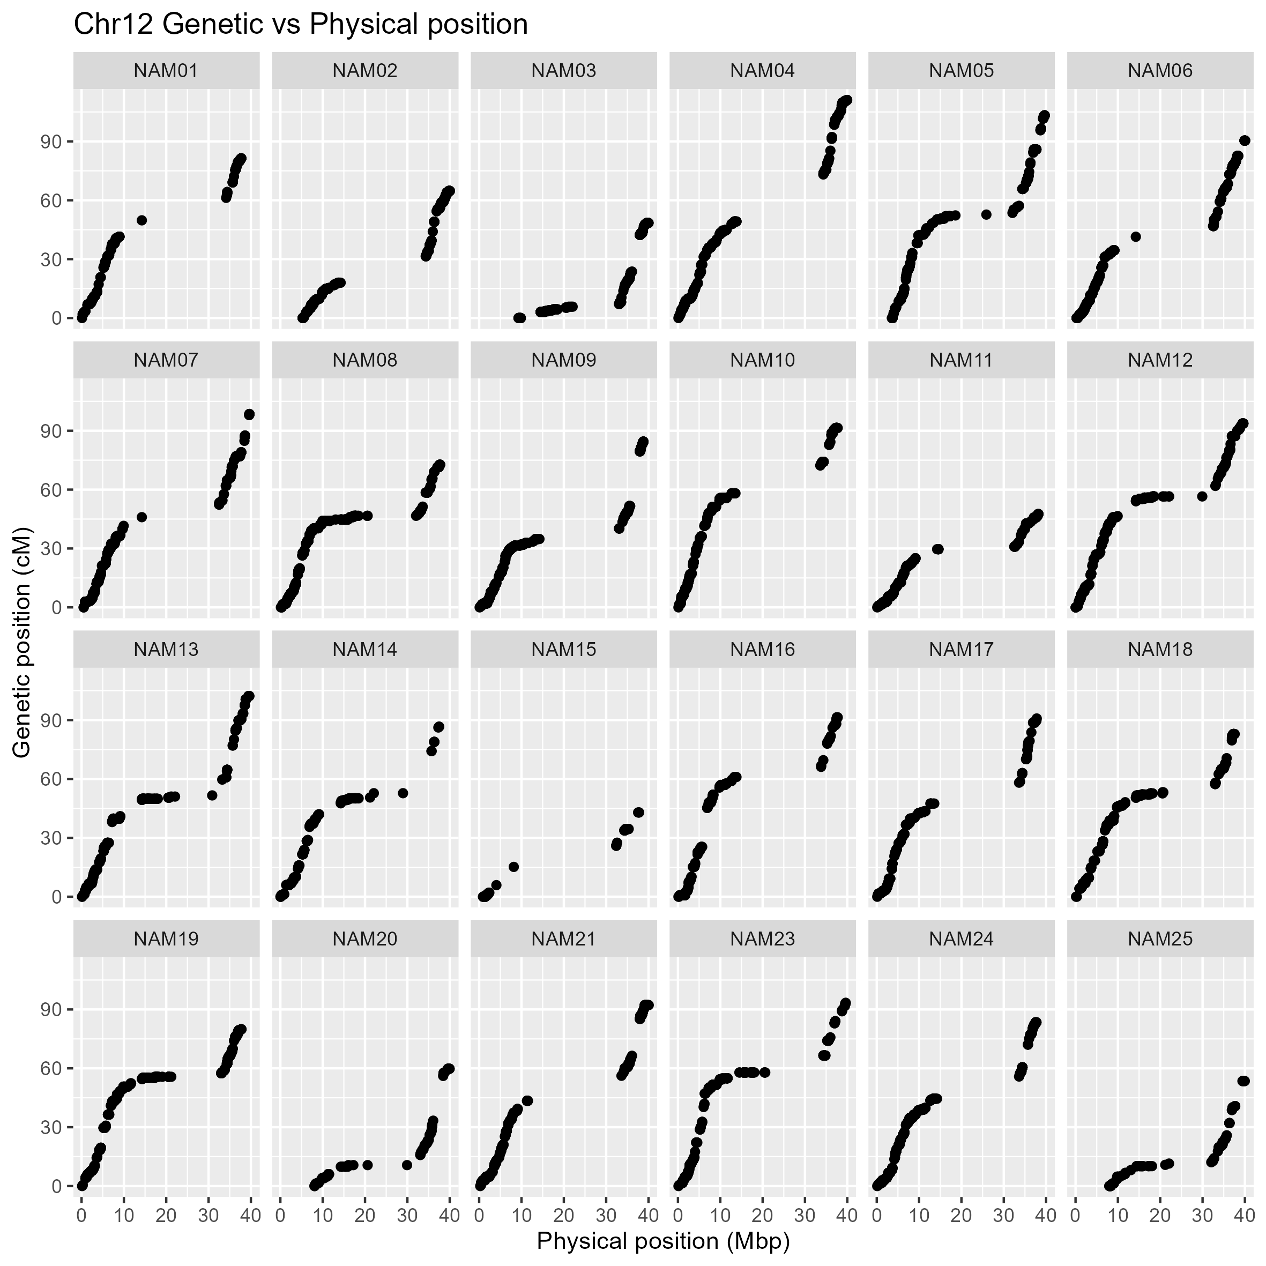
Supplementary Appendix B.12. Collinearity of genetic (cM) and physical position (Mbp) of the SNP integrated into the genetic map on chromosome 12 from 24 family of the K-SoyNAM population. The y-axis and x-axis indicate the genetic and physical positions based on the reference soybean genome, respectively (Glyma.Wm82.a2.v1).
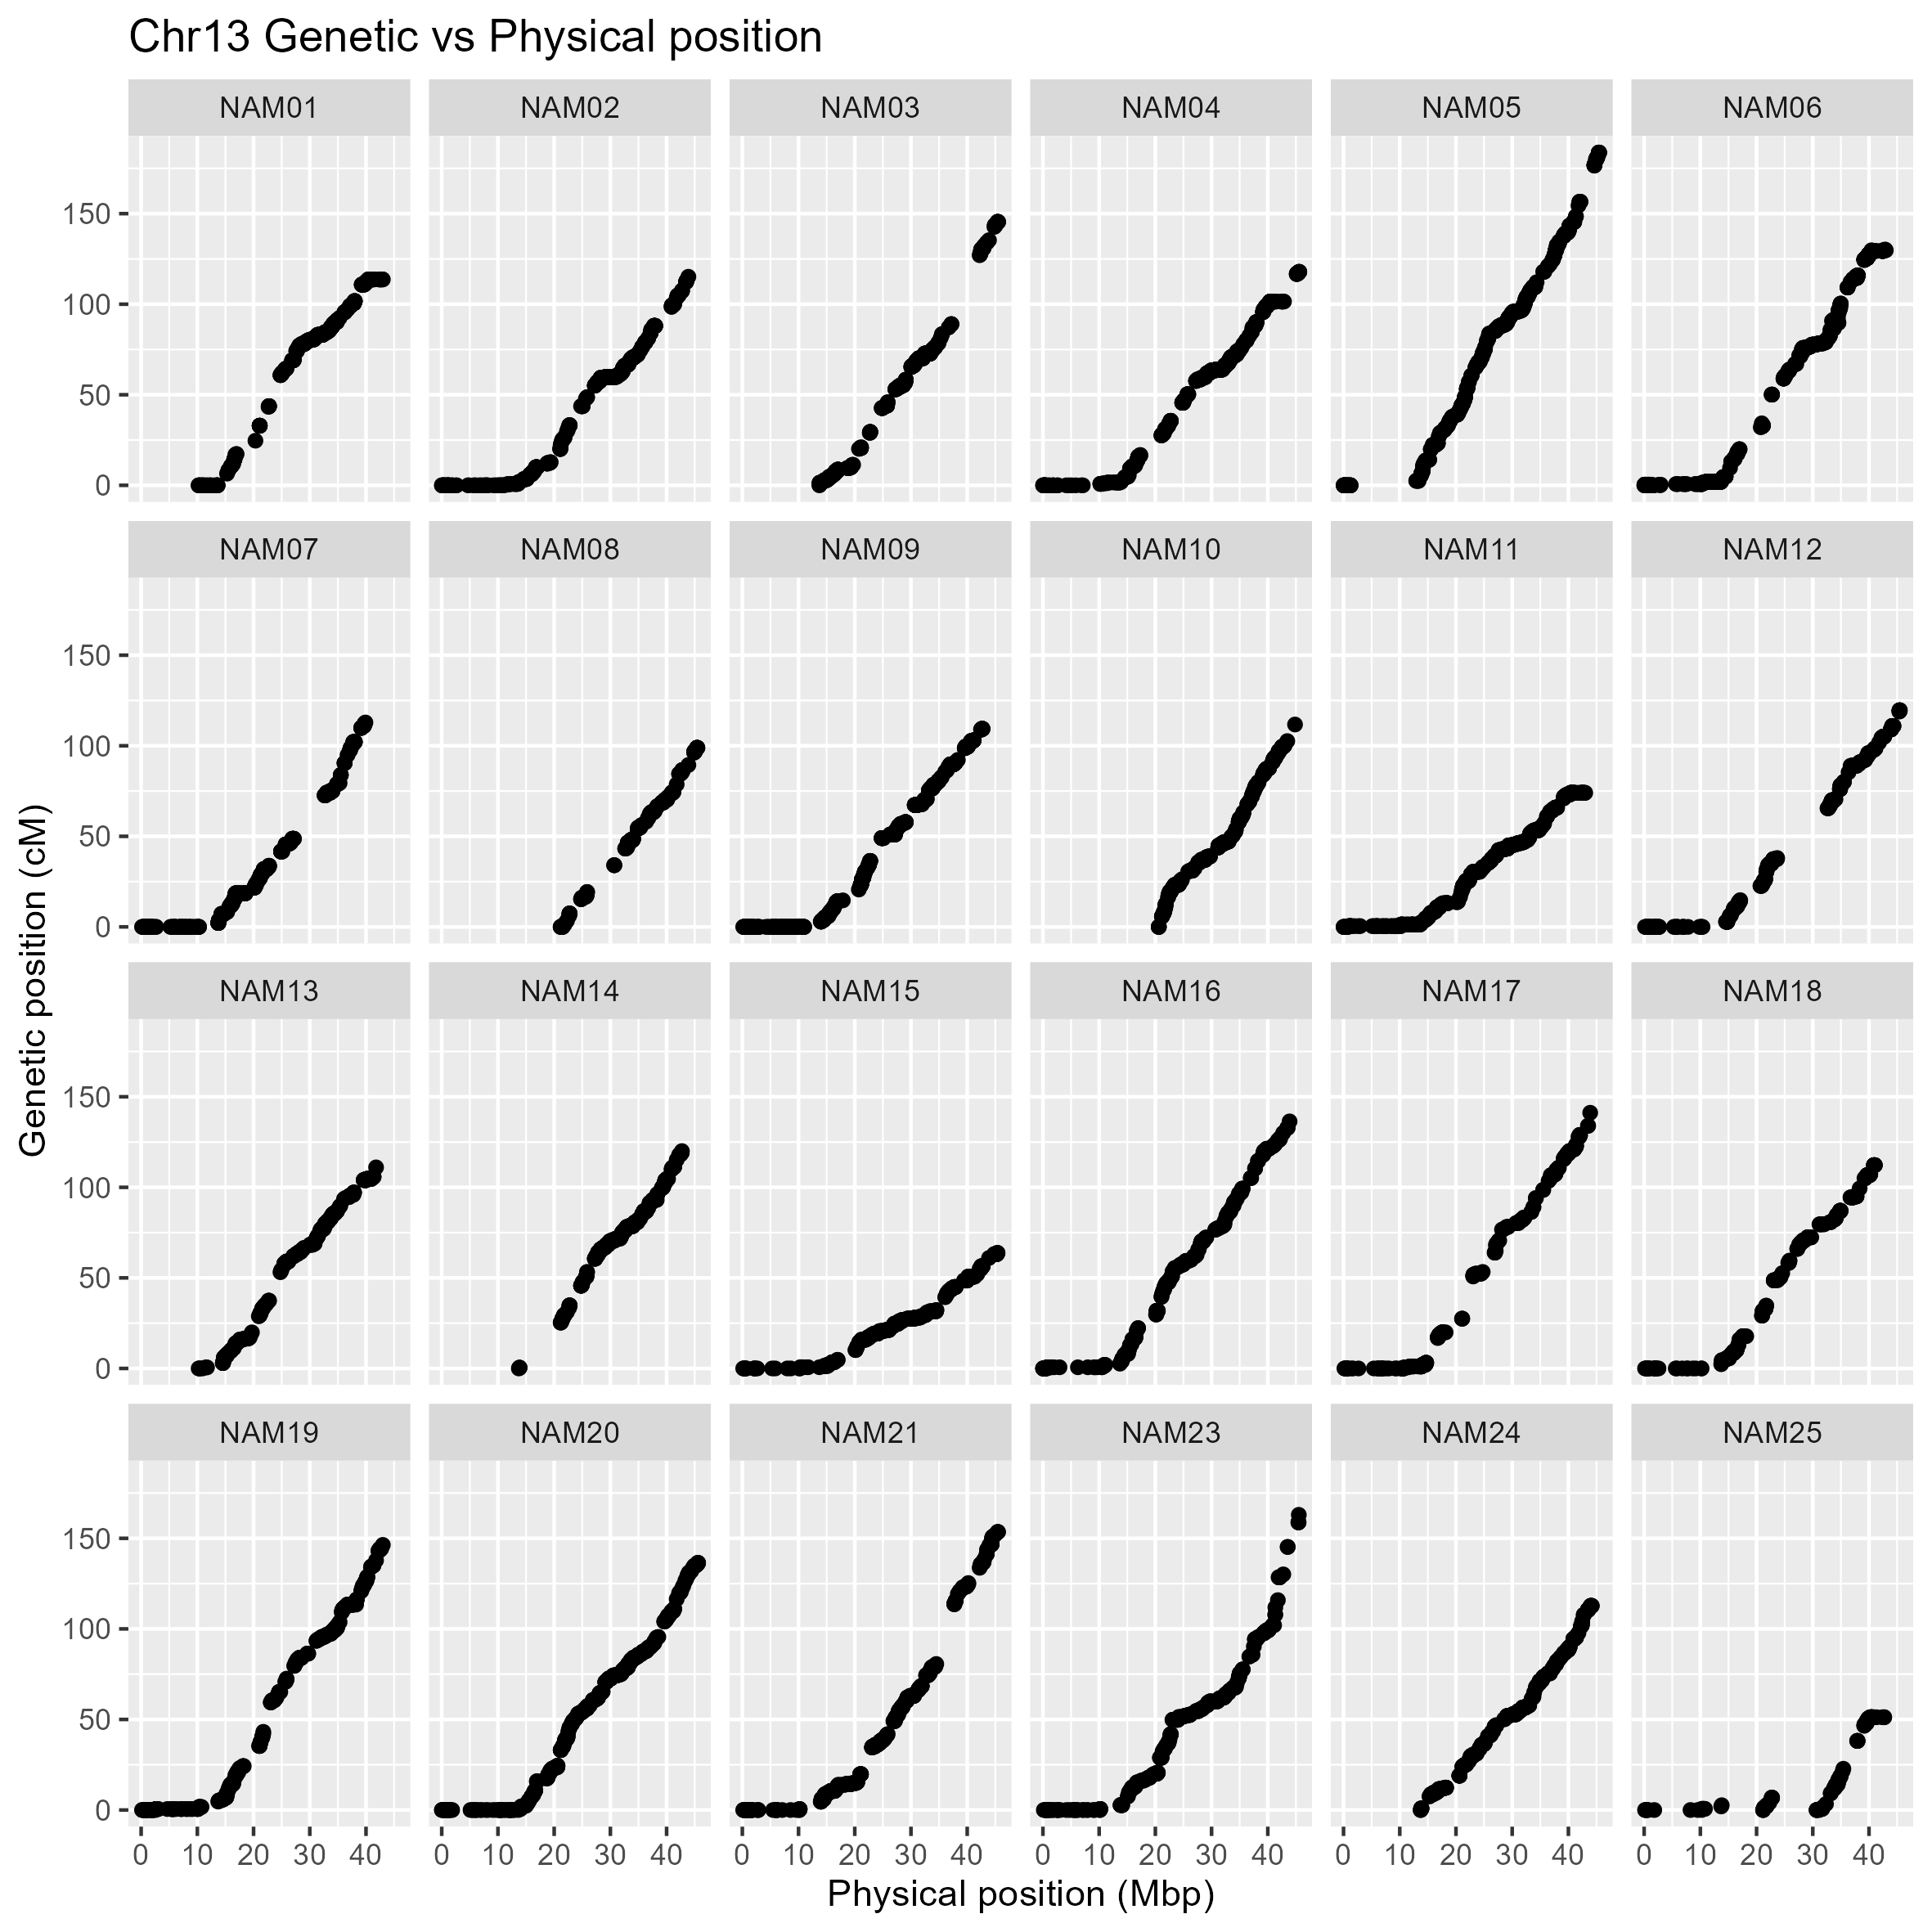
Supplementary Appendix B.13. Collinearity of genetic (cM) and physical position (Mbp) of the SNP integrated into the genetic map on chromosome 13 from 24 family of the K-SoyNAM population. The y-axis and x-axis indicate the genetic and physical positions based on the reference soybean genome, respectively (Glyma.Wm82.a2.v1).
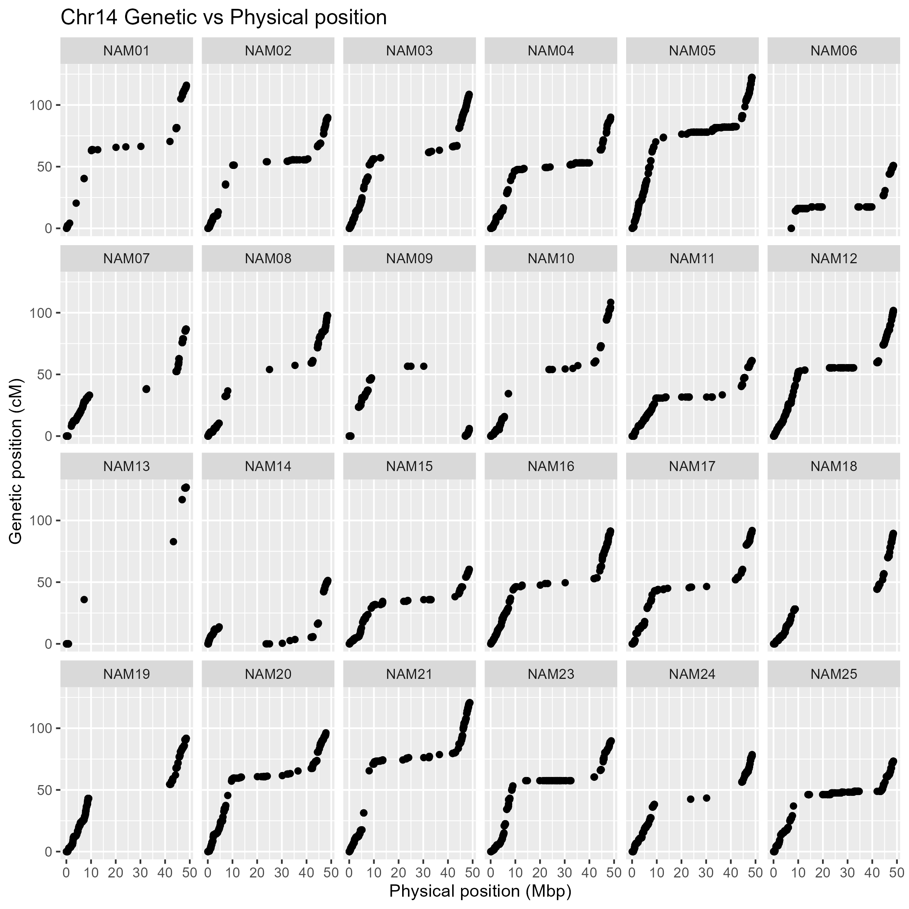Supplementary Appendix B.14. Collinearity of genetic (cM) and physical position (Mbp) of the SNP integrated into the genetic map on chromosome 14 from 24 family of the K-SoyNAM population. The y-axis and x-axis indicate the genetic and physical positions based on the reference soybean genome, respectively (Glyma.Wm82.a2.v1).
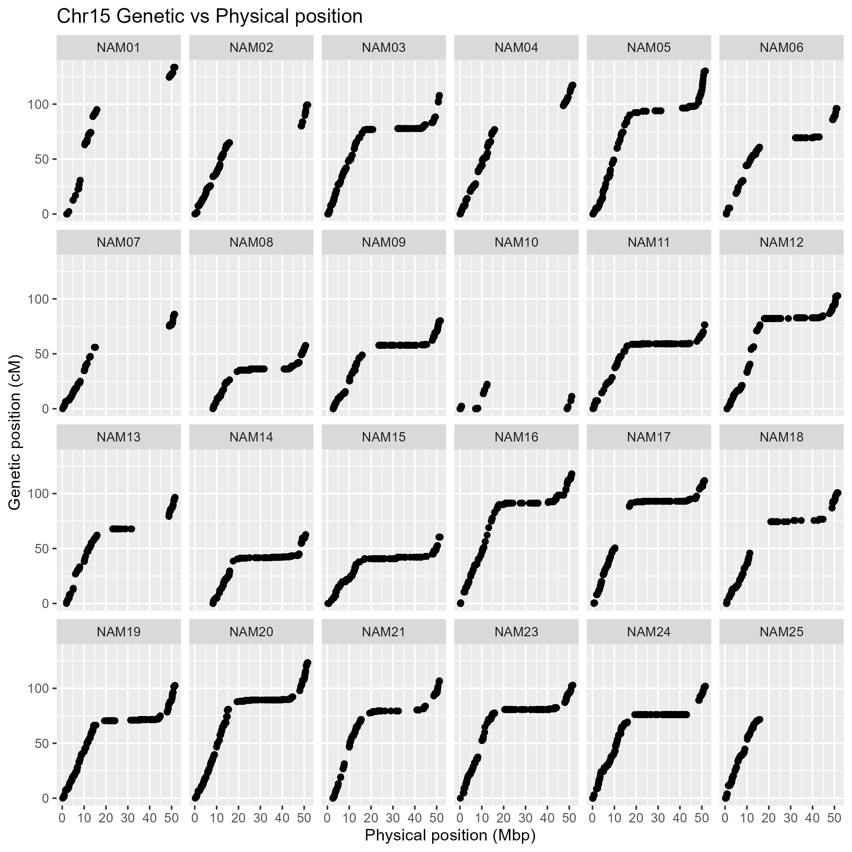
Supplementary Appendix B.15. Collinearity of genetic (cM) and physical position (Mbp) of the SNP integrated into the genetic map on chromosome 15 from 24 family of the K-SoyNAM population. The y-axis and x-axis indicate the genetic and physical positions based on the reference soybean genome, respectively (Glyma.Wm82.a2.v1).
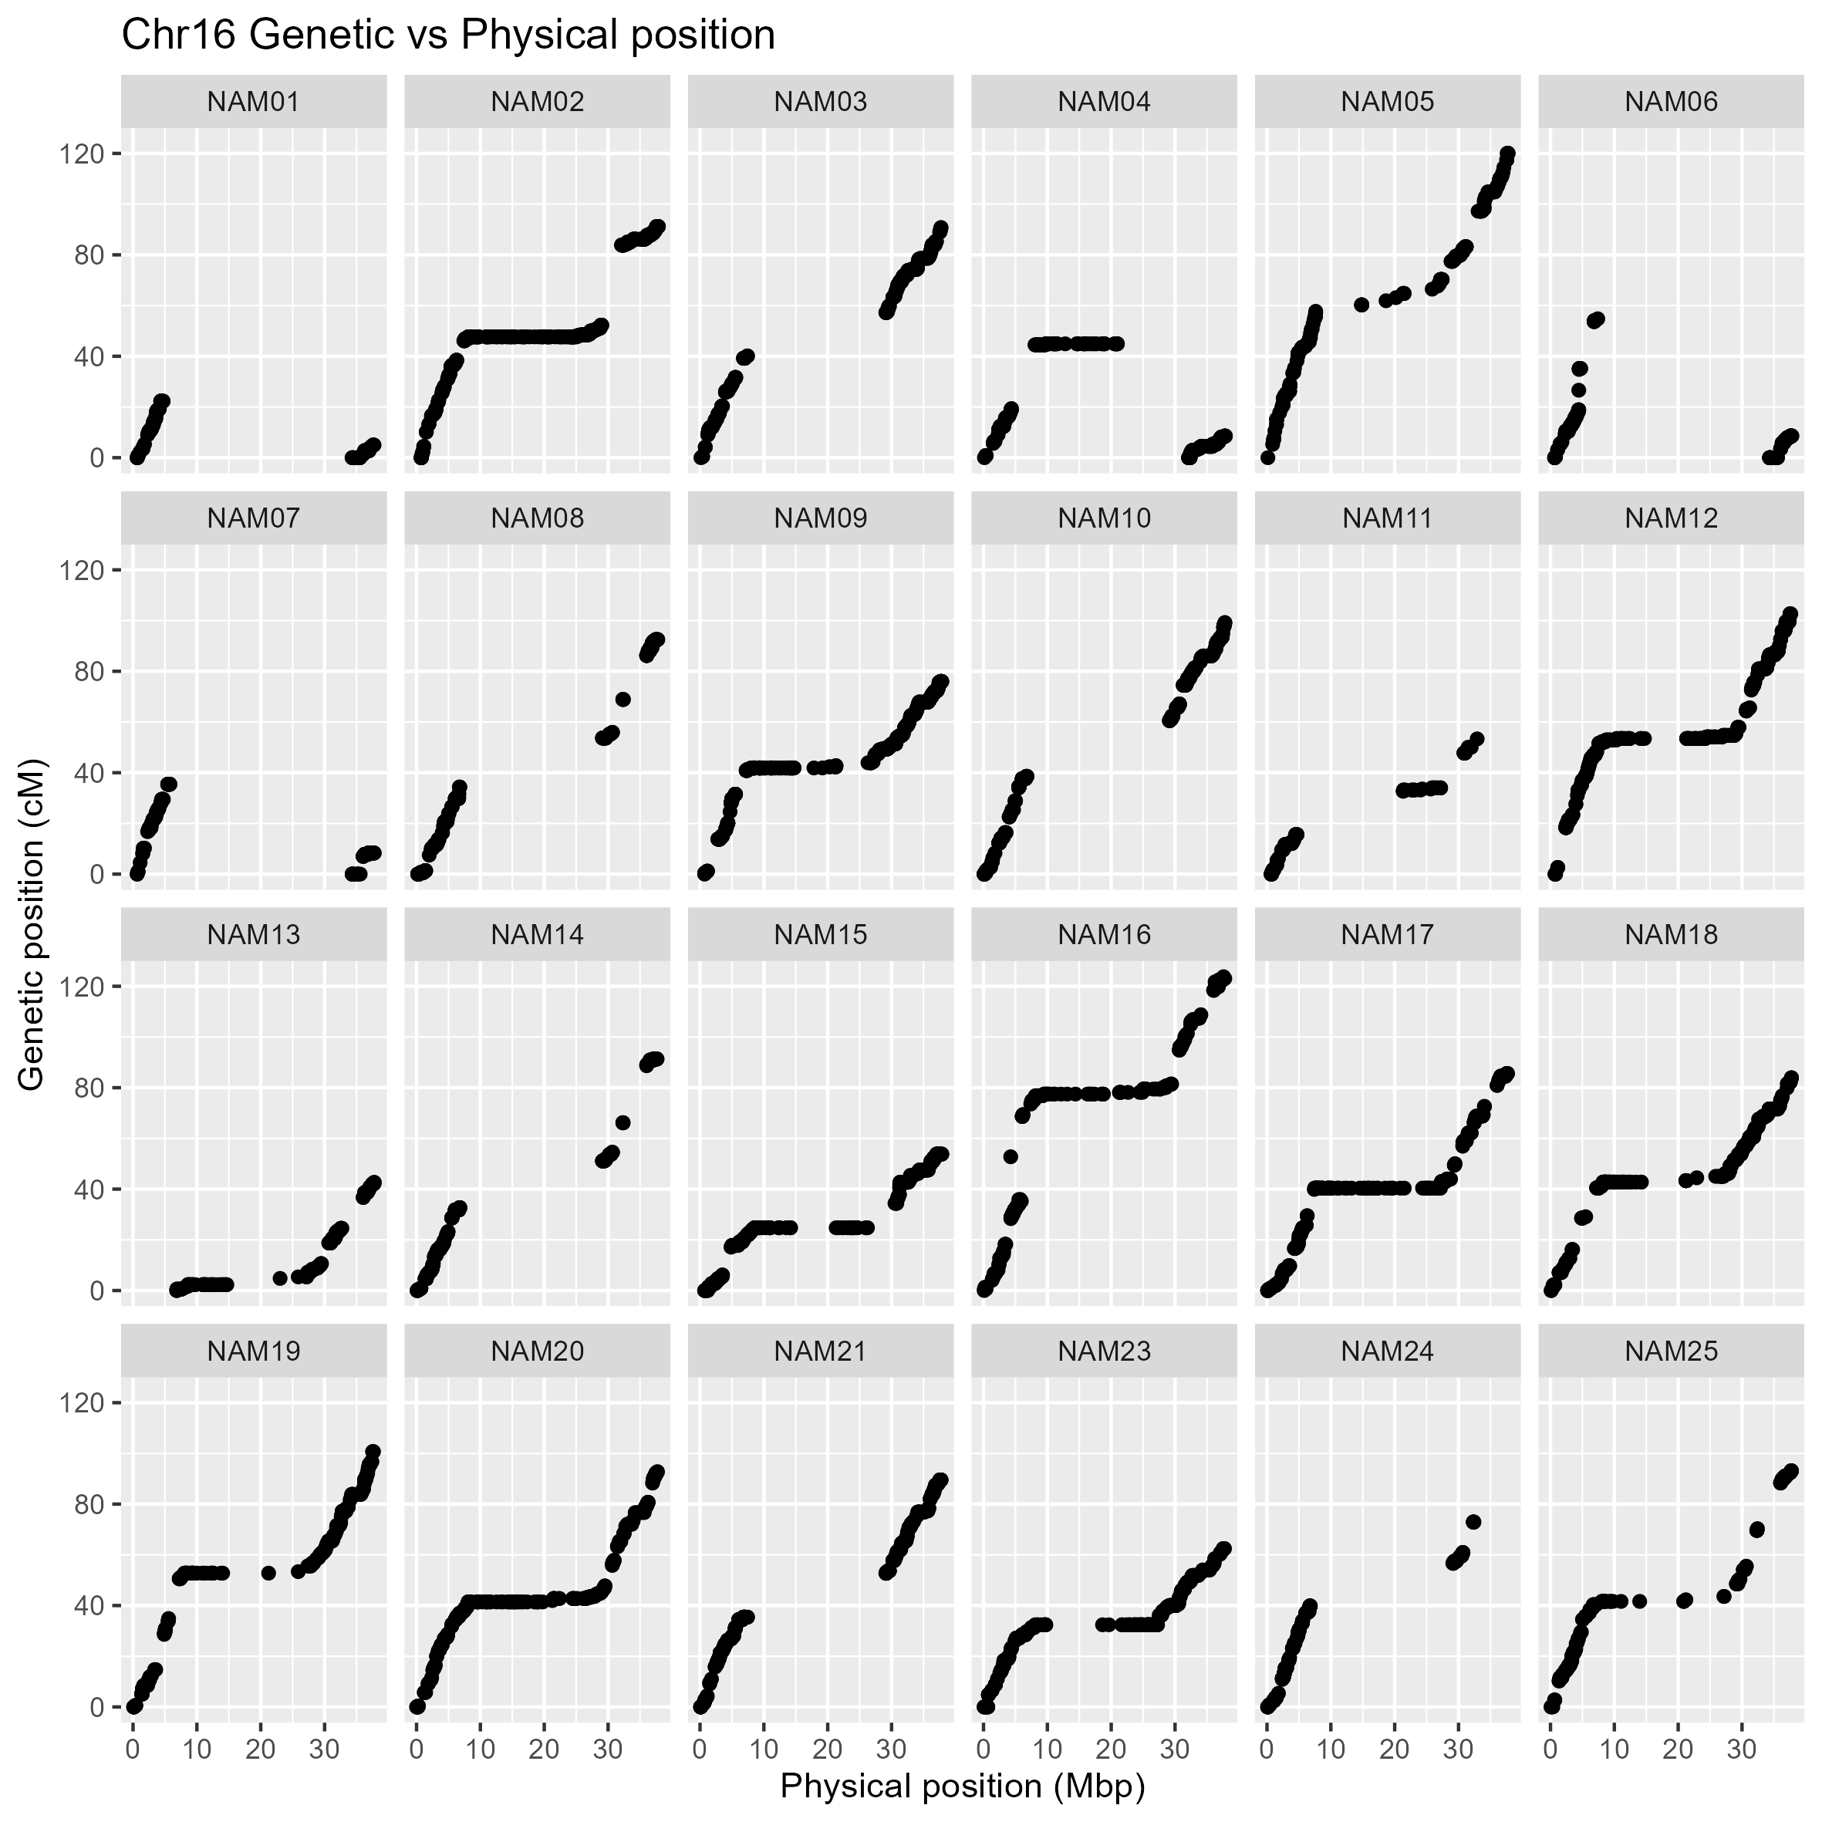Supplementary Appendix B.16. Collinearity of genetic (cM) and physical position (Mbp) of the SNP integrated into the genetic map on chromosome 16 from 24 family of the K-SoyNAM population. The y-axis and x-axis indicate the genetic and physical positions based on the reference soybean genome, respectively (Glyma.Wm82.a2.v1).
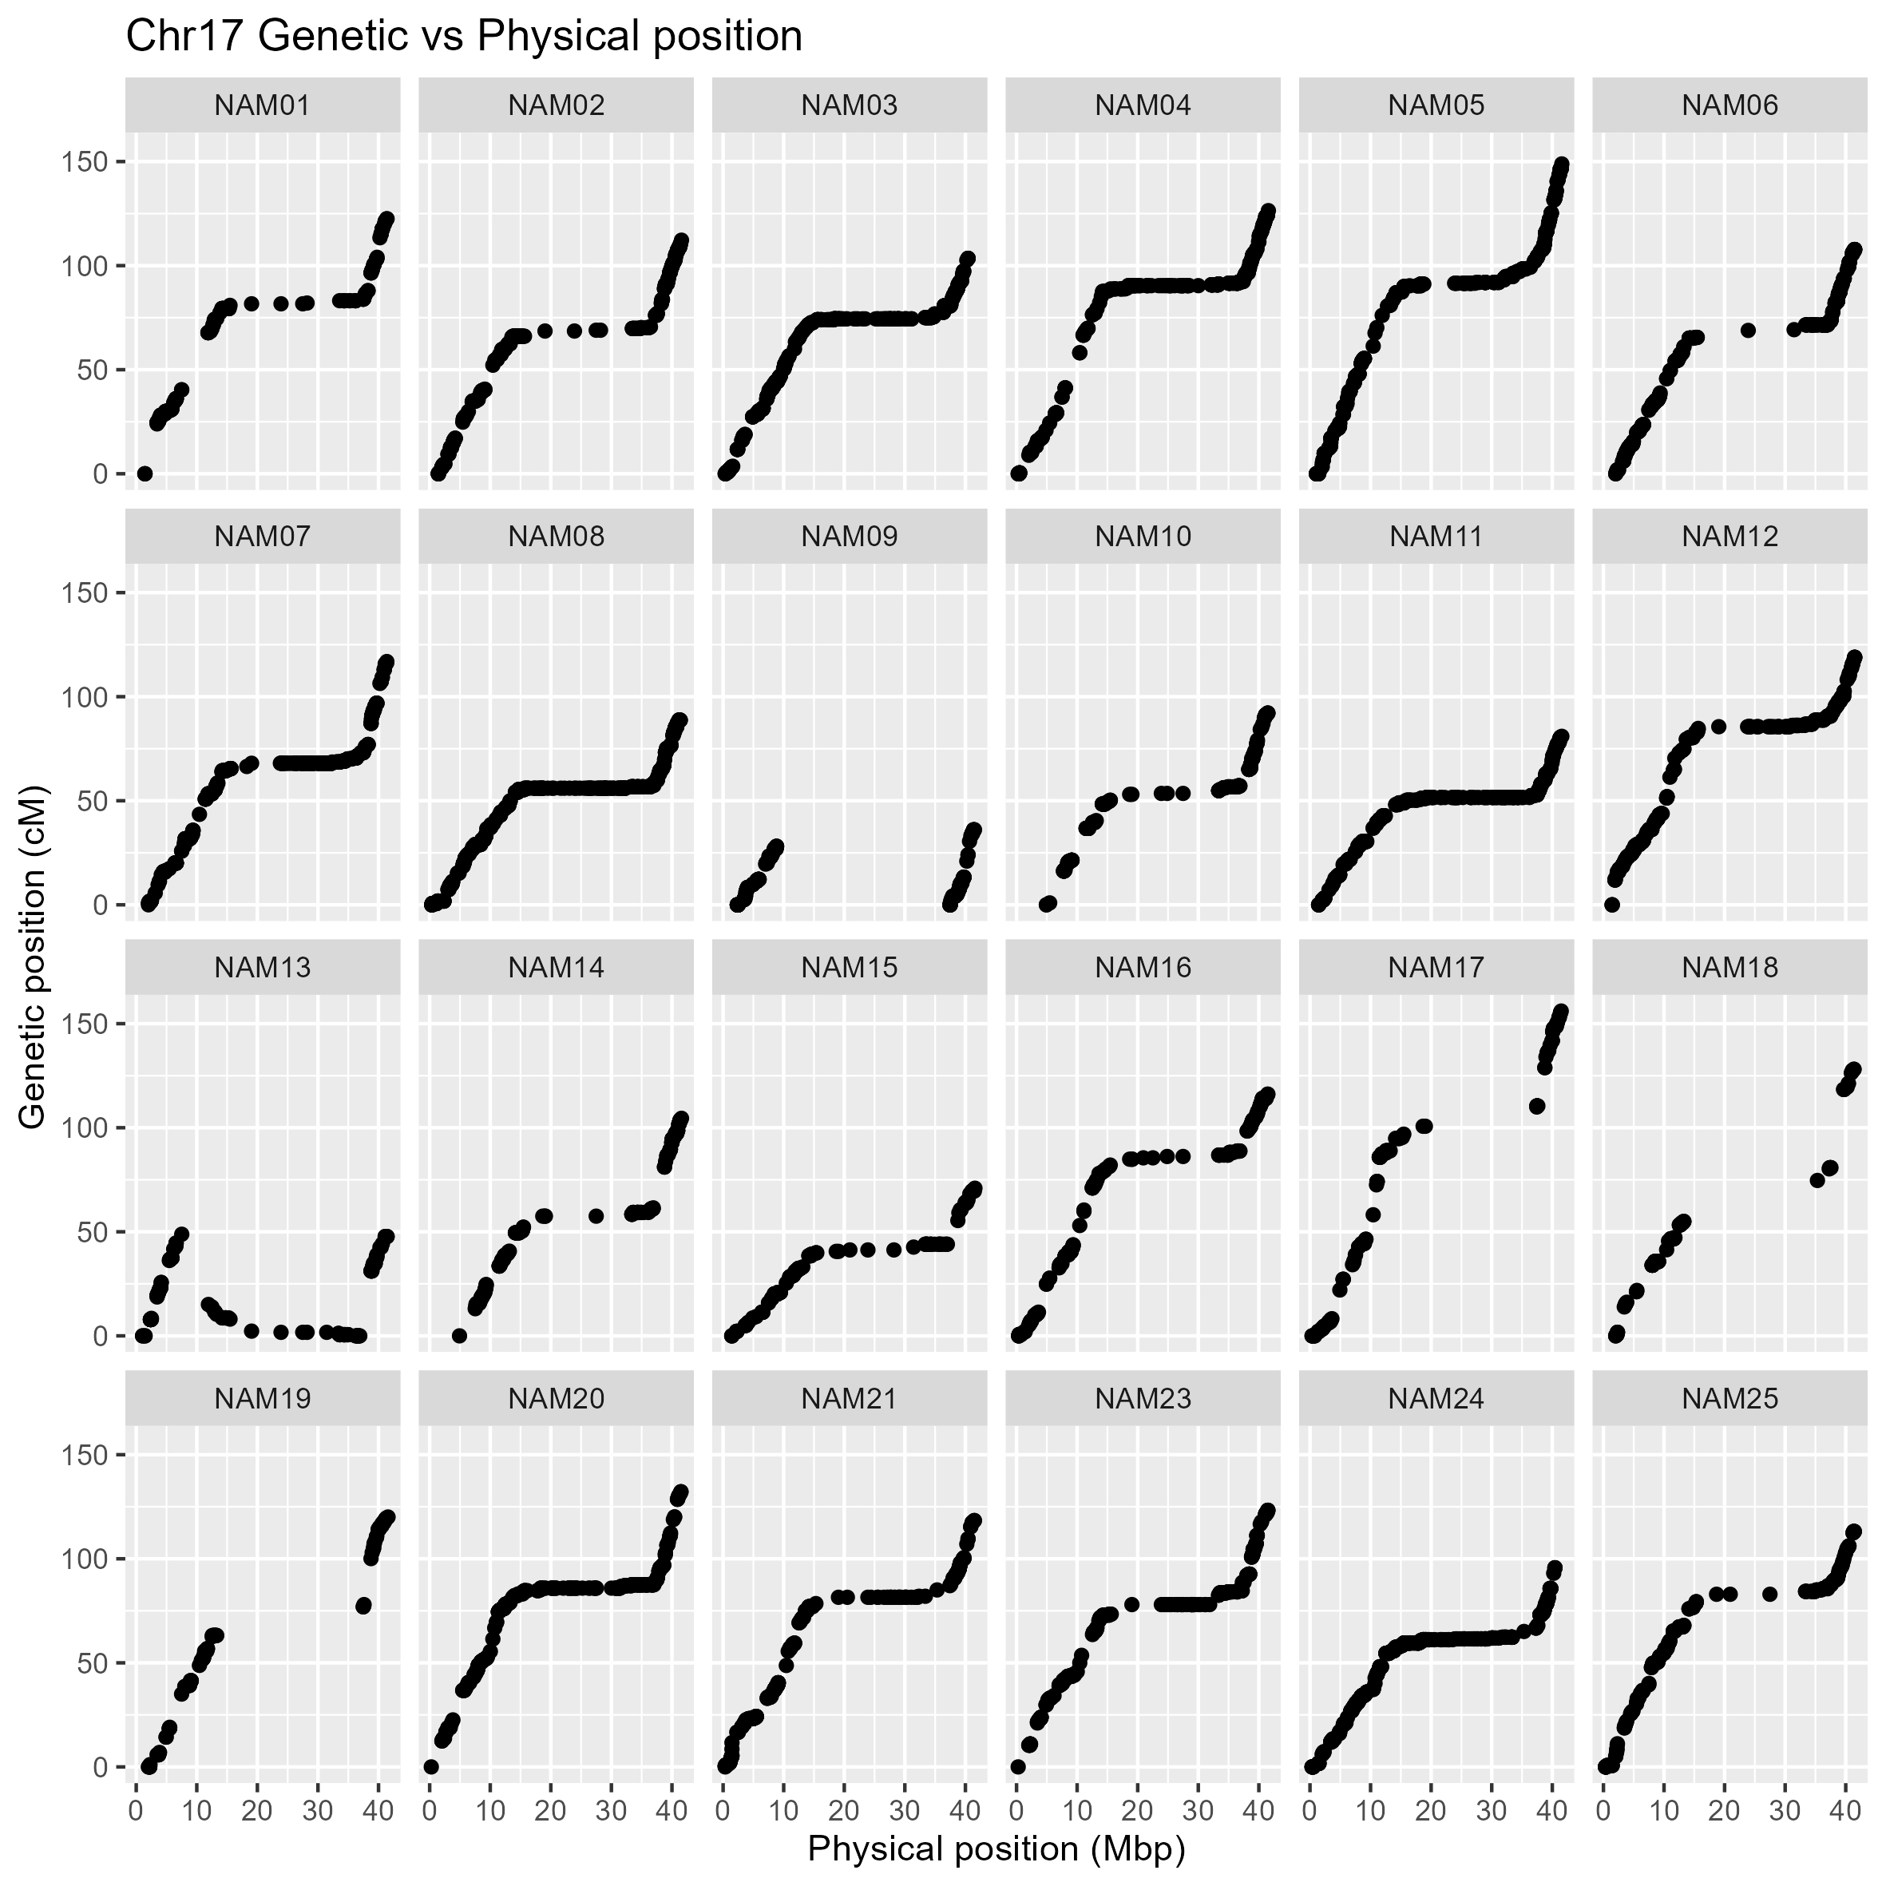Supplementary Appendix B.17. Collinearity of genetic (cM) and physical position (Mbp) of the SNP integrated into the genetic map on chromosome 17 from 24 family of the K-SoyNAM population. The y-axis and x-axis indicate the genetic and physical positions based on the reference soybean genome, respectively (Glyma.Wm82.a2.v1).
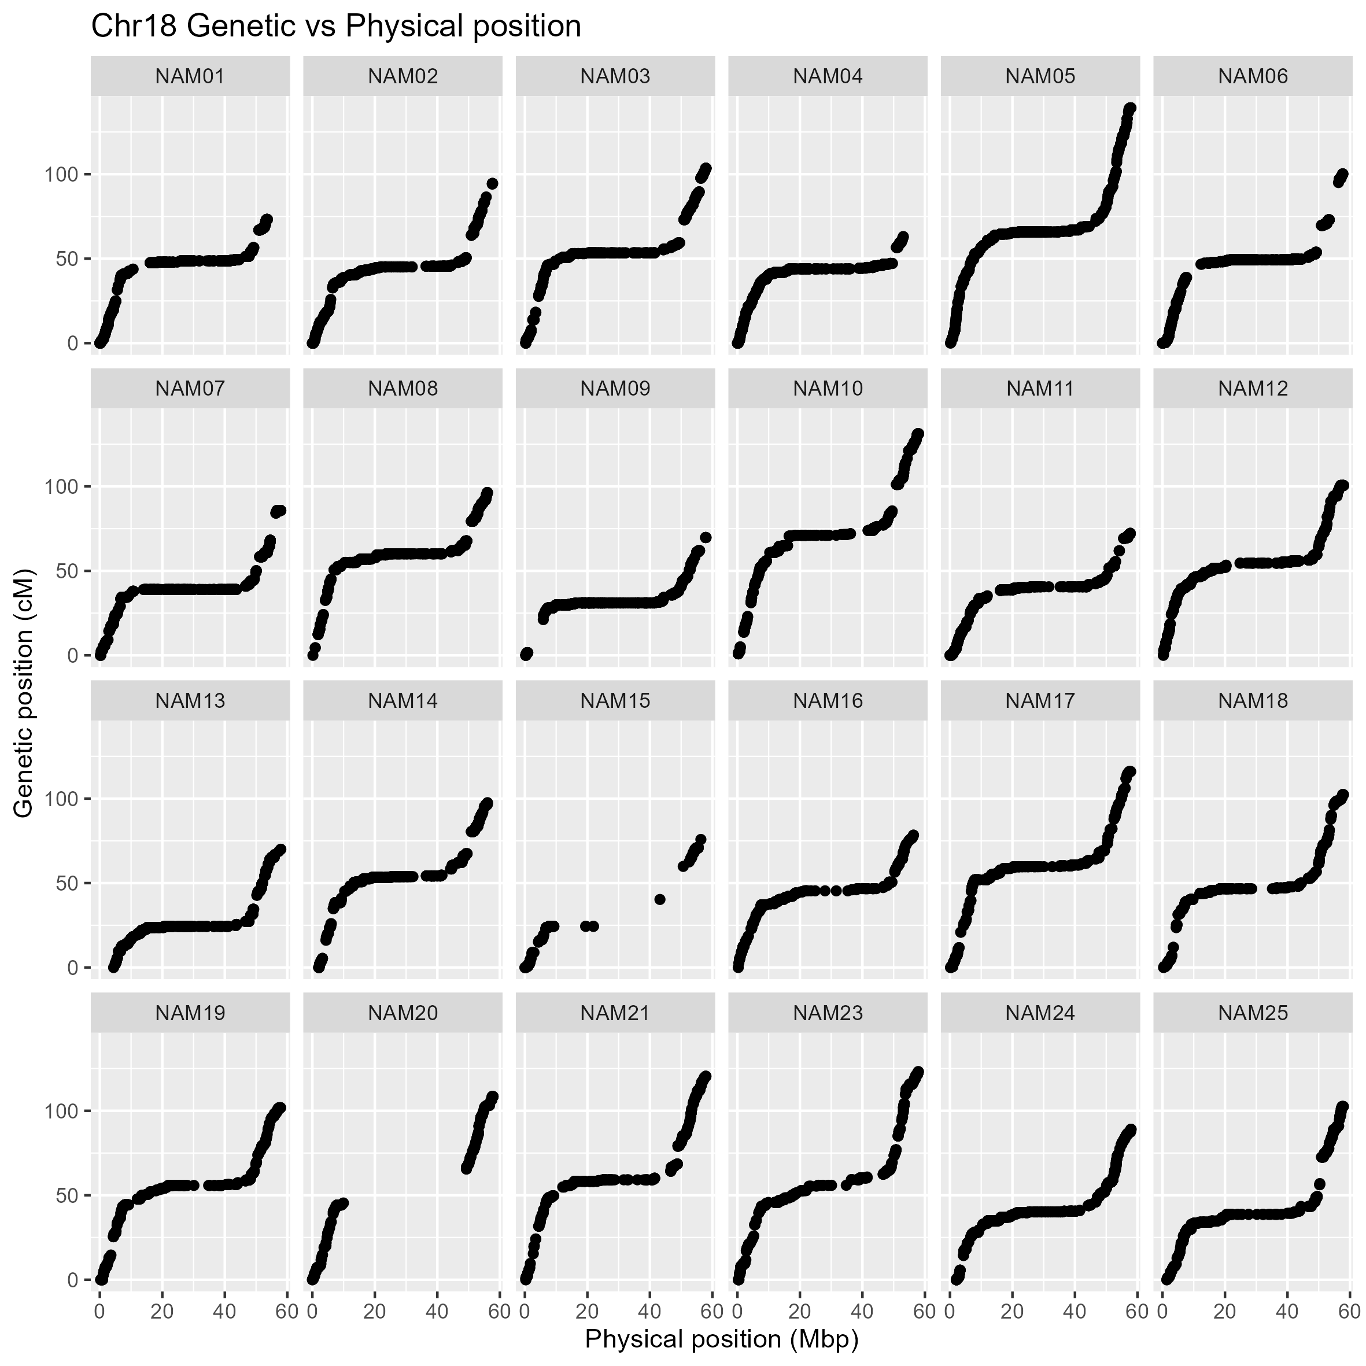
Supplementary Appendix B.18. Collinearity of genetic (cM) and physical position (Mbp) of the SNP integrated into the genetic map on chromosome 18 from 24 family of the K-SoyNAM population. The y-axis and x-axis indicate the genetic and physical positions based on the reference soybean genome, respectively (Glyma.Wm82.a2.v1).
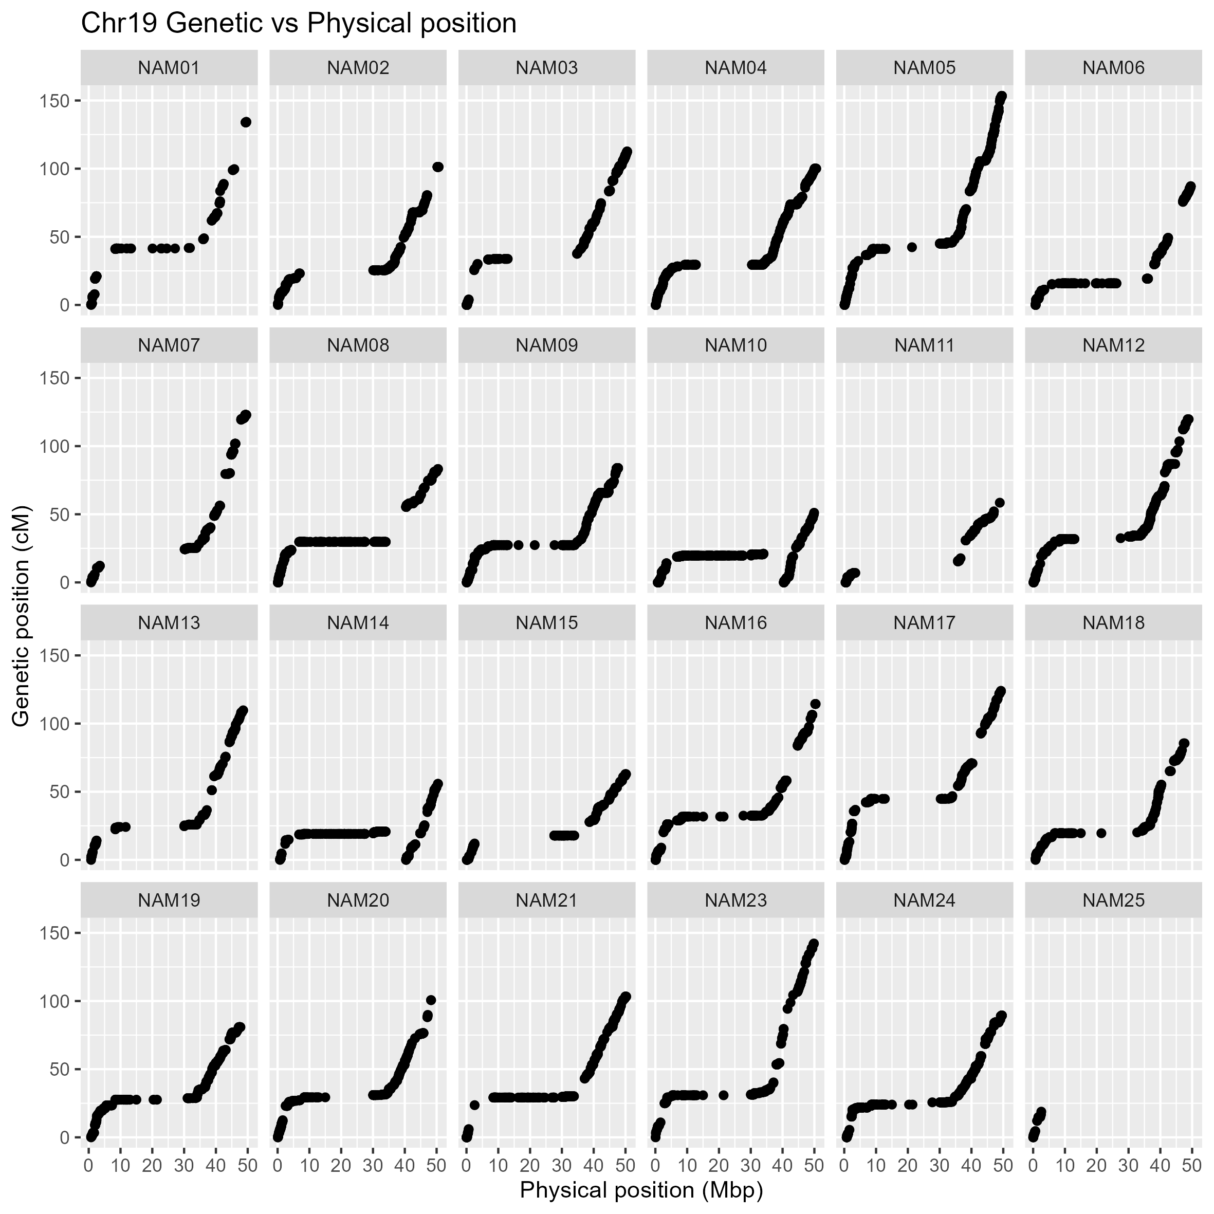Supplementary Appendix B.19. Collinearity of genetic (cM) and physical position (Mbp) of the SNP integrated into the genetic map on chromosome 7 from 24 family of the K-SoyNAM population. The y-axis and x-axis indicate the genetic and physical positions based on the reference soybean genome, respectively (Glyma.Wm82.a2.v1).
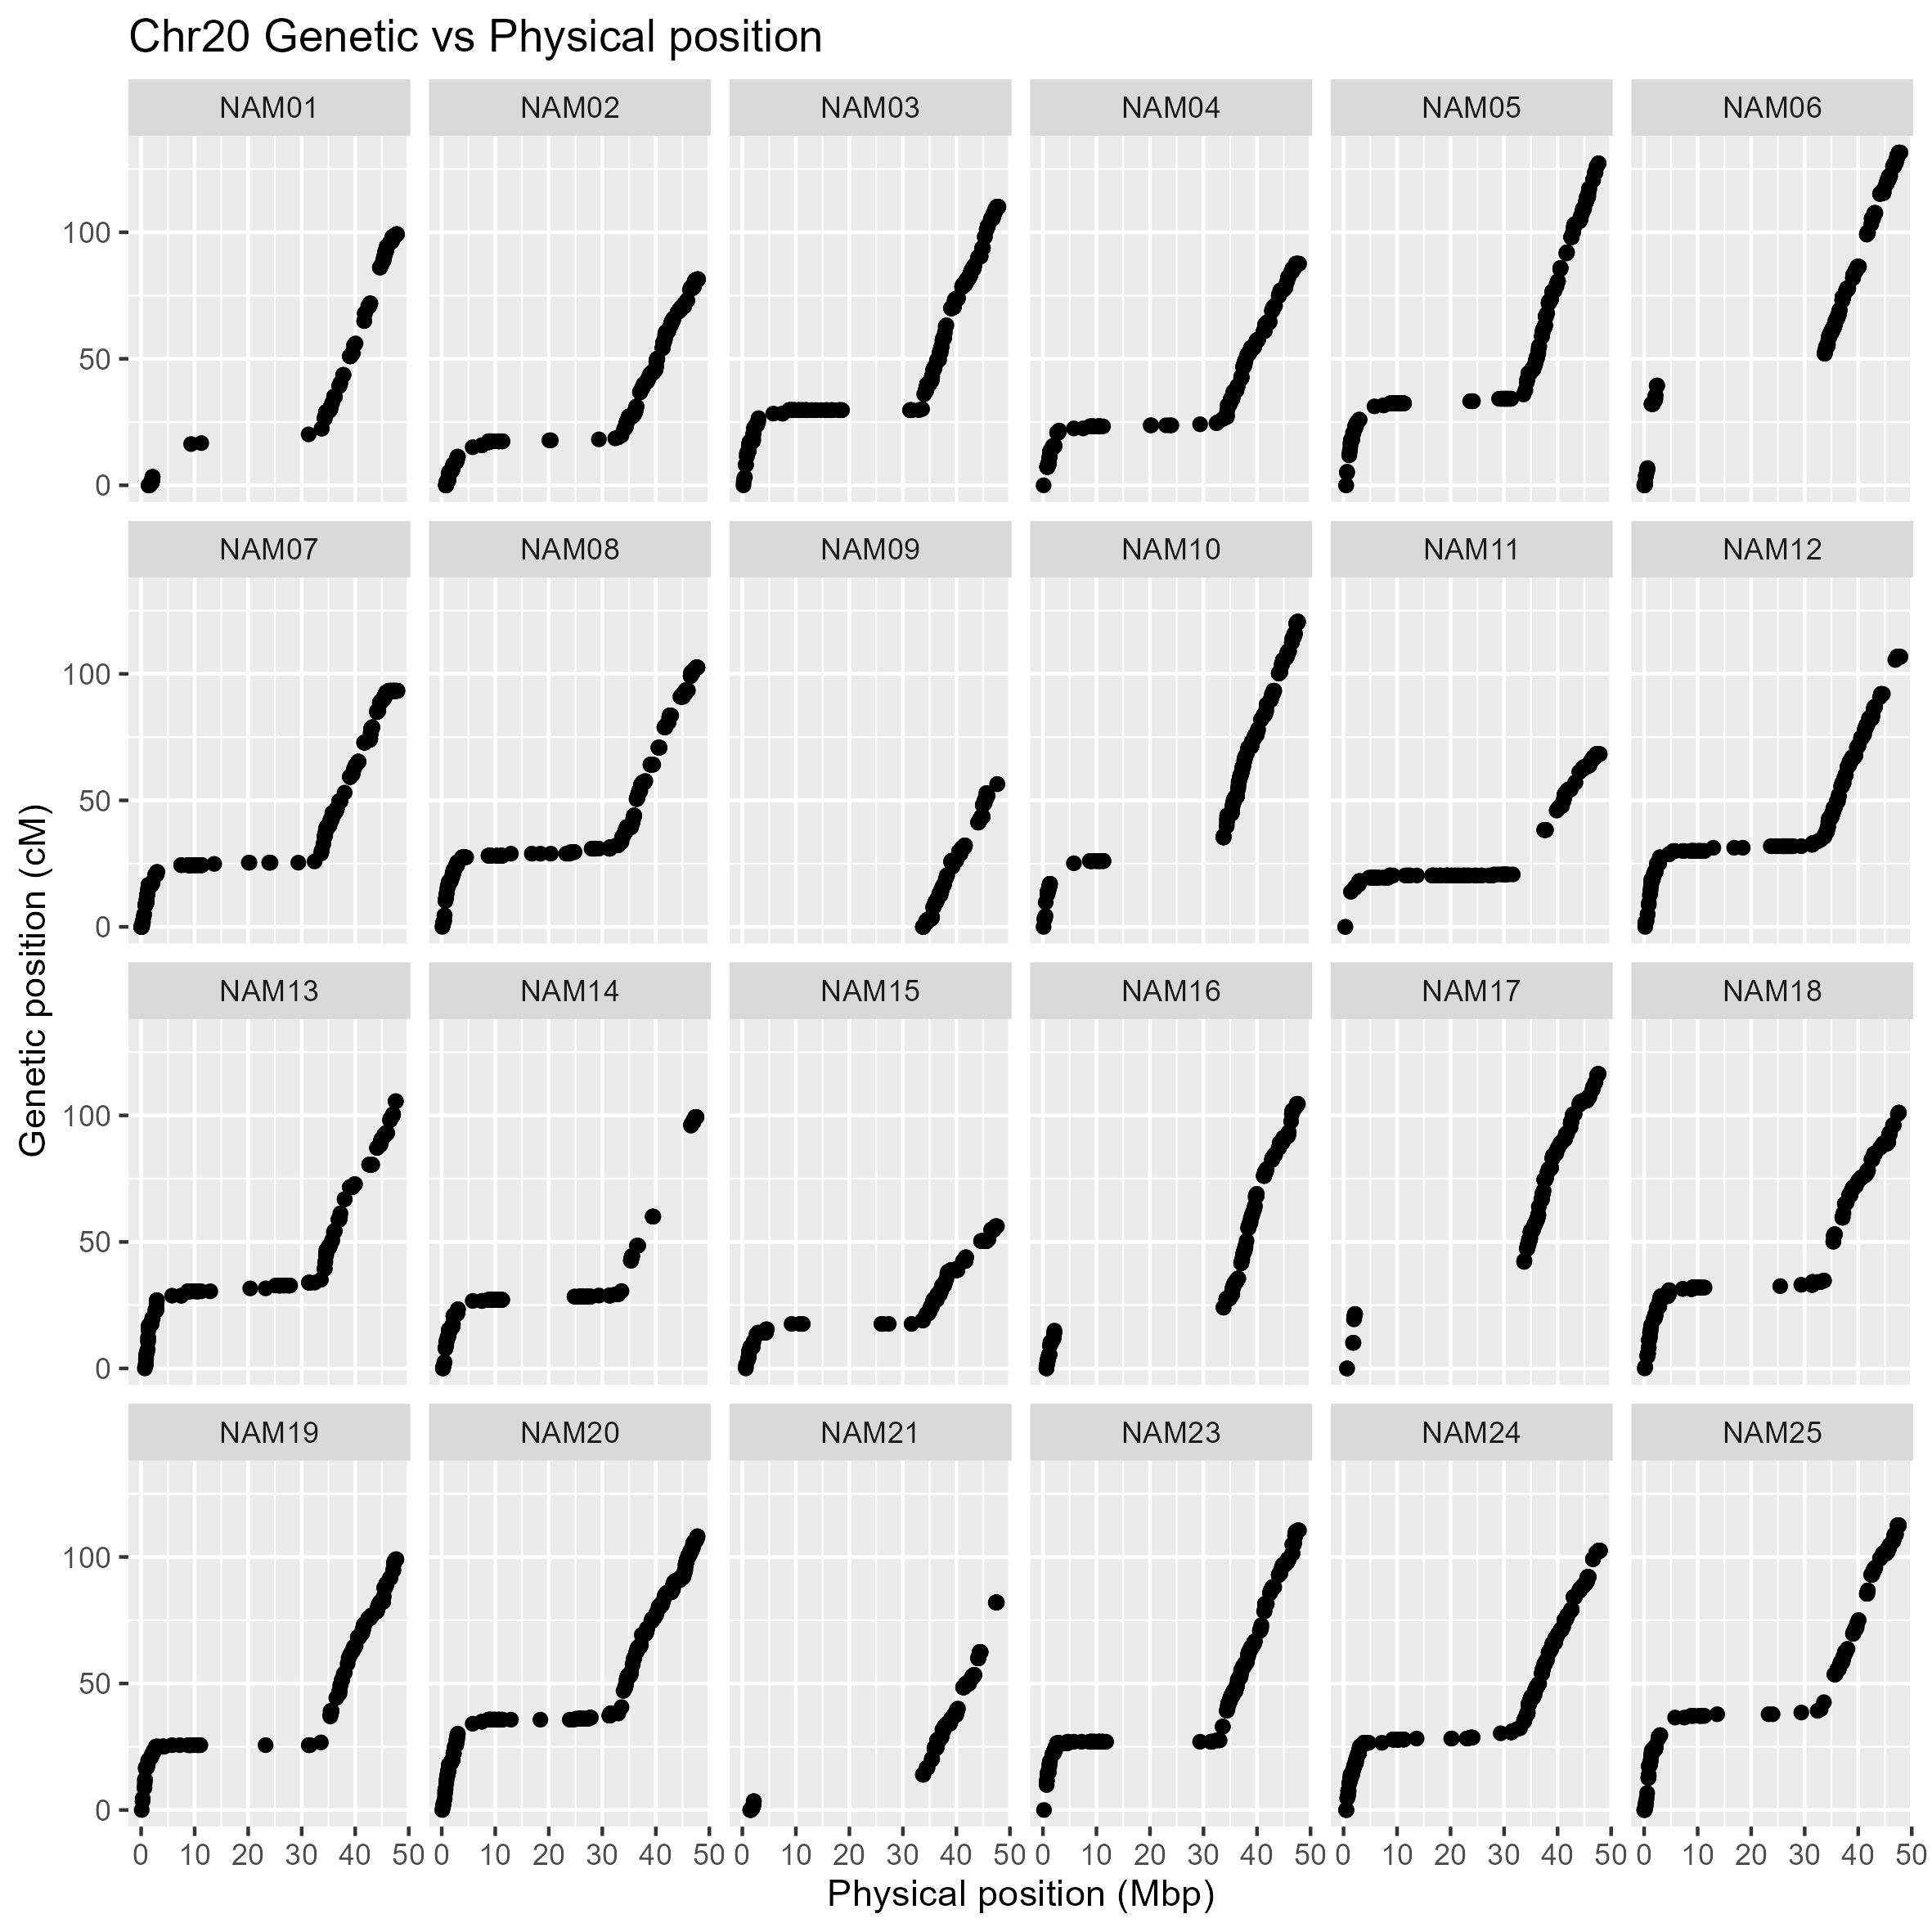
Supplementary Appendix B.20. Collinearity of genetic (cM) and physical position (Mbp) of the SNP integrated into the genetic map on chromosome 20 from 24 family of the K-SoyNAM population. The y-axis and x-axis indicate the genetic and physical positions based on the reference soybean genome, respectively (Glyma.Wm82.a2.v1).

Supplementary Appendix C: Comparison between the composite genetic linkage map and the genetic linkage map of a single RIL population. Chr number indicates the linkage groups representing the total number of chromosomes in the soybean genome (n = 20). Black bars indicate markers. Green bars indicate SNP markers of the composite genetic map. The left ruler indicates the length in cM. Common SNP loci are connected by red lines. For visualization, when two or more linkage groups were split within the same chromosome, each linkage group was arbitrarily placed with a 50 cM interval.
