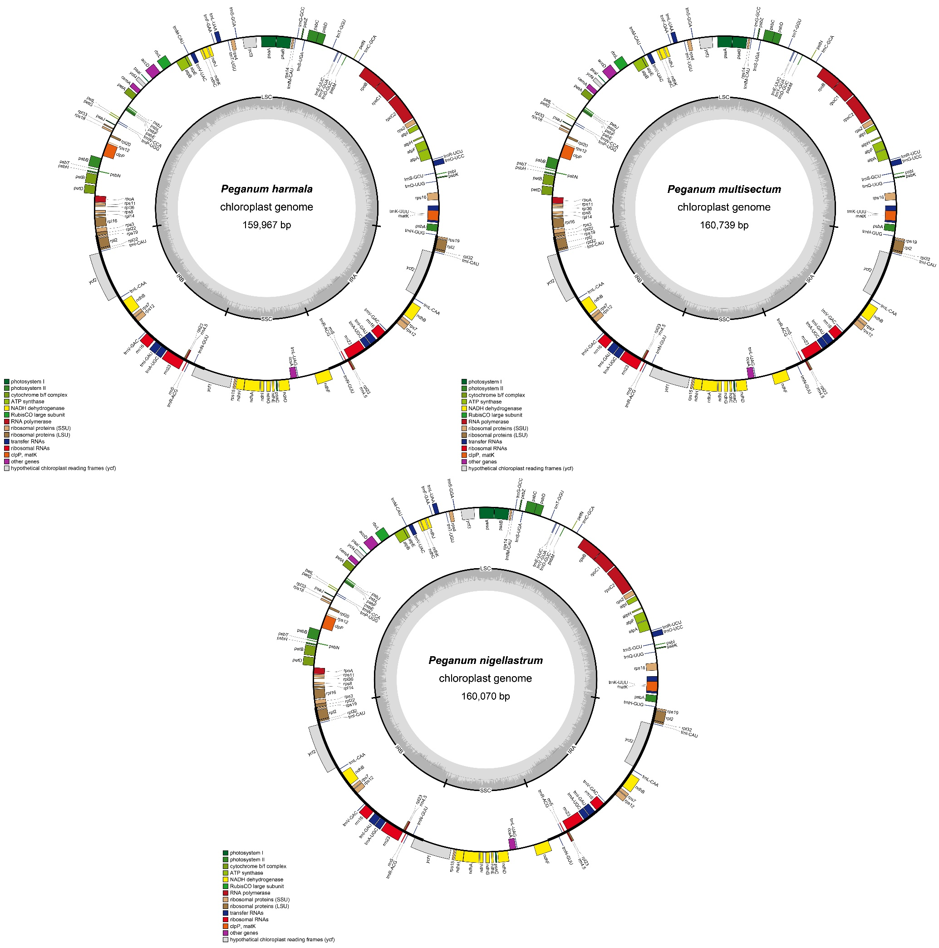
Figure S1. Circular DNA maps of the plastomes in P. harmala, P. multisectum, and P. nigellastrum.
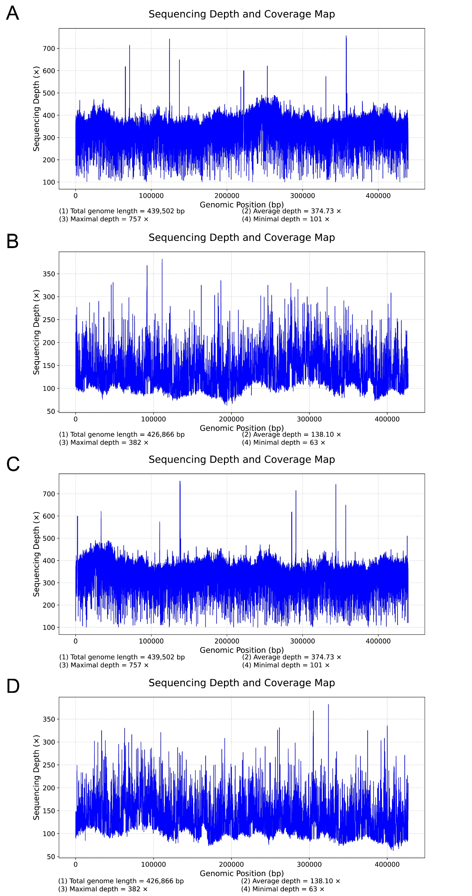
Figure S2. Long-read coverage profiles of the complete mitogenomes of (A) P. multisectum and (B) P. nigellastrum. Long-read coverage after shifting the original start position to an internal region are shown for (C) P. multisectum and (D) P. nigellastrum.
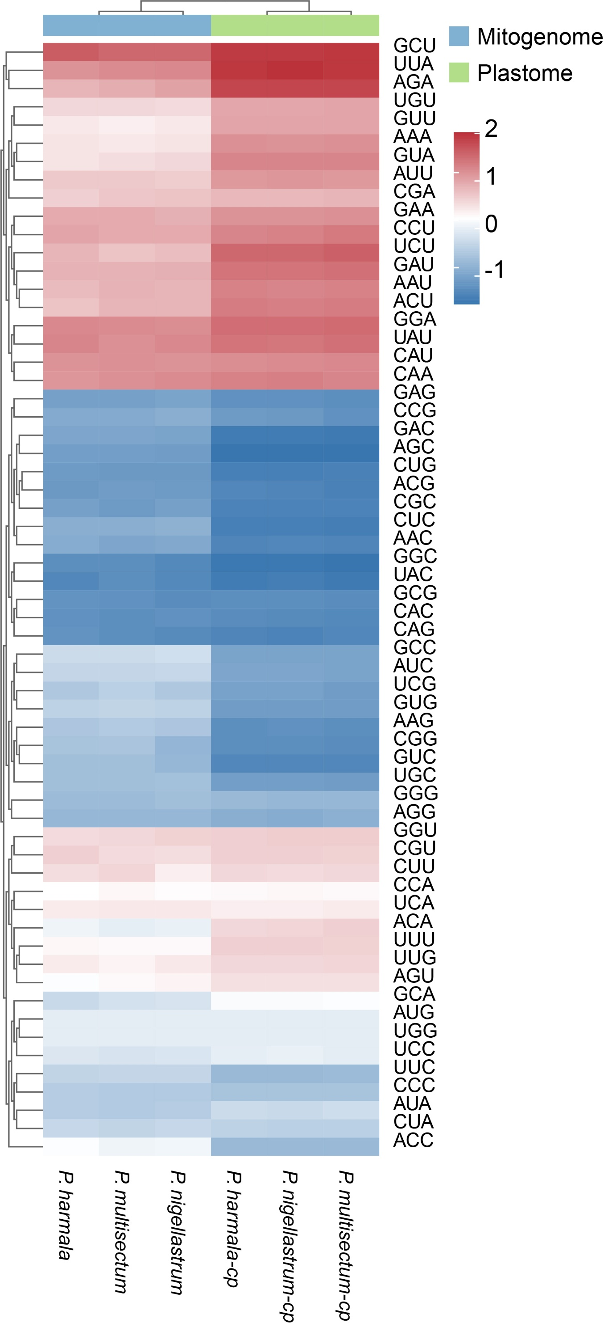
Figure S3. The heatmap of codon preference for P. harmala, P. multisectum, and P. nigellastrum.
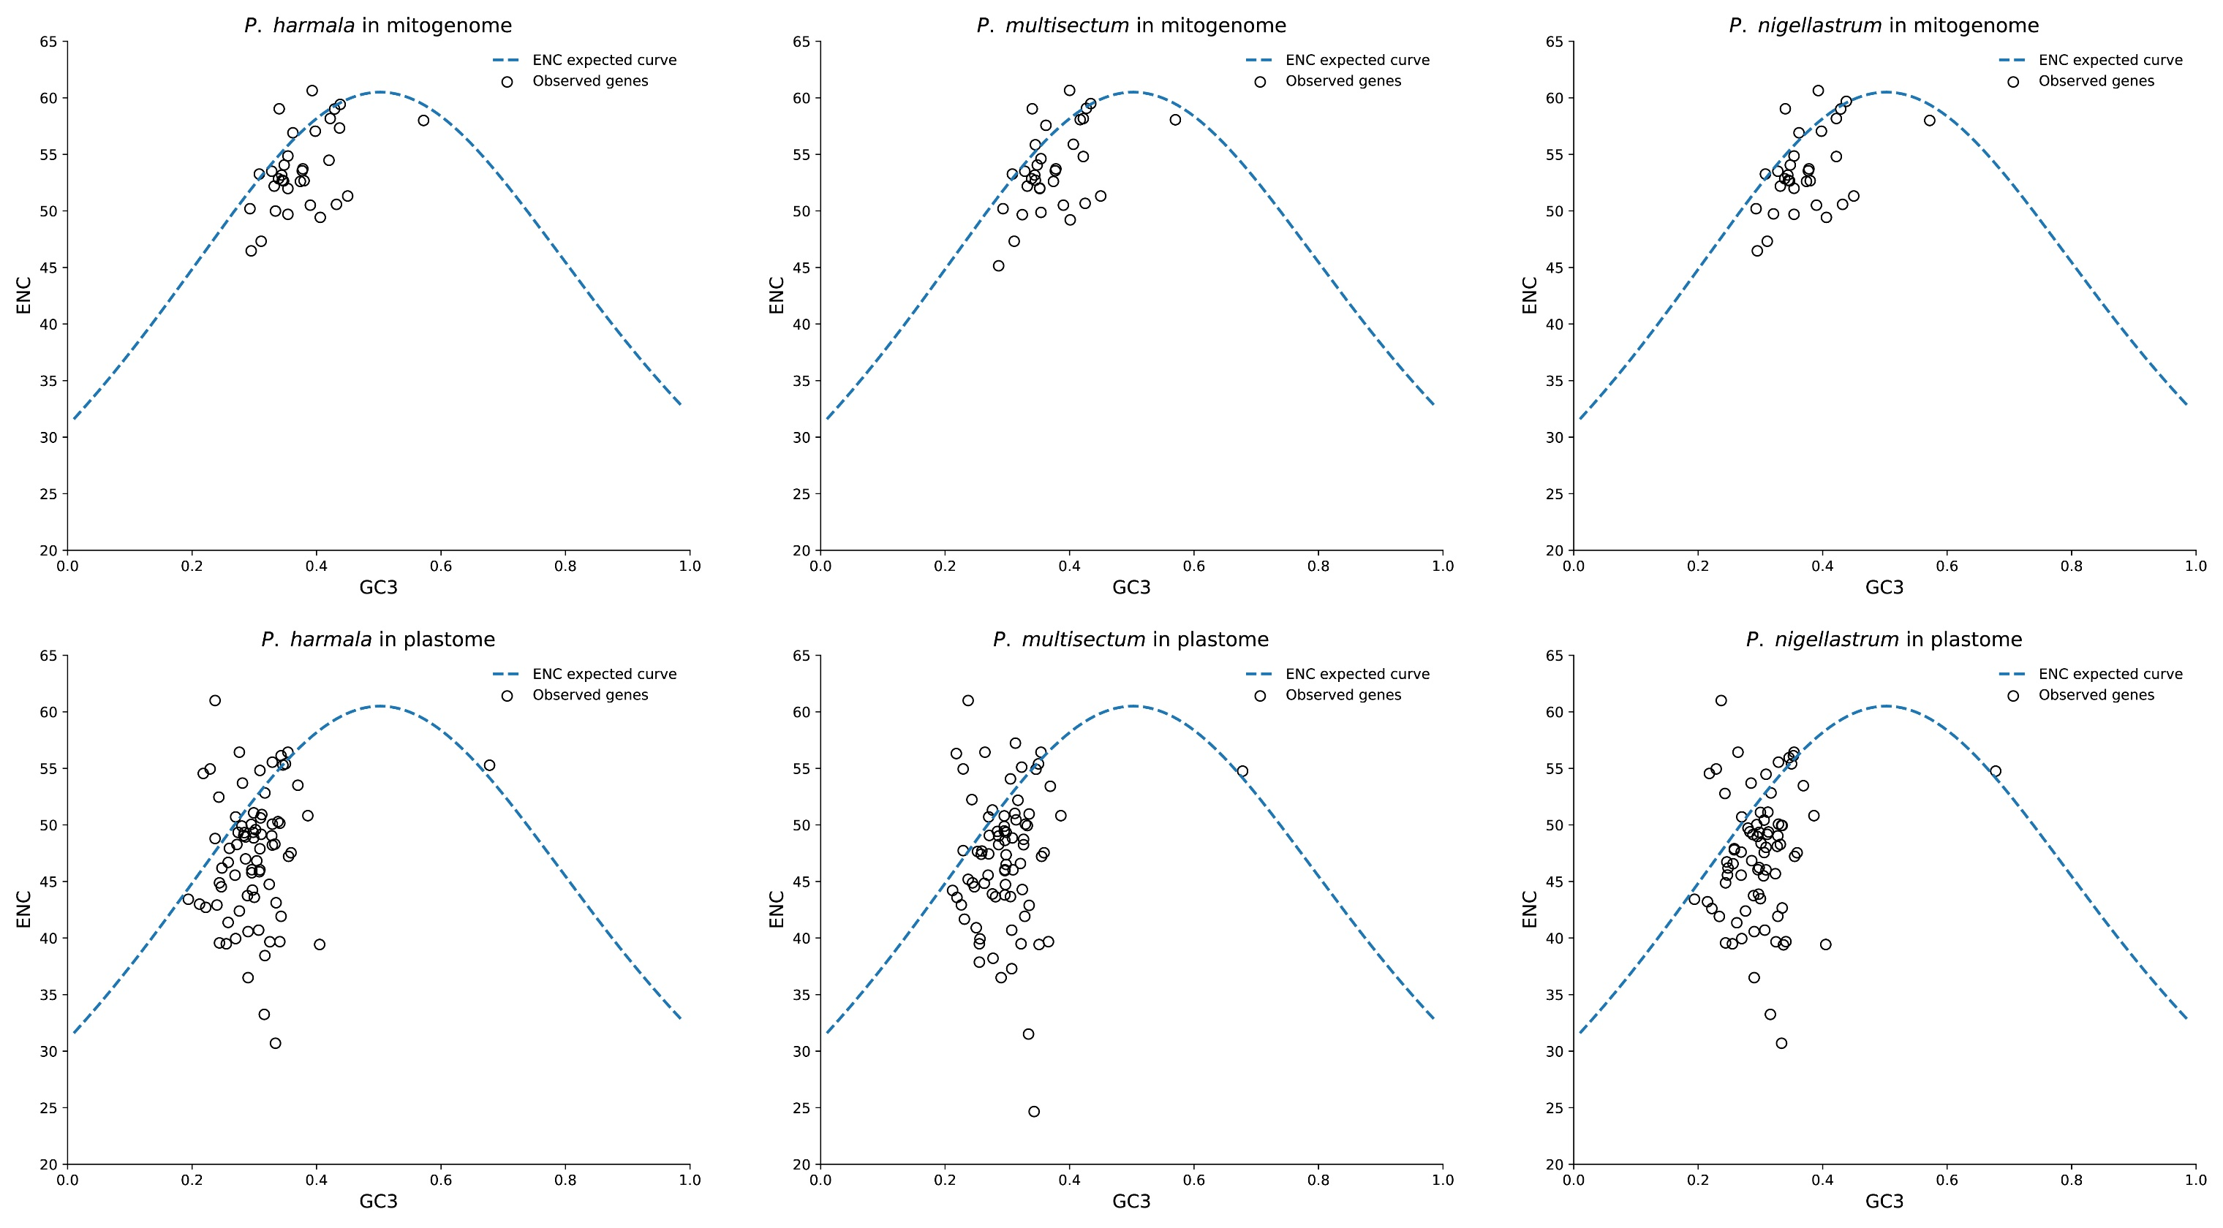
Figure S4. ENC-GC3 correlation plots for organelle-encoded genes of P. harmala, P. multisectum, and P. nigellastrum.

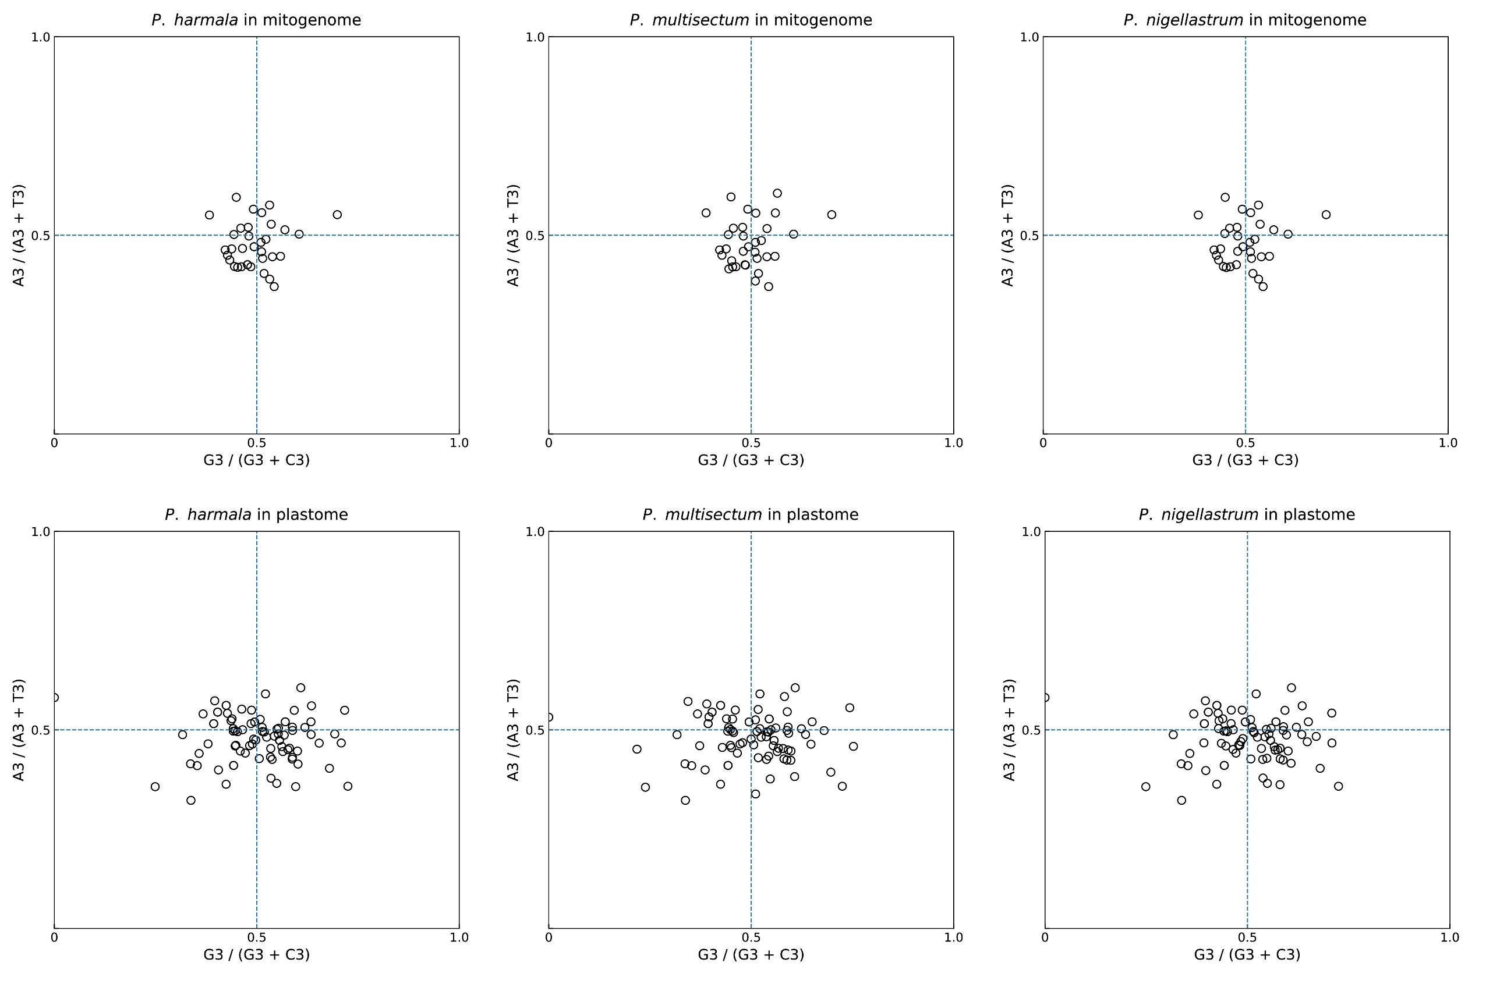
Figure S5. PR2-plots illustrating parity rule 2 (A3/T3 vs. G3/C3) bias in organelle-encoded genes of P. harmala, P. multisectum, and P. nigellastrum.
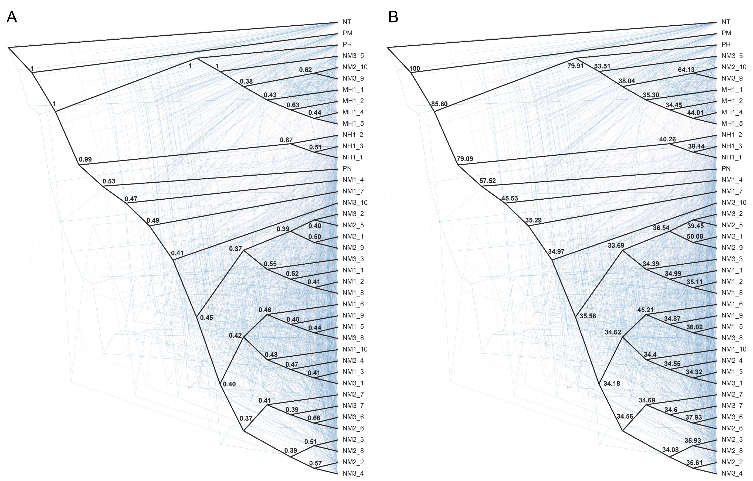
Figure S6. The species tree annotated with node support values, including (A) local posterior probabilities (local PP) and (B) quartet scores.
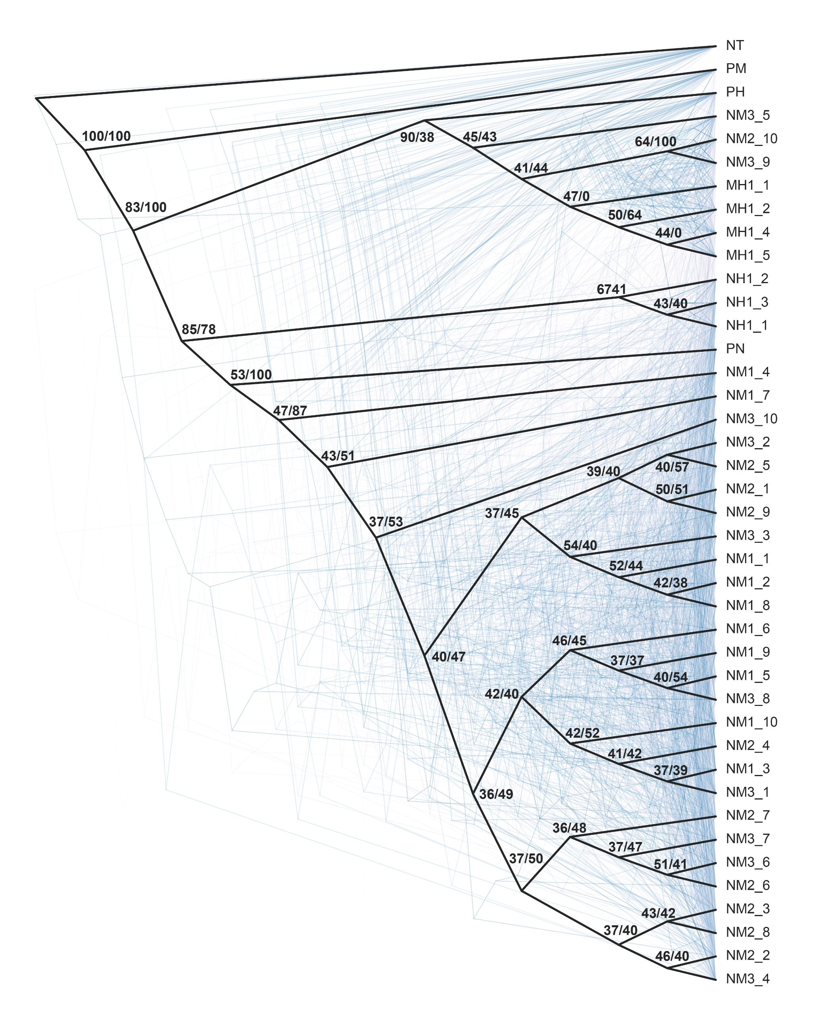
Figure S7. The species tree with node supports indicated by gene concordance factor and site concordance factor (gCF/sCF).

