Table S1: Comparison of current methods for sample preparation for microbial NGS
Method | ZymoBIOMICS DNA Microprep and MagBead DNA Kit | GenomeTrker WGS Workflow | MagMAX Microbiombe Ultra Nucleic Acid Isolation Kit | MagAttract Microbial DNA Kit | Pathogen to Read (this method)
Reagent Company | Zymo | Qiagen, Illumina | ThermoFisher | Qiagen | N/A
Lysis Method | Beat Beating | Enzymatic | Beat Beating | Beat Beating | Enzymatic
Purification Method | Spin Column | Spin Column | Bead Based | Bead Based | Bead Based
Extraction
Specified Library Preparation Workflow | × |  | × | ×
Gram + / Gram - workflows | Single extraction workflow | Separate Workflows for Gram+ and Gram- | Single extraction workflow | Single extraction workflow | Single unified workflow
Automation Integrated? | Partially |  | Partially
Single Workflow / Device ? | × | × | × | ×
Compatible Platform Manufacturers | Lysis: Off-deck bead beating  Purification: Qiagen (Microprep),  Opentrons (MagBead) | Lysis + Extraction: Qiagen, Promega  Library Preparation: Revvity, Hamilton, Beckman Coulter, Eppendorf, Tecan, SPT Labtech | Lysis: Off-deck bead beating  Extraction:  ThermoFisher | Lysis: Qiagen^  Extraction: ThermoFisher, Eppendorf  Library Preparation: Revvity, Hamilton, Beckman Coulter, Eppendorf, Tecan, SPT Labtech, Volta Labs | Revvity (Verified), compatible with any other NGS system with heating and bead capture capability
Primary Throughput Level of Automation | Medium - High  Throughput | Medium - High  Throughput | High Throughput | Medium – High Throughput | Low Throughput
Reference | [44][45] | [31] | [46] | [47] | n/a
*Manufacturer platforms are as follows: Hamilton (NGS STAR 2.0), Beckman Coulter (Biomek i7), Eppendorf (epMotion 5075t), Tecan (Freedom Evo), SPT Labtech (Firefly), Revvity (BioQule), Qiagen (QiaCube), Qiagen^ (TissueLyser II), Promega (Maxwell RSC), ThermoFisher (KingFisher Flex), SPT Labtech (Firefly), Volta Labs (Callisto)

Figure S2: Offset positioning of cartridge cannulas in 384 well plate. Green represents cannula 1 when inserted into column one of plate. Magenta represents corresponding position of cannula 2.
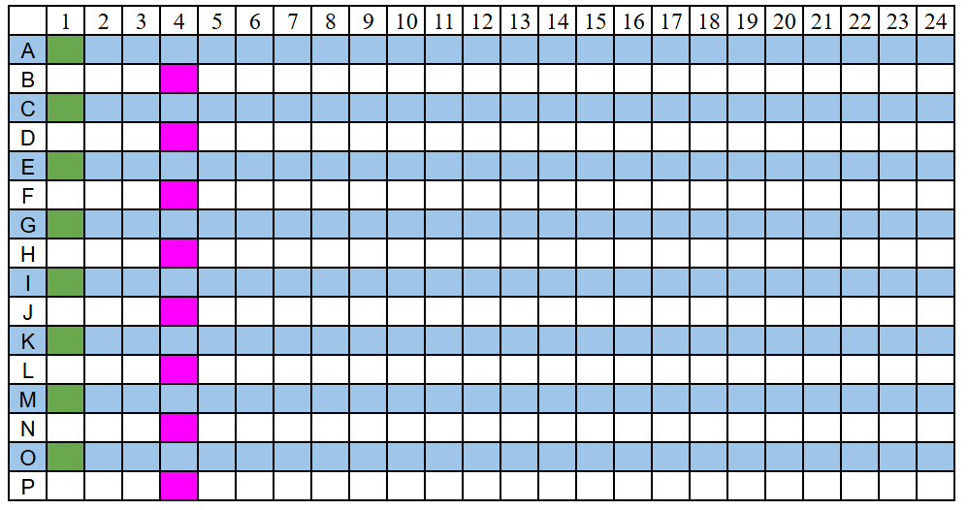

Table S3: Reagents, volumes, and manufacturers used in Pathogen to Read Workflow
Reagent |  |  | Manufacturer | Volume (µl) | Code for Figure S3
0.5% Tween20 |  |  | ThermoFisher | 200 | TW
Wash Buffer 3 |  |  | Revvity (chemagic nucleic acid purification) | 200 | WB3
Wash Buffer 4 |  |  | Revvity (chemagic nucleic acid purification) | 200 | WB4
Wash Buffer 5 |  |  | Revvity (chemagic nucleic acid purification) | 200 | WB5
1X TE |  |  | ThermoFisher | 33 | TE *
 |  |  | ThermoFisher | 30 | TE ^
 |  |  | ThermoFisher | 23 | TE ~
Pretreatment Buffer |  | 2.0/ERA buffer | ThermoFisher | 13 | PB
 |  | 20 mg/ml BSA | ThermoFisher | 0.75 | PB
 |  | 30 ng/µl oligo | ThermoFisher | 0.42 | PB
 |  | Tween-20 10% | ThermoFisher | 0.50 | PB
 |  | Water | ThermoFisher | 35.33 | PB
Frag/AT Buffer |  |  | Watchmaker DNA Library Preparation with Fragmentation | 5 | FB
Frag/AT Enzyme |  |  | Watchmaker DNA Library Preparation with Fragmentation | 6 | FE
Extraction Beads |  |  | Revvity (chemagic nucleic acid purification) | 9.9 | EB
Binding Buffer |  |  | Revvity (chemagic nucleic acid purification) | 55 | BB
Input | Metapolyzyme (1 mg/ml) |  | Zymo | 4 | In
Input | Sample |  | Zymo | 5 | In
Input | PBS |  | ThermoFisher | 35 | In
IPA (70%) |  |  | ThermoFisher | 200 | IPA
Diluted Barcode Adapter |  |  | Revvity | 10 | BA
Ligation Master Mix |  |  | Watchmaker DNA Library Preparation with Fragmentation | 20 | LM
Ampure XP Beads |  |  | Beckman Coulter | 50 | AB *
 |  |  | Beckman Coulter | 60 | AB ~
P5/P7 primer mix |  |  | Watchmaker DNA Library Preparation with Fragmentation | 10 | PM
Equinox Amplification Mix |  |  | Watchmaker DNA Library Preparation with Fragmentation | 25 | EM

Figure S4: 384 Well Plate layout of reagent loading
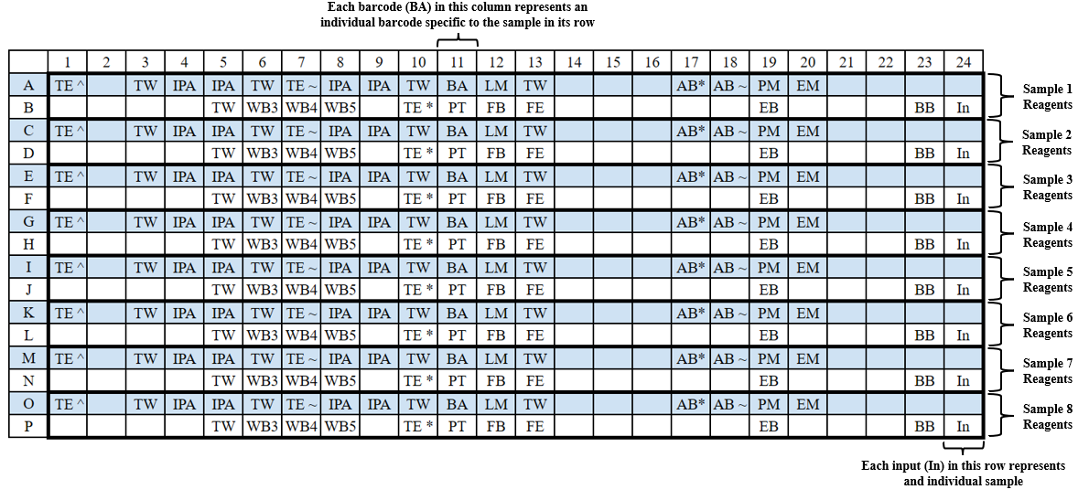
Table S5: Table of values for representation of different bacterial strains from library generated by the protocols against the theoretical input distribution
Organism | Theoretical Genome Copy Percent | Optimized Protocol |  |  | Standard Lysis Protocol
Organism | Theoretical Genome Copy Percent | Mean | Std | Deviation from Theoretical | Mean | Std | Deviation  from Theoretical
Pseudomonas aeruginosa | 6.1 | 14.36847 | 0.85161 | +1.355487 | 28.51122 | 3.272975 | +3.673971
Escherichia coli | 8.5 | 2.055013 | 0.073647 | -0.75823 | 6.483247 | 0.353381 | -0.23727
Salmonella enterica | 8.7 | 17.42029 | 0.606625 | +1.002332 | 37.14924 | 2.694434 | +3.270027
Lactobacillus fermentum | 21.6 | 25.83029 | 1.374329 | +0.195847 | 2.41865 | 0.068361 | -0.88803
Enterococcus faecalis | 14.6 | 6.555991 | 0.40606 | -0.55096 | 2.324559 | 0.063265 | -0.84078
Staphylococcus aureus | 15.2 | 2.608509 | 0.419218 | -0.82839 | 0.869309 | 0.148531 | -0.94281
Listeria monocytogenes | 13.9 | 18.03923 | 1.622186 | +0.297787 | 2.838385 | 0.098655 | -0.7958
Bacillus subtilis | 10.3 | 11.73896 | 0.567358 | +0.139705 | 17.88426 | 0.454774 | +0.736336

