Supplementary Material 4- Clustering Analysis for Outlier Detection in 36 Samples of Hotspot SSC6 (93,742,864 bp) (AA Genotype)
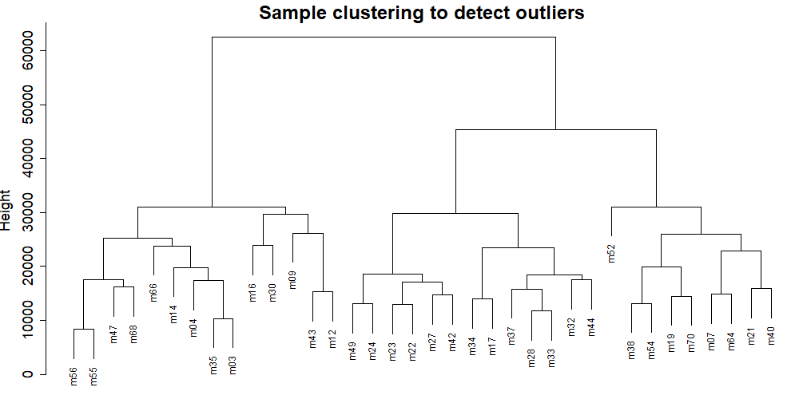

Clustering Analysis for Outlier Detection in 28 Samples of Hotspot SSC6 (93,742,864 bp) (AB Genotype)
