Supplementary Material 1- WGCNA network parameters, including soft-thresholding power (β), scale-free topology fit index (R²), and mean connectivity for each dataset.

Hotspot SSC3 (102,983,783 bp)
Genotype AA
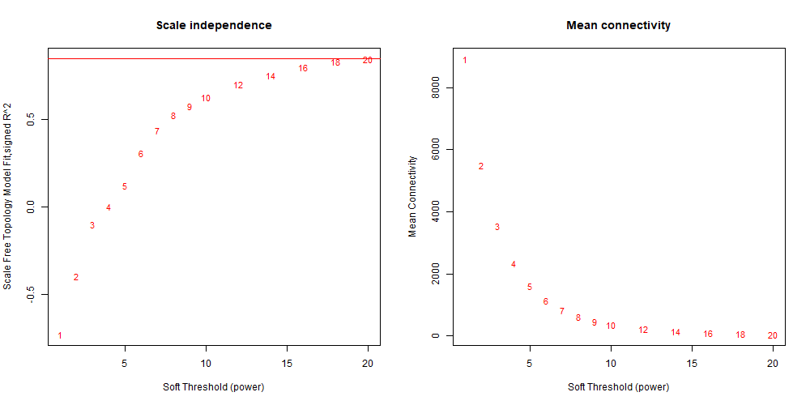
Genotype AB
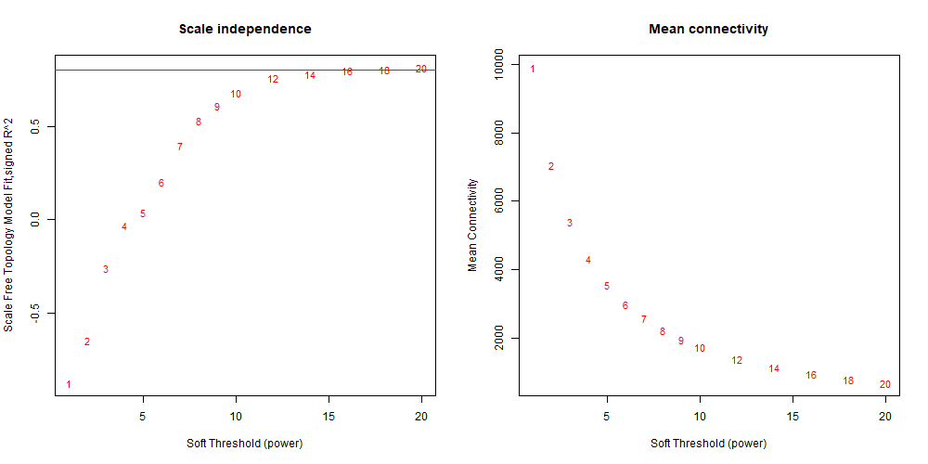

Hotspot SSC2 (67,926,641 bp)
Genotype AA
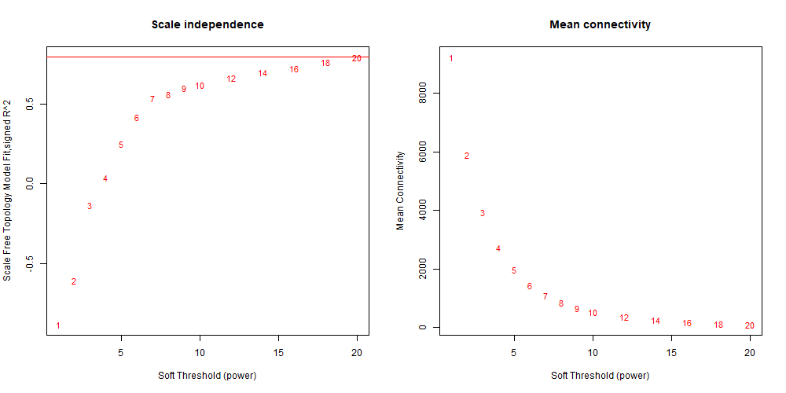
Genotype AB
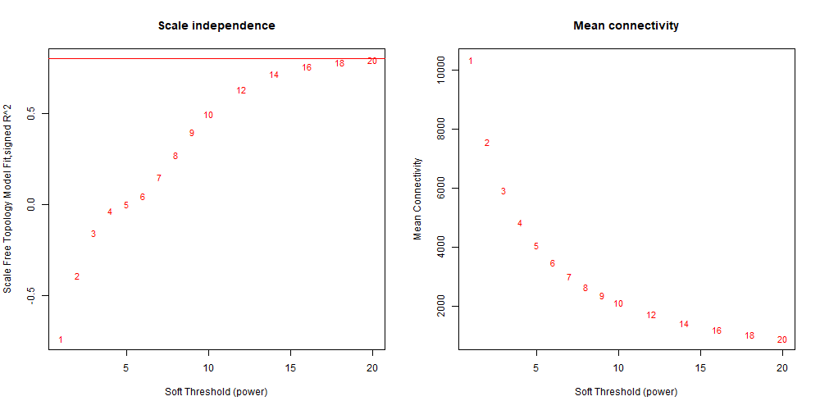

Hotspot SSC6 (93, 742,864 bp)
Genotype AA
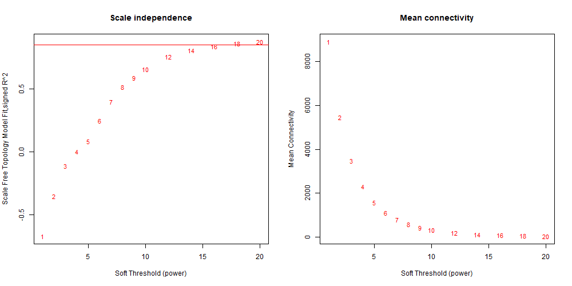
Genotype AB
