Supplementary Table 1. Characteristics of the HSP gene family in Andrais davidianus.
Sequence Names | Number of amino acids | Molecular weight (kDa) | Theoretical pI | Number of Negatively Charged Residues | Number of Positively Charged Residues | Amino Acid composition | N-terminal Amino Acid | Estimated half-life | Instability index | Aliphatic index | Grand average of hydropathicity
AndHSP20-01 | 171 | 19.54 | 5.89 | 25 | 20 | 20 | Met | 10095 | 55.95 | 77.43 | -0.437
AndHSP20-02 | 174 | 19.93 | 6.16 | 26 | 23 | 19 | Met | 15470 | 46.63 | 86.26 | -0.371
AndHSP20-03 | 168 | 18.42 | 5.18 | 20 | 16 | 19 | Met | 12170 | 61.51 | 68.99 | -0.444
AndHSP20-04 | 203 | 23.01 | 6.32 | 28 | 25 | 19 | Gln | 12045 | 47.47 | 81.63 | -0.528
AndHSP20-05 | 143 | 15.75 | 6.69 | 19 | 18 | 20 | Pro | 10220 | 63.4 | 66.78 | -0.628
AndHSP20-06 | 215 | 23.90 | 5.86 | 27 | 24 | 20 | Met | 39085 | 69.88 | 73.07 | -0.439
AndHSP20-07 | 285 | 31.19 | 6.76 | 36 | 36 | 20 | Met | 21470 | 52.48 | 66.46 | -0.571
AndHSP20-08 | 204 | 22.58 | 4.70 | 30 | 18 | 20 | Met | 31065 | 56.37 | 70.74 | -0.496
AndHSP20-09 | 168 | 18.57 | 6.43 | 22 | 21 | 19 | Met | 2980 | 58.06 | 59.76 | -0.691
AndHSP40-01 | 405 | 45.53 | 8.33 | 55 | 59 | 20 | Met | 28140 | 29.79 | 73.14 | -0.64
AndHSP40-02 | 793 | 90.44 | 7.27 | 101 | 101 | 20 | Met | 149670 | 36.2 | 79.57 | -0.405
AndHSP40-03 | 338 | 38.17 | 8.61 | 51 | 54 | 20 | Met | 24535 | 41.42 | 68.7 | -0.719
AndHSP40-04 | 380 | 42.73 | 8.54 | 51 | 55 | 20 | Met | 31205 | 39.35 | 59.61 | -0.883
AndHSP40-05 | 584 | 66.63 | 5.96 | 97 | 86 | 20 | Leu | 56435 | 48.05 | 82.47 | -0.629
AndHSP40-06 | 316 | 35.17 | 8.91 | 52 | 56 | 20 | Met | 20065 | 47.16 | 76.17 | -0.849
AndHSP40-07 | 399 | 44.95 | 6.90 | 62 | 61 | 20 | Met | 17015 | 33.11 | 71.28 | -0.743
AndHSP40-08 | 223 | 26.13 | 6.70 | 33 | 31 | 19 | Met | 10555 | 42.41 | 35.07 | -0.953
AndHSP40-09 | 768 | 85.23 | 8.83 | 97 | 113 | 19 | Met | 95600 | 52.16 | 62.16 | -0.677
AndHSP40-10 | 327 | 36.74 | 8.94 | 47 | 52 | 20 | Met | 26025 | 58.5 | 37.89 | -1.037
AndHSP40-11 | 2240 | 254.98 | 6.40 | 277 | 258 | 20 | Met | 241320 | 40.94 | 91.9 | -0.256
AndHSP40-12 | 398 | 44.92 | 8.66 | 54 | 58 | 20 | Met | 30160 | 45.34 | 65.88 | -0.707
AndHSP40-13 | 469 | 51.55 | 9.26 | 48 | 63 | 20 | Met | 39475 | 43.03 | 61.96 | -0.544
AndHSP40-14 | 269 | 30.89 | 9.55 | 31 | 43 | 20 | Met | 33140 | 62.7 | 58.77 | -0.919
AndHSP40-15 | 198 | 22.11 | 5.04 | 29 | 20 | 20 | Met | 26775 | 37.96 | 62.12 | -0.586
AndHSP40-16 | 149 | 17.38 | 4.59 | 30 | 17 | 20 | Met | 32805 | 54.21 | 71.34 | -0.668
AndHSP40-17 | 185 | 20.97 | 5.98 | 30 | 28 | 20 | Met | 21275 | 38.48 | 56.43 | -0.779
AndHSP40-18 | 553 | 63.61 | 5.37 | 111 | 93 | 20 | Met | 60445 | 56.84 | 55.06 | -1.159
AndHSP40-19 | 352 | 40.00 | 7.29 | 46 | 46 | 20 | Met | 29465 | 40.92 | 60.97 | -0.866
AndHSP40-20 | 246 | 27.94 | 8.08 | 34 | 36 | 20 | Met | 30285 | 38.19 | 74.88 | -0.412
AndHSP40-21 | 318 | 37.49 | 9.47 | 43 | 64 | 20 | Met | 60445 | 49.28 | 65.47 | -0.936
AndHSP40-22 | 532 | 62.05 | 8.22 | 91 | 94 | 20 | Met | 86205 | 52.44 | 80.77 | -0.819
AndHSP40-23 | 618 | 69.64 | 8.78 | 75 | 82 | 20 | Met | 63175 | 47.32 | 84.56 | -0.355
AndHSP40-24 | 374 | 41.71 | 6.58 | 53 | 51 | 20 | Met | 21930 | 37.83 | 77.3 | -0.526
AndHSP40-25 | 154 | 16.60 | 9.86 | 14 | 23 | 20 | Met | 14440 | 50.34 | 74.94 | -0.472
AndHSP40-26 | 482 | 54.60 | 8.87 | 61 | 70 | 20 | Met | 55070 | 60.12 | 57.18 | -0.835
AndHSP40-27 | 379 | 43.98 | 9.16 | 47 | 57 | 20 | Met | 44600 | 34.64 | 74.33 | -0.681
AndHSP40-28 | 468 | 51.56 | 9.52 | 51 | 65 | 20 | Met | 48610 | 50.56 | 73.42 | -0.594
AndHSP40-29 | 468 | 51.56 | 9.52 | 51 | 65 | 20 | Met | 48610 | 50.56 | 73.42 | -0.594
AndHSP60-01 | 535 | 57.85 | 5.86 | 74 | 63 | 20 | Met | 13325 | 28.3 | 102 | -0.024
AndHSP60-02 | 237 | 25.37 | 9.52 | 28 | 35 | 20 | Met | 13980 | 38.81 | 97.51 | -0.199
AndHSP60-03 | 541 | 59.62 | 5.28 | 81 | 66 | 20 | Met | 20440 | 38.67 | 97.74 | -0.164
AndHSP60-04 | 487 | 53.38 | 6.25 | 63 | 60 | 20 | Met | 19410 | 38.04 | 103.18 | -0.044
AndHSP60-05 | 537 | 57.82 | 8.19 | 63 | 66 | 20 | Met | 12545 | 34.89 | 108.58 | 0.036
AndHSP60-06 | 576 | 61.28 | 5.57 | 80 | 73 | 20 | Met | 14565 | 27.26 | 102.59 | -0.039
AndHSP60-07 | 115 | 12.04 | 4.57 | 17 | 11 | 17 | Leu | 1490 | 34.06 | 106.87 | 0.183
AndHSP70-01 | 402 | 45.11 | 5.57 | 66 | 59 | 20 | Ile | 17545 | 32.99 | 83.71 | -0.628
AndHSP70-02 | 177 | 19.39 | 4.96 | 24 | 18 | 19 | Ser | 4595 | 31.61 | 97.01 | -0.11
AndHSP70-03 | 680 | 73.36 | 5.53 | 94 | 85 | 20 | Met | 29255 | 42.27 | 83.94 | -0.367
AndHSP70-04 | 681 | 76.27 | 8.77 | 78 | 87 | 20 | Met | 65610 | 45.77 | 80.91 | -0.31
AndHSP70-05 | 785 | 88.46 | 5.14 | 128 | 104 | 20 | Met | 55780 | 40.86 | 76.62 | -0.55
AndHSP70-06 | 983 | 109.97 | 5.14 | 172 | 139 | 20 | Met | 57550 | 42.29 | 81.37 | -0.577
AndHSP70-07 | 484 | 53.43 | 6.62 | 51 | 49 | 20 | Met | 33350 | 36.89 | 94.44 | -0.168
AndHSP70-08 | 655 | 72.58 | 5.06 | 89 | 112 | 20 | Met | 30495 | 33.47 | 86.44 | -0.484
AndHSP70-09 | 109 | 12.13 | 7.04 | 15 | 15 | 19 | Ile | 8480 | 32.94 | 67.06 | -0.642
AndHSP70-10 | 125 | 13.90 | 6.81 | 18 | 18 | 18 | Ser | 4470 | 43.39 | 86.64 | -0.416
AndHSP70-11 | 163 | 18.46 | 9.17 | 22 | 27 | 19 | Met | 4595 | 35.35 | 92.21 | -0.261
AndHSP70-12 | 647 | 71.86 | 6.49 | 75 | 71 | 20 | Met | 71655 | 44.56 | 82.6 | -0.215
AndHSP70-13 | 100 | 11.06 | 11.44 | 5 | 21 | 17 | Met | 5625 | 40.51 | 64.4 | -0.854
AndHSP70-14 | 104 | 11.17 | 9.57 | 11 | 15 | 18 | Phe | 4470 | 45.85 | 81.73 | -0.292
AndHSP70-15 | 173 | 19.07 | 5.92 | 20 | 18 | 20 | Met | 18700 | 36.56 | 79.94 | -0.129
AndHSP70-16 | 142 | 16.28 | 5.37 | 29 | 25 | 20 | Asp | 11585 | 34.15 | 55.63 | -1.279
AndHSP70-17 | 571 | 63.52 | 6.13 | 84 | 80 | 20 | Met | 33140 | 38.98 | 83.01 | -0.494
AndHSP70-18 | 648 | 71.17 | 5.36 | 94 | 80 | 20 | Met | 35090 | 35.63 | 81.57 | -0.453
AndHSP70-19 | 198 | 22.50 | 7.00 | 23 | 23 | 20 | Met | 27180 | 38.86 | 88.08 | -0.223
AndHSP70-20 | 794 | 89.58 | 5.72 | 121 | 108 | 20 | Met | 55655 | 41.87 | 81.26 | -0.414
AndHSP70-21 | 508 | 54.59 | 5.18 | 66 | 50 | 19 | Met | 15775 | 34.83 | 96.14 | -0.038
AndHSP90-01 | 292 | 32.61 | 4.66 | 57 | 35 | 19 | Met | 17420 | 41.57 | 80.55 | -0.54
AndHSP90-02 | 128 | 14.33 | 3.98 | 33 | 9 | 19 | Lys | 4595 | 50.14 | 90.7 | -0.502
AndHSP90-03 | 327 | 37.28 | 4.56 | 74 | 43 | 20 | Met | 31400 | 43.24 | 75.2 | -0.805
AndHSP90-04 | 103 | 12.10 | 5.16 | 31 | 25 | 17 | Asp | 5960 | 53.55 | 47.28 | -1.868
AndHSP90-05 | 120 | 13.85 | 8.84 | 18 | 21 | 20 | Met | 17085 | 40.27 | 65.08 | -0.826
AndHSP90-06 | 259 | 29.59 | 4.82 | 52 | 36 | 20 | Met | 17670 | 40.11 | 79.73 | -0.566
Supplementary Table 2. Orthogroup distribution of the heat shock protein gene family across three species
Orthogroup | AndHSP | MicHSP | XenHSP
OG0000000 | AndHSP90-01, AndHSP90-02, AndHSP90-03, AndHSP90-04, AndHSP90-05, AndHSP90-06 | MicHSP90-01, MicHSP90-02, MicHSP90AA1, MicHSP90AB1, MicHSP90B1 | XenHSP90-01, XenHSP90aa1.1, XenHSP90aa1.2, XenHSP90ab1, XenHSP90b1
OG0000001 | AndHSP70-01, AndHSP70-02, AndHSP70-03, AndHSP70-08, AndHSP70-09, AndHSP70-10, AndHSP70-11, AndHSP70-13, AndHSP70-14, AndHSP70-15, AndHSP70-16, AndHSP70-17, AndHSP70-18
OG0000002 | AndHSP40-01, AndHSP40-07 | MicHSP40-01, MicHSP40-03, MicHSP40A1, MicHSP40A2 | XenHSP40a1, XenHSP40a2, XenHSP40a4.1, XenHSP40a4.2, XenHSP40c16
OG0000003 | AndHSP40-04, AndHSP40-19, AndHSP40-26 | MicHSP40-04, MicHSP40B12, MicHSP40B14 | XenHSP40b12, XenHSP40b14, XenHSP40c18
OG0000004 |  | MicHSP70A5, MicHSP70A9 | XenHSP70-01, XenHSP70a1a, XenHSP70a1l, XenHSP70a2, XenHSP70a5, XenHSP70a8, XenHSP70a9
OG0000005 | AndHSP40-03, AndHSP40-12 | MicHSP40B1, MicHSP40B4, MicHSP40B5 | XenHSP40b1, XenHSP40b4, XenHSP40b5
OG0000006 |  | MicHSP70-02, MicHSP70-03, MicHSP70-04, MicHSP70-05, MicHSP70-06, MicHSP70-07, MicHSP70A2, MicHSP70A8
OG0000007 | AndHSP40-15, AndHSP40-17 | MicHSP40C5, MicHSP40C5G | XenHSP40c5, XenHSP40c5g
OG0000008 | AndHSP70-04, AndHSP70-12, AndHSP70-19 | MicHSP70A12B | XenHSP70a12a, XenHSP70a12b
OG0000009 | AndHSP70-05, AndHSP70-20 | MicHSP70A4, MicHSP70H1 | XenHSP70a4, XenHSP70h1
OG0000010 | AndHSP20-01, AndHSP20-02 | MicHSP20B6 | XenHSP20-02, XenHSP20b6
OG0000011 | AndHSP60-02, AndHSP60-06, AndHSP60-07 | MicHSP60D1 | XenHSP60d1
OG0000012 |  |  | XenHSP20-03, XenHSP20-04, XensHSP20c, XensHSP20d, XensHSP20e
OG0000013 | AndHSP20-03, AndHSP20-09 | MicHSP20B7 | XenHSP20b7
OG0000014 | AndHSP20-07 | MicHSP20-05, MicHSP20-06 | XenHSP20-05
OG0000015 | AndHSP40-05 | MicHSP40-02, MicHSP40C3 | XenHSP40c3
OG0000016 | AndHSP40-06 | MicHSP40-05, MicHSP40C17 | XenHSP40c17
OG0000017 | AndHSP40-10 | MicHSP40B6 | XenHSP40b2, XenHSP40b6
OG0000018 | AndHSP40-28, AndHSP40-29 | MicHSP40C30 | XenHSP40c30
OG0000019 | AndHSP60-01, AndHSP60-03, AndHSP60-04, AndHSP60-05
OG0000020 |  | MicHSP20-01, MicHSP20-02, MicHSP20-03, MicHSP20-04
OG0000021 | AndHSP20-06 | MicHSP20B1 | XenHSP20b1
OG0000022 | AndHSP20-08 | MicHSP20B8 | XenHSP20b8
OG0000023 | AndHSP40-08 | MicHSP40B9 | XenHSP40b9
OG0000024 | AndHSP40-09 | MicHSP40C14 | XenHSP40c14
OG0000025 | AndHSP40-11 | MicHSP40C13 | XenHSP40c13
OG0000026 | AndHSP40-13 | MicHSP40A3 | XenHSP40a3
OG0000027 | AndHSP40-14 | MicHSP40C4 | XenHSP40c4
OG0000028 | AndHSP40-16 | MicHSP40C24 | XenHSP40c24
OG0000029 | AndHSP40-18 | MicHSP40C21 | XenHSP40c21
OG0000030 | AndHSP40-21 | MicHSP40C7 | XenHSP40c7
OG0000031 | AndHSP40-22 | MicHSP40C1 | XenHSP40c1
OG0000032 | AndHSP40-23 | MicHSP40C11 | XenHSP40c11
OG0000033 | AndHSP40-25 | MicHSP40C15 | XenHSP40c15
OG0000034 | AndHSP40-27 | MicHSP40C28 | XenHSP40c28
OG0000035 | AndHSP70-06 | MicHSP70-01 | XenHSP70-02
OG0000036 | AndHSP70-07 | MicHSP70A13 | XenHSP70a13
OG0000037 | AndHSP70-21 | MicHSP70A14 | XenHSP70a14
OG0000038 |  | MicHSP40-06, MicHSP40B13 | XenHSP40b13
OG0000039 |  | MicHSP40C5B | XenHSP40c5b, XenHSP40c6
OG0000040 | AndHSP20-04 |  | XenHSP20b2
OG0000041 | AndHSP20-05 |  | XenHSP20-01
OG0000042 | AndHSP40-02 | MicHSP40C10
OG0000043 | AndHSP40-20 | MicHSP40C27
OG0000044 | AndHSP40-24 |  | XenHSP40b11
OG0000045 |  | MicHSP20B3 | XenHSP20b3
OG0000046 |  | MicHSP40C12 | XenHSP40c12
OG0000047 |  | MicHSP40C2 | XenHSP40c2
OG0000048 |  | MicHSP40C22 | XenHSP40c22
OG0000049 |  | MicHSP40C25 | XenHSP40c25
OG0000050 |  | MicHSP40C8 | XenHSP40c8
OG0000051 |  | MicHSP40C9 | XenHSP40c9

Supplementary Table 3. Prediction of transmembrane regions, glycosylation sites, and subcellular localization of the HSP gene family in Andrais davidianus
Sequence name | Number of transmembrane regions | Signal peptide position | Number of glycosylation site | α-Helix | β-Turn | Random Coil | Extended Strand | Subcellular location
AndHSP20-01 | 0 | 0 | 1 | 25.15% | 4.09% | 53.80% | 16.96% | mitochondria
AndHSP20-02 | 0 | 0 | 0 | 18.39% | 4.02% | 60.92% | 16.09% | mitochondria
AndHSP20-03 | 0 | 0 | 2 | 6.55% | 4.17% | 74.40% | 14.88% | nucleus
AndHSP20-04 | 0 | 0 | 1 | 15.27% | 2.96% | 65.52% | 16.26% | cytoplasm
AndHSP20-05 | 0 | 0 | 0 | 10.49% | 4.90% | 62.94% | 21.68% | extracellular space
AndHSP20-06 | 0 | 0 | 0 | 10.70% | 3.26% | 72.56% | 13.49% | nucleus
AndHSP20-07 | 0 | 0 | 1 | 25.61% | 2.81% | 61.40% | 10.18% | nucleus
AndHSP20-08 | 0 | 0 | 0 | 9.31% | 3.43% | 74.02% | 13.24% | mitochondria
AndHSP20-09 | 0 | 0 | 0 | 20.24% | 4.17% | 57.14% | 18.45% | nucleus
AndHSP40-01 | 0 | 0 | 0 | 19.75% | 6.91% | 56.79% | 18.02% | cytoplasm
AndHSP40-02 | 0 | 1-28 | 2 | 39.72% | 1.89% | 42.50% | 15.89% | extracellular space
AndHSP40-03 | 0 | 0 | 1 | 24.85% | 6.21% | 53.25% | 15.68% | nucleus
AndHSP40-04 | 0 | 0 | 1 | 42.63% | 1.58% | 50.00% | 5.79% | plasma membrane
AndHSP40-05 | 0 | 0 | 0 | 65.24% | 3.77% | 25.34% | 5.65% | cytoplasm
AndHSP40-06 | 0 | 0 | 0 | 59.18% | 0.63% | 31.96% | 8.23% | cytoplasm
AndHSP40-07 | 0 | 0 | 1 | 22.81% | 7.27% | 53.38% | 16.54% | cytoplasm
AndHSP40-08 | 0 | 1-23 | 0 | 26.91% | 0.90% | 69.51% | 2.69% | extracellular space
AndHSP40-09 | 0 | 0 | 3 | 33.98% | 2.47% | 58.46% | 5.08% | plasma membrane
AndHSP40-10 | 0 | 0 | 0 | 20.49% | 3.36% | 68.20% | 7.95% | nucleus
AndHSP40-11 | 0 | 0 | 8 | 60.85% | 2.01% | 29.69% | 7.46% | nucleus
AndHSP40-12 | 0 | 0 | 1 | 21.86% | 6.03% | 56.78% | 15.33% | cytoplasm
AndHSP40-13 | 0 | 0 | 4 | 20.68% | 3.84% | 59.28% | 16.20% | mitochondria
AndHSP40-14 | 2 | 0 | 2 | 42.01% | 1.12% | 51.67% | 5.20% | extracellular space
AndHSP40-15 | 2 | 0 | 1 | 29.80% | 2.02% | 62.63% | 5.56% | extracellular space
AndHSP40-16 | 0 | 0 | 0 | 40.27% | 2.68% | 40.27% | 16.78% | extracellular space
AndHSP40-17 | 0 | 0 | 0 | 32.97% | 1.08% | 58.92% | 7.03% | extracellular space
AndHSP40-18 | 0 | 0 | 0 | 58.59% | 1.27% | 37.43% | 2.71% | nucleus
AndHSP40-19 | 1 | 0 | 1 | 43.47% | 1.14% | 48.86% | 6.53% | plasma membrane
AndHSP40-20 | 0 | 0 | 0 | 41.46% | 5.69% | 35.77% | 17.07% | cytoplasm
AndHSP40-21 | 0 | 0 | 0 | 67.30% | 2.20% | 26.73% | 3.77% | cytoplasm
AndHSP40-22 | 1 | 1-22 | 3 | 52.26% | 1.13% | 44.36% | 2.26% | endoplasmic reticulum
AndHSP40-23 | 0 | 0 | 2 | 35.92% | 2.10% | 46.60% | 15.37% | plasma membrane
AndHSP40-24 | 0 | 0 | 1 | 27.54% | 7.22% | 48.66% | 16.58% | mitochondria
AndHSP40-25 | 0 | 0 | 0 | 54.55% | 0.00% | 41.56% | 3.90% | mitochondria
AndHSP40-26 | 1 | 0 | 1 | 39.42% | 1.04% | 54.56% | 4.98% | plasma membrane
AndHSP40-27 | 0 | 0 | 4 | 61.74% | 1.32% | 34.56% | 2.37% | cytoplasm
AndHSP40-28 | 1 | 0 | 1 | 32.69% | 5.98% | 55.56% | 5.77% | plasma membrane
AndHSP40-29 | 1 | 0 | 1 | 32.69% | 5.98% | 55.56% | 5.77% | plasma membrane
AndHSP60-01 | 0 | 0 | 2 | 53.46% | 6.17% | 26.36% | 14.02% | cytoplasm
AndHSP60-02 | 0 | 0 | 0 | 52.74% | 7.59% | 29.96% | 9.70% | cytoplasm
AndHSP60-03 | 0 | 0 | 0 | 53.60% | 6.84% | 25.32% | 14.23% | cytoplasm
AndHSP60-04 | 0 | 0 | 0 | 51.13% | 6.78% | 26.90% | 15.20% | cytoplasm
AndHSP60-05 | 0 | 0 | 3 | 54.00% | 6.70% | 26.07% | 13.22% | cytoplasm
AndHSP60-06 | 0 | 0 | 2 | 55.73% | 5.73% | 27.95% | 10.59% | mitochondria
AndHSP60-07 | 0 | 0 | 0 | 61.74% | 5.22% | 31.30% | 1.74% | Cytoplasm,nucleus
AndHSP70-01 | 0 | 0 | 4 | 49.25% | 6.72% | 28.86% | 15.17% | Cytoplasm,nucleus
AndHSP70-02 | 0 | 0 | 2 | 38.98% | 10.17% | 33.33% | 17.51% | cytoskeleton
AndHSP70-03 | 0 | 0 | 3 | 41.47% | 6.32% | 33.09% | 19.12% | mitochondria
AndHSP70-04 | 0 | 0 | 2 | 28.63% | 5.58% | 45.81% | 19.97% | cytoplasm
AndHSP70-05 | 0 | 0 | 4 | 44.33% | 2.04% | 42.68% | 10.96% | nucleus
AndHSP70-06 | 0 | 1-25 | 8 | 46.08% | 2.85% | 40.18% | 10.89% | endoplasmic reticulum
AndHSP70-07 | 0 | 1-22 | 5 | 42.98% | 7.02% | 32.85% | 17.15% | endoplasmic reticulum
AndHSP70-08 | 0 | 1-20 | 0 | 43.66% | 6.87% | 31.15% | 18.32% | endoplasmic reticulum
AndHSP70-09 | 0 | 0 | 1 | 38.53% | 7.34% | 33.94% | 20.18% | cytoplasm
AndHSP70-10 | 0 | 0 | 1 | 34.40% | 12.00% | 28.80% | 24.80% | nucleus
AndHSP70-11 | 0 | 0 | 1 | 63.19% | 6.75% | 23.31% | 6.75% | cytoplasm,nucleus
AndHSP70-12 | 0 | 0 | 1 | 29.52% | 4.48% | 45.44% | 20.56% | cytoplasm
AndHSP70-13 | 0 | 0 | 1 | 38.00% | 6.00% | 34.00% | 22.00% | mitochondria
AndHSP70-14 | 0 | 0 | 0 | 49.04% | 3.85% | 26.92% | 20.19% | cytoplasm
AndHSP70-15 | 0 | 0 | 2 | 35.26% | 7.51% | 34.68% | 22.54% | cytoplasm
AndHSP70-16 | 0 | 0 | 0 | 70.42% | 1.41% | 24.65% | 3.52% | cytoplasm
AndHSP70-17 | 0 | 0 | 5 | 45.53% | 6.65% | 29.07% | 18.74% | Cytoplasm,nucleus
AndHSP70-18 | 0 | 0 | 7 | 41.82% | 6.02% | 33.33% | 18.83% | cytoplasm
AndHSP70-19 | 0 | 0 | 1 | 53.03% | 4.04% | 27.78% | 15.15% | cytoplasm
AndHSP70-20 | 0 | 0 | 4 | 46.10% | 2.52% | 37.41% | 13.98% | cytoplasm
AndHSP70-21 | 0 | 0 | 1 | 36.02% | 6.50% | 33.46% | 24.02% | plasma membrane
AndHSP90-01 | 0 | 0 | 1 | 38.70% | 4.79% | 43.49% | 13.01% | cytoplasm
AndHSP90-02 | 0 | 0 | 1 | 55.47% | 2.34% | 42.19% | 0.00% | extracellular space
AndHSP90-03 | 0 | 0 | 2 | 45.87% | 4.89% | 34.25% | 14.98% | cytoplasm
AndHSP90-04 | 0 | 0 | 1 | 70.87% | 0.00% | 23.30% | 5.83% | cytoplasm
AndHSP90-05 | 0 | 0 | 0 | 50.83% | 3.33% | 30.83% | 15.00% | cytoplasm
AndHSP90-06 | 0 | 0 | 1 | 53.67% | 3.86% | 33.20% | 9.27% | cytoplasm

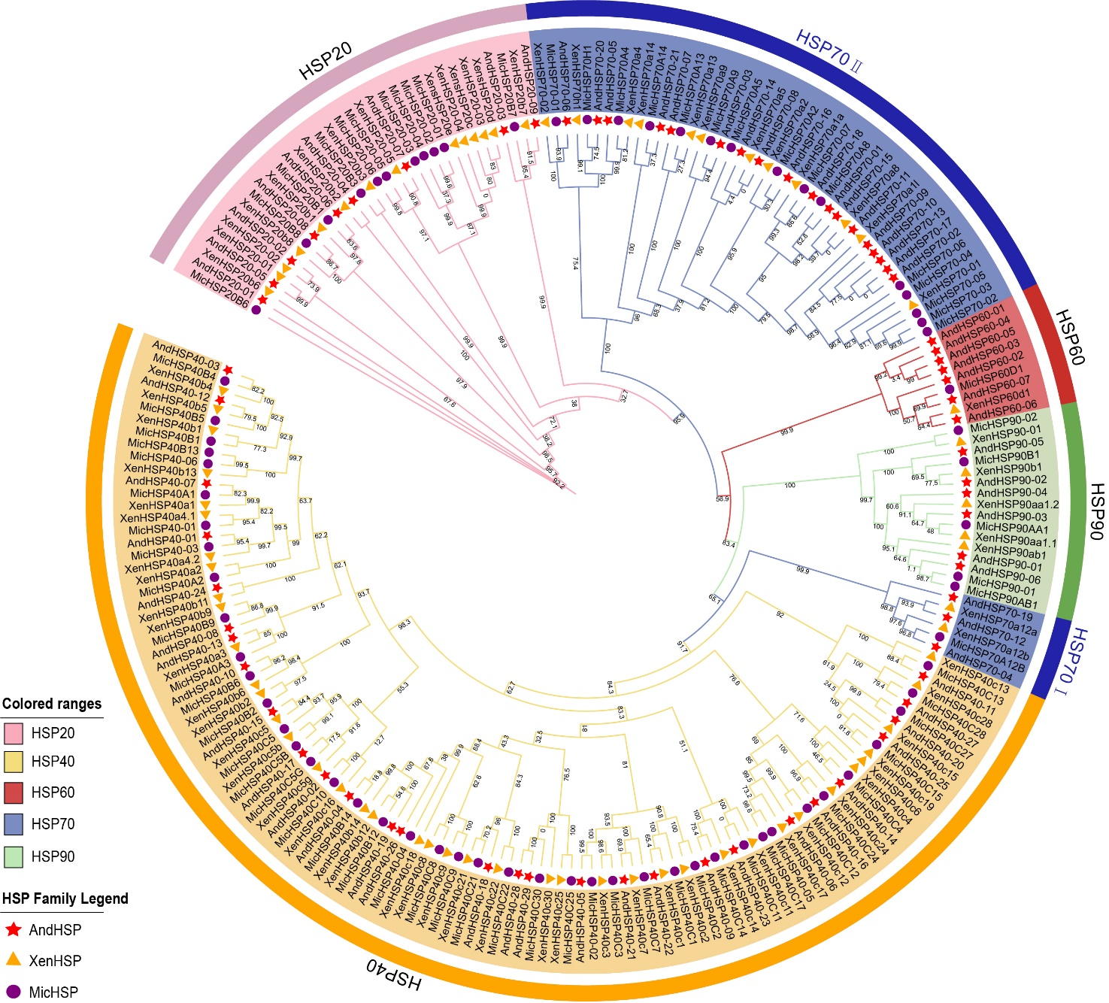

Supplementary Figure 1. BH Test Values for Phylogenetic Relationships of Heat Shock Proteins in Andrias davidianus, Xenopus tropicalis, and Microcaecilia unicolor.

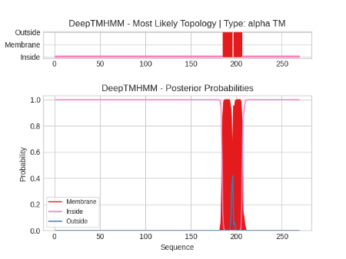  AndHSP40-14 | 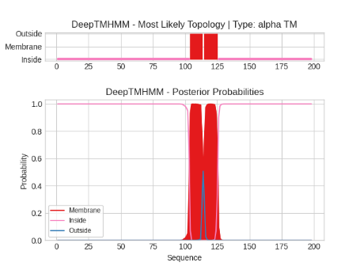  AndHSP40-15 | 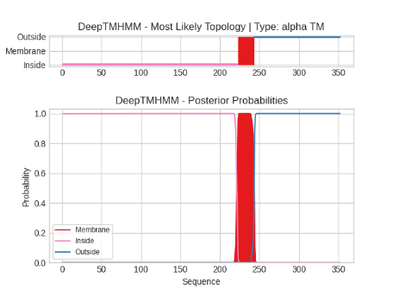  AndHSP40-19 | 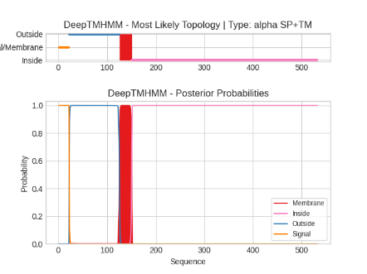  AndHSP40-22
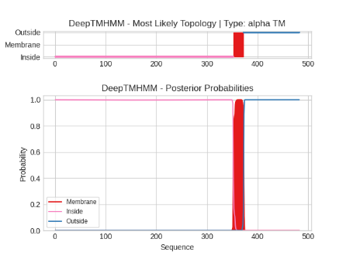  AndHSP40-26 | 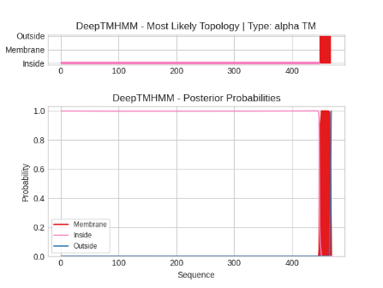  AndHSP40-28 | 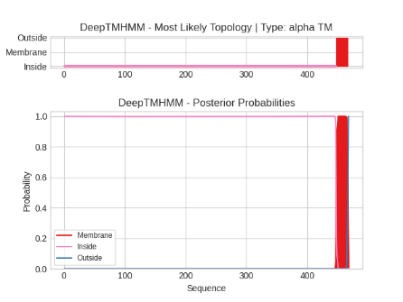  AndHSP40-29
Supplementary Figure 2. Prediction of transmembrane regions of the HSPs in Andrias davidianus.
Notes: The transmembrane regions are indicated by red lines, the inner side of the cell membrane by yellow lines, and the outer side of the cell membrane by blue areas.

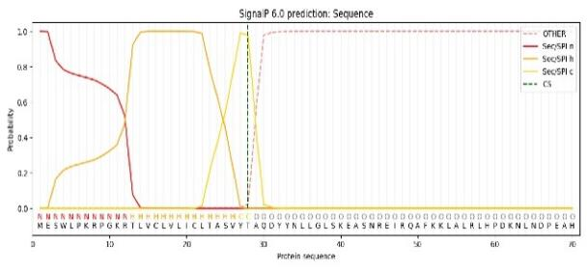  AndHSP40-02 | 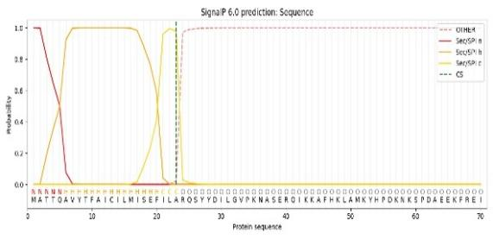  AndHSP40-08 | 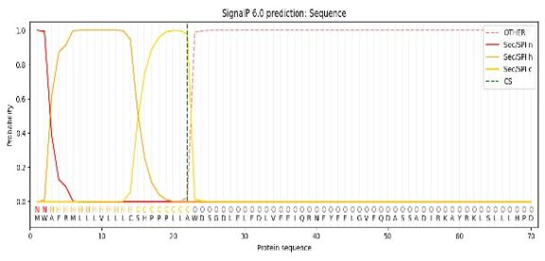  AndHSP40-22
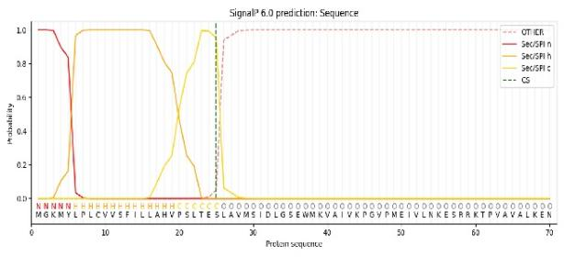  AndHSP70-06 | 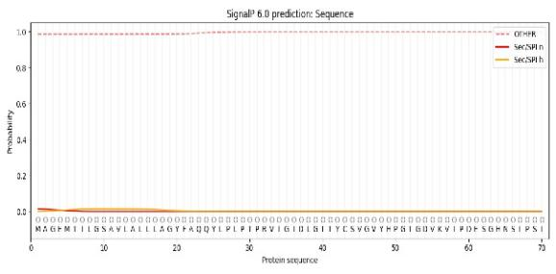  AndHSP70-07 | 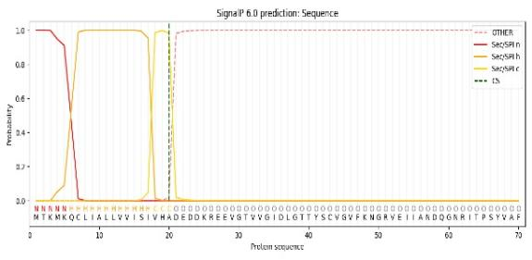  AndHSP70-08
Supplementary Figure 3. Prediction of signal peptides of the HSPs in Andrias davidianus.
Notes: Sec/SPI n denotes the N-terminal positively charged region of the signal peptide, Sec/SPI h represents the central hydrophobic core segment, and Sec/SPI c corresponds to the C-terminal region near the cleavage site of the signal peptide.

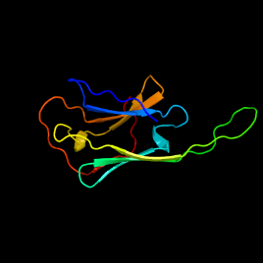 | 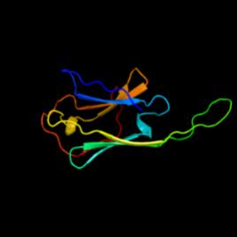 | 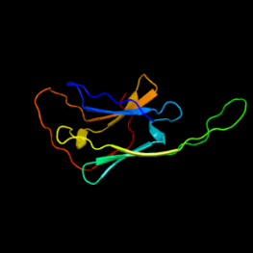 | 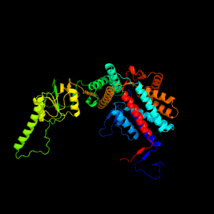 | 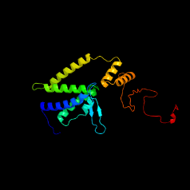 | 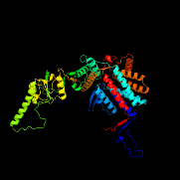 | 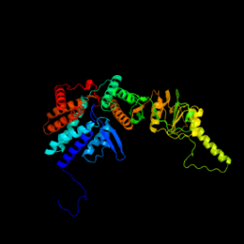
AndHSP20-01 | AndHSP20-02 | AndHSP20-05 | AndHSP60-01 | AndHSP60-02 | AndHSP60-03 | AndHSP60-04
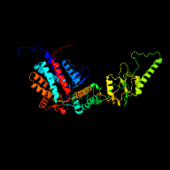 | 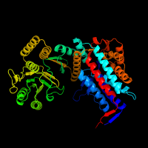 | 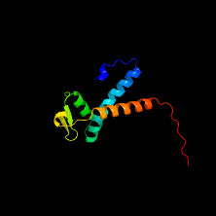 | 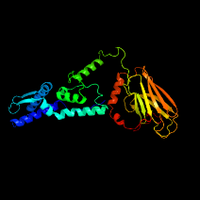 | 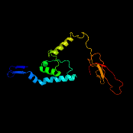 | 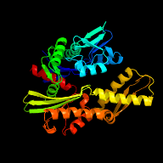 | 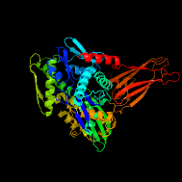
AndHSP60-05 | AndHSP60-06 | AndHSP60-07 | AndHSP70-01 | AndHSP70-02 | AndHSP70-07 | AndHSP70-08
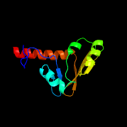 | 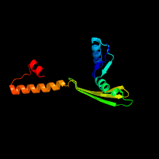 | 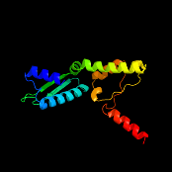 | 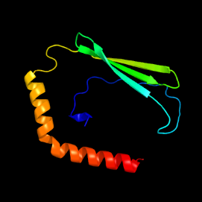 | 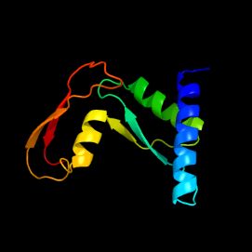 | 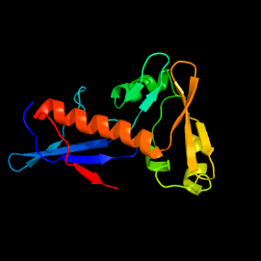 | 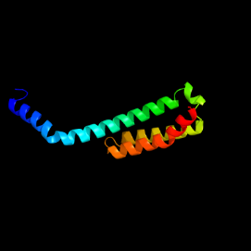
AndHSP70-09 | AndHSP70-10 | AndHSP70-11 | AndHSP70-13 | AndHSP70-14 | AndHSP70-15 | AndHSP70-17
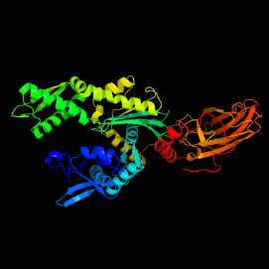 | 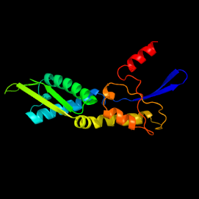 | 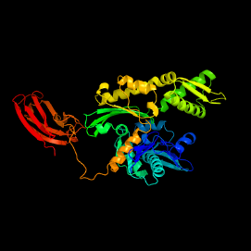 | 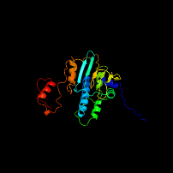 | 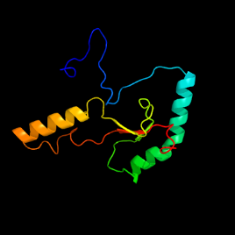 | 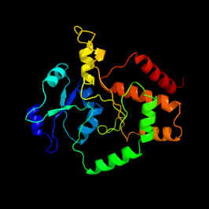
AndHSP70-18 | AndHSP70-19 | AndHSP70-21 | AndHSP90-03 | AndHSP90-05 | AndHSP90-06
Supplementary Figure 4. Three-dimensional structure prediction of some HSPs in Andrias davidianus.
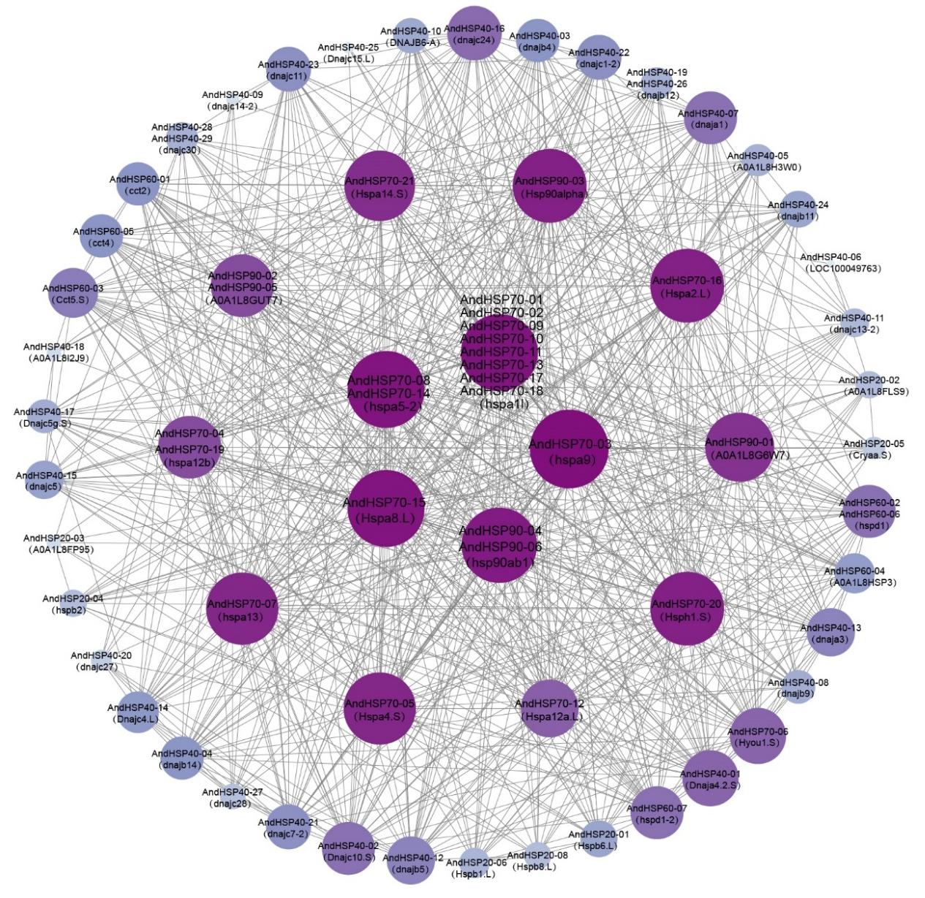
Supplementary Figure 5. Protein-protein interaction network of HSPs in Andrias davidianus, with the size and color of the circle represent interaction degree.

Supplementary Table 4. Number of differentially expressed AndHSPs genes in different comparison groups based on DESeq2
Tissue | Time | T1 | T2 | T3 | T4 | T5 | T6 | T7 | T8
Kidney | T0 | 0 | 1 | 4 | 19 | 10 | 10 | 13 | 25
 | T1 |  | 1 |  |  | 12
 | T2 |  |  | 1 |  |  | 10
 | T3 |  |  |  | 20 |  |  | 10
 | T4 |  |  |  |  |  |  |  | 6
 | T5 |  |  |  |  |  | 4
 | T6 |  |  |  |  |  |  | 4
 | T7 |  |  |  |  |  |  |  | 8
 | T8
Liver | T0 | 2 | 3 | 12 | 27 | 21 | 19 | 16 | 29
 | T1 |  | 4 |  |  | 16
 | T2 |  |  | 10 |  |  | 15
 | T3 |  |  |  | 21 |  |  | 17
 | T4 |  |  |  |  |  |  |  | 10
 | T5 |  |  |  |  |  | 5
 | T6 |  |  |  |  |  |  | 5
 | T7 |  |  |  |  |  |  |  | 10
 | T8
Spleen | T0 | 1 | 2 | 2 | 28 | 17 | 14 | 12 | 29
 | T1 |  | 2 |  |  | 13
 | T2 |  |  | 1 |  |  | 13
 | T3 |  |  |  | 28 |  |  | 13
 | T4 |  |  |  |  |  |  |  | 4
 | T5 |  |  |  |  |  | 3
 | T6 |  |  |  |  |  |  | 5
 | T7 |  |  |  |  |  |  |  | 10
 | T8

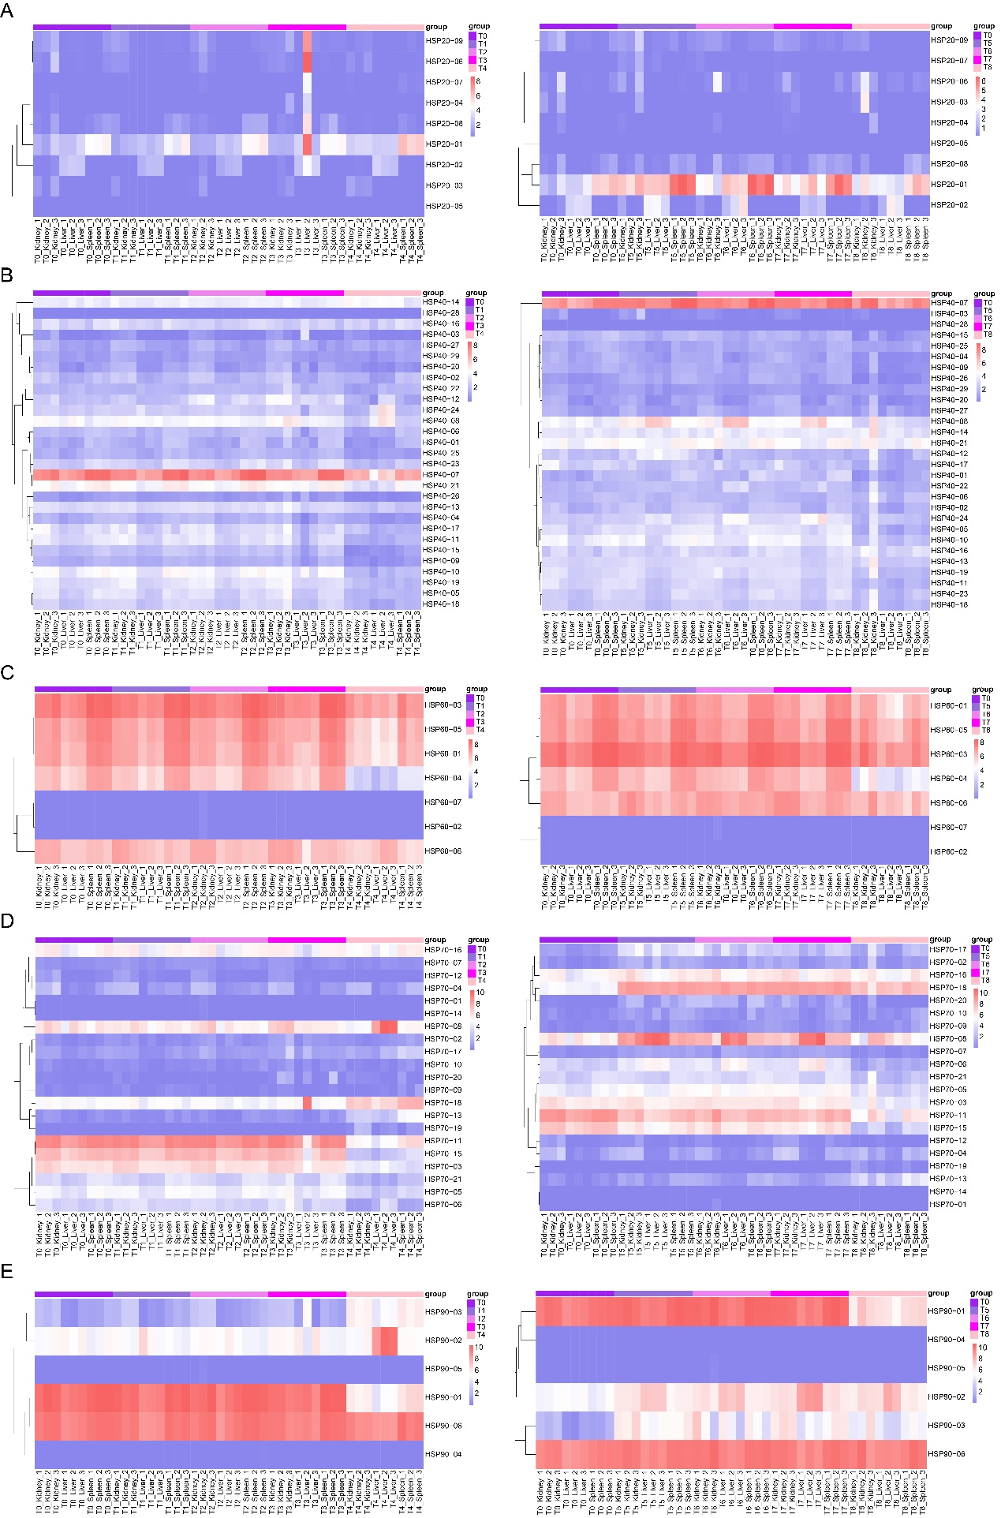
Supplementary Figure 6. Heat map showing the expression of the five AndHSPs subfamilies under normal and elevated temperature infections. (A) AndHSP20. (B) AndHSP40. (C) AndHSP60. (D) AndHSP70. (E) AndHSP90.

Supplementary Table 5. List of hub genes in the MEmagenta
Hub genes | Weight | Gene annotation
TRINITY_DN30679_c1_g1 | 4.94 | \
TRINITY_DN2580_c1_g1 | 4.93 | \
TRINITY_DN107015_c0_g2 | 4.75 | \
TRINITY_DN7029_c0_g1 | 4.62 | ERVFRD-1
TRINITY_DN118336_c0_g1 | 4.4
TRINITY_DN49800_c0_g1 | 4.06
TRINITY_DN43097_c1_g1 | 4.01
TRINITY_DN43097_c0_g1 | 3.97
TRINITY_DN2006_c0_g2 | 2.76
TRINITY_DN352267_c0_g1 | 1.11
TRINITY_DN1909_c2_g5 | 1.09
TRINITY_DN4676_c0_g2 | 1.08 | COL1A1

