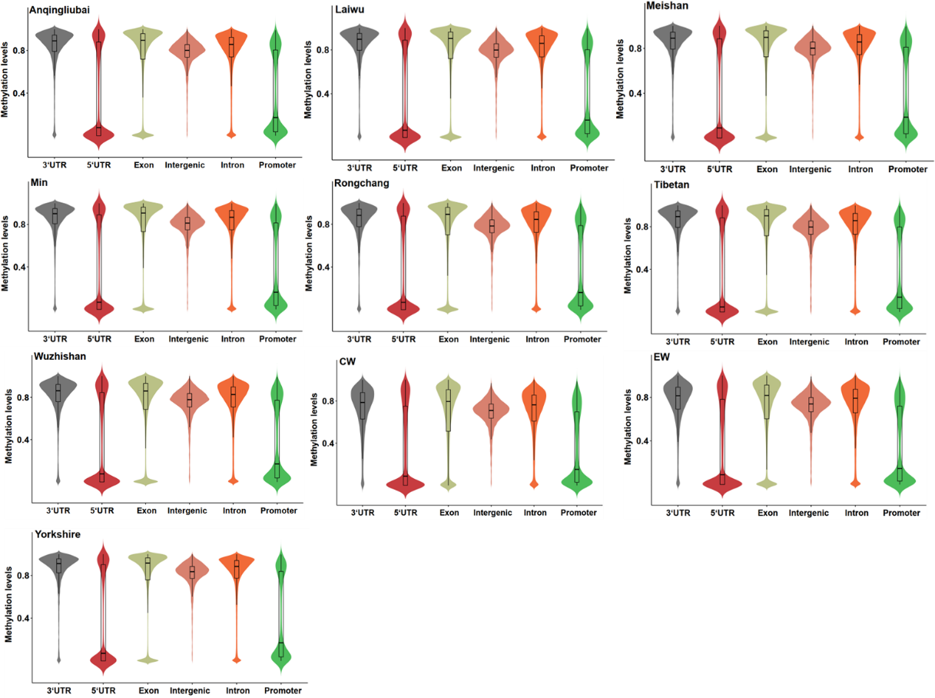
Figure S1. Distribution of methylation levels in different transcription elements of each sample.

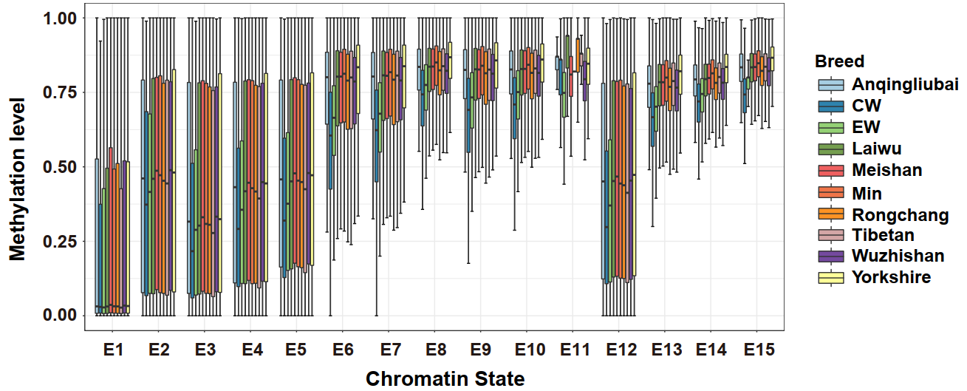
Figure S2. Methylation levels of 15 chromatin states in each individual. (E1: Active TSS; E2: Flanking active TSS without ATAC; E3: Transcription at gene 5’ and 3’; E4: Weak transcribed at gene; E5: Transcribed region with ATAC; E6: Active enhancer; E7: Medium enhancer with ATAC; E8: Weak active enhancer; E9: Active enhancer without ATAC; E10: Poised enhancer; E11: ATAC islands; E12: Poised TSS; E13: Repressed Polycomb; E14: Weak repressed Polycomb; and E15: Quiescent/Low).

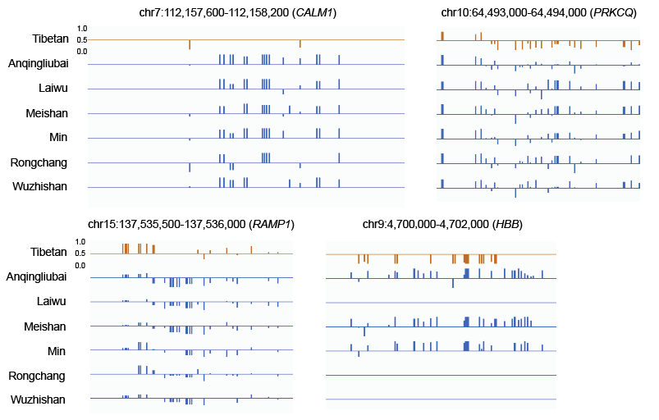
Figure S3. Differences in methylation levels of hypoxic-adaption-related differential methylation candidate genes (CALM1, HBB, PRKCQ and RAMP1 ) across individuals.

Figure S4. Structure of CALM1 gene and location of DMRs.

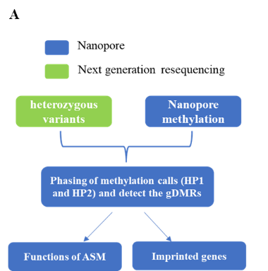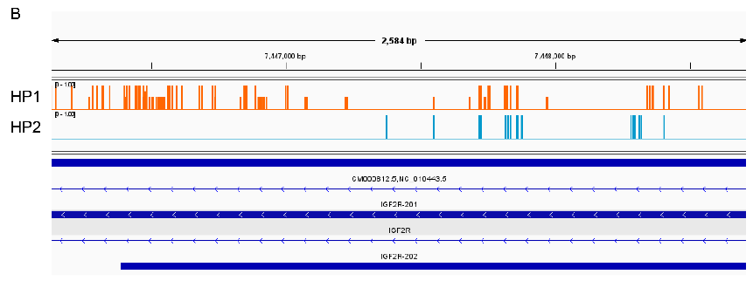
Figure S5. Workflow of ASM research. (A) Research methods of ASM; (B) ASM was identified from IGF2R gene in Laiwu pig.

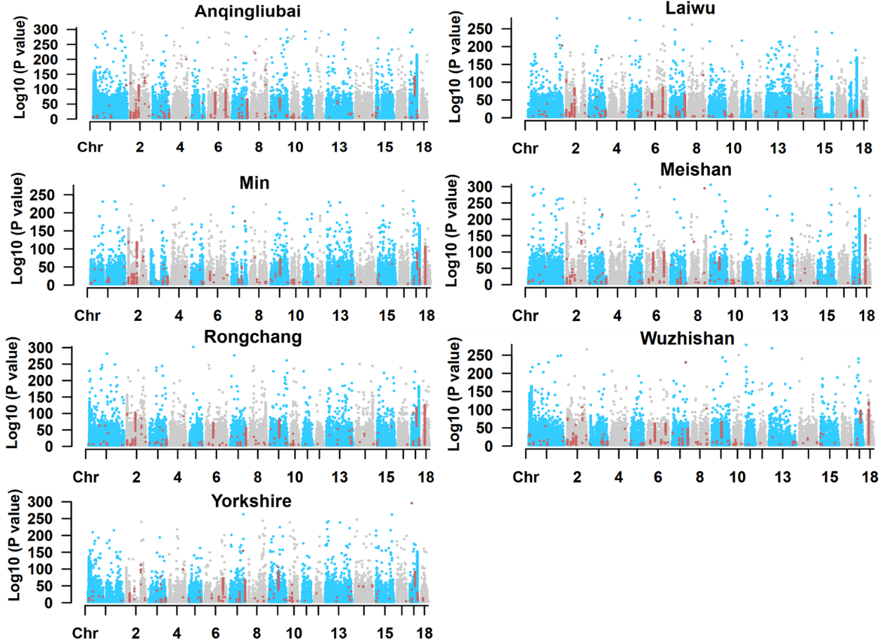
Figure S6. Manhattan plot of the genome-wide landscape of ASM for blood samples. The red highlighted mark represents the common ASM shared by all individuals.

