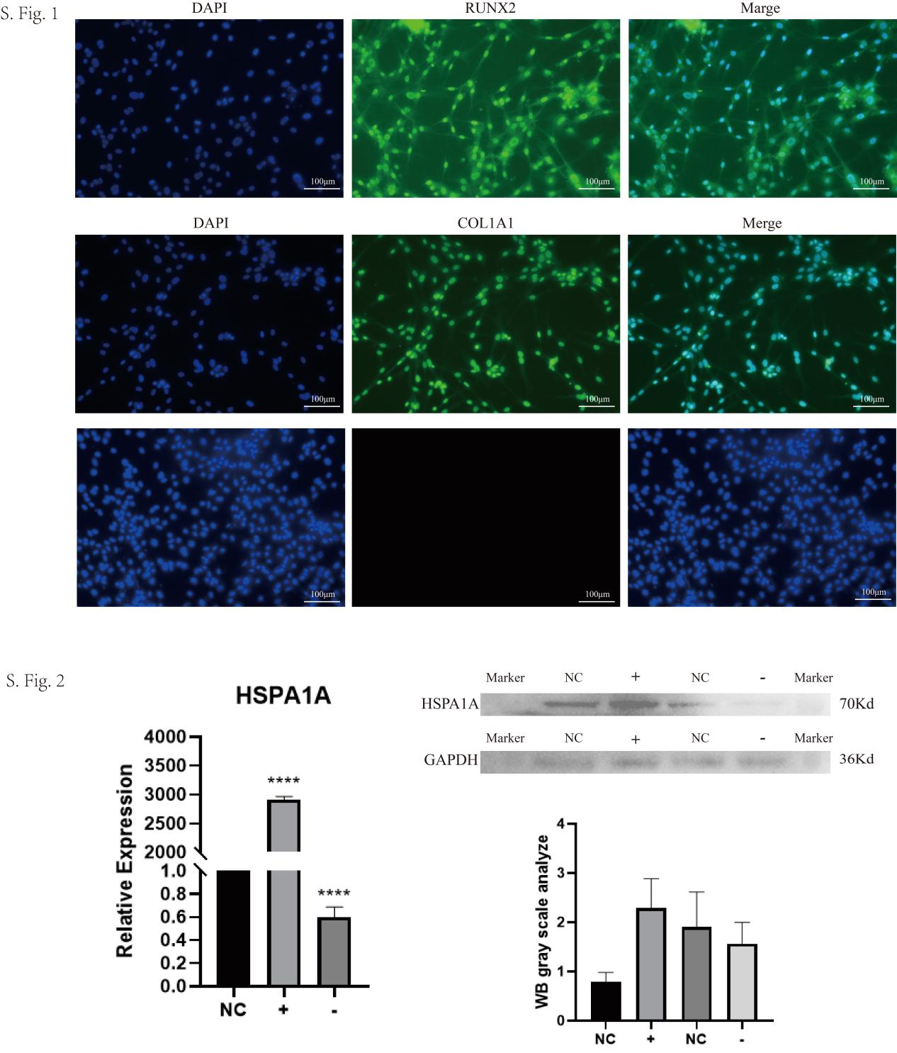
S.Fig.1
Immunofluorescence staining with RUNX2 and COL1A1 antibodies confirmed successful isolation of FAPs, as indicated by target gene expression.
S.Fig.2
FAPs were transfected with a pEGFP-N1-HSPA1A to upregulate its cellular levels and FAPs were transfected with si-HSPA1A, and successful transfection was confirmed by quantifying HSPA1A mRNA expression via qPCR and protein levels by Western blot.(n = 3, ****P<0.0001)

