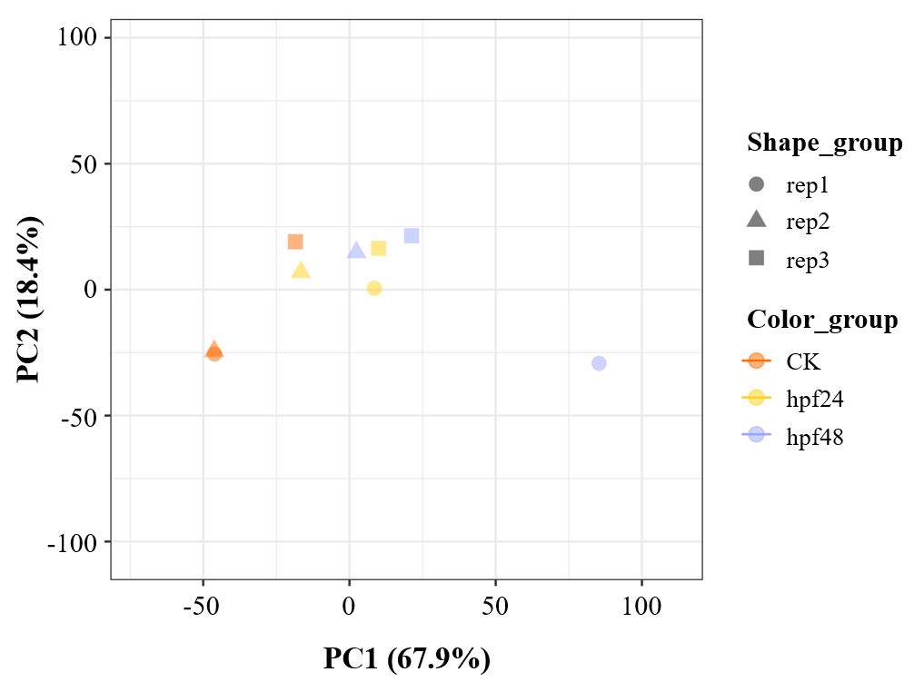
Figure S1. Principal component analysis (PCA) of expression profiles from different samples. PC1, the first principal component; PC2, the second principal component. CK, uninfested controls; hpf24, D. citri-infested shoots collected at 24 hours post feeding; hpf48, D. citri-infested shoots collected at 48 hours post feeding.

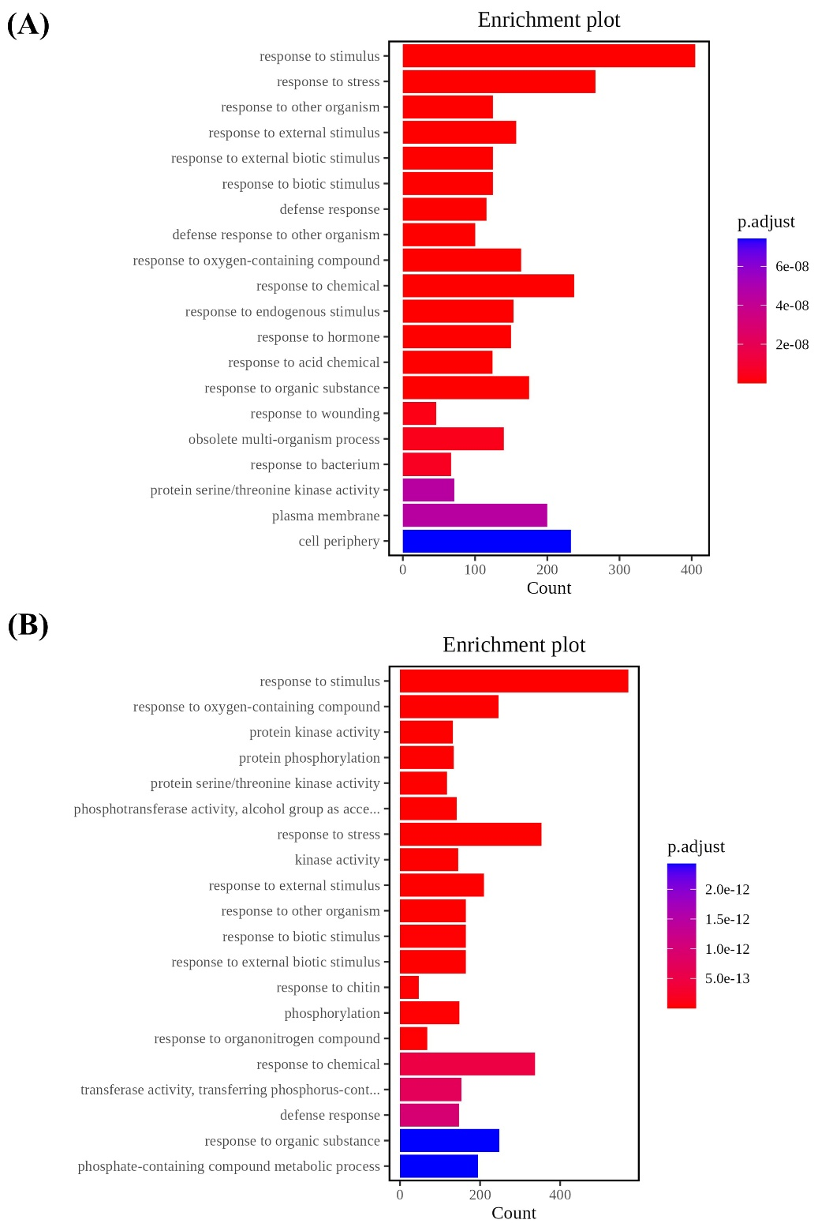
Figure S2. GO functional classifications of differentially expressed genes (DEGs) upregulated in D. citri-infested citrus. (A) GO enrichment analysis of DEGs upregulated in hpf24. (B) GO enrichment analysis of DEGs upregulated in hpf48. hpf24, D. citri-infested shoots collected at 24 hours post feeding; hpf48, D. citri-infested shoots collected at 48 hours post feeding.

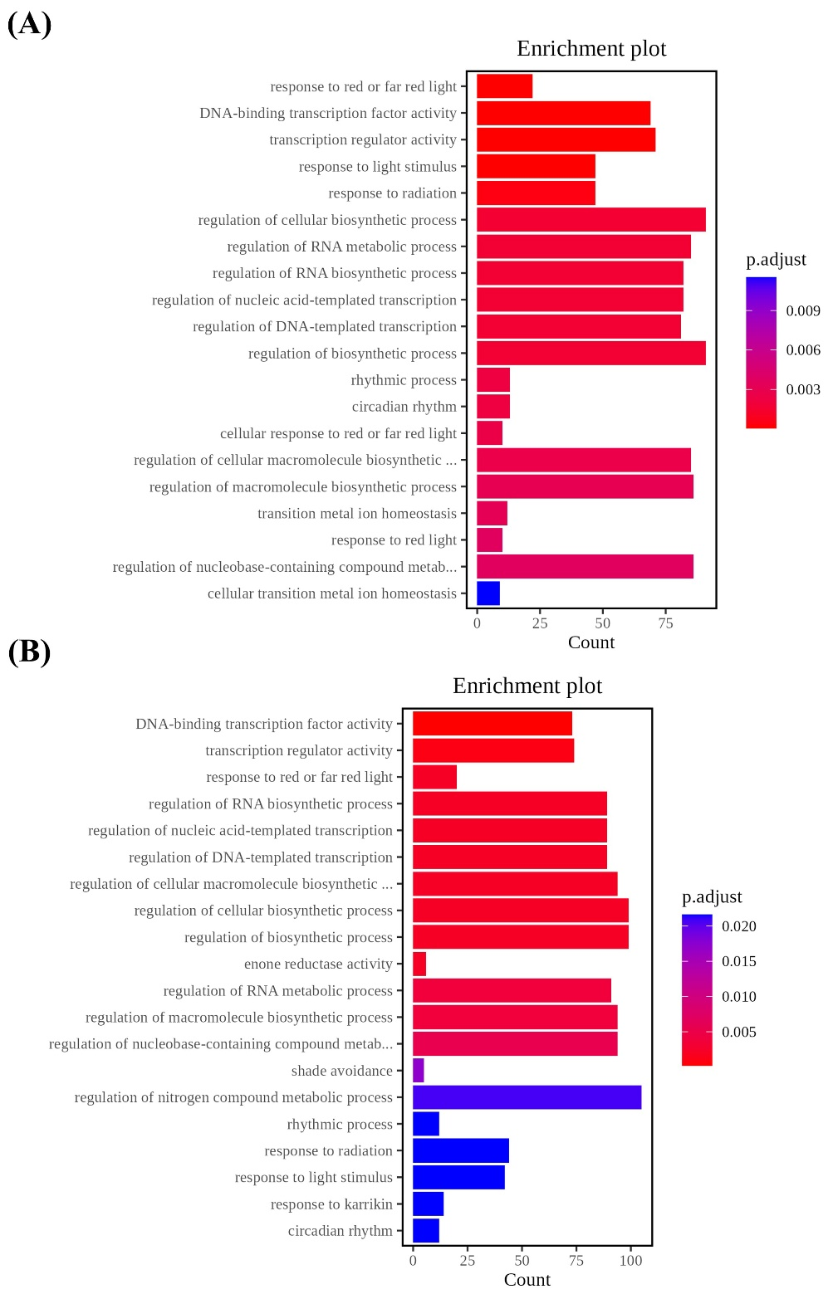
Figure S3. GO functional classifications of DEGs downregulated in D. citri-infested citrus. (A) GO enrichment analysis of DEGs downregulated in hpf24. (B) GO enrichment analysis of DEGs downregulated in hpf48. hpf24, D. citri-infested shoots collected at 24 hours post feeding; hpf48, D. citri-infested shoots collected at 48 hours post feeding.

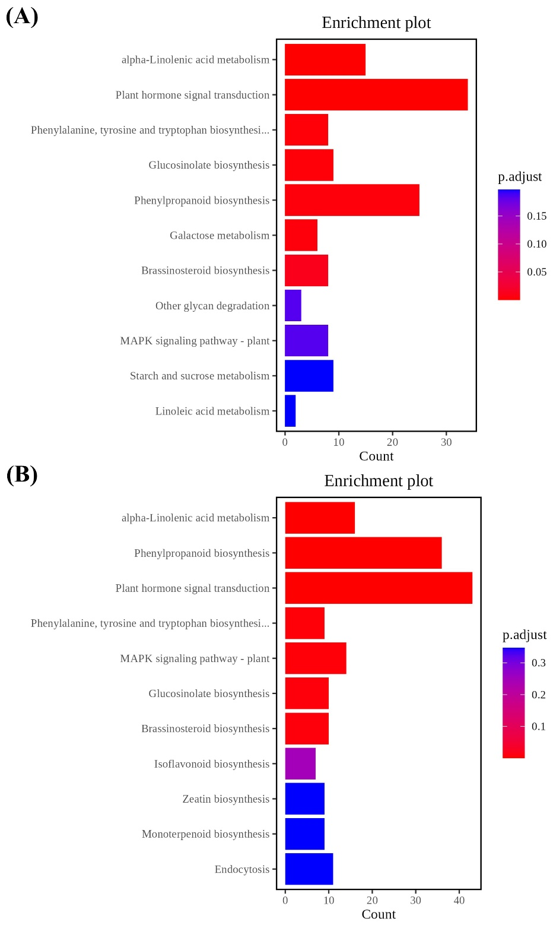
Figure S4. Kyoto Encyclopedia of Genes and Genomes (KEGG) annotation of DEGs upregulated in D. citri-infested citrus. (A) KEGG pathway analyses of DEGs upregulated in hpf24. (B) KEGG pathway analyses of DEGs upregulated in hpf48. hpf24, D. citri-infested shoots collected at 24 hours post feeding; hpf48, D. citri-infested shoots collected at 48 hours post feeding.

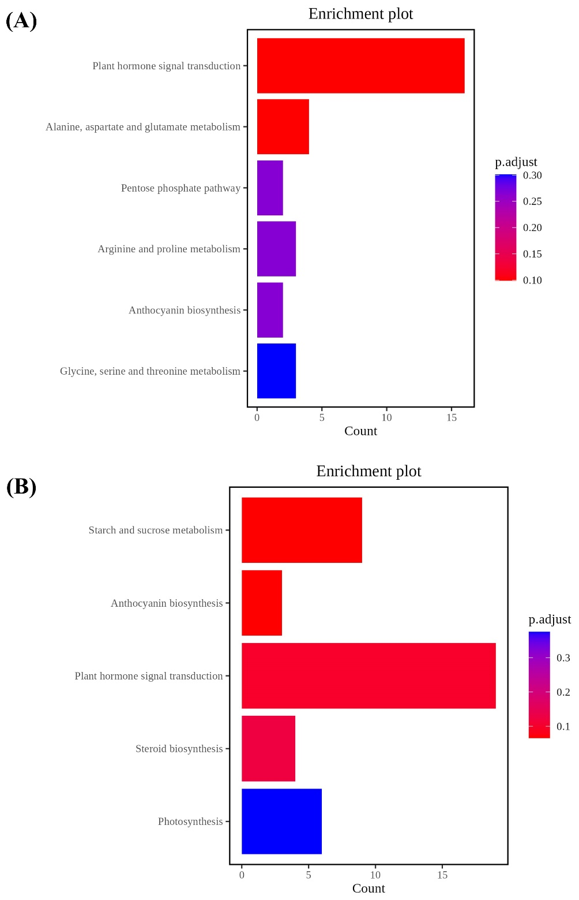
Figure S5. KEGG annotation of DEGs downregulated in D. citri-infested citrus. (A) KEGG pathway analyses of DEGs downregulated in hpf24. (B) KEGG pathway analyses of DEGs downregulated in hpf48. hpf24, D. citri-infested shoots collected at 24 hours post feeding; hpf48, D. citri-infested shoots collected at 48 hours post feeding.

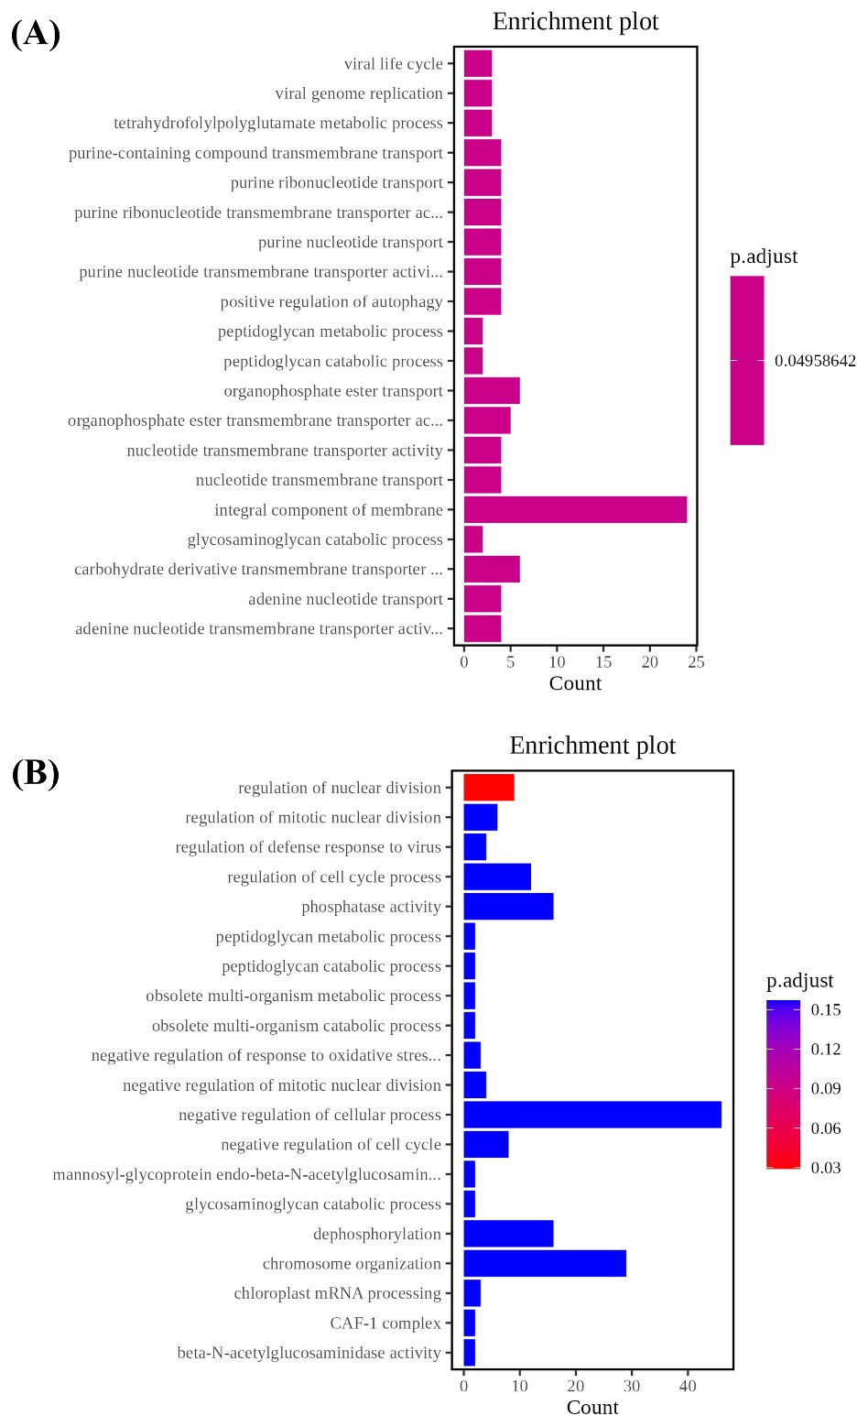
Figure S6. GO functional classifications of differentially spliced genes (DSGs) in D. citri-infested citrus. (A) GO enrichment analysis of DSGs in hpf24. (B) GO enrichment analysis of DSGs in hpf48. hpf24, D. citri-infested shoots collected at 24 hours post feeding; hpf48, D. citri-infested shoots collected at 48 hours post feeding.

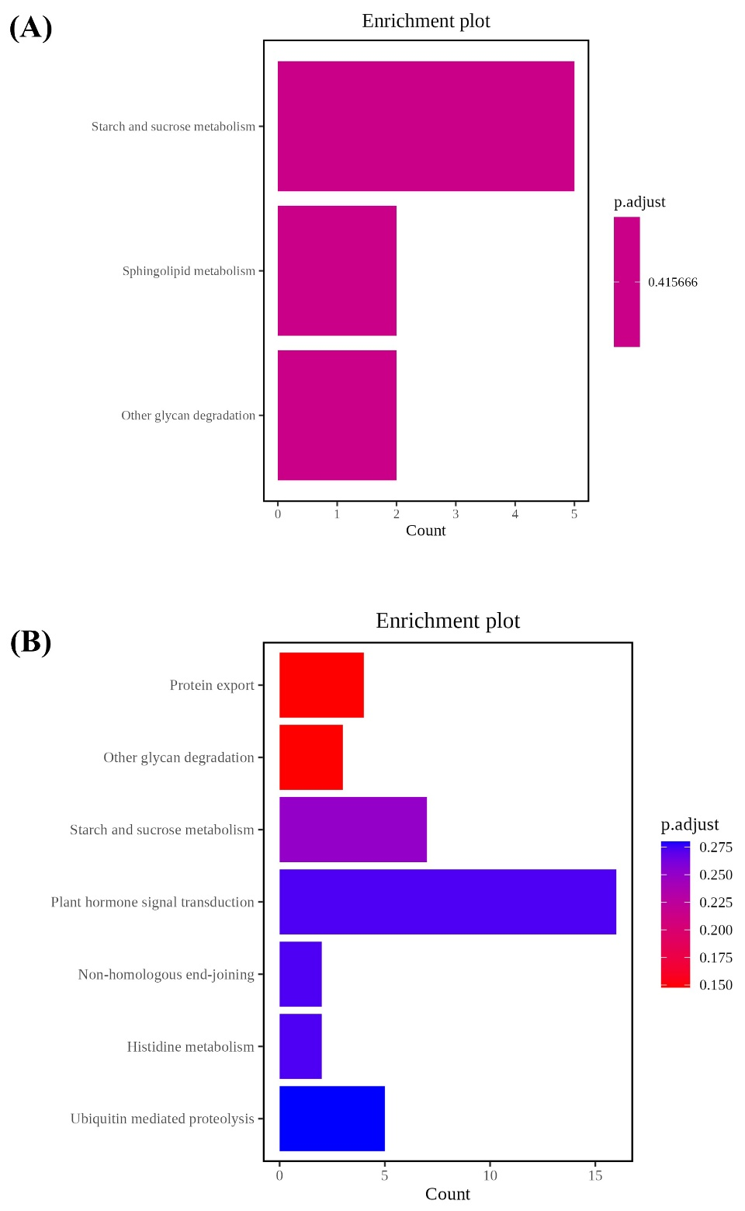
Figure S7. KEGG annotation of DSGs in D. citri-infested citrus. (A) KEGG pathway analyses of DSGs in hpf24. (B) KEGG pathway analyses of DSGs in hpf48. hpf24, D. citri-infested shoots collected at 24 hours post feeding; hpf48, D. citri-infested shoots collected at 48 hours post feeding.

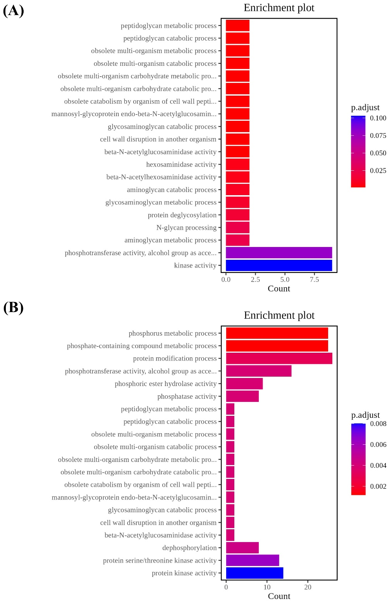
Figure S8. GO functional classifications of overlapping genes between DEGs and DSGs in D. citri-infested citrus. (A) GO enrichment analysis of overlapping genes in hpf24. (B) GO enrichment analysis of overlapping genes in hpf48. hpf24, D. citri-infested shoots collected at 24 hours post feeding; hpf48, D. citri-infested shoots collected at 48 hours post feeding.

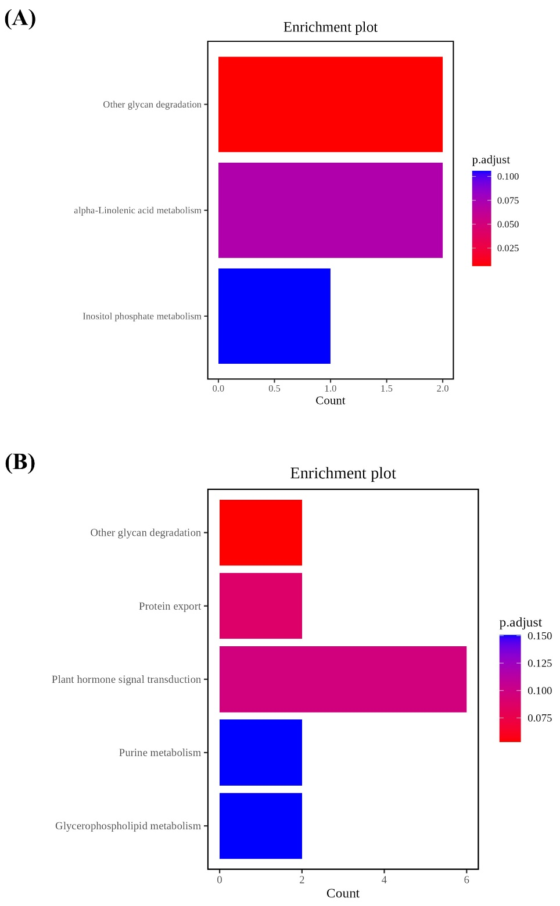
Figure S9. KEGG annotation of overlapping genes between DEGs and DSGs in D. citri-infested citrus. (A) KEGG pathway analyses of overlapping genes in hpf24. (B) KEGG pathway analyses of overlapping genes in hpf48. hpf24, D. citri-infested shoots collected at 24 hours post feeding; hpf48, D. citri-infested shoots collected at 48 hours post feeding.

Table S1. Oligonucleotide primer pairs used in this study
Gene | Primer name | Sequences of primers (5′→3′) | Application
CsLOX2-1 | CsLOX2-1 F | CAAACTCTCGCTGGTCTCAA | qRT-PCR
CsLOX2-1 | CsLOX2-1 R | CTGATTCTGGTGGTCCGTAAA | qRT-PCR
CsAOS | CsAOS F | GTTACCGTGTTCTGTCGTATCT | qRT-PCR
CsAOS | CsAOS R | CTCCGTGTAGGTGGAATGAAA | qRT-PCR
CsAOC3 | CsAOC3 F | CCCTAACTCGAGATCCTCTTCT | qRT-PCR
CsAOC3 | CsAOC3 R | ATCTTGGTGGGTTGTTGAGAG | qRT-PCR
CsOPR2-1 | CsOPR2-1 F | GGCAGATAGGGTTGGGATAAG | qRT-PCR
CsOPR2-1 | CsOPR2-1 R | GTTCAAGGATTCTGCCATGTAAAG | qRT-PCR
CsOPR3 | CsOPR3 F | GTCTAGGCTTGGCGGTTATT | qRT-PCR
CsOPR3 | CsOPR3 R | TCTGGCCATAAGCAGTGTATC | qRT-PCR
CsOPCL1 | CsOPCL1 F | GCGCTAGTAAAGGTGTCGTATC | qRT-PCR
CsOPCL1 | CsOPCL1 R | CTCGCCGTCCTCTAACTTAAATC | qRT-PCR
CsACX1 | CsACX1 F | CTAGGTGATTTCGTCTCCACTG | qRT-PCR
CsACX1 | CsACX1 R | GGTCGGACCTGGGAATATAAAG | qRT-PCR
CsJAR1 | CsJAR1 F | CGTTTGCTGTGCTTCCTAATATC | qRT-PCR
CsJAR1 | CsJAR1 R | CCTACTGGCTTGGGTTCTATG | qRT-PCR
CsMYC2-1 | CsMYC2-1 F | GAGCTCTGATTTGACCGGTATT | qRT-PCR
CsMYC2-1 | CsMYC2-1 R | GTTGCTGTTGTTGGGATGAAG | qRT-PCR
CsActin | CsActin F | ATGCTCCAAGGGCAGTATTC | qRT-PCR
CsActin | CsActin R | GGGCCTCATCACCAACATAG | qRT-PCR
CsGAPDH | CsGAPDH F | CTGGAGAAGGATGCTTCTTATG | qRT-PCR
CsGAPDH | CsGAPDH R | CCACATCATCCTCAGTGTATCC | qRT-PCR

Table S2. Summary of the transcriptome data
Samples | Total Raw Reads (M) | Total Clean Reads (M) | Total Clean Base (Gb) | Clean Reads Q20 (%) | Clean Reads Q30 (%) | Clean Reads Ratio (%) | GC ratio (%)
CK-1 | 42.81 | 42.08 | 5.99 | 99.09 | 97.11 | 98.31 | 43.80
CK-2 | 44.23 | 43.42 | 6.18 | 98.94 | 96.71 | 98.15 | 43.78
CK-3 | 50.12 | 49.19 | 7.00 | 98.95 | 96.75 | 98.15 | 43.84
hpf24-1 | 39.65 | 38.95 | 5.54 | 99.01 | 96.89 | 98.23 | 43.79
hpf24-2 | 37.37 | 36.68 | 5.22 | 98.93 | 96.67 | 98.16 | 43.89
hpf24-3 | 39.67 | 39.01 | 5.55 | 99.10 | 97.17 | 98.35 | 43.51
hpf48-1 | 48.02 | 47.16 | 6.71 | 98.97 | 96.80 | 98.20 | 43.41
hpf48-2 | 46.52 | 45.69 | 6.50 | 99.03 | 96.96 | 98.22 | 43.74
hpf48-3 | 38.96 | 38.29 | 5.45 | 98.98 | 96.82 | 98.27 | 43.69

Table S3. Alignment of clean reads to the citrus reference genome
Samples | Clean Reads (M) | Total mapped Reads (M) | Uniquely mapped Reads (M) | Removing Duplicate Reads (M)
CK-1 | 42.08 | 39.59 (94.08%) | 38.08 (90.49%) | 31.54 (74.95%)
CK-2 | 43.42 | 40.65 (93.62%) | 38.56 (88.81%) | 29.22 (67.29%)
CK-3 | 49.19 | 46.04 (93.59%) | 44.45 (90.36%) | 35.52 (72.22%)
hpf24-1 | 38.95 | 36.62 (94.01%) | 35.26 (90.54%) | 28.58 (73.37%)
hpf24-2 | 36.68 | 34.45 (93.93%) | 33.18 (90.47%) | 26.83 (73.14%)
hpf24-3 | 39.01 | 36.54 (93.65%) | 35.27 (90.40%) | 28.78 (73.76%)
hpf48-1 | 47.16 | 43.53 (92.31%) | 42.03 (89.13%) | 33.84 (71.75%)
hpf48-2 | 45.69 | 42.92 (93.93%) | 41.40 (90.61%) | 33.33 (72.94%)
hpf48-3 | 38.29 | 35.94 (93.86%) | 34.85 (91.01%) | 28.77 (75.15%)

