Supplementary Figures
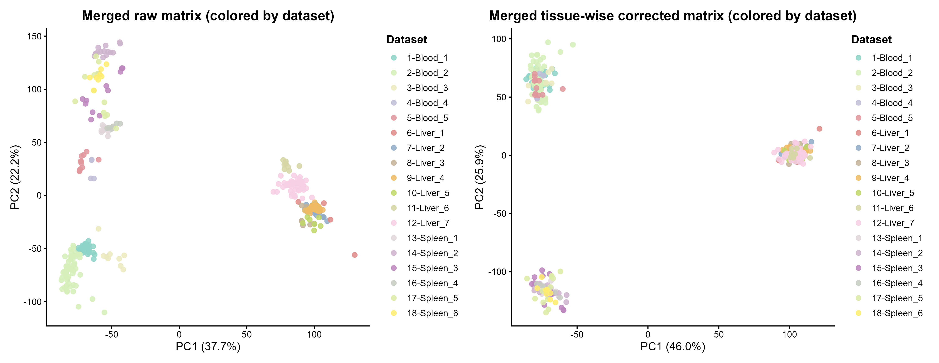
Extended Data Fig. 1. PCA showing dataset differences before and after SVA correction.
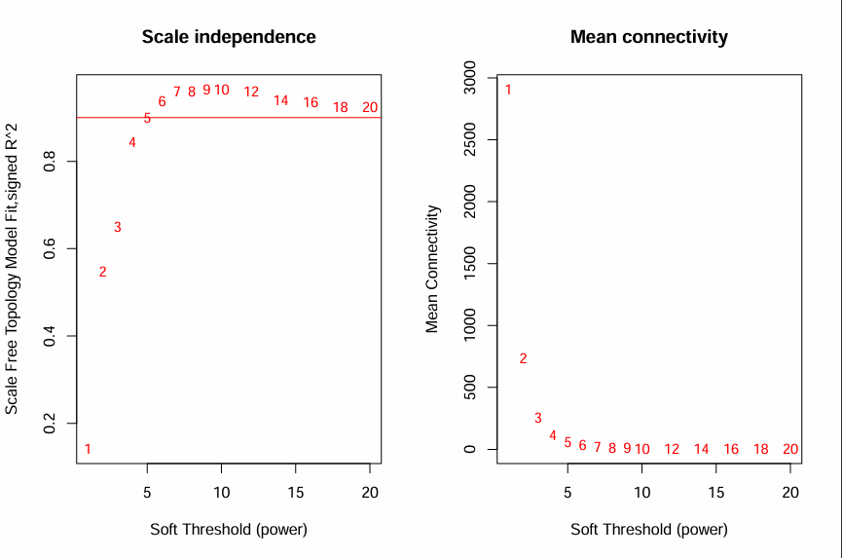
Extended Data Fig. 2. Selection of soft-thresholding power (β) in WGCNA to ensure scale-free network topology.
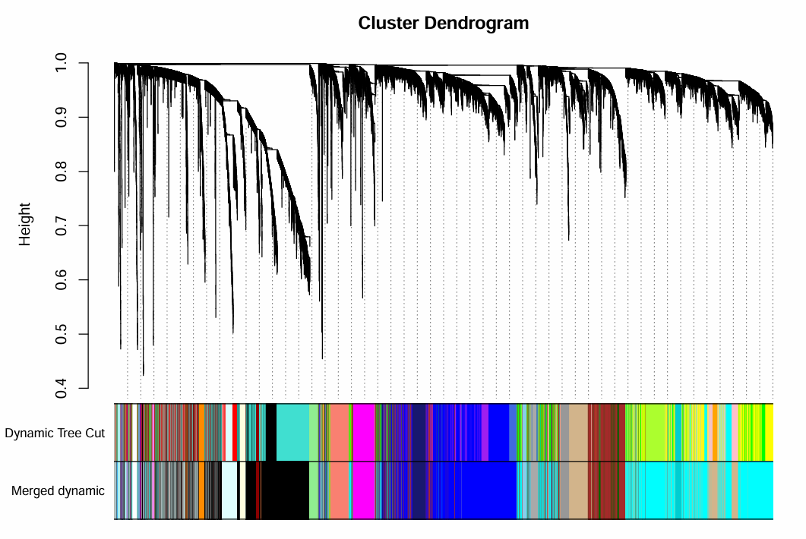
Extended Data Fig. 3. Summary of WGCNA modules constructed from the top 20,000 expressed genes across three tissues.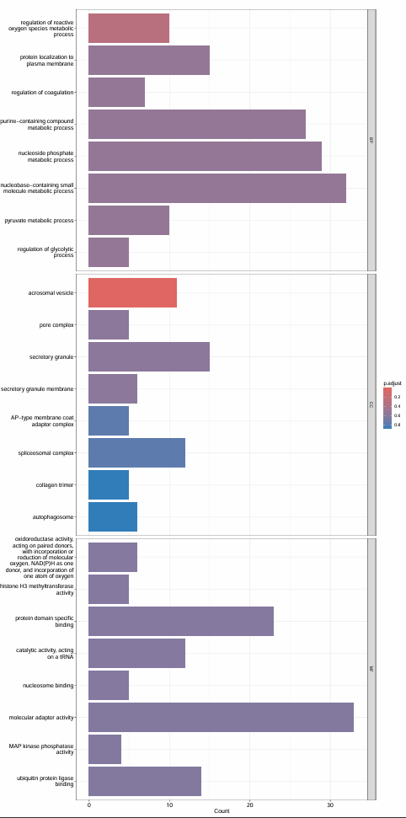
Extended Data Fig. 4. GO enrichment analysis of genes in the Brown module, associated with immune-related functions such as complement activation and B cell-mediated immunity.
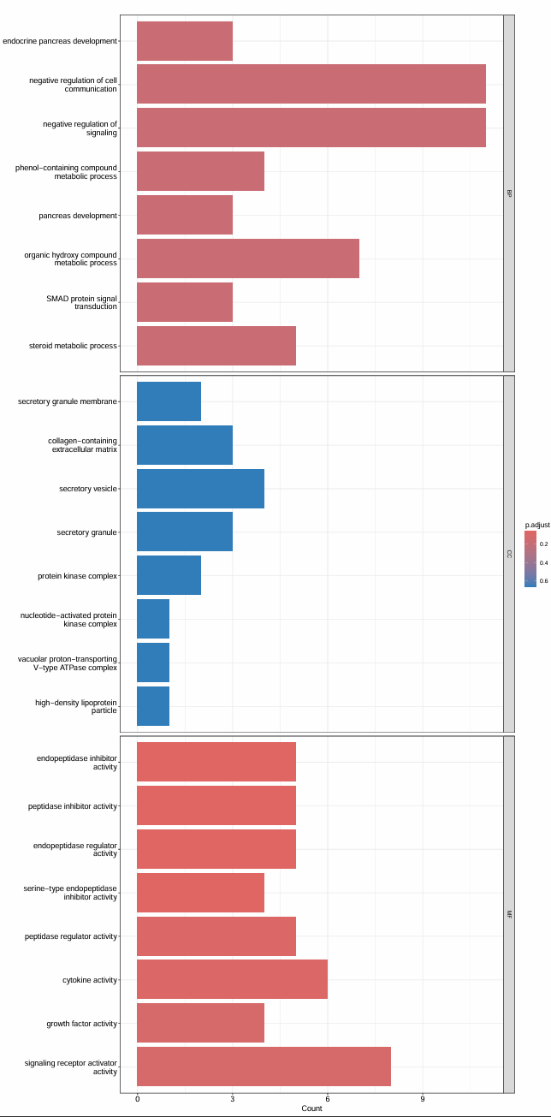
Extended Data Fig. 5. GO enrichment analysis of genes in the Darkgreen module, enriched in metabolic processes including hormone biosynthesis and coagulation.
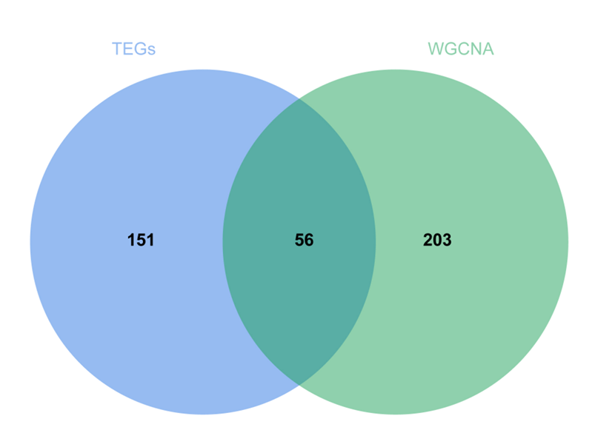
Extended Data Fig. 6. Overlap analysis between the Brown module and liver tissue-enriched genes, refining the immune-related gene set.
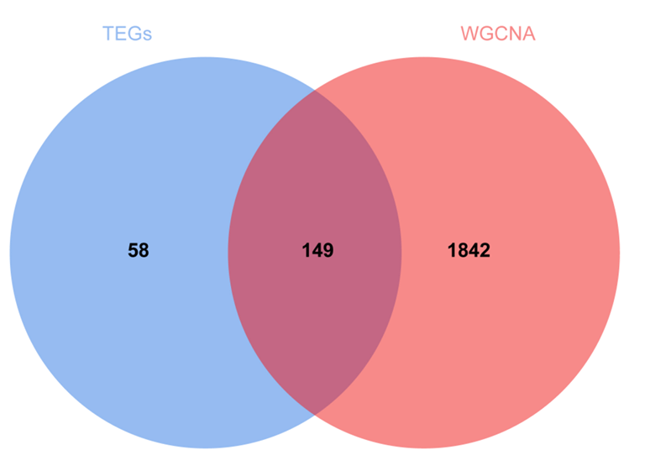
Extended Data Fig. 7. Overlap analysis between the Darkgreen module and liver tissue-enriched genes, identifying liver-specific metabolic genes.
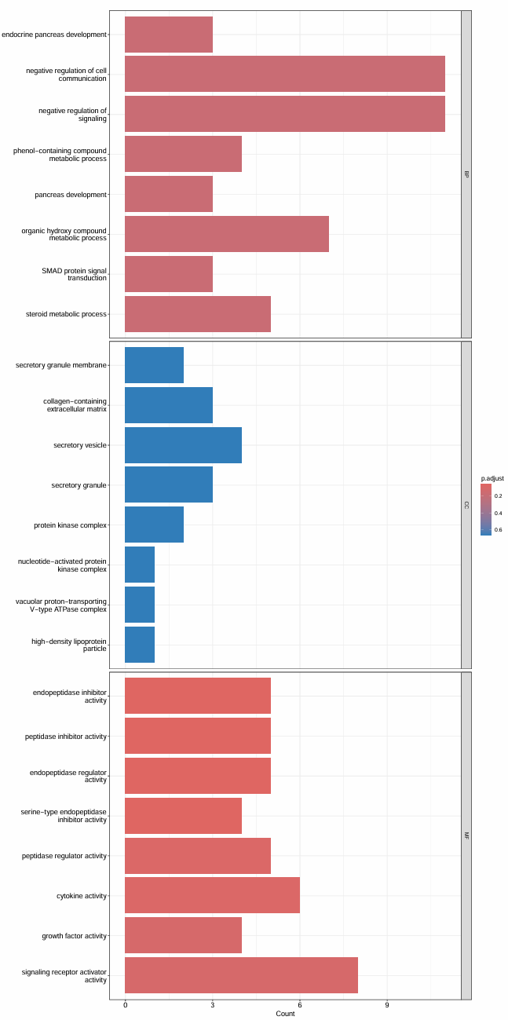
Extended Data Fig. 8. GO enrichment of the refined metabolic gene set, emphasizing coagulation, hormone metabolism, and structural integrity pathways.

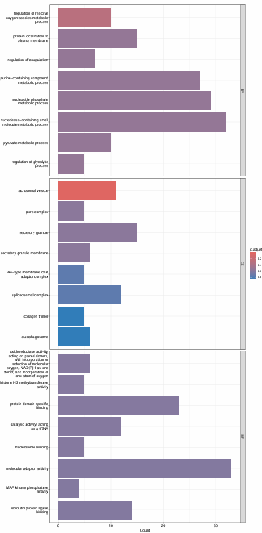
Extended Data Fig. 9. GO enrichment of the refined immune gene set, revealing enrichment in humoral immunity, tight junctions, and complement pathways.
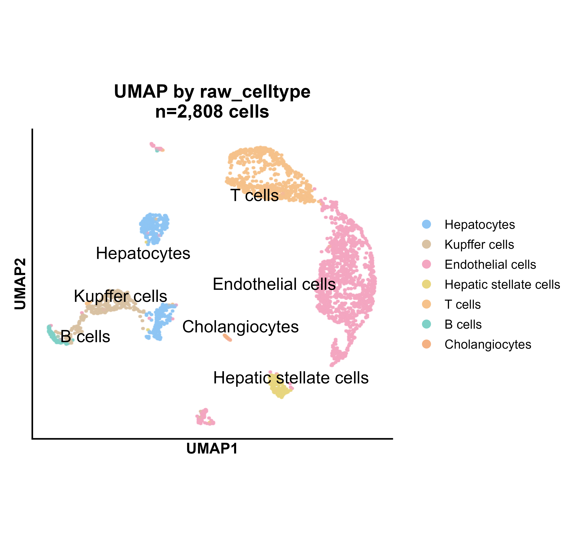
Extended Data Fig. 10. UMAP plot showing the basic annotation of porcine liver single-cell transcriptomic data.
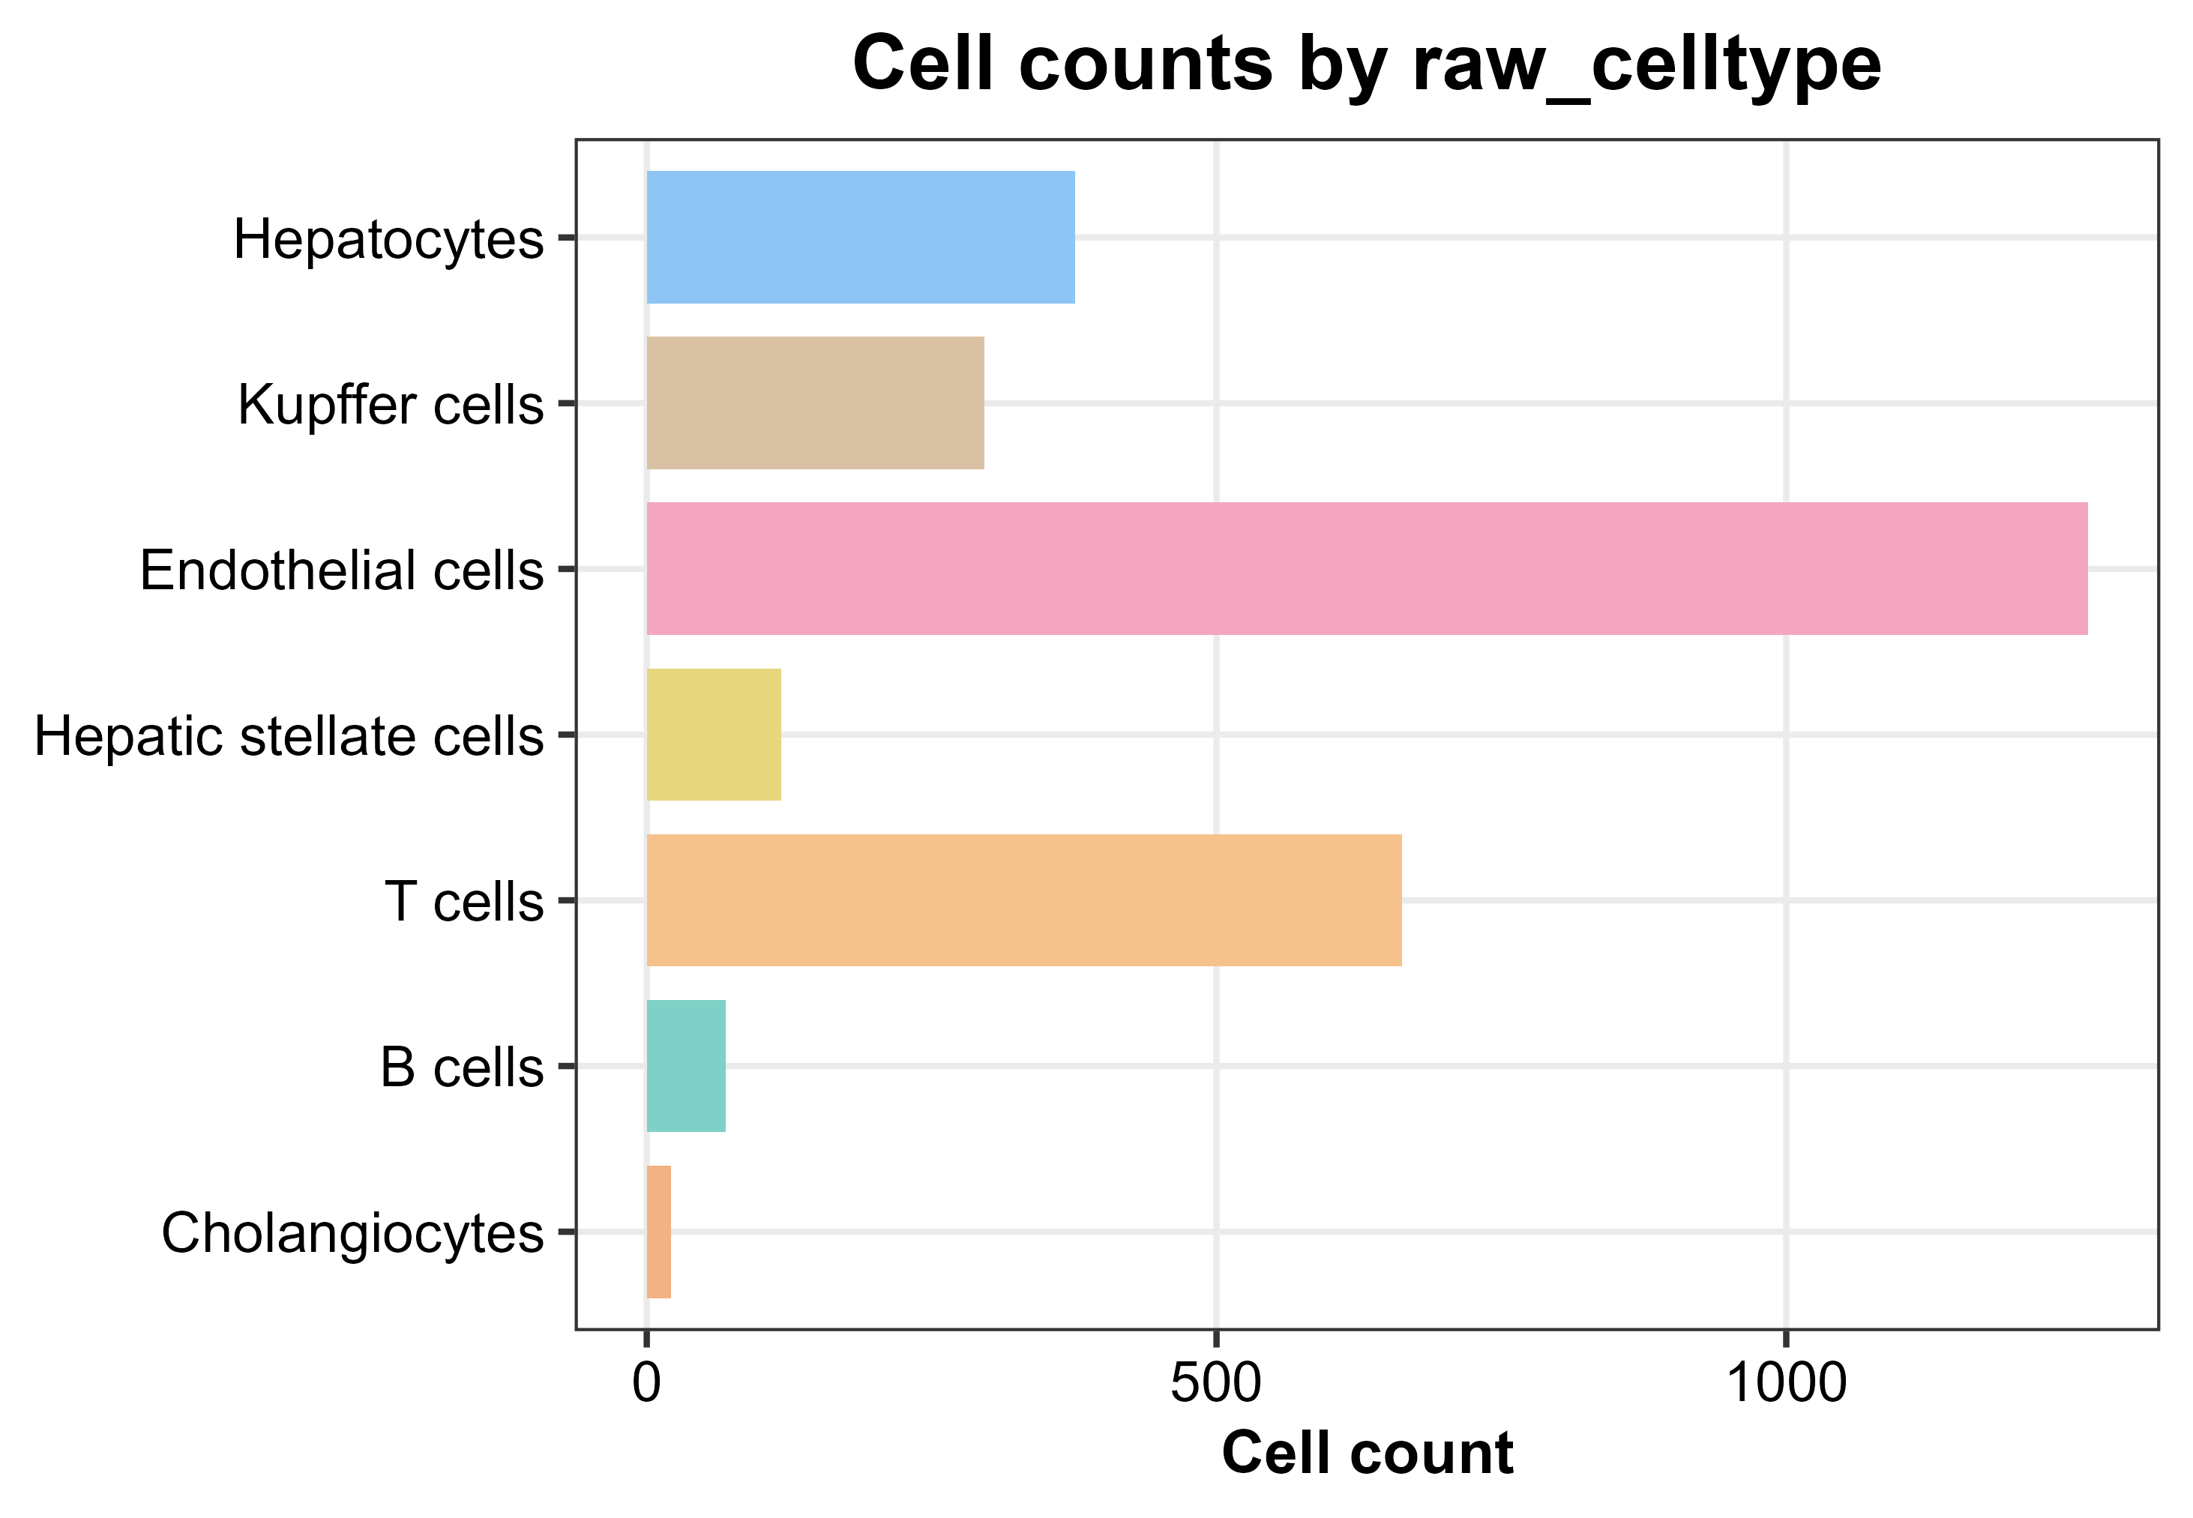
Extended Data Fig. 11. Summary statistics of cell type classification in porcine liver single-cell transcriptomic data.

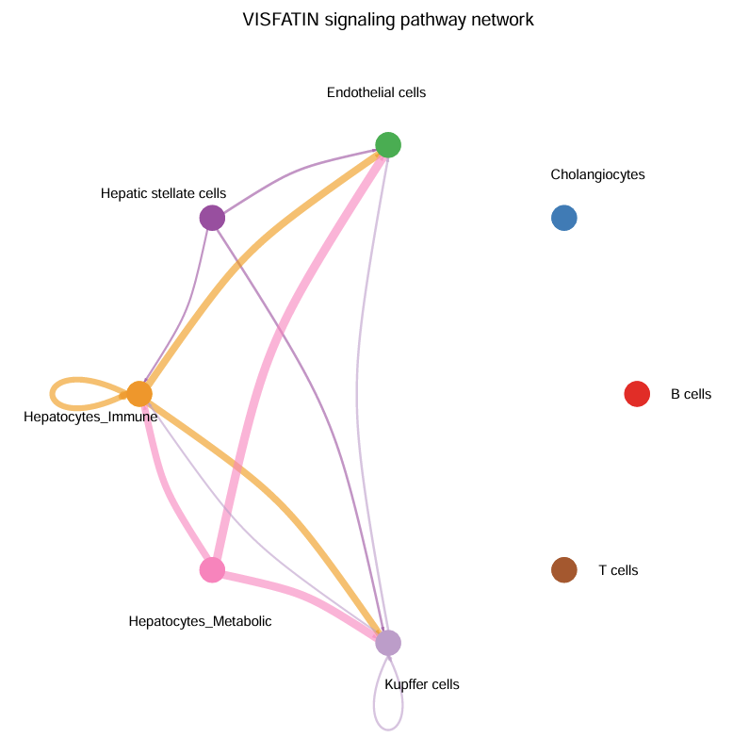
Extended Data Fig. 12. Cell–cell communication network for the VISFATIN signaling pathway.
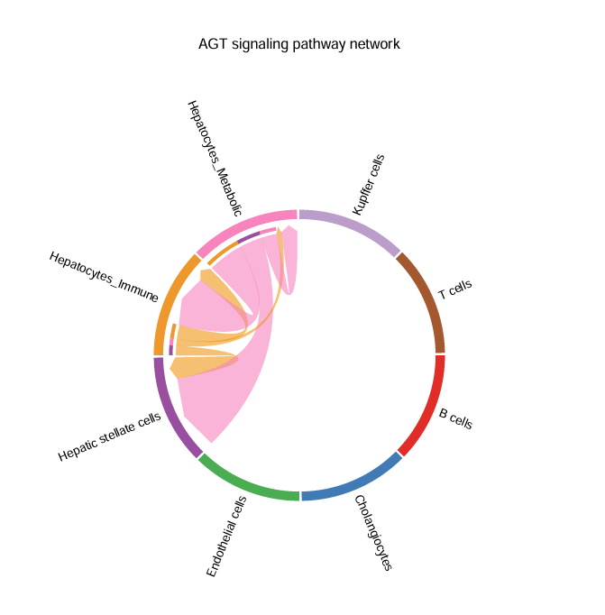
Extended Data Fig. 13. Cell–cell communication network for the AGT signaling pathway.
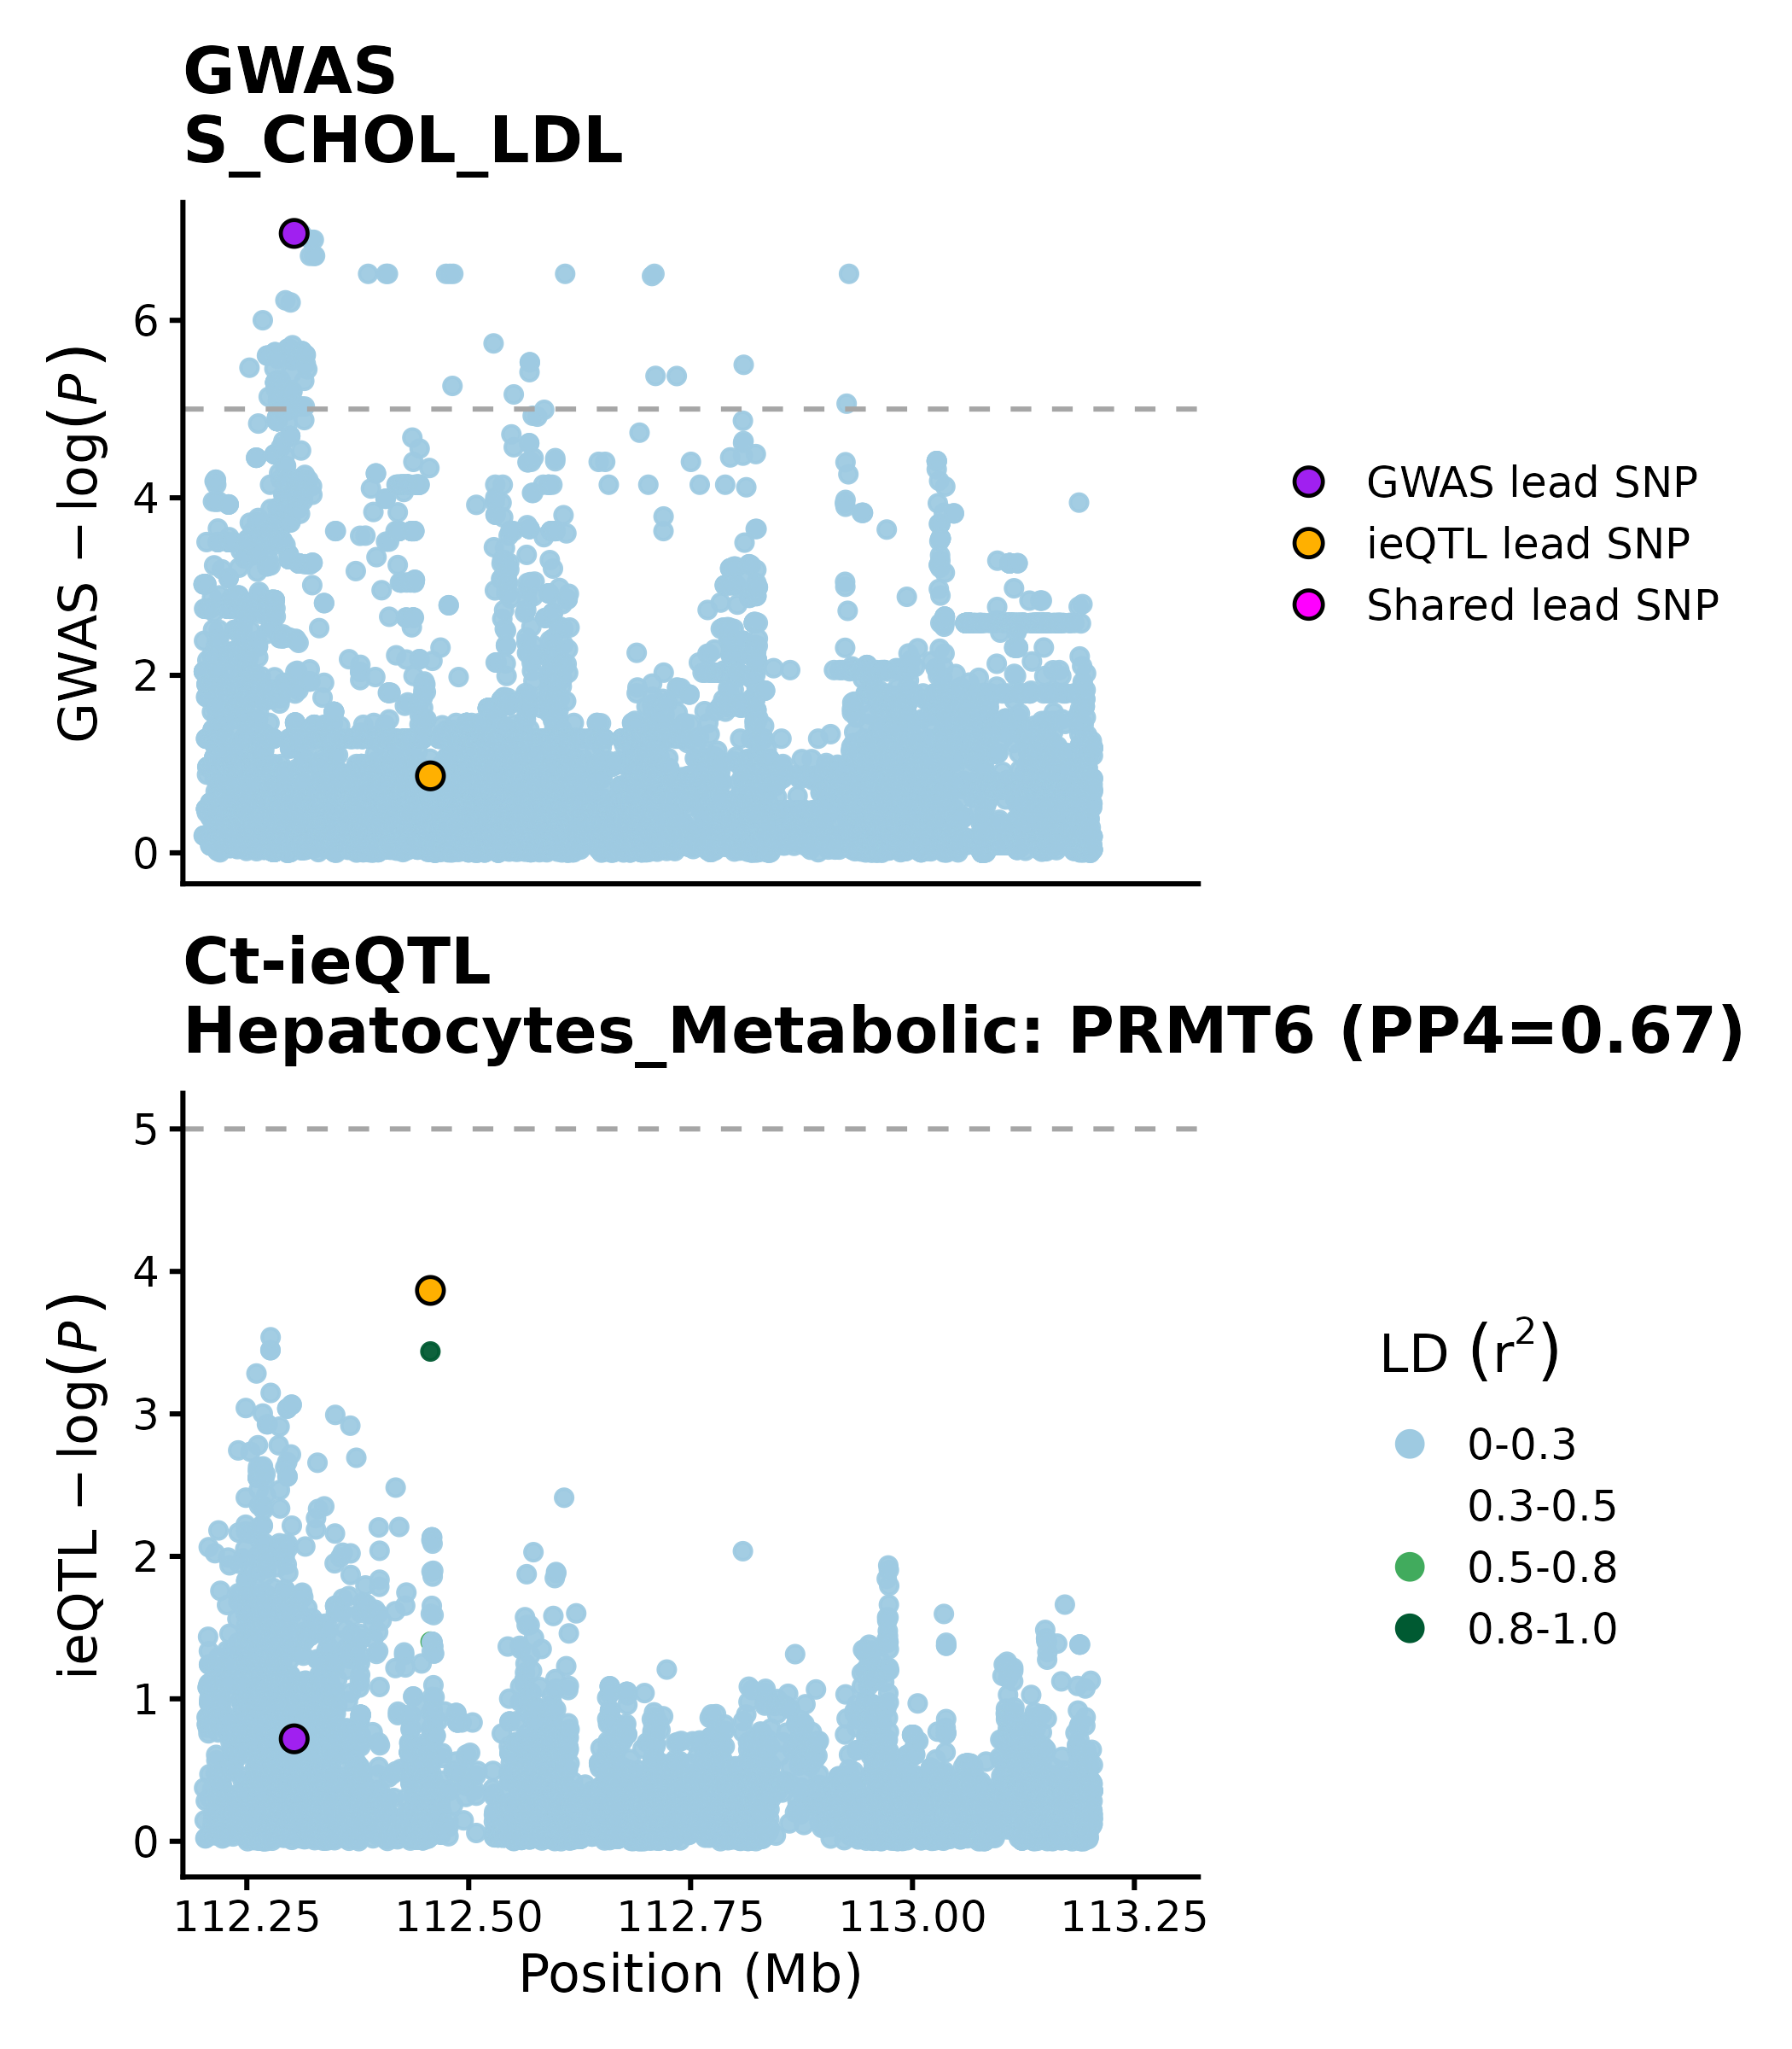
Extended Data Fig. 14. Colocalization between the PRMT6 ieQTL in Hepatocytes_Metabolic and the GWAS signal for S_CHOL_LDL.
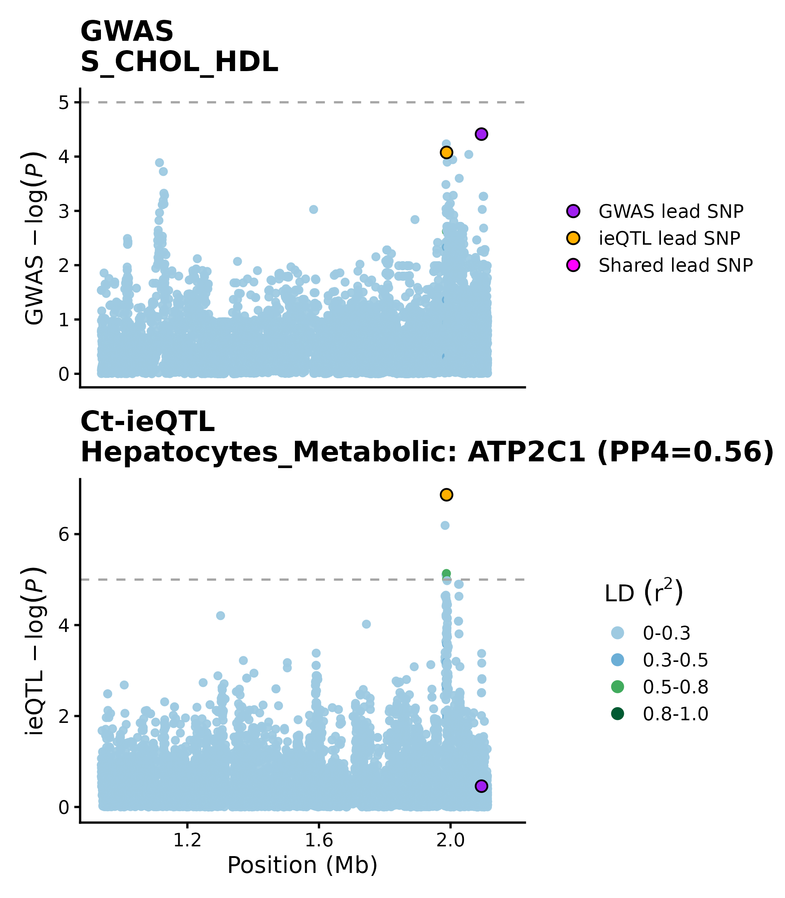
Extended Data Fig. 15. Colocalization between the liver ATP2C1 ieQTL and the GWAS signal for S_CHOL_HDL.

