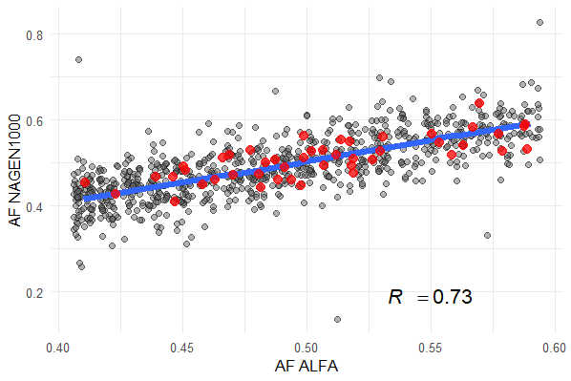
Supplementary figure 1. Allele frequency in ALFA global population vs local NAGEN cohort. For all 929 candidate SNPs. R=Pearson correlation coefficient.

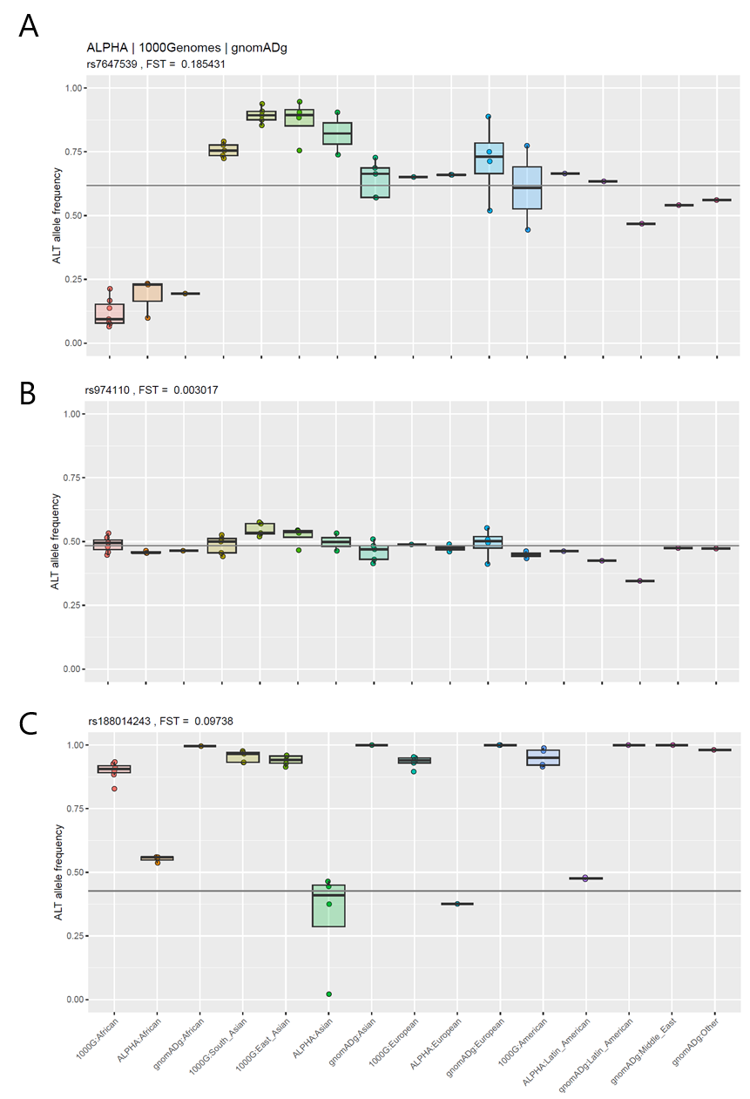
Supplementary figure 2. Allele frequency dispersion across world populations. Allele frequency data from ALFA/1000Genomes/gnomADg. A) SNP exhibiting high allelic frequency divergence between world populations, B) Low allele frequency divergence and C) SNPs with high divergence between annotation sources.
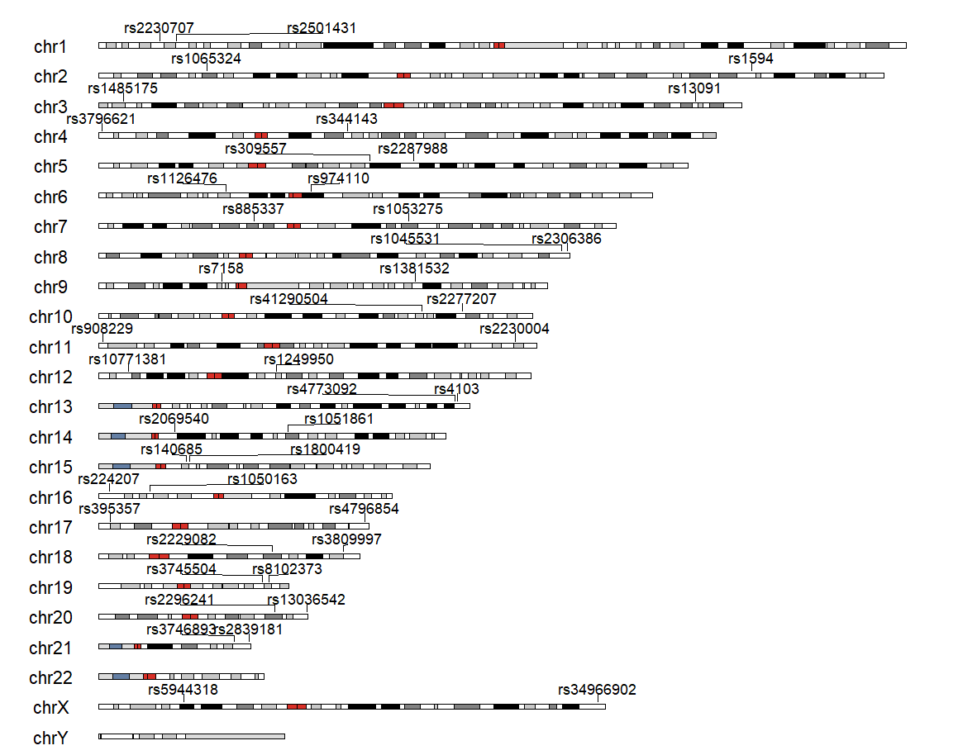
Supplementary figure 3. Karyoplot indicating genomic coverage. Position for each of the 44 genetic markers included in final SNP panel.

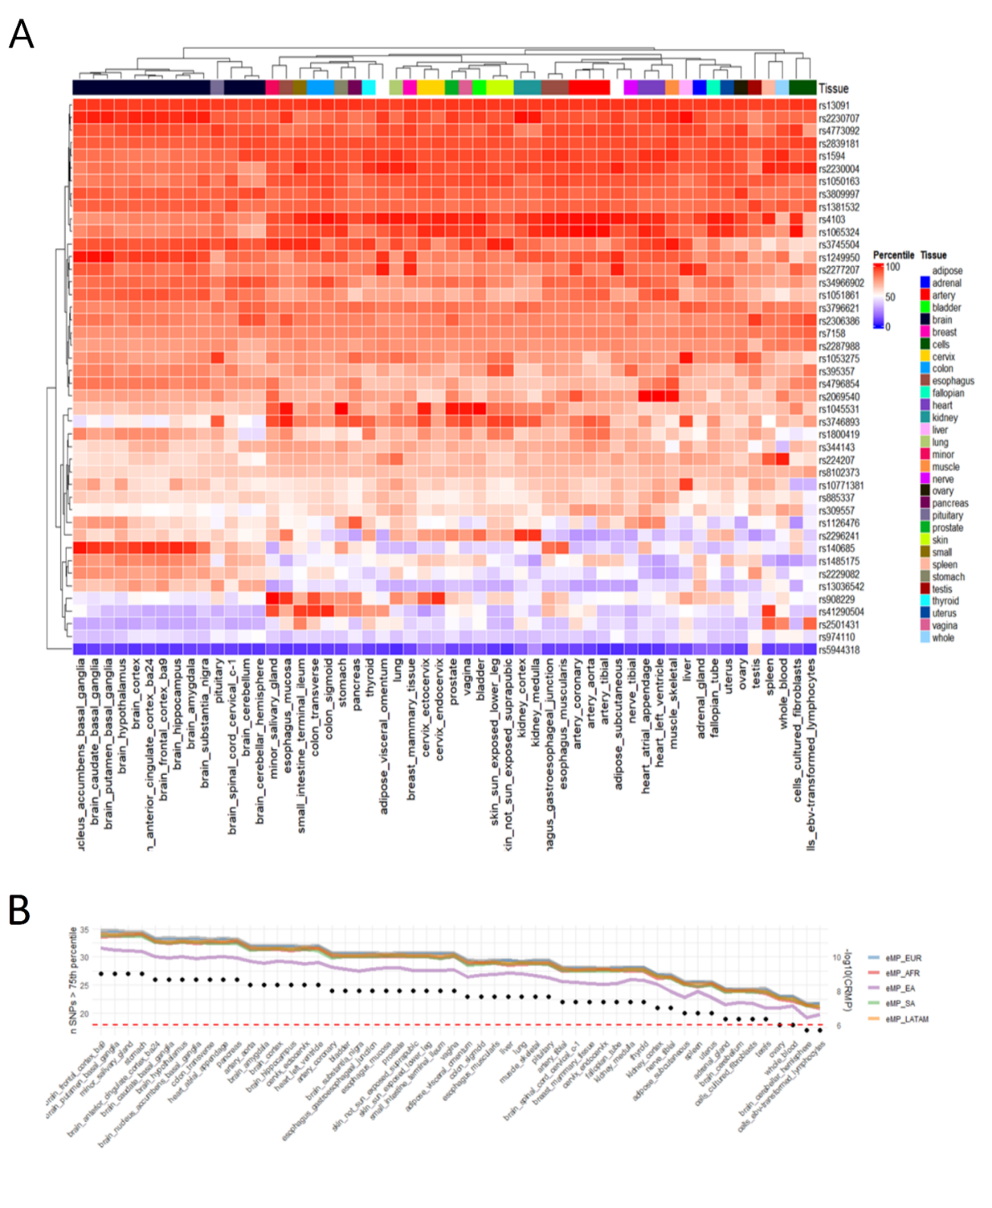
Supplementary figure 4. Expression profiles of SNP panel–associated genes across 54 human tissues (GTEx v10). A) Heatmap showing the percentile rank of gene expression for each SNP-hosting gene across 54 human tissues, derived from bulk RNA-seq data in the GTEx Portal (v10). Expression percentiles were calculated relative to all protein-coding genes within each tissue, with low expression shown in blue and high expression in red. B) Putative tissue-specific discrimination power. Left y-axis indicating number of SNPs located in genes expressed above 75th percentile, as represented by black dots. Righ y-axis showing –log10() of the CRMP, represented by color coded lines.
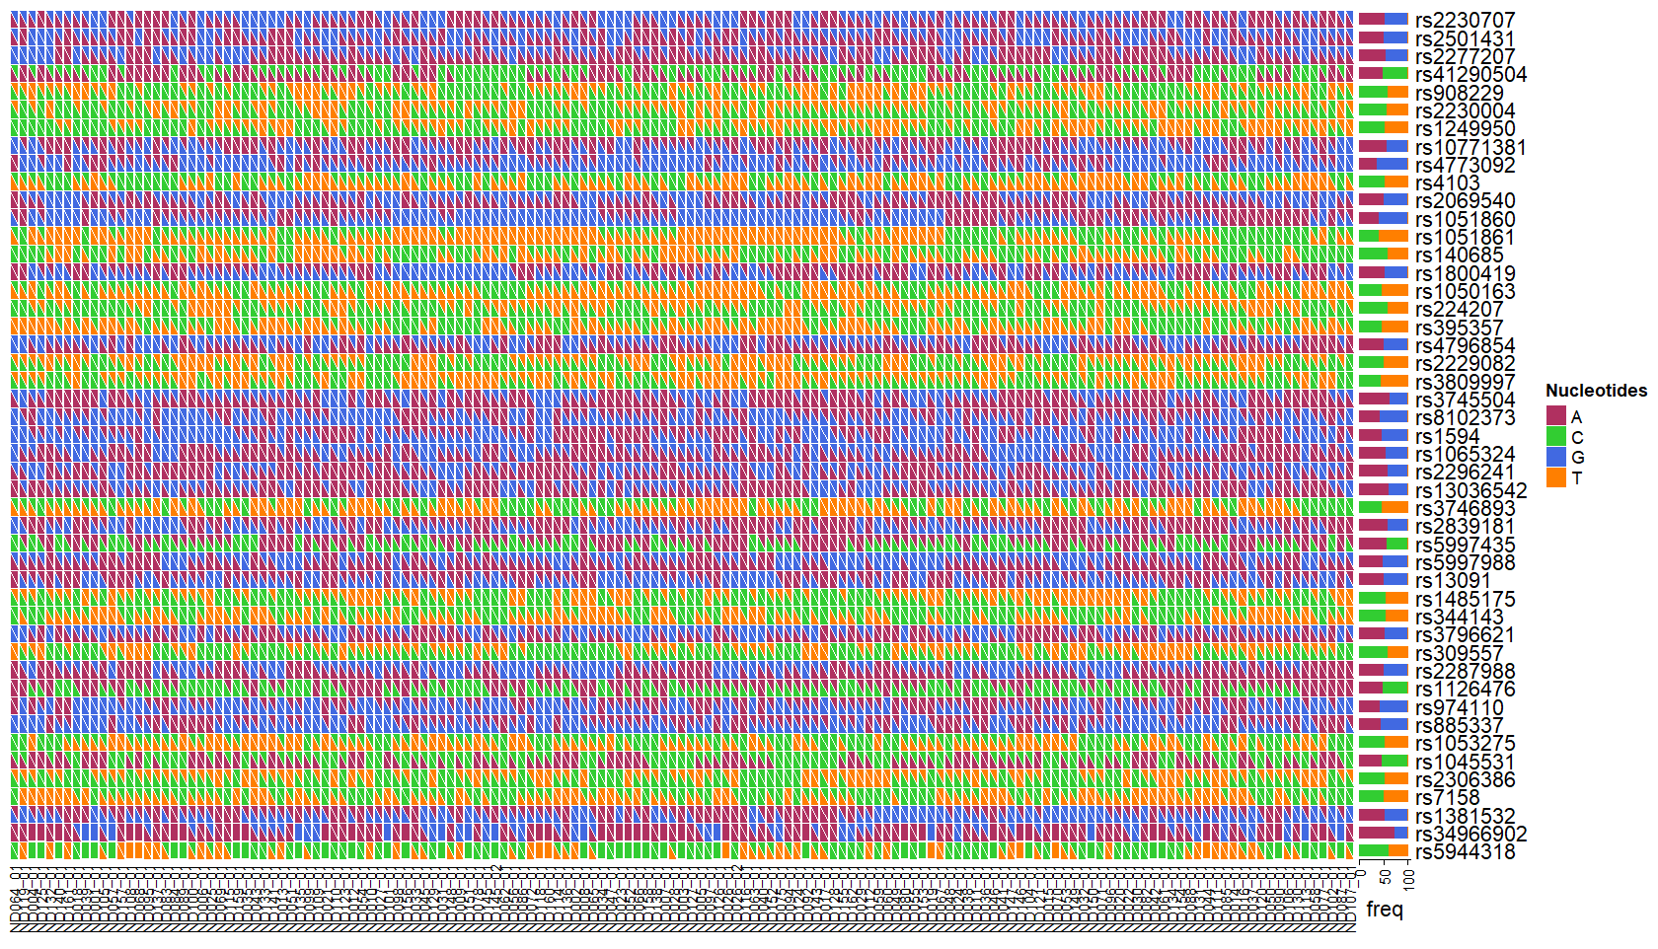
Supplementary figure 5. WGS derived genetic profiles for the 150 samples of the NAGENDATA cohort. Heatmap of WGS profiles for all 150 samples in the NAGENDATA cohort, displaying genotypes at each of the 44 SNPs. Columns represent individual samples; rows represent SNPs. Each cell is divided diagonally into two triangles, with color encoding the two alleles present, allowing visualization of heterozygous and homozygous calls. Barplots in the right side indicating allele frequencies.

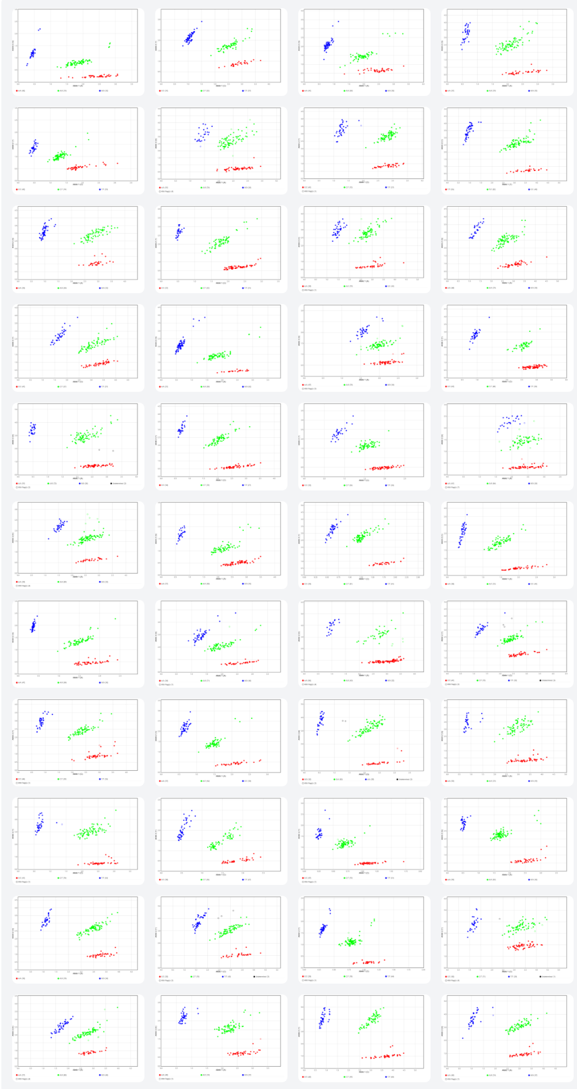
Supplementary figure 6. qPCR cluster plots for the 44 SNP genotyping assays. Two-dimensional scatter plots showing fluorescence intensity signals from TaqMan qPCR assays. Each dot represents a single sample, with x-axis intensity corresponding to channel 1 (allele 1) and y-axis intensity to the channel 2 (allele 2). Distinct clusters correspond to homozygous ref, heterozygous and homozygous alt.

