Fig. S1. Clustered heatmap of DEGs across three comparisons: L_SU vs. T_SU, L_LL vs. T_LL, and L_ST vs. T_ST.

Fig. S2. Bubble plot of GO molecular biological process for DEGs across three comparisons: L_SU vs. T_SU, L_LL vs. T_LL, and L_ST vs. T_ST.

Fig. S3. Bubble plot of GO molecular cellular component for DEGs across three comparisons: L_SU vs. T_SU, L_LL vs. T_LL, and L_ST vs. T_ST.

Fig. S4. PPI network of proteins encoded by DEGs across three comparisons: L_SU vs. T_SU, L_LL vs. T_LL, and L_ST vs. T_ST.

Fig. S5. PCA score plots in positive and negative ion modes across three comparisons: L_SU vs. T_SU, L_LL vs. T_LL, and L_ST vs. T_ST.

Fig. S6. OPLS-DA score plots and permutation validation plots in positive ion mode across three comparisons: L_SU vs. T_SU, L_LL vs. T_LL, and L_ST vs. T_ST.

Fig. S7. OPLS-DA score plots and permutation validation plots in negative ion mode across three comparisons: L_SU vs. T_SU, L_LL vs. T_LL, and L_ST vs. T_ST.

Fig. S8. Volcano plot of DEMs for two comparisons: L_SU vs. T_SU and L_LL vs. T_LL.

Fig. S9. Clustered heatmap of DEMs across three comparisons: L_SU vs. T_SU, L_LL vs. T_LL, and L_ST vs. T_ST.

Fig. S10. Bisulphite conversion efficiency evaluation for individual samples.

Fig. S11. Methylation level PCA results for individual samples.

Fig. S12. Violin plots of mean methylation levels for hyper and hypomethylated DMRs in L_LL vs. T_LL and L_ST vs. T_ST comparisons.

Fig. S13. Clustered heatmap of methylation levels for DMRs in L_LL vs. T_LL and L_ST vs. T_ST comparisons.

Fig. S14. DEG–DMR overlap gene numbers in the L_LL vs. T_LL and L_ST vs. T_ST comparisons.

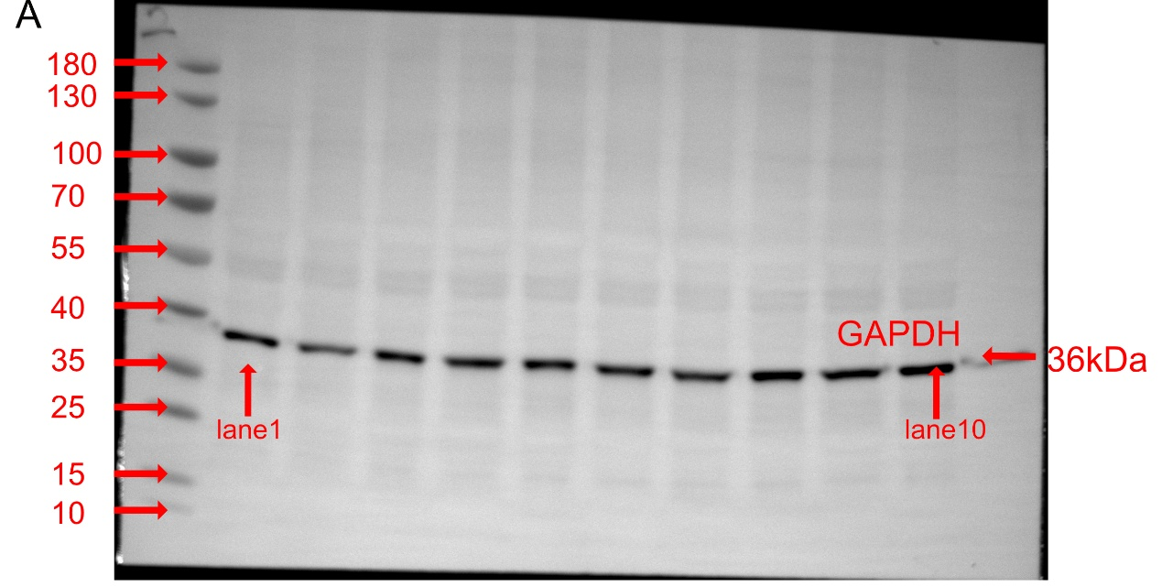

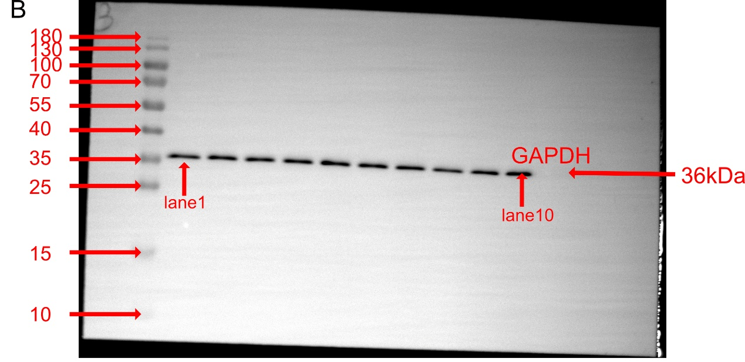

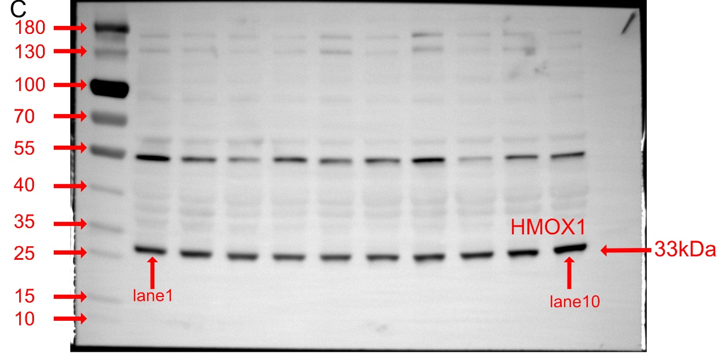
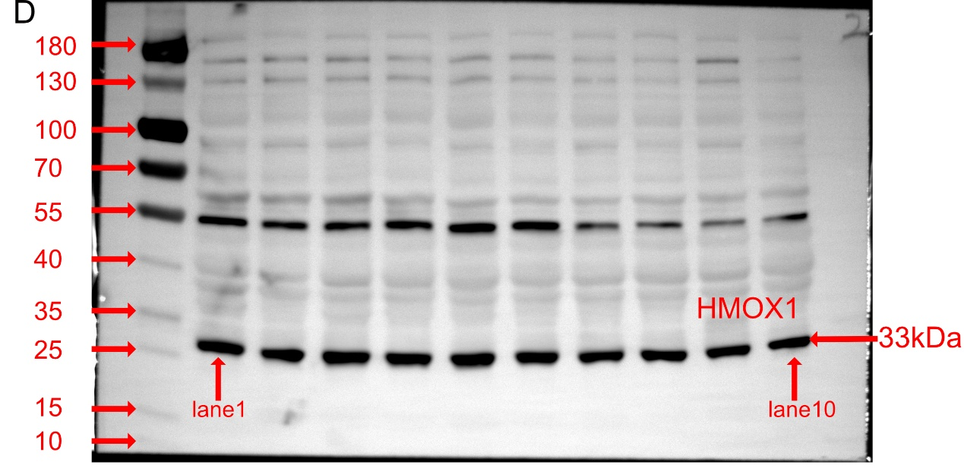

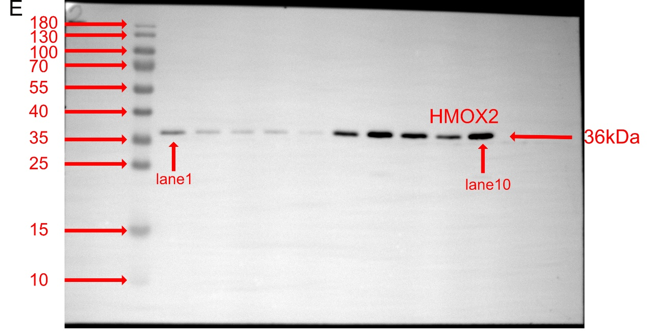

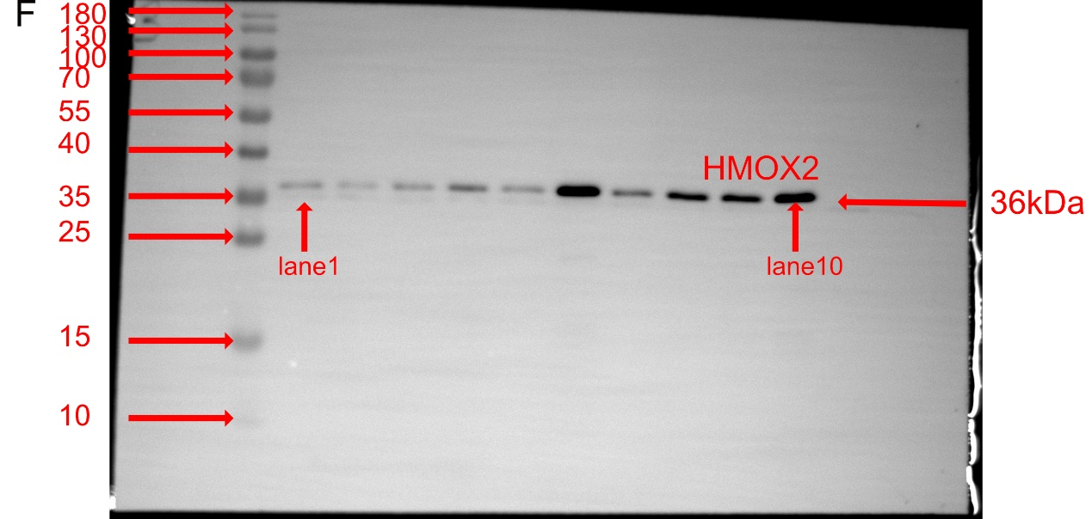
Fig. S15. Full-length, uncropped raw gel and blot images for GAPDH, HMOX1 and HMOX2. A and B Raw gel and blot images from the first and second membranes probed for GAPDH, respectively. C and D Raw gel and blot images from the first and second membranes probed for HMOX1, respectively. E and F Raw gel and blot images from the first and second membranes probed for HMOX2, respectively. Lanes 1–5 contain samples from the L_ST group, while lanes 6–10 contain samples from the T_ST group.

Fig. S16. Cytosine methylation frequency at target region amplicons in sample L_11ST across sequence contexts. A–C CpG, CHG, and CHH. The X-axis represents the chromosomal position, whereas the Y-axis represents the methylation rate of cytosine © bases. The numbers 1, 19, and 31 above Figure S16 correspond to the amplicon numbers.

Fig. S17. Statistical assessment of overall cytosine methylation frequency across all samples for each sequence context (CpG, CHH, CHG).

Fig. S18. Methylation level PCA results for individual samples.

Fig. 19. Paired intergroup methylation analysis: Bézier boxplots for HMOX1 amplicons in CpG/CHG/CHH contexts.

