Geographical variation and antibiotic exposure-associated perturbation of the early-life children's gut resistome
Okugbe Ebiotubo Ohore^{*1}, Sanji Zhou¹, Jingli Zhang², Emmanuel Stephen Odinga¹, Jing Zhang¹, Eneyi E Kpokiri, Tianle Tang¹, Xue-Liang Zhao⁴, Ji-Dong Gu^{5,**}, Guojing Yang^{1, **}

¹ NHC Key Laboratory of Tropical Disease Control, School of Tropical Medicine, Hainan Medical University, Haikou, Hainan, 571199, China.
² Key Laboratory of Reproductive Health Diseases Research and Translation of Ministry of Education & Key Laboratory of Human Reproductive Medicine and Genetic Research of Hainan Province & Hainan Provincial Clinical Research Center for Thalassemia, Department of Reproductive Medicine, The First Affiliated Hospital of Hainan Medical University, Hainan Medical University, Haikou, 570102, Hainan, China.
³ Clinical Research Department, London School of Hygiene and Tropical Medicine Faculty of Infectious and Tropical Diseases, London, UK.
⁴ National Key Laboratory of Veterinary Public Health and Safety, College of Veterinary Medicine, China Agricultural University, Beijing, 100193, China.
⁵ Environmental Science and Engineering Program, Guangdong Technion - Israel Institute of Technology, 241 Daxue Road, Jinping District, Shantou, Guangdong 515063, China.

*Corresponding Authors: Okugbe Ebiotubo Ohore (o.e.ohore@hainmc.edu.cn); Guo-Jing Yang (yangguojing@hainmc.edu.cn)

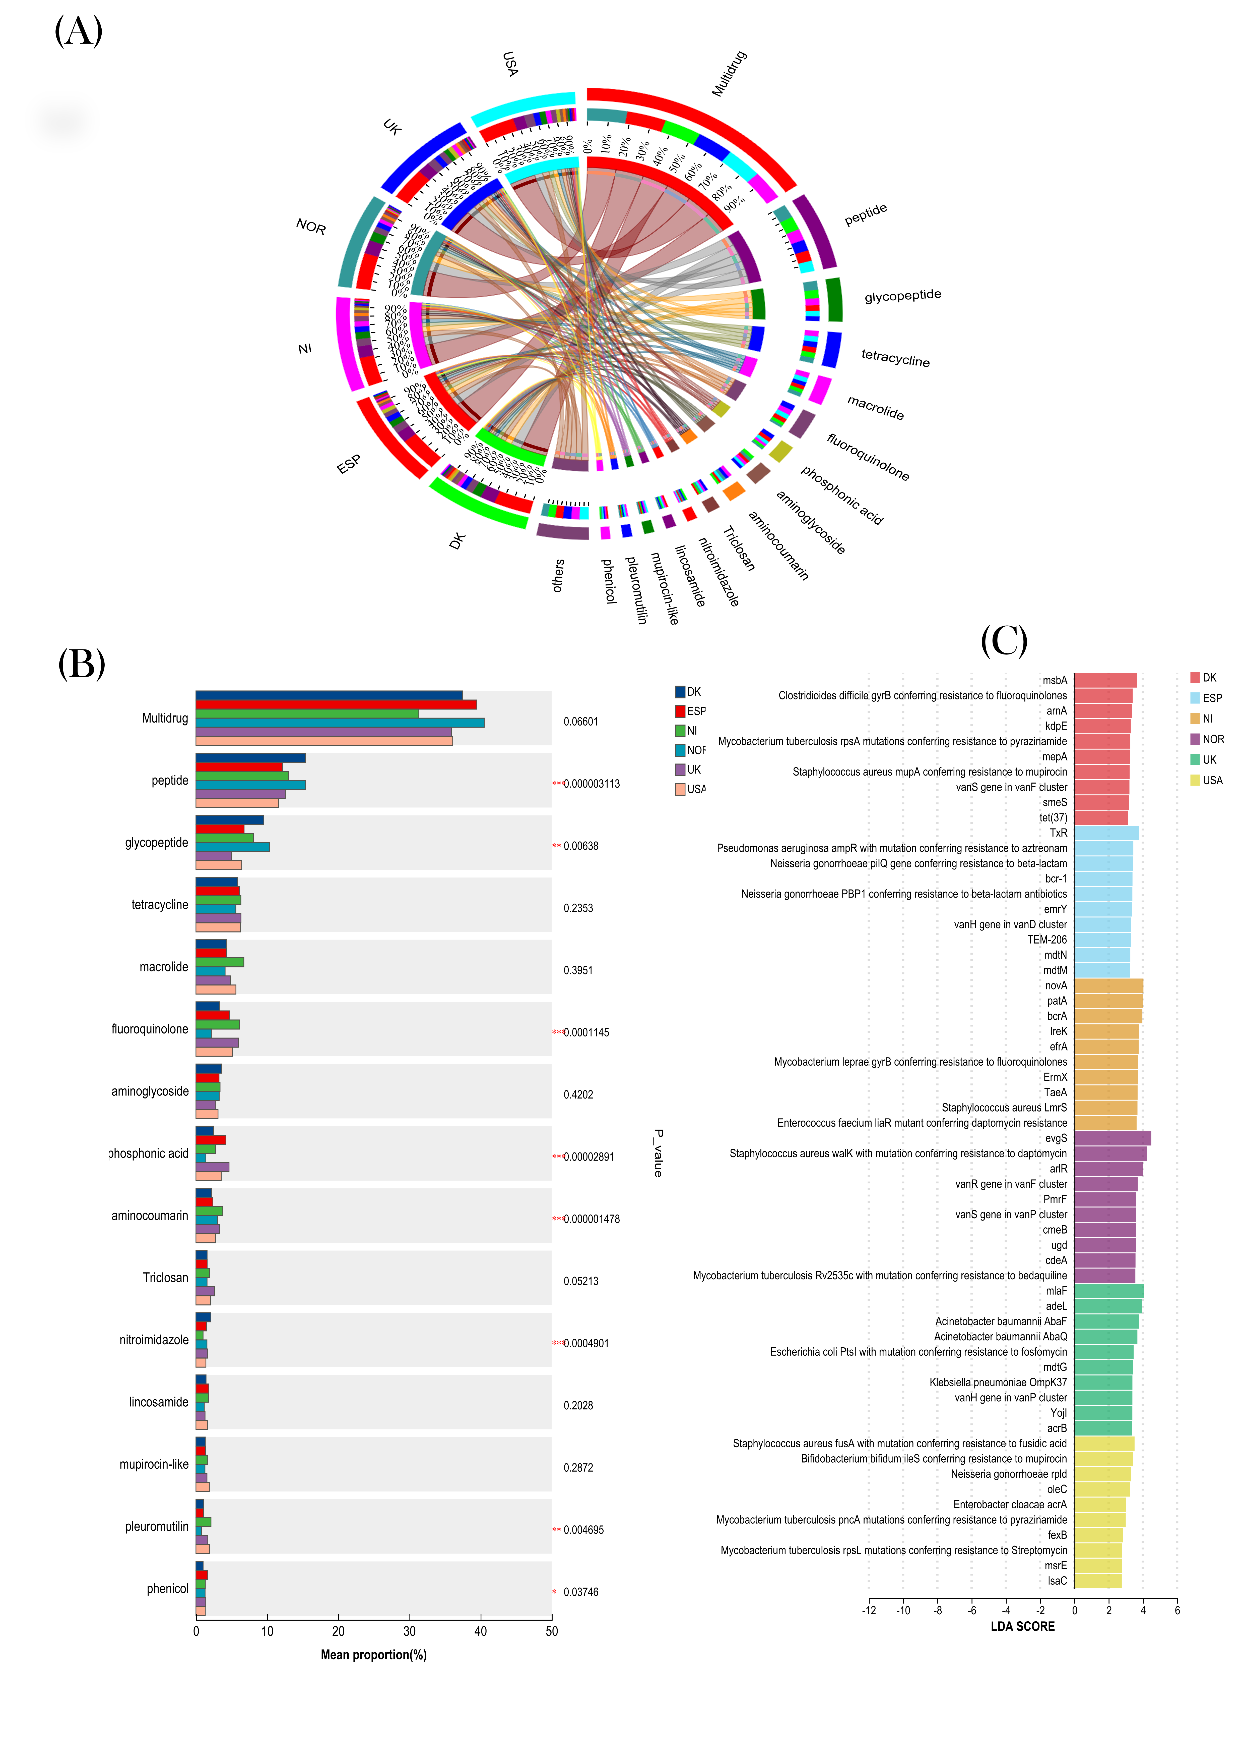

Supplementary Figure S1. Abundance of antibiotics resistance genes in infant gut (A)The relative abundance of antibiotics resistance class in the infant gut microbiota and the relationship between the countries. (B) Multiple group comparison of the relative abundance of top 15 antibiotic resistant genes class among the respective countries using Kruskal-Wallis test. The bar graph shows the difference in the average relative abundance of the resistant gene (ppm) between different countries, and marks whether the difference is significant (P-value, asterisk indicates significant difference). It intuitively shows the significance of the difference between multiple groups of the same gene class. Legend: The vertical axis represents the name of the CARD function at different classification levels, the horizontal axis represents the percentage value of the abundance of a certain CARD function in the sample, and different colors represent different groups. 0.01<p<0.05 *, 0.001< p <0.01 **, p<0.001 ***. (C) linear discriminant analysis (LDA) was used for identification of keystone ARGs and ARGs biomarkers among the respective countries (Dk: Denmark; ESP: Spain; NI: Nicaragua; NOR: Norway; UK: United Kingdom; and USA). The LDA discriminant (> 2.0 LDA scores, p < 0.05) column chart counts ARGs (top 10) with significant effect in multiple groups, and the LDA score obtained by LDA analysis (linear regression analysis), the larger the LDA score, the greater the influence of species abundance on the difference effect.

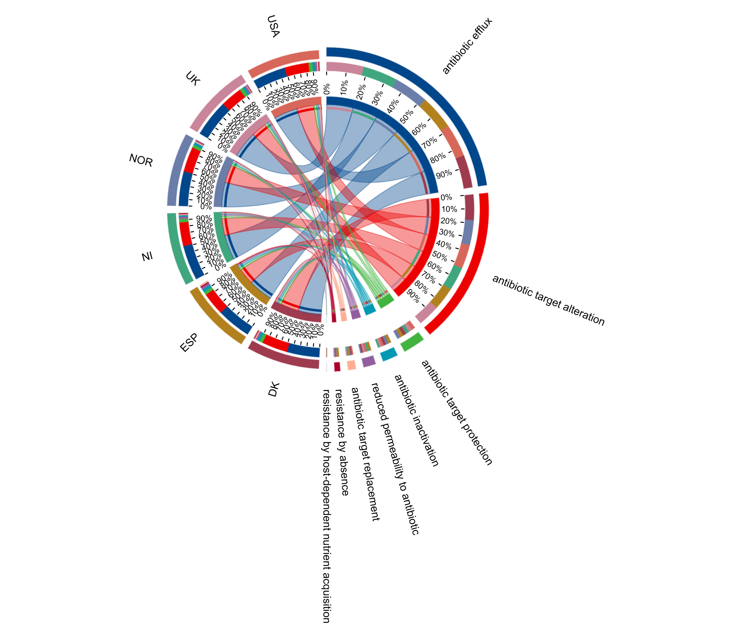
Supplementary Figure S2. Analysis of the antibiotic’s resistant mechanisms in the infant gut microbiome across different countries. Antibiotic efflux was the predominant mechanism.

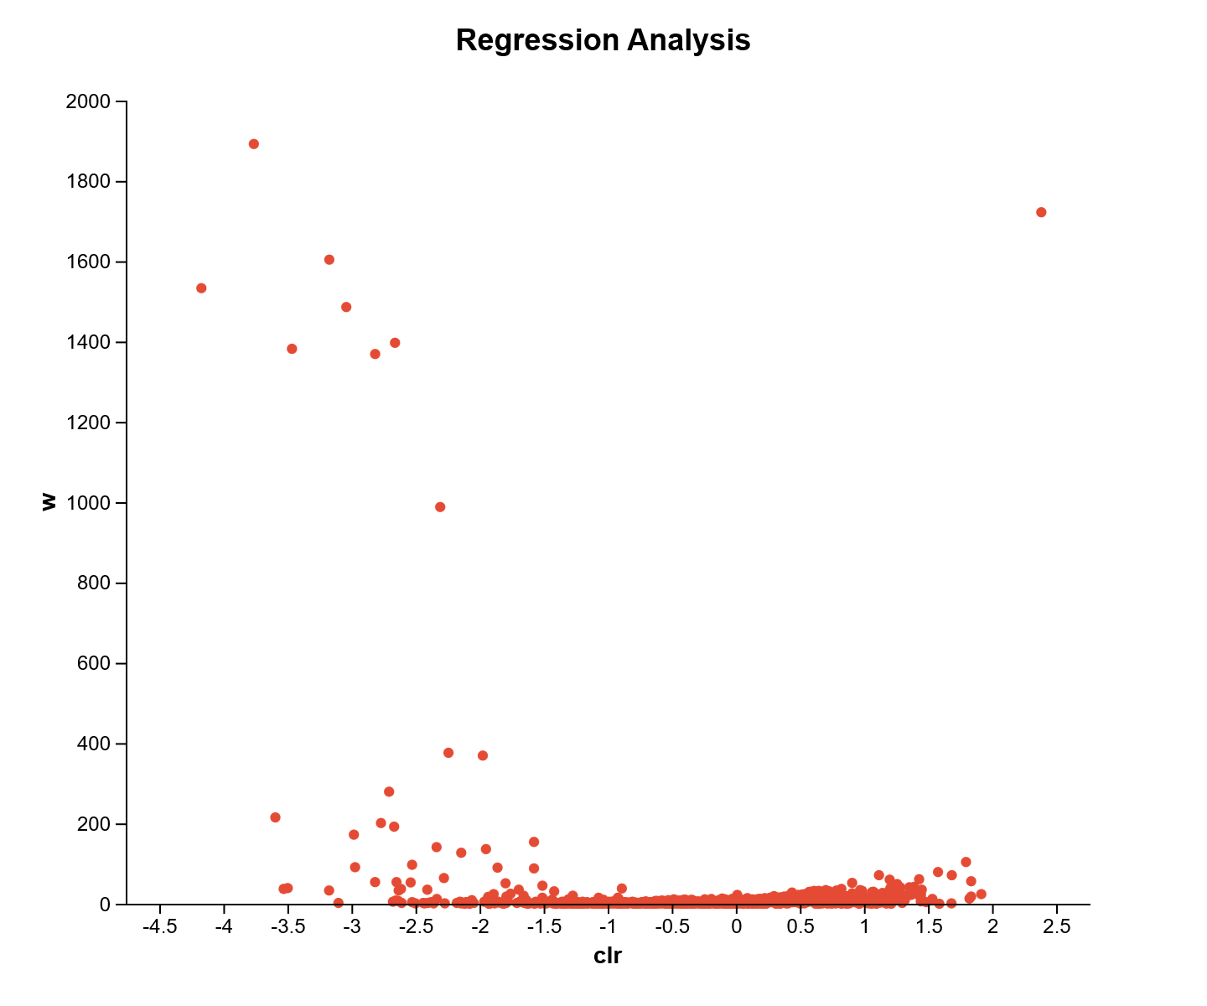
Figure S3. ANCOM volcano plot showing analysis of significance to identify bacterial genera that were differentially expressed between the antibiotic-exposed and un-exposed groups. The points in the figure represent the bacteria genera, the vertical axis represents the W value, and the horizontal axis represents the clr value (center log transform), which represents the degree of difference in sample abundance between groups. The higher the absolute value of the number, the greater the relative abundance difference. Therefore, the closer the point is to the upper right (or upper left) corner of the figure, the more significant the difference between that species and other species (species closer to the 0 position on the horizontal axis).

Supplementary Table S1. Multivariate PERMANOVA using Bray–Curtis dissimilarities for investigation of the factors influencing the resistome abundance in early life.

Characteristics | SumsOfSqs | MeanSqs | F.Model | R2 | P-value | P.adjust
Country | 2.7564 | 0.55128 | 4.48703 | 0.19778 | 0.001 | 0.00117
Feeding method | 2.11443 | 0.70481 | 5.54441 | 0.15172 | 0.001 | 0.00117
continent | 1.34016 | 0.67008 | 5.00036 | 0.09616 | 0.001 | 0.00117
Delivery method | 1.15167 | 0.57583 | 4.23372 | 0.08264 | 0.001 | 0.00117
Gender | 0.96225 | 0.48113 | 3.48577 | 0.06904 | 0.002 | 0.002
Antibiotics_exposure | 0.95626 | 0.47813 | 3.46246 | 0.06861 | 0.001 | 0.00117

Supplementary Table S2. Sample characteristics. Note: Country abbreviations (e.g., USA, Nor) were used, with gender indicated as male (M) or female (F). The method of delivery was classified as vaginal (V) or cesarean section (CS), while feeding methods were categorized as formula (F), breastfed (BF), or mixed (Mix). Antibiotic exposure was classified as exposed (AE) or unexposed (AU). Missing data for specific characteristics were marked as “X” and excluded from the analysis.

Assigned sample names | Bioproject | Number | corresponding number | Country | Continent | Gender | Cesarean or Vaginal delivery | Breastfed or Formula | Use of antibiotics | Age(days) | References
DK1_EUR_F_CS_F_AU | PRJEB6456 | ERR525689 | SAMEA2579906 | Denmark | Europe | Female | Cesarean | Formula | NO | 369 | [1]
DK2_EUR_F_V_BF_AU | PRJEB6456 | ERR525727 | SAMEA2579944 | Denmark | Europe | Female | Vaginal | Breastfed | NO | 128 | [1]
DK3_EUR_F_V_BF_AU | PRJEB6456 | ERR525739 | SAMEA2579956 | Denmark | Europe | Female | Vaginal | Breastfed | NO | 124 | [1]
DK4_EUR_F_V_BF_AU | PRJEB6456 | ERR525702 | SAMEA2579919 | Denmark | Europe | Female | Vaginal | Breastfed | NO | 11 | [1]
DK5_EUR_F_V_BF_AU | PRJEB6456 | ERR525740 | SAMEA2579957 | Denmark | Europe | Female | Vaginal | Breastfed | NO | 7 | [1]
DK6_EUR_F_V_F_AU | PRJEB6456 | ERR525722 | SAMEA2579939 | Denmark | Europe | Female | Vaginal | Formula | NO | 364 | [1]
DK7_EUR_F_V_F_AU | PRJEB6456 | ERR525728 | SAMEA2579945 | Denmark | Europe | Female | Vaginal | Formula | NO | 0 | [1]
DK8_EUR_F_V_F_AU | PRJEB6456 | ERR525734 | SAMEA2579951 | Denmark | Europe | Female | Vaginal | Formula | NO | 361 | [1]
DK9_EUR_M_V_BF_AE | PRJEB6456 | ERR525732 | SAMEA2579949 | Denmark | Europe | Male | Vaginal | Breastfed | YES | 3 | [1]
DK10_EUR_M_V_BF_AU | PRJEB6456 | ERR525718 | SAMEA2579935 | Denmark | Europe | Male | Vaginal | Breastfed | NO | 134 | [1]
DK11_EUR_M_V_BF_AU | PRJEB6456 | ERR525719 | SAMEA2579936 | Denmark | Europe | Male | Vaginal | Breastfed | NO | 1 | [1]
DK12_EUR_M_V_F_AU | PRJEB6456 | ERR525694 | SAMEA2579911 | Denmark | Europe | Male | Vaginal | Formula | NO | 354 | [1]
DK13_EUR_M_V_F_AU | PRJEB6456 | ERR525743 | SAMEA2579960 | Denmark | Europe | Male | Vaginal | Formula | NO | 374 | [1]
DK14_EUR_M_V_F_AU | PRJEB6456 | ERR525730 | SAMEA2579947 | Denmark | Europe | Male | Vaginal | Formula | NO | 364 | [1]
DK15_EUR_M_V_F_AU | PRJEB6456 | ERR525688 | SAMEA2579905 | Denmark | Europe | Male | Vaginal | Formula | NO | 380 | [1]
ESP1_EUR_M_CS_MIX_AU | PRJEB6972 | ERR579886 | SAMEA2699034 | Asturias/Spain | Europe | Male | Cesarean | Mix | NO | 84 | [2]
ESP2_EUR_M_CS_MIX_AU | PRJEB6972 | ERR579900 | SAMEA2699033 | Asturias/Spain | Europe | Male | Cesarean | Mix | NO | 77 | [2]
ESP3_EUR_M_CS_MIX_AU | PRJEB6972 | ERR579888 | SAMEA2699036 | Asturias/Spain | Europe | Male | Cesarean | Mix | NO | 112 | [2]
ESP4_EUR_M_CS_MIX_AU | PRJEB6972 | ERR579898 | SAMEA2699031 | Asturias/Spain | Europe | Male | Cesarean | Mix | NO | 49 | [2]
ESP5_EUR_M_CS_MIX_AU | PRJEB6972 | ERR579887 | SAMEA2699035 | Asturias/Spain | Europe | Male | Cesarean | Mix | NO | 105 | [2]
ESP6_EUR_M_V_BF_AU | PRJEB6972 | ERR579895 | SAMEA2699028 | Asturias/Spain | Europe | Male | Vaginal | Breastfed | NO | 77 | [2]
ESP7_EUR_M_V_BF_AU | PRJEB6972 | ERR579890 | SAMEA2699038 | Asturias/Spain | Europe | Male | Vaginal | Breastfed | NO | 112 | [2]
ESP8_EUR_M_V_BF_AU | PRJEB6972 | ERR579893 | SAMEA2699026 | Asturias/Spain | Europe | Male | Vaginal | Breastfed | NO | 49 | [2]
ESP9_EUR_M_V_BF_AU | PRJEB6972 | ERR579891 | SAMEA2699039 | Asturias/Spain | Europe | Male | Vaginal | Breastfed | NO | 168 | [2]
ESP10_EUR_M_V_BF_AU | PRJEB6972 | ERR579892 | SAMEA2699040 | Asturias/Spain | Europe | Male | Vaginal | Breastfed | NO | 168 | [2]
ESP11_EUR_M_V_BF_AU | PRJEB6972 | ERR579894 | SAMEA2699027 | Asturias/Spain | Europe | Male | Vaginal | Breastfed | NO | 56 | [2]
ESP12_EUR_M_V_BF_AU | PRJEB6972 | ERR579897 | SAMEA2699030 | Asturias/Spain | Europe | Male | Vaginal | Breastfed | NO | 112 | [2]
NI1_NA_M_CS_F_AE | PRJNA853174 | SRR19881284 | SAMN29363411 | Nicaragua: Leon | North America | Male | Cesarean | Formula | YES | 326 | [3]
NI2_NA_M_CS_F_AE | PRJNA853174 | SRR19881285 | SAMN29363410 | Nicaragua: Leon | North America | Male | Cesarean | Formula | YES | 298 | [3]
NI3_NA_M_CS_F_AE | PRJNA853174 | SRR19881280 | SAMN29363415 | Nicaragua: Leon | North America | Male | Cesarean | Formula | YES | 630 | [3]
NI4_NA_M_CS_F_AE | PRJNA853174 | SRR19881286 | SAMN29363409 | Nicaragua: Leon | North America | Male | Cesarean | Formula | YES | 285 | [3]
NI5_NA_M_CS_F_AE | PRJNA853174 | SRR19881282 | SAMN29363413 | Nicaragua: Leon | North America | Male | Cesarean | Formula | YES | 564 | [3]
NI6_NA_M_V_F_AU | PRJNA853174 | SRR19881293 | SAMN29363424 | Nicaragua: Leon | North America | Male | Vaginal | Formula | NO | 233 | [3]
NI7_NA_M_V_F_AU | PRJNA853174 | SRR19881302 | SAMN29363407 | Nicaragua: Leon | North America | Male | Vaginal | Formula | NO | 438 | [3]
NI8_NA_M_V_F_AU | PRJNA853174 | SRR19881289 | SAMN29363427 | Nicaragua: Leon | North America | Male | Vaginal | Formula | NO | 373 | [3]
NI9_NA_M_V_F_AU | PRJNA853174 | SRR19881301 | SAMN29363416 | Nicaragua: Leon | North America | Male | Vaginal | Formula | NO | 265 | [3]
NI10_NA_M_V_F_AU | PRJNA853174 | SRR19881296 | SAMN29363421 | Nicaragua: Leon | North America | Male | Vaginal | Formula | NO | 303 | [3]
NI11_NA_M_V_F_AU | PRJNA853174 | SRR19881291 | SAMN29363408 | Nicaragua: Leon | North America | Male | Vaginal | Formula | NO | 544 | [3]
NI12_NA_M_V_F_AU | PRJNA853174 | SRR19881292 | SAMN29363425 | Nicaragua: Leon | North America | Male | Vaginal | Formula | NO | 262 | [3]
NI13_NA_M_V_F_AU | PRJNA853174 | SRR19881295 | SAMN29363422 | Nicaragua: Leon | North America | Male | Vaginal | Formula | NO | 318 | [3]
NOR1_EUR_F_MIX_F_AU | PRJNA1085219 | SRR28352476 | SAMN40468063 | Oslo area of Norway | Europe | Female | Vaginal | Mix | NO | 60 | [4]
NOR2_EUR_F_V_BF_AU | PRJNA1085219 | SRR28270947 | SAMN40314163 | Oslo area of Norway | Europe | Female | Vaginal | Breastfed | NO | 365 | [4]
NOR3_EUR_F_V_BF_AU | PRJNA1085219 | SRR28256439 | SAMN40297639 | Oslo area of Norway | Europe | Female | Vaginal | Breastfed | NO | 332 | [4]
NOR4_EUR_F_V_F_AU | PRJNA1085219 | SRR28257832 | SAMN40299082 | Oslo area of Norway | Europe | Female | Vaginal | Formula | NO | 366 | [4]
NOR5_EUR_M_V_F_AU | PRJNA1085219 | SRR28257840 | SAMN40299085 | Oslo area of Norway | Europe | Male | Vaginal | Formula | NO | 91 | [4]
UK1_EUR_X_CS_X_AU | PRJEB15257 | ERR1600438 | SAMEA4413049 | UK | Europe | X | Cesarean | X | NO | 24 | [5]
UK2_EUR_X_CS_X_AU | PRJEB15257 | ERR1600429 | SAMEA4413040 | UK | Europe | X | Cesarean | X | NO | 24 | [5]
UK3_EUR_X_V_X_AE | PRJEB15257 | ERR1600435 | SAMEA4413046 | UK | Europe | X | Vaginal | X | YES | 17 | [5]
UK4_EUR_X_V_X_AE | PRJEB15257 | ERR1600439 | SAMEA4413050 | UK | Europe | X | Vaginal | X | YES | 14 | [5]
UK5_EUR_X_V_X_AE | PRJEB15257 | ERR1600432 | SAMEA4413043 | UK | Europe | X | Vaginal | X | YES | 35 | [5]
UK6_EUR_X_V_X_AE | PRJEB15257 | ERR1600433 | SAMEA4413044 | UK | Europe | X | Vaginal | X | YES | 14 | [5]
UK7_EUR_X_V_X_AE | PRJEB15257 | ERR1600428 | SAMEA4413039 | UK | Europe | X | Vaginal | X | YES | 27 | [5]
USA1_NA_F_CS_BF_AE | PRJNA532310 | SRR8882765 | SAMN11394106 | USA: Hershey, Pensylvania | North America | Female | Cesarean | Breastfed | YES | 36 | [6]
USA2_NA_F_CS_BF_AE | PRJNA532310 | SRR8882760 | SAMN11394099 | USA: Hershey, Pensylvania | North America | Female | Cesarean | Breastfed | YES | 17 | [6]
USA4_NA_F_CS_BF_AU | PRJNA532310 | SRR8882745 | SAMN11394120 | USA: Hershey, Pensylvania | North America | Female | Cesarean | Breastfed | NO | 14 | [6]
USA4_NA_F_CS_MIX_AE | PRJNA532310 | SRR8882764 | SAMN11394104 | USA: Hershey, Pensylvania | North America | Female | Cesarean | Mix | YES | 17 | [6]
USA5_NA_F_CS_MIX_AE | PRJNA532310 | SRR8882763 | SAMN11394107 | USA: Hershey, Pensylvania | North America | Female | Cesarean | Breastfed | NO | 14 | [6]
USA6_NA_F_CS_MIX_AU | PRJNA532310 | SRR8882753 | SAMN11394083 | USA: Hershey, Pensylvania | North America | Female | Cesarean | Mix | NO | 7 | [6]
USA7_NA_F_CS_MIX_AU | PRJNA532310 | SRR8882743 | SAMN11394118 | USA: Hershey, Pensylvania | North America | Female | Cesarean | Mix | NO | 14 | [6]
USA8_NA_F_V_BF_AE | PRJNA532310 | SRR8882774 | SAMN11394079 | USA: Hershey, Pensylvania | North America | Female | Vaginal | Breastfed | YES | 17 | [6]
USA9_NA_F_V_BF_AE | PRJNA532310 | SRR8882751 | SAMN11394110 | USA: Hershey, Pensylvania | North America | Female | Vaginal | Breastfed | YES | 17 | [6]
USA10_NA_M_CS_BF_AE | PRJNA532310 | SRR8882768 | SAMN11394100 | USA: Hershey, Pensylvania | North America | Male | Cesarean | Breastfed | YES | 21 | [6]
USA11_NA_M_CS_MIX_AE | PRJNA532310 | SRR8882766 | SAMN11394082 | USA: Hershey, Pensylvania | North America | Male | Cesarean | Mix | YES | 18 | [6]
USA12_NA_M_CS_MIX_AU | PRJNA532310 | SRR8882758 | SAMN11394097 | USA: Hershey, Pensylvania | North America | Male | Cesarean | Mix | NO | 14 | [6]
USA13_NA_M_V_BF_AE | PRJNA532310 | SRR8882773 | SAMN11394078 | USA: Hershey, Pensylvania | North America | Male | Vaginal | Breastfed | YES | 17 | [6]
USA14_NA_M_V_BF_AE | PRJNA532310 | SRR8882749 | SAMN11394113 | USA: Hershey, Pensylvania | North America | Female | Vaginal | Breastfed | YES | 17 | [6]
USA15_NA_M_V_BF_AE | PRJNA532310 | SRR8882779 | SAMN11394086 | USA: Hershey, Pensylvania | North America | Male | Vaginal | Breastfed | YES | 17 | [6]
USA16_NA_X_X_BF_AU | PRJNA927010 | SRR23254371 |  | USA:Cincinnati | North America | X | X | Breastfed | NO | X | https://www.ebi.ac.uk/ena/browser/view/PRJNA927010
USA17_NA_X_X_BF_AU | PRJNA927010 | SRR23254388 |  | USA:Cincinnati | North America | X | X | Breastfed | NO | X | https://www.ebi.ac.uk/ena/browser/view/PRJNA927010
USA18_NA_X_X_BF_AU | PRJNA927010 | SRR23254383 |  | USA:Cincinnati | North America | X | X | Breastfed | NO | X | https://www.ebi.ac.uk/ena/browser/view/PRJNA927010
USA19_NA_X_X_BF_AU | PRJNA927010 | SRR23254375 |  | USA:Cincinnati | North America | X | X | Breastfed | NO | X | https://www.ebi.ac.uk/ena/browser/view/PRJNA927010
USA20_NA_X_X_BF_AU | PRJNA927010 | SRR23254389 |  | USA:Cincinnati | North America | X | X | Breastfed | NO | X | https://www.ebi.ac.uk/ena/browser/view/PRJNA927010
USA21_NA_X_X_BF_AU | PRJNA927010 | SRR23254398 |  | USA:Cincinnati | North America | X | X | Breastfed | NO | X | https://www.ebi.ac.uk/ena/browser/view/PRJNA927010
USA22_NA_X_X_BF_AU | PRJNA927010 | SRR23254385 |  | USA:Cincinnati | North America | X | X | Breastfed | NO | X | https://www.ebi.ac.uk/ena/browser/view/PRJNA927010
USA23_NA_X_X_BF_AU | PRJNA927010 | SRR23254399 |  | USA:Cincinnati | North America | X | X | Breastfed | NO | X | https://www.ebi.ac.uk/ena/browser/view/PRJNA927010
USA24_NA_X_X_BF_AU | PRJNA927010 | SRR23254391 |  | USA:Cincinnati | North America | X | X | Breastfed | NO | X | https://www.ebi.ac.uk/ena/browser/view/PRJNA927010
USA25_NA_X_X_BF_AU | PRJNA927010 | SRR23254370 |  | USA:Cincinnati | North America | X | X | Breastfed | NO | X | https://www.ebi.ac.uk/ena/browser/view/PRJNA927010
USA26_NA_X_X_BF_AU | PRJNA927010 | SRR23254393 |  | USA:Cincinnati | North America | X | X | Breastfed | NO | X | https://www.ebi.ac.uk/ena/browser/view/PRJNA927010
USA27_NA_X_X_BF_AU | PRJNA927010 | SRR23254382 |  | USA:Cincinnati | North America | X | X | Breastfed | NO | X | https://www.ebi.ac.uk/ena/browser/view/PRJNA927010
USA28_NA_X_X_BF_AU | PRJNA927010 | SRR23254386 |  | USA:Cincinnati | North America | X | X | Breastfed | NO | X | https://www.ebi.ac.uk/ena/browser/view/PRJNA927010
USA29_NA_X_X_BF_AU | PRJNA927010 | SRR23254395 |  | USA:Cincinnati | North America | X | X | Breastfed | NO | X | https://www.ebi.ac.uk/ena/browser/view/PRJNA927010
USA30_NA_X_X_BF_AU | PRJNA927010 | SRR23254377 |  | USA:Cincinnati | North America | X | X | Breastfed | NO | X | https://www.ebi.ac.uk/ena/browser/view/PRJNA927010
USA31_NA_X_X_BF_AU | PRJNA927010 | SRR23254374 |  | USA:Cincinnati | North America | X | X | Breastfed | NO | X | https://www.ebi.ac.uk/ena/browser/view/PRJNA927010
USA32_NA_X_X_X_X | PRJNA772730 | SRR16483198 | SAMN22406995 | USA:Orlando | North America | X | X | X | X | X | [7]
USA33_NA_X_X_X_X | PRJNA772730 | SRR16483190 | SAMN22407003 | USA:Orlando | North America | X | X | X | X | X | [7]
USA34_NA_X_X_X_X | PRJNA772730 | SRR16483193 | SAMN22407000 | USA:Orlando | North America | X | X | X | X | X | [7]
USA35_NA_X_X_X_X | PRJNA772730 | SRR16483187 | SAMN22407005 | USA:Orlando | North America | X | X | X | X | X | [7]
USA36_NA_X_X_X_X | PRJNA772730 | SRR16483185 | SAMN22407007 | USA:Orlando | North America | X | X | X | X | X | [7]
USA37_NA_X_X_X_X | PRJNA772730 | SRR16483196 | SAMN22406997 | USA:Orlando | North America | X | X | X | X | X | [7]
USA38_NA_X_X_X_X | PRJEB46659 | ERR6576383 | SAMEA9555558 | USA | North America | X | X | X | X | X | [8]
USA39_NA_X_X_X_X | PRJEB46659 | ERR6576424 | SAMEA9555599 | USA | North America | X | X | X | X | X | [8]
USA40_NA_X_X_X_X | PRJEB46659 | ERR6576381 | SAMEA9555556 | USA | North America | X | X | X | X | X | [8]
USA41_NA_X_X_X_X | PRJEB46659 | ERR6576415 | SAMEA9555590 | USA | North America | X | X | X | X | X | [8]
USA42_NA_X_X_X_X | PRJEB46659 | ERR6576408 | SAMEA9555583 | USA | North America | X | X | X | X | X | [8]
USA43_NA_X_X_X_X | PRJEB46659 | ERR6576428 | SAMEA9555603 | USA | North America | X | X | X | X | X | [8]
USA44_NA_X_X_X_X | PRJEB46659 | ERR6576406 | SAMEA9555581 | USA | North America | X | X | X | X | X | [8]
USA45_NA_X_X_X_X | PRJEB46659 | ERR6576402 | SAMEA9555577 | USA | North America | X | X | X | X | X | [8]

Supplementary Table S3. Network statistic demonstrating the microbial interactions and the key stone resistance genes with the strongest horizontal gene transfer potential among infants in the USA (top 50). Degree: the number of edges connected to the focused node; Weighted degree: the sum of weighted values of the edges connecting node. Betweenness centrality: the amount of influence a node has over the flow of information in a graph; Clustering: connections between nodes
Id | Aro_name | Label | Degree | Weighted Degree | Betweeness centrality
ARO:3000535 | macB | Macrolide | 20 | 19.1 | 237.7
ARO:3003445 | Mycobacterium tuberculosis tlyA mutations conferring resistance to aminoglycosides | Aminoglycoside | 20 | 16.8 | 89.9
ARO:3003776 | Staphylococcus aureus murA with mutation conferring resistance to fosfomycin | Phosphonic acid | 12 | 16.8 | 14.2
ARO:3004572 | Staphylococcus aureus LmrS | Multidrug | 14 | 16.3 | 38.1
ARO:3003797 | Enterococcus faecalis YybT with mutation conferring daptomycin resistance | Peptide | 11 | 15.4 | 7.2
ARO:3003986 | TaeA | Pleuromutilin | 16 | 15.1 | 148.1
ARO:3007678 | IreK | Cephalosporin | 17 | 14.3 | 67.5
ARO:3000521 | Staphylococcus aureus mupA conferring resistance to mupirocin | Mupirocin-like | 10 | 13.4 | 14.6
ARO:3003438 | Enterococcus faecium EF-Tu mutants conferring resistance to GE2270A | Elfamycin | 10 | 13.2 | 16.0
ARO:3003323 | Staphylococcus aureus pgsA mutations conferring resistance to daptomycin | Peptide | 15 | 12.7 | 40.5
ARO:3000025 | patB | Fluoroquinolone | 10 | 12.7 | 14.0
ARO:3005081 | Thermus thermophilus uL3 mutations conferring resistance to pleuromutilin antibiotics | Pleuromutilin | 13 | 12.0 | 25.7
ARO:3004033 | tetB(46) | Tetracycline | 9 | 11.5 | 2.7
ARO:3004097 | Streptococcus mitis CdsA with mutation conferring daptomycin resistance | Peptide | 13 | 10.9 | 37.0
ARO:3003792 | Enterococcus faecalis liaR mutant conferring daptomycin resistance | Peptide | 10 | 10.6 | 123.5
ARO:3003041 | Streptococcus pneumoniae PBP1a conferring resistance to amoxicillin | Multidrug | 8 | 10.6 | 2.4
ARO:3007028 | salD | Multidrug | 8 | 9.7 | 7.7
ARO:3003291 | Staphylococcus aureus rpoC conferring resistance to daptomycin | Peptide | 7 | 9.2 | 12.3
ARO:3007073 | Bacillus subtilis rpoB mutants conferring resistance to rifampin | Multidrug | 7 | 9.1 | 1.3
ARO:3007527 | Bacillus subtilis rpsE mutations conferring resistance to spectinomycin | Aminoglycoside | 7 | 9.0 | 0.3
ARO:3003078 | Enterococcus faecium liaR mutant conferring daptomycin resistance | Peptide | 7 | 8.8 | 49.9
ARO:3002522 | novA | Aminocoumarin | 11 | 8.6 | 16.8
ARO:3003746 | optrA | Multidrug | 9 | 8.4 | 1.7
ARO:3004681 | Clostridioides difficile rpoC with mutation conferring resistance to vancomycin | Glycopeptide | 13 | 8.4 | 34.4
ARO:3004956 | Neisseria gonorrhoeae rpld | Multidrug | 6 | 7.8 | 2.2
ARO:3003470 | Mycobacterium tuberculosis gidB mutation conferring resistance to streptomycin | Aminoglycoside | 7 | 6.1 | 3.9
ARO:3003737 | Staphylococcus aureus fusE with mutation conferring resistance to fusidic acid | Fusidane | 5 | 6.1 | 0.6
ARO:3004721 | Mycobacterium tuberculosis rpsA mutations conferring resistance to pyrazinamide | Pyrazine | 5 | 6.0 | 0.0
ARO:3003729 | Staphylococcus aureus ileS with mutation conferring resistance to mupirocin | Mupirocin-like | 5 | 6.0 | 2.0
ARO:3003930 | rpsJ | Tetracycline | 5 | 5.9 | 0.0
ARO:3004153 | Mycobacterium tuberculosis thyA with mutation conferring resistance to para-aminosalicylic acid | Salicylic acid | 5 | 5.8 | 38.0
ARO:3002987 | bcrA | Peptide | 5 | 5.8 | 0.0
ARO:3003949 | efrB | Multidrug | 6 | 4.9 | 0.6
ARO:3003735 | Staphylococcus aureus fusA with mutation conferring resistance to fusidic acid | Fusidane | 4 | 4.8 | 0.0
ARO:3003948 | efrA | Multidrug | 4 | 4.7 | 38.0
ARO:3002928 | vanR gene in vanM cluster | Glycopeptide | 4 | 4.6 | 38.0
ARO:3003899 | Escherichia coli PtsI with mutation conferring resistance to fosfomycin | Phosphonic acid | 4 | 4.6 | 0.0
ARO:3003301 | Staphylococcus aureus gyrB conferring resistance to aminocoumarin | Aminocoumarin | 3 | 3.6 | 0.0
ARO:3004561 | Clostridioides difficile murG with mutation conferring resistance to vancomycin | Glycopeptide | 3 | 3.5 | 0.0
ARO:3003728 | vanR gene in vanI cluster | Glycopeptide | 5 | 3.5 | 110.0
ARO:3000024 | patA | Fluoroquinolone | 3 | 3.5 | 0.0
ARO:3002882 | lmrD | Lincosamide | 3 | 3.5 | 0.0
ARO:3003794 | Staphylococcus aureus walK with mutation conferring resistance to daptomycin | Peptide | 3 | 3.4 | 0.0
ARO:3000839 | arlS | Multidrug | 3 | 3.4 | 0.0
ARO:3000838 | arlR | Multidrug | 3 | 3.3 | 0.0
ARO:3003980 | tetA(58) | Tetracycline | 3 | 3.3 | 0.0
ARO:3003296 | Staphylococcus aureus gyrA conferring resistance to fluoroquinolones | Multidrug | 3 | 3.3 | 0.0
ARO:3003992 | rphB | Rifamycin | 3 | 3.3 | 0.0
ARO:3004035 | tetA(60) | Tetracycline | 3 | 3.3 | 0.0
ARO:3003801 | bcr-1 | Bicyclomycin-like | 3 | 3.3 | 0.0

Supplementary Table S4. Network statistic demonstrating the microbial interactions and the keystone resistance genes with the strongest horizontal gene transfer potential among infants in the Denmark (top 50).
Id | Aro_name | Label | Degree | Weighted Degree | Betweenesscentrality | Clustering
ARO:3003926 | Salmonella enterica gyrA conferring resistance to fluoroquinolones | Multidrug | 81 | 83.1 | 124.3 | 0.7
ARO:3000620 | adeL | Multidrug | 74 | 79.6 | 144.3 | 0.7
ARO:3002817 | carA | Macrolide | 75 | 78.2 | 110.6 | 0.8
ARO:3003843 | leuO | Multidrug | 70 | 77.3 | 115.9 | 0.7
ARO:3000074 | emrB | Fluoroquinolone | 82 | 75.6 | 285.2 | 0.7
ARO:3000237 | TolC | Multidrug | 90 | 73.9 | 157.3 | 0.7
ARO:3003900 | Escherichia coli cyaA with mutation conferring resistance to fosfomycin | Phosphonic acid | 96 | 73.6 | 149.5 | 0.7
ARO:3005042 | mlaD | Multidrug | 84 | 72.5 | 144.1 | 0.7
ARO:3001302 | chrB | Multidrug | 72 | 71.7 | 453.6 | 0.6
ARO:3003369 | Escherichia coli EF-Tu mutants conferring resistance to Pulvomycin | Elfamycin | 72 | 68.8 | 57.6 | 0.8
ARO:3000775 | adeB | Multidrug | 86 | 68.7 | 114.1 | 0.7
ARO:3003303 | Escherichia coli gyrB conferring resistance to aminocoumarin | Aminocoumarin | 98 | 68.2 | 167.1 | 0.7
ARO:3004127 | Escherichia coli mipA | Multidrug | 94 | 68.1 | 111.4 | 0.7
ARO:3002974 | vanTr gene in vanL cluster | Glycopeptide | 78 | 67.2 | 294.7 | 0.7
ARO:3000656 | AcrS | Multidrug | 95 | 66.8 | 103.1 | 0.7
ARO:3003890 | Escherichia coli UhpT with mutation conferring resistance to fosfomycin | Phosphonic acid | 97 | 66.8 | 167.8 | 0.7
ARO:3005059 | LptD | Multidrug | 93 | 66.6 | 130.5 | 0.7
ARO:3000676 | H-NS | Multidrug | 94 | 65.9 | 100.8 | 0.7
ARO:3007019 | fexB | Phenicol | 98 | 65.4 | 252.5 | 0.7
ARO:3003392 | Mycobacterium tuberculosis katG mutations conferring resistance to isoniazid | Isoniazid-like | 100 | 65.3 | 188.6 | 0.7
ARO:3007055 | Helicobacter pylori rdxA mutation conferring resistance to metronidazole | Nitroimidazole | 95 | 64.4 | 104.2 | 0.7
ARO:3000499 | AcrE | Multidrug | 95 | 63.8 | 209.1 | 0.7
ARO:3004122 | Klebsiella pneumoniae OmpK37 | Multidrug | 95 | 62.9 | 115.7 | 0.7
ARO:3003805 | Enterococcus faecalis gshF with mutation conferring daptomycin resistance | Peptide | 98 | 62.5 | 125.9 | 0.7
ARO:3002815 | clbB | Multidrug | 88 | 60.7 | 241.3 | 0.7
ARO:3001328 | Escherichia coli mdfA | Multidrug | 100 | 59.8 | 356.0 | 0.7
ARO:3004835 | Neisseria gonorrhoeae pilQ gene conferring resistance to beta-lactam | Multidrug | 96 | 59.4 | 188.5 | 0.7
ARO:3003797 | Enterococcus faecalis YybT with mutation conferring daptomycin resistance | Peptide | 69 | 59.3 | 411.5 | 0.5
ARO:3000502 | AcrF | Multidrug | 64 | 59.0 | 665.4 | 0.6
ARO:3003109 | msrE | Multidrug | 75 | 58.2 | 151.9 | 0.7
ARO:3007051 | Helicobacter pylori rpoB mutation conferring resistance to rifampicin | Multidrug | 76 | 57.9 | 239.2 | 0.7
ARO:3003308 | Escherichia coli parC conferring resistance to fluoroquinolones | Fluoroquinolone | 98 | 57.2 | 226.0 | 0.7
ARO:3003548 | mdtN | Multidrug | 97 | 57.1 | 104.5 | 0.7
ARO:3004114 | porin OmpC | Multidrug | 84 | 56.0 | 148.6 | 0.7
ARO:3000027 | emrA | Fluoroquinolone | 101 | 54.2 | 235.1 | 0.7
ARO:3000826 | sdiA | Multidrug | 98 | 53.2 | 167.7 | 0.7
ARO:3005183 | CMY-160 | Cephamycin | 98 | 52.6 | 140.6 | 0.7
ARO:3004128 | Serratia marcescens Omp1 | Multidrug | 89 | 51.7 | 110.1 | 0.8
ARO:3003294 | Escherichia coli gyrA conferring resistance to fluoroquinolones | Multidrug | 95 | 50.3 | 283.9 | 0.6
ARO:3000830 | cpxA | Multidrug | 84 | 47.5 | 210.9 | 0.7
ARO:3003801 | bcr-1 | Bicyclomycin-like | 103 | 45.8 | 233.5 | 0.6
ARO:3004573 | Acinetobacter baumannii AbaF | Phosphonic acid | 104 | 45.6 | 326.8 | 0.6
ARO:3003964 | hp1181 | Multidrug | 84 | 45.3 | 113.0 | 0.7
ARO:3007491 | Pseudomonas aeruginosa ampR with mutation conferring resistance to aztreonam | Multidrug | 55 | 44.8 | 522.2 | 0.6
ARO:3003288 | Escherichia coli rpoB mutants conferring resistance to rifampicin | Multidrug | 86 | 44.4 | 406.1 | 0.7
ARO:3000533 | macA | Macrolide | 83 | 43.5 | 91.9 | 0.8
ARO:3002893 | tcr3 | Tetracycline | 100 | 42.9 | 144.3 | 0.7
ARO:3000216 | acrB | Multidrug | 56 | 41.8 | 391.5 | 0.7
ARO:3003749 | salA | Multidrug | 46 | 40.7 | 363.1 | 0.4
ARO:3002939 | vanS gene in vanM cluster | Glycopeptide | 98 | 39.6 | 342.0 | 0.6

Supplementary Table S5. Network statistic demonstrating the microbial interactions and the keystone resistance genes with the strongest horizontal gene transfer potential among infants in the Spain (top 50).

Id | Aro_name | Label | Degree | Weighted Degree | Betweeness centrality
ARO:3002948 | vanH gene in vanO cluster | Glycopeptide | 187.0 | 174.3 | 151.2
ARO:3007055 | Helicobacter pylori rdxA mutation conferring resistance to metronidazole | Nitroimidazole | 193.0 | 172.0 | 189.5
ARO:3002817 | carA | Macrolide | 171.0 | 171.0 | 139.1
ARO:3000816 | mtrA | Multidrug | 192.0 | 170.9 | 157.5
ARO:3003250 | bcrC | Peptide | 192.0 | 170.9 | 157.5
ARO:3000074 | emrB | Fluoroquinolone | 196.0 | 170.7 | 189.4
ARO:3000237 | TolC | Multidrug | 196.0 | 170.7 | 189.4
ARO:3003048 | rosA | Peptide | 189.0 | 167.5 | 201.8
ARO:3005121 | lsaD | Multidrug | 173.0 | 166.5 | 78.4
ARO:3003964 | hp1181 | Multidrug | 186.0 | 165.7 | 151.2
ARO:3000556 | tet(44) | Tetracycline | 191.0 | 165.3 | 128.9
ARO:3004573 | Acinetobacter baumannii AbaF | Phosphonic acid | 190.0 | 164.9 | 112.3
ARO:3005067 | ParS | Multidrug | 167.0 | 164.4 | 120.2
ARO:3002844 | vatE | Multidrug | 196.0 | 164.4 | 181.9
ARO:3003303 | Escherichia coli gyrB conferring resistance to aminocoumarin | Aminocoumarin | 192.0 | 163.8 | 116.0
ARO:3003007 | bmr | Multidrug | 179.0 | 163.6 | 204.2
ARO:3003548 | mdtN | Multidrug | 179.0 | 163.6 | 204.2
ARO:3003801 | bcr-1 | Bicyclomycin-like | 165.0 | 163.3 | 48.3
ARO:3000499 | AcrE | Multidrug | 195.0 | 162.7 | 146.0
ARO:3000828 | baeR | Multidrug | 195.0 | 162.6 | 132.1
ARO:3003665 | NmcR | Multidrug | 146.0 | 162.1 | 428.1
ARO:3005069 | rsmA | Multidrug | 147.0 | 161.3 | 384.8
ARO:3007042 | msr(G) | Multidrug | 192.0 | 161.2 | 107.9
ARO:3004122 | Klebsiella pneumoniae OmpK37 | Multidrug | 172.0 | 161.1 | 418.0
ARO:3005042 | mlaD | Multidrug | 157.0 | 159.8 | 297.0
ARO:3003901 | Staphylococcus aureus GlpT with mutation conferring resistance to fosfomycin | Phosphonic acid | 178.0 | 159.7 | 192.3
ARO:3000656 | AcrS | Multidrug | 196.0 | 159.4 | 134.6
ARO:3001328 | Escherichia coli mdfA | Multidrug | 196.0 | 159.4 | 134.6
ARO:3003900 | Escherichia coli cyaA with mutation conferring resistance to fosfomycin | Phosphonic acid | 196.0 | 159.4 | 134.6
ARO:3000533 | macA | Macrolide | 188.0 | 159.3 | 84.9
ARO:3003843 | leuO | Multidrug | 139.0 | 158.8 | 327.9
ARO:3001329 | mdtG | Phosphonic acid | 147.0 | 158.1 | 421.3
ARO:3003049 | rosB | Peptide | 151.0 | 157.4 | 523.7
ARO:3000676 | H-NS | Multidrug | 203.0 | 157.1 | 208.9
ARO:3004583 | Klebsiella pneumoniae KpnF | Multidrug | 191.0 | 156.5 | 112.1
ARO:3001302 | chrB | Multidrug | 194.0 | 156.1 | 120.8
ARO:3003890 | Escherichia coli UhpT with mutation conferring resistance to fosfomycin | Phosphonic acid | 153.0 | 155.9 | 412.4
ARO:3003961 | farA | Antibacterial_free_fatty_acids | 138.0 | 155.3 | 328.6
ARO:3003288 | Escherichia coli rpoB mutants conferring resistance to rifampicin | Multidrug | 190.0 | 154.7 | 105.6
ARO:3000508 | gadX | Multidrug | 203.0 | 154.2 | 180.0
ARO:3003549 | mdtO | Multidrug | 197.0 | 153.4 | 125.5
ARO:3003583 | basS | Peptide | 200.0 | 153.4 | 142.7
ARO:3000792 | mdtA | Aminocoumarin | 149.0 | 153.1 | 370.9
ARO:3005053 | ArnT | Peptide | 198.0 | 153.0 | 128.4
ARO:3002698 | cmlB | Phenicol | 195.0 | 151.6 | 123.3
ARO:3004580 | Klebsiella pneumoniae KpnE | Multidrug | 207.0 | 151.6 | 238.4
ARO:3003053 | smeC | Multidrug | 176.0 | 151.4 | 83.5
ARO:3003067 | smeS | Multidrug | 191.0 | 150.8 | 103.7
ARO:3002985 | arnA | Peptide | 191.0 | 150.7 | 122.3
ARO:3000216 | acrB | Multidrug | 147.0 | 150.5 | 453.8

Supplementary Table S6. Network statistic demonstrating the microbial interactions and the keystone resistance genes with the strongest horizontal gene transfer potential among infants in the Nicaragua (top 50).
Id | Aro_name | Label | Degree | Weighted Degree | Betweeness centrality
ARO:3003314 | Staphylococcus aureus parE conferring resistance to aminocoumarin | aminocoumarin | 49.0 | 71.2 | 19.9
ARO:3002926 | vanR gene in vanG cluster | glycopeptide | 53.0 | 71.0 | 41.4
ARO:3002919 | vanR gene in vanA cluster | glycopeptide | 49.0 | 70.7 | 14.1
ARO:3003995 | Clostridioides difficile gyrA conferring resistance to fluoroquinolones | Multidrug | 54.0 | 70.7 | 69.3
ARO:3003074 | Staphylococcus aureus cls conferring resistance to daptomycin | peptide | 53.0 | 68.5 | 37.3
ARO:3003283 | Mycobacterium tuberculosis rpoB mutants conferring resistance to rifampicin | Multidrug | 50.0 | 68.0 | 19.6
ARO:3003749 | salA | Multidrug | 48.0 | 67.3 | 8.4
ARO:3004563 | Clostridioides difficile rpoB with mutation conferring resistance to rifampicin | Multidrug | 53.0 | 67.2 | 36.6
ARO:3002844 | vatE | Multidrug | 52.0 | 67.1 | 30.6
ARO:3003776 | Staphylococcus aureus murA with mutation conferring resistance to fosfomycin | phosphonic acid | 54.0 | 66.5 | 43.4
ARO:3003291 | Staphylococcus aureus rpoC conferring resistance to daptomycin | peptide | 53.0 | 65.9 | 51.5
ARO:3000118 | vgaB | Multidrug | 52.0 | 65.6 | 30.2
ARO:3000616 | mel | Multidrug | 53.0 | 65.2 | 29.6
ARO:3004561 | Clostridioides difficile murG with mutation conferring resistance to vancomycin | glycopeptide | 51.0 | 64.9 | 98.1
ARO:3007692 | Mycobacterium tuberculosis Rv2535c with mutation conferring resistance to bedaquiline | Multidrug | 56.0 | 64.9 | 72.5
ARO:3003043 | Streptococcus pneumoniae PBP2x conferring resistance to amoxicillin | Multidrug | 56.0 | 64.7 | 53.4
ARO:3003438 | Enterococcus faecium EF-Tu mutants conferring resistance to GE2270A | elfamycin | 55.0 | 64.6 | 140.2
ARO:3003285 | Staphylococcus aureus rpoB mutants conferring resistance to rifampicin | Multidrug | 53.0 | 64.3 | 78.0
ARO:3004562 | Clostridioides difficile gyrB conferring resistance to fluoroquinolones | Multidrug | 49.0 | 63.7 | 35.3
ARO:3000521 | Staphylococcus aureus mupA conferring resistance to mupirocin | mupirocin-like | 50.0 | 63.2 | 50.9
ARO:3000026 | mepA | Multidrug | 52.0 | 63.0 | 91.0
ARO:3007191 | vanR gene in vanP cluster | glycopeptide | 52.0 | 63.0 | 80.6
ARO:3002892 | otr(B) | tetracycline | 47.0 | 60.0 | 50.0
ARO:3007121 | tet(O/W) | tetracycline | 51.0 | 59.7 | 36.3
ARO:3007073 | Bacillus subtilis rpoB mutants conferring resistance to rifampin | Multidrug | 55.0 | 59.2 | 74.7
ARO:3000549 | adeS | Multidrug | 51.0 | 58.8 | 89.8
ARO:3000829 | baeS | Multidrug | 48.0 | 58.7 | 56.7
ARO:3003797 | Enterococcus faecalis YybT with mutation conferring daptomycin resistance | peptide | 45.0 | 57.1 | 78.3
ARO:3003735 | Staphylococcus aureus fusA with mutation conferring resistance to fusidic acid | fusidane | 55.0 | 55.1 | 114.0
ARO:3004476 | vmlR | Multidrug | 49.0 | 53.3 | 108.0
ARO:3003794 | Staphylococcus aureus walK with mutation conferring resistance to daptomycin | peptide | 50.0 | 53.0 | 98.2
ARO:3000614 | mef(E) | macrolide | 51.0 | 52.5 | 29.4
ARO:3007531 | Streptococcus pyogenes PBP2x conferring resistance to beta-lactam antibiotics | Multidrug | 40.0 | 47.3 | 32.3
ARO:3003948 | efrA | Multidrug | 60.0 | 46.2 | 248.4
ARO:3004925 | Mycobacterium tuberculosis mshA mutations conferring resistance to isoniazid | isoniazid-like | 45.0 | 45.7 | 92.6
ARO:3003301 | Staphylococcus aureus gyrB conferring resistance to aminocoumarin | aminocoumarin | 50.0 | 45.1 | 248.1
ARO:3000822 | pmrA | fluoroquinolone | 41.0 | 43.7 | 64.6
ARO:3004470 | poxtA | Multidrug | 41.0 | 43.5 | 114.0
ARO:3003930 | rpsJ | tetracycline | 50.0 | 43.2 | 90.3
ARO:3000025 | patB | fluoroquinolone | 52.0 | 38.8 | 119.0
ARO:3003041 | Streptococcus pneumoniae PBP1a conferring resistance to amoxicillin | Multidrug | 67.0 | 38.3 | 328.2
ARO:3007029 | salE | Multidrug | 59.0 | 37.5 | 37.3
ARO:3004033 | tetB(46) | tetracycline | 75.0 | 37.0 | 51.1
ARO:3003974 | Cutibacterium acnes gyrA conferring resistance to fluoroquinolones | Multidrug | 40.0 | 35.8 | 53.1
ARO:3005008 | TxR | tetracycline | 78.0 | 35.7 | 68.9
ARO:3000196 | tet(32) | tetracycline | 72.0 | 35.3 | 67.7
ARO:3002928 | vanR gene in vanM cluster | glycopeptide | 46.0 | 35.1 | 183.8
ARO:3003049 | rosB | peptide | 77.0 | 34.9 | 56.6
ARO:3003970 | D-Ala-D-Ala ligase | glycopeptide | 55.0 | 34.9 | 327.3
ARO:3005068 | ParR | Multidrug | 75.0 | 34.8 | 51.7

Supplementary Table S7. Network statistic demonstrating the microbial interactions and the keystone resistance genes with the strongest horizontal gene transfer potential among infants in the Norway (top 50).
Id | Aro_name | Label | Degree | Weighted Degree | Betweeness centrality
ARO:3000237 | TolC | Multidrug | 64.0 | 49.0 | 668.4
ARO:3000815 | mgrA | Multidrug | 64.0 | 49.0 | 668.4
ARO:3003053 | smeC | Multidrug | 64.0 | 49.0 | 668.4
ARO:3003063 | ykkC | Multidrug | 64.0 | 49.0 | 668.4
ARO:3003066 | smeR | Multidrug | 64.0 | 49.0 | 668.4
ARO:3003303 | Escherichia coli gyrB conferring resistance to aminocoumarin | Aminocoumarin | 64.0 | 49.0 | 668.4
ARO:3003312 | Staphylococcus aureus parC conferring resistance to fluoroquinolones | Fluoroquinolone | 64.0 | 49.0 | 668.4
ARO:3003805 | Enterococcus faecalis gshF with mutation conferring daptomycin resistance | Peptide | 64.0 | 49.0 | 668.4
ARO:3003889 | Escherichia coli GlpT with mutation conferring resistance to fosfomycin | Phosphonic acid | 64.0 | 49.0 | 668.4
ARO:3003964 | hp1181 | Multidrug | 64.0 | 49.0 | 668.4
ARO:3004956 | Neisseria gonorrhoeae rpld | Multidrug | 64.0 | 49.0 | 668.4
ARO:3000191 | tet(Q) | Tetracycline | 93.0 | 47.4 | 431.3
ARO:3000803 | MexE | Multidrug | 93.0 | 47.4 | 431.3
ARO:3000809 | OpmD | Multidrug | 93.0 | 47.4 | 431.3
ARO:3002894 | otr(C) | Tetracycline | 93.0 | 47.4 | 431.3
ARO:3003665 | NmcR | Multidrug | 93.0 | 47.4 | 431.3
ARO:3003688 | PvrR | Multidrug | 93.0 | 47.4 | 431.3
ARO:3003737 | Staphylococcus aureus fusE with mutation conferring resistance to fusidic acid | Fusidane | 93.0 | 47.4 | 431.3
ARO:3003893 | Escherichia coli uhpA with mutation conferring resistance to fosfomycin | Phosphonic acid | 93.0 | 47.4 | 431.3
ARO:3003899 | Escherichia coli PtsI with mutation conferring resistance to fosfomycin | Phosphonic acid | 93.0 | 47.4 | 431.3
ARO:3003992 | rphB | Rifamycin | 93.0 | 47.4 | 431.3
ARO:3004043 | Escherichia coli acrA | Multidrug | 93.0 | 47.4 | 431.3
ARO:3004153 | Mycobacterium tuberculosis thyA with mutation conferring resistance to para-aminosalicylic acid | Salicylic acid | 93.0 | 47.4 | 431.3
ARO:3004446 | Haemophilus influenzae PBP3 conferring resistance to beta-lactam antibiotics | Multidrug | 93.0 | 47.4 | 431.3
ARO:3004715 | vga(E) Staphylococcus cohnii | Multidrug | 93.0 | 47.4 | 431.3
ARO:3004835 | Neisseria gonorrhoeae pilQ gene conferring resistance to beta-lactam | Multidrug | 93.0 | 47.4 | 431.3
ARO:3005040 | YajC | Multidrug | 93.0 | 47.4 | 431.3
ARO:3005042 | mlaD | Multidrug | 93.0 | 47.4 | 431.3
ARO:3005059 | LptD | Multidrug | 93.0 | 47.4 | 431.3
ARO:3005121 | lsaD | Multidrug | 93.0 | 47.4 | 431.3
ARO:3007059 | Helicobacter pylori frxA mutation conferring resistance to metronidazole | Nitroimidazole | 93.0 | 47.4 | 431.3
ARO:3000074 | emrB | Fluoroquinolone | 39.0 | 46.7 | 228.0
ARO:3000216 | acrB | Multidrug | 39.0 | 46.7 | 228.0
ARO:3000516 | emrR | Fluoroquinolone | 39.0 | 46.7 | 228.0
ARO:3000533 | macA | Macrolide | 39.0 | 46.7 | 228.0
ARO:3000614 | mef(E) | Macrolide | 39.0 | 46.7 | 228.0
ARO:3000805 | OprN | Multidrug | 39.0 | 46.7 | 228.0
ARO:3001216 | mdtH | Fluoroquinolone | 39.0 | 46.7 | 228.0
ARO:3002831 | vgaC | Multidrug | 39.0 | 46.7 | 228.0
ARO:3002893 | tcr3 | Tetracycline | 39.0 | 46.7 | 228.0
ARO:3004049 | Escherichia coli fabG mutations conferring resistance to triclosan | Triclosan | 39.0 | 46.7 | 228.0
ARO:3004583 | Klebsiella pneumoniae KpnF | Multidrug | 39.0 | 46.7 | 228.0
ARO:3005047 | eptB | Peptide | 39.0 | 46.7 | 228.0
ARO:3007043 | msr(I) | Multidrug | 39.0 | 46.7 | 228.0
ARO:3000025 | patB | Fluoroquinolone | 57.0 | 31.9 | 402.7
ARO:3000193 | tet(T) | Tetracycline | 57.0 | 31.9 | 402.7
ARO:3000196 | tet(32) | Tetracycline | 57.0 | 31.9 | 402.7
ARO:3000510 | Staphylococcus aureus mupB conferring resistance to mupirocin | Mupirocin-like | 57.0 | 31.9 | 402.7
ARO:3000616 | mel | Multidrug | 57.0 | 31.9 | 402.7
ARO:3000778 | adeG | Multidrug | 57.0 | 31.9 | 402.7

Supplementary Table S8. Network statistic demonstrating the microbial interactions and the keystone resistance genes with the strongest horizontal gene transfer potential among infants in the United Kingdom (top 50).
Id | Aro_name | Label | Degree | Weighted Degree | Betweeness centrality
ARO:3003770 | Listeria monocytogenes mprF | peptide | 34.0 | 38.6 | 346.1
ARO:3003791 | Enterococcus faecalis liaS mutant conferring daptomycin resistance | peptide | 31.0 | 38.4 | 111.9
ARO:3005292 | PDC-19b | Multidrug | 31.0 | 38.4 | 111.9
ARO:3002678 | Pseudomonas aeruginosa catB6 | phenicol | 26.0 | 37.9 | 42.5
ARO:3002940 | vanS gene in vanN cluster | glycopeptide | 26.0 | 37.9 | 42.5
ARO:3003077 | Enterococcus faecalis liaF mutant conferring daptomycin resistance | peptide | 26.0 | 37.9 | 42.5
ARO:3004715 | vga(E) Staphylococcus cohnii | Multidrug | 26.0 | 37.9 | 42.5
ARO:3007043 | msr(I) | Multidrug | 26.0 | 37.9 | 42.5
ARO:3000326 | ErmE | MLS | 28.0 | 37.3 | 81.3
ARO:3003109 | msrE | Multidrug | 28.0 | 37.3 | 81.3
ARO:3003760 | Enterococcus faecalis cls with mutation conferring resistance to daptomycin | peptide | 28.0 | 37.3 | 81.3
ARO:3002701 | Rhodococcus fascians cmr | phenicol | 27.0 | 36.0 | 90.1
ARO:3002845 | vatH | Multidrug | 27.0 | 36.0 | 90.1
ARO:3002936 | vanS gene in vanF cluster | glycopeptide | 27.0 | 36.0 | 90.1
ARO:3002705 | floR | phenicol | 29.0 | 35.4 | 133.0
ARO:3003551 | emeA | MDR | 31.0 | 32.8 | 246.9
ARO:3000521 | Staphylococcus aureus mupA conferring resistance to mupirocin | mupirocin-like | 47.0 | 31.3 | 175.1
ARO:3003042 | Streptococcus pneumoniae PBP2b conferring resistance to amoxicillin | Multidrug | 47.0 | 31.3 | 175.1
ARO:3003797 | Enterococcus faecalis YybT with mutation conferring daptomycin resistance | peptide | 47.0 | 31.3 | 175.1
ARO:3001301 | RlmA(II) | Multidrug | 33.0 | 30.8 | 50.4
ARO:3002875 | dfrE | diaminopyrimidine | 33.0 | 30.8 | 50.4
ARO:3002925 | vanR gene in vanF cluster | glycopeptide | 33.0 | 30.8 | 50.4
ARO:3003805 | Enterococcus faecalis gshF with mutation conferring daptomycin resistance | peptide | 33.0 | 30.8 | 50.4
ARO:3003835 | cdeA | Multidrug | 33.0 | 30.8 | 50.4
ARO:3000504 | golS | Multidrug | 39.0 | 30.7 | 516.7
ARO:3002972 | vanT gene in vanG cluster | glycopeptide | 39.0 | 30.7 | 516.7
ARO:3000251 | msrA | Multidrug | 48.0 | 30.2 | 172.5
ARO:3001313 | facT | elfamycin | 31.0 | 29.1 | 129.4
ARO:3002944 | vanH gene in vanD cluster | glycopeptide | 31.0 | 29.1 | 129.4
ARO:3003665 | NmcR | Multidrug | 31.0 | 29.1 | 129.4
ARO:3003893 | Escherichia coli uhpA with mutation conferring resistance to fosfomycin | phosphonic acid | 31.0 | 29.1 | 129.4
ARO:3004036 | tetB(60) | tetracycline | 31.0 | 29.1 | 129.4
ARO:3004451 | Agrobacterium fabrum chloramphenicol acetyltransferase | phenicol | 54.0 | 29.1 | 267.8
ARO:3004045 | Escherichia coli fabI mutations conferring resistance to isoniazid and triclosan | Multidrug | 30.0 | 28.9 | 192.8
ARO:3000245 | RbpA | rifamycin | 79.0 | 28.5 | 334.2
ARO:3000481 | tet(35) | tetracycline | 79.0 | 28.5 | 334.2
ARO:3002626 | ANT(6)-Ia | aminoglycoside | 24.0 | 27.6 | 122.1
ARO:3002892 | otr(B) | tetracycline | 35.0 | 27.3 | 86.5
ARO:3003092 | Enterococcus faecium cls conferring resistance to daptomycin | peptide | 35.0 | 27.3 | 86.5
ARO:3007692 | Mycobacterium tuberculosis Rv2535c with mutation conferring resistance to bedaquiline | Multidrug | 35.0 | 27.3 | 86.5
ARO:3003731 | fusD | fusidane | 25.0 | 27.2 | 170.6
ARO:3003311 | Streptococcus pneumoniae parC conferring resistance to fluoroquinolones | fluoroquinolone | 34.0 | 27.0 | 115.1
ARO:3003043 | Streptococcus pneumoniae PBP2x conferring resistance to amoxicillin | Multidrug | 44.0 | 27.0 | 93.7
ARO:3003438 | Enterococcus faecium EF-Tu mutants conferring resistance to GE2270A | elfamycin | 44.0 | 27.0 | 93.7
ARO:3003729 | Staphylococcus aureus ileS with mutation conferring resistance to mupirocin | mupirocin-like | 44.0 | 27.0 | 93.7
ARO:3000822 | pmrA | fluoroquinolone | 30.0 | 26.6 | 18.6
ARO:3003920 | pgpB | peptide | 28.0 | 26.3 | 9.7
ARO:3000250 | ErmC | MLS | 45.0 | 25.6 | 147.5
ARO:3004721 | Mycobacterium tuberculosis rpsA mutations conferring resistance to pyrazinamide | pyrazine | 45.0 | 25.6 | 147.5
ARO:3007026 | salB | Multidrug | 45.0 | 25.6 | 147.5

Supplementary Table S9. Network statistic demonstrating the microbial interactions and the keystone resistance genes with the strongest horizontal gene transfer potential among infants among all 6 countries (top 50).
Id | Label | Degree | Weighted Degree | Betweeness centrality
patA | fluoroquinolone | 15.0 | -2.0 | 126.1
lmrD | lincosamide | 4.0 | 4.6 | 0.0
AxyY | Multidrug | 2.0 | 2.0 | 0.0
Morganella morganii gyrB conferring resistance to fluoroquinolones | Multidrug | 2.0 | 2.0 | 0.0
PJM-1 | Multidrug | 2.0 | 2.0 | 0.0
OprZ | Multidrug | 2.0 | 2.0 | 0.0
MexH | Multidrug | 2.0 | 2.0 | 0.0
vanE | glycopeptide | 36.0 | 43.8 | 844.9
Bartonella bacilliformis gyrA conferring resistance to fluoroquinolones | Multidrug | 2.0 | 2.0 | 0.0
VatI | Multidrug | 6.0 | 2.1 | 28.4
OpmB | Multidrug | 4.0 | 4.7 | 10.5
LpeB | macrolide | 40.0 | 10.7 | 1611.4
Borreliella burgdorferi murA with mutation conferring resistance to fosfomycin | phosphonic acid | 44.0 | 43.8 | 1246.5
ykkD | Multidrug | 3.0 | 3.3 | 0.0
patB | fluoroquinolone | 5.0 | 3.5 | 0.3
Staphylococcus aureus pgsA mutations conferring resistance to daptomycin | peptide | 19.0 | 14.0 | 678.1
Mycobacterium tuberculosis tlyA mutations conferring resistance to aminoglycosides | aminoglycoside | 45.0 | 28.3 | 618.0
LpxC | peptide | 22.0 | -3.0 | 887.5
Staphylococcus aureus mupB conferring resistance to mupirocin | mupirocin-like | 18.0 | -0.1 | 303.0
MexI | Multidrug | 3.0 | 3.2 | 0.0
mreA | macrolide | 58.0 | -13.1 | 827.6
Salmonella serovars gyrB conferring resistance to fluoroquinolones | Multidrug | 2.0 | 2.0 | 0.0
tet(32) | tetracycline | 21.0 | 26.7 | 287.3
Planobispora rosea EF-Tu mutants conferring resistance to inhibitor GE2270A | elfamycin | 39.0 | 45.0 | 245.5
MexS | Multidrug | 2.0 | 2.0 | 0.0
OprN | Multidrug | 3.0 | 3.2 | 0.0
MexD | Multidrug | 3.0 | 3.2 | 0.0
CrcB | aminoglycoside | 39.0 | 44.5 | 215.8
msrF | Multidrug | 2.0 | 2.0 | 0.0
acrD | aminoglycoside | 19.0 | 22.4 | 419.0
tet(V) | tetracycline | 43.0 | 39.1 | 498.5
Erm(36) | MLS | 49.0 | 44.7 | 800.0
iri | rifamycin | 66.0 | 92.2 | 1165.1
Staphylococcus aureus mupA conferring resistance to mupirocin | mupirocin-like | 24.0 | 31.9 | 926.4
Enterococcus faecium EF-Tu mutants conferring resistance to GE2270A | elfamycin | 12.0 | 15.1 | 613.5
Staphylococcus aureus murA with mutation conferring resistance to fosfomycin | phosphonic acid | 18.0 | 24.0 | 247.8
Enterococcus faecalis YybT with mutation conferring daptomycin resistance | peptide | 28.0 | 37.4 | 2123.1
vgaC | Multidrug | 3.0 | 3.3 | 0.0
vanR gene in vanE cluster | glycopeptide | 38.0 | 43.2 | 1407.6
Staphylococcus aureus parE conferring resistance to aminocoumarin | aminocoumarin | 23.0 | 30.9 | 1276.2
efpA | Multidrug | 3.0 | 3.5 | 0.0
vanR gene in vanG cluster | glycopeptide | 33.0 | 43.4 | 421.9
blt | Multidrug | 3.0 | 3.2 | 0.0
Ureaplasma urealyticum gyrB conferring resistance to fluoroquinolones | Multidrug | 3.0 | 0.7 | 0.0
vanS gene in vanF cluster | glycopeptide | 7.0 | 8.8 | 54.7
pgpB | peptide | 12.0 | 15.1 | 97.8
adeN | Multidrug | 2.0 | 2.0 | 0.0
MexB | Multidrug | 3.0 | 3.3 | 0.0
mecI | Multidrug | 3.0 | 3.2 | 0.0
vanW gene in vanI cluster | glycopeptide | 13.0 | 16.3 | 38.8

References：
1. Bäckhed F, Roswall J, Peng Y, Feng Q, Jia H, Kovatcheva-Datchary P, et al. Dynamics and stabilization of the human gut microbiome during the first year of life. Cell Host Microbe. Cell Press; 2015;17:690–703. https://doi.org/10.1016/j.chom.2015.04.004
2. Ang L, Arboleya S, Lihua G, Chuihui Y, Nan Q, Suarez M, et al. The establishment of the infant intestinal microbiome is not affected by rotavirus vaccination. Sci Rep. Nature Publishing Group; 2014;4. https://doi.org/10.1038/srep07417
3. Cannon JL, Seabolt MH, Xu R, Montmayeur A, Suh SH, Diez-Valcarce M, et al. Gut Microbiome Changes Occurring with Norovirus Infection and Recovery in Infants Enrolled in a Longitudinal Birth Cohort in Leon, Nicaragua. Viruses. MDPI; 2022;14. https://doi.org/10.3390/v14071395
4. Trosvik P, Noordzij HT, de Muinck EJ. Antibiotic resistance gene dynamics in the commensal infant gut microbiome over the first year of life. Sci Rep. Nature Research; 2024;14. https://doi.org/10.1038/s41598-024-69275-w
5. Rose G, Shaw AG, Sim K, Wooldridge DJ, Li MS, Gharbia S, et al. Antibiotic resistance potential of the healthy preterm infant gut microbiome. PeerJ. PeerJ Inc.; 2017;2017. https://doi.org/10.7717/peerj.2928
6. Pärnänen KMM, Hultman J, Markkanen M, Satokari R, Rautava S, Lamendella R, et al. Early-life formula feeding is associated with infant gut microbiota alterations and an increased antibiotic resistance load. American Journal of Clinical Nutrition. Oxford University Press; 2022;115:407–21. https://doi.org/10.1093/ajcn/nqab353
7. Bajorek S, Duar RM, Corrigan M, Matrone C, Winn KA, Norman S, et al. B. infantis EVC001 Is Well-Tolerated and Improves Human Milk Oligosaccharide Utilization in Preterm Infants in the Neonatal Intensive Care Unit. Front Pediatr. Frontiers Media S.A.; 2022;9. https://doi.org/10.3389/fped.2021.795970
8. McCauley KE, Rackaityte E, LaMere B, Fadrosh DW, Fujimura KE, Panzer AR, et al. Heritable vaginal bacteria influence immune tolerance and relate to early-life markers of allergic sensitization in infancy. Cell Rep Med. Cell Press; 2022;3. https://doi.org/10.1016/j.xcrm.2022.100713

