Supplementary Table S1. Five-fold validation results on the training set for Set1-nonAVP.
Fold | ACC | MCC | SN | SP
1 | 0.9190 | 0.8387 | 0.9390 | 0.8991
2 | 0.9354 | 0.8710 | 0.9296 | 0.9413
3 | 0.9308 | 0.8618 | 0.9178 | 0.9437
4 | 0.9285 | 0.8568 | 0.9178 | 0.9388
5 | 0.9224 | 0.8453 | 0.9059 | 0.9390
Supplementary Table S2. Independent-test performance of simple-property baselines and AVP-Pro on Set2-nonAMP.
Method | Input feature(s) | ACC | MCC | SN | SP
Length-only  logistic regression | Raw sequence length | 0.9756 | 0.9515 | 0.9887 | 0.9625
RBF-SVM | AAC | 0.9606 | 0.9214 | 0.9512 | 0.9700
Random Forest | AAC | 0.9869 | 0.9738 | 0.9812 | 0.9925
AVP-Pro | Multi-representation sequence and descriptor features | 0.9981 | 0.9963 | 1.0000 | 0.9962
Supplementary Table S3. Performance of AVP-Pro across five random seeds on the Set1-nonAVP benchmark.
Seed | 5-fold  CV ACC | 5-fold  CV MCC | 5-fold CV SN | 5-fold CV SP | Test ACC | Test MCC | Test SN | Test SP
1064 | 0.9272±0.0065 | 0.8547±0.0129 | 0.9220±0.0126 | 0.9324±0.0187 | 0.9465 | 0.8942 | 0.9719 | 0.9212
66 | 0.9305±0.0064 | 0.8612±0.0129 | 0.9253±0.0162 | 0.9357±0.0091 | 0.9437 | 0.8876 | 0.9531 | 0.9343
2019 | 0.9298±0.0092 | 0.8597±0.0183 | 0.9272±0.0072 | 0.9324±0.0187 | 0.9465 | 0.8931 | 0.9475 | 0.9456
1395 | 0.9331±0.0160 | 0.8668±0.0317 | 0.9202±0.0271 | 0.9460±0.0195 | 0.9475 | 0.8953 | 0.9325 | 0.9625
5939 | 0.9326±0.0047 | 0.8658±0.0093 | 0.9324±0.0209 | 0.9328±0.0221 | 0.9465 | 0.8935 | 0.9306 | 0.9625
Mean  ±SD | 0.9306±0.0024 | 0.8616±0.0049 | 0.9254±0.0048 | 0.9359±0.0058 | 0.9461 ±0.0014 | 0.8927  ±0.0030 | 0.9471  ±0.0169 | 0.9452  ±0.0180
Supplementary Table S4. Performance of AVP-Pro across five random seeds on the Set1-nonAMP benchmark.
Seed | OOF Threshold | 5-fold  CV MCC | ACC | MCC | SN | SP | G-mean | AUPRC | AUROC | F1
66 | 0.35 | 0.9991±0.0021 | 0.9981 | 0.9963 | 1.0000 | 0.9962 | 0.9981 | 1.0000 | 1.0000 | 0.9981
2019 | 0.30 | 0.9981±0.0020 | 0.9972 | 0.9944 | 1.0000 | 0.9944 | 0.9972 | 1.0000 | 1.0000 | 0.9972
1064 | 0.30 | 0.9972±0.0031 | 0.9981 | 0.9963 | 1.0000 | 0.9962 | 0.9981 | 1.0000 | 1.0000 | 0.9981
1395 | 0.25 | 0.9986±0.0013 | 1.0000 | 1.0000 | 1.0000 | 1.0000 | 1.0000 | 1.0000 | 1.0000 | 1.0000
5939 | 0.30 | 0.9962±0.0021 | 0.9962 | 0.9925 | 1.0000 | 0.9925 | 0.9962 | 1.0000 | 1.0000 | 0.9963
Mean  ±SD | 0.3000±0.0354 | 0.9978±0.0012 | 0.9979±0.0014 | 0.9959±0.0028 | 1.0000±0.0000 | 0.9959±0.0028 | 0.9979±0.0014 | 1.0000±0.0000 | 1.0000±0.0000 | 0.9979±0.0014

Supplementary Figure S1. Exploratory attention-weight distributions for representative Coronaviridae and HCV peptides.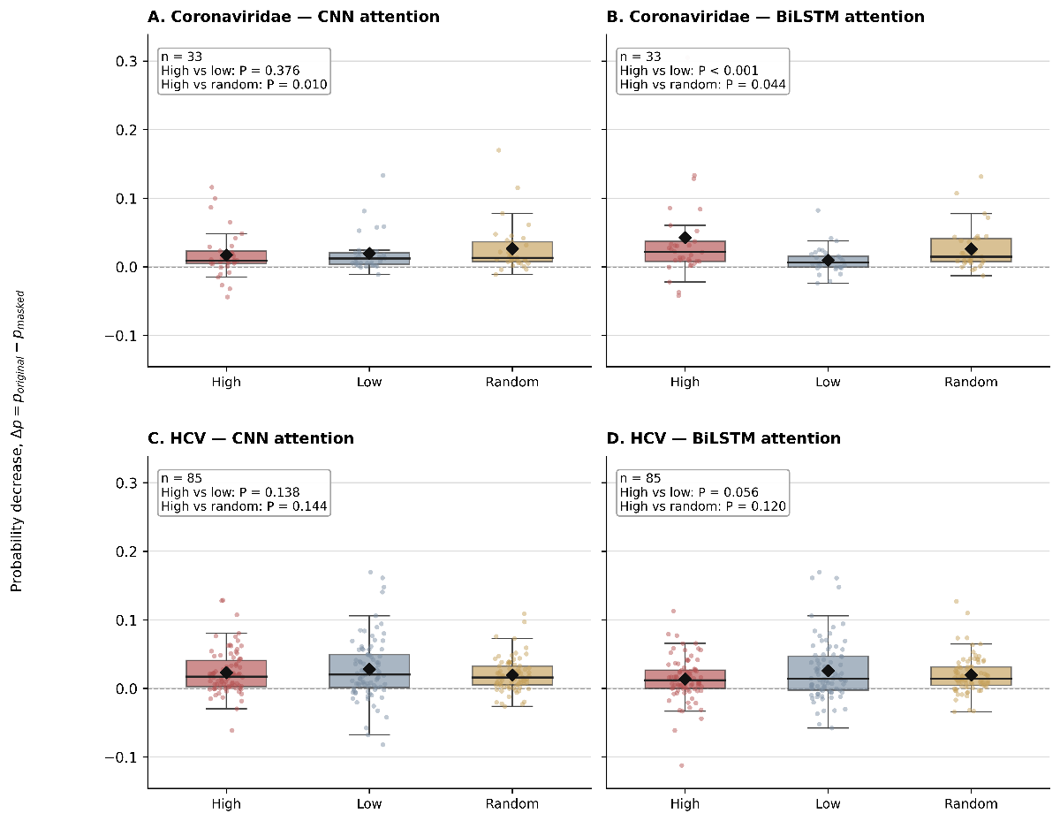
Supplementary Figure S2. Perturbation-based sensitivity analysis of attention-ranked residues in the Coronaviridae and HCV tasks.

