Pan-African genomics of Pseudomonas aeruginosa highlights regional population structure and AMR stratification
Abubakari Abdulwasid*¹, Charity Ahiabor¹, George Osei-Adjei² & Hizbullah Khan*^{3, 4}
Affiliations:
¹Department of Science Laboratory Technology, Accra Technical University, Accra, Ghana
²Department of Medical Laboratory Technology, Accra Technical University, Accra, Ghana.
³Guangdong Provincial Key Laboratory of Medical Immunology and Molecular Diagnostics, The First Dongguan Affiliated Hospital, School of Medical Technology, Guangdong Medical University, Dongguan, People’s Republic of China.
⁴Dongguan Key Laboratory of Molecular Immunology and Cell Therapy, Guangdong Medical University, Dongguan, People’s Republic of China.
Corresponding author*: Abubakari Abdulwasid (aabdulwasid@atu.edu.gh) & Hizbullah Khan (hizbullahkhan@gdmu.edu.cn)

Supplementary Note 1: Detailed Bioinformatics Workflow
All analyses were performed on a standardized Linux environment (WSL2, Ubuntu 24.04) using the Miniforge3 distribution of Conda. To ensure full reproducibility, the primary commands and parameters are detailed below:
- Data Retrieval: 473 assemblies were retrieved using ncbi-datasets-cli (v16.0) via the dehydrated/rehydrate protocol to ensure data integrity over unstable connections.
- Genome Quality Control (Completeness & Contamination): Assembly quality was evaluated with CheckM2 v1.0.1 using the default DIAMOND reference database (release 2023-12); genomes with completeness < 95% or contamination > 5% were excluded. Six assemblies failed these thresholds and were removed prior to downstream analysis. Completeness was additionally cross-validated with BUSCO v5.5.0 against the pseudomonadales_odb10 lineage dataset; 100% of retained isolates achieved > 95% completeness.
- MLST Typing: mlst v2.23.0 was run against the PubMLST P. aeruginosa scheme.
- AMR Gene Detection: AMRFinderPlus v3.12.8 with database release 2024-05-02, using species-specific curation (--organism Pseudomonas_aeruginosa).
- Plasmid Replicon Detection: PlasmidFinder v2.1 (database release 2024-05) with default identity ≥ 90% and coverage ≥ 60% thresholds. Note: given short-read assemblies, the chromosomal vs plasmid location of resistance genes cannot be resolved definitively; this caveat is discussed in the main text Limitations.
- Virulence Gene Detection: abricate v1.0.1 against the VFDB 2024 release with identity ≥ 75% and coverage ≥ 50%.
- Pan-genome Analysis: Panaroo v1.5.0 in strict mode with --clean-mode strict --remove-invalid-genes; core-gene threshold 99%.
- Phylogenetic Reconstruction: Core-gene alignment produced with MAFFT v7.520; maximum-likelihood tree inferred with IQ-TREE v2.3.
- Pan-GWAS: Scoary v1.6.16 with Fisher's exact test and Benjamini–Hochberg FDR correction; confirmatory analysis restricted to countries with n ≥ 15 assemblies (eight high-confidence hubs).
- Data & Code Availability: All analysis scripts, and configuration files are archived at: https://github.com/AbubakariAbdulwasid/pan-african-pseudomonas-aeruginosa-genomics.
- Raw NCBI accession IDs are provided in Supplementary Table S1 (Metadata).

Supplementary Figure Legends
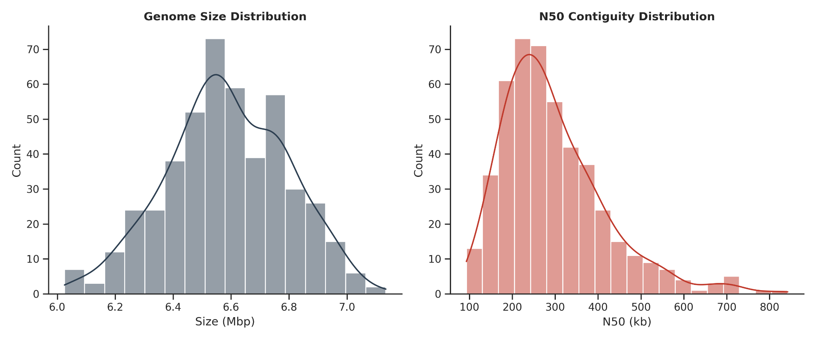
Supplementary Figure S1 | Dataset Assembly Quality Statistics. Histograms displaying the distribution of total assembly lengths (Mbp) and N50 contiguity scores (kb) for the 467 P. aeruginosa isolates. Metrics were generated via QUAST v5.2.
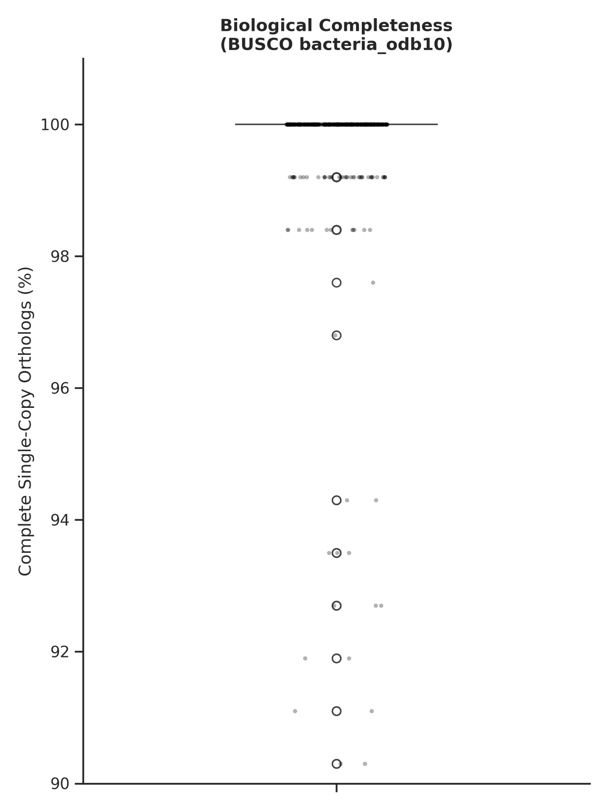
Supplementary Figure S2 | Biological Completeness Assessment. Boxplot showing the percentage of universal single-copy bacterial orthologs identified per genome using BUSCO v5.5.0. 100% of final isolates achieved >95% completeness.

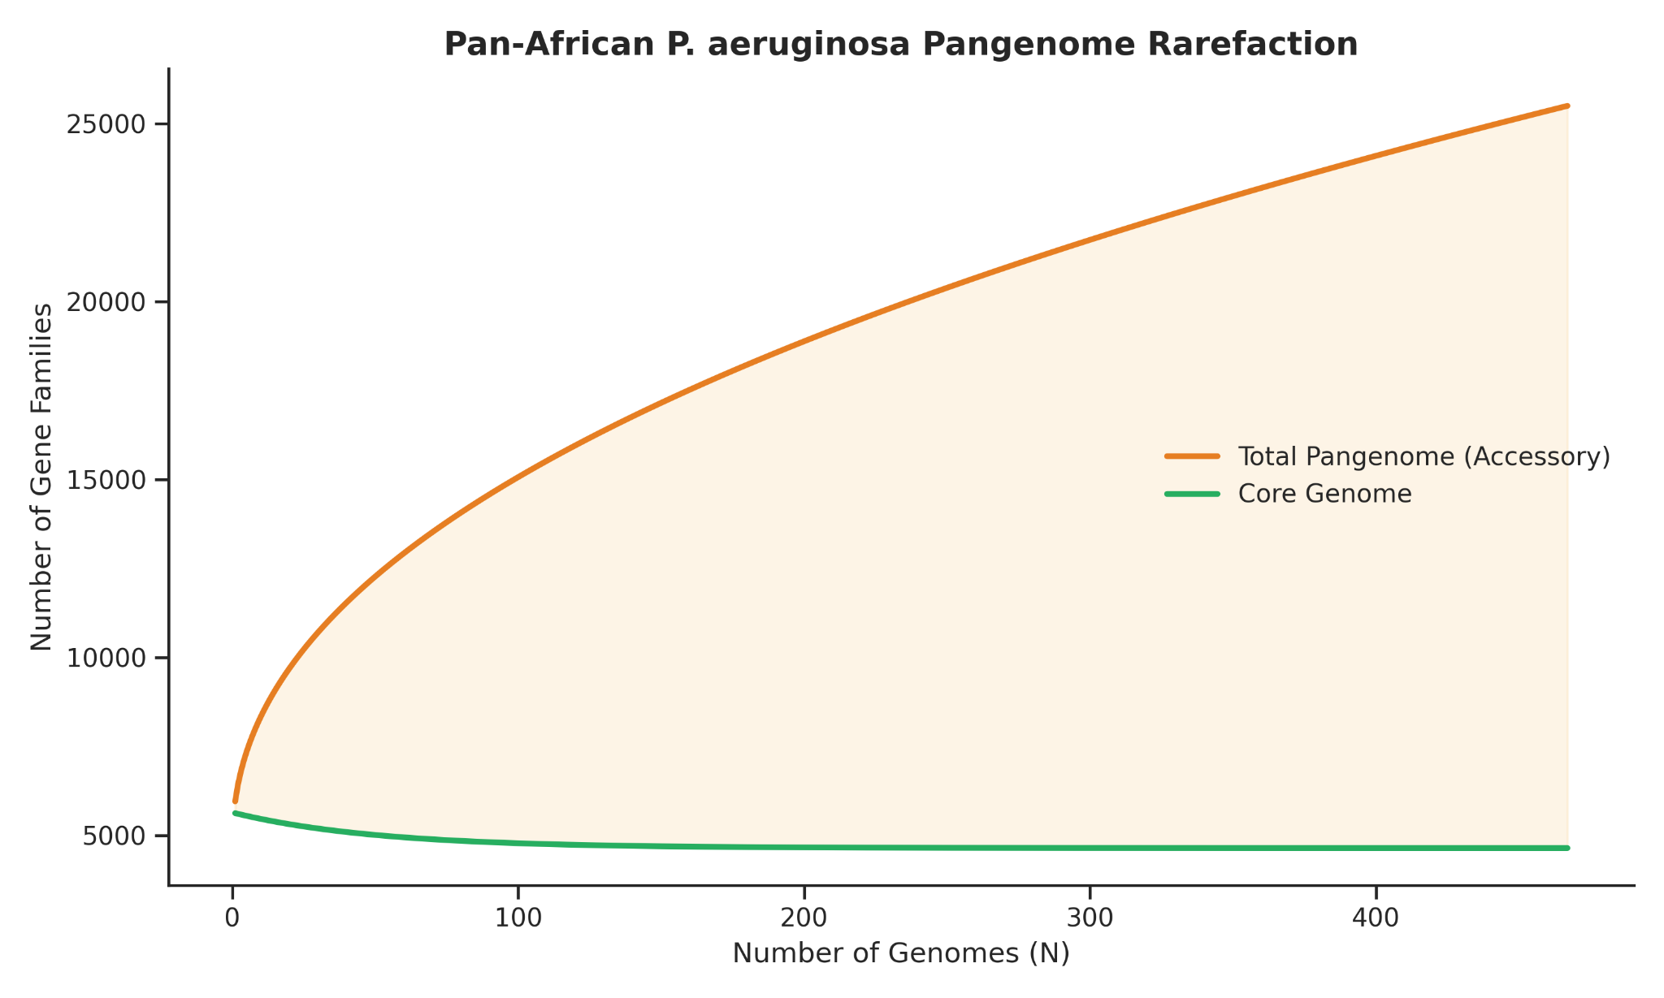
Supplementary Figure S3 | Pangenome Rarefaction and Accumulation. Rarefaction curves showing the expansion of the total pangenome (orange) and the stabilization of the core genome (green) as isolates are added. The curve follows Heap’s Law, confirming an "Open" pangenome architecture.

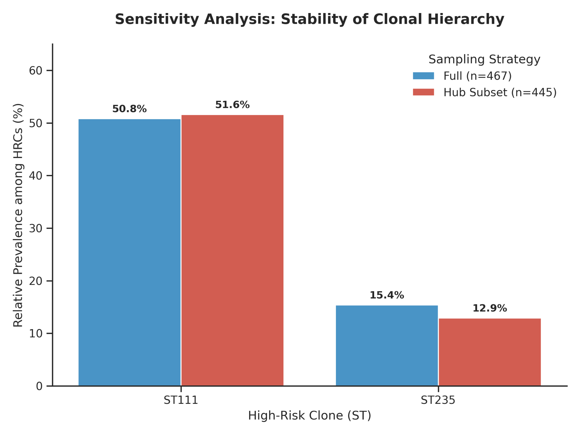
Supplementary Figure S4 | Geographic distribution of high-risk clones across major surveillance hubs. Grouped bar chart displaying the frequency of ST111 and ST235 across the eight African countries with ≥15 genomic assemblies. The consistent identification of ST111 as the primary multidrug-resistant lineage across multiple West, East, and North African nations supports the robustness of the continental clonal hierarchy described in the main text.

Supplementary Table Descriptions
- Table S1: Master isolate metadata (Accession, Country, Year, Quality, Project).
- Supplementary Table S1b
- Table S2: Full MLST profiles and allelic definitions for 467 isolates.
- Table S3: Complete AMR gene matrix (NCBI database).
- Table S4: Virulence factor inventory (VFDB).
- Table S5: Top 100 statistically significant Pan-GWAS hits per country.
- Table S6: Pangenome gene family catalogue (25,501 clusters).

