Supplementary Table S1: Samples collected, categorized according to location, animal species, and sample category, and their frequency (adapted from Seakamela et al., 2022).
Samples | Location/  Municipalities | Animal species | Sample category | No of samples
1 | Bronkhospruit | Beef | Raw intact meat | 16
2 | Bronkhospruit | Beef | Raw processed meat | 9
3 | Bronkhospruit | Beef | Ready to eat | 4
4 | Bronkhospruit | Pork | Raw intact meat | 3
5 | Bronkhospruit | Pork | Raw processed meat | 6
6 | Bronkhospruit | Pork | Ready to eat | 11
7 | Emalahleni | Beef | Raw intact meat | 33
8 | Emalahleni | Beef | Raw processed meat | 6
9 | Emalahleni | Pork | Raw intact meat | 2
10 | Emalahleni | Pork | Raw processed meat | 19
11 | Emalahleni | Pork | Ready to eat | 7
12 | Pretoria | Beef | Raw intact meat | 125
13 | Pretoria | Beef | Raw processed meat | 34
14 | Pretoria | Beef | Ready to eat | 15
15 | Pretoria | Pork | Raw intact meat | 47
16 | Pretoria | Pork | Raw processed meat | 50
17 | Pretoria | Pork | Ready to eat | 44
18 | Rustenburg | Beef | Raw intact meat | 38
19 | Rustenburg | Beef | Raw processed meat | 25
20 | Rustenburg | Beef | Ready to eat | 27
21 | Rustenburg | Pork | Raw intact meat | 28
22 | Rustenburg | Pork | Raw processed meat | 18
23 | Rustenburg | Pork | Ready to eat | 14
Total |  |  |  | 581

Supplementary Table S2: Prediction of biotypes of Yersinia enterocolitica based on virulence determinants
ST | No of Isolates | Genes
ST | No of Isolates | Ail | Inv | myfA | hreP | YadA | virF | YstA | ystB | Yop
661 | 5 | 0 | 1 | 0 | 1 | 0 | 0 | 0 | 1 | 0
688 | 2 | 0 | 1 | 1 | 1 | 0 | 0 | 0 | 1 | 0
684 | 2 | 0 | 1 | 1 | 1 | 0 | 0 | 0 | 1 | 0
178 | 2 | 0 | 1 | 0 | 1 | 0 | 0 | 0 | 1 | 0
4 | 1 | 0 | 1 | 0 | 1 | 0 | 0 | 0 | 1 | 0
173 | 1 | 0 | 1 | 0 | 1 | 0 | 0 | 0 | 1 | 0
166 | 1 | 0 | 1 | 0 | 1 | 0 | 0 | 0 | 1 | 0
3 | 1 | 0 | 1 | 0 | 1 | 0 | 0 | 0 | 1 | 0
352 | 1 | 0 | 1 | 0 | 1 | 0 | 0 | 0 | 1 | 0
278 | 1 | 0 | 1 | 0 | 1 | 0 | 0 | 0 | 1 | 0
329 | 1 | 0 | 1 | 0 | 1 | 0 | 0 | 0 | 1 | 0

Supplementary Table S3: Intact Prophage Characteristics in Yersinia enterocolitica.
Sample name | Size | Completeness | No of proteins | Common phage | GC
Y3 | 14.5Kb | Intact | 21 | PHAGE_Salmon_118970_sal3_NC_031940(6) | 47.02%
Y4 | 39.7Kb  14.1Kb  31.6Kb  59.7Kb | Intact  Intact  Intact  Intact | 45  21  38  63 | PHAGE_Entero_186_NC_001317(15)  PHAGE_Salmon_118970_sal3_NC_031940(6)  PHAGE_Salmon_118970_sal3_NC_031940(20)  PHAGE_Escher_ArgO145_NC_049918(12) | 48.09%  47.22%  47.54%  45.78%
Y5 | 14.5Kb | Intact | 21 | PHAGE_Salmon_118970_sal3_NC_031940(6) | 47.02%
Y15 | 14.5Kb | Intact | 21 | PHAGE_Salmon_118970_sal3_NC_031940(6) | 47.02%
Y17 | 31.3Kb  14.5Kb | Intact  Intact | 37  21 | PHAGE_Cronob_ESSI_2_NC_047854(25)  PHAGE_Salmon_118970_sal3_NC_031940(6) | 49.19%  47.03%
Y18 | 30.5Kb  33.3Kb  42.9Kb  60.8Kb  26.5Kb | Intact  Intact  Intact  Intact  Intact | 38  40  64  63  39 | PHAGE_Cronob_ESSI_2_NC_047854(25)  PHAGE_Salmon_SEN5_NC_028701(16)  PHAGE_Salmon_118970_sal3_NC_031940(12)  PHAGE_Pectob_ZF40_NC_019522(18)  PHAGE_Vibrio_VBM1_NC_020850(15) | 49.00%  49.96%  45.79%  46.16%  48.50%
Y19 | 52.3Kb  15.8Kb | Intact  Intact | 54  24 | PHAGE_Entero_186_NC_001317(16)  PHAGE_Salmon_118970_sal3_NC_031940(6) | 48.00%  46.71%
Y20 | 45.6Kb  16.6Kb | Intact  Intact | 62  24 | PHAGE_Salmon_118970_sal3_NC_031940(11)  PHAGE_Salmon_118970_sal3_NC_031940(6) | 48.39%  46.38%
Y21 | 14.1Kb  34.5Kb  30.2Kb  73.4Kb  45.7Kb  54.5Kb | Intact  Intact  Intact  Intact  Intact  Intact | 21  50  16  87  81  70 | PHAGE_Salmon_118970_sal3_NC_031940(6)  PHAGE_Mannhe_vB_MhM_3927AP2_NC_028766(17)  PHAGE_Erwini_vB_EhrS_49_NC_048197(7)  PHAGE_Pectob_ZF40_NC_019522(18)  PHAGE_Edward_GF_2_NC_026611(21)  PHAGE_Vibrio_VBM1_NC_020850(15) | 47.23%  50.04%  44.07%  47.61%  46.22%  47.30%
Y34 | 46.9Kb  14.5Kb  38Kb | Intact  Intact  Intact | 47  20  55 | PHAGE_Escher_500465_1_NC_049342(11)  PHAGE_Salmon_118970_sal3_NC_031940(6)  PHAGE_Mannhe_vB_MhM_3927AP2_NC_028766(16) | 46.56%  47.01%  49.29%
Y35 | 46.9Kb  46.5Kb  14.5Kb | Intact  Intact  Intact | 47  55  21 | PHAGE_Escher_500465_1_NC_049342(11)  PHAGE_Mannhe_vB_MhM_3927AP2_NC_028766(16)  PHAGE_Salmon_118970_sal3_NC_031940(6) | 46.56%  49.29%  47.01%
Y44 | 15.8Kb  47.9Kb  40.5Kb  32.6Kb  35.6Kb  49.9Kb  17.8Kb | Intact  Intact  Intact  Intact  Intact  Intact  Intact | 24  59  53  40  43  61  43 | PHAGE_Salmon_118970_sal3_NC_031940(6)  PHAGE_Pectob_ZF40_NC_019522(32)  PHAGE_Klebsi_4LV2017_NC_047818(11)  PHAGE_Salmon_SI7_NC_049460(24)  PHAGE_Salmon_118970_sal3_NC_031940(14)  PHAGE_Salmon_SEN34_NC_028699(22)  PHAGE_Salmon_118970_sal3_NC_031940(6) | 46.86%  45.25%  47.37%  49.83%  47.91%  48.11%  50.26%
Y47 | 14.5Kb  48.3Kb  54Kb  37Kb | Intact  Intact  Intact  Intact | 21  58  75  61 | PHAGE_Salmon_118970_sal3_NC_031940(6)  PHAGE_Cronob_ENT47670_NC_019927(10)  PHAGE_Salmon_SEN34_NC_028699(22)  PHAGE_Vibrio_VBM1_NC_020850(15) | 46.79%  46.14%  46.35%  47.19%
Y53 | 14.5Kb | Intact | 21 | PHAGE_Salmon_118970_sal3_NC_031940(6) | 47.02%
Y60 | 14.5Kb | Intact | 21 | PHAGE_Salmon_118970_sal3_NC_031940(6) | 47.02%
T19 | 14.5Kb  38.1kb  38.7Kb  45.4Kb  30.2Kb  40.2Kb | Intact  Intact  Intact  Intact  Intact  Intact | 21  47  54  37  16  42 | PHAGE_Salmon_118970_sal3_NC_031940(6)  PHAGE_Salmon_SI7_NC_049460(21)  PHAGE_Haemop_SuMu_NC_019455(17)  PHAGE_Stenot_IME15_NC_019416(4)  PHAGE_Erwini_vB_EhrS_49_NC_048197(7)  PHAGE_Pectob_ZF40_NC_019522(18) | 46.98%  48.95%  49.63%  38.19%  44.10%  46.46%
T8 | 38.7Kb  30.2Kb  40.2Kb  45.4Kb | Intact  Intact  Intact  Intact | 55  17  44  36 | PHAGE_Haemop_SuMu_NC_019455(17)  PHAGE_Erwini_vB_EhrS_49_NC_048197(7)  PHAGE_Pectob_ZF40_NC_019522(17)  PHAGE_Stenot_IME15_NC_019416(4) | 49.63%  44.10%  46.46%  38.19%
T217 | 14.5Kb  31.3Kb | Intact  Intact | 21  37 | PHAGE_Salmon_118970_sal3_NC_031940(6)  PHAGE_Cronob_ESSI_2_NC_047854(25) | 47.03%  49.19%

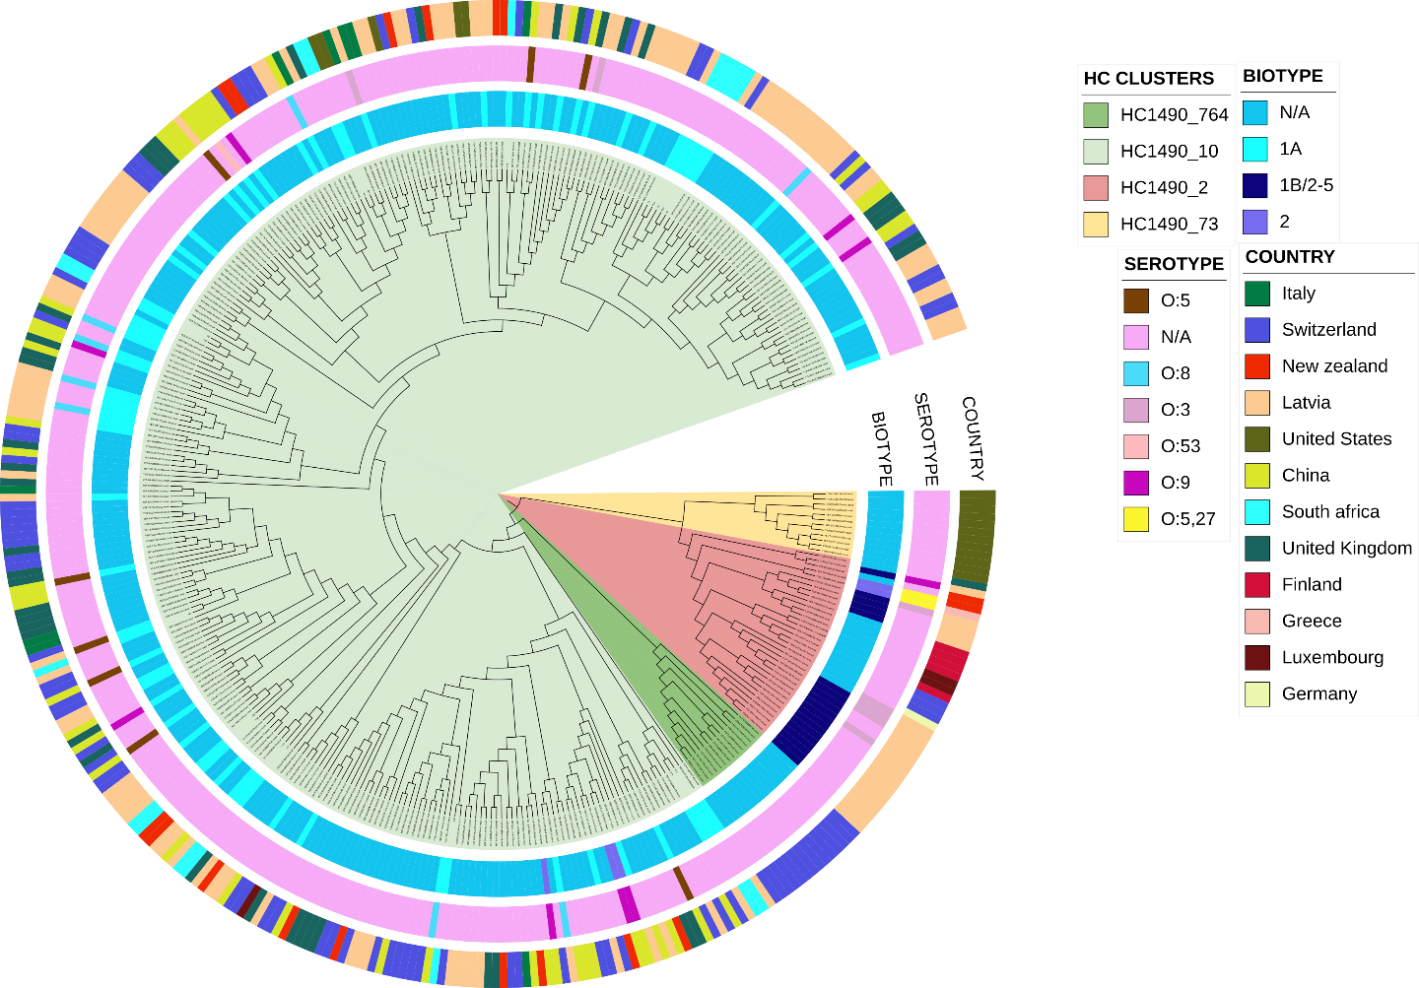

Figure S1: The maximum-likelihood phylogenetic structure of 374 Y. enterocolitica isolates across 12 countries based on the metadata derived from Enterobase. The branch colors denote the four major HC1490 clusters identified through cgMLST hierarchical clustering, with the first outer ring representing isolate biotypes, the second ring indicating serogroups, and the outermost ring showing the country of origin for each isolate. Color schemes for all attributes correspond to the legends displayed on the right.

