Comparative mitochondrial genomics of the medicinal mushroom Phellinus tuberculosus reveals conserved core genes and dynamic genome evolution within Hymenochaetaceae

Can Jin¹, Mu-Xi Yuan¹, Jin-Xin Ma¹, Ying-Yi Ji¹, Lu-Xin Tang¹, Xin Li¹, Mu-Yu Chen¹, Jing Si^{1*}, Bao-Kai Cui^{1*}

*Correspondence.
Jing Si
jingsi1788@126.com
Bao-Kai Cui
cuibaokai@bjfu.edu.cn
¹State Key Laboratory of Efficient Production of Forest Resources, School of Ecology and Nature Conservation, Beijing Forestry University, Beijing 100083, China
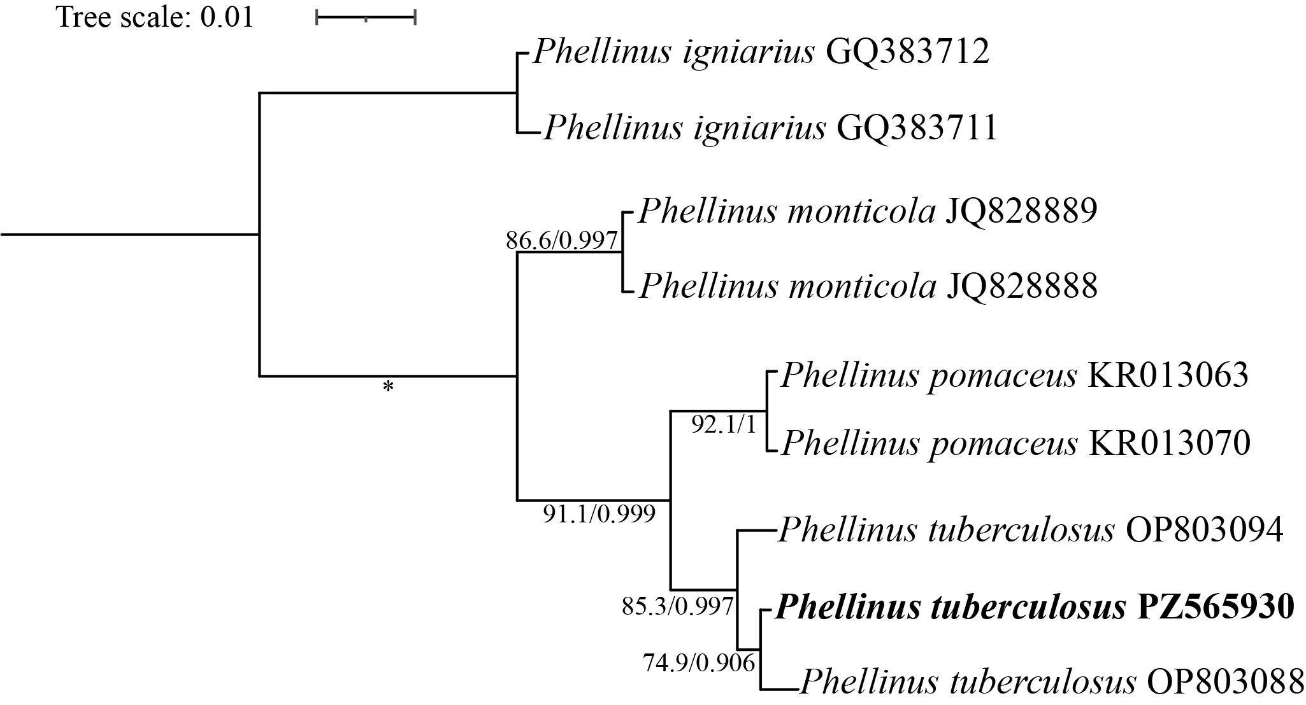
Fig. S1 Phylogenetic relationships of three Phellinus species inferred from the nuclear ribosomal internal transcribed spacer sequences using maximum likelihood (ML) and Bayesian inference (BI). Phellinus igniarius was designated as the outgroup to root the tree. Branch support values are presented as ML bootstrap percentages (%)/BI posterior probabilities. Asterisks indicate nodes with full support (100% ML bootstrap and 1.00 BI posterior probability).

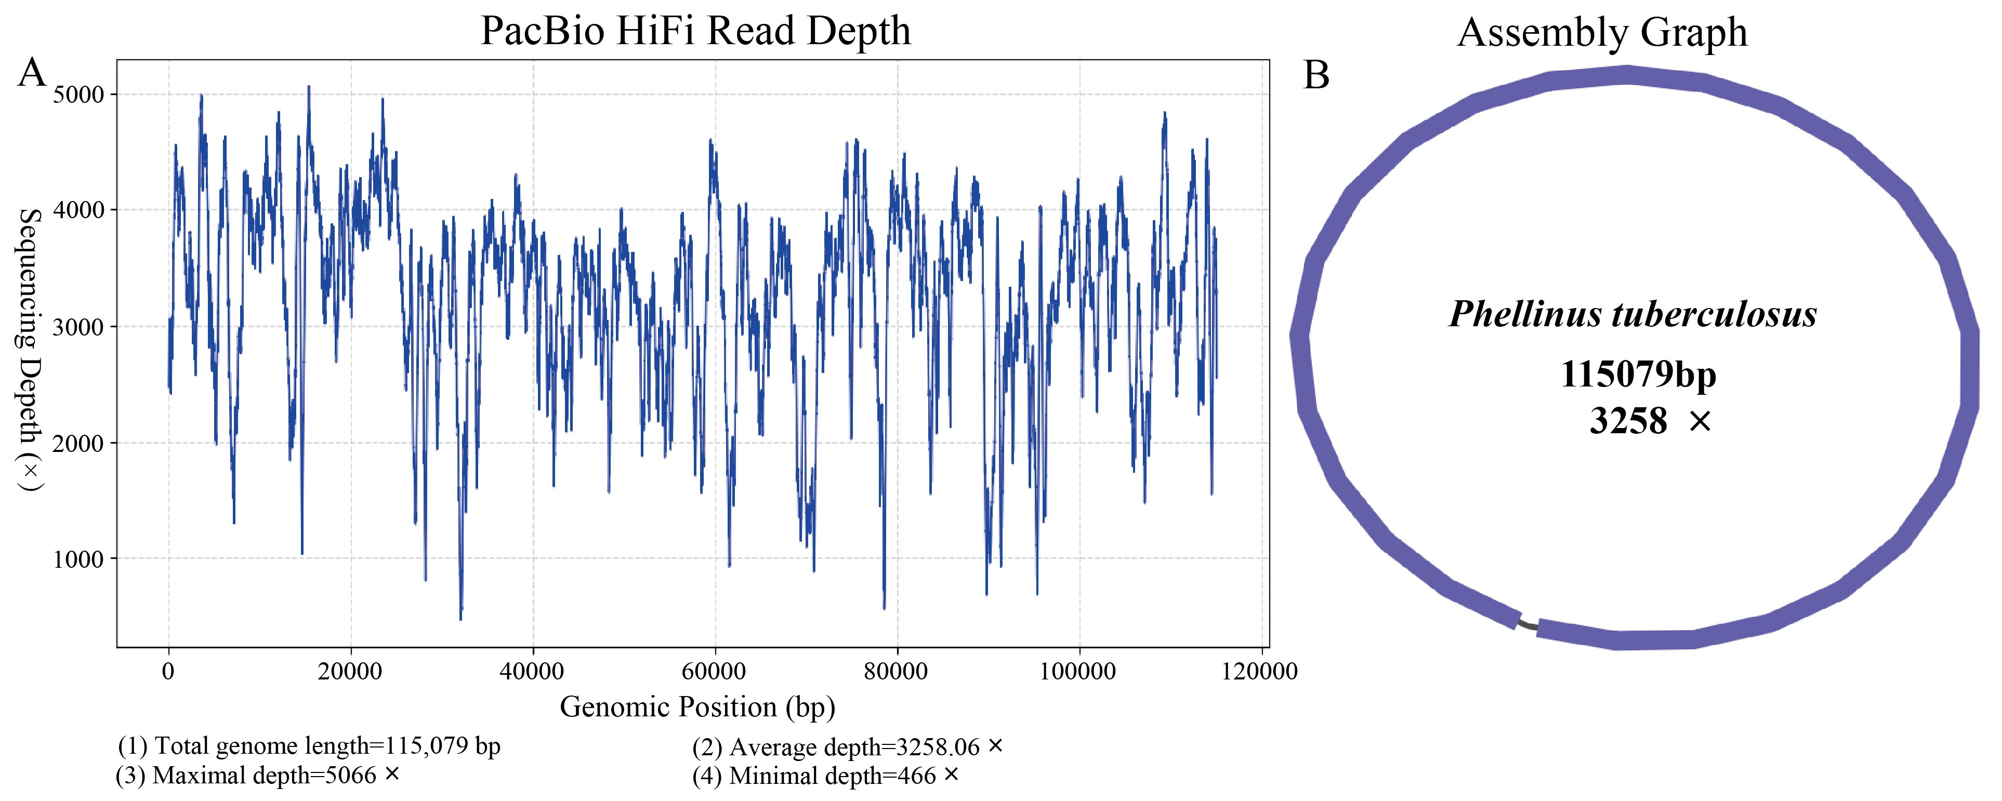
Fig. S2 PacBio HiFi read-depth profile and assembly graph of the complete mitochondrial genome of Phellinus tuberculosus. (A) Read depth across the final mitochondrial genome based on mapping PacBio HiFi reads to the assembled mitochondrial genome. (B) Assembly graph of the mitochondrial genome generated during genome assembly, showing the circular structure.

Fig. S3 Circular maps of the mitochondrial genomes of the three Phellinus species analyzed. Genes are represented by different colored blocks. Colored blocks outside each ring indicate that the genes are on the direct strand and are transcribed in a counterclockwise direction. The inner grayscale bar graph shows the GC content of the mitochondrial sequences. The circle inside the GC content graph marks the 50% threshold.

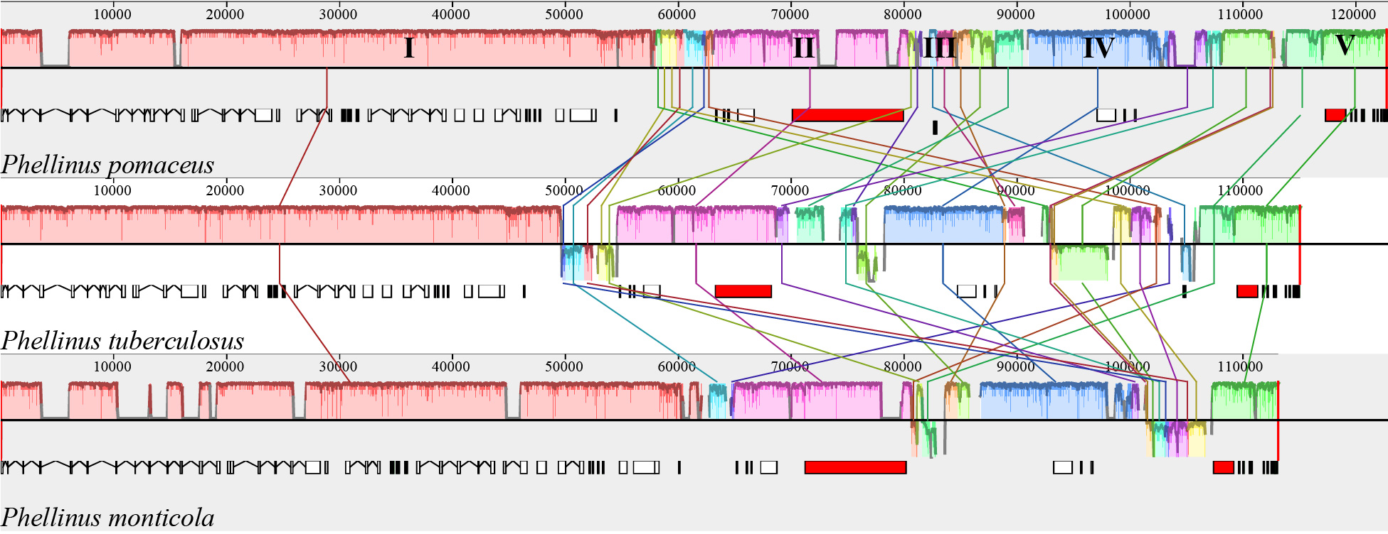
Fig. S4 All syntenic blocks identified by Mauve, showing the correspondence between alignment blocks and genes.

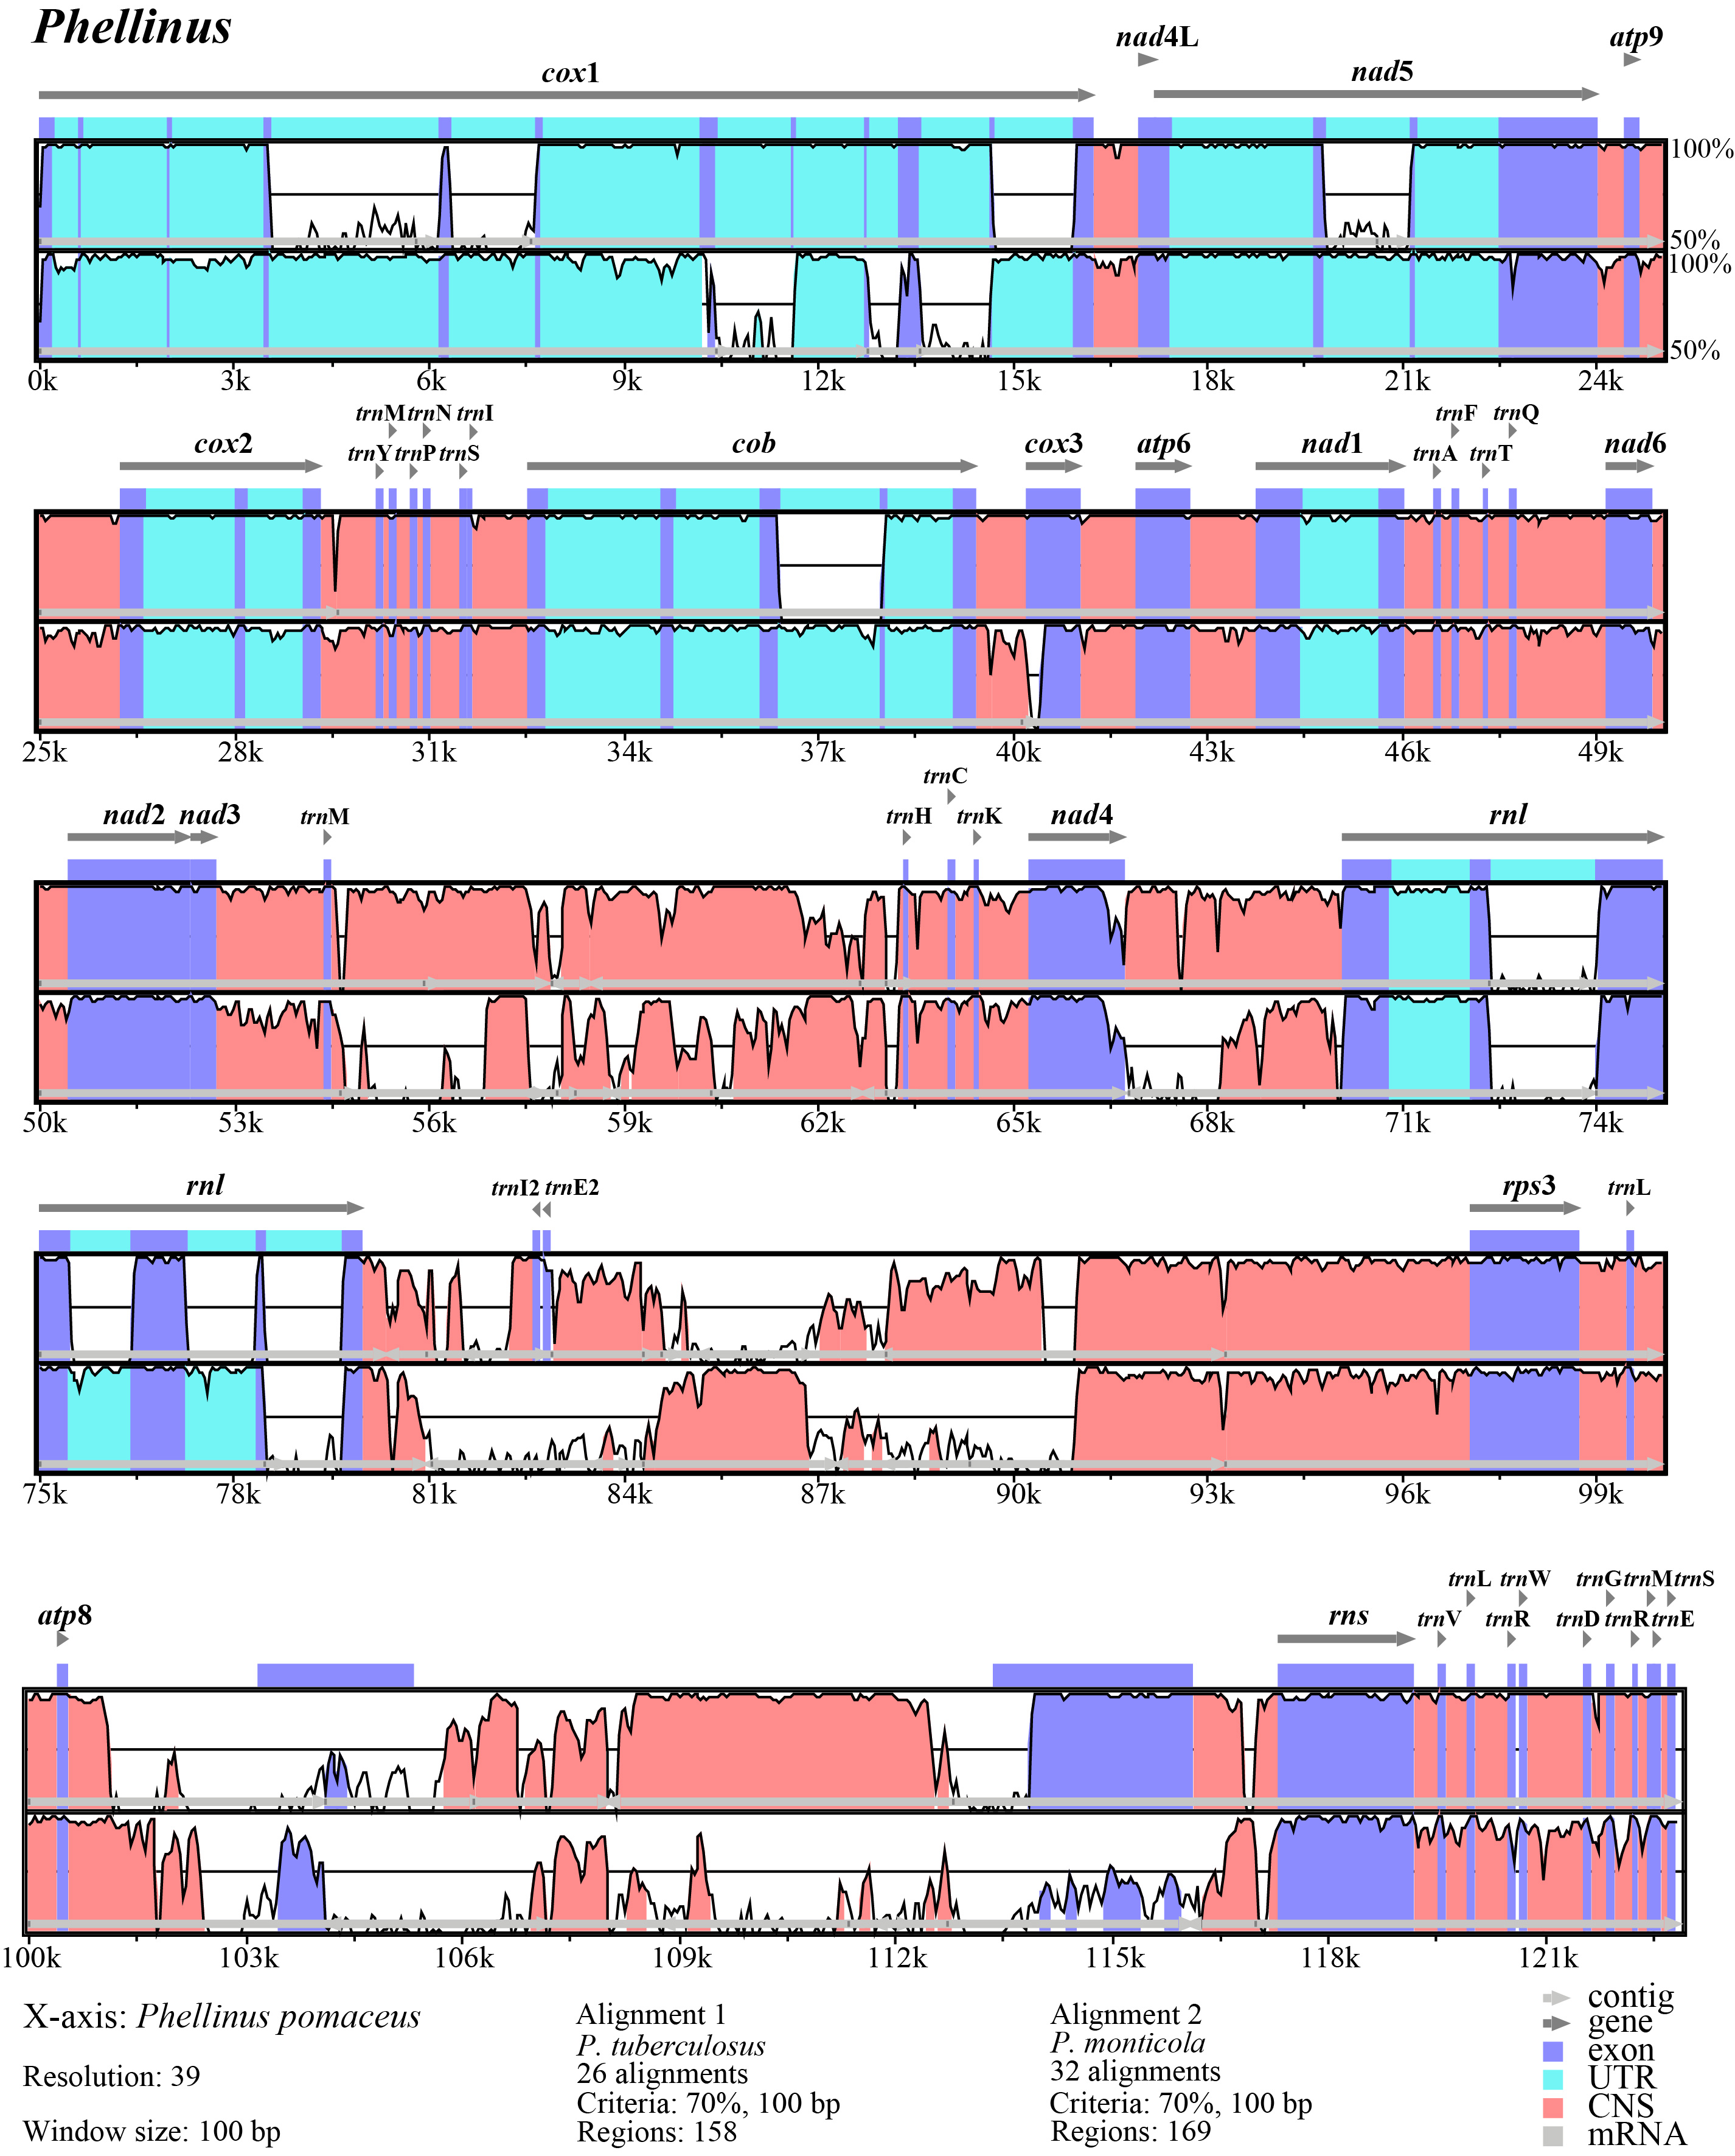
Fig. S5 Comparative visualization of similarity alignments in the mitochondrial genomes of the three Phellinus species analyzed.
Fig. S6 Inferred secondary structures of 27 tRNAs from the Phellinus tuberculosus mitochondrial genome. The tRNAs are labeled with the abbreviations of their corresponding amino acids.

