RNA sequencing of antennae and comparative analysis of key gene families in Apis mellifera workers exhibiting drastic differences in propolis yield

Guochang Wang ^{1,2}, Ziyue Zhang ^{1,2}, Dongbiao Lü ^{1,2,*}, Xing Ge ^{1,2}, Li Wang ^{1,2}, Saili Sun ^{1,2}, Chenlong Guo ^{1,2}, Jiayi Tian ^{1,2}, Pei Zhang ^{1,2}, Meng Yang ^{1,2}, Kaishu Du ^{1,2}, Dongfang Li ^{1,2}, Zhongyin Zhang ^{1,2}, Hao Yu ^{1,2}, Yunchao Kan ^{1,2,*}

1. School of Plant Protection and Environment, School of Bee Science, Henan Institute of Science and Technology, 655 Hualan Avenue, Xinxiang 453003, China;
2. Henan Key Laboratory of Insect Biology, Henan Institute of Science and Technology, 655 Hualan Avenue, Xinxiang 453003, China.
* Correspondence: Dongbiao Lü and Yunchao Kan; School of Plant Protection and Environment, School of Bee Science, Henan Key Laboratory of Insect Biology, Henan Institute of Science and Technology, 655 Hualan Avenue, Xinxiang 453003, China.
E-mail: dongbiao_0613@163.com; kanyunchao@163.com.
Abstract
Background Propolis is a composite substance that Apis mellifera worker bees produce from plant resins they collect and blend with their own secretions. The antennae detect signals from nectar, pollen, and propolis sources during the foraging process, thereby regulating foraging behavior. However, the relationship between resin collection behavior and olfaction in worker bees from different colonies remains unclear. We compared the antennal morphology and RNA-seq profiles of foragers from high propolis-producing and ordinary colonies of A. mellifera worker bees, comprehensively characterized three gene families (OBPs, CSPs, and ORs), and validated expression patterns by qRT-PCR.
Results We found that the total length of both the left and right antennae, as well as the lengths of flagellomeres FL7 and FL10, were significantly shorter in high-yield colonies than in ordinary colonies. We analyzed the FPKM heatmaps, chromosomal locations, and conserved domains of six CSPs, 19 OBPs, and 34 ORs, and performed phylogenetic analyses with Apis cerana, Chouioia cunea, Nasonia vitripennis, and Bombus. qRT-PCR expression levels of these 58 genes were consistent with the RNA-seq expression patterns. We report for the first time the differences in antennal morphology and RNA-seq results between colonies with differential propolis yield, as well as differences in gene expression of these three gene families between the two colony types.
Conclusions Results not only provide a molecular basis for further research into how worker bee antennae function in honeybee colonies, but also offer new perspectives on the molecular mechanisms underlying the interaction between worker bee behavioral differentiation and the olfactory system.
Keywords Apis mellifera workers, Propolis, Antennal morphology, Antennal transcriptome, Gene family analysis.
1. Introduction
The western honey bee, Apis mellifera (Hymenoptera: Apidae), is an important eusocial insect that play a vital role in crop production, food security, and ecosystems [1]. Within the complex social organization of honey bees, worker bees undertake the majority of laborious tasks, including in-hive brood rearing, honey production, comb construction, and out-of-hive foraging [2]. The division of labor in worker bees is age-dependent: individuals aged 18-25 days become foragers responsible for locating sources of nectar, pollen, propolis, and water outside the hive, as well as performing all other external tasks [3]. The execution of these complex external tasks is highly dependent on their sensitive and efficient sensory systems, particularly olfaction and touch. The antennae, as the primary sensory organs, undertake physiological functions such as recognition and perception, and play a critical role in regulating social interactions in complex eusocial insect colonies [4]. However, the molecular mechanisms by which olfaction influences worker bee behavior remain unclear.
The western honey bee exhibits sophisticated olfactory behaviors, making it an ideal model for investigating olfactory neurophysiology as well as olfaction and associative learning [5]. Paoli and Galizia discussed that honeybees communicate via olfactory cues and maintain colony homeostasis, and illustrated the neuroanatomy and physiological mechanisms of olfactory circuits [5]. In the study of honey bee antennae, three classes of proteins are considered the most fundamental and critical components of the olfactory signaling pathway and have attracted considerable attention (Odorant-binding Proteins, OBPs; Chemosensory Proteins, CSPs; Odorant Receptors, ORs) [6]. OBPs are the most abundant and the first identified class of olfactory-related proteins. Honey bee OBPs not only exhibit varying degrees of binding selectivity for pheromones and plant volatiles but also interact with various exogenous compounds, potentially interfering with normal worker bee behavior, making them an important entry point for behavioral research [7]. Honeybee OBPs can specifically bind to insecticide-based agrochemicals, which may compromise the honeybee olfactory system, thereby impairing the recognition and localization of environmental odorant molecules [8]. Mayack et al. found that AmelOBP14 exhibits high binding affinity to toxic chemicals such as xanthone, 2-phenylphenol, and chloridazon, thereby interfering with olfactory recognition in honeybees [9]. Li et al. investigated the binding of imidacloprid to AcerASP2 and demonstrated that this interaction weakens intramolecular forces such as α-helices and hydrogen bonds within the protein [10]. They further confirmed that neonicotinoid insecticides significantly reduce the binding affinity of AcerASP2 to β-ionone, indicating that neonicotinoid insecticides exert a substantial negative impact on honeybee olfactory cognitive behavior. Qiu et al. found that AcerOBP17 binds to imidacloprid, which delays the binding of the insecticide to its target acetylcholine receptor, thereby indirectly producing a detoxification or defensive effect [11]. A small number of honey bee OBPs have been confirmed to be antenna-specifically expressed, whereas the majority are widely distributed in various non-olfactory tissues, suggesting that their functions may extend far beyond odorant transport and involve broader physiological processes [12]. CSPs and ORs have also received widespread attention, with numerous studies dedicated to them [7]. Nie et al. performed comparative transcriptome sequencing analysis on the antennae of worker bees of different tasks in A. mellifera [12]. Liu et al. revealed the molecular mechanisms underlying the division of labor among worker bees based on analyses of antennal transcriptome data from A. mellifera [6]. Guo et al. systematically analyzed the antennal transcriptomes and gustatory receptor genes of Apis cerana foraging on pollen from different nectar plant species [13].
Propolis is collected by worker bees of Apis mellifera from plant buds and bark crevices, and manufactured by mixing plant resins with beeswax and other hive-derived substances [14]. It possesses a broad spectrum of biological activities, including antibacterial [15], antiviral [16], anti-inflammatory [17], antioxidant [18], immunomodulatory [19], and antitumor [20] effects. Due to its scarce yield and high value, propolis is often referred to as “purple gold” [21]. An ordinary A. mellifera colony (YG, normal propolis yields) of 50,000-60,000 bees produces approximately 70-100 g of propolis per year, with a flavonoid content of 11%-14% [16]. In contrast, the high-yielding propolis A. mellifera colonies (FG) from our university's honey bee research team produce 1,000-2,500 g of propolis per year, which is 10-25 times higher than that of ordinary A. mellifera worker bee colonies, and the flavonoid content exceeds 20%, representing superior quality propolis (This high-yield honeybee strain was independently bred by our team, and its queen bees have already been promoted for production application. If other researchers wish to obtain this bee strain, they may contact the corresponding author). Worker bees from different colonies exhibit marked ecological adaptation traits, with significant differences in foraging preferences, cold tolerance, and defensive behavior. Such behavioral differentiation may be closely associated with structural differences in their peripheral sensory systems [2]. Foraging for and collecting resin are tasks performed exclusively by forager bees. Given the same geographical environment, why do such large differences exist among different colonies? The molecular mechanism by which olfaction influences the behavior of forager bees during resin location and collection remains unclear.
In this study, we compared the morphological characteristics of forager bee antennae from different A. mellifera colonies. Subsequently, based on the Illumina sequencing platform, we performed RNA‑Seq using next‑generation sequencing technology, followed by reference genome alignment and comprehensive analysis of three antennal gene families (OBPs, CSPs, and ORs). Finally, we validated the expression patterns of these family genes using qRT‑PCR. Our results provide a molecular basis for an in‑depth understanding of the antennae function of worker bees from different colonies, and offer a new perspective on the molecular mechanisms underlying the interaction between worker bee behavioral differentiation and the olfactory system.
2. Materials and methods
2.1 Insect rearing and tissue collection
All worker bees used in this experiment were 25-day-old A. mellifera (Place the pupated ‌honeycomb separately, wait for the pupae to mature, and emerge as newly hatched larvae. Apply paint for labeling, and 25 days later, 25-day-old worker bees were collected for subsequent experiments), including those from a high-propolis-yielding colony (FG) and an ordinary colony (YG, normal propolis yields). Each of the two honeybee groups consisted of 300 complete colonies with identical traits and stable heritability. The high-propolis-yielding colony was collected from the Honey Bee Research Institute of Henan Institute of Science and Technology (Longitude: 113.93°, Latitude: 35.28°). The ordinary colony was collected from a beekeeping cooperative in Changyuan City (Longitude: 114.65°, Latitude: 35.31°), and the bees were reared for 10 generations of queens (10 rounds of colony selection and queen replacement) at the Institute of Apiculture, Henan Institute of Science and Technology, and experiments were carried out after the population remained stable. All colonies were maintained by professional technicians. To ensure consistent colony size, each hive contained approximately 3,000-3,500 worker bees, one queen, and a small number of larvae [13]. This study focused on the antennae morphology and RNA-seq transcriptome profiling of 25-day-old forager bees (CJF) from two different A. mellifera colonies (FG and YG). For morphological measurements, antennae were sequentially immersed in 95% and 75% ethanol. For each group, 100 pairs of antennae were randomly selected and measured, the mean values were calculated, and three biological replicates were performed. For sequencing and molecular experiments, 500 pairs of antennae were pooled as one sample with three biological replicates. The antennae were sterilized and cleaned with sodium hypochlorite, ethanol, sterile water, and PBS buffer (all procedures were performed on ice), then immediately frozen in liquid nitrogen and stored at -80°C [22]. Samples were collected from 100 hives for each of the two honeybee colonies.
2.2 Morphological measurement
Antennae were observed and photographed using Leica S8APO and M420 dissecting microscopes, respectively. Images were processed and measured using Image J software [23]. 100 pairs antenna were randomly selected, and the average value was calculated for each measurement. Three biological replicates were set up in total.
2.3 RNA extraction and RNA‑seq sequencing
Total RNA was extracted from the samples using the Trizol Reagent Kit. RNA purity, concentration, integrity, and total amount were measured using NanoDrop ND‑1000 spectrophotometer and Agilent 2100 bioanalyzer, respectively. The RNA samples were then stored at -80°C until use [22]. After library preparation from the RNA samples, paired‑end sequencing was performed using next‑generation sequencing (NGS) technology on the Illumina sequencing platform at Personal Biotechnology Co., Ltd. (Shanghai, China).
2.4 Sequencing data quality control and reference genome alignment
The raw data were processed using an in-house Perl script, and the image data of sequence fragments were converted into raw sequence data (raw reads) through CASAVA-based base calling. Quality control was performed using fastp with the parameters: -g -q5 -u50 -n15 -l 150. Reads containing adapters, ambiguous bases and low-quality reads were removed from the raw reads to filter them, and indicators including Q20, Q30 and GC content were calculated. All subsequent analyses were carried out on the basis of clean reads with high quality to obtain clean reads for subsequent analyses [22]. The cleaned reads after quality control were rapidly and accurately aligned to A. mellifera reference genome (https://ftp.ncbi.nlm.nih.gov/genomes/all/GCF/003/254/395/GCF_003254395.2_Amel_HAv3.1/). A spliced database was generated based on the gene model annotation file, and the alignment information and annotation file of the reads on the reference genome were obtained [24, 25].
2.5 Expression and chromosomal localization analysis of key antennal gene families
Based on the reference genome information of A. mellifera, combined with RNA-seq sequencing data from antennae of different honeybee colonies, all members of the CSP, OBP and OR gene families were identified following read mapping and functional annotation (Tab. S1). Statistical analysis of reads coverage per gene and gene expression level was performed. The clean reads after quality control were used to calculate the number of reads mapped to each gene via featureCounts, and the read counts were normalized to FPKM of transcripts [22]. After the completion of gene expression quantification, normalization correction was carried out on the original read counts, and the probability value was calculated through statistical model hypothesis testing. Correction for multiple hypothesis tests was implemented, and finally the FDR were obtained. The expression levels of gene family members in the antennae of different honeybee colonies were obtained, and heatmaps were generated using the Pretty Heatmaps package in R software (Tab. S2) [22]. The chromosomal positions of the three gene families were obtained from the genome GFF3 file and visualized using Mapchart (Tab. S3) (v2.32, https://www.wur.nl/en/show/Mapchart.htm) [26].
2.6 Conserved structural motif and phylogenetic analysis of gene families
Based on the GFF3 file, the exon-intron organization and untranslated regions (UTRs) of the three gene families were annotated. Conserved motifs were analyzed, predicted, and visualized using the Gene Structure Display Server (v2.0, http://gsds.gao-lab.org/) and Multiple EM for Motif Elicitation (v5.4.1, http://meme-suite.org/) (Tab. S4) [27]. Based on the sequences of the three gene families, phylogenetic trees were constructed after BLAST homology search. The CSPs tree was constructed using sequences from A. cerana, Bombus, Chouioia cunea, and A. mellifera. The OBPs and ORs trees were both constructed using sequences from A. cerana, Bombus terrestris, Nasonia vitripennis, and A. mellifera. A concatenated gene alignment dataset was prepared using PhyloSuite (v1.1.15) and PartitionFinder (v2.1.1) (Tab. S5). Optimal partitioning schemes were determined using PartitionFinder based on the Bayesian information criterion. A Bayesian inference phylogenetic tree was constructed using MrBayes 3.2.6 [28, 29].
2.7 Validation of expression patterns by qRT-PCR
After removing gDNA from the total RNA extracted above, first-strand cDNA was synthesized by reverse transcription using the HiScript III First-Strand cDNA Synthesis Kit following the manufacturer's instructions, and stored at -80°C until use. The expression patterns of members of the three gene families in the antennae of different colonies were validated by quantitative real-time PCR (qRT-PCR). The specific primers used are listed in Table 1, β-actin and RPS18 (XM.017065464 and XM.006565026) was used as the internal reference gene [13, 30]. Experiments were performed using 2× ChamQ SYBR qPCR Master Mix. The thermal cycling conditions were as follows: 95°C for 30 s for initial denaturation, followed by 40 cycles of 95°C for 10 s and 60°C for 30 s [27]. The relative expression levels of genes were calculated using the 2^{−ΔΔCt} method [31]. Three biological replicates were performed for each sample. The qRT-PCR results were compared with the FPKM values from RNA-seq.
2.8 Data analysis and statistics
All data were analyzed using SPSS 26.0. Normality tests and homogeneity of variance tests were performed first. After confirming that the data conformed to a normal distribution and exhibited homogeneity of variance, Student’s t-test was adopted for pairwise comparisons. Differences were considered significant at P<0.05 (*), extremely significant at P<0.01 (**), and nonsignificant at P>0.05 (ns).
3. Results
3.1 Comparison of antennal morphology
The antennae of A. mellifera worker bees consist of the scape (SC), pedicel (PE), and flagellum (FL, comprising 10 flagellomeres, FL1-FL10) (Fig. 1). The lengths of each part were measured. Significant differences were observed between the two colonies in the total length of both left and right antennae, as well as in the lengths of FL7 and FL10, with all these lengths being shorter in the high-propolis-yielding colony than in the ordinary colony (Tab. 2). No significant differences were detected in the lengths of the SC, PE, FL1-FL6, and FL8-FL9.
3.2 Heatmaps of FPKM values for gene families
The heatmaps revealed good reproducibility among the three biological replicates, with generally consistent expression trends. CSP2 showed high expression in the ordinary colony, whereas CSP3, CSP5, and CSP6 exhibited high expression in the high-propolis-yielding colony, but low expression in the other experimental group. CSP4 was expressed in both colonies, with slightly higher expression in the ordinary colony than in the high-propolis-yielding colony. CSP1 was expressed only in the ordinary colony and at relatively low levels (Fig. 2A). For OBP genes, OBP4-7 and OBP13-14 were highly expressed in the high-propolis-yielding colony, whereas OBP3, OBP11, and OBP12 were highly expressed in the ordinary colony, but low in the other experimental group. OBP9 and OBP19 were expressed in both colonies. OBP2 was expressed only in the high-propolis-yielding colony and at low levels (Fig. 2B). For OR genes, OR2, OR4, OR5, OR9-14, OR25-27, OR30, OR50, OR53, OR57, OR63, OR98, OR109, OR115, and OR130 showed high expression in the high-propolis-yielding colony, while OR35, OR51, OR56, OR105, and OR131 exhibited high expression in the ordinary colony, but low expression in the other experimental group. OR19, OR107, and OR170 were expressed in both colonies. OR52 was expressed only in the ordinary colony and at low levels (Fig. 2C).
3.3 Chromosomal locations of family genes
The six CSP genes were distributed on four chromosomes. CSP1 and CSP2 were located on chromosomes 8 and 2, respectively; CSP3 and CSP4 were on chromosome 2; and CSP5 and CSP6 were on chromosome 1 (Fig. 3A). The 19 OBP genes were distributed on five chromosomes. OBP1 and OBP12 were located on chromosomes 2 and 12, respectively; OBP2-7 were on chromosome 9; OBP10 and OBP11 were on chromosome 10; and OBP9, OBP21, and OBP13-19 were on chromosome 15 (Fig. 3B). The 34 OR genes were distributed on nine chromosomes. OR2, OR130, OR170, OR115, OR131, and OR63 were located on chromosomes 1, 4, 7, 9, 13, and 15, respectively; OR105 and OR98 were on chromosome 11; OR107 and OR109 were on chromosome 12; and OR19, OR30, OR35, OR37, OR41, OR4-5, OR9-14, OR25-27, OR50-53, and OR55-58 were on chromosome 2 (Fig. 3C).
3.4 Conserved motif analysis of family genes
Analysis of conserved protein sequences provides important and valuable information for studying gene functional diversification. CSP3 and CSP6 were composed of Motif1-3; CSP1 andCSP2 of Motif1-2; CSP5 of Motif1-2, and Motif5; and CSP4 of Motif1-4. Only CSP3 possessed untranslated regions (UTRs) (Fig. 4A). OBP13-19 and OBP21 were composed of Motif1-3; OBP1 and OBP10 of Motif2 and Motif4; OBP9 of Motif1-2; OBP5 and OBP11 of Motif4 and Motif6; OBP6 of Motif4-5; OBP2-4, OBP7, and OBP12 of Motif4-5; OBP3, OBP7, OBP9, and OBP11–13 had only coding sequences (CDS) without UTRs (Fig. 4B). Regarding OR, except for OR2, OR63, OR98, OR170, OR105, OR107, OR109, OR115, and OR130-131, the motif modules of the other genes were generally similar (differing by 1-2 motifs) (Fig. 4C).
3.5 Phylogenetic analysis of family genes
The CSP phylogenetic tree was constructed using a total of 43 amino acid sequences, including 6 CSPs from A. mellifera, 6 CSPs from A. cerana, 11 CSPs from C. cunea, and 20 CSPs from Bombus species. The six A. mellifera CSPs were distributed in separate branches but each clustered with A. cerana. The CSPs from C. cunea and Bombus mostly formed species-specific clades (Fig. 5A). The OBP phylogenetic tree was constructed using a total of 69 amino acid sequences, including 19 OBPs from A. mellifera, 18 OBPs from A. cerana, 22 OBPs from N. vitripennis, and 10 OBPs from B. terrestris. All A. mellifera OBPs clustered with those from A. cerana (Fig. 5B). The OR phylogenetic tree was constructed using a total of 94 amino acid sequences, including 34 ORs from A. mellifera, 20 ORs from A. cerana, 20 ORs from N. vitripennis, and 20 ORs from B. terrestris. The A. mellifera ORs were distributed in separate branches, generally clustering either within the same species or together with A. cerana (Fig. 5C). Overall, these results indicate that the evolution of these three gene families in A. mellifera is relatively conserved.
3.6 Expression pattern validation
The expression patterns of a total of 58 genes from A. mellifera (6 CSPs, 19 OBPs, and 34 ORs) were validated by qRT-PCR. Comparison of the qRT-PCR results with the FPKM heatmaps of the gene families revealed similar expression patterns, confirming that the expression patterns of these three gene families indeed differ between the two colonies (Fig. 2 and Fig. 6). Except for CSP4, all other CSP genes showed significantly different expression levels between the two colonies (Fig. 6A). For OBPs, OBP2, OBP3, OBP4, OBP5, OBP6, OBP11, OBP15, and OBP16 exhibited significant expression differences between the two colonies (Fig. 6B). For ORs, except for OR19, OR15, OR26, OR27, OR37, OR41, OR52, OR55, OR107, and OR170, other OR genes showed significant expression differences between the two colonies (Fig. 6C, D). The differential expression levels were consistent with the trends observed in the FPKM heatmaps. These differentially expressed genes may influence the foraging preference, foraging behavior, and peripheral sensory system of worker bees during the search for and collection of resin.
4. Discussion and conclusion
The antenna of honey bees serves as an indispensable structural and functional basis linking the recognition of external resources and the transformation of substances inside the hive [6]. Zhang et al. measured the antennal morphology of A. mellifera queens and found that the antenna of one-day-old queens is geniculate, consisting of three parts: the scape, pedicel, and flagellum, with the flagellum comprising ten subsegments [32]. Zhao et al. studied the antennal morphology of A. cerana and reported that the antenna of the worker bee is also geniculate and composed of three parts, with an elongated scape and a flagellum of ten subsegments [33]. Shi et al. found that the antenna of Vespa soror workers bee similarly consists of three parts, also with a ten-segmented flagellum [34]. The results of the present study are consistent with the above-mentioned findings. Moreover, our comparison revealed that the total length of both left and right antennae, as well as the lengths of FL7 and FL10, were significantly shorter in the high-propolis-yielding colony (FG) than in the ordinary colony (YG). We propose that these differences are closely related to the foraging and collection of resin by the colonies.
The antenna is a critical olfactory organ, sensitive to volatile chemical compounds, and plays an important role in regulating complex social interactions. The three key gene families (OBPs, CSPs, and ORs) in the antenna are of great interest [35]. ORs are primarily responsible for detecting volatile compounds and mediating olfactory localization. OBPs and CSPs are soluble proteins that facilitate the transport of hydrophobic odorants and tastants through the sensillum lymph to their corresponding membrane receptors. Together, these proteins form an integrated sensory network. This synergistic action highlights the functional diversity of antennal proteins, enabling honey bees to rapidly evaluate the attractiveness and collectability of resources and thereby enhance foraging efficiency [36]. Zhao et al. identified 109 candidate genes from five major CSPs gene families, including OBPs, CSPs, ORs, IRs, and SNMPs, from the antennal transcriptome of A. cerana, providing a rich resource for subsequent functional studies [37]. Robertson et al. analyzed the chemoreceptor superfamily of A. mellifera using publicly available genomic data and revealed a significant expansion of the ORs family, which may be associated with complex sociality [36]. Robertson et al. performed the first comprehensive analysis of the OBP-like gene family in A. mellifera, revealing that these genes exist in clusters in the genome, are driven by positive selection for diversification, and that only nine OBPs are specifically expressed in the antennae, whereas most are widely expressed in various tissues [36]. Foret et al. early identified the CSPs family in the honey bee genome and revealed their differential expression across tissues and developmental stages, suggesting that although CSPs share similarities with OBPs, their functions may be specialized [38]. Wang et al. found that the expression of CSP1, CSP2, and CSP6 in A. mellifera exhibits distinct spatiotemporal specificity. CSP1 and CSP6 expression is associated with olfactory communication, whereas CSP2 is related to digestion or metabolism, providing evidence for functional differentiation within the CSPs family [39]. Zhao et al. confirmed that Orco in the antennae of A. cerana is highly expressed in drone antennae and is localized to multiple sensillum neuron types responsible for signal reception, demonstrating its central role in olfactory transduction [33]. Zhao et al. compared the antennal transcriptomes of A. cerana at four different developmental stages (larva, pupa, newly emerged adult, and adult bee), revealing the expression dynamics of olfactory gene families during honey bee development and providing a basis for understanding the maturation of antennal function [40].
Nie et al. compared the complete antennal transcriptomes of three developmental stages (newly emerged worker, nurse, and forager) of A. mellifera, revealing gene expression patterns in the primary olfactory organ (antenna) [12]. They also identified 14 effective genes associated with feeding behavior, which were linked to nursing and foraging activities, thereby laying a foundation for research on chemosensory gene families in the antennae of A. mellifera. Liu et al. performed a comprehensive and quantitative analysis of antennal gene expression in newly emerged workers, nurses, foragers, and defenders [6]. They found that the antennal tissue continues to develop after the transition from newly emerged workers to adult bees. They also identified differentially expressed genes associated with honey bee development and division of labor, verified that royal jelly protein genes are highly and specifically expressed in nurse bees, and explored important alternative splicing events related to development and division of labor. Guo et al. investigated the antennal transcriptomes and gustatory receptor genes of A. cerana foraging on pollen from different nectar sources [13]. By comparing the antennal transcriptomic data of bees collecting rapeseed pollen, pear pollen, and pollen-free controls, and based on differentially expressed genes combined with GO annotation and KEGG pathway enrichment analysis, the study confirmed that GR28b and GR68a-like may represent novel bitter taste receptors. These findings suggest that GRs play a key role in regulating nectar foraging preference. This study represents a preliminary investigation by our research team into the two honeybee colonies exhibiting dramatic differences in propolis yields, with antennal transcriptomes and propolis production serving as the research entry points. Follow-up in-depth mechanistic studies will be performed to uncover the underlying regulatory pathways. The limitation of this study is that we compared ordinary bee colonies with artificially selected high-yield bee colonies. In artificial breeding, correlation traits may be altered by multiple factors (including linkage disequilibrium), and differences in gene expression cannot be directly attributed to phenotypic differences. Some potential confounding factors have not been considered, which is a limitation of this study. In future research, we will focus on these factors and strive to eliminate the influence of these additional uncertain factors. The studies described above mainly focus on antennal-related genes in A. mellifera and A. cerana, as well as transcriptome analyses across different developmental stages and division of labor. However, they did not involve gene family analysis of the antennae or results concerning resin collection by worker bees. In this study, we provide a comprehensive and detailed comparison of antennal morphology and length, RNA-seq data, gene family analysis of OBPs, CSPs, and ORs, and qRT-PCR validation between high-propolis-yielding colony and ordinary colony of A. mellifera worker bees. Our findings provide a molecular basis for further research on how worker bee antennae function in honeybee colonies, and offer a new perspective on the molecular mechanisms underlying the interaction between worker bee behavioral differentiation and the olfactory system.
Supplementary Information
The following are provided: Tab. S1 Gene sequences of gene family members. Tab. S2 Expression heatmap data of gene family members. Tab. S3 Chromosomal localization data of gene family members. Tab. S4 Conserved structural motif data. Tab. S5 Phylogenetic analysis data.
Acknowledgements
We thank the anonymous reviewers for valuable comments on the manuscript. We are grateful for the assistance of all staff members and students of the Bee Products and Biomedicine Research and Development Team, Henan Institute of Science and Technology at Xinxiang, Henan, China.
Authors’ contributions
Conceptualization: Z.Y.Z., H.Y. and Y.C.K. Supervision: Z.Y.Z., D.F.L. and H.Y. Project administration: G.C.W., H.Y. and Y.C.K. Funding acquisition: D.B.L., H.Y. and Y.C.K. Methodology: G.C.W., D.F.L., X.G. and K.S.D. Formal analysis: Z.Y.Z., D.B.L., M.Y., L.W., C.L.G. and S.L.S. Data curation: X.G., Z.Y.Z., J.Y.T., L.W., C.L.G., S.L.S. and P.Z. Investigation: Z.Y.Z., L.W., C.L.G., S.L.S., J.Y.T., M.Y., K.S.D. and P.Z. Writing - review & editing: G.C.W. and D.B.L. Writing - original draft: G.C.W. and D.B.L. All authors have read and agreed to the published version of the manuscript.
Funding
This research was funded by the China Agriculture Research System (CARS-44-SYZ07) and Henan Institute of Science and Technology High-level Talent Research Project (103010426001/139).
Data availability
RNA-Seq raw data have been deposited in the Sequence Read Archive (SRA) under the accession number PRJNA1495448 (https://www.ncbi.nlm.nih.gov/sra/PRJNA1495448). The data sets supporting the conclusions of this article are included within the article and its supplementary files. All data, including gene sequences, expression heatmaps, chromosomal localization, conserved structural motifs, and phylogenetic analysis for the three gene family members SCP/OBP and OR, are available in the supplementary information (Tab. S1-S5).
Declarations
Ethics approval and consent to participate
Not applicable in this study.
Consent for publication
Not applicable in this study.
Declaration of interest
The authors declare no competing interests.
References
1. Luo A, Orr MC, Zhu CD. Pollinator bees in China: diversity, function, and conservation. Annual Review of Entomology. 2026; 71: 299-316.
2. Berenbaum MR, Calla B. Honey as a functional food for Apis mellifera. Annual Review of Entomology. 2021; 66: 185-208.
3. Navas-Zuloaga MG, Pavlic TP, Smith BH. Alternative model systems for cognitive variation: eusocial-insect colonies. Trends in Cognitive Sciences. 2022; 26: 836-848.
4. Wright GA, Nicolson SW, Shafir S. Nutritional physiology and ecology of honey bees. Annual Review of Entomology. 2018; 63: 327-44.
5. Paoli M, Galizia GC. Olfactory coding in honeybees. Cell and Tissue Research. 2021; 383: 35-58.
6. Liu BR, Xu Y, Zhang WX. Transcriptome analysis of Apis mellifera antennae reveals molecular divergence underlying the division of labour in worker bees. Insect Molecular Biology. 2022; 33: 101-111.
7. Johnson RM. Honey bee toxicology. Annual Review of Entomology. 2015; 60: 1-20.
8. Chen PT, Yan R, Zhu GN, Chen ML, Guo YR. Research progress on the interaction mechanism of honey bee odorant-binding proteins with exogenous compounds. Chinese Journal of Pesticide Science. 2024; 26: 257-265.
9. Mayack BK. Modeling disruption of Apis mellifera odorant-binding protein function with high-affinity binders. Journal of Molecular Recognition. 2023; 36: e3008.
10. Li HL, Wu F, Zhao L, Tan J, Jiang HT, Hu FL. Neonicotinoid insecticide interact with honeybee odorant-binding protein: implication for olfactory dysfunction. International Journal of Biological Macromolecules. 2015; 81: 624-630.
11. Qiu YL, Wu F, Zhang L, Jiang HQ, Chen JT, Pan YJ, et al. A sublethal dose of neonicotinoid imidacloprid precisely sensed and detoxified by a C-minus odorant-binding protein 17 highly expressed in the legs of Apis cerana. Science of The Total Environment. 2023; 885: 163762.
12. Nie HY, Xu SP, Xie CQ, Geng HY, Zhao YZ, Li JH, et al. Comparative transcriptome analysis of Apis mellifera antennae of workers performing different tasks. Molecular Genetics and Genomics. 2018; 293: 237-248.
13. Guo LN, Song C, Zhang Y, Guo Y. Analysis of antennal transcriptome and gustatory receptor genes in Apis cerana cerana collecting pollens from different nectar source plants. BMC Genomics. 2025; 26: 1015.
14. Salatino A, Salatino MLF, Negri G. How diverse is the chemistry and plant origin of Brazilian propolis? Apidologie. 2021; 52: 1075-1097.
15. Przybyłek I, Karpiński TM. Antibacterial properties of propolis. Molecules. 2019; 24: 2047.
16. Lu YX, Granato D, Hu L, Wang K. Bee propolis for inflammatory bowel disease: A review of its gastroprotective effects, mechanisms, and translation strategies. Phytomedicine. 2026; 153: 157849.
17. Araujo MAR, Libério SA, Guerra RNM, Ribeiro MNS, Nascimento FRF. Mechanisms of action underlying the anti-inflammatory and immunomodulatory effects of propolis: a brief review. Brazilian Journal of Pharmacognosy. 2012; 22: 208-219.
18. Kurek-Górecka A, Rzepecka-Stojko A, Górecki M, Stojko J, Sosada M, Świerczek-Zięba G. Structure and antioxidant activity of polyphenols derived from propolis. Molecules. 2014; 19: 78-101.
19. Sforcin JM. Propolis and the immune system: a review. Journal of Ethnopharmacology. 2007; 113: 1-14.
20. Oroli N, Jazvinšćak Jembrek M. Molecular and cellular mechanisms of propolis and its polyphenolic compounds against cancer. International Journal of Molecular Sciences. 2022; 23: 10479.
21. Simone-Finstrom M, Spivak M. Propolis and bee health: the natural history and significance of resin use by honey bees. Apidologie. 2010; 41: 295-311.
22. Lü DB, Yan ZZ, Hu D, Zhao AP, Wei SJ, Wang P, et al. RNA sequencing reveals the potential adaptation mechanism to different hosts of Grapholita molesta. Insects. 2022; 13: 893.
23. Lü DB, Yan YH, Li WH, Wang HL. A new species of the genus Chinoperla (Plecoptera: Perlidae) from southern China. Zootaxa. 2019; 4614: 187-190.
24. Mortazavi A, Williams BA, McCue K, Schaeffer L, Wold B. Mapping and quantifying mammalian transcriptomes by RNA-seq. Nature Methods. 2008; 5: 621-628.
25. Wallberg A, Bunikis L, Pettersson OV, Mosbech MB, Childers AK, Evans JD, et al. A hybrid de novo genome assembly of the honeybee, Apis mellifera, with chromosome-length scaffolds. BMC Genomics. 2019; 20: 275.
26. Zhou JF, Song TQ, Zhou HW, Zhang MF, Li N, Xiang JS. Genome-wide identification, characterization, evolution, and expression pattern analyses of the typical thioredoxin gene family in wheat (Triticum aestivum). Frontiers in Plant Science. 2022; 13: 1020584.
27. Lü DB, Kassen K, Men CX, Yang XY, Pan DD, Wang XC, et al. Trypsin-encoding gene function of efficient star polycation nanomaterial-mediated dsRNA feeding delivery system of Grapholita molesta. Pest Management Science. 2024; 80: 10.
28. Zhang D, Gao FL, Jakovlić I, Zou H, Zhang J, Li WX. et al, PhyloSuite: an integrated and scalable desktop platform for streamlined molecular sequence data management and evolutionary phylogenetics studies. Molecular Ecology Resources. 2020; 20: 348-355.
29. Lanfear R, Frandsen PB, Wright AM, Senfeld T, Calcott B. PartitionFinder 2: new methods for selecting partitioned models of evolution for molecular and morphological phylogenetic analyses. Molecular Biology and Evolution. 2017; 34: 772-773.
30. Deng YC, Zhao HX, Yang S, Zhang L, Zhang LN, and Hou CS. Screening and validation of reference genes for RT-qPCR under different honey bee viral infections and dsRNA treatment. Frontiers in Microbiology. 2020; 11: 1715.
31. Schmittgen TD, Livak KJ. Analyzing real-time PCR data by the comparative CT method. Nature Protocols. 2008; 3: 1101-1108.
32. Zhang HM, Xie JX, Guo Y. Ultrastructure of sensilla on antenna of Apis mellifera queen. Journal of Environmental Entomology. 2025. DOI: 10.25491/j.issn.1674-0858.2025.0145.
33. Zhao HT, Peng Z, Du YL, Jiang YS. Scanning Electron Microscopy Observation of Antennal Sensilla of Apis cerana cerana. Apiculture of China. 2019; 70: 68-72.
34. Shi W, Li CY, Wang YC, Liu Q, Yi CH, He QJ, et al. Antennal morphology and sensilla of Vespa bicolor observed with scanning electron microscopy. Chinese Agricultural Science Bulletin. 2021; 37: 120-125.
35. Forêt S, Maleszka R. Function and evolution of a gene family encoding odorant binding-like proteins in a social insect, the honey bee (Apis mellifera). Genome Research. 2006; 16: 1404-1413.
36. Robertson HM, Wanner KW. The chemoreceptor superfamily in the honey bee, Apis mellifera: expansion of the odorant, but not gustatory, receptor family. Genome Research. 2006; 16: 1395-1403.
37. Zhao HT, Du YL, Gao PF, Wang SJ, Pan JF, Jiang YS. Antennal transcriptome and differential expression analysis of five chemosensory gene families from the Asian honeybee Apis cerana cerana. PLoS ONE. 2016; 11: e0165374.
38. Forêt S, Wanner KW, Maleszka R. Chemosensory proteins in the honey bee: Insights from the annotated genome, comparative analyses and expressional profiling. Insect Biochemistry and Molecular Biology. 2007; 37: 19-28.
39. Wang YF, Shi TF, Qi L, Liu F, Zhu YJ, Hou C, et al. Spatiotemporal expression levels of three chemosensory proteins in adult Apis mellifera ligustica workers. Chinese Journal of Applied Entomology. 2018; 55: 71-78.
40. Zhao HT, Peng Z, Du YL, Xu K, Guo LN, Yang S, et al. Comparative antennal transcriptome of Apis cerana cerana from four developmental stages. Gene. 2018; 660: 102-108.

Table legends
Table 1 Lengths of antennal segments.
Table 2 Primers used for qRT-PCR.

Figure legends
Figure 1 Apis mellifera worker bee antennae.
Figure 2 Apis mellifera worker bee antennal gene expression heatmap.
Figure 3 Apis mellifera antennal gene relative positions on genomic chromosomes.
Figure 4 Apis mellifera antennal gene phylogenetic, conserved motifs, and structures.
Figure 5 Apis mellifera antennal genes phylogenetic tree.
Figure 6 Antennal gene expression patterns validated by qRT-PCR.

Table 1 Lengths of antennal segments
 | Left |  | Right
 | FG_CJF_CJ | YG_CJF_CJ | FG_CJF_CJ | YG_CJF_CJ
TL | 4.1046±0.0166 | 4.1878±0.0159* | 4.0980±0.2855 | 4.1873±0.0109*
SC | 1.1942±0.0062 | 1.2044±0.0095 | 1.1973±0.0180 | 1.2121±0.0063
PE | 0.1864±0.0086 | 0.1923±0.0044 | 0.2057±0.0080 | 0.2138±0.0080
FL1 | 0.2448±0.0072 | 0.2404±0.0048 | 0.2250±0.0074 | 0.2438±0.0061
FL2 | 0.1710±0.0076 | 0.1776±0.0058 | 0.1797±0.0049 | 0.1773±0.0057
FL3 | 0.2958±0.0054 | 0.3116±0.0097 | 0.3051±0.0088 | 0.3096±0.0045
FL4 | 0.3057±0.0030 | 0.3111±0.0077 | 0.3169±0.0059 | 0.3139±0.0054
FL5 | 0.2865±0.0036 | 0.2968±0.0053 | 0.2844±0.0062 | 0.2956±0.0071
FL6 | 0.2742±0.0039 | 0.2864±0.0035 | 0.2845±0.0074 | 0.2805±0.0081
FL7 | 0.2629±0.0054 | 0.2790±0.0043* | 0.2624±0.0036 | 0.2807±0.0056*
FL8 | 0.2714±0.0053 | 0.2758±0.0038 | 0.2732±0.0053 | 0.2816±0.0041
FL9 | 0.2586±0.0049 | 0.2601±0.0049 | 0.2658±0.0091 | 0.2747±0.0064
FL10 | 0.2829±0.0046 | 0.3021±0.0063* | 0.2910±0.0035 | 0.3089±0.0072*
All data in this table are in mm. Values are expressed as the Mean ± standard deviation (SD). TL: Total length; SC: Scape; PE: Pedicel; FL: Flagellum. *, significant differences between the FG_CJF_CJ and YG_CJF_CJ groups (P<0.05); no marking indicates no significant difference (P>0.05).

Table 2 Primers used for qRT-PCR
Genes | Primer sequence
CSP1 | F: ATGATCGTCTACGAAATC | R: CATTTCTTACATTGTGTTTGA
CSP2 | F: ACACCGTTACGGCAGAGAC | R: CATACTGCTGCACTATCTTC
CSP3 | F: AATGTGGACGAAATTC | R: GATCACTTTCTTGATCA
CSP4 | F: ACGTCGACATCGATGTTG | R: TGCTGCTTATAAGCTC
CSP5 | F: GAAGCGCAAGATGAT | R: TCAACTGCCATTCATAG
CSP6 | F: AGCGGAAGATTATAC | R: CATGGTCCTTCATCCA
OBP1 | F: AGGCTCGGTGCATGAG | R: CAATACATGTAGCAAGT
OBP2 | F: ATGCCATGCGCCGACGA | R: TTGACTCATATCGGCT
OBP3 | F: ACGATACAGATATGGA | R: GCACTTATCCTCGTTCT
OBP4 | F: TTCACGCAGACACGGTAGC | R: GCTGTTAGCTTCGTACAT
OBP5 | F: ATCACGATCTTCAATGC | R: ACGACATACCGCTACGAT
OBP6 | F: AGCGATCGAGGATACCGTG | R: GCTTCCTCGATCGTCAT
OBP7 | F: AGATATACGCTACTGCA | R: TCCGATATATCTTCCT
OBP9 | F: CATGACGAAACATGGTATTCT | R: CGAGTCTTGCATGCTTCGT
OBP10 | F: ACCAAGTGTTCATTGTGG | R: GCATTCACCACGCTGGCT
OBP11 | F: ATCATTGTACTGGTATCTG | R: CATCCTCAATTGTCGT
OBP12 | F: AGACTGCGTGGATCGATC | R: CTGCTATGTTGTACGTGCTCA
OBP13 | F: ATTCTGGCAGTTTCTG | R: TCAGCATACAATCAACGT
OBP14 | F: TGCATACTGAGCAATCAG | R: CATTCACAGTACAATTGA
OBP15 | F: ATGCGATACGTATGGGAC | R: CATCGCACATTCAATGTAT
OBP16 | F: AATGACACATGAGG | R: CATTGACGTTGCCATT
OBP17 | F: TGAGGGCAAGATCAATAT | R: GCTCTCACAATATCGCT
OBP18 | F: TGCAGGATAGAAACTAGC | R: CATCGTCATAGCCATT
OBP19 | F: TCAGCAAACAGTAGATG | R: CCACTCTCATCAACAAT
OBP21 | F: TGCGTTTGCGTTGGTGC | R: AATGATGCCGTTACGA
OR2 | F: AGTGATGGAAGCAGC | R: GCCCCTGAAATCGACA
OR4 | F: AGCACAAACATGTATTAC | R: CGGTGAAGGTGGTT
OR5 | F: AGATACGAAATTGGTTC | R: CAAAGTGTTAGTGAGCA
OR9 | F: ACTTATGAGCACTATCGC | R: CAACTTGTGCTCGATGGA
OR10 | F: TGATAGTAGTGATCCCAAG | R: TCCGTGGCTATCGACCAAT
OR11 | F: TGATAGTCTTGATCCCA | R: CTTCTTTATCTCGTCCA
OR12 | F: ATGGTCCCAGGCCTTC | R: TCGCTGGCTGTCATCCA
OR13 | F: TGATATCTATCTGTTATC | R: TCGTATACTTGGACACTT
OR14 | F: AGTATTGGTTCCAGGCT | R: TTCATCTCGTTCAACA
OR19 | F: ATTGAGAACGATCGGA | R: TCTTTCATCTCGAGA
OR25 | F: TGGCTGTTGACACCGA | R: CTGTTATATACCTTCT
OR26 | F: ATCTCACGAAGGCCACAAG | R: CTTCGTAGAAAATGTACAT
OR27 | F: ACAGTGACTACAGTC | R: CTAGGAGTCGCGCAT
OR30 | F: ACGCGAGTCAAGAATAGGG | R: CGTATCCTTCACCTCGAC
OR35 | F: ATCTGGCCTCTCTCATTG | R: CGTATCGAGATCTCCTGT
OR37 | F: ATCGCGCTATTTGACGC | R: CACGGCGTAATTGAGTC
OR41 | F: AGGCGTATGGCCATTTAC | R: GTTATGATATCTTCTTTCAC
OR50 | F: ATGGTACTTGAAACCATTAGG | R: CCAGGTATTACCGTGAAT
OR51 | F: ATGGTCCTAATCCTGATCTGC | R: GCAATGACCAAGCTCTGAACT
OR52 | F: ACCTATCGGAGTGTGGCC | R: ACCTTGAGATGCATATC
OR53 | F: CAGATTCGAGCAATTGA | R: AGGATATGATGGCCGGAT
OR55 | F: TGATGAAACATAACAAATG | R: GCACTTTGAATCAGGATGA
OR56 | F: ATTGCATTGAACAAGTGCA | R: GTAATACTACCCATGTACAT
OR57 | F: ACACTGACTCAAAGTGCAT | R: TTCCGGTTTGCGTATCA
OR58 | F: TCACCGTGATTCAATGTGTTC | R: TGTATCTGTTCTATGCAGAGT
OR63 | F: TCGATCATACGTGCTACG | R: GTACATGAAAACATAT
OR98 | F: CAGATTCTTCTCGATC | R: CGTATACTGTTAACGCG
OR105 | F: ACGTCTATACAATTATGGGA | R: GAGTAAATTTGTCTAACATGA
OR107 | F: TCCTTATCGTAATGATT | R: TCTGAGCTTTTTCTCAT
OR109 | F: ATACGATTCGTCACGTTCACC | R: GTTCTCTGAGCTTATCCTCGT
OR115 | F: TCTGGTTCACCACACTCG | R: TCTGCTTGATCAGTGCA
OR130 | F: ACTCGATCTACGTTTGGA | R: CTATAGAACCTATATATCGT
OR131 | F: AGATCTGAAATTACGT | R: ACCGATGTATTTCATTCGTA
OR170 | F: TCATAATGCCAGCCGTT | R: AAGGCACAAGTATATGGT
β-action | F: GTTTTCCCATCTATCGTCGG | R: TTTTCTCCATATCATCCCAG
RPS18 | F: TCTGGCCAACGGTGAGATGTT | R: CGATGGTCGTCTTGTGCTTGT

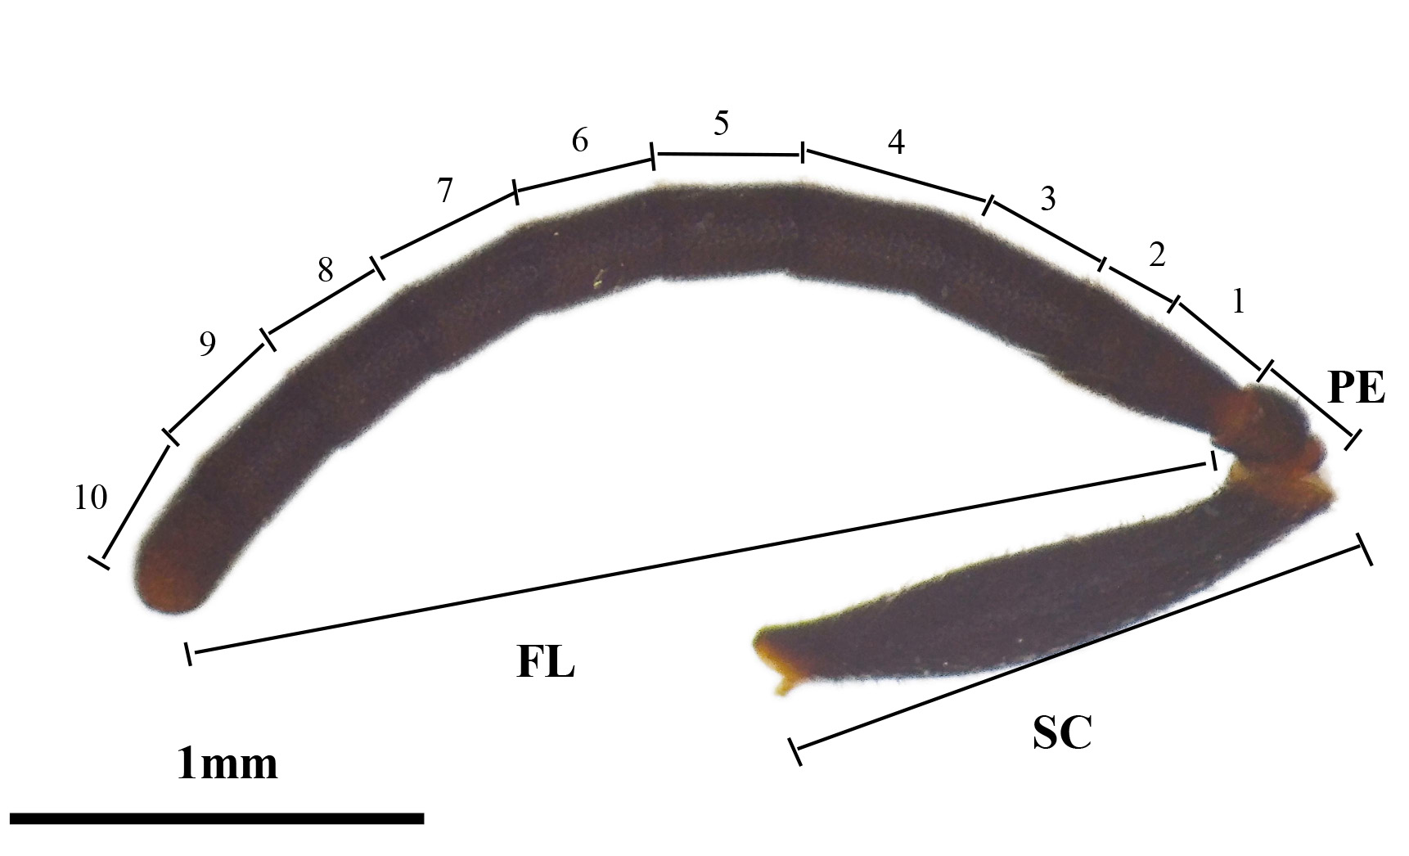
Figure 1 Apis mellifera worker bee antennae
SC: Scape; PE: Pedicel; FL: Flagellum, FL1-FL10.

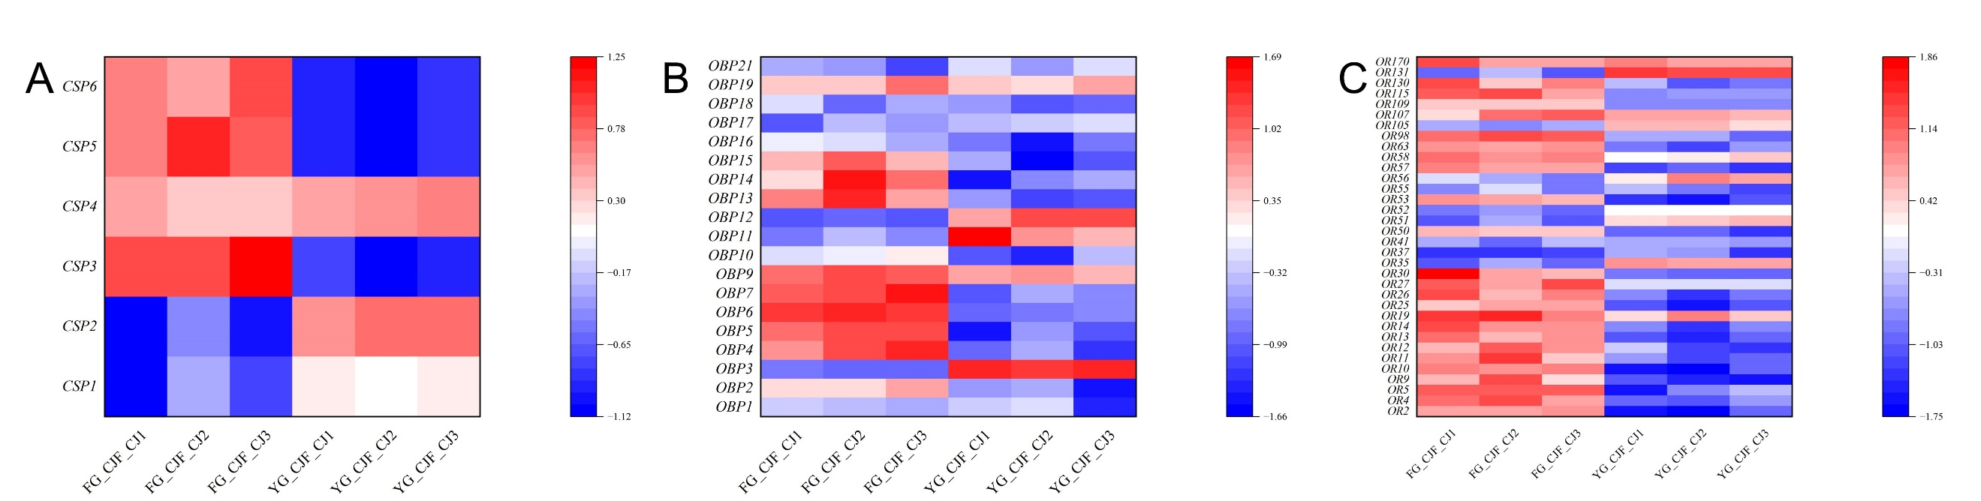
Figure 2 Apis mellifera worker bee antennal gene expression heatmap
A: CSPs; B: OBPs; C: ORs.

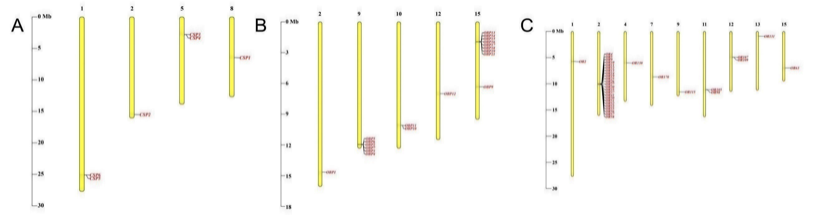
Figure 3 Apis mellifera antennal gene relative positions on genomic chromosomes
A: CSPs; B: OBPs; C: ORs.
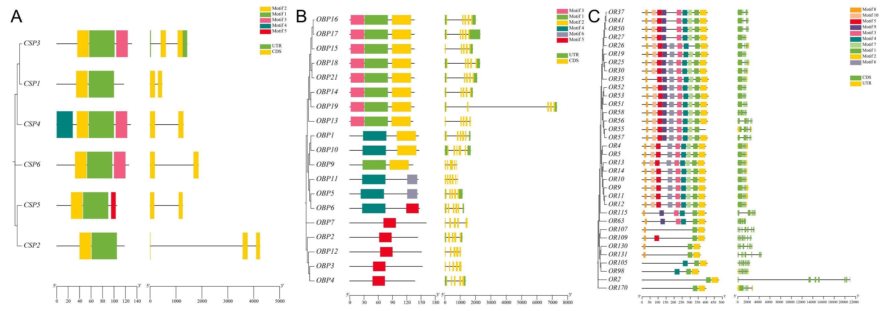
Figure 4 Apis mellifera antennal gene phylogenetic, conserved motifs, and structures
A: CSPs; B: OBPs; C: ORs.

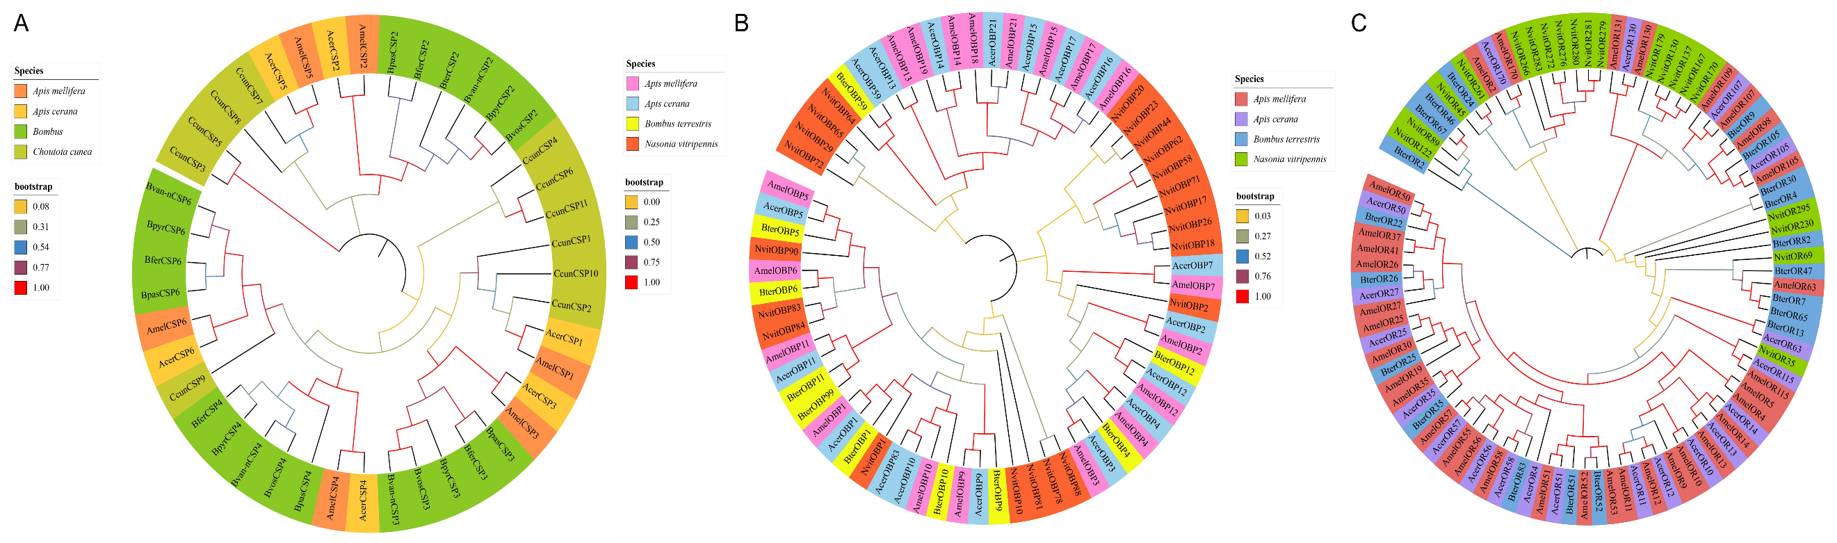
Figure 5 Apis mellifera antennal genes phylogenetic tree
A: CSPs; B: OBPs; C: ORs.
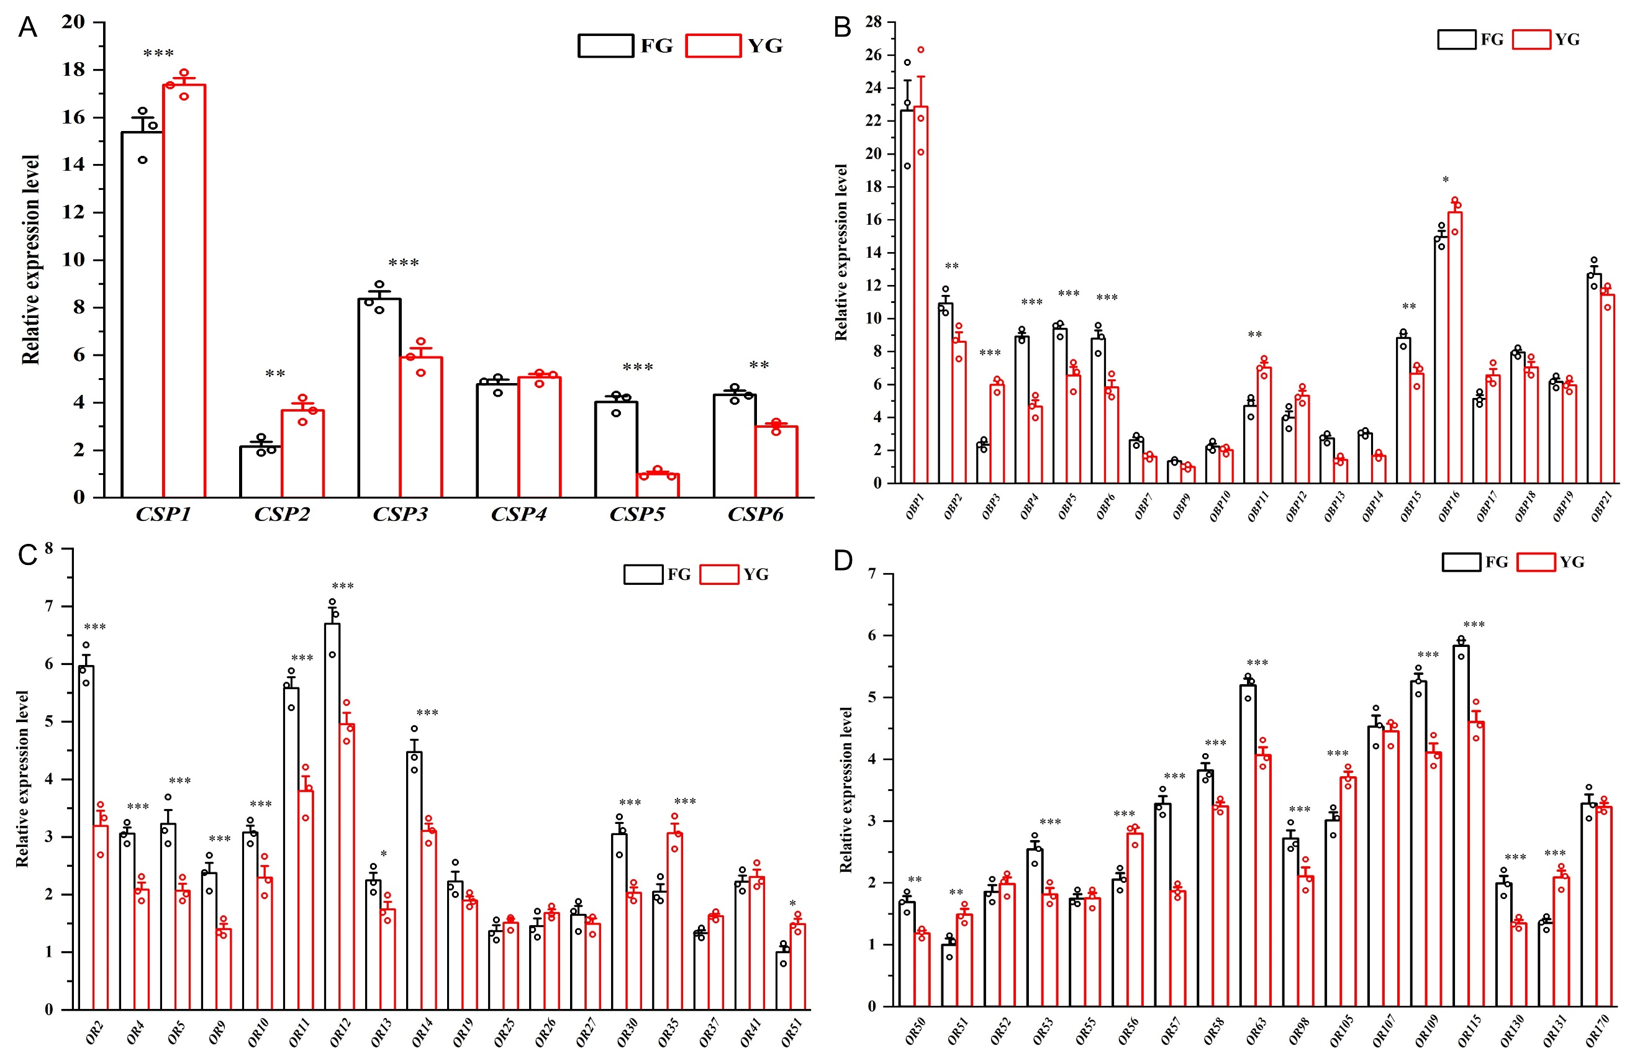
Figure 6 Antennal gene expression patterns validated by qRT-PCR
A: CSPs; B: OBPs; C-D: ORs. Data are shown as Mean ± standard error of the mean (SEM).

