Supplementary Information
Fig. S1 Principal component analysis (PCA) of transcriptomic profiles.
Fig. S2 GO enrichment of stage-specific DEGs at the blastula and heartbeat stages.
Fig. S3 Cluster-specific triploid–diploid expression differences across developmental stages.
Fig. S4 Gene-level relationships between regional DNA methylation differences and concurrent RNA-seq expression differences across genomic contexts.
Table S1 Summary of RNA‑sequencing data quality metrics.
Table S2 Summary of whole-genome bisulfite sequencing (WGBS) read quality statistics.
Table S3 Genomic-feature enrichment of stage-specific candidate DMRs.
Table S4 Summary of DEGs, DMRs, and DMGs across stages.
Table S5 Same-stage enrichment analysis of DMR-associated genes among differentially expressed genes.
Table S6 Enrichment analysis of promoter-associated DMR genes among trajectory-responsive genes and transcriptomic trajectory modules.

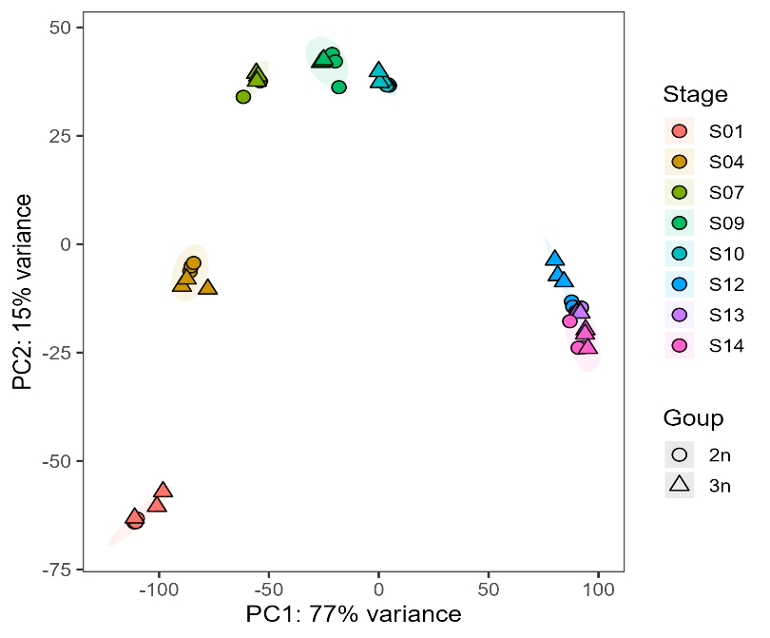
Fig. S1 Principal component analysis (PCA) of transcriptomic profiles.. Colors indicate developmental stages, and symbol shapes indicate diploid (2n) and triploid-induced (3n) embryos. Percentages on the axes indicate the proportion of total variance explained by each principal component. S01, one-cell stage; S04, blastula stage; S07, late gastrula I stage; S09, neurula stage; S10, blastopore closure stage; S12, heartbeat stage; S13, muscle contraction stage; and S14, hatching stage.
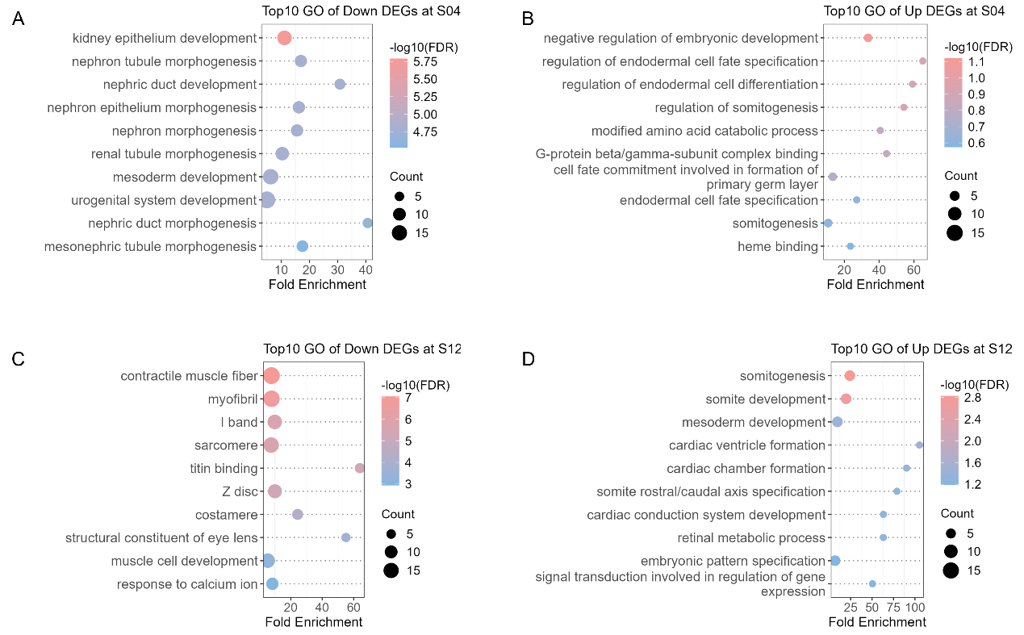
Fig. S2 GO enrichment of stage-specific DEGs at the blastula and heartbeat stages. A GO enrichment analysis of genes downregulated in triploid embryos at the blastula stage (S04). B GO enrichment analysis of genes upregulated in triploid embryos at the blastula stage (S04). No GO term in this gene set remains significant at FDR < 0.05. C GO enrichment analysis of genes downregulated in triploid embryos at the heart-beating stage (S12). D GO enrichment analysis of genes upregulated in triploid embryos at the heart-beating stage (S12). Dot size represents gene count, color represents −log10(FDR), and the x-axis indicates fold enrichment.
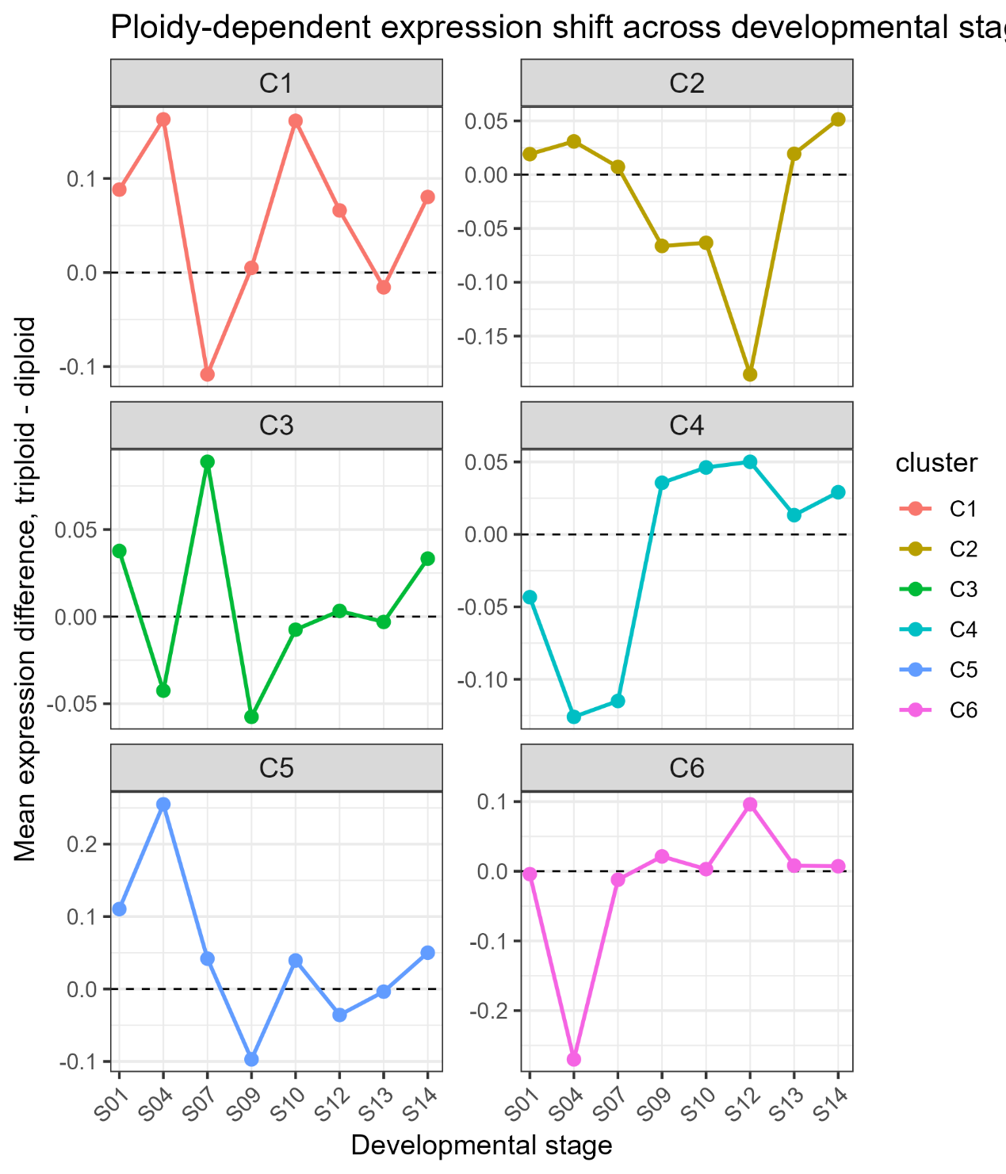
Fig. S3 Cluster-specific triploid–diploid expression differences across developmental stages. For each trajectory-DEG cluster, expression shifts were calculated as the difference between the mean gene-wise Z-scored expression of triploid and diploid embryos at each developmental stage. Positive values indicate higher mean expression in triploids, whereas negative values indicate lower mean expression in triploids. These values represent cluster-level descriptive differences rather than gene-level fold changes. S01, one-cell stage; S02, two-cell stage; S03, multicellular stage; S04, blastula stage; S05, early gastrula stage; S06, mid-gastrula stage; S07, late gastrula I stage; S08, late gastrula II stage; S09, neurula stage; S10, blastopore closure stage; S11, tail-bud stage; S12, heartbeat stage; S13, muscle contraction stage; and S14, hatching stage.
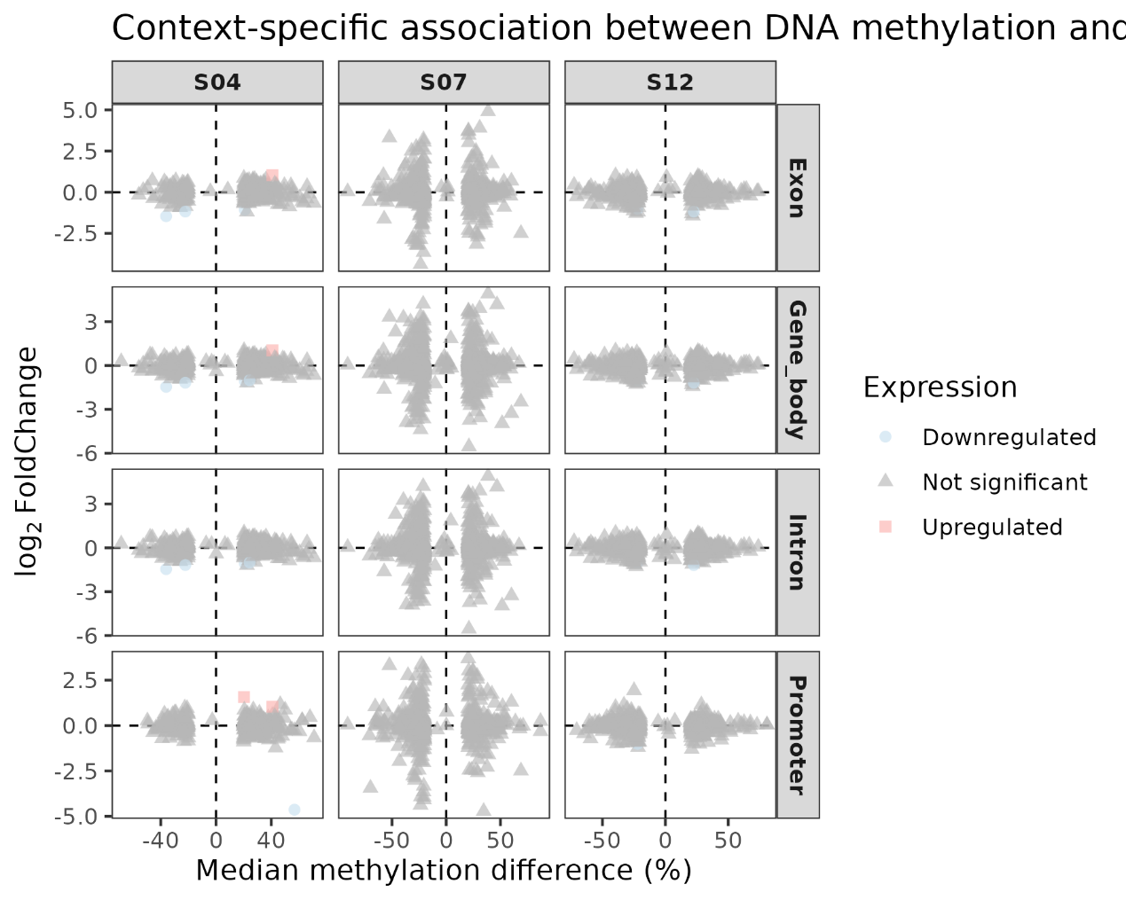
Fig. S4 Gene-level relationships between regional DNA methylation differences and concurrent RNA-seq expression differences across genomic contexts. Scatterplots show genes with matched methylation and expression measurements at S04, S07, and S12, separately for promoter, gene-body, exonic, and intronic DMR associations. For genes associated with multiple DMRs within the same feature class and stage, methylation differences are summarized by the median methylation difference. The x-axis indicates the median methylation difference in triploid relative to diploid embryos (percentage points), and the y-axis indicates same-stage RNA-seq log2FoldChange. Dashed lines indicate zero methylation difference and zero expression difference. Gray triangles represent genes not meeting the DEG criteria, whereas colored symbols identify significantly upregulated or downregulated genes.
Table S1 Summary of RNA‑sequencing data quality metrics.
Sample | Raw reads | Clean reads | Q30 (%) | GC (%) | Mapping rate (%)
1-2n-A | 40785110 | 40419866 | 95.08 | 50.27 | 78.76
1-2n-B | 42694034 | 42271770 | 94.67 | 50.23 | 79.92
1-2n-C | 47358880 | 46873984 | 94.16 | 50.44 | 80.53
1-3n-A | 42602094 | 42239716 | 95.38 | 50.21 | 81.16
1-3n-B | 42434456 | 41978026 | 94.35 | 50.10 | 82.15
1-3n-C | 49164216 | 48712498 | 94.81 | 50.76 | 84.38
4-2n-A | 44742322 | 44262156 | 94.16 | 49.63 | 86.19
4-2n-B | 44450240 | 44039594 | 95.19 | 49.66 | 86.72
4-2n-C | 41665984 | 41279182 | 95.19 | 49.70 | 85.74
4-3n-A | 42639134 | 42255388 | 95.26 | 49.59 | 86.66
4-3n-B | 51517700 | 51038732 | 94.99 | 50.71 | 89.11
4-3n-C | 51373860 | 50902742 | 95.00 | 49.81 | 87.74
7-2n-A | 43673092 | 43325272 | 95.72 | 50.06 | 89.32
7-2n-B | 42932134 | 42523060 | 95.29 | 48.78 | 86.66
7-2n-C | 42493514 | 42080222 | 94.81 | 49.65 | 89.39
7-3n-A | 49673656 | 49271736 | 95.52 | 49.93 | 88.68
7-3n-B | 39319534 | 38948344 | 94.85 | 49.86 | 88.83
7-3n-C | 43683388 | 43308460 | 95.13 | 49.61 | 88.41
9-2n-A | 48103050 | 47680294 | 95.23 | 49.75 | 89.47
9-2n-B | 42996018 | 42631040 | 95.20 | 49.84 | 90.21
9-2n-C | 43901392 | 43516430 | 95.20 | 49.72 | 89.36
9-3n-A | 43140666 | 42764374 | 95.87 | 49.81 | 89.13
9-3n-B | 41151466 | 40779038 | 95.01 | 49.81 | 88.81
9-3n-C | 45376560 | 44910598 | 94.40 | 49.50 | 87.91
10-2n-A | 41232050 | 40906438 | 95.52 | 49.63 | 88.97
10-2n-B | 41580180 | 41251970 | 95.59 | 49.71 | 89.34
10-2n-C | 41533964 | 41202738 | 95.67 | 49.81 | 88.88
10-3n-A | 48552634 | 48175618 | 95.29 | 49.84 | 90.26
10-3n-B | 45935114 | 45531506 | 94.96 | 50.07 | 88.6
10-3n-C | 45583698 | 45188602 | 95.06 | 50.00 | 89.44
12-2n-A | 40952720 | 40644456 | 95.77 | 49.94 | 90.77
12-2n-B | 41843638 | 41525374 | 95.03 | 49.97 | 89.28
12-2n-C | 41550596 | 41182700 | 95.05 | 49.89 | 89.98
12-3n-A | 46565676 | 46148936 | 94.82 | 50.06 | 89.14
12-3n-B | 45255318 | 44869256 | 95.29 | 50.03 | 89.08
12-3n-C | 51503444 | 51075648 | 94.78 | 50.11 | 89.14
13-2n-A | 42476738 | 42100906 | 94.82 | 50.39 | 90.68
13-2n-B | 41695270 | 41357956 | 95.15 | 49.93 | 89.92
13-2n-C | 42042304 | 41682404 | 95.40 | 49.88 | 89.58
13-3n-A | 49120036 | 48710382 | 95.05 | 50.04 | 88.6
13-3n-B | 39816802 | 39442830 | 94.62 | 49.92 | 88.41
13-3n-C | 52251140 | 51817428 | 95.28 | 50.43 | 87.27
14-2n-A | 42202304 | 41889912 | 94.21 | 50.48 | 90.71
14-2n-B | 44460264 | 44103048 | 95.24 | 50.17 | 89.81
14-2n-C | 43880086 | 43449462 | 94.20 | 50.02 | 88.83
14-3n-A | 46697022 | 46331780 | 96.24 | 51.27 | 93.07
14-3n-B | 45583220 | 45220938 | 95.14 | 51.14 | 91.82
14-3n-C | 45915044 | 45558142 | 94.90 | 51.03 | 91.48
2n and 3n denote the diploid and triploid-induced groups, respectively; A–C denote separately processed three non-overlapping within-batch embryo pools from the same fertilization batch.

Table S2 Summary of whole-genome bisulfite sequencing (WGBS) read quality statistics.
Sample | Clean reads | Q30 (%) | BS conversion rate (%) | Mapping efficiency (%) | Duplicate rate (%) | Mean depth at CpG cytosines  (×) | CpGs cytosines ≥5×  (%)
4-2N-D | 283641632 | 93.36 | 99.56 | 58.30 | 31.49 | 8.55 | 68.18
4-2N-E | 183318568 | 93.91 | 99.59 | 60.00 | 26.54 | 6.18 | 59.07
4-2N-F | 315290162 | 93.58 | 99.58 | 60.20 | 27.92 | 10.24 | 72.62
4-3N-D | 216553738 | 93.91 | 99.55 | 59.50 | 27.19 | 7.02 | 63.12
4-3N-E | 183077454 | 93.79 | 99.52 | 59.00 | 29.77 | 5.68 | 55.44
4-3N-F | 224280498 | 93.46 | 99.58 | 59.80 | 28.39 | 7.12 | 63.41
7-2N-D | 197949620 | 93.95 | 99.61 | 62.30 | 25.58 | 6.95 | 63.56
7-2N-E | 231596318 | 93.55 | 99.59 | 59.90 | 29.49 | 7.28 | 63.79
7-2N-F | 177637002 | 94.05 | 99.57 | 61.00 | 25.85 | 6.23 | 59.63
7-3N-D | 185481404 | 94.15 | 99.65 | 62.60 | 25.11 | 6.44 | 60.88
7-3N-E | 177791476 | 93.89 | 99.57 | 61.20 | 24.58 | 6.33 | 60.09
7-3N-F | 200461314 | 93.91 | 99.6 | 62.30 | 26.87 | 6.92 | 63.38
12-2N-D | 191606390 | 93.77 | 99.57 | 60.40 | 28.91 | 6.08 | 58.3
12-2N-E | 177404270 | 94.12 | 99.58 | 58.70 | 26.95 | 5.74 | 56.41
12-2N-F | 247957542 | 93.72 | 99.56 | 60.00 | 32.95 | 7.5 | 65.03
12-3N-D | 231412418 | 93.9 | 99.58 | 61.20 | 28.49 | 7.41 | 65.03
12-3N-E | 247188712 | 94.06 | 99.63 | 62.00 | 26.36 | 8.24 | 68.49
12-3N-F | 193690244 | 93.99 | 99.61 | 61.20 | 27.35 | 6.41 | 60.49
Mean depth at CpG cytosines and the percentage of CpG cytosines covered at ≥5× were calculated from deduplicated Bismark cytosine reports across all reference CpG cytosine positions, including positions with zero coverage. Because strand-specific CpG cytosines were not merged, these coverage metrics refer to CpG cytosine positions rather than strand-merged CpG dinucleotides. 2N and 3N denote the diploid and triploid-induced groups, respectively; D–F denote separately processed three non-overlapping within-batch embryo pools from the same fertilization batch.

Table S3 Genomic-feature enrichment of stage-specific candidate DMRs.
Stage | Feature | Total DMR | Observed DMR | Expected DMR | O/E ratio | Odds Ratio | P value | FDR
S04 | Promoter | 1846 | 602 | 199.81 | 3.01 | 4.02 | 4.93E-140 | 2.96E-139
S04 | Gene body | 1846 | 867 | 905.14 | 0.96 | 0.92 | 7.63E-02 | 8.59E-02
S04 | Exon | 1846 | 566 | 490.52 | 1.15 | 1.22 | 8.33E-05 | 1.25E-04
S04 | Intron | 1846 | 788 | 862.55 | 0.91 | 0.85 | 4.96E-04 | 6.86E-04
S04 | Intergenic | 1846 | 816 | 955.73 | 0.85 | 0.74 | 7.03E-11 | 1.27E-10
S04 | CGI | 1846 | 172 | 39.87 | 4.31 | 4.71 | 1.93E-56 | 8.69E-56
S07 | Promoter | 2385 | 717 | 251.29 | 2.85 | 3.69 | 2.02E-151 | 1.82E-150
S07 | Gene body | 2385 | 1132 | 1172.40 | 0.97 | 0.93 | 1.01E-01 | 1.06E-01
S07 | Exon | 2385 | 698 | 633.03 | 1.10 | 1.15 | 2.71E-03 | 3.49E-03
S07 | Intron | 2385 | 1052 | 1117.24 | 0.94 | 0.90 | 7.50E-03 | 9.00E-03
S07 | Intergenic | 2385 | 1058 | 1234.20 | 0.86 | 0.74 | 5.15E-13 | 1.03E-12
S07 | CGI | 2385 | 172 | 53.24 | 3.23 | 3.44 | 1.04E-39 | 3.11E-39
S12 | Promoter | 1838 | 643 | 188.79 | 3.41 | 4.75 | 2.50E-178 | 4.51E-177
S12 | Gene body | 1838 | 976 | 886.91 | 1.10 | 1.22 | 3.13E-05 | 5.12E-05
S12 | Exon | 1838 | 657 | 471.23 | 1.39 | 1.62 | 8.11E-22 | 1.82E-21
S12 | Intron | 1838 | 873 | 845.96 | 1.03 | 1.06 | 2.06E-01 | 2.06E-01
S12 | Intergenic | 1838 | 736 | 966.55 | 0.76 | 0.60 | 3.65E-27 | 9.40E-27
S12 | CGI | 1838 | 160 | 36.18 | 4.42 | 4.81 | 7.32E-54 | 2.63E-53
Feature categories are not mutually exclusive. Enrichment was evaluated relative to the stage-specific set of 1-kb windows that passed filtering and entered differential-methylation testing.

Table S4 Summary of DEGs, DMRs, and DMGs across stages.
Stage | Total DEGs | Up DEGs | Down DEGs | Total DMRs | Hyper DMRs | Hypo DMRs | Total DMGs | Hyper-only DMGs | Hypo-only DMGs | Mixed DMGs | DMG–DEG overlap
S04 | 192 | 52 | 140 | 1846 | 1023 | 823 | 1255 | 744 | 496 | 15 | 7
S07 | 0 | 0 | 0 | 2385 | 1158 | 1227 | 1606 | 769 | 814 | 23 | 0
S12 | 192 | 47 | 145 | 1838 | 913 | 925 | 1363 | 633 | 700 | 30 | 2

Table S5 Same-stage enrichment analysis of DMR-associated genes among differentially expressed genes.
Stage | General DMGs | RNA-testable DMGs | DEGs | Observed overlap | Expected overlap | O/E ratio | Odds ratio | P value | FDR (3 stages)
S04 | 1255 | 696 | 192 | 7 | 10.61 | 0.66 | 0.64 | 0.91 | 1
S07 | 1606 | 1507 | 0 | 0 | 0.00 | - | 0.00 | 1.00 | 1
S12 | 1363 | 1197 | 192 | 2 | 11.59 | 0.17 | 0.16 | 1.00 | 1
Stage-specific overlap between RNA-testable DMGs and DEGs was compared with the expectation under independence using Fisher's exact tests within the common WGBS–RNA testable gene universe.

Table S6 Enrichment analysis of promoter-associated DMR genes among trajectory-responsive genes and transcriptomic trajectory modules.
Stage | Target set | Target genes in universe | Observed overlap | Expected overlap | O/E ratio | Odds ratio | P value | FDR within stage | Primary FDR | Multiple testing scope | FDR across all 21 tests
S04 | All | 3373 | 94 | 98.31 | 0.96 | 0.95 | 0.70 | - | 0.73 | 3 stage-level | 0.96
S04 | C1 | 448 | 13 | 13.06 | 1.00 | 1.00 | 0.55 | 0.84 | 0.93 | 18 stage-by-module tests | 0.96
S04 | C2 | 862 | 19 | 25.12 | 0.76 | 0.74 | 0.92 | 0.92 | 0.98 | 18 stage-by-module tests | 0.98
S04 | C3 | 684 | 23 | 19.94 | 1.15 | 1.17 | 0.27 | 0.84 | 0.93 | 18 stage-by-module tests | 0.96
S04 | C4 | 435 | 12 | 12.68 | 0.95 | 0.94 | 0.62 | 0.84 | 0.93 | 18 stage-by-module tests | 0.96
S04 | C5 | 336 | 11 | 9.79 | 1.12 | 1.13 | 0.39 | 0.84 | 0.93 | 18 stage-by-module tests | 0.96
S04 | C6 | 608 | 16 | 17.72 | 0.90 | 0.90 | 0.70 | 0.84 | 0.97 | 18 stage-by-module tests | 0.96
S07 | All | 3346 | 120 | 118.29 | 1.01 | 1.02 | 0.45 | - | 0.73 | 3 stage-level | 0.96
S07 | C1 | 437 | 15 | 15.45 | 0.97 | 0.97 | 0.58 | 0.70 | 0.93 | 18 stage-by-module tests | 0.96
S07 | C2 | 857 | 31 | 30.3 | 1.02 | 1.03 | 0.47 | 0.70 | 0.93 | 18 stage-by-module tests | 0.96
S07 | C3 | 682 | 31 | 24.11 | 1.29 | 1.31 | 0.09 | 0.55 | 0.83 | 18 stage-by-module tests | 0.96
S07 | C4 | 432 | 18 | 15.27 | 1.18 | 1.19 | 0.27 | 0.70 | 0.93 | 18 stage-by-module tests | 0.96
S07 | C5 | 336 | 12 | 11.88 | 1.01 | 1.01 | 0.53 | 0.70 | 0.93 | 18 stage-by-module tests | 0.96
S07 | C6 | 602 | 13 | 21.28 | 0.61 | 0.60 | 0.98 | 0.98 | 0.98 | 18 stage-by-module tests | 0.98
S12 | All | 3313 | 103 | 108.36 | 0.95 | 0.94 | 0.73 | - | 0.73 | 3 stage-level | 0.96
S12 | C1 | 434 | 11 | 14.2 | 0.78 | 0.77 | 0.84 | 0.95 | 0.98 | 18 stage-by-module tests | 0.98
S12 | C2 | 849 | 20 | 27.77 | 0.72 | 0.71 | 0.95 | 0.95 | 0.98 | 18 stage-by-module tests | 0.98
S12 | C3 | 670 | 17 | 21.91 | 0.78 | 0.76 | 0.89 | 0.95 | 0.98 | 18 stage-by-module tests | 0.98
S12 | C4 | 428 | 15 | 14 | 1.07 | 1.08 | 0.43 | 0.86 | 0.93 | 18 stage-by-module tests | 0.96
S12 | C5 | 338 | 17 | 11.06 | 1.54 | 1.58 | 0.05 | 0.32 | 0.83 | 18 stage-by-module tests | 0.96
S12 | C6 | 594 | 23 | 19.43 | 1.18 | 1.20 | 0.23 | 0.69 | 0.93 | 18 stage-by-module tests | 0.96
One-sided Fisher's exact tests were used to assess whether promoter-associated DMGs were over-represented among genes showing significant stage-by-ploidy interaction effects or within individual trajectory modules. Gene universes were restricted to genes evaluable in the corresponding WGBS and RNA-seq analyses. No tested comparison remained significant after multiple-testing correction.

