Table S1. Age, gender and chronic illness of 20 healthy individuals
Healthy individual | Age | Gender | Chronic illness
H001 | 43 | male | no
H002 | 62 | male | no
H003 | 32 | male | no
H004 | 29 | male | no
H005 | 30 | male | no
H006 | 29 | male | no
H007 | 31 | male | no
H008 | 58 | male | no
H009 | 35 | male | no
H010 | 28 | male | no
H011 | 28 | female | no
H012 | 39 | male | no
H013 | 42 | male | no
H014 | 48 | male | no
H015 | 32 | male | no
H016 | 25 | male | no
H017 | 46 | male | no
H018 | 25 | male | no
H019 | 28 | male | no
H020 | 26 | male | no
Median | 31.5

Table S2. Numbers of unique reads, reads and nucleotides in TRA reads obtained from PBMCs of 20 healthy individuals
Healthy individual | Total number of unique reads | Total number of reads | Total number of nucleotides | Mean number of nucleotides per read
H001 | 5,902 | 8,805 | 3,732,329 | 423.9
H002 | 2,809 | 5,812 | 2,477,523 | 426.3
H003 | 1,707 | 7,334 | 3,269,817 | 445.8
H004 | 5,586 | 6,981 | 3,047,583 | 436.6
H005 | 3,250 | 5,815 | 2,507,968 | 431.3
H006 | 4,267 | 7,043 | 3,052,709 | 433.4
H007 | 5,467 | 6,462 | 2,784,462 | 430.9
H008 | 3,350 | 6,206 | 2,700,726 | 435.2
H009 | 4,966 | 7,267 | 3,119,902 | 429.3
H010 | 5,019 | 6,641 | 2,861,613 | 430.9
H011 | 8,327 | 16,254 | 6,188,290 | 380.7
H012 | 2,289 | 7,203 | 2,386,452 | 331.3
H013 | 3,025 | 6,118 | 2,185,135 | 357.2
H014 | 2,221 | 5,790 | 2,237,670 | 386.5
H015 | 3,976 | 7,009 | 2,944,857 | 420.2
H016 | 8,152 | 20,493 | 8,147,320 | 397.6
H017 | 1,565 | 3,244 | 1,042,278 | 321.3
H018 | 6,303 | 14,768 | 6,169,277 | 417.7
H019 | 10,001 | 17,719 | 7,165,649 | 404.4
H020 | 3,052 | 5,145 | 2,096,401 | 407.5
Mean | 4,561.7 | 8,605.5 | 3,505,898 | 407.4
SD | 2,326.4 | 4,693.4 | 1,870,983 | 35.4
Total | 91,234 | 172,109 | 7,011,7961
PBMCs, peripheral blood mononuclear cells; SD, standard deviation
Table S3. Numbers of unique reads, reads and nucleotides in TRB reads obtained from PBMCs of 20 healthy individuals
Healthy individual | Total number of unique reads | Total number of reads | Total number of nucleotides | Mean number of nucleotides per read
H001 | 3,092 | 4,007 | 1,626,917 | 406.0
H002 | 2,069 | 3,624 | 1,620,164 | 447.1
H003 | 979 | 3,602 | 1,595,988 | 443.1
H004 | 3,025 | 3,664 | 1,637,322 | 446.9
H005 | 1,275 | 1,970 | 884,000 | 448.7
H006 | 1,274 | 2,122 | 952,553 | 448.9
H007 | 3,301 | 3,760 | 1,665,584 | 443.0
H008 | 2,089 | 3,956 | 1,737,410 | 439.2
H009 | 2,664 | 3,575 | 1,595,609 | 446.3
H010 | 2,761 | 3,384 | 1,517,514 | 448.4
H011 | 5,198 | 8,182 | 3,369,499 | 411.8
H012 | 4,882 | 11,759 | 4,421,616 | 376.0
H013 | 4,272 | 8,117 | 2,793,454 | 344.1
H014 | 2,119 | 4,652 | 1,578,364 | 339.3
H015 | 3,735 | 5,298 | 1,929,452 | 364.2
H016 | 2,663 | 4,086 | 1,582,494 | 387.3
H017 | 2,348 | 4,341 | 1,676,546 | 386.2
H018 | 3,044 | 4,807 | 1,804,197 | 375.3
H019 | 4,317 | 5,923 | 2,285,404 | 385.9
H020 | 2,875 | 4,099 | 1,639,809 | 400.1
mean | 2,899.1 | 4,746.4 | 1,895,695 | 409.4
SD | 1,156.2 | 2,280.0 | 806,581 | 37.8
Total | 57,982 | 94,928 | 37,913,896
PBMCs, peripheral blood mononuclear cells; SD, standard deviation.

Table S4. Percentage of mismatched nucleotides in in-frame and out-of-frame TCR sequences
Healthy individuals | % Mismatched nucleotides
Healthy individuals | TRAV |  |  |  |  | TRAJ |  |  |  |  |  | TRBV |  |  |  |  |  | TRBJ
Healthy individuals | all | in-frame | out-of-frame |  | all |  | in-frame | out-of-frame |  |  | all |  | in-frame | out-of-frame |  |  | all |  | in-frame | out-of-frame
H001 | 0.54 | 0.51 | 0.67 |  | 0.40 |  | 0.32 | 0.78 |  |  | 0.58 |  | 0.54 | 0.71 |  |  | 0.54 |  | 0.35 | 1.16
H002 | 0.92 | 0.90 | 0.99 |  | 0.61 |  | 0.39 | 1.25 |  |  | 0.89 |  | 0.83 | 1.17 |  |  | 0.36 |  | 0.24 | 0.96
H003 | 0.93 | 0.89 | 1.04 |  | 0.63 |  | 0.41 | 1.28 |  |  | 0.83 |  | 0.77 | 1.14 |  |  | 0.36 |  | 0.23 | 0.98
H004 | 0.93 | 0.88 | 1.07 |  | 0.60 |  | 0.40 | 1.22 |  |  | 0.85 |  | 0.79 | 1.14 |  |  | 0.40 |  | 0.24 | 1.12
H005 | 0.87 | 0.81 | 1.05 |  | 0.61 |  | 0.39 | 1.22 |  |  | 0.90 |  | 0.84 | 1.22 |  |  | 0.37 |  | 0.26 | 0.95
H006 | 0.89 | 0.86 | 0.98 |  | 0.56 |  | 0.36 | 1.19 |  |  | 0.77 |  | 0.71 | 1.08 |  |  | 0.34 |  | 0.22 | 1.13
H007 | 0.89 | 0.83 | 1.07 |  | 0.59 |  | 0.36 | 1.22 |  |  | 0.80 |  | 0.72 | 1.19 |  |  | 0.46 |  | 0.30 | 1.19
H008 | 0.89 | 0.85 | 1.02 |  | 0.61 |  | 0.41 | 1.31 |  |  | 0.89 |  | 0.83 | 1.14 |  |  | 0.49 |  | 0.28 | 1.30
H009 | 0.93 | 0.87 | 1.11 |  | 0.63 |  | 0.40 | 1.29 |  |  | 0.91 |  | 0.84 | 1.24 |  |  | 0.39 |  | 0.26 | 1.04
H010 | 0.88 | 0.85 | 0.97 |  | 0.61 |  | 0.37 | 1.26 |  |  | 0.85 |  | 0.80 | 1.16 |  |  | 0.35 |  | 0.21 | 1.05
H011 | 0.54 | 0.50 | 0.63 |  | 0.48 |  | 0.35 | 0.85 |  |  | 0.54 |  | 0.51 | 0.66 |  |  | 0.52 |  | 0.36 | 1.08
H012 | 0.58 | 0.50 | 0.83 |  | 0.65 |  | 0.46 | 1.22 |  |  | 0.61 |  | 0.56 | 0.75 |  |  | 0.69 |  | 0.48 | 1.32
H013 | 0.58 | 0.51 | 0.79 |  | 0.56 |  | 0.36 | 1.18 |  |  | 0.57 |  | 0.52 | 0.70 |  |  | 0.64 |  | 0.42 | 1.27
H014 | 0.68 | 0.62 | 0.90 |  | 0.48 |  | 0.34 | 1.00 |  |  | 0.54 |  | 0.50 | 0.68 |  |  | 0.59 |  | 0.40 | 1.19
H015 | 0.65 | 0.61 | 0.84 |  | 0.40 |  | 0.31 | 0.89 |  |  | 0.57 |  | 0.53 | 0.68 |  |  | 0.70 |  | 0.46 | 1.33
H016 | 0.55 | 0.49 | 0.72 |  | 0.50 |  | 0.35 | 0.94 |  |  | 0.57 |  | 0.52 | 0.74 |  |  | 0.59 |  | 0.38 | 1.23
H017 | 0.57 | 0.53 | 0.69 |  | 0.53 |  | 0.38 | 0.94 |  |  | 0.57 |  | 0.53 | 0.70 |  |  | 0.57 |  | 0.38 | 1.27
H018 | 0.51 | 0.46 | 0.68 |  | 0.47 |  | 0.38 | 0.81 |  |  | 0.56 |  | 0.52 | 0.70 |  |  | 0.53 |  | 0.34 | 1.18
H019 | 0.53 | 0.45 | 0.79 |  | 0.44 |  | 0.32 | 0.86 |  |  | 0.63 |  | 0.58 | 0.76 |  |  | 0.66 |  | 0.41 | 1.37
H020 | 0.47 | 0.41 | 0.74 |  | 0.43 |  | 0.31 | 0.96 |  |  | 0.54 |  | 0.50 | 0.66 |  |  | 0.50 |  | 0.31 | 1.15
mean | 0.72 | 0.67 | 0.88 |  | 0.54 |  | 0.37 | 1.08 |  |  | 0.70 |  | 0.65 | 0.91 |  |  | 0.50 |  | 0.33 | 1.16
SD | 0.18 | 0.19 | 0.16 |  | 0.08 |  | 0.04 | 0.19 |  |  | 0.15 |  | 0.14 | 0.24 |  |  | 0.12 |  | 0.08 | 0.13
SD, standard deviation.

Table S5. Occurrence frequency of out-of-frame unique sequence reads in TRA and TRB
Healthy individual | %Frequency
Healthy individual | TRA | TRB
H001 | 21.9 | 27.0
H002 | 35.8 | 26.1
H003 | 52.3 | 42.7
H004 | 27.8 | 20.7
H005 | 33.8 | 22.3
H006 | 31.8 | 19.8
H007 | 28.6 | 19.5
H008 | 31.0 | 27.4
H009 | 31.2 | 21.5
H010 | 30.6 | 19.1
H011 | 29.1 | 27.5
H012 | 41.5 | 46.0
H013 | 33.4 | 38.1
H014 | 29.4 | 39.4
H015 | 21.1 | 34.3
H016 | 34.3 | 32.1
H017 | 32.7 | 33.2
H018 | 27.9 | 29.2
H019 | 27.4 | 32.1
H020 | 21.7 | 28.3
mean | 31.2 | 29.3
SD | 7.0 | 7.9
SD, standard deviation.

Table S6. Percentage frequency of shared TRA reads between all pairs of individuals
 | H001 | H002 | H003 | H004 | H005 | H006 | H007 | H008 | H009 | H010 | H011 | H012 | H013 | H014 | H015 | H016 | H017 | H018 | H019 | H020
H001 | – | 0.71 | 0.29 | 1.04 | 1.29 | 0.80 | 1.61 | 0.78 | 0.89 | 0.84 | 1.12 | 0.87 | 0.73 | 0.77 | 1.28 | 0.92 | 0.77 | 1.05 | 1.13 | 1.11
H002 | 0.34 | – | 0.47 | 0.59 | 0.37 | 0.37 | 0.51 | 0.27 | 0.72 | 0.36 | 0.23 | 0.31 | 0.26 | 0.23 | 0.25 | 0.33 | 0.32 | 0.35 | 0.26 | 0.46
H003 | 0.08 | 0.28 | – | 0.21 | 0.15 | 0.23 | 0.04 | 0.21 | 0.16 | 0.12 | 0.08 | 0.13 | 0.10 | 0.00 | 0.15 | 0.07 | 0.19 | 0.10 | 0.10 | 0.13
H004 | 0.98 | 1.17 | 0.70 | – | 1.05 | 1.05 | 1.32 | 1.25 | 1.41 | 1.24 | 0.82 | 1.00 | 0.79 | 0.68 | 1.26 | 0.72 | 0.83 | 0.78 | 0.78 | 0.79
H005 | 0.71 | 0.43 | 0.29 | 0.61 | – | 0.89 | 0.90 | 0.84 | 0.79 | 0.74 | 0.59 | 0.66 | 0.50 | 0.45 | 0.80 | 0.58 | 0.89 | 0.71 | 0.53 | 0.69
H006 | 0.58 | 0.57 | 0.59 | 0.81 | 1.17 | – | 1.01 | 0.63 | 1.07 | 0.92 | 0.82 | 1.05 | 0.63 | 0.54 | 0.93 | 0.75 | 0.89 | 0.75 | 0.57 | 0.75
H007 | 1.49 | 1.00 | 0.12 | 1.29 | 1.51 | 1.29 | – | 1.13 | 1.31 | 1.28 | 0.94 | 1.00 | 0.69 | 1.04 | 1.58 | 0.88 | 1.28 | 1.14 | 1.05 | 1.05
H008 | 0.44 | 0.32 | 0.41 | 0.75 | 0.86 | 0.49 | 0.70 | – | 0.58 | 0.66 | 0.36 | 0.48 | 0.26 | 0.36 | 0.68 | 0.47 | 0.32 | 0.41 | 0.38 | 0.43
H009 | 0.75 | 1.28 | 0.47 | 1.25 | 1.20 | 1.24 | 1.19 | 0.87 | – | 1.18 | 0.77 | 0.87 | 0.63 | 0.63 | 1.18 | 0.80 | 0.89 | 0.81 | 0.60 | 0.92
H010 | 0.71 | 0.64 | 0.35 | 1.11 | 1.14 | 1.08 | 1.17 | 0.99 | 1.19 | – | 0.90 | 0.96 | 0.79 | 0.59 | 1.16 | 0.74 | 0.64 | 0.95 | 0.86 | 0.85
H011 | 1.58 | 0.68 | 0.41 | 1.22 | 1.51 | 1.59 | 1.43 | 0.90 | 1.29 | 1.49 | – | 1.66 | 6.02 | 0.99 | 2.04 | 1.37 | 1.21 | 1.52 | 1.49 | 1.38
H012 | 0.34 | 0.25 | 0.18 | 0.41 | 0.46 | 0.56 | 0.42 | 0.33 | 0.40 | 0.44 | 0.46 | – | 0.36 | 0.09 | 0.58 | 0.44 | 0.58 | 0.48 | 0.42 | 0.36
H013 | 0.37 | 0.28 | 0.18 | 0.43 | 0.46 | 0.45 | 0.38 | 0.24 | 0.38 | 0.48 | 2.19 | 0.48 | – | 0.41 | 0.58 | 0.33 | 0.38 | 0.38 | 0.46 | 0.56
H014 | 0.29 | 0.18 | 0.00 | 0.27 | 0.31 | 0.28 | 0.42 | 0.24 | 0.28 | 0.26 | 0.26 | 0.09 | 0.30 | – | 0.50 | 0.33 | 0.26 | 0.17 | 0.35 | 0.29
H015 | 0.86 | 0.36 | 0.35 | 0.90 | 0.98 | 0.87 | 1.15 | 0.81 | 0.95 | 0.92 | 0.97 | 1.00 | 0.76 | 0.90 | – | 0.82 | 0.89 | 0.84 | 0.95 | 0.85
H016 | 1.27 | 0.96 | 0.35 | 1.06 | 1.45 | 1.43 | 1.32 | 1.13 | 1.31 | 1.20 | 1.35 | 1.57 | 0.89 | 1.22 | 1.69 | – | 0.83 | 1.19 | 1.20 | 0.66
H017 | 0.20 | 0.18 | 0.18 | 0.23 | 0.43 | 0.33 | 0.37 | 0.15 | 0.28 | 0.20 | 0.23 | 0.39 | 0.20 | 0.18 | 0.35 | 0.16 | – | 0.17 | 0.20 | 0.26
H018 | 1.12 | 0.78 | 0.35 | 0.88 | 1.38 | 1.10 | 1.32 | 0.78 | 1.03 | 1.20 | 1.15 | 1.31 | 0.79 | 0.50 | 1.33 | 0.92 | 0.70 | – | 1.18 | 0.92
H019 | 1.91 | 0.93 | 0.59 | 1.40 | 1.63 | 1.34 | 1.92 | 1.13 | 1.21 | 1.71 | 1.79 | 1.83 | 1.52 | 1.58 | 2.39 | 1.47 | 1.28 | 1.87 | – | 1.77
H020 | 0.58 | 0.50 | 0.23 | 0.43 | 0.65 | 0.54 | 0.59 | 0.39 | 0.56 | 0.52 | 0.50 | 0.48 | 0.56 | 0.41 | 0.65 | 0.25 | 0.51 | 0.44 | 0.54 | –

Table S7. Percentage frequency of shared TRB reads between all pairs of individuals
 | H001 | H002 | H003 | H004 | H005 | H006 | H007 | H008 | H009 | H010 | H011 | H012 | H013 | H014 | H015 | H016 | H017 | H018 | H019 | H020
H001 | – | 0.05 | 0.00 | 0.00 | 0.08 | 0.00 | 0.03 | 0.05 | 0.11 | 0.07 | 0.08 | 0.02 | 0.05 | 0.00 | 0.00 | 0.11 | 0.00 | 0.00 | 0.12 | 0.07
H002 | 0.03 | – | 0.00 | 0.03 | 0.08 | 0.00 | 0.00 | 0.05 | 0.04 | 0.00 | 0.02 | 0.02 | 0.00 | 0.00 | 0.00 | 0.04 | 0.04 | 0.00 | 0.02 | 0.00
H003 | 0.00 | 0.00 | – | 0.00 | 0.00 | 0.00 | 0.00 | 0.00 | 0.00 | 0.00 | 0.00 | 0.00 | 0.00 | 0.00 | 0.00 | 0.00 | 0.00 | 0.00 | 0.02 | 0.00
H004 | 0.00 | 0.05 | 0.00 | – | 0.16 | 0.00 | 0.03 | 0.05 | 0.08 | 0.07 | 0.00 | 0.02 | 0.00 | 0.05 | 0.00 | 0.08 | 0.04 | 0.03 | 0.02 | 0.00
H005 | 0.03 | 0.05 | 0.00 | 0.07 | – | 0.00 | 0.00 | 0.00 | 0.04 | 0.00 | 0.00 | 0.00 | 0.00 | 0.00 | 0.03 | 0.04 | 0.04 | 0.00 | 0.00 | 0.03
H006 | 0.00 | 0.00 | 0.00 | 0.00 | 0.00 | – | 0.03 | 0.00 | 0.04 | 0.04 | 0.02 | 0.02 | 0.00 | 0.05 | 0.11 | 0.00 | 0.04 | 0.00 | 0.02 | 0.00
H007 | 0.03 | 0.00 | 0.00 | 0.03 | 0.00 | 0.08 | – | 0.05 | 0.04 | 0.04 | 0.02 | 0.02 | 0.00 | 0.00 | 0.00 | 0.04 | 0.00 | 0.00 | 0.00 | 0.03
H008 | 0.03 | 0.05 | 0.00 | 0.03 | 0.00 | 0.00 | 0.03 | – | 0.00 | 0.04 | 0.02 | 0.00 | 0.00 | 0.00 | 0.03 | 0.11 | 0.00 | 0.00 | 0.02 | 0.00
H009 | 0.10 | 0.05 | 0.00 | 0.07 | 0.08 | 0.08 | 0.03 | 0.00 | – | 0.11 | 0.06 | 0.02 | 0.00 | 0.00 | 0.03 | 0.04 | 0.00 | 0.03 | 0.02 | 0.00
H010 | 0.06 | 0.00 | 0.00 | 0.07 | 0.00 | 0.08 | 0.03 | 0.05 | 0.11 | – | 0.00 | 0.02 | 0.00 | 0.09 | 0.03 | 0.11 | 0.00 | 0.00 | 0.07 | 0.07
H011 | 0.13 | 0.05 | 0.00 | 0.00 | 0.00 | 0.08 | 0.03 | 0.05 | 0.11 | 0.00 | – | 0.04 | 0.16 | 0.00 | 0.08 | 0.11 | 0.00 | 0.16 | 0.05 | 0.14
H012 | 0.03 | 0.05 | 0.00 | 0.03 | 0.00 | 0.08 | 0.03 | 0.00 | 0.04 | 0.04 | 0.04 | – | 0.30 | 0.14 | 0.21 | 0.45 | 0.26 | 0.03 | 0.02 | 0.00
H013 | 0.06 | 0.00 | 0.00 | 0.00 | 0.00 | 0.00 | 0.00 | 0.00 | 0.00 | 0.00 | 0.13 | 0.27 | – | 0.14 | 0.16 | 0.19 | 0.13 | 0.03 | 0.02 | 0.03
H014 | 0.00 | 0.00 | 0.00 | 0.03 | 0.00 | 0.08 | 0.00 | 0.00 | 0.00 | 0.07 | 0.00 | 0.06 | 0.07 | – | 0.00 | 0.04 | 0.21 | 0.00 | 0.00 | 0.03
H015 | 0.00 | 0.00 | 0.00 | 0.00 | 0.08 | 0.31 | 0.00 | 0.05 | 0.04 | 0.04 | 0.06 | 0.16 | 0.14 | 0.00 | – | 0.15 | 0.09 | 0.03 | 0.02 | 0.00
H016 | 0.10 | 0.05 | 0.00 | 0.07 | 0.08 | 0.00 | 0.03 | 0.14 | 0.04 | 0.11 | 0.06 | 0.25 | 0.12 | 0.05 | 0.11 | – | 0.13 | 0.03 | 0.02 | 0.03
H017 | 0.00 | 0.05 | 0.00 | 0.03 | 0.08 | 0.08 | 0.00 | 0.00 | 0.00 | 0.00 | 0.00 | 0.12 | 0.07 | 0.24 | 0.05 | 0.11 | – | 0.00 | 0.00 | 0.00
H018 | 0.00 | 0.00 | 0.00 | 0.03 | 0.00 | 0.00 | 0.00 | 0.00 | 0.04 | 0.00 | 0.10 | 0.02 | 0.02 | 0.00 | 0.03 | 0.04 | 0.00 | – | 0.14 | 0.10
H019 | 0.16 | 0.05 | 0.10 | 0.03 | 0.00 | 0.08 | 0.00 | 0.05 | 0.04 | 0.11 | 0.04 | 0.02 | 0.02 | 0.00 | 0.03 | 0.04 | 0.00 | 0.20 | – | 0.10
H020 | 0.06 | 0.00 | 0.00 | 0.00 | 0.08 | 0.00 | 0.03 | 0.00 | 0.00 | 0.07 | 0.08 | 0.00 | 0.02 | 0.05 | 0.00 | 0.04 | 0.00 | 0.10 | 0.07 | –

Figure S1.
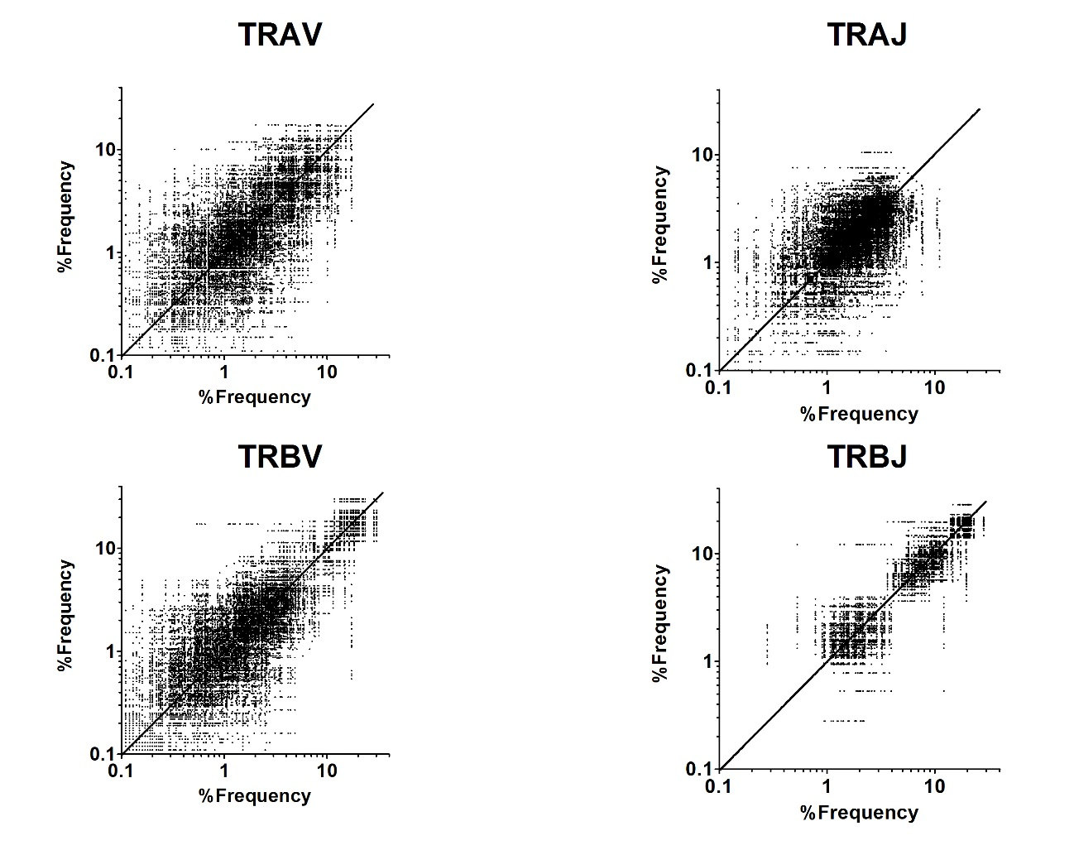
Correlation of gene usage of TRAV, TRAJ, TRBV and TRBJ between healthy individuals.
Percentage frequencies of TRAV (upper left), TRAJ (upper right), TRBV (lower left) and TRBJ (lower right) between all pairs of individuals are plotted. A dot with lower deviation from diagonal line (y=x) indicates a better correlation.

Figure S2.
Concordance correlation coefficient in TRAV, TRAJ, TRBV and TRBJ.
The correlation coefficient between two samples from healthy individuals was calculated by Spearman’s correlation test. Each dot indicates a correlation coefficient value between a pair of individuals. Mean correlation coefficient is shown as a red horizontal bar (n=190)

Figure S3
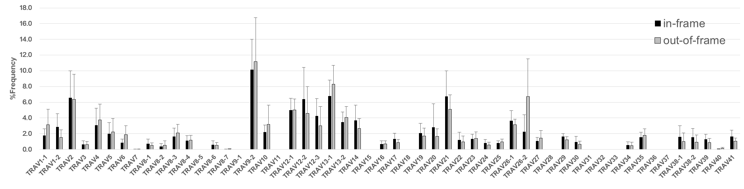
A
B
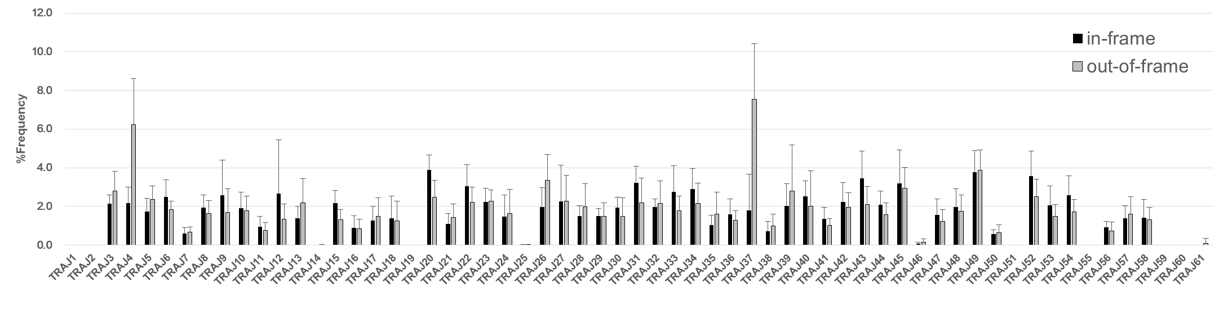

Figure S3, continued
C
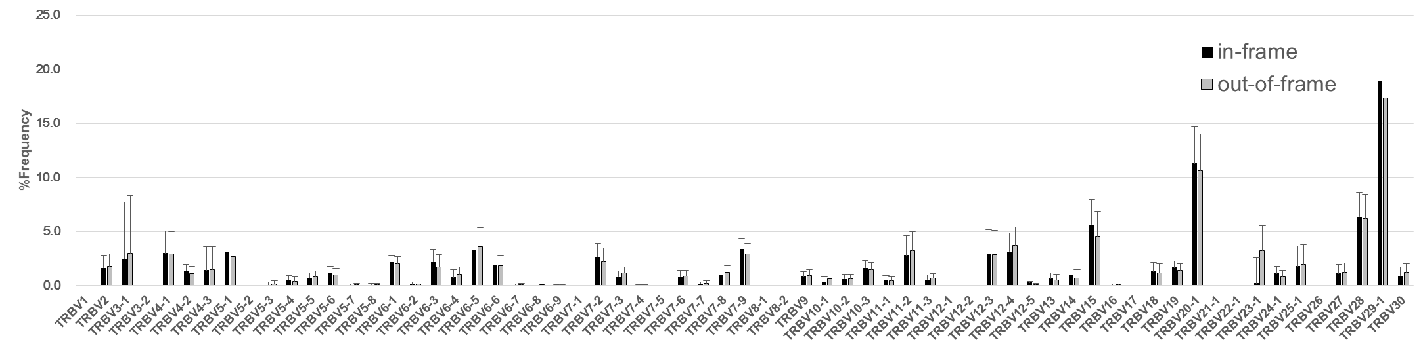
Comparison of TCR usages between in-frame and out-of-frame reads sequences
Mean percentage frequencies and standard deviations (error bars) of TRAV (A), TRAJ (B), TRBV (C) and TRBJ (D) in in-frame reads (black) and out-of-frame (grey) were shown (n = 20). On the whole, similar usages of TCR were observed between in-frame and out-of-frame reads. On the other hand, there were differences in the frequencies of TRAV26-2, TRAJ4, TRAJ37, TRBV23-1, TRBJ1-4 and TRBJ2-2 between in-frame and out-of-frame reads.
D
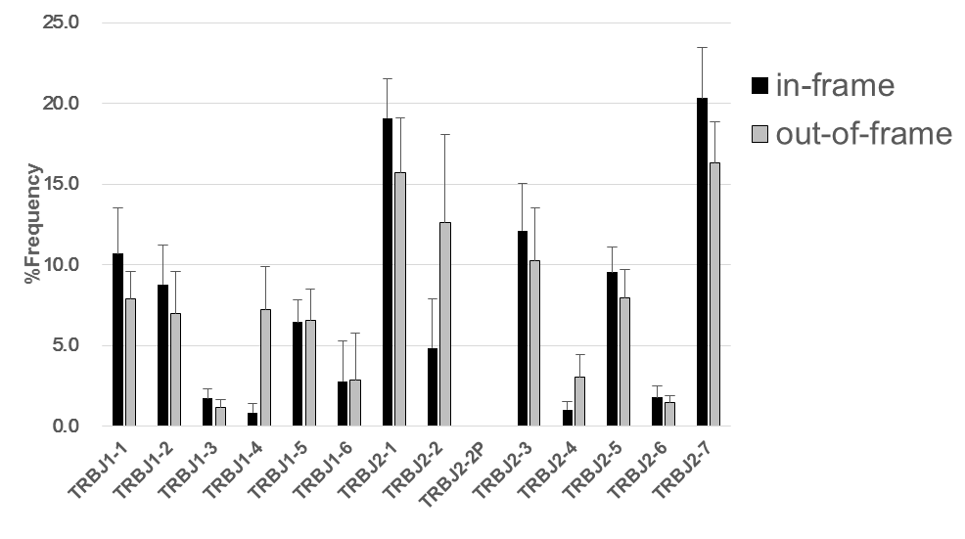

Figure S4
Diversity indices of in-frame and out-of-frame TRA and TRB.
Inverse Simpson index (A) and Shannon-Weaver Index (B) were compared between in-frame (IN) and out-of-frame (OUT) reads of TRA and TRB. The Shannon diversity indices were significantly higher in in-frame reads than in out-of-frame reads (TRA: 7.37 ± 0.72 vs. 6.81 ± 0.49, p < 0.05, TRB: 7.05 ± 0.64 vs. 6.46 ± 0.60, P < 0.005). However, there was no difference in the inverse Simpson index between in-frame and out-of-frame reads.

Figure S5
Correlation of TCR diversity with age.
Diversity indices (A: Shannon index in TRA, B: Shannon index in TRB, C: Inverse Simpson index in TRA, D: Inverse Simpson index in TRB) were plotted against individual’s age (n=20). Each dot indicates each healthy individual. There was a significant correlation of Shannon index in TRA with age (P<0.05, Spearman’s correlation) but no correlation of the other indices with age. Overall, there were tendencies for inverse relationship of diversity indices with age.

Figure S6

Correlation of TCR usage from a published FACS data with AL-PCR and Multiplex PCR
Mean percentage frequencies of each TRBV with FACS were plotted against that with AL-PCR (n=20) (A) or that with Multiplex PCR (n=3) (B). Correlation coefficients and p values were shown in figures. For datasets with flow cytometric analysis, data published by van der Beemd et al. (van den Beemd, Cytometry, 40:336-345, 2000) were used. Datasets were obtained with PBMCs from 3 Japanese healthy individuals with a multiplex PCR method by Adaptive Biotechnologies Inc. (Seattle, WA) in this study. There was a better correlation of FACS data with AL-PCR than Multiplex-PCR

