Supporting Figures and Legends

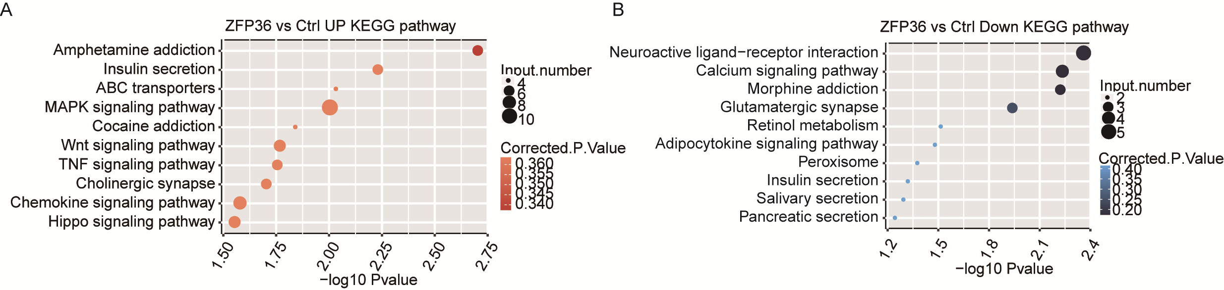
Figure S1 KEGG pathway analysis of differential expressed genes in HeLa cells after ZFP36 overexpression. (A) And (B) Top 10 GO pathway of up-regulated and down-regulated gene sets.

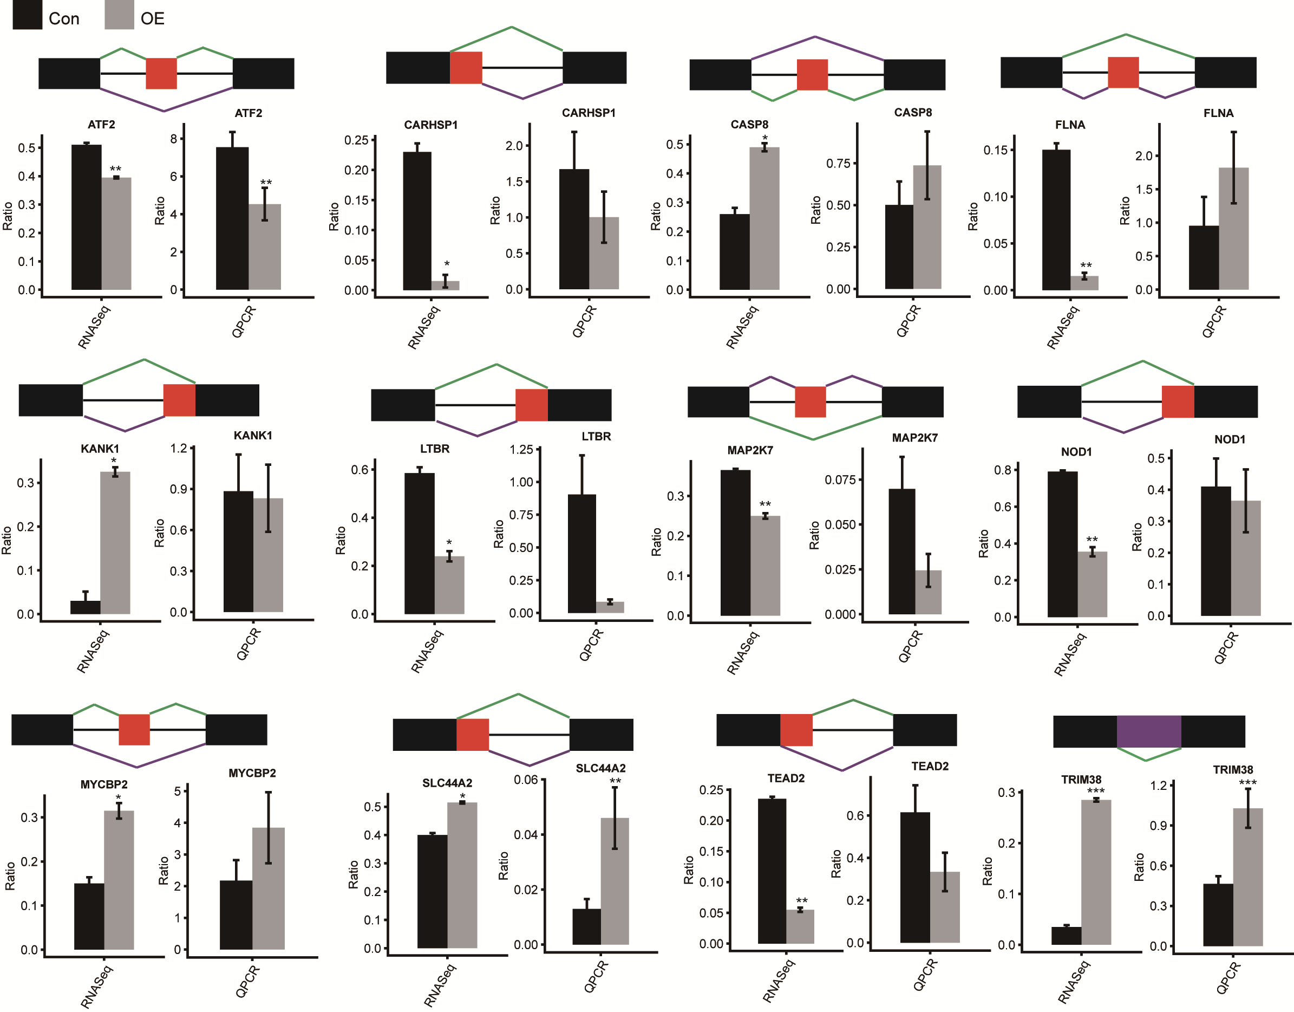
Figure S2 Validation of ZFP36-affected AS events (continued). (Top panel) the schematic diagrams depict the structures of alternative splicing events, AS1 (shown in purple) and AS2 (shown in green); exon sequences are denoted by boxes, and intron sequences by the horizontal line. (Bottom panel) RNA-seq quantification and RT-PCR validation of alternative splicing events. The altered ratio of AS events in RNA-seq were calculated using the formula: AS1 junction reads/AS1junction reads +AS2 junction reads; while the altered ratio of AS events in q-PCR were calculated using the formula: AS1 transcripts level/ AS2 transcripts level.

Supporting Tables and Legend

Table S1 the number of gene expressed in four samples
Sample | Expressed genes(FPKM>0) | Expressed genes(FPKM>=1)
Ctrl_1st | 22635 | 12712
Ctrl_2nd | 23692 | 12697
ZFP36_1st | 24417 | 12908
ZFP36_2nd | 23564 | 12776
Total genes | 28837

Table S2 Known or novel splicing events detected from ABLas.
Known splicing events
Sample | 3pMXE | 5pMXE | A3SS | A3SS&ES | A5SS | A5SS&ES | ES | IntronR | MXE | cassetteExon | Total | Detected junction
Ctrl_1st | 342 | 650 | 3222 | 354 | 3666 | 459 | 2481 | 1172 | 311 | 1762 | 14419 | 146811
Ctrl_2nd | 392 | 717 | 3597 | 387 | 4257 | 520 | 2757 | 1214 | 370 | 2022 | 16233 | 150744
ZFP36_1st | 409 | 770 | 3640 | 399 | 4308 | 501 | 2763 | 1233 | 366 | 2040 | 16429 | 153038
ZFP36_2nd | 370 | 721 | 3531 | 397 | 4062 | 519 | 2699 | 1268 | 344 | 1946 | 15857 | 148679
Total | 531 | 1015 | 4837 | 533 | 5668 | 692 | 3503 | 1696 | 540 | 2666 | 21681 | 166260
Novel splicing events
Sample | 3pMXE | 5pMXE | A3SS | A3SS&ES | A5SS | A5SS&ES | ES | IntronR | MXE | cassetteExon | Total | Detected junction
Ctrl_1st | 868 | 2193 | 4608 | 534 | 6108 | 605 | 1920 | * | 331 | 1157 | 18324 | 74418
Ctrl_2nd | 1050 | 2495 | 5219 | 623 | 6759 | 690 | 2153 | * | 375 | 1341 | 20705 | 95700
ZFP36_1st | 985 | 2514 | 5074 | 580 | 6994 | 714 | 2131 | * | 382 | 1374 | 20748 | 98821
ZFP36_2nd | 1043 | 2400 | 5411 | 650 | 7121 | 689 | 2444 | * | 408 | 1288 | 21454 | 84909
Total | 2502 | 5504 | 12801 | 1643 | 16017 | 1759 | 4928 | * | 949 | 3033 | 49136 | 211482
* predicted novel introns are omitted

