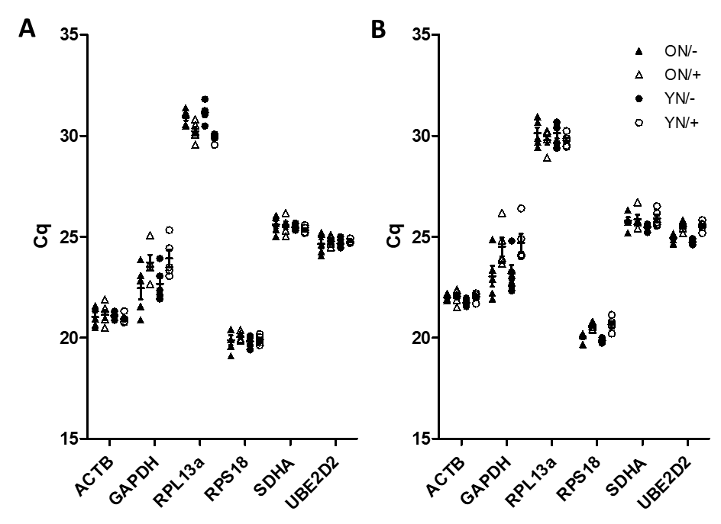
Supplementary figure 1: Cq values for candidate reference genes in PBMCs and T-cells, stratified by age and stimulation status. Mean quantification cycle (Cq) values are presented for young (YN) and old (ON) unstimulated (-) and influenza A/Victoria/375 stimulated (+) donor PBMCs (A) and CD3+ T-cells (B). No significant differences (p>0.20) were detected by Wilcoxon rank-sum test and data from a total of 10 donors is presented.

