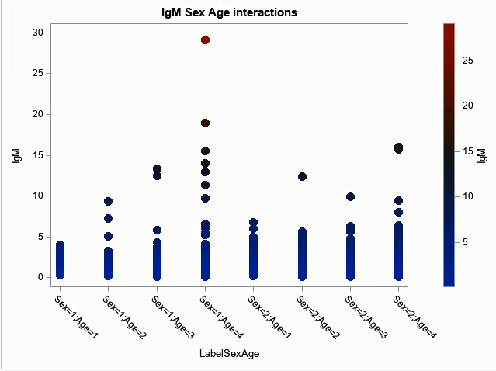
Figure S1 interactions between Sex and Age for IgM – Sex and Age interactions were statistically significant in IgM. The plot presents the dependent continuous variable (IgM values Y axis) versus the categories resulted of the combinations of the two independent variables studied (sex and age combinations categories X axis).
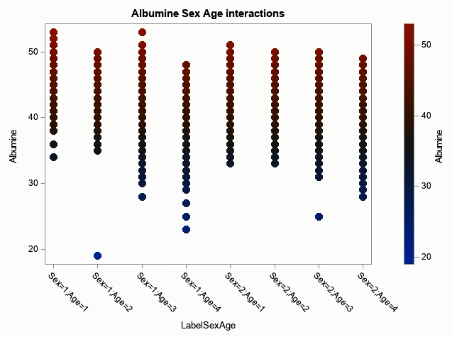

Figure S2 interactions between Sex and Age for Albumin – Sex and Age interactions were statistically significant in Albumin. The plot presents the dependent continuous variable (Albumin values Y axis) versus the categories resulted of the combinations of the two independent variables studied (sex and age combinations categories X axis).

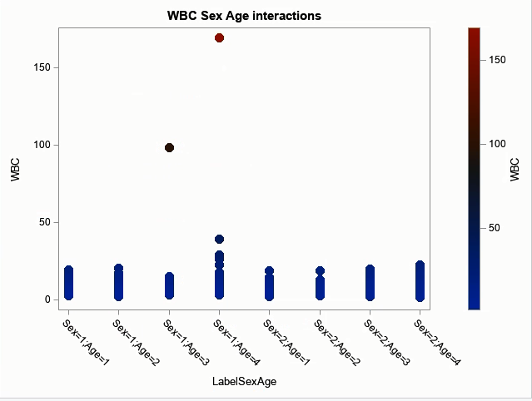
Figure S3 interactions between Sex and Age for WBC – Sex and Age interactions were statistically significant in WBC. The plot presents the dependent continuous variable (WBC values Y axis) versus the categories resulted of the combinations of the two independent variables studied (sex and age combinations categories X axis).

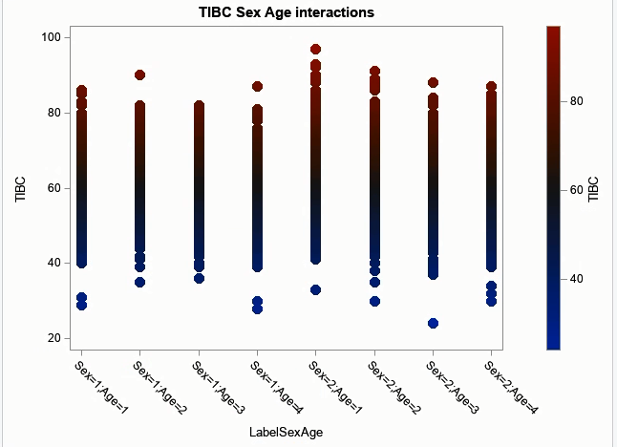
Figure S4 interactions between Sex and Age for TIBC – Sex and Age interactions were statistically significant in TIBC. The plot presents the dependent continuous variable (TIBC values Y axis) versus the categories resulted of the combinations of the two independent variables studied (sex and age combinations categories X axis).

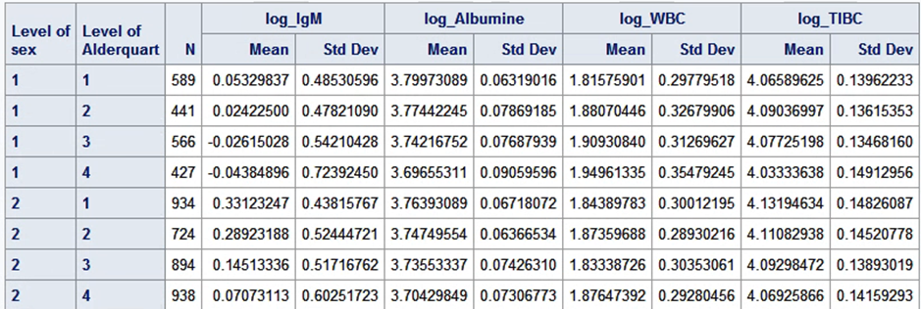
Table S1 presents the estimates for interaction between Age and Sex for the four biomarker IgM, Albumin, WBC and TIBC. Please note adelquart is the age variable. We use parametric manova to explore these interactions.

