Table S1. Number of available samples at each time point for responses to PPD
Time point  (weeks) | LTBI-Negative (n=150) | LTBI-Positive (n=132) | Total (n=282)
0 | 138 | 116 | 254
1 | 71 | 58 | 129
4 | 66 | 53 | 119
6 | 57 | 56 | 113
10 | 57 | 51 | 108
14 | 21 | 32 | 53
24 | 27 | 29 | 56
52 | 110 | 95 | 205
Table shows the number of samples assayed at each time point. Half of the infants were expected at time points other than weeks 0 and 52. Weeks 14 and 24 have lower numbers because they were introduced later.

Table S2. Comparison of Fractional polynomial and conventional higher order polynomials using various fit-statistics
Outcome | Model | AIC | Deviance | R² | Adjusted R²
IFN-gamma | Cubic | 2309.9 | 864.83 | 0.2562 | 0.2533
 | FP (0.5, 0.5)* | 2303.5 | 859.99 | 0.2604 | 0.2585
TNF | Cubic | 1513.2 | 316.42 | 0.247 | 0.2441
 | FP (0.5, 0.5) | 1508.4 | 315.28 | 0.2498 | 0.2478
IL-13 | Cubic | 1976.8 | 567.37 | 0.1463 | 0.143
 | FP (-0.5, 3) | 1961.3 | 557.66 | 0.1609 | 0.1588
IL-17A | Cubic | 1527.7 | 318.48 | 0.0544 | 0.0507
 | FP (-2, -2) | 1476.7 | 299.15 | 0.1118 | 0.1095
IL-2 | Cubic | 1465.7 | 294.89 | 0.2146 | 0.2115
 | FP (0) | 1457.6 | 293.35 | 0.2187 | 0.2177
IL-5 | Cubic | 1844 | 477.81 | 0.1065 | 0.103
 | FP (-1, 3) | 1817.6 | 463.12 | 0.1339 | 0.1317
IL-10 | Quadratic | 1400.6 | 271.46 | 0.006027 | 0.003478
 | Linear | 1398.8 | 271.53 | 0.005768 | 0.004495
*FP indicates a Fractional Polynomial model with the corresponding powers of time in brackets.

Table S3. Correlation matrix of random effects from the pairwise model
 | IFN-γ | IL-10 | IL-13 | IL-17 | IL-2 | IL-5 | TNF
IFN-γ | 1
IL-10 | 0.81 | 1
IL-13 | 0.71 | 0.70 | 1
IL-17 | 0.28 | 0.21 | 0.29 | 1
IL-2 | 0.21 | -0.01 | 0.14 | 0.09 | 1
IL-5 | 0.31 | 0.01 | 0.73 | 0.42 | -0.04 | 1
TNF | 0.89 | 0.77 | 0.75 | 0.42 | -0.07 | 0.27 | 1
Correlation coefficients greater than 0.5 are in bold.

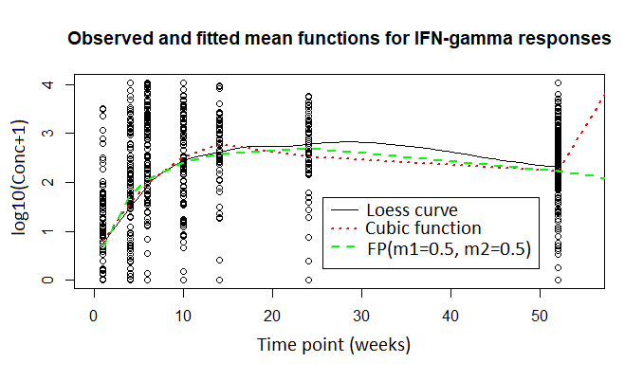
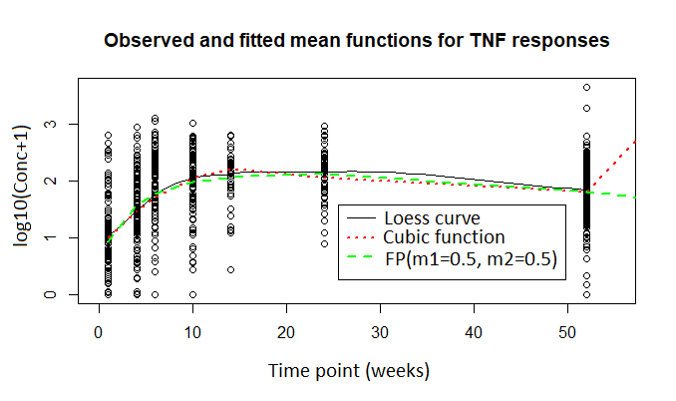
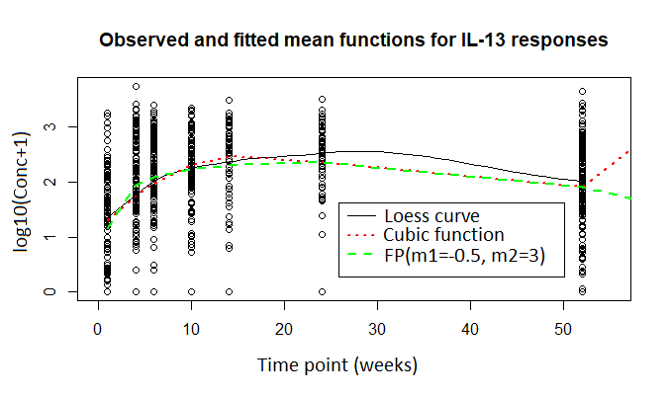
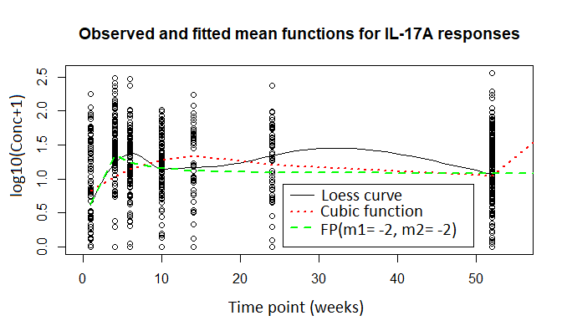
Figure S1A. Observed and fitted mean functions for the cytokine responses to PPD
Observed mean functions from loess smoothing are represented by black solid lines, red dotted lines represent the best fitting conventional higher order polynomial function while green dashed lines represent the best fitting fractional polynomial (FP) function of time. The figures in brackets for the FP functions represent the corresponding powers of time.

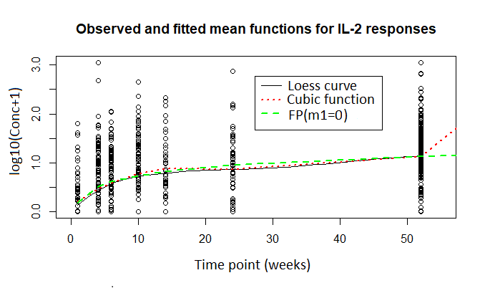
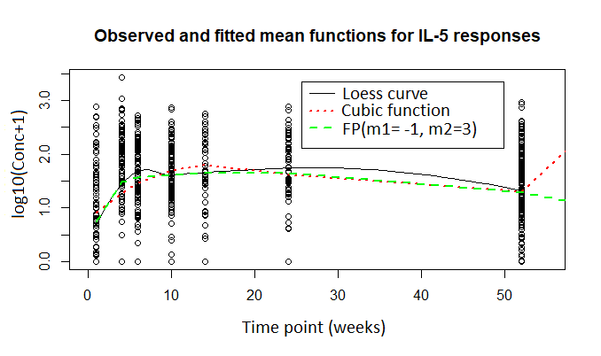
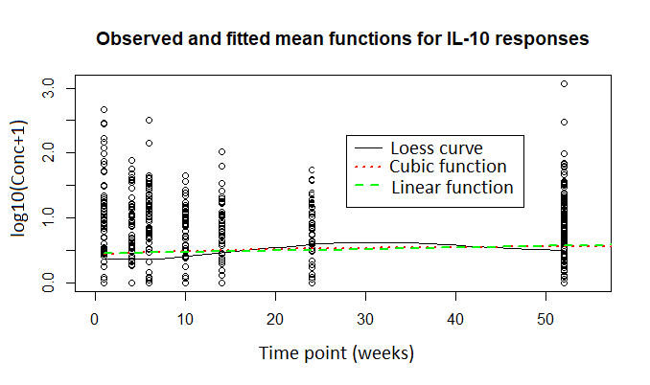
Figure S1B. Observed and fitted mean functions for the cytokine responses to PPD
Observed mean functions from loess smoothing are represented by black solid lines, red dotted lines represent the best fitting conventional higher order polynomial function while green dashed lines represent the best fitting fractional polynomial (FP) function of time. The figures in brackets for the FP functions represent the corresponding powers of time.

