Additional file 2. Antigen specificity of TFRs
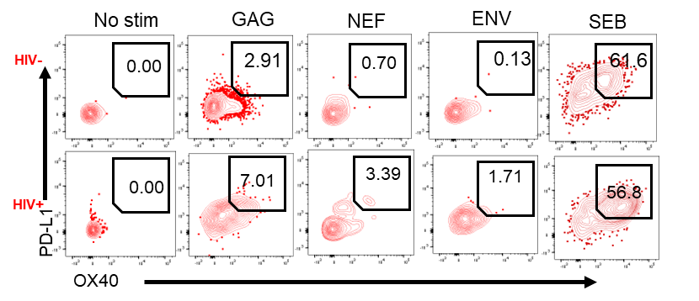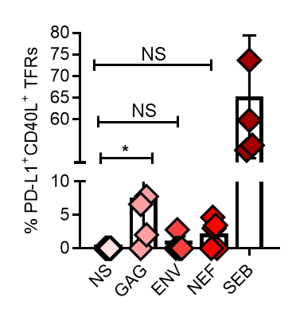
(A)
(B)
Additional file 2. Antigen specificity of TFRs
(A) Representative flow cytometry plots for HIV-uninfected and HIV-infected individual and (B) summary plot showing AIM+ TFRs identified as PD-L1+CD40L+ in HIV-infected subjects (n=5). Net frequency of the HIV-stimulated condition was calculated by subtracting the frequency detected in the unstimulated control. P values were determined using Mann-Whitney U test.

