Additional file 4. Gating strategy and sorting purity for TFRs and TFH cells

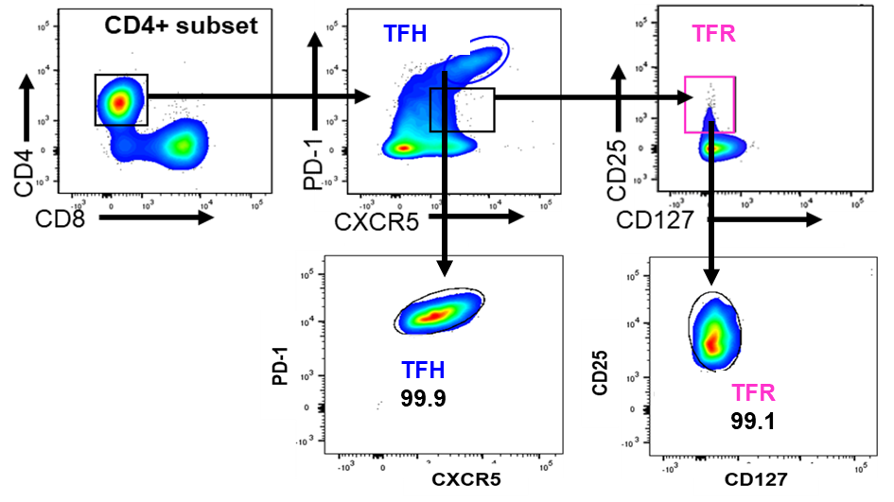
Additional file 4. Gating strategy and sorting purity of TFRs and TFH cells. TFRs were identified based on CD4⁺CXCR5⁺PD1^{hi}CD127⁻CD25⁺ phenotypic markers and TFH cells were defined by CD4⁺CXCR5^{hi}PD1^{hi} and sorted from LN samples on BD FACSAria II (BD Biosciences) with a sorting purity of ~99%.

