Additional file 2
Figure S2
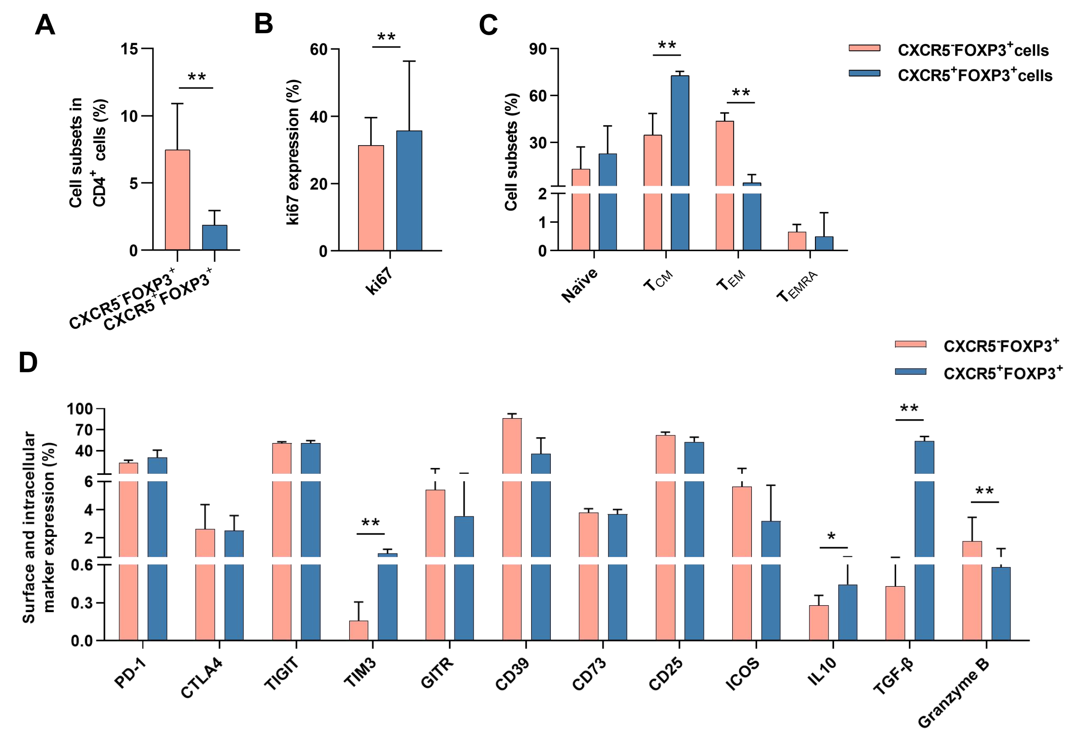
Fig. S2. Identification of CD4⁺CXCR5⁻FOXP3⁺ T cells and CD4⁺CXCR5⁺FOXP3⁺ T cells in peripheral blood. (A) The frequency of CD4⁺CXCR5⁻FOXP3⁺ T cells and CD4⁺CXCR5⁺FOXP3⁺ T cells in peripheral blood from patients with HBV infection (n=9). Horizontal bars reflect the median. (B and C) The percentage of ki67 and T cell subsets (n=9) in CD4⁺CXCR5⁻FOXP3⁺ T cells and CD4⁺CXCR5⁺FOXP3⁺ T cells. T cell subsets were defined using the following gating strategy: naïve T cells (CCR7⁺CD45RO⁻), T_{CM}: central memory T cells (CCR7⁺CD45RO⁺), T_{EM}: effector memory T cells (CCR7⁻CD45RO⁺), T_{EMRA}: CD45RA expressing effector memory T cells (CCR7⁻CD45RO⁻) (D) The expression of surface and intracellular cytokines (n=9) in CD4⁺CXCR5⁻FOXP3⁺ T cells and CD4⁺CXCR5⁺FOXP3⁺ T cells. Wilcoxon signed-rank test. *p <0.05, **p <0.01, ***p<0.001.

