Additional file 1: Confirmation of the accuracy of end-point RT-qPCR product using agarose gel electrophoresis.
Figure A1.1 showed the end-point RT-qPCR products of IL31RA, OSMR, GAPDH and RPL13A mRNA that were validated using agarose gel electrophoresis. You can see the results of the expression in Figure 2C and 2D.
Figure A1.2 showed the end-point RT-qPCR products of TRPV4, GAPDH and RPL13A mRNA that were validated using agarose gel electrophoresis. You can see the results of the expression in Figure 5H.

A B
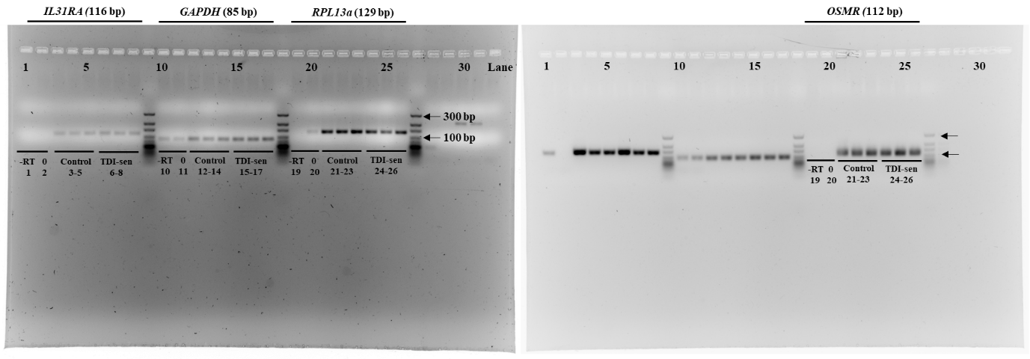
Figure A1.1 Confirmation of the accuracy of end-point RT-qPCR product of IL31RA and OSMR gene using agarose gel electrophoresis. -RT and 0 stand for minus reverse transcriptase control (MRT) and a no template control (NTC) respectively. There are three samples per group (N=3, control and TDI-sensitized group).

A B
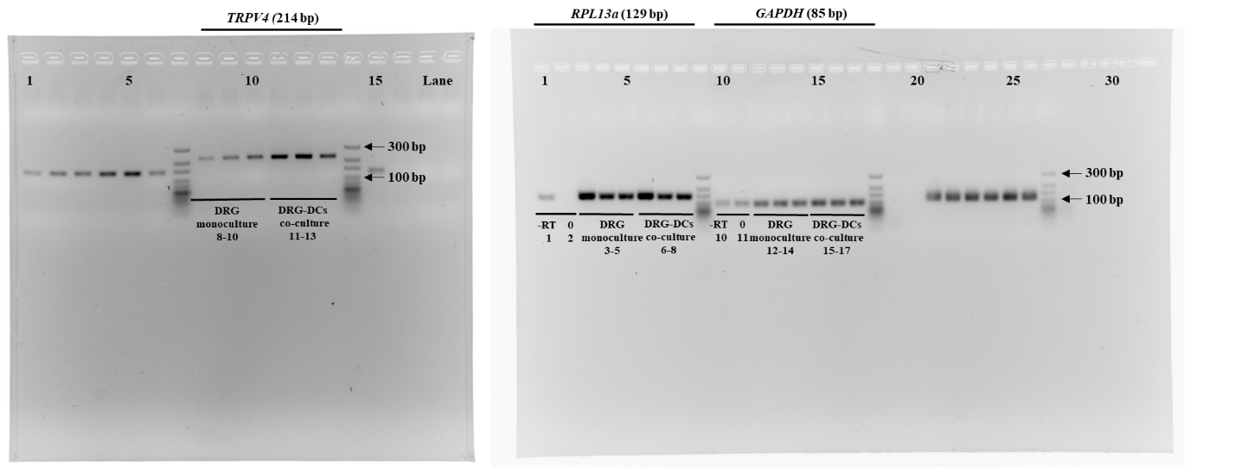
Figure A1.2 Confirmation of the accuracy of end-point RT-qPCR product of TRPV4 gene using agarose gel electrophoresis. -RT and 0 stand for minus reverse transcriptase control (MRT) and a no template control (NTC) respectively. There are three samples per group (N=3, control and TDI-sensitized group).

