Additional file
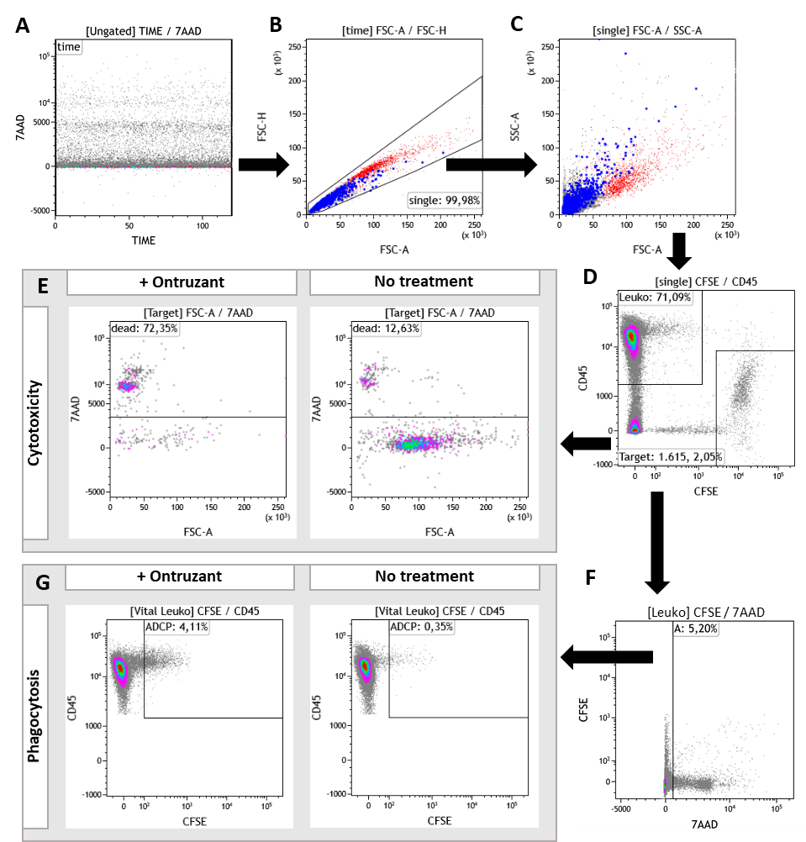
Additional figure 1. Gating strategy for ADCC and ADCP Assay. (A) The time parameter allowed to monitor instrument stability. (B) Cell singlets were selected via forwards scatter height (FSC-H) and forward scatter area (FSC-A).(C) Cells were visualized in the sideward scatter area (SSC-A) and the FSC-A. (D) Target cells were determined by CD45- and CFSE+ gate and leukocytes by the CD45+ and CFSE- gate. The CD45+ CFSE+ gate with strong CFSE signal was excluded from further analysis. Cells with strong CD45+ and CFSE+ signal are likely to be leukocytes bound to tumor cells. For phagocytosis we assumed the CFSE signal decreased. (E) Cytotoxicity was defined as dead target cells determined as 7AAD+ cells in the target cell gate. Cytotoxicity was determined in two separate FACS tubes one containing ontruzant (10µg/ml) and one without treatment. (F) Vital leukocytes were determined as 7AAD- in the leucocyte gate. (G) Phagocytosis was defined as CFSE+ and CD45+ cells in the vital PBMC fraction. The vital PBMCs gate was chosen since dead PBMCs are assumed to be irrelevant for phagocytosis. A gap between CD45+ and CFSE- and the CD45+ and CFSE+ gate was left to exclude CD45+ cells with weak CFSE signal due to other reasons. Phagocytosis was evaluated in two separate FACS tubes one with ontruzant and one without treatment.

